**Chapter 4**

**RESULTS AND DISCUSSIONS**

In this chapter, the proponent presented and discussed the statement of the problems, specifically the probability of issues that could arise from the current evaluation of the research template. The information, procedures, and responses that the proponent gathered would contribute to the development of the proposed system.

**Procedures Involved in the Existing Hotel Management System of Hotel Le Duc**

The proponent conducted an interview and observation to collect data

and information to analyze and state the processes involved in the existing Hotel Management System of Hotel Le Duc. The evaluation research is divided into the following processes:

Initiating the Reservation. Guests start by providing their basic information. This can be done through an online form on the hotel’s website, including their name and contact details. Alternatively, guests can skip the website and call the hotel directly.

Hotel Receives the information. Once the hotel receives the basic information, either from the website, or from a phone call, the staff will reach out to the guest.

Checking Availability. With all the details in hand, the staff checks the reservation system to see if the desired room type is available for the requested dates.

Reservation Confirmation. The staff will confirm the reservation details with the guest and gather any additional information needed.

Confirmation Email. Once confirmed, the hotel will send the guest a confirmation email outlining all the reservation details.

Guest Arrives. Upon arrival at the hotel, the guest proceeds to the reception area and informs the staff of their arrival and reservation.

Registration and Payment. The staff will complete any necessary registration steps, which may involve collecting additional information and payment for the stay.

Room Key Issuance. Once the registration and payment process completed, the staff will issue the guest a room key for their assigned room.

Completing the Check-In Experience. The hotel staff will finalize the check-in process by warmly welcoming the guest, providing directions to their room, and answering any questions they may have.

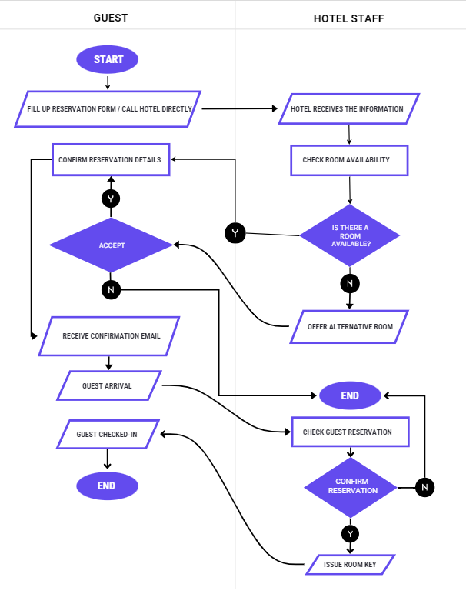

Figure 3. Swimlane Diagram of the Existing System

**Difficulties Encountered in the Existing Hotel Management System of Hotel Le Duc**

Based on the conducted interview, observations, and data gathered by the proponent, the current system encountered the following problems:

Limited Information Gathering. The initial online form captures only basic details. It necessitates a phone call to finalize the reservation, potentially adding an extra step and increasing the time it takes to book a room.

Lack of Transparency. Guest cannot see available room options or rates directly online. They have to rely on phone communication to determine availability and pricing.

Inefficient Communication. The guest might experience delays if the hotel staff is busy with other tasks when they call to complete the reservation.

Incomplete Information. Starting the reservation process with limited guest information necessitates additional phone calls to gather missing details like desired dates, room type preference, and arrival time. This can be time-consuming for both staff and guests.

Manual Data Entry. Staff might need to manually enter reservation details into the system after phone conversations, increasing the risk of errors.

Limited Online Booking Potential. The limited online functionality restricts the hotel from capturing guests who prefer the convenience of online booking platforms. This could potentially lead to missed booking opportunities.

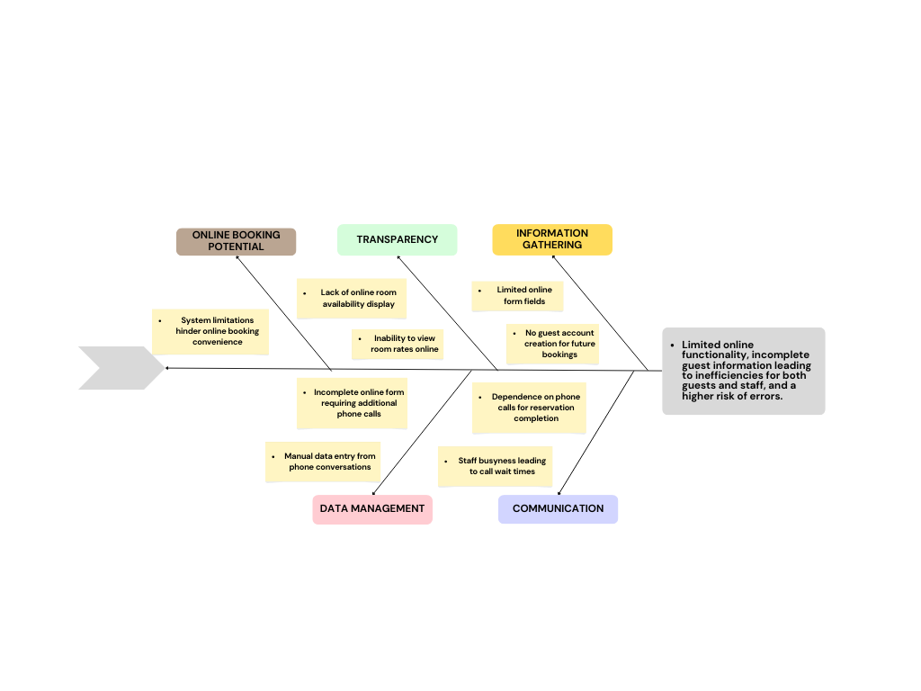

Figure 4: Ishikawa Diagram of the Existing System

**Features incorporated of the Proposed System**

The development of a centralized management system of Hotel Le Duc aimed to provide the following features:

Online Reservation System. Reserve a room directly with real-time availability and pricing, eliminating phone calls and delays.

In Room Ordering. Order food and drinks conveniently from your room, enhancing guest comfort and satisfaction. Orders are seamlessly integrated with the billing system, allowing charges to be automatically added to the final bill.

Walk-In Booking Capabilities. Cater spontaneous travelers allowing walk-in guests to book available room directly at the hotel.

Guest Profiles. Manage guest information in one place, allowing for personalized service and improved efficiency.

Real-Time Inventory. Track room availability accurately to avoid overbooking and ensure a smooth guest experience.

Automated Billing. Generate bills and invoices automatically, reducing errors and streamlining financial processes.

Check-In/Check-Out. Streamline guest check-in and check-out processes, minimizing wait times and improving guest satisfaction.

Employee Profiles. Manage employee access and permissions, ensuring data security and streamlined internal operations.

**Acceptance Level of the Proposed System**

The evaluation of the proposed Centralized Management System of Hotel Le Duc focused on its completeness, accuracy, reliability, timeliness and

security (CARTS).

The completion of the system was presented to the management. The proponent conducted a survey of 100 respondents, consisting of past guests, potential guests, hotel front desk staff, and travel agents.

Completeness. Table 2 shows the perception of the evaluators of the system with respect to its completeness. The respondents strongly agree on the completeness of the system as reflected in the weighted mean of 3.67.

|  |  |  |
| --- | --- | --- |
| **Completeness** | **Mean** | **Description** |
| 1. The system works well. 2. It is easy to use. 3. I think, I don’t need technical support to be able to use the system. 4. I found the various functions in the system very well integrated. 5. There was consistency in the system. 6. I felt very confident using the system. 7. I would imagine that most people would learn to use the system very quickly. | 3.58  3.63  3.65  3.71  3.69  3.71  3.73 | Strongly Agree  Strongly Agree  Strongly Agree  Strongly Agree  Strongly Agree  Strongly Agree  Strongly Agree |
| Weighted Mean | 3.67 | Strongly Agree |

Table 2. System Evaluation According to Completeness

Accuracy. Table 3 shows the perceptions of the evaluators of the system with respects to its accuracy, The respondents strongly agree on the accuracy of

the system, as reflected in the weighted mean of 3.70.

|  |  |  |
| --- | --- | --- |
| **Accuracy** | **Mean** | **Description** |
| 1. It is easy to find my way around the system. 2. I can get the information quickly. 3. It is fun to explore the system. 4. The user can easily navigate from one task to another. 5. It is easy to remember where to find things. 6. Information is organized on the screen | 3.74  3.71  3.71  3.71  3.65  3.68 | Strongly Agree  Strongly Agree  Strongly Agree  Strongly Agree  Strongly Agree  Strongly Agree |
| Weighted Mean | 3.70 | Strongly Agree |

Table 3. System Evaluation According to Accuracy

Reliability. Table 4 shows the perceptions of evaluators of the system according to its reliability. The respondents strongly agree on getting information quickly and reliably reflected in the weighted mean of 3.72.

|  |  |  |
| --- | --- | --- |
| **Reliability** | **Mean** | **Description** |
| 1. The system provides clear information. 2. Information is easy to read. 3. It is easy to input information into the electronic record. 4. Screens have the right amount of information. 5. The system effectively communicates the school’s identity. 6. Data manipulation efficiency is up-to-date. 7. The data that has been kept in the database is exactly the same data when retrieved. | 3.71  3.75  3.74  3.71  3.69  3.71  3.70 | Strongly Agree  Strongly Agree  Strongly Agree  Strongly Agree  Strongly Agree  Strongly Agree  Strongly Agree |
| Weighted Mean | 3.72 | Strongly Agree |

Table 4. System Evaluation According to Reliability

Timeliness. Table 5 shows the perceptions of the evaluators of the system according to its timeliness factor. The respondents strongly agree on the real-time response of the proposed system, as reflected in a weighted mean of 3.73

|  |  |  |
| --- | --- | --- |
| **Timeliness** | **Mean** | **Description** |
| 1. The system responds quicker to every action. 2. It is faster to save, update, and delete information. 3. The page loads faster.   4. The system content makes me want to explore the system further. | 3.72  3.74  3.73  3.73 | Strongly Agree  Strongly Agree  Strongly Agree  Strongly Agree |
| Weighted Mean | 3.73 | Strongly Agree |

Table 5. System Evaluation According to Timeliness

Security. Table 6 shows the perceptions of evaluators of the system according to security purposes. The respondents strongly agree on the security factor of the system, as indicated by the reflected weighted mean of 3.71.

|  |  |  |
| --- | --- | --- |
| **Security** | **Mean** | **Description** |
| 1. The system facilitates work in the sector of guidelines and authorizations. 2. The system allows the office staff to manage the system efficiently. 3. The users can modify their personal details as passwords. 4. It reduces the occurrences of fraud | 3.64  3.72  3.75  3.72 | Strongly Agree  Strongly Agree  Strongly Agree  Strongly Agree |
| Weighted Mean | 3.71 | Strongly Agree |

Table 6. System Evaluation According to Security

As a summary, the overall acceptance level of the proposed system, as shown in Table 7 below, which resulted in a weighted mean of 3.71, indicates that the respondents are satisfied with the incorporated features of the proposed system.

|  |  |  |
| --- | --- | --- |
| **Criteria** | **Mean** | **Description** |
| 1. COMPLETENESS 2. ACCURACY 3. RELIABILITY 4. TIMELINESS 5. SECURITY | 3.67  3.70  3.72  3.73  3.71 | Strongly Agree  Strongly Agree  Strongly Agree  Strongly Agree  Strongly Agree |
| Weighted Mean | 3.71 | Strongly Agree |

Table 7. Overall Acceptance Level of the Proposed System