Use Case Diagram and Specifications - Anime World Shop
Related documents: Requirement Analysis - ERD - API documentation
The diagrams are written in PlantUML (diagrams/*.puml) and exported as PNG. To change one, edit the .puml file and run:
java -jar plantuml.jar -tpng -Sdpi=150 docs/requirements/diagrams/use-case-*.puml
The Word copies (.docx) are made from these Markdown files with python make_docx.py docs/requirements (needs pip install pypandoc_binary python-docx); the PDFs are exported from Word.

1. Actors
Actor | Type | Description
User (not signed in) | Primary | Anyone who opens the app without being logged in. Can only register, log in or reset a password.
Customer | Primary | A registered shopper. A specialisation of User: everything a User can do, plus shopping.
Admin | Primary | The shop owner or staff. A specialisation of User. Uses the admin tabs of the app, the React web admin at /dashboard or the panel at /admin.
Bakong KHQR | Secondary (external system) | Cambodia's national QR payment network. Receives KHQR payment requests and reports when they are paid.
ABA PayWay | Secondary (external system) | ABA Bank's payment gateway. Creates a payment (KHQR + ABA Mobile link), answers status checks and posts the result back.
Email service | Secondary (external system) | Sends the 6-digit password reset codes.

2. Use case diagrams

2.1 Overview - all actors
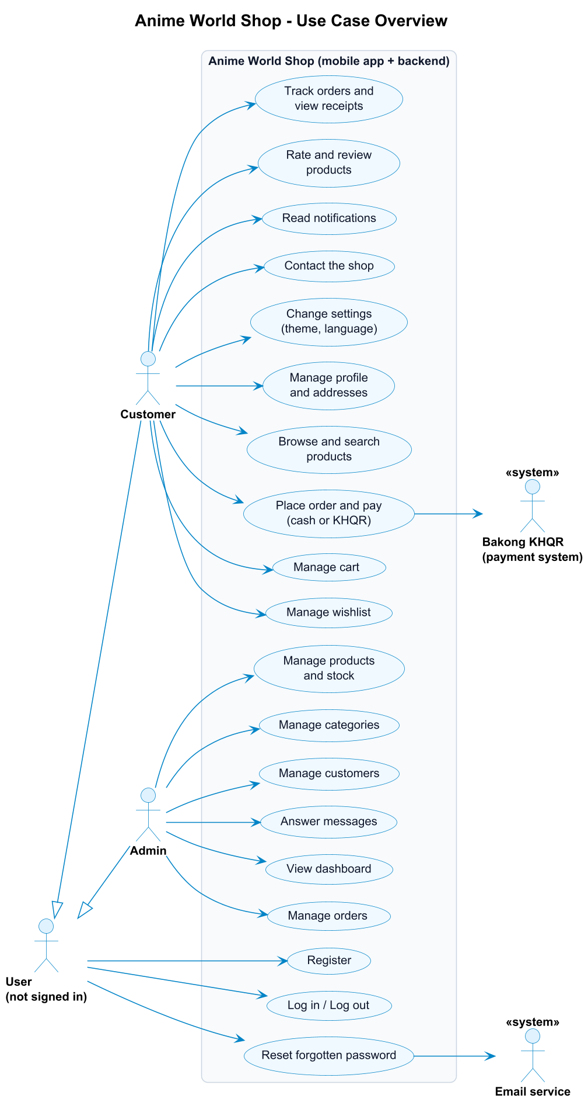
<<include>> = always part of the base use case. <<extend>> = optional extra behaviour that happens only in some cases.

2.2 Customer - browse, cart and wishlist
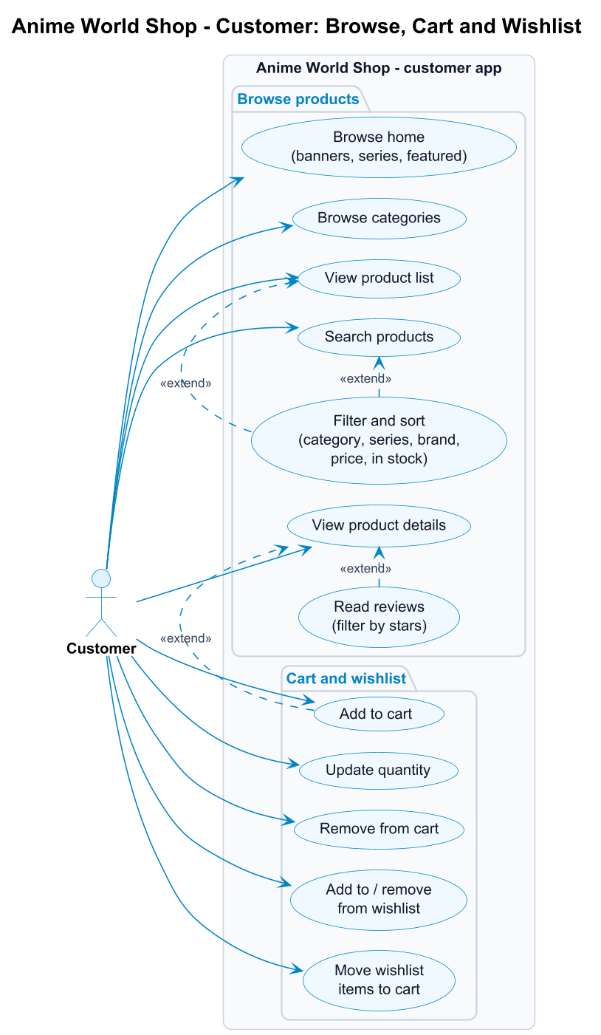

2.3 Customer - checkout and orders
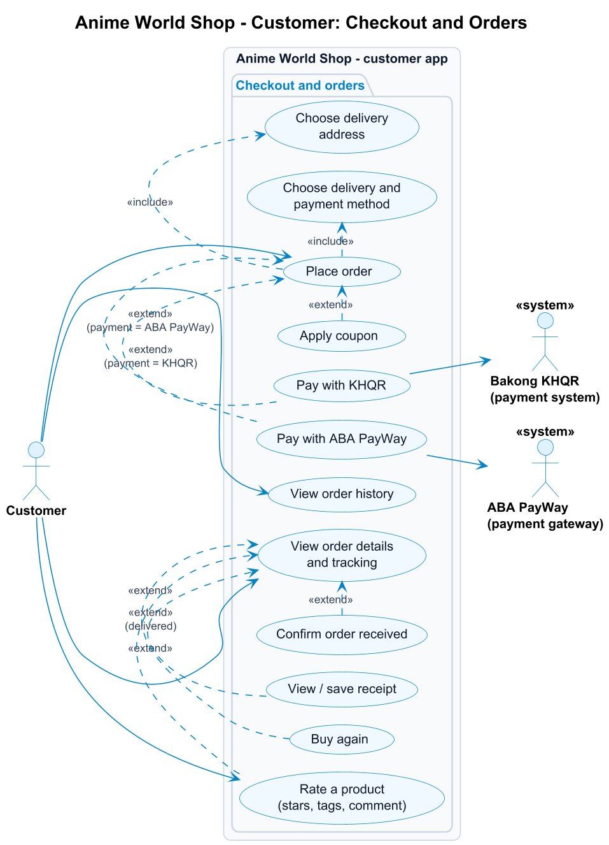

2.4 Customer - account and support
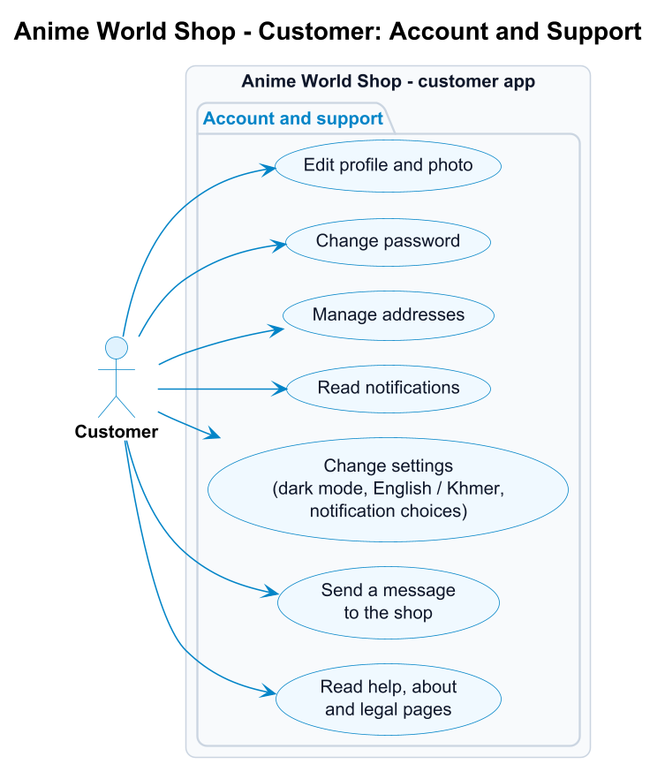

2.5 Admin
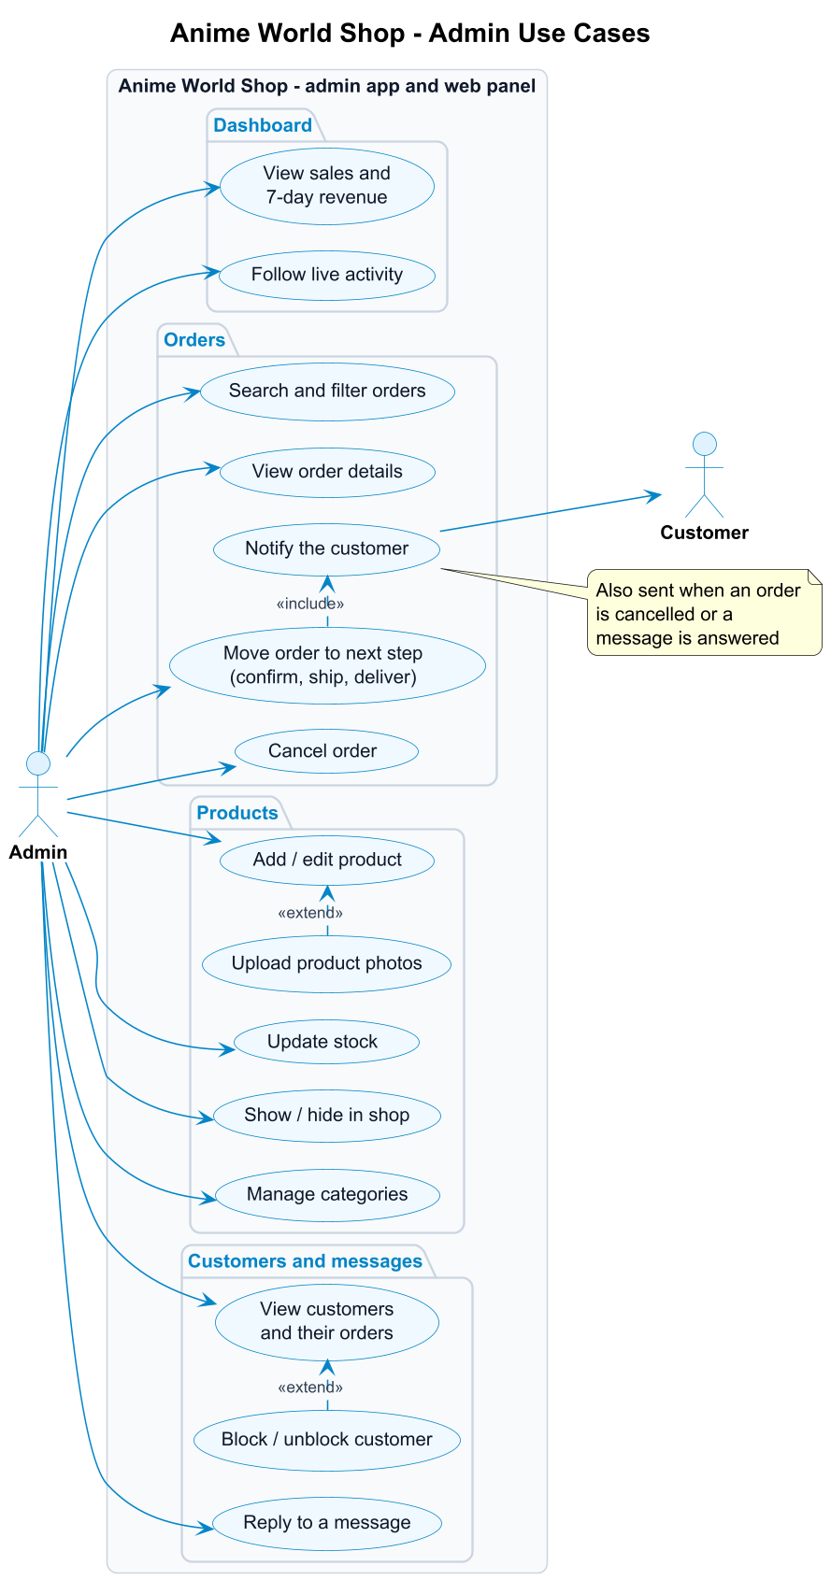

3. Use case list
ID | Use case | Actor | Requirement | Screen(s)
UC-01 | Register | User | FR-U02 | Register
UC-02 | Log in / log out | User | FR-U03, FR-U09 | Login, Profile
UC-03 | Reset forgotten password | User, Email service | FR-U04 | Forgot Password, Verify Code, Reset Password
UC-04 | Edit profile and photo | Customer | FR-U05, FR-U06 | Profile, Edit Profile
UC-05 | Change password | Customer, Admin | FR-U07 | Change Password
UC-06 | Manage addresses | Customer | FR-U08 | My Addresses, Address Form
UC-07 | Browse home and categories | Customer | FR-P01, FR-P02 | Home, Categories
UC-08 | Search, filter and sort products | Customer | FR-P05, FR-P06 | Search, Product List, Filter
UC-09 | View product details | Customer | FR-P04 | Product Details
UC-10 | Add to cart | Customer | FR-C01 | Product List, Product Details
UC-11 | Update quantity / remove from cart | Customer | FR-C02, FR-C03 | Cart
UC-12 | Manage wishlist | Customer | FR-C06 | Wishlist
UC-13 | Place order (checkout) | Customer | FR-O01 - FR-O03 | Checkout, Order Placed
UC-14 | Apply coupon | Customer | FR-C05 | Cart
UC-15 | Pay with KHQR | Customer, Bakong KHQR | FR-O04 | KHQR Payment
UC-15b | Pay with ABA PayWay | Customer, ABA PayWay | FR-O04b | ABA PayWay Payment
UC-16 | View order history and details | Customer | FR-O05, FR-O06 | My Orders, Order Details
UC-17 | Confirm received / buy again / view receipt | Customer | FR-O07 | Order Details, Receipt
UC-18 | Read notifications | Customer | FR-A01 | Notifications
UC-19 | Change settings | Customer, Admin | FR-A02 | Settings
UC-20 | Send a message to the shop | Customer | FR-A04 | Contact Us
UC-21 | Read help, about and legal pages | Customer | FR-A03, FR-A05 | Help, About, Legal
UC-22 | Rate a product (edit / delete my review) | Customer | FR-R01, FR-R02 | Rate sheet (from Order Details, Notifications, To review, Product Details)
UC-23 | Read reviews | Customer | FR-R03, FR-R04 | Product Details, Reviews
UC-A1 | View dashboard and live activity | Admin | FR-AD01 | Admin Dashboard
UC-A2 | Manage orders (next step, cancel) | Admin | FR-AD02 | Admin Orders, Admin Order Details
UC-A3 | Add / edit product and photos | Admin | FR-AD03 | Admin Products, Add / Edit Product
UC-A4 | Update stock, show / hide product | Admin | FR-AD03 | Admin Products
UC-A5 | Manage categories | Admin | FR-AD04 | Admin Categories
UC-A6 | View and block / unblock customers | Admin | FR-AD05 | Admin Customers, Customer Details
UC-A7 | Reply to a message | Admin | FR-AD06 | Admin Messages

4. Use case specifications
The main use cases in detail. Numbers in the flows are steps; "A" flows are alternatives or errors that branch off a step.

UC-01 Register
Actor | User (not signed in)
Goal | Create a customer account and start shopping.
Precondition | The user has no account with this email.
Trigger | The user taps "Create account" on the Login screen.
Main flow
- The user enters full name, email, phone (optional) and password, and ticks "I agree to the Terms & Privacy Policy".
- The app checks the fields and sends POST /api/auth/register.
- The system validates the data, stores the password as a bcrypt hash and creates the account with the role customer.
- The system returns a login token and creates a welcome notification.
- The app saves the token and opens the Home screen.
Alternative flows
- A1 (step 2/3): a field is wrong (empty name, invalid email, password shorter than 6 characters, invalid phone). The system returns 422 with the wrong fields; the app shows each message under its field.
- A2 (step 3): the email is already registered. 422; the app shows "Email is already registered" under the email field.
- A3: no connection. The app shows "Cannot connect to server. Check your internet connection."
Postcondition A new customer account exists and the user is logged in.

UC-02 Log in
Actor | User (not signed in) - becomes Customer or Admin
Precondition | The user has an account.
Main flow
- The user enters email and password and taps Log in.
- The app sends POST /api/auth/login.
- The system checks the password against the stored hash and that the account is active.
- The system returns a JWT (valid 7 days) and the user's profile, including the role.
- The app opens the shop for a customer, or the Admin Dashboard for an admin.
Alternative flows
- A1 (step 3): wrong email or password. 401, "Incorrect email or password"; the fields shake.
- A2 (step 3): the account is blocked. 403, "This account has been disabled".
Postcondition The token is stored on the device; the user stays logged in until they log out (UC-02 log out: confirm dialog, token deleted, Login screen shown).

UC-03 Reset forgotten password
Actors | User, Email service
Precondition | The user has an account but forgot the password.
Main flow
- On Login the user taps "Forgot password?" and enters their email.
- The system creates a 6-digit code valid for 10 minutes, stores only its hash, and sends it by email.
- The user enters the code on the Verify Code screen.
- The system checks the code and returns a short-lived reset token (15 minutes).
- The user enters and confirms a new password.
- The system saves the new password hash and marks the code as used.
- The app shows "Password changed" and returns to Login.
Alternative flows
- A1 (step 2): the email is not registered. The app shows the same "code sent" message, so nobody can find out which emails have accounts.
- A2 (step 2): the user asks again within 60 seconds ("Please wait Ns before requesting a new code") or more than 5 times in an hour ("Too many code requests. Please try again in an hour."). 429; the Resend button counts down.
- A3 (step 4): wrong code, or older than 10 minutes. 400, "The code is incorrect or has expired".
- A4 (step 4): 5 wrong tries. 429, "Too many wrong attempts. Please request a new code." The code is locked.
Postcondition The account has the new password; the old one no longer works.

UC-08 Search, filter and sort products
Actor | Customer
Precondition | Logged in.
Main flow
- The customer taps the search bar on Home.
- The app shows recent searches; as the customer types, it shows suggestions (GET /api/search/suggestions).
- The customer submits a search or picks a suggestion.
- The system returns matching active products (name, brand or series) a page at a time.
- The customer opens Filters and chooses category, series, brands, price range and "in stock only", and a sort order.
- The app reloads the list with those filters (GET /api/products?q=&category_id=&brand=&min_price=&max_price=&in_stock=1&sort=) and shows the active filters as chips.
Alternative flows
- A1 (step 4): nothing matches. The app shows an empty state ("Try removing a filter.").
- A2: the customer removes a chip, or taps "Clear all"; the list reloads without those filters.
Postcondition The customer sees the products that match.

UC-10 Add to cart
Actor | Customer
Extends | UC-09 View product details (and the product list)
Main flow
- The customer taps "Add to cart" on a product.
- The app sends POST /api/cart with the product and quantity.
- The system checks that the product is active and in stock, then adds the line or increases its quantity.
- The app plays the cart animation, updates the Cart badge and shows "Added to your cart" with a View cart button.
Alternative flows
- A1 (step 3): sold out (409, "This item is sold out") or the cart would exceed the stock (409, "Only N can be added for this item"). The app shows the message and nothing is added.
Postcondition The cart contains the product.

UC-13 Place order (checkout)
Actor | Customer
Includes | Choose delivery address; choose delivery and payment method
Extended by | UC-14 Apply coupon; UC-15 Pay with KHQR; UC-15b Pay with ABA PayWay
Precondition | Logged in; the cart is not empty.
Main flow
- In the Cart the customer taps "Go to checkout".
- The app loads GET /api/checkout: cart lines, addresses, delivery options and totals.
- The customer chooses (or adds) a delivery address.
- The customer chooses Standard delivery ($2, free from $50) or Store pickup (free).
- The customer chooses KHQR, ABA PayWay or Cash on delivery and can add a note.
- The customer taps "Place order"; the app sends POST /api/orders.
- The system checks every line against the current stock, then in one transaction takes the stock (a conditional update, so the last item can't be sold twice), creates the order (number like AWS-20261016-00042) and its items, and empties the cart.
- The system creates an "Order placed" notification.
- Cash on delivery: the app shows the Order Placed screen. KHQR: continue with UC-15. ABA PayWay: continue with UC-15b.
Alternative flows
- A1 (step 3): no address yet. The app opens the Address Form first.
- A2 (step 7): an item sold out or has less stock than ordered since it was added. 409, e.g. "Some items changed. Only 1 left of Nendoroid Anya Forger."; nothing is ordered and the customer can fix the cart.
- A4 (step 6): the cart is empty. 409, "Your cart is empty".
- A3 (step 6): no payment method chosen. 422, "Choose KHQR, ABA PayWay or Cash on delivery".
Postcondition A pending order exists, stock is reserved and the cart is empty.

UC-15 Pay with KHQR
Actors | Customer, Bakong KHQR
Extends | UC-13 Place order, when the payment method is KHQR
Precondition | A pending, unpaid KHQR order.
Main flow
- The app requests a payment (POST /api/orders/<id>/khqr).
- The system generates a KHQR code for the order total with the shop's Bakong account and stores its MD5 reference. The code expires after 15 minutes.
- The app shows the QR, the amount and a countdown.
- The customer scans the code with any Cambodian bank app (ABA, ACLEDA, Wing ...) and pays.
- The app checks the status every few seconds (GET /api/orders/<id>/payment); the system asks Bakong whether that reference is paid.
- When Bakong reports paid, the system marks the payment and the order as paid and sends a "Payment received" notification.
- The app prints out the receipt and offers Save receipt, View order and Continue shopping.
Alternative flows
- A1 (step 5): 15 minutes pass without payment. The order is cancelled and its stock returned; the app shows "This QR code expired" and a Try again button.
- A2 (step 5): the customer taps "I've paid - check now" to check straight away instead of waiting for the next automatic check.
Postcondition The order is paid and waits for the shop to confirm it.

UC-15b Pay with ABA PayWay
Actors | Customer, ABA PayWay
Extends | UC-13 Place order, when the payment method is ABA PayWay
Precondition | A pending, unpaid ABA PayWay order.
Main flow
- The app requests a payment (POST /api/orders/<id>/payway).
- The system sends PayWay a signed purchase (HMAC-SHA512 over the fields in PayWay's order) with the order total, the items and a 15-minute lifetime, and stores PayWay's transaction id, KHQR and ABA Mobile link.
- The app shows the ABA PayWay card (QR, amount, countdown) and an Open ABA Mobile button.
- The customer taps Open ABA Mobile and confirms the payment there, or scans the QR with any bank app.
- The app checks the status every few seconds (GET /api/orders/<id>/payment); the system asks PayWay (check-transaction-2) about that transaction.
- When PayWay reports APPROVED, the system marks the payment and the order as paid and sends a "Payment received" notification.
- The app prints out the receipt ("Paid by ABA PayWay") and offers Save receipt, View order and Continue shopping.
Alternative flows
- A1 (step 2): PayWay refuses or cannot be reached. 502, "ABA PayWay is not available right now"; the order stays pending and the customer can try again.
- A2 (step 4): ABA Mobile is not installed. The app says so and offers the app store; the QR still works with any bank app.
- A3 (step 5): PayWay posts the result to /api/payments/payway/callback. The system does not trust the posted data: it asks PayWay itself (step 5) before marking anything paid.
- A4 (step 5): 15 minutes pass without payment. As UC-15 A1: the order is cancelled and its stock returned.
Postcondition The order is paid and waits for the shop to confirm it.

UC-16 View order history and details
Actor | Customer
Main flow
- The customer opens My Orders from Profile.
- The app shows orders in progress (with an animated tracker) and past orders (GET /api/orders).
- The customer opens an order; the app shows the tracker (placed, paid, shipped, delivered), the items with photos, the address, the payment and the totals.
- Optional (UC-17): when the order is on the way the customer taps "Got it" to confirm it was received; for a finished order they can tap "Buy again" (the items go back into the cart); for a paid order they can view, save or share the receipt.
Alternative flows
- A1 (step 2): no orders yet. Empty state with "Start shopping".

UC-22 Rate a product
Actor | Customer
Precondition | The product is in one of the customer's delivered orders.
Trigger | "Rate it" on an item of a delivered order, on the "Delivered" notification, in Profile > To review, or "You bought this. Rate it" on the product page.
Main flow
- The app opens the rating sheet with the product photo and name ("Rate your figure").
- The customer taps a star; the star pops and the word under it changes (Terrible ... Excellent). Post review stays disabled until a star is chosen.
- The customer may pick quick tags and write a comment.
- The customer taps Post review; the app sends POST /api/products/<id>/reviews.
- The system checks that the product was delivered to them, validates the data and saves the review (or updates their existing one).
- The sheet shows "Thanks for your review!" and closes; the item now shows its stars and "Reviewed", and the product's rating is updated.
Alternative flows
- A1 (step 5): not delivered to this customer. 403, "You can review a product once it has been delivered to you".
- A2 (step 5): comment longer than 1,000 characters, unknown tag or rating not 1-5. 422; the sheet shows the message and stays open.
- A3: the customer already reviewed it. The sheet opens as "Edit your review" with their stars, tags and comment; Save changes edits it, Delete review (after a confirmation) removes it.
Postcondition The review is on the product page and the Reviews page, marked as a verified buyer.

UC-A2 Manage orders
Actor | Admin
Includes | Notify the customer
Precondition | Logged in as admin.
Main flow
- The admin opens the Orders tab (the badge shows how many orders need handling).
- The app lists all orders (GET /api/admin/orders) with counts per status; the admin can search by order number or customer, or filter by status.
- The admin taps the order's next-step button (Confirm, Ship or Delivered), or opens the order details first.
- The system checks that the step is allowed (pending -> confirmed -> shipped -> delivered) and saves the new status (PUT /api/admin/orders/<id>/status).
- The system creates a notification for the customer ("Your order has shipped" ...).
- The app updates the list, the badge and the dashboard.
Alternative flows
- A1 (step 3): the admin taps Cancel. The app asks "Cancel this order?"; on confirm the order is cancelled, its stock returned and the customer notified.
- A2 (step 4): the step is not allowed (e.g. shipping a pending order, cancelling a shipped one). 409, "A shipped order cannot be marked cancelled".
- A3 (step 4): an unpaid KHQR order can only be cancelled, not confirmed.
Postcondition The order has its new status and the customer knows.

UC-A3 Add / edit product
Actor | Admin
Extended by | Upload product photos
Main flow
- The admin taps the raised + button (or a product in the Products tab to edit it).
- The admin fills in name, category, series, brand, price, sale price, stock, description, Featured and In the shop, and picks photos from the gallery.
- The admin taps "Save product"; the app sends POST /api/admin/products (or PUT for an edit).
- The system validates the data and saves the product with a URL slug.
- The app uploads each new photo (POST /api/admin/products/<id>/images); the first one becomes the main photo.
- The product appears in the shop (if "In the shop" is on).
Alternative flows
- A1 (step 4): a field is wrong (no name, price not a number, sale price not lower than the price, negative stock). 422; the app shows each message under its field.
- A2 (step 5): a photo is not a JPG, PNG or WebP image, or is larger than 5 MB. 422; that photo is refused with a message and the product is still saved. Accepted photos are cropped square and stored as WebP.
Postcondition The product exists with its photos.

UC-A6 View and block / unblock customers
Actor | Admin
Main flow
- From More, the admin opens Customers and can search by name, email or phone, or filter All / Active / Blocked.
- The admin opens a customer and sees their contact details, orders, total spent and addresses.
- The admin taps "Block customer" and confirms.
- The system marks the account inactive (PUT /api/admin/customers/<id>).
- From now on the customer's login and any existing token are refused (403).
Alternative flows
- A1: the admin taps "Unblock customer"; the account is active again at once.
Postcondition The customer can, or can no longer, use the shop.

UC-A7 Reply to a message
Actors | Admin (and the Customer who receives the answer)
Includes | Notify the customer
Main flow
- The admin opens Messages (from More or the dashboard feed); open questions are listed first.
- The admin taps Reply, writes the answer and taps "Send reply".
- The system saves the reply, marks the message answered (POST /api/admin/contact-messages/<id>/reply) and notifies the customer.
- The message moves to the Answered list.
Postcondition The customer sees the answer in Notifications and on the Contact screen.

