Лабораторна робота №4
Тема: CRUD-операції в EF Core. Валідація даних.
Мета: набути навичок роботи з ORM, навчитися реалізовувати операції створення, читання, оновлення та видалення даних з використанням EF Core, набути навичок роботи з механізмами валідації даних.
Хід роботи:
Завдання 1. Використовуючи підхід Code First, створити модель, яка разом з існуючою моделлю, утворюватиме зв’язок один-до-багатьох.
Лістинг MaintenanceController.cs
using Microsoft.AspNetCore.Mvc;
using Microsoft.EntityFrameworkCore;
using System.Linq;
using vanchik21Car.Models;

namespace vanchik21Car.Controllers
{
public class MaintenanceController : Controller
{
private readonly VehicleDbContext _context;

public MaintenanceController(VehicleDbContext context)
{
_context = context;
}

public IActionResult Index(long? vehicleId)
{
var query = _context.MaintenanceRecords
.Include(m => m.Vehicle)
.AsQueryable();

if (vehicleId.HasValue)
{
query = query.Where(m => m.VehicleID == vehicleId);
}

var items = query
.OrderByDescending(m => m.PerformedAt)
.ToList();

ViewBag.VehicleId = vehicleId;
ViewBag.Vehicles = _context.Vehicles
.OrderBy(v => v.Make)
.ThenBy(v => v.Model)
.Select(v => new { v.VehicleID, Title = v.Make + " " + v.Model })
.ToList();

return View(items);
}

public IActionResult Create(long? vehicleId)
{
ViewData["VehicleID"] = new Microsoft.AspNetCore.Mvc.Rendering.SelectList(
_context.Vehicles
.OrderBy(v => v.Make)
.ThenBy(v => v.Model)
.Select(v => new { v.VehicleID, Title = v.Make + " " + v.Model })
.ToList(),
"VehicleID", "Title", vehicleId);
return View(new MaintenanceRecord { VehicleID = vehicleId ??0, PerformedAt = System.DateTime.UtcNow });
}

[HttpPost]
[ValidateAntiForgeryToken]
public IActionResult Create(MaintenanceRecord record)
{
if (!ModelState.IsValid)
{
ViewData["VehicleID"] = new Microsoft.AspNetCore.Mvc.Rendering.SelectList(
_context.Vehicles
.OrderBy(v => v.Make)
.ThenBy(v => v.Model)
.Select(v => new { v.VehicleID, Title = v.Make + " " + v.Model })
.ToList(),
"VehicleID", "Title", record.VehicleID);
return View(record);
}

_context.MaintenanceRecords.Add(record);
_context.SaveChanges();
return RedirectToAction(nameof(Index), new { vehicleId = record.VehicleID });
}
}
}
Лістинг MaintenanceRecord.cs
using System;
using System.ComponentModel.DataAnnotations;
using System.ComponentModel.DataAnnotations.Schema;

namespace vanchik21Car.Models
{
public class MaintenanceRecord
{
[Key]
public long MaintenanceRecordID { get; set; }

[Required]
public long VehicleID { get; set; }

[ForeignKey(nameof(VehicleID))]
public Vehicle Vehicle { get; set; } = null!;

[Required]
[MaxLength(200)]
public string Description { get; set; } = string.Empty;

public DateTime PerformedAt { get; set; } = DateTime.UtcNow;

[Column(TypeName = "decimal(10,2)")]
public decimal Cost { get; set; }

[MaxLength(100)]
public string? PerformedBy { get; set; }
}
}
Зміни в SeedData.cs
if (!context.MaintenanceRecords.Any())
{
var vehicles = context.Vehicles
.OrderBy(v => v.VehicleID)
.Take(3)
.Select(v => new { v.VehicleID, v.Make, v.Model })
.ToList();

if (vehicles.Any())
{
var now = DateTime.UtcNow;
context.MaintenanceRecords.AddRange(
new MaintenanceRecord
{
VehicleID = vehicles[0].VehicleID,
Description = $"Oil change for {vehicles[0].Make} {vehicles[0].Model}",
PerformedAt = now.AddDays(-14),
Cost =39.99m,
PerformedBy = "QuickLube"
},
new MaintenanceRecord
{
VehicleID = vehicles[0].VehicleID,
Description = "Tire rotation",
PerformedAt = now.AddDays(-7),
Cost =25.00m,
PerformedBy = "AutoCare"
},
new MaintenanceRecord
{
VehicleID = vehicles[Math.Min(1, vehicles.Count -1)].VehicleID,
Description = "Brake inspection",
PerformedAt = now.AddDays(-30),
Cost =59.00m,
PerformedBy = "BrakeMasters"
},
new MaintenanceRecord
{
VehicleID = vehicles[Math.Min(2, vehicles.Count -1)].VehicleID,
Description = "Battery check",
PerformedAt = now.AddDays(-3),
Cost =0.00m,
PerformedBy = "ServiceCenter"
}
);
context.SaveChanges();
}
Лістинг Create.cshtml
@model vanchik21Car.Models.MaintenanceRecord
@{
ViewData["Title"] = "Add Maintenance Record";
var selectList = ViewData["VehicleID"] as Microsoft.AspNetCore.Mvc.Rendering.SelectList;
}
<div class="container my-4">
<h2 class="mb-3">Add Maintenance Record</h2>

<form asp-action="Create" method="post" class="row g-3">
<div class="col-md-6">
<label asp-for="VehicleID" class="form-label">Vehicle</label>
<select asp-for="VehicleID" class="form-select" asp-items="@selectList" required></select>
</div>
<div class="col-md-6">
<label asp-for="PerformedAt" class="form-label">Performed At (UTC)</label>
<input asp-for="PerformedAt" type="datetime-local" class="form-control" />
</div>
<div class="col-12">
<label asp-for="Description" class="form-label">Description</label>
<input asp-for="Description" class="form-control" />
<span asp-validation-for="Description" class="text-danger"></span>
</div>
<div class="col-md-6">
<label asp-for="Cost" class="form-label">Cost</label>
<input asp-for="Cost" class="form-control" />
</div>
<div class="col-md-6">
<label asp-for="PerformedBy" class="form-label">Performed By</label>
<input asp-for="PerformedBy" class="form-control" />
</div>
<div class="col-12">
<button type="submit" class="btn btn-primary">Save</button>
<a asp-action="Index" class="btn btn-secondary">Cancel</a>
</div>
</form>
</div>
Додано у хедері розділ для записів про технічне обслуговування транспортних засобів
Рис. 1
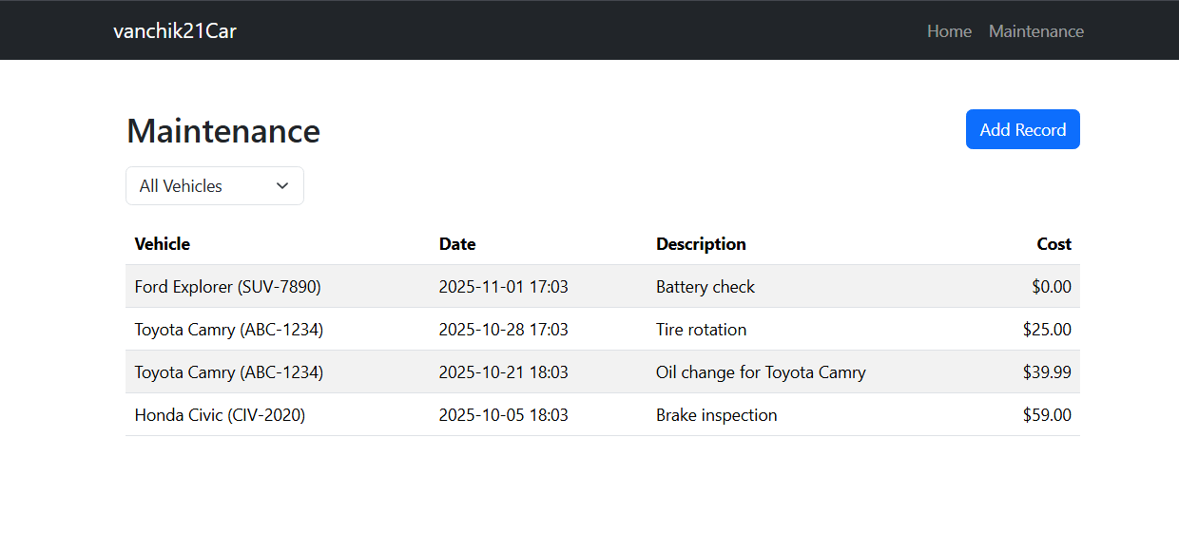
Переходячи на сторінку ми бачимо список виконаних робіт з можливістю сортувати за моделлю авто
Рис. 2

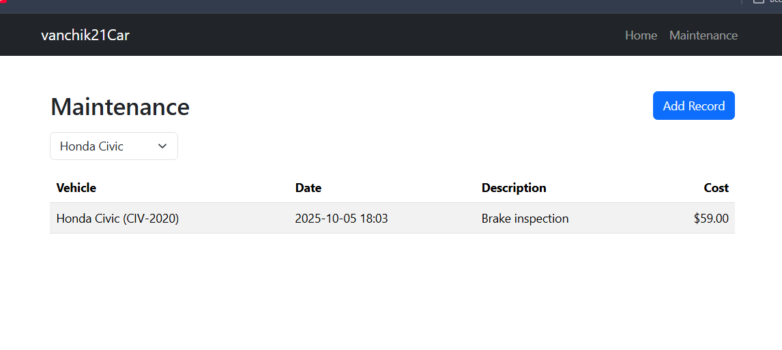
Рис. 3
Завдання 2. Реалізувати CRUD (Сreate, Read, Update, Delete) операції для обох моделей, враховуючи наступні вимоги:
- Реалізувати представлення з формами для операцій Create та Update
- Для виконання операції Read реалізувати окрему Details сторінку, на якій будуть виводитися всі дані про сутність.
- Перед виконанням операції Delete запитати користувача, підтвердження видалення запису.
Лістинг VehicleController.cs
using Microsoft.AspNetCore.Mvc;
using Microsoft.EntityFrameworkCore;
using System.Linq;
using vanchik21Car.Models;

namespace vanchik21Car.Controllers
{
public class VehiclesController : Controller
{
private readonly VehicleDbContext _context;

public VehiclesController(VehicleDbContext context)
{
_context = context;
}

public IActionResult Index()
{
var items = _context.Vehicles
.OrderBy(v => v.Make).ThenBy(v => v.Model)
.ToList();
return View(items);
}

public IActionResult Details(long id)
{
var vehicle = _context.Vehicles
.Include(v => v.MaintenanceRecords)
.FirstOrDefault(v => v.VehicleID == id);
if (vehicle == null) return NotFound();
return View(vehicle);
}

public IActionResult Create()
{
return View(new Vehicle());
}

[HttpPost]
[ValidateAntiForgeryToken]
public IActionResult Create(Vehicle vehicle)
{
if (!ModelState.IsValid)
{
return View(vehicle);
}
vehicle.CreatedAt = DateTime.UtcNow;
_context.Vehicles.Add(vehicle);
_context.SaveChanges();
return RedirectToAction(nameof(Index));
}

public IActionResult Edit(long id)
{
var vehicle = _context.Vehicles.Find(id);
if (vehicle == null) return NotFound();
return View(vehicle);
}

[HttpPost]
[ValidateAntiForgeryToken]
public IActionResult Edit(long id, Vehicle vehicle)
{
if (id != vehicle.VehicleID) return BadRequest();
if (!ModelState.IsValid)
{
return View(vehicle);
}
var entity = _context.Vehicles.FirstOrDefault(v => v.VehicleID == id);
if (entity == null) return NotFound();

entity.Make = vehicle.Make;
entity.Model = vehicle.Model;
entity.Year = vehicle.Year;
entity.VIN = vehicle.VIN;
entity.LicensePlate = vehicle.LicensePlate;
entity.Category = vehicle.Category;
entity.DailyRate = vehicle.DailyRate;
entity.Status = vehicle.Status;
entity.UpdatedAt = DateTime.UtcNow;

_context.SaveChanges();
return RedirectToAction(nameof(Index));
}

public IActionResult Delete(long id)
{
var vehicle = _context.Vehicles.FirstOrDefault(v => v.VehicleID == id);
if (vehicle == null) return NotFound();
return View(vehicle);
}

[HttpPost, ActionName("Delete")]
[ValidateAntiForgeryToken]
public IActionResult DeleteConfirmed(long id)
{
var entity = _context.Vehicles.FirstOrDefault(v => v.VehicleID == id);
if (entity == null) return NotFound();
_context.Vehicles.Remove(entity);
_context.SaveChanges();
return RedirectToAction(nameof(Index));
}
}
}
_Layout.cshtml
<!DOCTYPE html>
<html lang="en">
<head>
<meta charset="utf-8" />
<meta name="viewport" content="width=device-width, initial-scale=1" />
<title>vanchik21Car</title>
<link rel="stylesheet" href="~/lib/bootstrap/css/bootstrap.min.css" />
<link rel="stylesheet" href="~/css/site.css" />
</head>
<body class="d-flex flex-column min-vh-100">
<header class="navbar navbar-expand-lg navbar-dark bg-dark">
<div class="container">
<a class="navbar-brand" asp-controller="Home" asp-action="Index">vanchik21Car</a>
<button class="navbar-toggler" type="button" data-bs-toggle="collapse" data-bs-target="#mainNavbar" aria-controls="mainNavbar" aria-expanded="false" aria-label="Toggle navigation">
<span class="navbar-toggler-icon"></span>
</button>
<div class="collapse navbar-collapse" id="mainNavbar">
<ul class="navbar-nav ms-auto mb-2 mb-lg-0">
<li class="nav-item">
<a class="nav-link" asp-controller="Home" asp-action="Index">Home</a>
</li>
<li class="nav-item">
<a class="nav-link" asp-controller="Vehicles" asp-action="Index">Vehicles</a>
</li>
<li class="nav-item">
<a class="nav-link" asp-controller="Maintenance" asp-action="Index">Maintenance</a>
</li>
</ul>
</div>
</div>
</header>

<main class="container py-4 flex-fill">
@RenderBody()
</main>

<footer class="bg-light border-top py-3 mt-auto">
<div class="container">
<span class="text-muted">&copy; @DateTime.Now.Year - vanchik21Car</span>
</div>
</footer>

<script src="~/lib/bootstrap/js/bootstrap.bundle.min.js"></script>
</body>
</html>
Index.cshtml
@model vanchik21Car.Models.ViewModels.VehicleListViewModel

<div class="container-fluid ps-0 my-4">
<div class="row g-4">
<aside class="col-12 col-md-3">
@await Component.InvokeAsync("NavigationMenu")
<div class="list-group mt-3">
<a class="list-group-item list-group-item-action" asp-controller="Vehicles" asp-action="Index">All Vehicles</a>
<a class="list-group-item list-group-item-action" asp-controller="Maintenance" asp-action="Index">Maintenance</a>
</div>
</aside>
<section class="col-12 col-md-9">
<div class="d-flex justify-content-between align-items-center mb-3">
<h2 class="m-0">Vehicles</h2>
<span class="text-muted">Page @Model.PagingInfo.CurrentPage of @Model.PagingInfo.TotalPages (@Model.PagingInfo.TotalItems items)</span>
</div>

<div class="row row-cols-1 row-cols-md-2 row-cols-lg-3 g-3">
@foreach (var p in Model.Vehicles ?? Enumerable.Empty<vanchik21Car.Models.Vehicle>())
{
<partial name="VehicleSummary" model="p" />
}
</div>

<nav class="pager-1line mt-4" aria-label="Vehicle pages">
<ul class="pagination pagination-sm"
page-model="@Model.PagingInfo"
page-action="Index"
page-classes-enabled="true"
page-item-class="page-item"
page-item-class-selected="active"
page-item-class-disabled="disabled"
page-link-class="page-link"
page-url-category="@(Model.CurrentCategory ?? "")">
</ul>
</nav>
</section>
</div>
</div>

Details.cshtml
@model vanchik21Car.Models.MaintenanceRecord
@{
ViewData["Title"] = "Maintenance Details";
}
<div class="container my-4">
<h2 class="mb-3">Maintenance Details</h2>
<dl class="row">
<dt class="col-sm-3">Vehicle</dt>
<dd class="col-sm-9">@Model.Vehicle?.Make @Model.Vehicle?.Model (@Model.Vehicle?.LicensePlate)</dd>
<dt class="col-sm-3">Date</dt>
<dd class="col-sm-9">@Model.PerformedAt.ToLocalTime().ToString("yyyy-MM-dd HH:mm")</dd>
<dt class="col-sm-3">Description</dt>
<dd class="col-sm-9">@Model.Description</dd>
<dt class="col-sm-3">Cost</dt>
<dd class="col-sm-9">@Model.Cost.ToString("C", System.Globalization.CultureInfo.GetCultureInfo("en-US"))</dd>
<dt class="col-sm-3">Performed By</dt>
<dd class="col-sm-9">@Model.PerformedBy</dd>
</dl>
<div class="mt-3">
<a asp-action="Index" asp-route-vehicleId="@Model.VehicleID" class="btn btn-secondary">Back</a>
<a asp-action="Edit" asp-route-id="@Model.MaintenanceRecordID" class="btn btn-primary">Edit</a>
</div>
</div>
Create.cshtml
@model vanchik21Car.Models.MaintenanceRecord
@{
ViewData["Title"] = "Add Maintenance Record";
var selectList = ViewData["VehicleID"] as Microsoft.AspNetCore.Mvc.Rendering.SelectList;
}
<div class="container my-4">
<h2 class="mb-3">Add Maintenance Record</h2>

<form asp-action="Create" method="post" class="row g-3">
<div class="col-md-6">
<label asp-for="VehicleID" class="form-label">Vehicle</label>
<select asp-for="VehicleID" class="form-select" asp-items="@selectList" required></select>
</div>
<div class="col-md-6">
<label asp-for="PerformedAt" class="form-label">Performed At (UTC)</label>
<input asp-for="PerformedAt" type="datetime-local" class="form-control" />
</div>
<div class="col-12">
<label asp-for="Description" class="form-label">Description</label>
<input asp-for="Description" class="form-control" />
<span asp-validation-for="Description" class="text-danger"></span>
</div>
<div class="col-md-6">
<label asp-for="Cost" class="form-label">Cost</label>
<input asp-for="Cost" class="form-control" />
</div>
<div class="col-md-6">
<label asp-for="PerformedBy" class="form-label">Performed By</label>
<input asp-for="PerformedBy" class="form-control" />
</div>
<div class="col-12">
<button type="submit" class="btn btn-primary">Save</button>
<a asp-action="Index" class="btn btn-secondary">Cancel</a>
</div>
</form>
</div>
Edit.cshtml
@model vanchik21Car.Models.MaintenanceRecord
@{
ViewData["Title"] = "Edit Maintenance";
var selectList = ViewData["VehicleID"] as Microsoft.AspNetCore.Mvc.Rendering.SelectList;
}
<div class="container my-4">
<h2 class="mb-3">Edit Maintenance</h2>
<form asp-action="Edit" method="post" class="row g-3">
<input type="hidden" asp-for="MaintenanceRecordID" />
<div class="col-md-6">
<label asp-for="VehicleID" class="form-label">Vehicle</label>
<select asp-for="VehicleID" class="form-select" asp-items="@selectList"></select>
</div>
<div class="col-md-6">
<label asp-for="PerformedAt" class="form-label">Performed At (UTC)</label>
<input asp-for="PerformedAt" type="datetime-local" class="form-control" />
</div>
<div class="col-12">
<label asp-for="Description" class="form-label">Description</label>
<input asp-for="Description" class="form-control" />
</div>
<div class="col-md-6">
<label asp-for="Cost" class="form-label">Cost</label>
<input asp-for="Cost" class="form-control" />
</div>
<div class="col-md-6">
<label asp-for="PerformedBy" class="form-label">Performed By</label>
<input asp-for="PerformedBy" class="form-control" />
</div>
<div class="col-12">
<button type="submit" class="btn btn-primary">Save</button>
<a asp-action="Index" asp-route-vehicleId="@Model.VehicleID" class="btn btn-secondary">Cancel</a>
</div>
</form>
</div>
Delete.cshtml
@model vanchik21Car.Models.MaintenanceRecord
@{
ViewData["Title"] = "Delete Maintenance";
}
<div class="container my-4">
<h2 class="mb-3">Delete Maintenance</h2>
<div class="alert alert-warning">Are you sure you want to delete this maintenance record?</div>
<dl class="row">
<dt class="col-sm-3">Vehicle</dt>
<dd class="col-sm-9">@Model.Vehicle?.Make @Model.Vehicle?.Model (@Model.Vehicle?.LicensePlate)</dd>
<dt class="col-sm-3">Date</dt>
<dd class="col-sm-9">@Model.PerformedAt.ToLocalTime().ToString("yyyy-MM-dd HH:mm")</dd>
<dt class="col-sm-3">Description</dt>
<dd class="col-sm-9">@Model.Description</dd>
<dt class="col-sm-3">Cost</dt>
<dd class="col-sm-9">@Model.Cost.ToString("C", System.Globalization.CultureInfo.GetCultureInfo("en-US"))</dd>
</dl>
<form asp-action="Delete" method="post">
<input type="hidden" asp-for="MaintenanceRecordID" />
<button type="submit" class="btn btn-danger">Delete</button>
<a asp-action="Index" asp-route-vehicleId="@Model.VehicleID" class="btn btn-secondary">Cancel</a>
</form>
</div>
MaintenanceController.cs
using Microsoft.AspNetCore.Mvc;
using Microsoft.EntityFrameworkCore;
using System.Linq;
using vanchik21Car.Models;

namespace vanchik21Car.Controllers
{
public class MaintenanceController : Controller
{
private readonly VehicleDbContext _context;

public MaintenanceController(VehicleDbContext context)
{
_context = context;
}

public IActionResult Index(long? vehicleId)
{
var query = _context.MaintenanceRecords
.Include(m => m.Vehicle)
.AsQueryable();

if (vehicleId.HasValue)
{
query = query.Where(m => m.VehicleID == vehicleId);
}

var items = query
.OrderByDescending(m => m.PerformedAt)
.ToList();

ViewBag.VehicleId = vehicleId;
ViewBag.Vehicles = _context.Vehicles
.OrderBy(v => v.Make)
.ThenBy(v => v.Model)
.Select(v => new { v.VehicleID, Title = v.Make + " " + v.Model })
.ToList();

return View(items);
}

public IActionResult Details(long id)
{
var entity = _context.MaintenanceRecords
.Include(m => m.Vehicle)
.FirstOrDefault(m => m.MaintenanceRecordID == id);
if (entity == null) return NotFound();
return View(entity);
}

public IActionResult Create(long? vehicleId)
{
ViewData["VehicleID"] = new Microsoft.AspNetCore.Mvc.Rendering.SelectList(
_context.Vehicles
.OrderBy(v => v.Make)
.ThenBy(v => v.Model)
.Select(v => new { v.VehicleID, Title = v.Make + " " + v.Model })
.ToList(),
"VehicleID", "Title", vehicleId);
return View(new MaintenanceRecord { VehicleID = vehicleId ??0, PerformedAt = System.DateTime.UtcNow });
}

[HttpPost]
[ValidateAntiForgeryToken]
public IActionResult Create(MaintenanceRecord record)
{
if (!ModelState.IsValid)
{
ViewData["VehicleID"] = new Microsoft.AspNetCore.Mvc.Rendering.SelectList(
_context.Vehicles
.OrderBy(v => v.Make)
.ThenBy(v => v.Model)
.Select(v => new { v.VehicleID, Title = v.Make + " " + v.Model })
.ToList(),
"VehicleID", "Title", record.VehicleID);
return View(record);
}

_context.MaintenanceRecords.Add(record);
_context.SaveChanges();
return RedirectToAction(nameof(Index), new { vehicleId = record.VehicleID });
}

public IActionResult Edit(long id)
{
var entity = _context.MaintenanceRecords.Find(id);
if (entity == null) return NotFound();

ViewData["VehicleID"] = new Microsoft.AspNetCore.Mvc.Rendering.SelectList(
_context.Vehicles
.OrderBy(v => v.Make)
.ThenBy(v => v.Model)
.Select(v => new { v.VehicleID, Title = v.Make + " " + v.Model })
.ToList(),
"VehicleID", "Title", entity.VehicleID);

return View(entity);
}

[HttpPost]
[ValidateAntiForgeryToken]
public IActionResult Edit(long id, MaintenanceRecord model)
{
if (id != model.MaintenanceRecordID) return BadRequest();

if (!ModelState.IsValid)
{
ViewData["VehicleID"] = new Microsoft.AspNetCore.Mvc.Rendering.SelectList(
_context.Vehicles
.OrderBy(v => v.Make)
.ThenBy(v => v.Model)
.Select(v => new { v.VehicleID, Title = v.Make + " " + v.Model })
.ToList(),
"VehicleID", "Title", model.VehicleID);
return View(model);
}

var entity = _context.MaintenanceRecords.FirstOrDefault(m => m.MaintenanceRecordID == id);
if (entity == null) return NotFound();

entity.VehicleID = model.VehicleID;
entity.Description = model.Description;
entity.PerformedAt = model.PerformedAt;
entity.Cost = model.Cost;
entity.PerformedBy = model.PerformedBy;

_context.SaveChanges();
return RedirectToAction(nameof(Index), new { vehicleId = entity.VehicleID });
}

public IActionResult Delete(long id)
{
var entity = _context.MaintenanceRecords
.Include(m => m.Vehicle)
.FirstOrDefault(m => m.MaintenanceRecordID == id);
if (entity == null) return NotFound();
return View(entity);
}

[HttpPost, ActionName("Delete")]
[ValidateAntiForgeryToken]
public IActionResult DeleteConfirmed(long id)
{
var entity = _context.MaintenanceRecords.FirstOrDefault(m => m.MaintenanceRecordID == id);
if (entity == null) return NotFound();
var vid = entity.VehicleID;
_context.MaintenanceRecords.Remove(entity);
_context.SaveChanges();
return RedirectToAction(nameof(Index), new { vehicleId = vid });
}
}
}
І відповідні файли для редагування, видалення та перегляду опису для ремонтних робіт.
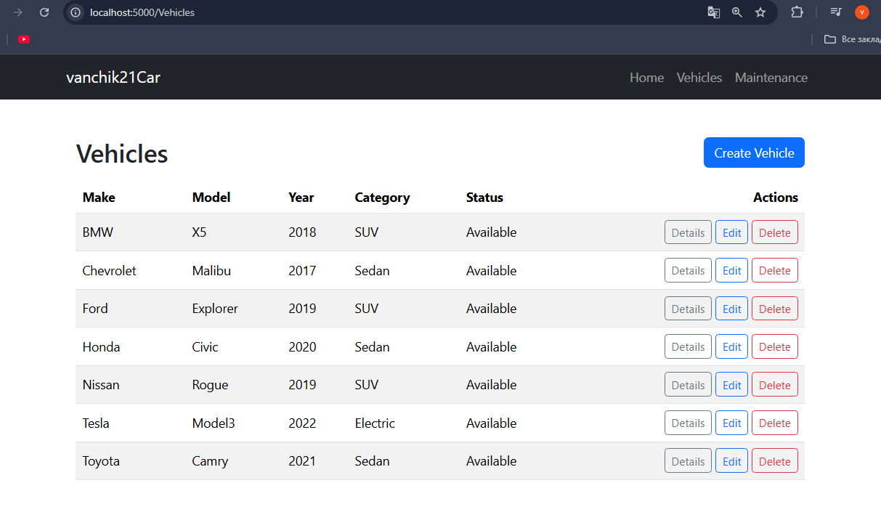
Рис. 4
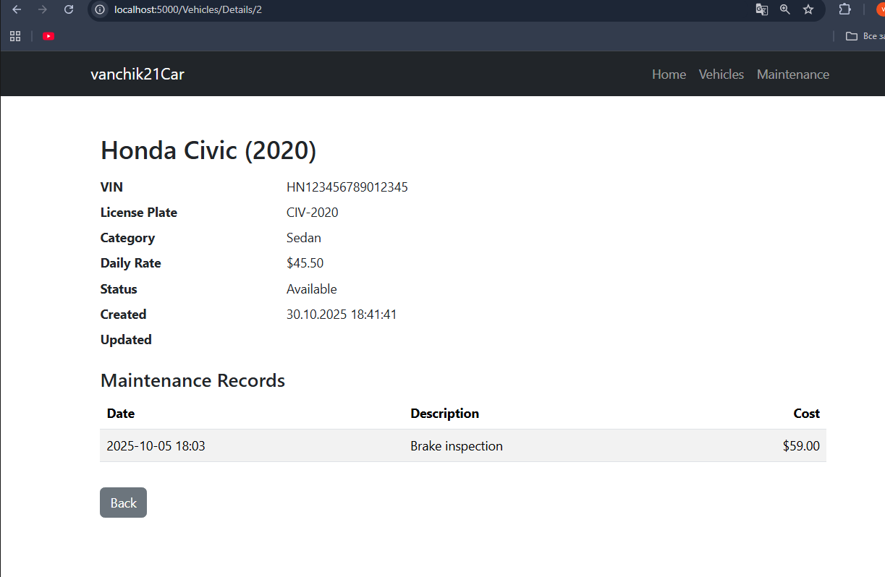
Рис. 5
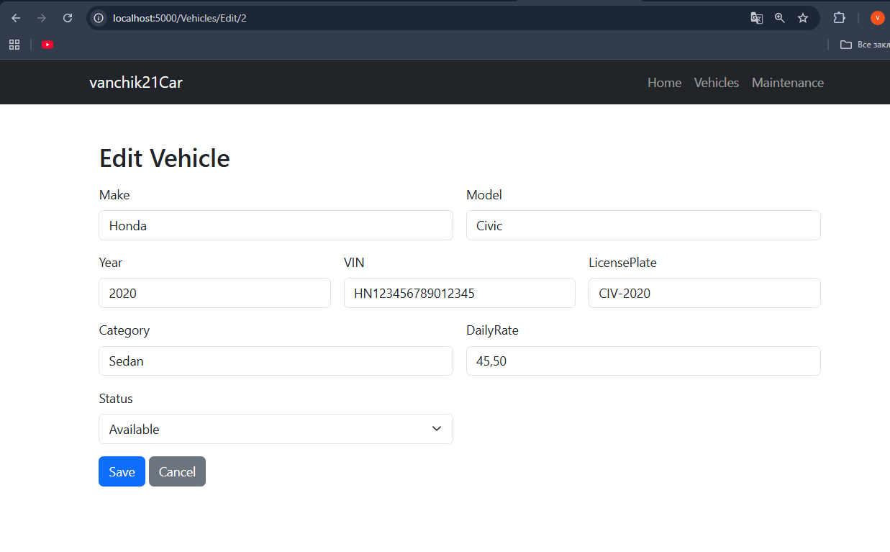
Рис. 6

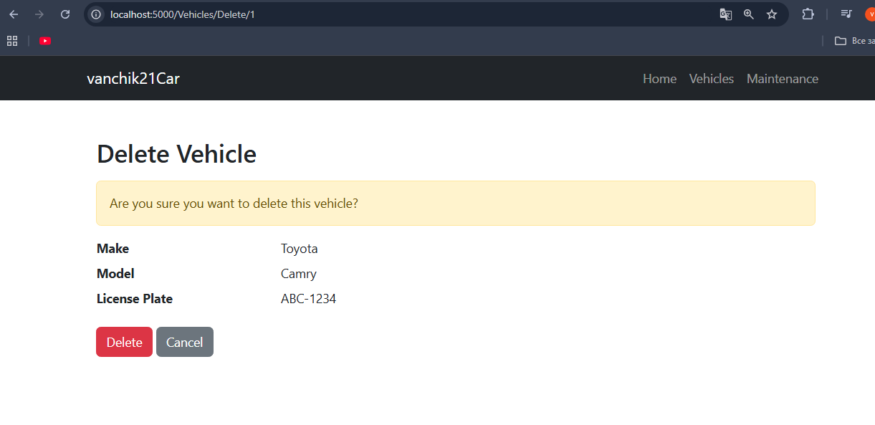
Рис. 7
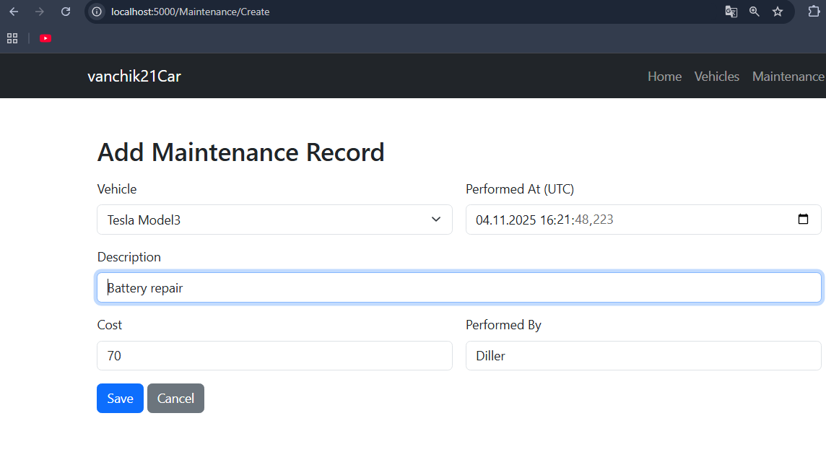
Рис. 8

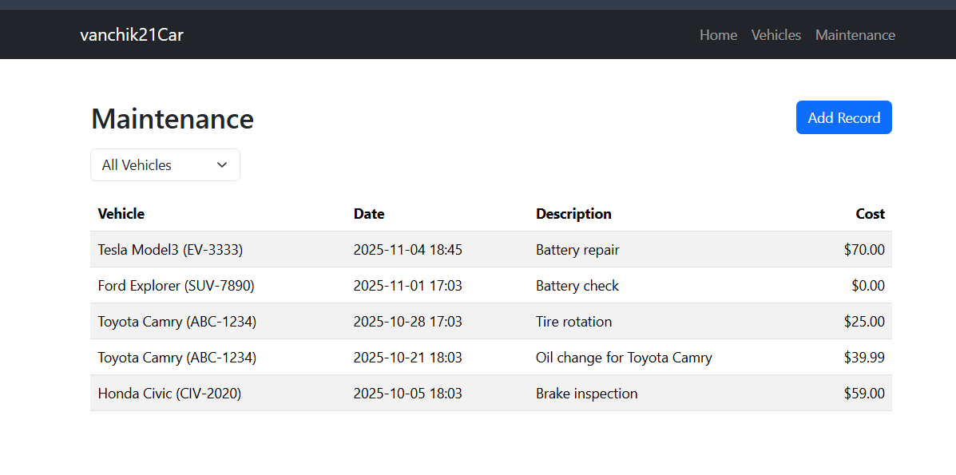
Рис. 9
Завдання 3. Додати серверну валідацію для перевірки введених користувачем даних перед виконанням CRUD-операцій. Використати DataAnnotations для реалізації перевірки введених даних.
Зміни в Vehicle.cs
using System;
using System.ComponentModel.DataAnnotations;
using System.ComponentModel.DataAnnotations.Schema;
using System.Collections.Generic;

namespace vanchik21Car.Models
{
public enum VehicleStatus
{
Available,
Rented,
Maintenance,
Reserved,
Decommissioned
}

public class Vehicle
{
[Key]
public long VehicleID { get; set; }

[Required(ErrorMessage = "Please enter a make")]
[MaxLength(50)]
public string Make { get; set; } = String.Empty;

[Required(ErrorMessage = "Please enter a model")]
[MaxLength(50)]
public string Model { get; set; } = String.Empty;

[Range(1900,2100, ErrorMessage = "Please enter a valid year")]
public int Year { get; set; }

[MaxLength(17, ErrorMessage = "VIN must be 17 characters or less")]
public string VIN { get; set; } = String.Empty;

[MaxLength(20, ErrorMessage = "License plate is too long")]
public string LicensePlate { get; set; } = String.Empty;

[Required(ErrorMessage = "Please specify a category")]
[MaxLength(50)]
public string Category { get; set; } = String.Empty;

private decimal _dailyRate;

[Column(TypeName = "decimal(8,2)")]
[Range(0.01,100000, ErrorMessage = "Please enter a positive daily rate")]
public decimal DailyRate
{
get => _dailyRate;
set => _dailyRate = value;
}

public VehicleStatus Status { get; set; } = VehicleStatus.Available;

[NotMapped]
public bool IsAvailable => Status == VehicleStatus.Available;

public DateTime CreatedAt { get; set; } = DateTime.UtcNow;
public DateTime? UpdatedAt { get; set; }

public ICollection<MaintenanceRecord> MaintenanceRecords { get; set; } = new List<MaintenanceRecord>();
}
}
Зміни в MaintenanceRecord.cs
using System;
using System.ComponentModel.DataAnnotations;
using System.ComponentModel.DataAnnotations.Schema;
using Microsoft.AspNetCore.Mvc.ModelBinding.Validation;

namespace vanchik21Car.Models
{
public class MaintenanceRecord
{
[Key]
public long MaintenanceRecordID { get; set; }

[Required]
[Range(1, long.MaxValue, ErrorMessage = "Please select a vehicle")]
public long VehicleID { get; set; }

[ForeignKey(nameof(VehicleID))]
[ValidateNever]
public Vehicle? Vehicle { get; set; }

[Required(ErrorMessage = "Please enter a description")]
[MaxLength(200, ErrorMessage = "Description is too long")]
public string Description { get; set; } = string.Empty;

public DateTime PerformedAt { get; set; } = DateTime.UtcNow;

[Column(TypeName = "decimal(10,2)")]
[Range(0,1000000, ErrorMessage = "Please enter a valid cost")]
public decimal Cost { get; set; }

[MaxLength(100)]
public string? PerformedBy { get; set; }
}
}
Vehicles\Create.cshtml
@model vanchik21Car.Models.Vehicle
@{
ViewData["Title"] = "Create Vehicle";
}
<div class="container my-4">
<h2 class="mb-3">Create Vehicle</h2>
<form asp-action="Create" method="post" class="row g-3">
<div class="col-md-6">
<label asp-for="Make" class="form-label"></label>
<input asp-for="Make" class="form-control" />
<span asp-validation-for="Make" class="text-danger"></span>
</div>
<div class="col-md-6">
<label asp-for="Model" class="form-label"></label>
<input asp-for="Model" class="form-control" />
<span asp-validation-for="Model" class="text-danger"></span>
</div>
<div class="col-md-4">
<label asp-for="Year" class="form-label"></label>
<input asp-for="Year" class="form-control" />
<span asp-validation-for="Year" class="text-danger"></span>
</div>
<div class="col-md-4">
<label asp-for="VIN" class="form-label"></label>
<input asp-for="VIN" class="form-control" />
<span asp-validation-for="VIN" class="text-danger"></span>
</div>
<div class="col-md-4">
<label asp-for="LicensePlate" class="form-label"></label>
<input asp-for="LicensePlate" class="form-control" />
<span asp-validation-for="LicensePlate" class="text-danger"></span>
</div>
<div class="col-md-6">
<label asp-for="Category" class="form-label"></label>
<input asp-for="Category" class="form-control" />
<span asp-validation-for="Category" class="text-danger"></span>
</div>
<div class="col-md-6">
<label asp-for="DailyRate" class="form-label"></label>
<input asp-for="DailyRate" class="form-control" />
<span asp-validation-for="DailyRate" class="text-danger"></span>
</div>
<div class="col-md-6">
<label asp-for="Status" class="form-label"></label>
<select asp-for="Status" class="form-select" asp-items="Html.GetEnumSelectList<vanchik21Car.Models.VehicleStatus>()"></select>
<span asp-validation-for="Status" class="text-danger"></span>
</div>
<div class="col-12">
<button type="submit" class="btn btn-primary">Save</button>
<a asp-action="Index" class="btn btn-secondary">Cancel</a>
</div>
</form>
</div>

Vehicles\Edit.cshtml
@model vanchik21Car.Models.Vehicle
@{
ViewData["Title"] = "Edit Vehicle";
}
<div class="container my-4">
<h2 class="mb-3">Edit Vehicle</h2>
<form asp-action="Edit" method="post" class="row g-3">
<input type="hidden" asp-for="VehicleID" />
<div class="col-md-6">
<label asp-for="Make" class="form-label"></label>
<input asp-for="Make" class="form-control" />
<span asp-validation-for="Make" class="text-danger"></span>
</div>
<div class="col-md-6">
<label asp-for="Model" class="form-label"></label>
<input asp-for="Model" class="form-control" />
<span asp-validation-for="Model" class="text-danger"></span>
</div>
<div class="col-md-4">
<label asp-for="Year" class="form-label"></label>
<input asp-for="Year" class="form-control" />
<span asp-validation-for="Year" class="text-danger"></span>
</div>
<div class="col-md-4">
<label asp-for="VIN" class="form-label"></label>
<input asp-for="VIN" class="form-control" />
<span asp-validation-for="VIN" class="text-danger"></span>
</div>
<div class="col-md-4">
<label asp-for="LicensePlate" class="form-label"></label>
<input asp-for="LicensePlate" class="form-control" />
<span asp-validation-for="LicensePlate" class="text-danger"></span>
</div>
<div class="col-md-6">
<label asp-for="Category" class="form-label"></label>
<input asp-for="Category" class="form-control" />
<span asp-validation-for="Category" class="text-danger"></span>
</div>
<div class="col-md-6">
<label asp-for="DailyRate" class="form-label"></label>
<input asp-for="DailyRate" class="form-control" />
<span asp-validation-for="DailyRate" class="text-danger"></span>
</div>
<div class="col-md-6">
<label asp-for="Status" class="form-label"></label>
<select asp-for="Status" class="form-select" asp-items="Html.GetEnumSelectList<vanchik21Car.Models.VehicleStatus>()"></select>
<span asp-validation-for="Status" class="text-danger"></span>
</div>
<div class="col-12">
<button type="submit" class="btn btn-primary">Save</button>
<a asp-action="Index" class="btn btn-secondary">Cancel</a>
</div>
</form>
</div>

Maintenance\Create.cshtml
@model vanchik21Car.Models.MaintenanceRecord
@{
ViewData["Title"] = "Add Maintenance Record";
var selectList = ViewData["VehicleID"] as Microsoft.AspNetCore.Mvc.Rendering.SelectList;
}
<div class="container my-4">
<h2 class="mb-3">Add Maintenance Record</h2>

<form asp-action="Create" method="post" class="row g-3">
<div asp-validation-summary="All" class="text-danger"></div>
<div class="col-md-6">
<label asp-for="VehicleID" class="form-label">Vehicle</label>
<select asp-for="VehicleID" class="form-select" asp-items="@selectList" required>
<option value="">-- select vehicle --</option>
</select>
<span asp-validation-for="VehicleID" class="text-danger"></span>
</div>
<div class="col-md-6">
<label asp-for="PerformedAt" class="form-label">Performed At (UTC)</label>
<input asp-for="PerformedAt" type="datetime-local" class="form-control" />
</div>
<div class="col-12">
<label asp-for="Description" class="form-label">Description</label>
<input asp-for="Description" class="form-control" />
<span asp-validation-for="Description" class="text-danger"></span>
</div>
<div class="col-md-6">
<label asp-for="Cost" class="form-label">Cost</label>
<input asp-for="Cost" class="form-control" />
<span asp-validation-for="Cost" class="text-danger"></span>
</div>
<div class="col-md-6">
<label asp-for="PerformedBy" class="form-label">Performed By</label>
<input asp-for="PerformedBy" class="form-control" />
</div>
<div class="col-12">
<button type="submit" class="btn btn-primary">Save</button>
<a asp-action="Index" class="btn btn-secondary">Cancel</a>
</div>
</form>
</div>
VehicleSummary.cshtml
@model vanchik21Car.Models.Vehicle

<div class="col">
<div class="card h-100 shadow-sm border-0 position-relative">
<div class="card-body">
<h5 class="card-title mb-1">@Model.Make @Model.Model</h5>
<ul class="list-unstyled small text-muted mb-2">
<li>Year: <strong class="text-dark">@Model.Year</strong></li>
<li>Category: <strong class="text-dark">@Model.Category</strong></li>
<li>Status: <span class="badge bg-@(Model.Status == vanchik21Car.Models.VehicleStatus.Available ? "success" : "secondary")">@Model.Status</span></li>
</ul>
<div class="fs-5 fw-semibold">@Model.DailyRate.ToString("C", System.Globalization.CultureInfo.GetCultureInfo("en-US")) / day</div>

<a asp-controller="Vehicles"
asp-action="Details"
asp-route-id="@Model.VehicleID"
class="stretched-link"
aria-label="View details for @Model.Make @Model.Model">
</a>
</div>
</div>
</div>
Home\Index.cshtml
@model vanchik21Car.Models.ViewModels.VehicleListViewModel

<div class="container-fluid ps-0 my-4">
<div class="row g-4">
<aside class="col-12 col-md-3">
@await Component.InvokeAsync("NavigationMenu")
<div class="list-group mt-3">
<a class="list-group-item list-group-item-action" asp-controller="Vehicles" asp-action="Index">All Vehicles</a>
<a class="list-group-item list-group-item-action" asp-controller="Maintenance" asp-action="Index">Maintenance</a>
</div>
</aside>
<section class="col-12 col-md-9">
<div class="d-flex justify-content-between align-items-center mb-3">
<h2 class="m-0">Vehicles</h2>
<span class="text-muted">Page @Model.PagingInfo.CurrentPage of @Model.PagingInfo.TotalPages (@Model.PagingInfo.TotalItems items)</span>
</div>

<div class="row row-cols-1 row-cols-md-2 row-cols-lg-3 g-3">
@foreach (var p in Model.Vehicles ?? Enumerable.Empty<vanchik21Car.Models.Vehicle>())
{
<partial name="VehicleSummary" model="p" />
}
</div>

<nav class="pager-1line mt-4" aria-label="Vehicle pages">
<ul class="pagination pagination-sm"
page-model="@Model.PagingInfo"
page-action="Index"
page-classes-enabled="true"
page-item-class="page-item"
page-item-class-selected="active"
page-item-class-disabled="disabled"
page-link-class="page-link"
page-url-category="@(Model.CurrentCategory ?? "")">
</ul>
</nav>
</section>
</div>
</div>

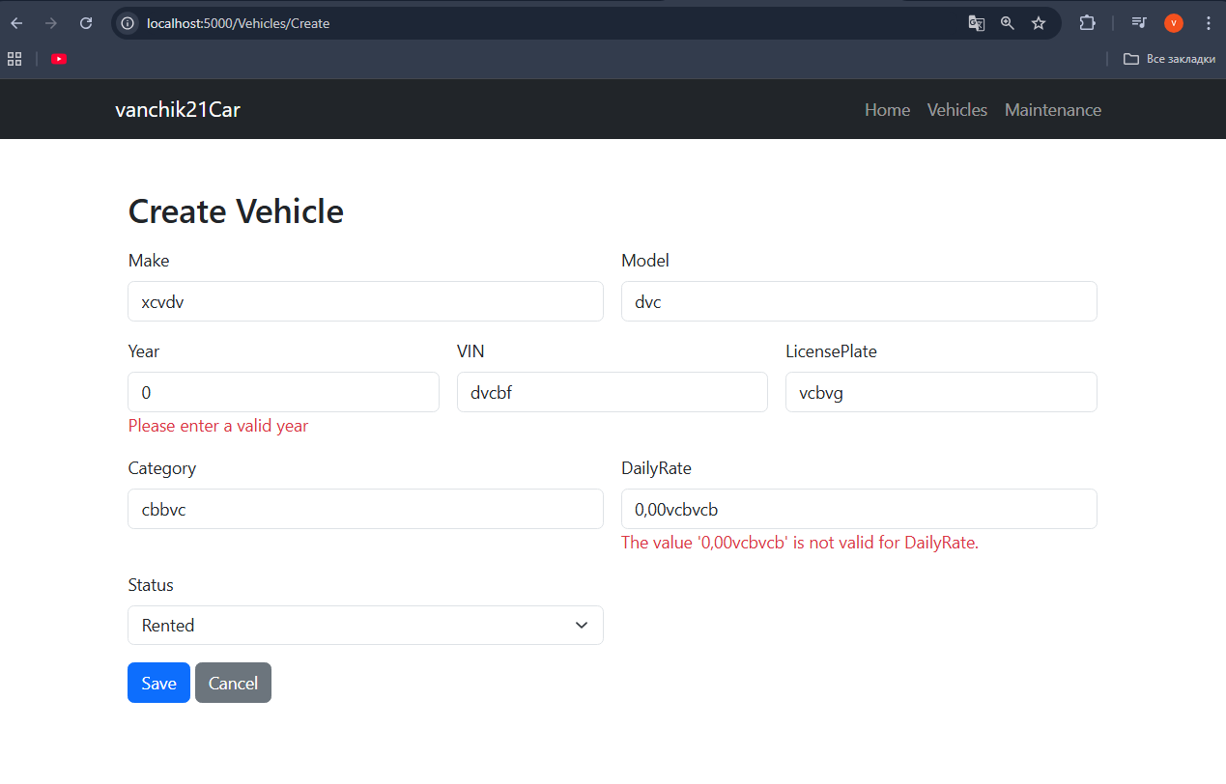
Рис. 10
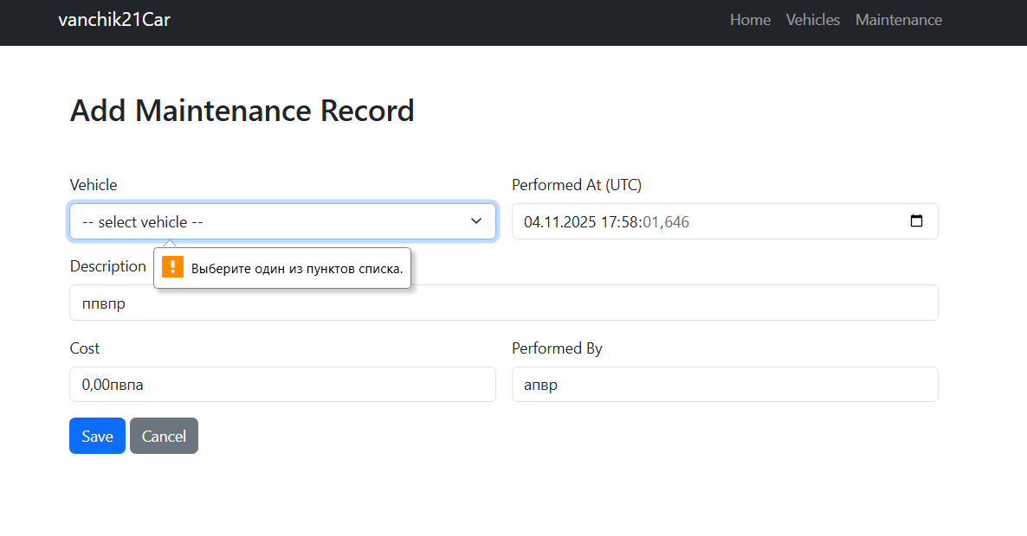
Рис. 11
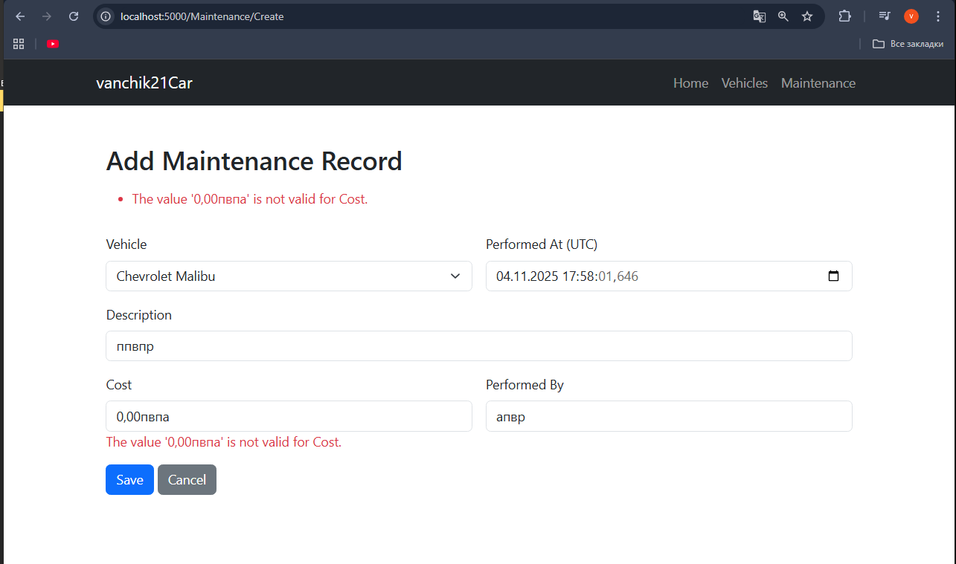
Рис. 12
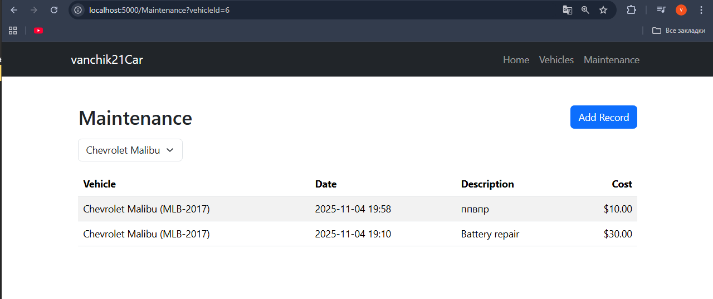
Рис. 13
Посилання на гітхаб: https://github.com/Vanchik21/ASP
Висновки: сьогодні ми набули навичок роботи з ORM, навчилися реалізовувати операції створення, читання, оновлення та видалення даних з використанням EF Core, набули навичок роботи з механізмами валідації даних.

