**CS255: System Analysis and Design**

**Project Two: System Design Document**

Buddy Marcey

[buddy.marcey@snhu.edu](mailto:buddy.marcey@snhu.edu)

Southern New Hampshire University

December 10, 2023

## UML Diagrams

### UML Use Case Diagram

### UML Activity Diagrams

### UML Sequence Diagram

### UML Class Diagram

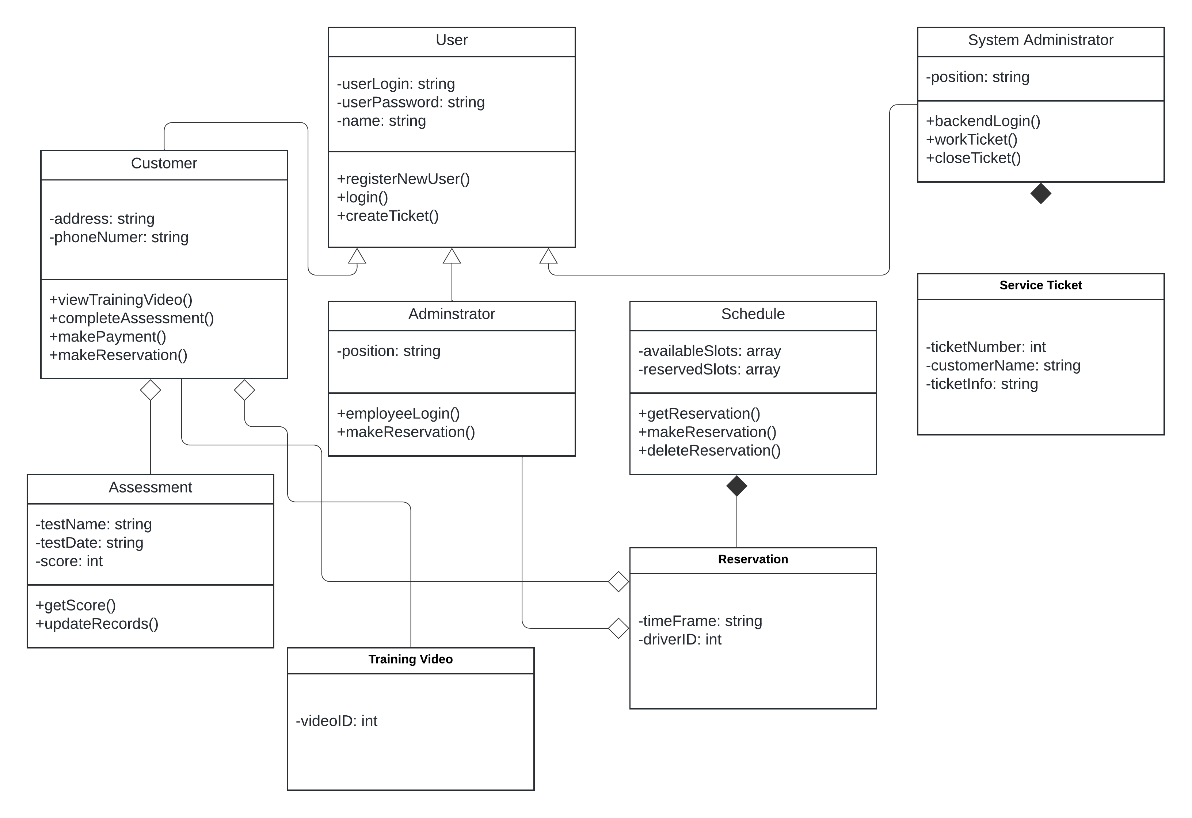

## Technical Requirements

**Hardware and Infrastructure:**

* Employee workstations
  + Web-enabled PC
  + I/O devices (mouse, keyboard, monitor)
  + Printer
* User database
* Payment collection device
* SMB office hardware
  + Router
  + Switch
  + Firewall
  + Modem

**Software:**

* Web Browser
* Service Ticket software
* Windows OS
* Security software

**Tools:**

* Cloud Connection tools
  + Database manager
  + Payment manager
  + Cloud Security manager
* System Administrator tools
* Billing tools
* Fleet Management tools
* Fleet (cars)

**References**

Dennis, A. R., Wixom, B. H., & Tegarden, D. P. (2012). *Systems Analysis and Design with UML*. https://dl.acm.org/citation.cfm?id=2331260

Lucid Software. (2018, August 27). *How to make a UML sequence Diagram* [Video]. YouTube. <https://www.youtube.com/watch?v=pCK6prSq8aw>

Lucid Software. (2017, July 21). *UML Class Diagram Tutorial* [Video]. YouTube. <https://www.youtube.com/watch?v=UI6lqHOVHic>

Lucid Software. (2018a, February 7). *UML Use Case Diagram Tutorial* [Video]. YouTube. https://www.youtube.com/watch?v=zid-MVo7M-E

*UML Activity Diagram Tutorial*. (n.d.). Lucidchart. https://www.lucidchart.com/pages/uml-activity-diagram

Valacich, J., Valacich, J. S., & George, J. (2019). *Modern systems analysis and design*. Pearson.