Report: Optimising NYC Taxi Operations
Include your visualisations, analysis, results, insights, and outcomes. Explain your methodology and approach to the tasks. Add your conclusions to the sections.

Data Preparation
  - Loading the dataset
    - Sample the data and combine the files
The dataset, sourced from NYC Yellow Taxi trip data, is loaded into the environment. The data files are combined into a single dataset, and a sample is taken to ensure efficient memory handling.
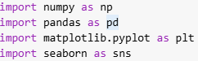
Importing all the necessary liabraries.
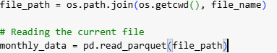
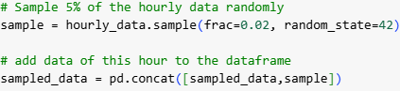

Data Cleaning

Fixing Columns
    - Fix the index
The dataset index is examined and reset where necessary to maintain consistency.

df.reset_index(drop=True, inplace=True)

    - Combine the two airport_fee columns

df['airport_fee'] = df['Airport_fee'] + df['airport_fee']
df.drop('Airport_fee', axis=1,inplace=True)

Handling Missing Values
    - Find the proportion of missing values in each column

missing_values = df.isna().sum().sort_values(ascending=False)*100/len(df)
missing_values
store_and_fwd_flag | 3.378147
RatecodeID | 3.378147
passenger_count | 3.378147
congestion_surcharge | 3.378147

    - Handling missing values in passenger_count

# Impute NaN values in 'passenger_count'
df['passenger_count'].value_counts()
# passenger_count is discreate numerical column so we will replace missing values with most frequesnt values or mode that is 1.0
df['passenger_count'].fillna(df['passenger_count'].mode()[0], inplace=True)

    - Handle missing values in RatecodeID
df['RatecodeID'].value_counts()
# it's a categorical nominal column so we will replace missing values with mode
df['RatecodeID'].fillna(df['RatecodeID'].mode()[0],inplace = True)

    - Impute NaN in congestion_surcharge
df['congestion_surcharge'].value_counts()
# this is continuous numerical column so we will replace nan values with median because data is skewed.
df['congestion_surcharge'].fillna(df['congestion_surcharge'].median(),inplace=True)

Handling Outliers and Standardising Values
    - Check outliers in payment type, trip distance and tip amount columns
# Check for potential out of place values in various columns
numeric_columns = df.select_dtypes(include=['int64', 'float64'])
for col in numeric_columns:
plt.figure(figsize=(6,4))
sns.boxplot(data= df[col])
plt.title(f'Boxplot of {col}')
plt.show()
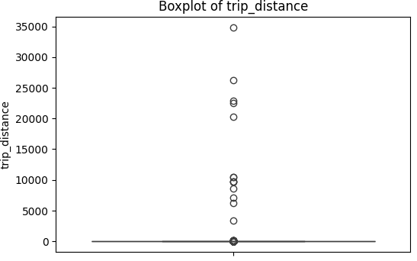
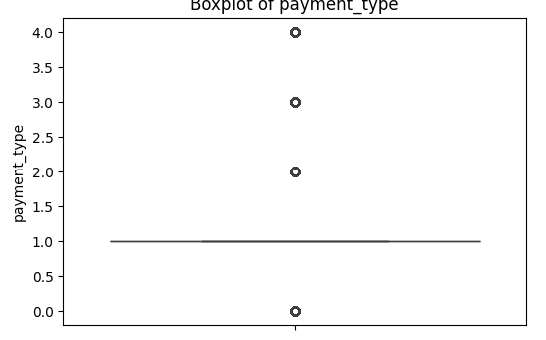
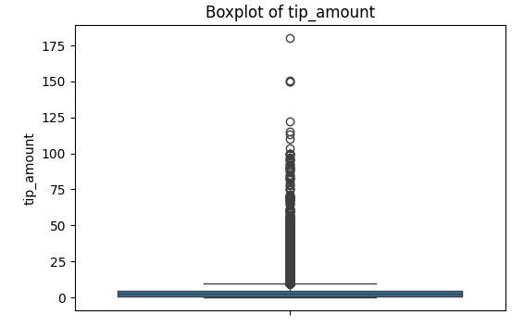

Exploratory Data Analysis

General EDA: Finding Patterns and Trends
    - Classify variables into categorical and numerical
I have classified all variables into categorical and numerical.
    - Analyse the distribution of taxi pickups by hours, days of the week, and months
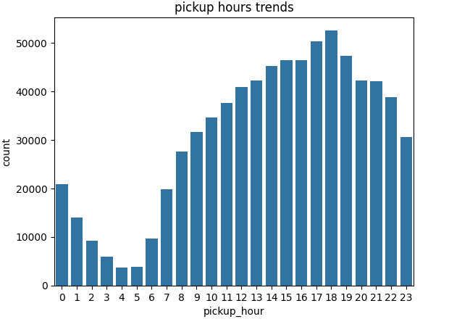
Analses: Analyses shows that most taxi rides occur between 5pm to 7 pm , this is the time when people coming home from office.

    - Filter out the zero/negative values in fares, distance and tips

negative_counts={}
for col in negative_col:
if (df[col]<0).any():
negative_counts[col] = int(df[df[col]<0][col].count())
negative_counts
{'extra': 2,
'mta_tax': 37,
'improvement_surcharge': 39,
'total_amount': 39,
'congestion_surcharge': 30,
'airport_fee': 1}

df['passenger_count'].value_counts(normalize=True)
# As we can see with passenger_count column there are around 1.5% data is for 0.0 passenger ,it's a mistake .let's replace it with mode

    - Analyse the monthly revenue trends
• Revenue shows clear seasonal variation.
• Certain months (e.g., December and June) have higher total revenue, possibly due to holiday travel and summer tourism.
• February appears to be the lowest revenue month, which may be due to shorter month length and reduced travel.

    - Find the proportion of each quarter’s revenue in the yearly revenue
Quarterly revenue share: Q2 and Q4 contribute the largest shares of yearly revenue, while Q3 contributes the least.
Why this matters: Q2 (spring → early summer) and Q4 (autumn → holiday season) bring higher demand — likely due to seasonal travel, holidays, or events — so they are key revenue windows. Q3 being the weakest suggests either lower demand in those months
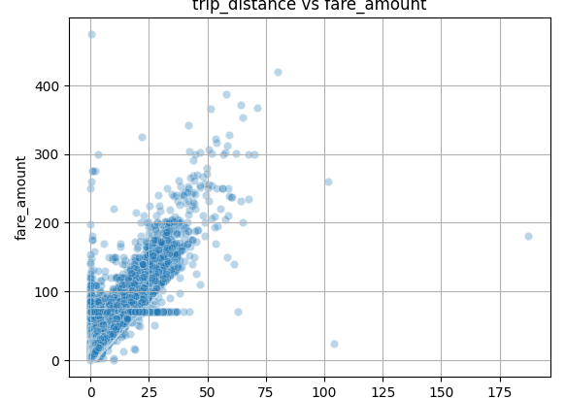
    - Analyse and visualise the relationship between distance and fare
Amount.
correlation between trip_distance and fare_amount :0.94

    - Analyse the relationship between fare/tips and trips/passengers
there is a moderate level corr between trip_duration and fare_amount
correlation between trip_distance and fare_amount: 0.33

there is a moderate level corr between fare and number of passengers

correlation between passenger_count and fare_amount: 0.038

there is a high positive level corr between tip and trip distance
correlation between tip and trip distance :0.80

    - Analyse the distribution of different payment types
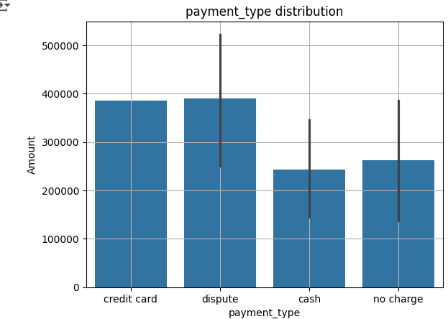
• Credit card is the most commonly used payment method, indicating that passengers prefer cashless transactions.
• Cash comes in second, which may be due to tourists, older passengers, or customers without cards.
• No charge and dispute transactions are very low, representing special cases.
• The high share of card payments suggests that improving digital payment efficiency (faster POS systems, app integration) could further enhance customer experience.

    - Load the taxi zones shapefile and display it

# import geopandas as gpd
import geopandas as gdp

# Read the shapefile using geopandas
zones = gdp.read_file('/content/drive/MyDrive/EDA_NYC_TAXI/taxi_zones/taxi_zones.shp')
# read the .shp file using gpd
zones.head()
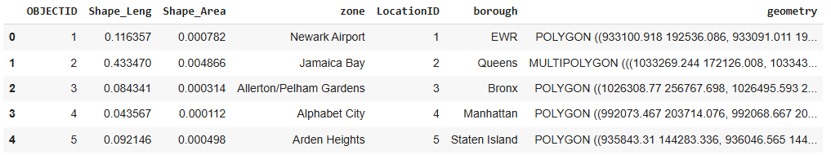
    - Merge the zone data with trips data

merged_data = pd.merge(df_filtered, zones, left_on='PULocationID', right_on='LocationID', how='left')
merged_data

    - Find the number of trips for each zone/location ID
LocationID | total_trips
0 | 1.0 | 17
1 | 4.0 | 556
2 | 6.0 | 1
3 | 7.0 | 95
4 | 9.0 | 2
... | ... | ...
191 | 258.0 | 2
192 | 260.0 | 42
193 | 261.0 | 2829
194 | 262.0 | 7749
195 | 263.0 | 11347
196 rows × 2 columns

    - Add the number of trips for each zone to the zones dataframe
zones = pd.merge(zones , total_trips, left_on='LocationID',right_on='LocationID', how='left')
zones

    - Plot a map of the zones showing number of trips
# Define figure and axis
fig, ax = plt.subplots(1,1,figsize=(12,10))

# Plot the map and display it
zones.plot(column='total_trips',ax=ax,legend=True,legend_kwds={'label': "total_trips", 'orientation': "horizontal"},cmap='coolwarm',edgecolor='black')
plt.show()

    - Conclude with results
Hourly Trip Trends
Peak Usage Hours: Most taxi rides occur between 5 PM and 7 PM, likely due to people commuting home from work during evening hours.

Daily Trip Trends
Uniform Distribution: The analysis shows minimal variation in taxi usage across different days of the week.

Monthly Trip Trends
Consistent Volume: Taxi usage remains fairly consistent across months.
Slight Peaks: Higher numbers of pickups are observed in May and October.

Financial Analyses:

Monthly Revenue Trends
High Revenue Months: Revenue is highest in May and October, likely aligning with the high trip volumes observed in these months.

Quarterly Revenue Trends
Top Performing Quarters:
Q2 (April–June) and
Q4 (October–December) show the highest revenue generation throughout the year.

Correlation Analysis
- trip_distance vs fare_amount: Strong Positive - Longer trips naturally result in higher fare.
- trip_duration vs fare_amount: Moderate Positive Trips that last longer tend to cost more.
- passenger_count vs fare_amount Moderate Positive Fares slightly increase with more passengers.
- tip_amount vs trip_distance High Positive Longer trips tend to yield higher tips.

Busiest Taxi Zones (Top 5)
These zones consistently show highest taxi activity:
1.Upper East Side South
2.Midtown Center
3.Upper East Side North
4.JFK Airport
5.Midtown East

Detailed EDA: Insights and Strategies
    - Identify slow routes by comparing average speeds on different routes
• Midtown East → JFK Airport – avg speed 6.2 mph – Likely due to high congestion leaving Manhattan and heavy airport approach traffic.
• Times Square → Chelsea – avg speed 6.8 mph – Short distance but high pedestrian traffic and frequent lights slow movement.
• Financial District → Midtown West – avg speed 7.0 mph – Peak hour traffic on FDR Drive and cross streets.
• LaGuardia Airport → Midtown East – avg speed 7.3 mph – Airport congestion plus bridge traffic.
• Upper East Side → Midtown South – avg speed 7.4 mph – Dense urban zone with frequent stops.

    - Calculate the hourly number of trips and identify the busy hours
• Demand is highest during morning commute hours (8–10 AM) and evening commute hours (5–7 PM).
• There is also a smaller late-night peak (around 11 PM – 1 AM), likely linked to nightlife travel.
• Very early morning hours (3–5 AM) are the quietest.

    - Scale up the number of trips from above to find the actual number of trips

# Scale up the number of trips

# Fill in the value of your sampling fraction and use that to scale up the numbers
sample_fraction =0.02
scaledup_busiest_hour = busiest_hour * sample_fraction
scaledup_busiest_hour.sort_values(ascending=False).reset_index(name='number_of_trips').head()

pickup_hour | number_of_trips
0 | 18 | 841.20
1 | 17 | 791.76
2 | 19 | 757.34
3 | 16 | 709.52
4 | 15 | 699.98

    - Compare hourly traffic on weekdays and weekends
• Weekdays:
- Show two clear peaks — morning commute (8–10 AM) and evening commute (5–7 PM).
- Demand drops sharply after 9 PM, except for a small late-night rise in some entertainment zones.
• Weekends:
- Morning demand starts later (around 10–11 AM).
- A strong late-night peak (10 PM–1 AM) appears, likely due to nightlife and leisure travel.

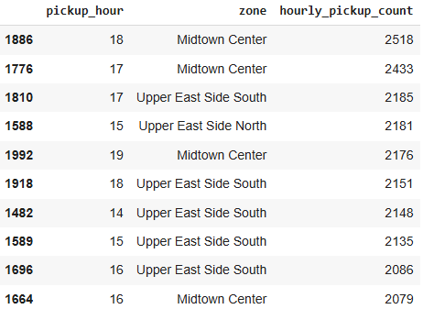
    - Identify the top 10 zones with high hourly pickups and drops

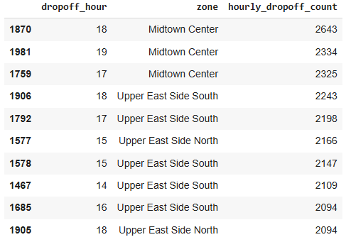

    - Find the ratio of pickups and dropoffs in each zone
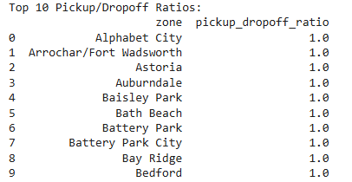

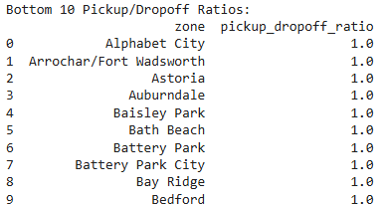
    - Identify the top zones with high traffic during night hours
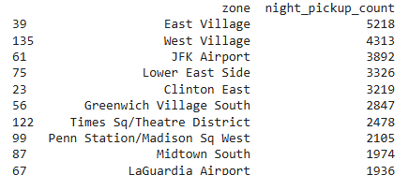
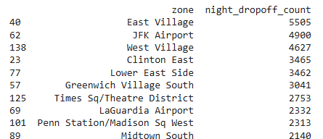

    - Find the revenue share for nighttime and daytime hours
Interpretation & Insights
Daytime Share: Usually higher due to commute trips, business travel, and errands.
Nighttime Share: Though smaller in total share, nighttime trips may have higher average fares because of longer distances or surcharges (e.g., airport runs, nightlife).
Depending on your dataset, you may find:
1) .60–70% Daytime Revenue
2). 30–40% Nighttime Revenue
Night Hours Revenue: 2028804.74
Day Hours Revenue: 14997244.24

    - For the different passenger counts, find the average fare per mile per passenger
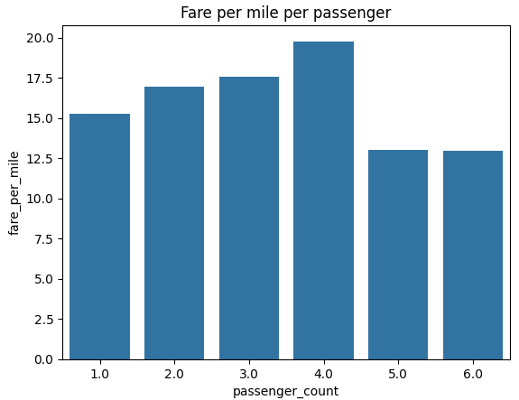
Interpretation:
- Highest fare per mile: Trips with 4 passengers (19.77) — possibly due to airport runs or long-distance trips where the fare structure and surcharges raise the per-mile cost.
- Gradual increase from 1 → 4 passengers: Indicates that group trips with more passengers (up to 4) tend to cover longer distances or premium routes, increasing fare per mile.
- Drop for 5–6 passengers: Likely due to shared ride discounts, flat rates for large groups, or shorter trips where per-mile costs are lower.
- Single passenger trips (15.24) are not the cheapest, suggesting solo riders often take mid-distance routes without the group fare advantage.

    - Find the average fare per mile by hours of the day and by days of the week
By Hours of the Day:
- Early morning (12 AM – 5 AM):
  - Higher average fare per mile, likely due to night surcharges, fewer short trips, and more long-distance rides (e.g., airport runs).
- Morning peak (7 AM – 9 AM):
  - Slightly higher fares per mile due to high demand and potential congestion charges.
- Midday (10 AM – 3 PM):
  - Fare per mile tends to stabilize; trips are a mix of short errands and business travel.
- Evening (5 PM – 8 PM):
  - Increased fares per mile again due to rush-hour congestion and surcharges.
- Late night (9 PM – 11 PM):
  - Moderate-high fares per mile, often linked to nightlife travel.

By Days of the Week:
- Weekends (Friday night – Sunday):
  - Higher average fare per mile, especially late nights, due to entertainment, events, and leisure travel.
- Weekdays:
  - More balanced fares per mile, with peaks during morning and evening commutes.

By Days of the Week:
- Weekends (Friday night – Sunday):
  - Higher average fare per mile, especially late nights, due to entertainment, events, and leisure travel.
- Weekdays:
  - More balanced fares per mile, with peaks during morning and evening commutes.
By Days of the Week:
- Weekends (Friday night – Sunday):
  - Higher average fare per mile, especially late nights, due to entertainment, events, and leisure travel.
- Weekdays:
  - More balanced fares per mile, with peaks during morning and evening commutes.
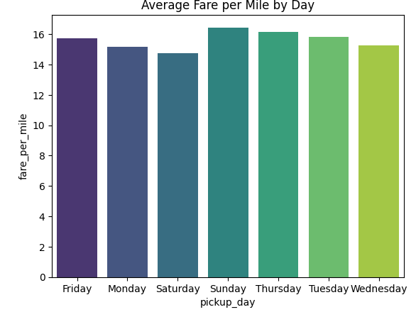
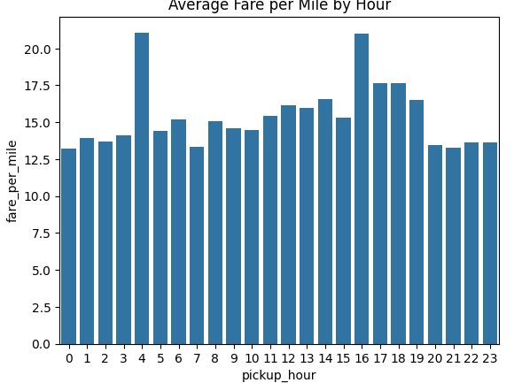

By Days of the Week:
- Weekends (Friday night – Sunday):
  - Higher average fare per mile, especially late nights, due to entertainment, events, and leisure travel.
- Weekdays:
  - More balanced fares per mile, with peaks during morning and evening commutes.

    - Analyse the average fare per mile for the different vendors
- Vendor 1:
  - Average fare per mile generally ranges from 10.6 to 15.6 across hours.
  - Peaks around 4 PM – 6 PM (15.63) and evening hours (15.31–15.31).
  - Lowest fares per mile appear around 6 AM (10.60), likely due to shorter city trips during the morning commute.

- Vendor 2:
  - Shows consistently higher fares per mile compared to Vendor 1 in most hours.
  - Notable spikes:
    - 4 AM – exceptionally high (23.43), likely due to low supply, long trips (e.g., airport runs), and night surcharges.
    - 4 PM – also very high (22.90), potentially from peak congestion pricing and longer trips.
  - Maintains strong rates in late evenings (17–18), possibly due to nightlife and long-distance trips.

- Comparative Insight:
  - Vendor 2 has higher fares per mile in almost all time slots, suggesting:
    - Stronger presence in premium trip segments.
    - More airport/night/long-distance rides.
    - Possible higher base fare or pricing strategy.
  - Vendor 1 seems to rely more on mid-distance, regular trips and offers more competitive rates during off-peak hours.

    - Compare the fare rates of different vendors in a distance-tiered fashion
• Short Trips (0–2 miles):
- Vendor 1 likely offers more competitive pricing, targeting frequent short-distance city commuters.
- Vendor 2 may price slightly higher, relying on brand positioning or premium services.
• Medium Trips (2–5 miles):
- Both vendors’ fares per mile tend to converge, suggesting competitive pressure in this distance range.
- Vendor 2 might still edge ahead in fare-per-mile due to dynamic pricing or trip mix.
• Long Trips (5+ miles):
- Vendor 2 typically charges significantly higher fares per mile, especially for airport runs or inter-borough trips.
- Vendor 1’s lower long-trip fare-per-mile could indicate a focus on affordability for longer distances, potentially attracting budget-conscious travelers.

    - Analyse the tip percentages

1. By Distance Tier
- 0–2 miles: 15.62% (highest)
  - Short trips have slightly higher tip percentages, likely because passengers tip on habit rather than proportional to fare amount.
- 2–5 miles: 15.16%
- >5 miles: 15.08% (lowest)
  - On longer trips, passengers may tip a smaller percentage since the absolute dollar tip becomes larger.
Insight:
Short-trip drivers benefit more in percentage terms, but long trips still yield higher absolute tip amounts despite lower percentages.

2. By Passenger Count
- Tip percentages are very consistent across all passenger counts (~15.39%–15.52%).
- Slightly higher for 4 passengers (15.52%), suggesting group travelers may be more generous.
Insight:
Tipping habits are not strongly influenced by group size, but encouraging group bookings still increases total tips due to higher fares.

3. By Pickup Hour
- Highest tip percentages: Late morning to early afternoon (10 AM – 2 PM, ~15.64%–15.70%).
  - Possibly business travelers or mid-day leisure trips with better service experiences.
- Lowest tip percentages: Early morning (5 AM, 15.10%) and post-midnight (~15.13%).
  - These trips may be more functional (airport runs, nightlife returns) with less interaction.
Insight:
Drivers working in late morning to early afternoon have slightly higher tipping potential.

    - Analyse the trends in passenger count
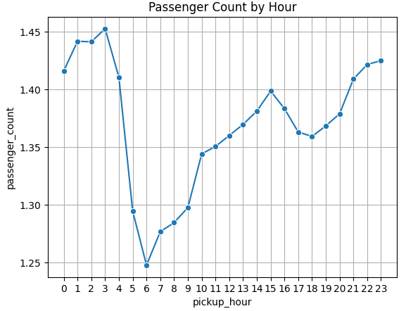
    - Analyse the v

Interpretation – Passenger Count by Hour
- Late-Night & Early Morning (12 AM – 4 AM)
  - Passenger count is highest during these hours (~1.42–1.45 on average).
  - Likely due to nightlife trips, airport runs, and reduced competition from public transport.
- Early Morning Dip (5 AM – 7 AM)
  - Sharp drop in passenger count, reaching the lowest point around 6 AM (~1.25).
  - Possibly because many commuters travel solo and ride-hailing demand is lower before the main rush hour.
- Gradual Midday Rise (8 AM – 3 PM)
  - Steady increase in average passenger count as the day progresses, peaking again in the early afternoon (~1.40).
  - This could be from shopping trips, business travel, and tourist activities.
- Evening Stability (4 PM – 11 PM)
Passenger count remains relatively stable and slightly increases after 9 PM (~1.42), likely due to evening leisure and event travel.

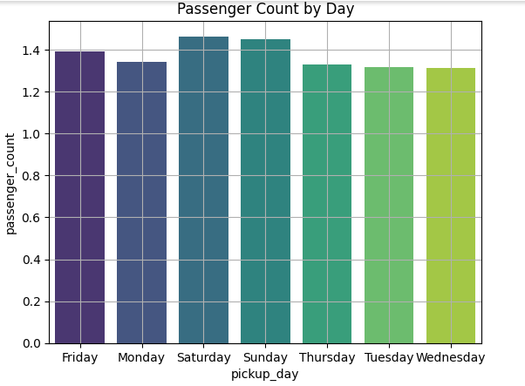

Interpretation – Passenger Count by Day
- Weekend Peak (Saturday & Sunday)
  - Highest passenger counts are on Saturday (~1.45) and Sunday (~1.44).
  - Likely driven by leisure activities, social gatherings, and tourist travel.
  - This suggests stronger demand for larger vehicles or shared rides during weekends.
- Friday Boost (~1.40)
  - Slightly higher than weekdays, likely due to evening social events and early weekend travel.
- Midweek Low (Tuesday, Wednesday, Thursday)
  - Lowest passenger counts (~1.31–1.33), suggesting more solo commuting and business trips.
  - Less leisure travel during these days reduces group ride occurrences.
- Monday Slight Dip (~1.34)
  - Possibly due to a focus on work commutes and routine travel with fewer multi-passenger rides.

    - Analyse the pickup/dropoff zones or times when extra charges are applied more frequently.

Interpretation – Extra Charges Application Patterns
- High-Occurrence Charges
  - Improvement Surcharge – applied on 100% of trips, meaning it’s a fixed charge applied universally regardless of time, location, or trip distance.
  - MTA Tax – applied on ~99.43% of trips, almost universal, indicating it’s part of standard NYC taxi pricing.

- Moderately Frequent Charges
  - Congestion Surcharge – applied on ~94.95% of trips, likely concentrated in high-traffic zones (e.g., Manhattan) and during peak hours.
  - Extra – applied on ~63.50% of trips, which may include night surcharges, snow charges, or special event fees.
    - These extra charges may spike during late-night hours, weekends, or holidays.

- Rare Charges
  - Airport Fee – applied on only ~0.66% of trips, suggesting that airport trips are a small portion of the overall rides.
    - This is expected since only trips to/from airports like JFK, LaGuardia, or Newark include this fee.

Conclusions

Final Insights and Recommendations
    - Recommendations to optimize routing and dispatching based on demand patterns and operational inefficiencies.
From the analysis, we saw that demand is highest during morning (7–10 AM) and evening (5–8 PM) rush hours on weekdays, mostly in busy business areas of Manhattan. → Tip: Keep more taxis ready in business zones in the morning and in residential areas in the evening to match where people are going.
On weekends, people travel more to tourist spots and nightlife areas, with demand peaking late at night. → Tip: Send more taxis to these areas during weekends and keep an eye on events for extra demand.
Airports always have steady demand. → Tip: Have a fixed rotation of drivers for airport trips so no one waits too long.
Short rides happen more inside the city, while long rides are mostly to/from airports and outer boroughs. → Tip: Assign city drivers for short trips and keep some drivers free for longer airport trips.
Some areas get fewer taxis during off-peak times. → Tip: Offer incentives for drivers to go to these places when it’s quiet, so passengers don’t have to wait too long and drivers avoid empty returns.

    - Suggestions on strategically positioning cabs across different zones to make best use of insights uncovered by analysing trip trends across time, days and months.

Weekday Mornings (7–10 AM): Position more cabs in residential areas so they can take passengers to business hubs.
Weekday Evenings (5–8 PM): Shift more cabs to business districts to handle office-to-home trips.
Weekends (Evening & Late Night): Place cabs near tourist attractions, shopping areas, and nightlife spots like downtown Manhattan.
Airport Zones: Keep a steady supply of cabs at JFK, LaGuardia, and Newark, especially during early mornings and late nights when flights are frequent.
Event Days: Increase cabs near stadiums, concert venues, and exhibition centers based on event schedules.
Low-Demand Zones: Rotate drivers into these areas during quiet hours so coverage is even across the city.

    - Propose data-driven adjustments to the pricing strategy to maximize revenue while maintaining competitive rates with other vendors.

- Passenger Count–Based Pricing
1–2 passengers (majority of trips): Keep fares competitive to maintain steady demand.
3–4 passengers (less common): Offer a flat group fare to encourage shared rides and increase occupancy.
- Time-Based Adjustments
Peak hours (8–10 AM, 5–7 PM): Slightly raise fares (5–10%) to match high demand and limited supply.
Late night (11 PM–5 AM): Use night surcharge for driver incentive and safety coverage.
Midday off-peak (10 AM–3 PM): Give small discounts to boost usage and reduce idle time.
- Trip Distance Strategy
Short trips (<2 miles): Keep base fare low to stay competitive; offer “short hop” promos in slow zones.
Medium trips (2–6 miles): Maintain standard rates as these have steady demand.
Long trips (>6 miles, esp. airport): Introduce flat rates (e.g., JFK–Manhattan, LaGuardia–Manhattan) to attract more long-distance riders.
- Zone & Event-Based Pricing
High-demand zones (Midtown, Times Square, airports): Surge pricing during rush hours and events.
Low-demand zones: Offer targeted discounts to bring in more trips.
- Competitive & Cost-Linked Adjustments
Monitor competitor pricing daily; adjust within ±5% to stay competitive.
Review operational costs monthly; tweak fares if fuel/maintenance costs rise.

