We need to create EC2 instance with Ubuntu

Go to security groups edit inbound rules give all traffic and save

Ps –ef | grep jenkins

Sudo cat means it give path

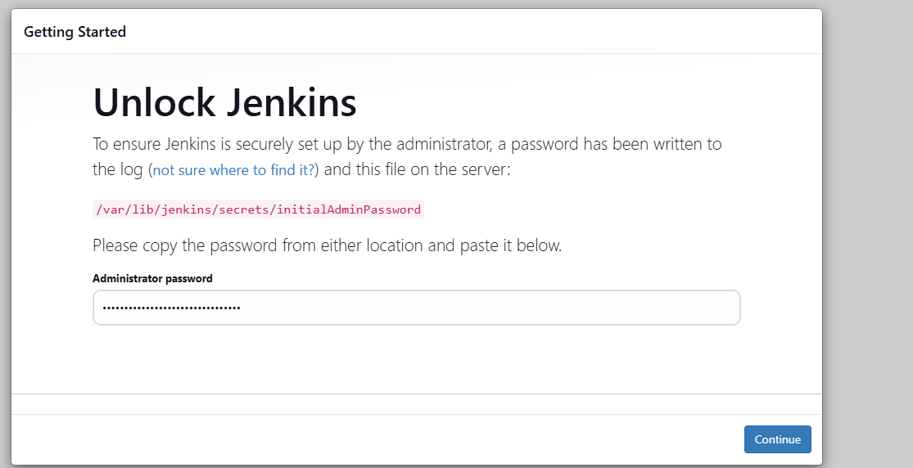

7bed5913125141d9937258ecff7dace3

Select pipeline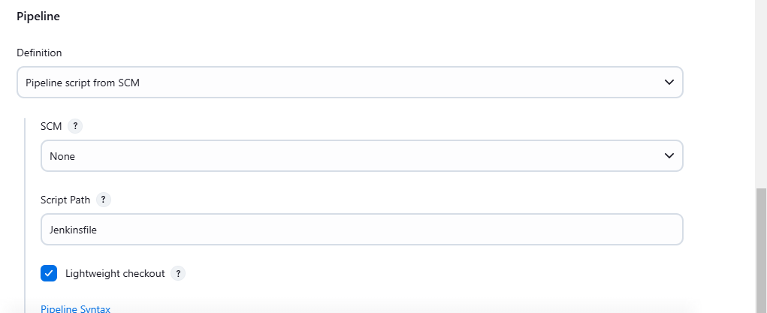https://github.com/Vandana-R-dev/Jenkins-Zero-To-Hero

Check and give main

Script path===== java-maven-sonar-argocd-helm-k8s/spring-boot-app/JenkinsFile

Install docker pipeline plugin

Go to sudo user

Ctrl+d to comeout root

Sonarqube runs in 9000 port

Default it will be admin and pw is admin

Vandu@123$=======pw

Click on my account----security------jenkins-genreate----copy

fd9287f6d116afceb3ae0dc7dc9c383894707205ss

manage Jenkins-credentials-------kind-secret text