**AWS**

**DAY-1**

In earlier days if any organization needs servers means they used to go to IBM, HP any other company they used to get servres and they were forming datacenter with an organization.

a data center is a physical facility that organizations use to house their critical applications and data. A data center's design is based on a network of computing and storage resources that enable the delivery of shared applications and data. The key components of a data center design include routers, switches, firewalls, storage systems, servers, and application-delivery controllers.

Virtualization creates a simulated, or virtual, computing environment as opposed to a physical environment. Virtualization often includes computer-generated versions of hardware, operating systems, storage devices, and more.

Why virtualization came?(create virtual servers for each application)

On each server if we run one application means it will get wasted other resources so with the help of virtualization we can run multiple applications on same server.

All these setups are doing privately within our organisation so called as private cloud.

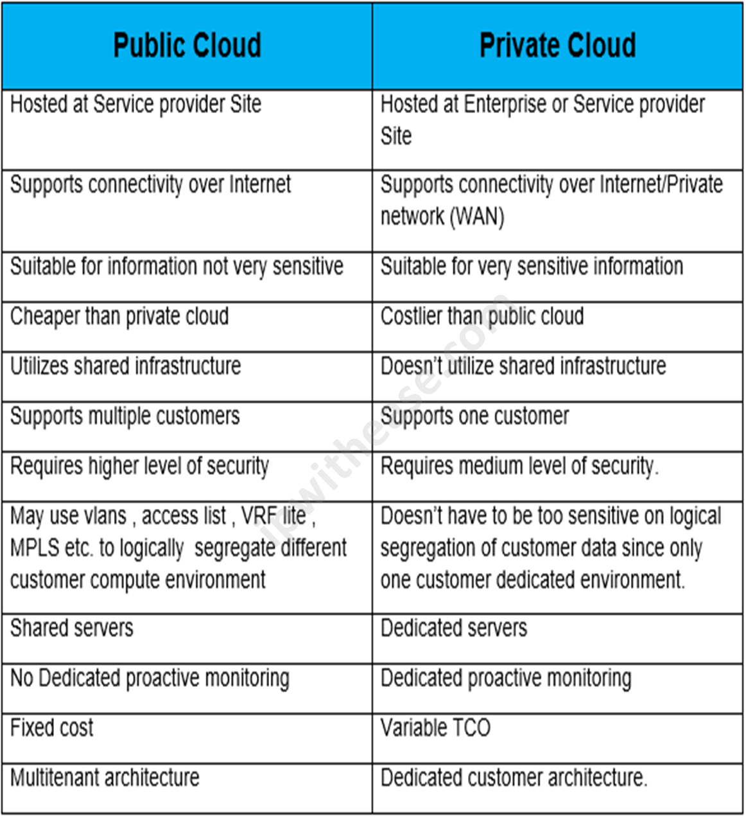

If its public cloud means security breach can be there that we can overcome by creating virtual private cloud inside public cloud.

Why public cloud is so popular?

Cost optimization-maintaining data center is too costly keeping power on always, Ac , hacker and all.

It is also pay as you go.

How AWS is better that others?

1.First-Mover Advantage

2. Extensive service portfolio(AWS offers 200 fully featured services ranging from computing, storage and database to Machine Learning.

3. Global infrastructure

AWS has largest and most well distributed global infrstructure. It operates in 31 geographic regions.

4. Scalability and flexibility(AWS is desired to scale with businesses of all sizes from startups to enterprise.

5. Reliability and security(AWS is known for its robust security measures, compliances, certifications and reliability.

6. Cost optimization(pay as you go)

7.Innovation(Introducing new services)

8. Developer friendly(with a rich set of API, SDKs)

Are people going back from cloud?

Yes but very few due to security issues, cost optimization.

**DAY-2**

IAM:(Identity access Management)

It’s a service that allows you to securely control access to AWS resources. With IAM you can manage users, groups, roles and their permissions to ensure your resources are protected.

Core concepts:

1. Users:

Individual accounts with credentials to access AWS services.

1. Groups: (like dev, QA,prod)

Collections of users with common permissions.

1. Roles:  
   Used to grant temporary access to AWS services

(If you want to access any application that is in private cloud we should give temporary access i.e. roles)

1. Policies:

JSON document that define permissions for users, group and roles.

1. IAM identity center(SSO):

Allows signle sign on access to AWS accounts.

Authentication and authorization are both security processes that work together to ensure the security of applications, systems, and data:

* **Authentication**

Verifies a user's identity. For example, logging in to Facebook with a username and password or using TouchID on a phone.

* **Authorization**

Determines a user's level of access and grants access based on that level. For example, using a card to enter a room and access specific services

IAM practice:

First login to AWS account with root access

Go to IAM

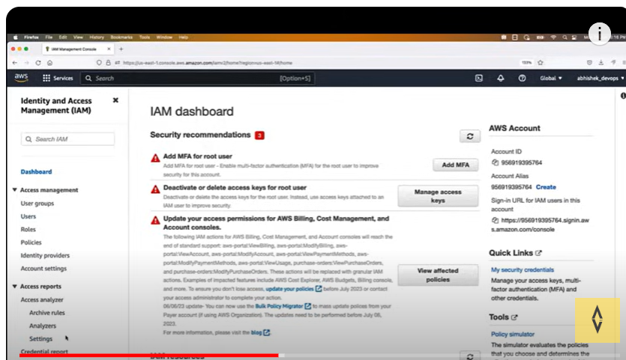

Create user

Dowload CSV file so that you can send for your reference

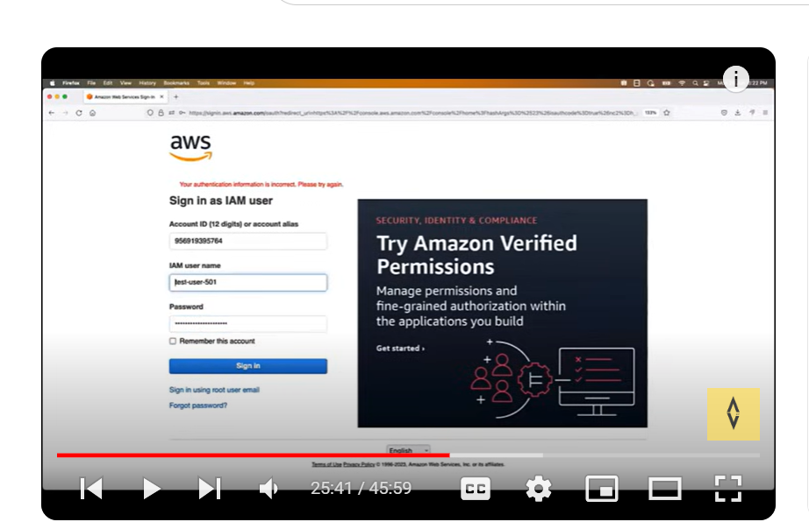

As a devops engineer I gave authentication but not authorization for that go back to Rakesh account via root login

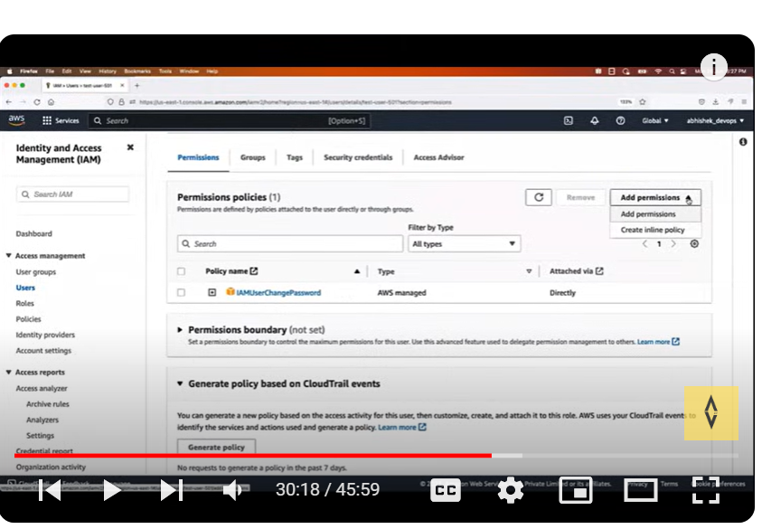

It is always good practice to use IAM user instead of root user .in interview you should tell that they provided some access to devops group with limited roles so based on that we are creating it.

To create groups sign in root user

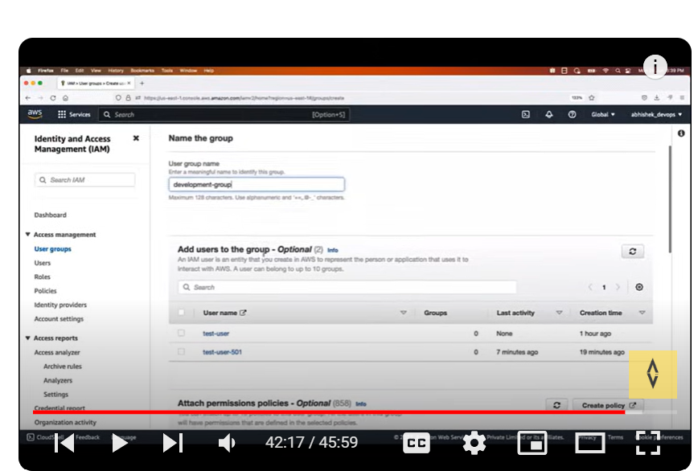

We can add users later as well and give permission down there.

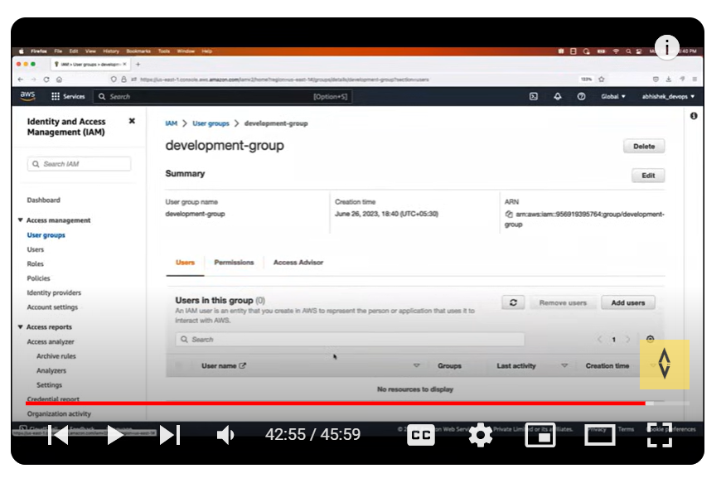

We can add same policy to whole development group instead of each user.

Day-3

**EC2-Elastic cloud compute**

Compute means you are asking AWS to provide cpu, ram, disk virtual server.

If that service can be scaled up or scaled down based on application needs that service named as elastic.

(EC2-you are asking AWS cloud to create a virtual server with elastic feature )

To check Timely upgrade, security issue, server up or not all these cannot be done by one devops engineer.

EC2 providing scalability, cost, maintenance.

**EC2 types:**

General purpose(Usually we use general purpose ec2 instance)

General Purpose instances are designed to deliver a balance of compute, memory, and network resources. They are suitable for a wide range of applications, including web servers,

small databases, development and test environments, and more.

Compute Optimized

Compute Optimized instances provide a higher ratio of compute power to memory. They excel in workloads that require high-performance processing such as batch processing,

scientific modeling, gaming servers, and high-performance web servers.

Memory Optimized

Memory Optimized instances are designed to handle memory-intensive workloads. They are suitable for applications that require large amounts of memory, such as in-memory databases,

real-time big data analytics, and high-performance computing.

Storage Optimized

Storage Optimized instances are optimized for applications that require high, sequential read and write access to large datasets.

They are ideal for tasks like data warehousing, log processing, and distributed file systems.

Accelerated computing

Accelerated Computing Instances typically come with one or more types of accelerators, such as Graphics Processing Units (GPUs),

Field Programmable Gate Arrays (FPGAs), or custom Application Specific Integrated Circuits (ASICs).

These accelerators offload computationally intensive tasks from the main CPU, enabling faster and more efficient processing for specific workloads.

Latency:

Time taken to reach an application and giving response back to application.

You should create an EC2 instance based on application demand which region they need .

Regions: like Mumbai, us-east-1

Availability zones:

We have availability zones within a region

For example, us-east-1a, us-east-1b

So any region goes down other availability zone works fine

Key-pair-combination of public and private key

EC2 instance creation

Create an EC2 instance