Bank Management System

Project Member :
❑ Member
- Mrs.Vandana Thopate
- Ms.Jaymala Malpure
- Ms.Chandrika
- Ms. Komal Bahire
❑ Guided By
- Prof. Indrakka Mali

Index
❑Introduction
❑Objective
❑Technology to be Used
❑Proposed System
❑Snapshots
❑Diagrams
❑Benefits of bank management
❑Conclusion

Introduction
- Bank Management System application is used to store all type of employee data.
- Admin can access ,insert ,update , delete data of all the users.
- This application can be used to store employee data in secure form in company.
Software and hardware requirements
• Software Requirements
- Operating System : Windows 7 , Windows 10 or Windows 11
- Language : Java
- IDE : Spring Boot,PostMan
- Backend : Microsoft MySQL server
• Hardware Requirements
- CPU : Intel Pentium IV processor
- RAM : 512 MB or above
- Hard Disk : 2 GB hard disk space or minimum

❑Back-End
⮚Core Java
⮚Spring Boot
⮚Spring Data JPA
⮚Hibernate
⮚Spring Boot Web
⮚MySQL Database

About Back-end:
❑ There are mainly four operations will be performed by the user and admin Ex. Insert, update, retrieve/fetch, delete.
❑ These operation will be performed using the spring boot framework, core java and spring boot web , spring data Jpa , and hibernate.
❑ For connectivity purpose we are using MySQL database. It is connected to the java and database.

Proposed System
❑ First we have to run the Application on the browser, the index page will be shown after that if the user is registered then he/she can login the page and he/she can entering in the application.
❑ If the user is not registered then he/she needs to register themselves and then he/she can continuing to login and he/she can access any time.
❑ After that related pages will be there like if user is admin so he/she can access all the operations like insert, delete, update and search the details.
❑ If the user is customer then he/she can view the related record and he/she can update the record.
❑ And after that he/she can logged out by themselves.

Working Of Back-End
















❑ There are mainly three stages –
Service
Repository
UIController
Client
Database

❑UIController - In Spring Boot, the UIController class is responsible for processing incoming requests, preparing a model, and returning the view to be rendered as a response.
❑ Service - Components are the class file which contains @Service annotation. These class files are used to write business logic in a different layer.
❑ Repository - Repository is a specialization of @Component annotation which is used to indicate that the class provides the mechanism for storage, retrieval, update, delete and search operation on objects.
❑ Repository is directly connected with the database and then it can return to the repository and response to the service and it can return to the controller and then response send to the client.

Snapshots
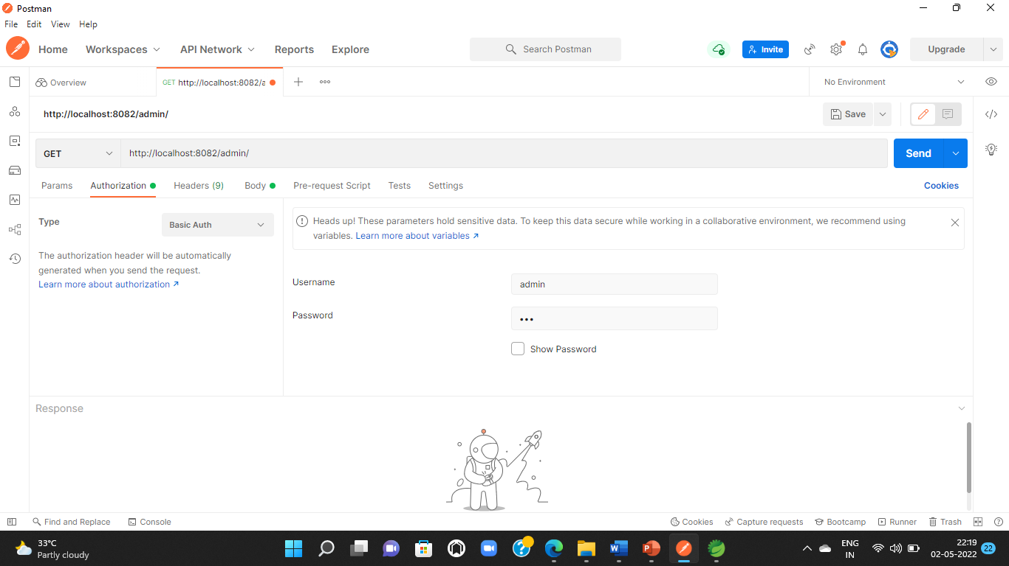
- Login Page:

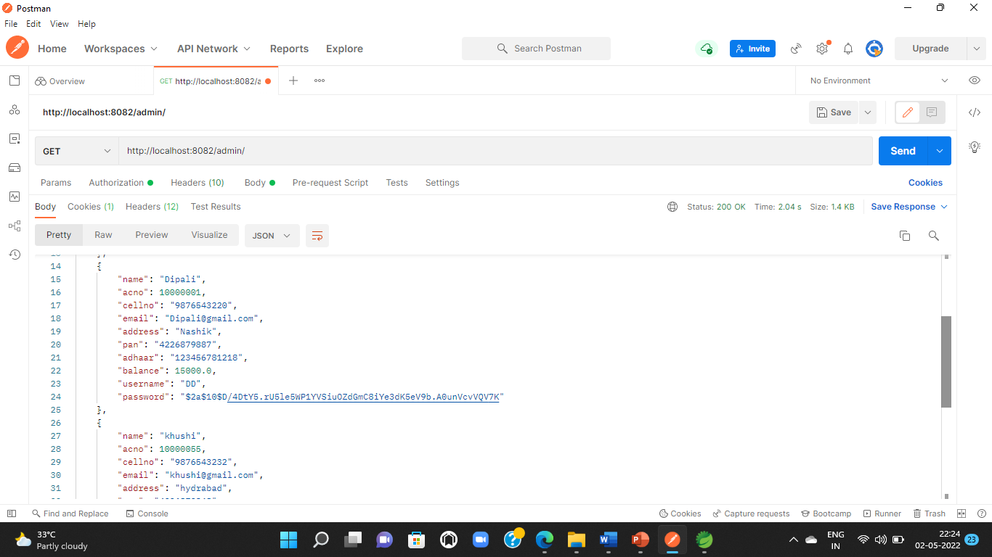
2 Get All Users Record:/admin/

Update Record:/admin/{acno}

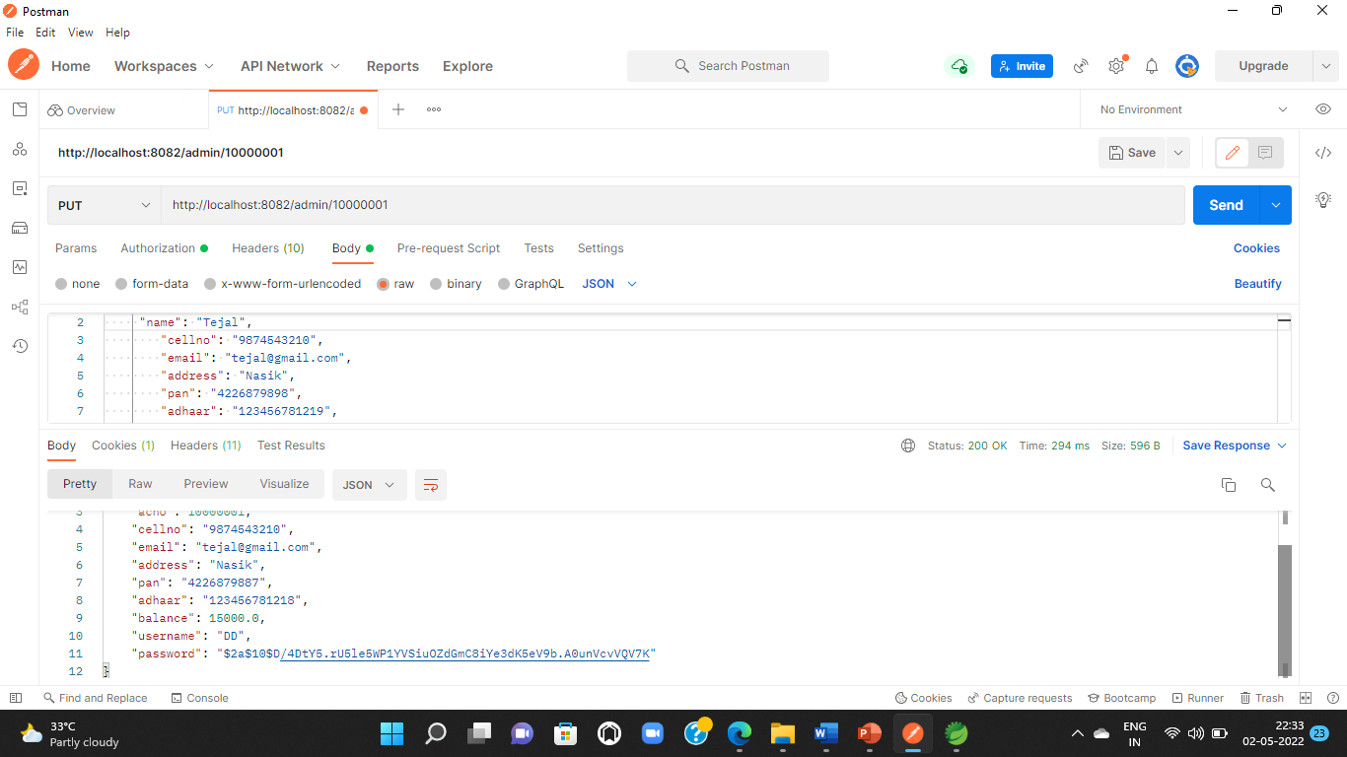

- Delete Record:/admin/delete/{acno}
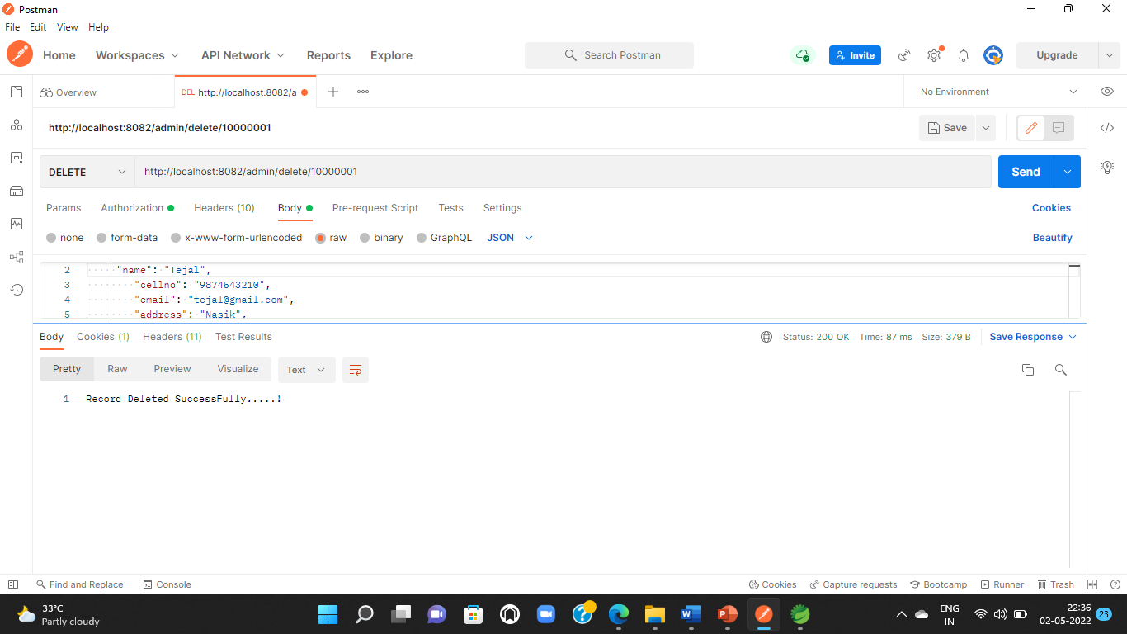

- Add Record:/admin/save/

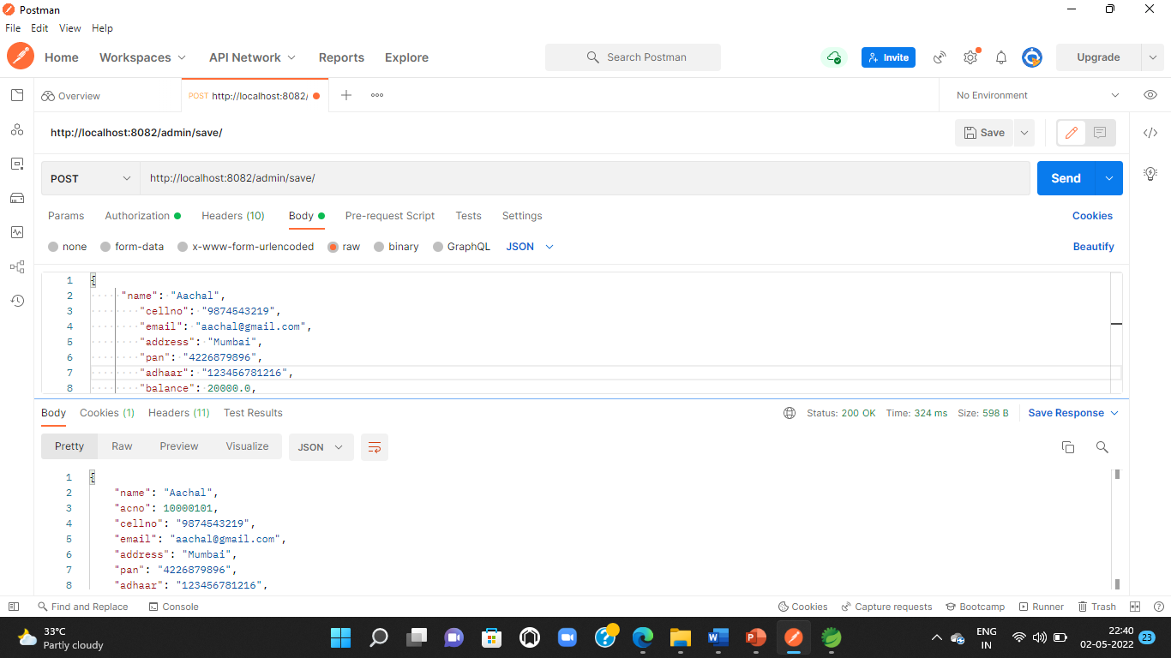
- User Login
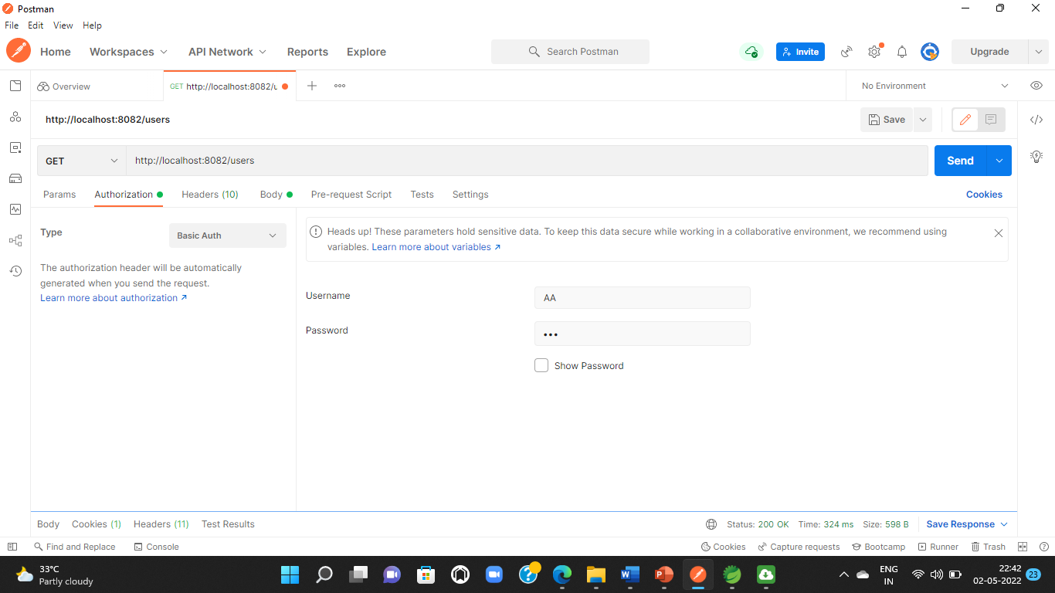

Display Balance:/users/{acno}
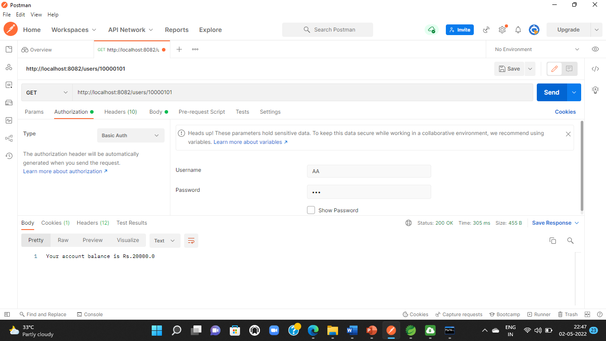

- Transaction:/users/{acno}

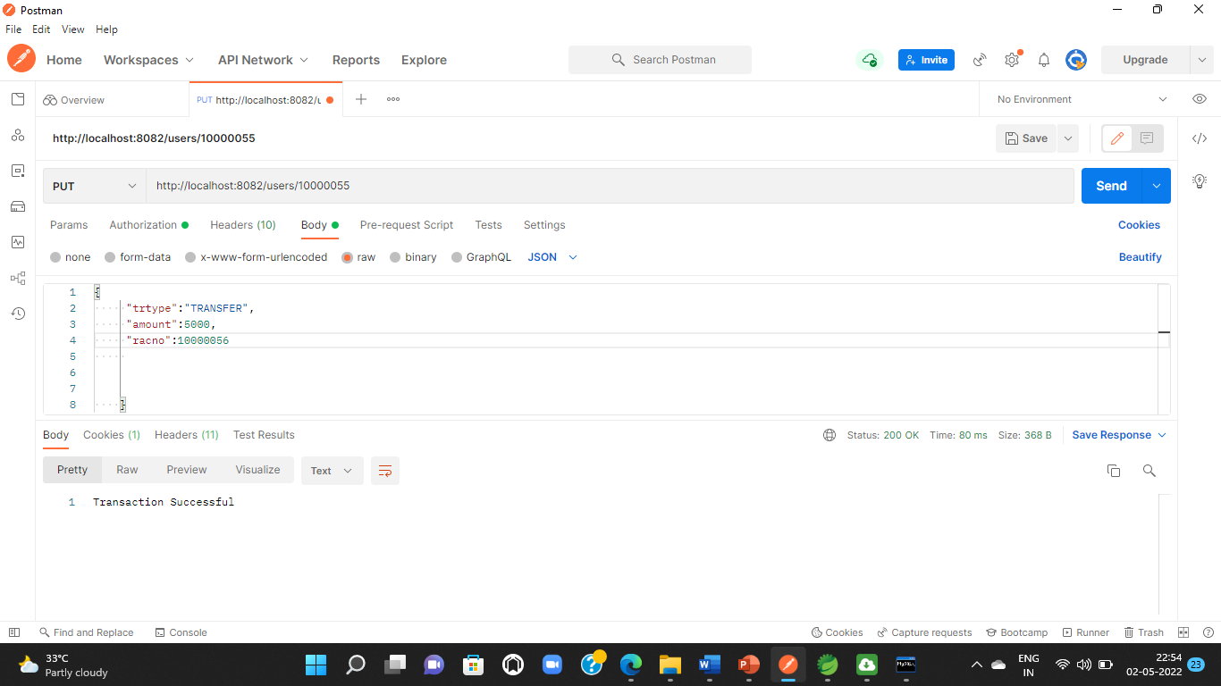

Benefits of bank management
o You don't have to wait in line.
o You don't have to plan your day around the bank's hours.
o You can look at your balance whenever you want, not just when you get a statement.

You don't have to wait in line.
o You don't have to plan your day around the bank's hours.
o You can look at your balance whenever you want, not just when you get a statement
You don't have to wait in line.
o You don't have to plan your day around the bank's hours.
o You can look at your balance whenever you want, not just when you get a statement.
You don't have to wait in line.
o You don't have to plan your day around the bank's hours.
o You can look at your balance whenever you want, not just when you get a statement.

You don't have to wait in line.
o You don't have to plan your day around the bank's hours.
o You can look at your balance whenever you want, not just when you get a statem

Conclusion
This project is developed to nurture the needs of a user in a banking sector by embedding all
the tasks of transactions taking place in a bank. Future version of this project will still be
much enhanced than the current version.

THANK
YOU…..!!!!!!

