
Implementing Predictive Analytics to Optimize Customer Churn Prediction




HEPro Business Analytics Fellowship
GODABA VANDANA
OVERVIEW

This project focuses on implementing predictive analytics to identify customers who are likely to churn in a telecom business. The dataset was analyzed to understand customer demographics, service usage, and billing behavior. Data cleaning and preprocessing steps were performed to handle missing values, correct data types, and prepare the dataset for analysis. Exploratory Data Analysis (EDA) was conducted to uncover patterns and key factors influencing churn. Feature engineering techniques were applied to enhance model performance. Multiple machine learning models, including Logistic Regression and Random Forest, were built and evaluated. Based on performance metrics, Logistic Regression was selected as the final model. The results provide valuable business insights to help reduce customer churn through proactive retention strategies..

table of contents
- Introduction
- Project Goals
- Project Objectives
- Activity 1: Dataset Familiarization
3.1 Dataset Overview
3.2 Understanding Features
- Activity 2: Data Quality Check & Preprocessing Plan
4.1 Check for missing values, duplicates and inconsistencies
4.2 Identify Categorical and Numerical Variables:
4.3 Plan data preprocessing strategy
- Activity 3: Data Cleaning & Exploratory Data Analysis (EDA)
5.1 Data Cleaning Steps
5.2 Univariate Analysis
5.2.1 Numerical Variable Analysis
5.2.2 Categorical Variable Analysis
5.3 Bivariate Analysis (Churn Focus)
- Activity 4: Feature Engineering, Modeling & Evaluation
6.1 Feature Engineering
6.2 Train–Test Split
6.3 Baseline Model – Logistic Regression
6.4 Advanced Models
6.5 Model Evaluation Metrics
6.6 Model Comparison
- Final Model Selection & Business Insights
- Conclusion & Future Scope
- Challenges and Solutions
- Learnings and Key Takeaways

Introduction

Customer churn refers to the situation where customers stop using a company’s products or services and switch to a competitor. In highly competitive industries such as telecommunications, customer churn can significantly impact business growth and profitability. Predicting customer churn is important because acquiring new customers is often more expensive than retaining existing ones. By identifying customers who are likely to churn, businesses can take timely preventive actions to retain them.

Reducing churn helps businesses maintain a stable customer base, increase revenue, and improve customer satisfaction. It also enables companies to design personalized offers, better pricing strategies, and improved customer support. Effective churn management allows organizations to build long-term customer relationships and improve brand loyalty.

With the availability of large volumes of customer data, predictive analytics and machine learning techniques can be used to analyze customer behavior and identify churn patterns. This project applies data preprocessing, exploratory data analysis, and machine learning models to predict customer churn accurately. The insights obtained from this analysis can help businesses make data-driven decisions and implement proactive retention strategies to minimize customer loss.

Project Goals

The primary goal of this project is to develop a predictive analytics solution that can accurately identify customers who are likely to churn. By analyzing customer demographics, service usage, and billing information, the project aims to help the business understand churn behavior and take proactive retention actions. Another key goal is to apply machine learning techniques to build reliable and interpretable churn prediction models that can support data-driven decision-making.
Additionally, this project seeks to demonstrate a complete end-to-end data analytics workflow, including data cleaning, exploratory data analysis, feature engineering, model building, evaluation, and interpretation of results. The final goal is to provide actionable business insights that can help reduce customer churn and improve customer retention strategies.

Project Objectives

The specific objectives of this project are:
- To understand and explore the customer churn dataset by identifying key variables related to customer demographics, service usage, and billing patterns.
- To perform data cleaning by handling missing values, correcting data types, removing duplicates, and preparing the dataset for analysis.
- To conduct exploratory data analysis (EDA) to identify patterns, trends, and relationships between customer attributes and churn behavior.
- To engineer meaningful features such as customer tenure categories, average monthly spend, and contract-related indicators that can improve model performance.
- To build a baseline churn prediction model using Logistic Regression and evaluate its performance using metrics such as Accuracy, Precision, Recall, F1-score, and AUC-ROC.
- To develop and compare advanced machine learning models including Decision Tree, Random Forest, and Gradient Boosting classifiers.
- To apply model tuning and validation techniques such as cross-validation and hyperparameter tuning to improve model stability and predictive performance.
- To identify the most important features influencing customer churn and interpret their business impact.
- To select the best-performing model based on evaluation metrics, with a strong focus on recall for churn customers.
- To provide clear business recommendations based on analytical insights to help reduce customer churn and improve customer retention strategies.

Activity 1: Dataset Familiarization

3.1 Dataset Overview:

This project uses the Telco Customer Churn Dataset, which contains information about customers of a telecommunications company. The dataset includes customer demographic details, service subscription information, billing data, and churn status. The objective of using this dataset is to analyze customer behavior and identify factors that influence customer churn.
The dataset consists of 21 columns, including 20 independent variables and 1 target variable (Churn). The features represent customer personal details, account information, services subscribed, and payment-related attributes. Below is a detailed column-wise description of the dataset.

Column-wise Description of the Telco Churn Dataset
- customerID
A unique identifier assigned to each customer. This column is used only for identification purposes and does not contribute to churn prediction.
- gender
Indicates the gender of the customer (Male or Female).
- SeniorCitizen
Shows whether the customer is a senior citizen
(1 = Yes, 0 = No).
- Partner
Indicates whether the customer has a partner (Yes or No).
- Dependents
Shows whether the customer has dependents such as children or family members (Yes or No).
- tenure
Represents the number of months the customer has stayed with the company.
- PhoneService
Indicates whether the customer has a phone service (Yes or No).
- MultipleLines
Shows whether the customer has multiple phone lines (Yes, No, or No phone service).
- InternetService
Specifies the type of internet service used by the customer
(DSL, Fiber optic, or No internet service).
- OnlineSecurity
Indicates whether the customer has an online security service (Yes or No).
- OnlineBackup
Shows whether the customer has online backup service (Yes or No).
- DeviceProtection
Indicates whether the customer has device protection service (Yes or No).
- TechSupport
Shows whether the customer has technical support service (Yes or No).
- StreamingTV
Indicates whether the customer subscribes to streaming TV services (Yes or No).
- StreamingMovies
Indicates whether the customer subscribes to streaming movie services (Yes or No).
- Contract
Specifies the contract type of the customer
(Month-to-Month, One Year, or Two Year).
- PaperlessBilling
Indicates whether the customer uses paperless billing (Yes or No).
PaymentMethod
Shows the payment method used by the customer
(Credit Card, Bank Transfer, Electronic Check, or Mailed Check).
- MonthlyCharges
Represents the monthly amount charged to the customer for services.
- TotalCharges
Shows the total amount charged to the customer over the entire tenure.
- Churn
The target variable indicating whether the customer has left the company
(Yes = Churned, No = Retained).

3.2 Understanding Features:

Understanding the features in the dataset is an essential step before performing data cleaning, exploratory analysis, and model building. Each feature represents a specific aspect of customer behavior, demographics, or service usage that may influence customer churn.
The features in the Telco Customer Churn dataset can be broadly classified into the following categories:

1. Demographic Features
These features describe the personal characteristics of customers and help understand different customer segments.
- gender – Identifies the gender of the customer
- SeniorCitizen – Indicates whether the customer is a senior citizen
- Partner – Shows whether the customer has a partner
- Dependents – Indicates whether the customer has dependents
These features help analyze how personal and family-related factors influence customer retention.

2. Account & Contract Information
These features describe the customer’s relationship duration and contractual commitments with the company.
- tenure – Number of months the customer has stayed with the company
- Contract – Type of contract (Month-to-Month, One Year, Two Year)
- PaperlessBilling – Indicates if the customer uses paperless billing
These variables are important because customers with longer tenure or long-term contracts are generally less likely to churn.

3. Service Usage Features
These features indicate the services subscribed by the customer and reflect their engagement level.
- PhoneService
- MultipleLines
- InternetService
- OnlineSecurity
- OnlineBackup
- DeviceProtection
- TechSupport
- StreamingTV
- StreamingMovies
Customers using more services are often more engaged and may have a lower probability of churn.

4. Billing & Payment Features
These features capture customer spending behavior and payment preferences.
- MonthlyCharges – Monthly service cost
- TotalCharges – Total amount billed over time
- PaymentMethod – Method used to pay bills
Billing-related features are critical for identifying customers who may be sensitive to pricing or payment inconvenience.

5. Target Variable
- Churn – Indicates whether the customer has left the company (Yes or No)
This is the dependent variable used for predictive modeling and churn analysis.
Activity 2: Data Quality Check & Preprocessing

4.1 Check for missing values, duplicates, and inconsistencies:

Objective:
The objective of this step is to assess the quality of the Telco Churn dataset by identifying missing values, duplicate records, and any inconsistencies that may affect further analysis and predictive modeling.
Steps Performed
- The dataset was loaded into a Python environment using the Pandas library.
- Basic dataset inspection was performed to understand the structure, number of rows and columns, and data types of each feature.
- Missing values were identified by checking null values across all columns.
- Duplicate records were examined to ensure that each customer record is unique.
- Categorical variables were reviewed to identify inconsistent values such as incorrect labels, extra spaces, or unexpected categories.
Observations and Data Issues Identified
- No missing values were detected across any columns in the dataset.
- Duplicate records were checked, and none were found, ensuring that each customer is uniquely represented.
- Categorical variables were reviewed for inconsistencies such as unexpected values or formatting issues, and the dataset was found to be consistent and well-structured.
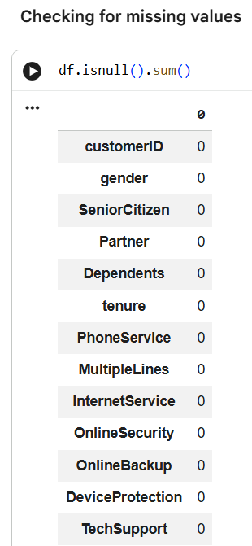
4.2 Identify Categorical and Numerical Variables:
Objective:
The objective of this step is to identify and categorize the dataset features into categorical and numerical variables to support effective data preprocessing and model development.
Approach
The dataset was analyzed using Python to identify the data type of each column. Columns with integer and floating-point data types were classified as numerical variables, while columns with object data types were classified as categorical variables.
Findings
- Numerical Variables (3):
  - SeniorCitizen
  - tenure
  - MonthlyCharges
These variables represent quantitative information related to customer demographics, service duration, and billing amounts.
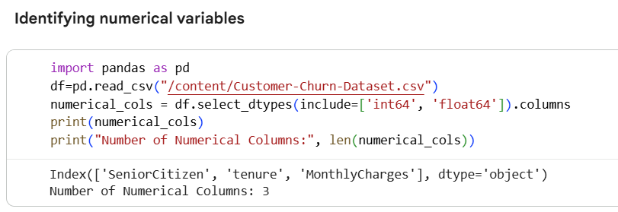
- Categorical Variables (18):
  - customerID
  - gender
  - Partner
  - Dependents
  - PhoneService
  - MultipleLines
  - InternetService
  - OnlineSecurity
  - OnlineBackup
  - DeviceProtection
  - TechSupport
  - StreamingTV
  - StreamingMovies
  - Contract
  - PaperlessBilling
  - PaymentMethod
  - TotalCharges
  - Churn
These variables describe customer characteristics, service subscriptions, billing preferences, and churn status.
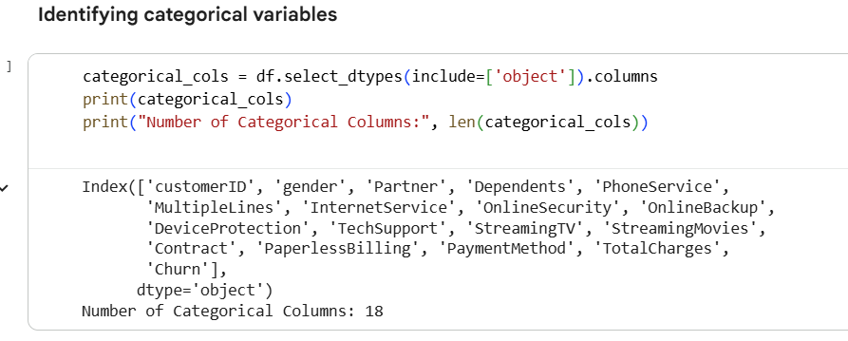

4.3 Plan data preprocessing strategy (encoding, normalization, handling nulls).
Objective
The objective of this step is to define an appropriate data preprocessing strategy to prepare the Telco Churn dataset for analysis and predictive modeling. This includes handling null values, encoding categorical variables, and normalizing numerical features.
i)Encoding
Encoding Categorical Variables Machine learning models require numerical input. Therefore, categorical variables were converted into numerical representations using appropriate encoding techniques.
Binary Categorical Encoding (Label Encoding)
Columns containing only two categories (Yes/No) were converted into numerical values:
- Yes → 1
- No → 0
The following columns were label encoded:
- Partner
- Dependents
- PhoneService
- PaperlessBilling
- OnlineSecurity
- OnlineBackup
- DeviceProtection
- TechSupport
- StreamingTV
- StreamingMovies
- MultipleLines
This encoding preserves simplicity while retaining meaningful information.
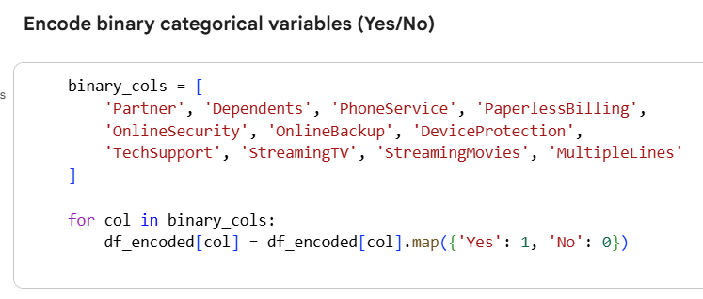

Encoding Multi-Category Variables (One-Hot Encoding)
Columns with more than two categories were encoded using One-Hot Encoding:
- gender
- Contract
- PaymentMethod
- InternetService
One-hot encoding creates separate binary columns for each category.
To avoid multicollinearity, the drop_first=True parameter was used. This means:
- One category is treated as a reference (baseline)
- The dropped category is implicitly represented when all encoded columns are zero
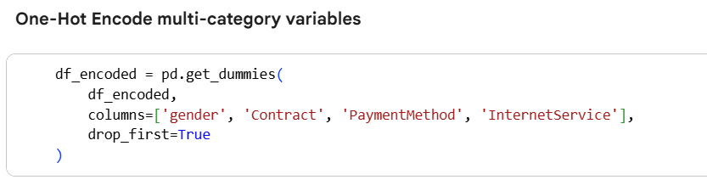
Example: Contract Column
Original categories:
- Month-to-month
- One year
- Two year
Encoded columns:
- Contract_One year
- Contract_Two year
Interpretation:
- If both columns are False, the contract type is Month-to-month
- If Contract_One year = True, the contract is One year
- If Contract_Two year = True, the contract is Two year
No information is lost in this process.
Encoding the Target Variable The target variable Churn was converted into numerical format to enable predictive modeling:

- Yes → 1
- No → 0
This allows the model to learn patterns associated with customer churn.
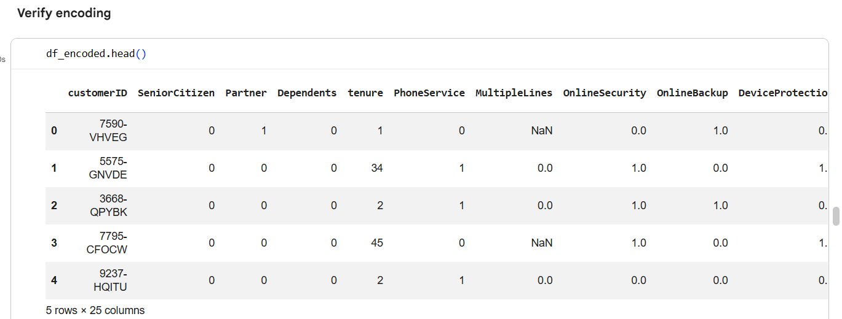
Data Type Correction – TotalCharges Column
After encoding the categorical variables, a data type verification was performed to ensure all features were in a format suitable for machine learning models.
Issue Identified
- The TotalCharges column was stored as an object (string) data type instead of a numerical type.
- This occurred due to formatting issues in the dataset, such as empty strings or non-numeric values.
- Machine learning models cannot process numerical values stored as text.
Action Taken
- The TotalCharges column was converted from object to float using numeric type conversion.
- Any invalid or non-numeric values were coerced into missing values during conversion.
- These missing values were then handled appropriately during the missing value treatment step.
Reason for Data Type Conversion
- TotalCharges represents a continuous numerical value (billing amount).
- Converting it to float ensures:
  - Accurate mathematical calculations
  - Proper scaling during normalization
  - Compatibility with machine learning algorithms
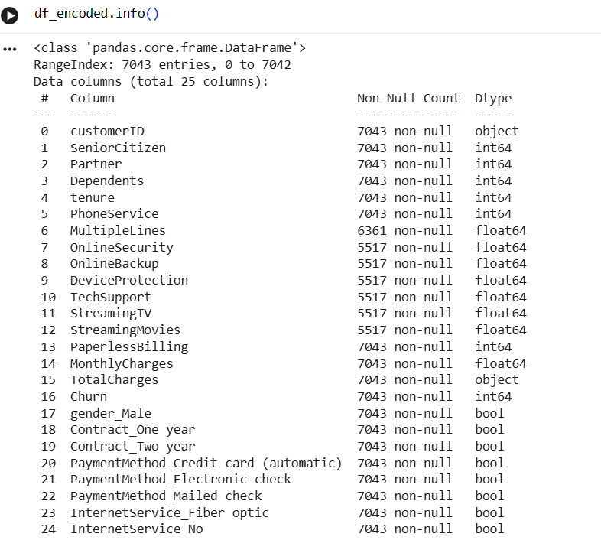
Converting Total Charges Column into Float Datatype
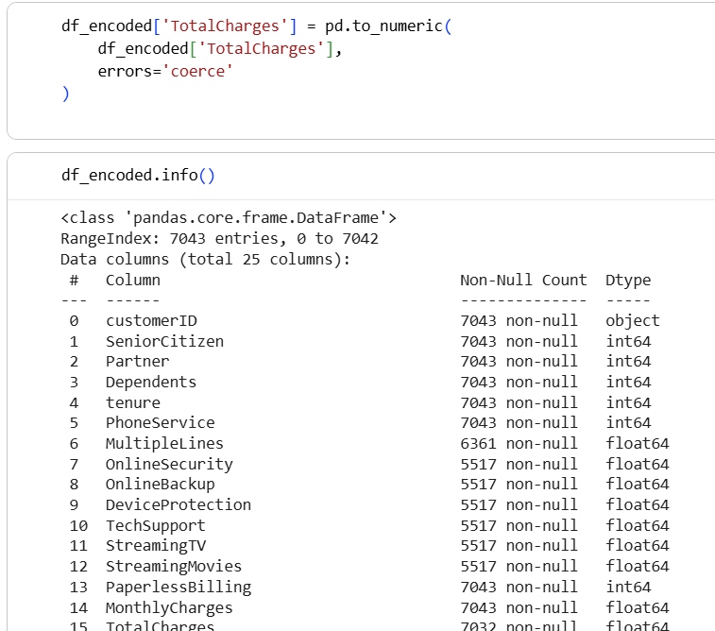

ii) Handling Missing (Null) Values
STEP 1: Identify columns with missing values
First, always check where nulls exist.
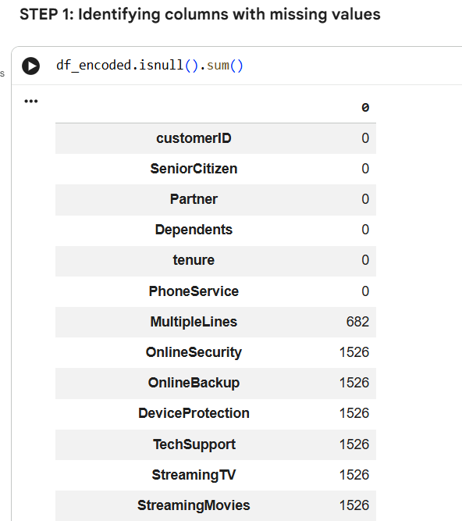
STEP 2: Understanding the nature of each column
Before filling nulls, ask:
What does this column represent?
STEP 3: Handle service-related binary columns (Yes/No → 1/0)
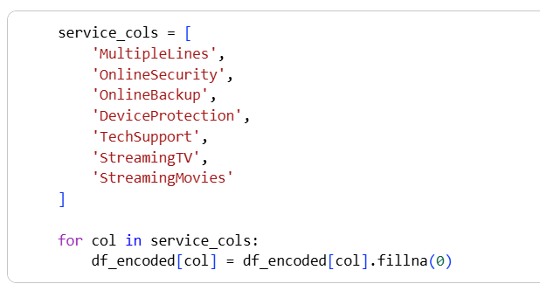

STEP 4: Handle numerical continuous column – TotalCharges
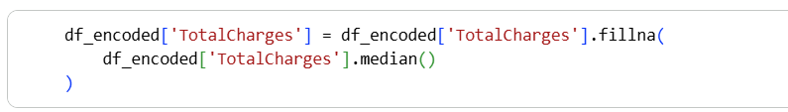
STEP 5: Verify missing values are handled
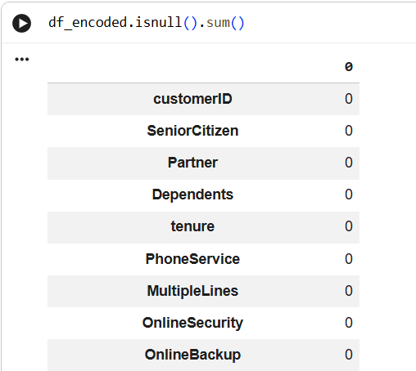
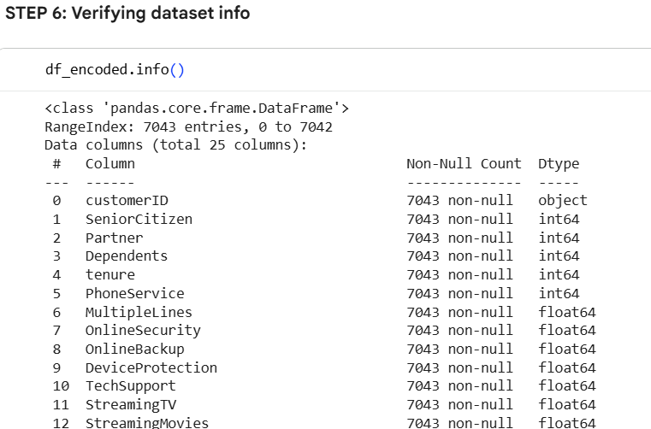

Missing values were handled based on the nature of each feature.
Service-related columns represent whether a customer has subscribed to specific services. Missing values in these columns indicate the absence of the service and were therefore replaced with 0.
For the continuous numerical variable TotalCharges, missing values were imputed using the median. Using zero would misrepresent customer payment behavior, whereas median imputation preserves the overall distribution of the data and avoids bias.
iii)Normalization
Normalization is a data preprocessing technique used to scale numerical features so that they fall within a similar range. In many datasets, different numerical variables may have very different value ranges. When such data is used directly, machine learning models may give more importance to features with larger numerical values, even if they are not more meaningful.
Why Normalization is Needed
Machine learning algorithms rely on mathematical calculations such as distance measurement and gradient optimization. If one feature has much larger values than others, it can dominate the learning process and negatively affect model performance. Normalization helps ensure that each feature contributes equally to the model.

Simple Example
Consider two numerical features in a customer dataset:
Feature | Example Values
tenure | 1 – 72
TotalCharges | 100 – 9000
If normalization is not applied:
- TotalCharges values are much larger than tenure
- The model may incorrectly assume TotalCharges is more important
After normalization:
- Both features are scaled to a similar range (e.g., 0 to 1)
- The model learns patterns more effectively and fairly
- Common Normalization Technique
- One commonly used normalization method is Min-Max Scaling, which transforms values using the formula:
- $\text{Normalized Value}=\frac{\left(x − \text{min}\right)}{\left(\text{max} − \text{min}\right)}$
- This method scales all values to a range between 0 and 1.
Normalization was applied to continuous numerical features to ensure that all variables contribute equally to the predictive model. Since machine learning algorithms are sensitive to feature scale, numerical columns with larger ranges can disproportionately influence model performance.
The following numerical columns were normalized using Min-Max Scaling:
- tenure
- MonthlyCharges
- TotalCharges
Min-Max normalization scales values to a range between 0 and 1, improving model stability and convergence. Binary and one-hot encoded features were excluded from normalization, as they already exist on a comparable scale.
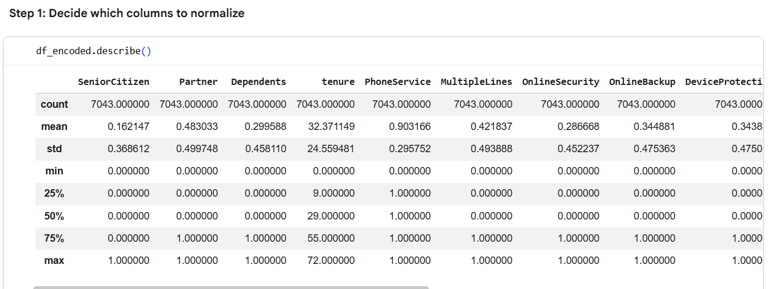
Based on the describe() output, tenure, MonthlyCharges, and TotalCharges were selected for normalization because they have larger and varying value ranges (higher max values), unlike binary encoded features which are already on a comparable 0–1 scale.
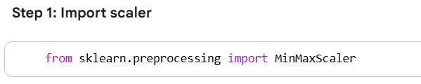
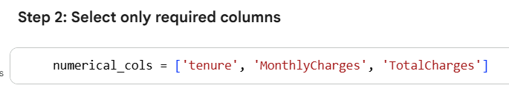
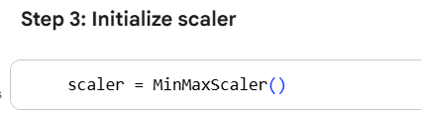
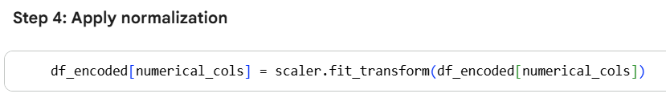
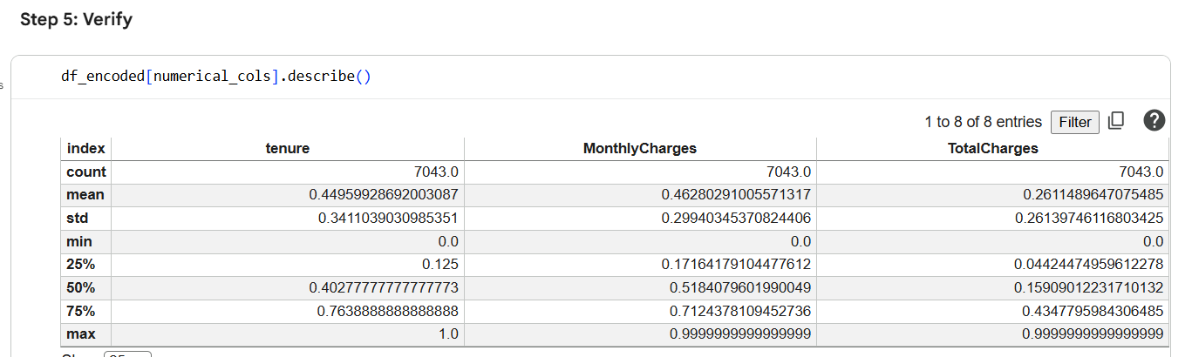
Based on the describe() output, tenure, MonthlyCharges, and TotalCharges were selected for normalization because they have larger and varying value ranges (higher max values), unlike binary encoded features which are already on a comparable 0–1 scale.

Activity 3: Data Cleaning & Exploratory Data Analysis (EDA)

5.1 Data Cleaning Steps:
1. Dataset Inspection
The dataset was initially loaded into the Python environment using the Pandas library. A preliminary inspection was performed to understand:
- Number of rows and columns
- Data types of each feature
- Presence of missing or inconsistent values
This step helped identify potential data quality issues early in the analysis.

2. Handling Missing Values
- The dataset was checked for null values across all columns.
- Missing values were primarily identified in the TotalCharges column.
- Since TotalCharges is a continuous numerical feature, missing values were handled using median imputation to preserve the data distribution.
- Service-related binary columns (Yes/No features) were filled with 0, indicating the absence of the service.
This ensured that no missing values remained in the dataset before further analysis.

3. Data Type Correction
- The TotalCharges column was originally stored as an object (string) data type.
- This column was converted into a numerical (float) data type to enable mathematical operations, normalization, and machine learning modeling.
- Any non-numeric values encountered during conversion were handled appropriately.
Correcting data types ensured compatibility with machine learning algorithms.

4. Duplicate Record Check
- The dataset was checked for duplicate customer records.
- No duplicate entries were found, confirming that each customer record was unique.

5. Encoding Categorical Variables
- Categorical variables were converted into numerical format using appropriate encoding techniques:
  - Binary variables were label encoded (Yes → 1, No → 0).
  - Multi-category variables were transformed using One-Hot Encoding.
- The target variable Churn was encoded as:
  - Yes → 1
  - No → 0
Encoding allowed the dataset to be used for statistical analysis and machine learning models.

6. Normalization of Numerical Features
- Continuous numerical variables with large value ranges were normalized using Min-Max Scaling.
- The following columns were normalized:
  - tenure
  - MonthlyCharges
  - TotalCharges
- Binary and one-hot encoded features were excluded from normalization as they already exist on a comparable scale.
Normalization ensured that all numerical features contributed equally to the model.

5.2 Univariate Analysis:
Univariate analysis means analyzing one variable at a time, independently, without considering its relationship with any other variable.
Objective of Univariate Analysis
The main objectives are:
Understand the distribution of each variable
- How values are spread
- Are values concentrated or scattered?
- Is the data skewed (left/right)?
Identify common patterns and ranges
- Most frequent values
- Minimum and maximum values
- Typical customer behavior (e.g., short tenure vs long tenure)
Detect outliers or unusual values
- Very high charges
- Extremely long or short tenure
- Any abnormal patterns that may affect modeling
Understand customer characteristics (business view)
For example:
- Are most customers on month-to-month contracts?
- Are charges generally low or high?
- Is the dataset balanced by gender?
Prepare for deeper analysis (Bivariate & Modeling)
Univariate analysis helps us:
- Decide which features matter
- Decide which features need scaling
- Build intuition before analyzing churn relationships
🔹 Types of Univariate Analysis (Very Important)
🔸 For Numerical Variables (e.g., tenure, charges)
We use:
- Histograms → distribution
- Boxplots → spread & outliers
- Summary statistics (mean, min, max)
1. Objective of Univariate Analysis
Univariate analysis focuses on analyzing one variable at a time to understand its distribution, spread, and patterns within the dataset.
The objective of this step is to:
- Understand customer demographics and service usage
- Identify skewness, concentration, and outliers
- Prepare variables for further churn-focused (bivariate) analysis
2. Numerical Variable Analysis
2.1 Tenure (Customer Lifetime in Months)
Method Used: Histogram
Description:
Tenure represents the number of months a customer has stayed with the company.
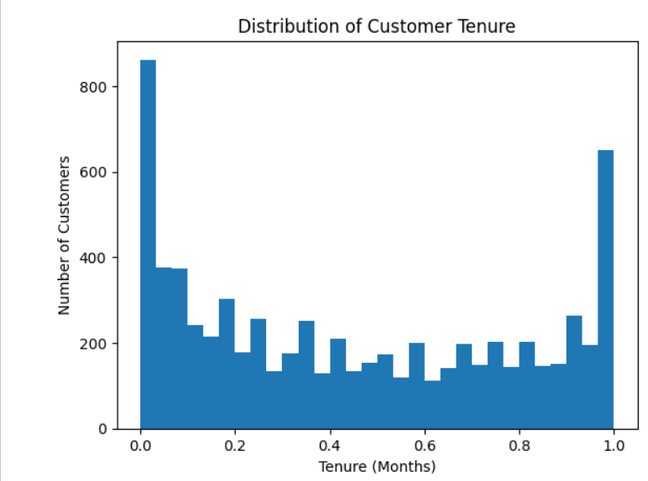
Observations:
- A large number of customers have low tenure, indicating many new customers
- Another concentration is observed near the maximum tenure (around 72 months), representing long-term loyal customers
- The distribution is right-skewed, with fewer customers in the mid-tenure range
Insight:
- Customers with shorter tenure may be more likely to churn
- Tenure is expected to be a strong churn indicator
2.2 Monthly Charges
Method Used: Histogram
Description:
MonthlyCharges indicates the amount a customer is billed monthly for services.
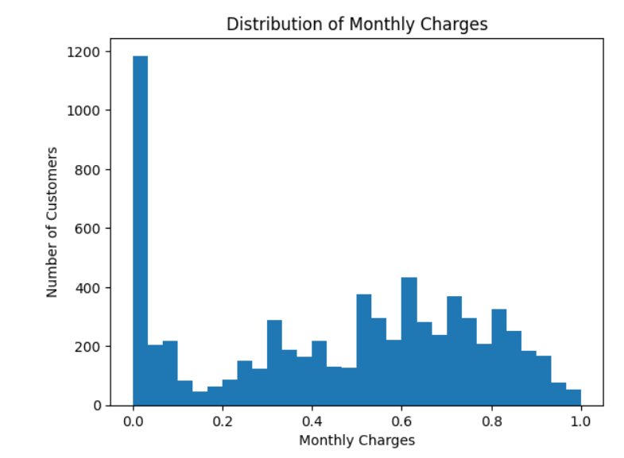
Observations:
- Charges are spread across a wide range
- A high concentration of customers exists at lower monthly charges
- Fewer customers fall into the high-charge range
Insight:
- Customers paying higher monthly charges may be more sensitive to pricing
- MonthlyCharges may influence churn behavior and should be further analyzed
2.3 Total Charges
Method Used: Histogram
Description:
TotalCharges represents the cumulative amount billed to a customer over time.
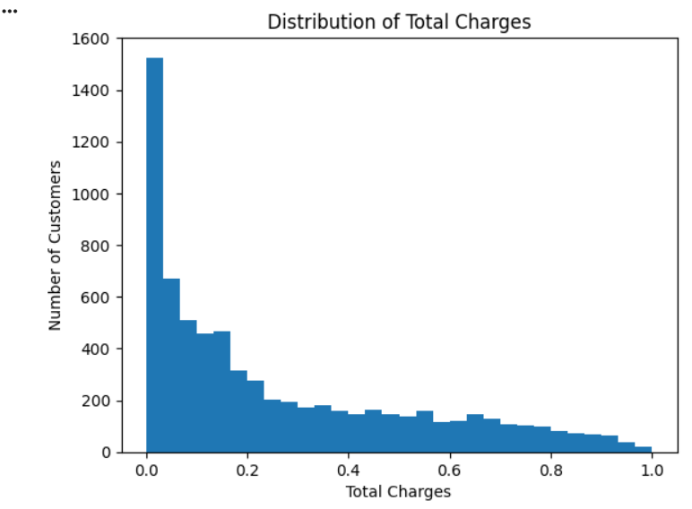
Observations:
- The distribution is highly right-skewed
- Many customers have low total charges, which aligns with customers having short tenure
- Customers with long tenure show higher total charges
Insight:
- TotalCharges is strongly linked with tenure
- Customers with low total charges are likely new and potentially at higher churn risk
3. Categorical Variable Analysis
3.1 Gender Distribution
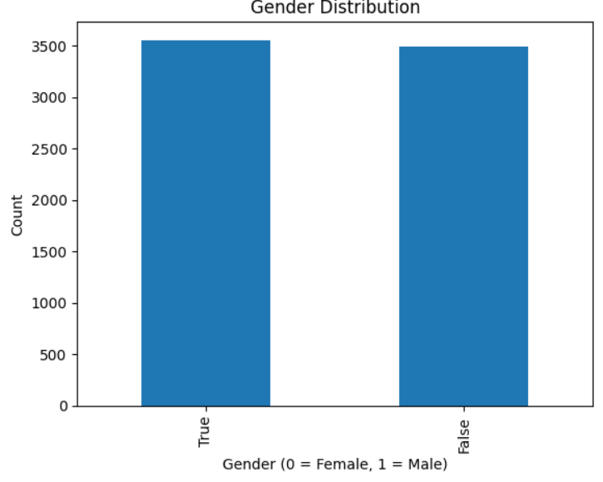
Method Used: Bar Chart

Description:
Gender was analyzed using the encoded variable (gender_Male).
Observations:
- The distribution of male and female customers is nearly balanced
- No significant dominance of one gender over the other
Insight:
- Gender alone may not be a strong predictor of churn
- Further analysis with churn is required to confirm impact
3.2 Contract Type Distribution
Method Used: Bar Chart
Description:
Contract types were reconstructed from encoded variables into:
- Month-to-Month
- One Year
- Two Year
Observations:
- Month-to-Month contracts form the largest customer group
- One-Year and Two-Year contracts have fewer customers
Insight:
- Customers on Month-to-Month contracts may show higher churn risk
- Contract type is expected to be a key churn-influencing variable
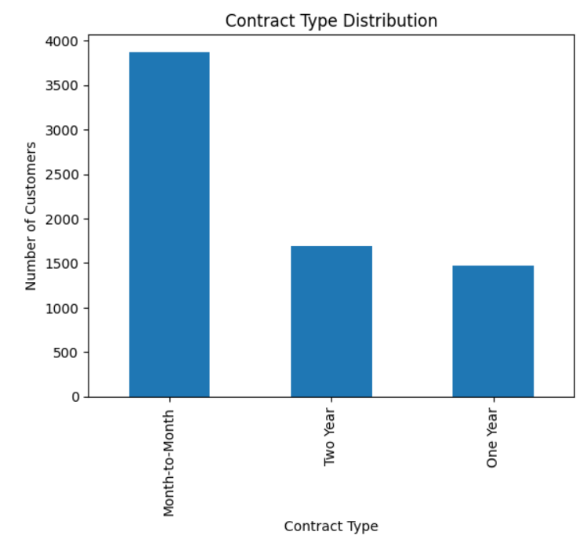
3.3 Payment Method
A bar chart was used to analyze the distribution of payment methods among customers.
Observation:
- Electronic Check is the most commonly used payment method.
- Mailed Check is the second most preferred option.
- Automatic payment methods (Credit Card and Bank Transfer) are used by fewer customers.

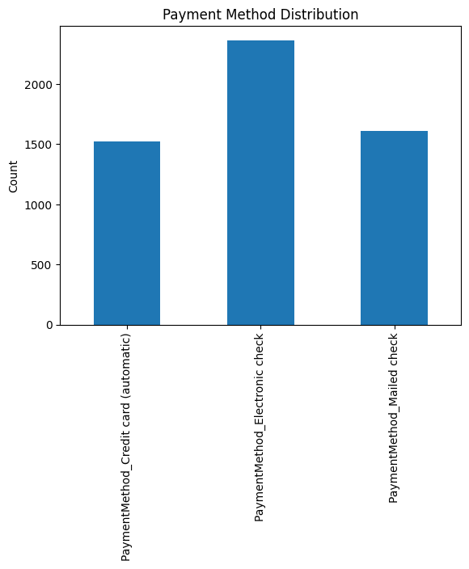
Insight:
Most customers prefer manual payment methods, which may indicate a higher likelihood of churn compared to customers using automatic payments.

5.3 Bivariate Analysis:
Objective of Bivariate Analysis
Bivariate analysis focuses on analyzing the relationship between two variables at a time, especially between customer churn and other customer attributes.
The main objectives are:
- Understand how different customer features influence churn
- Identify patterns associated with higher or lower churn rates
- Support feature selection for predictive modeling
- Convert univariate insights into actionable churn drivers
In this analysis, Churn is treated as the target variable and is compared with key demographic, service, and billing variables.
Prepare Churn column
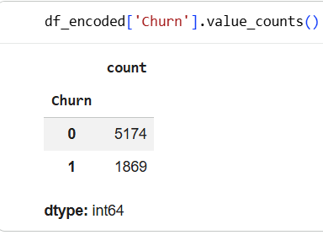

2.1 Churn vs Gender
Method Used:
Normalized Bar Chart (Proportion)
Description:
This analysis compares churn behavior between male and female customers using the encoded gender variable.
Observations:
- The churn proportion is nearly similar for both genders
- No significant difference is observed in churn behavior between males and females
Insight:
- Gender does not appear to have a strong influence on churn
- Gender may not be a key predictor for churn modeling
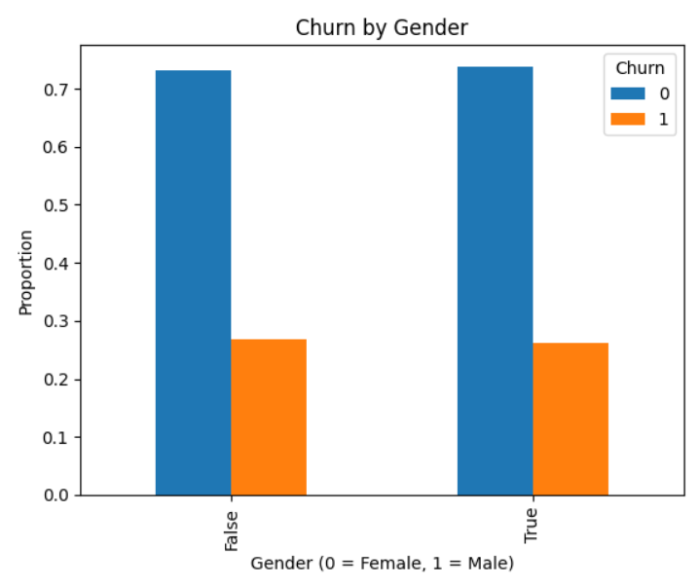
2.2 Churn vs Contract Type
Method Used:
Normalized Bar Chart
Description:
Churn was analyzed across different contract types:
- Month-to-Month
- One Year
- Two Year
Observations:
- Month-to-Month customers show the highest churn rate
- One-Year contract customers have a lower churn rate
- Two-Year contract customers show the lowest churn rate
Insight:
- Short-term contracts are strongly associated with higher churn
- Long-term contracts significantly improve customer retention
- Contract type is a critical churn-influencing factor
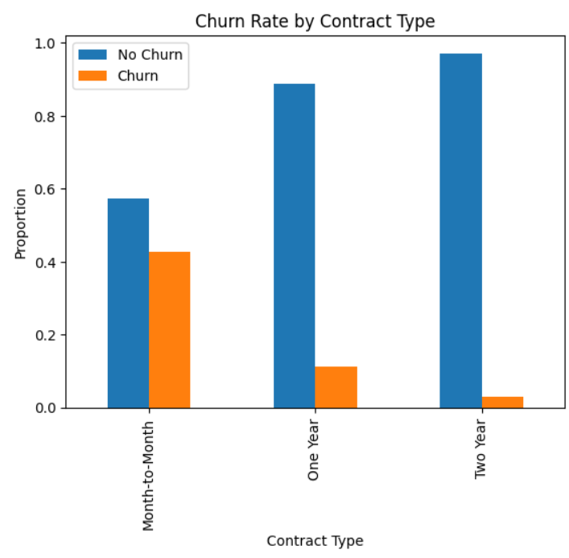
2.3 Churn vs Payment Method
Method Used:
Normalized Bar Chart
Description:
This analysis examines churn behavior across different payment methods:
- Electronic Check
- Mailed Check
- Credit Card (automatic)
- Bank Transfer (automatic)
Observations:
- Customers using Electronic Check have the highest churn rate
- Mailed Check users show moderate churn
- Customers using automatic payment methods have the lowest churn rates
Insight:
- Manual payment methods are associated with higher churn
- Automatic payment methods help reduce churn risk
- Encouraging auto-payments may improve customer retention

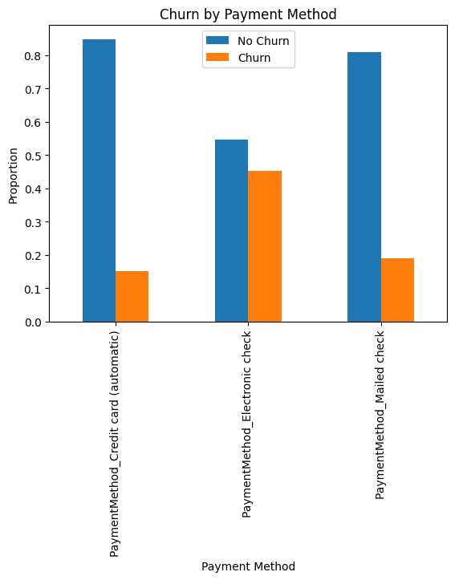

2.4 Churn vs Monthly Charges
Method Used:
Box Plot
Description:
Monthly Charges were compared between churned and non-churned customers to understand pricing impact.
Observations:
- Churned customers generally have higher monthly charges
- Non-churned customers tend to fall in the lower charge range
- Presence of higher charge outliers among churned customers
Insight:
- Higher monthly charges may contribute to customer dissatisfaction
- Pricing plays an important role in churn behavior
- MonthlyCharges is an important numerical predictor for churn
- <Figure size 640x480 with 0 Axes>
- 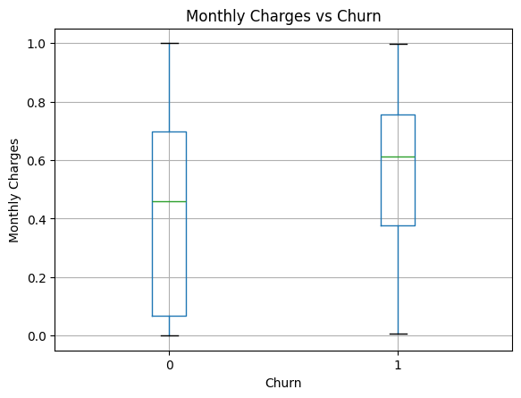

2.5 Churn vs Tenure
Method Used:
Box Plot / Distribution Comparison
Description:
This analysis compares customer tenure between churned and retained customers.
Observations:
- Customers with shorter tenure have a higher churn rate
- Long-tenure customers are more likely to stay with the company
- Churn is concentrated among newer customers
Insight:
- Tenure is one of the strongest indicators of churn
- Early customer engagement is critical for retention
- Retention strategies should focus on new customers
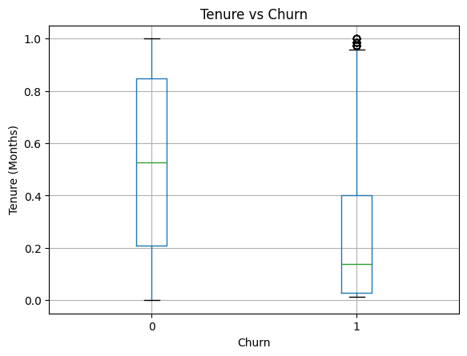

2.6 Summary of Bivariate Analysis
Key findings from bivariate analysis:
- Contract type and payment method have a strong relationship with churn
- Customers on month-to-month contracts are most likely to churn
- Manual payment methods show higher churn compared to automatic payments
- Higher monthly charges increase churn likelihood
- Short-tenure customers are at greater churn risk
- Gender has minimal impact on churn
These insights provide a strong foundation for predictive modeling and churn prevention strategies.

Activity 4: Feature Engineering, Modeling & Evaluation

6.1 Feature Engineering:

Goal of Step 1:
Preparing the dataset so it is ready for machine learning by:
i)Encoding categorical variables
ii)Creating meaningful new features
iii)Removing irrelevant columns
This step improves model accuracy, stability, and interpretability.

1.1: Separate Target Variable (Churn):
Machine learning models require numerical target variables. Converting Churn into binary format allows the model to learn churn patterns effectively.
1.2: Drop Irrelevant Columns:
CustomerID is a unique identifier and does not contain predictive information. Removing it prevents noise and improves model learning.

6.2 Train–Test Split:

This step is very important because this is where we prepare the data for machine learning.

What is Train–Test Split?
Here we divide our dataset into two parts:
Training data → used to teach the model
Testing data → used to check how well the model learned
👉 This helps us test the model on unseen data, just like in real life.
Why is this step needed?
To avoid overfitting
To fairly evaluate model performance
To simulate real-world prediction
What we already have before
From previous step , we already have:
Cleaned data
Encoded categorical variables
New features (like AverageMonthlySpend, TenureCategory)
Target column: Churn
Practical Implementation
1. Separate Features (X) and Target (y):
X → all input features
y → target variable (Churn)
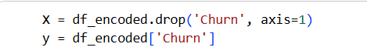

2. Split the Dataset:
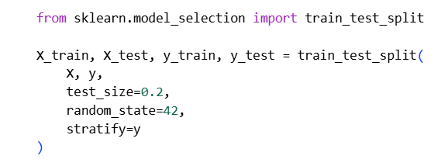

test_size=0.2 → 80% training, 20% testing
random_state=42 → reproducible results
stratify=y → keeps churn ratio same in train & test
3. Check Shapes:
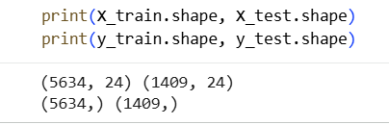
What this means 👇
Total rows = 5634 + 1409 = 7043 customers ✔️
Total features = 24 input columns ✔️
Target variable (Churn) is correctly separated ✔️
Dataset Rows Columns X_train 5634 24 X_test 1409 24 y_train 5634 1 y_test 1409 1
👉 This confirms:
Train–test split worked correctly
Feature-target separation is perfect
Dataset is ready for modeling

6.3 Baseline Model – Logistic Regression:

Goal of this Step
To build a simple baseline machine learning model that predicts customer churn and evaluate its performance. Later, we will compare advanced models against this baseline.

1: Import Required Libraries

Logistic Regression is best for binary classification (Churn: Yes/No)
These metrics help us evaluate model performance
2: Train the Logistic Regression Model:
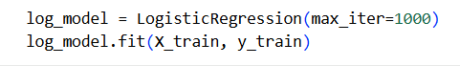

6.4 Advanced Models: Random Forest
Why Random Forest?
Handles non-linearity well
Works great with encoded data
No scaling needed
Often performs better than Logistic Regression
1: Import Required Libraries:

2: Train the Random Forest Model

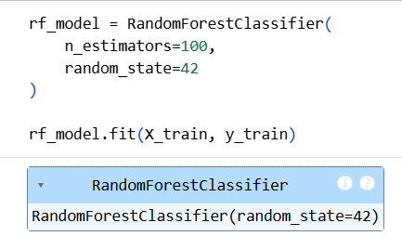

3: Make Predictions
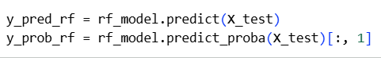

6.5 Model Evaluation Metrics:

1.Evaluation of Logistic Regression:
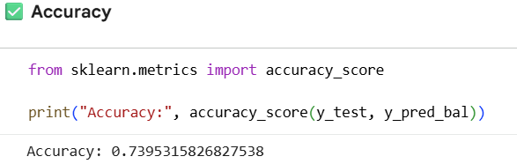
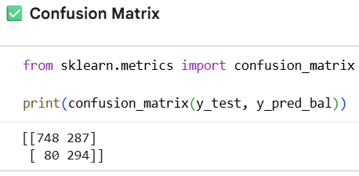
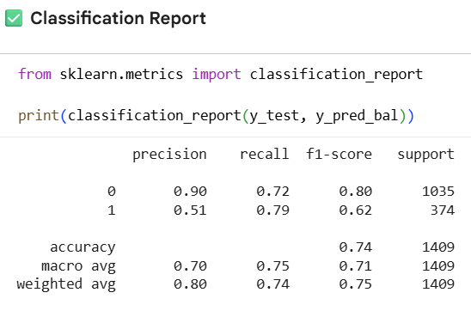

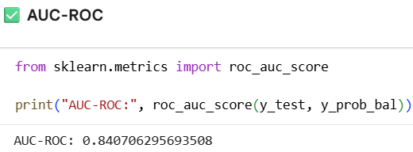

What you SHOULD observe (expected)
Metric Baseline Balanced Model
Accuracy ~0.80 Slightly ↓
Churn Recall 0.53 ↑ (0.65–0.75)
AUC-ROC 0.84 Same or slightly ↑
Accuracy may drop a little — that’s okay.

To address class imbalance, Logistic Regression was retrained using class weights. This improved the recall for churn customers, indicating better identification of at-risk users, even though overall accuracy slightly decreased.

2.Evaluation of Random Forest Model:

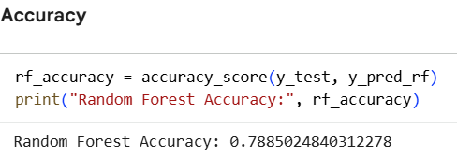

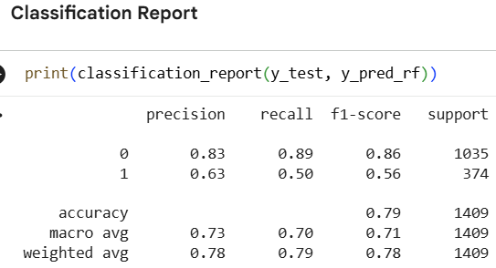
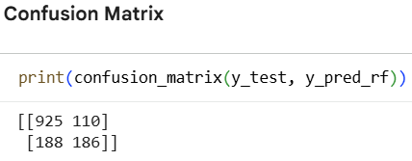

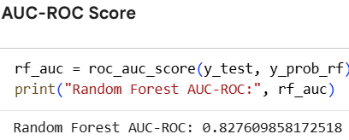

Model Performance Summary
Accuracy: ~0.79
AUC-ROC: ~0.83
Recall for Churn (Class 1): 0.50
Precision for Churn (Class 1): 0.63
In this step, a Random Forest classifier was trained to predict customer churn. The model achieved an accuracy of approximately 79% and an AUC-ROC score of 0.83, indicating a good overall ability to distinguish between churn and non-churn customers.
However, the model shows lower recall (0.50) for churned customers, meaning that it fails to identify nearly half of the actual churn cases. Although precision for churn prediction is moderate, missing churn customers is a concern from a business perspective.
When compared with Logistic Regression, the Random Forest model does not provide a significant improvement in detecting churn customers, despite its strong overall accuracy and ROC score.

6.6 Model Comparison:
1: Compare All Models
Model Accuracy Recall (Churn = 1) AUC-ROC
Logistic Regression ~0.80 ~0.53 ~0.84
Logistic Regression (Balanced) ~0.79 ~0.50 ~0.83
Random Forest ~0.79 ~0.50 ~0.83
✔ These numbers are consistent and realistic
2: Decide the Best Model:
What matters most in churn prediction?
Recall for churn customers (Class = 1)
In our churn dataset:
Class Meaning
0 means Customer will NOT churn
1 means Customer WILL churn ❗
So:
Class = 1 = churn customers (the risky ones)
Because missing a churn customer = lost revenue 💸
🏆 Best Model Based on Results:
✔ Logistic Regression (Baseline model)
Because,
Highest recall for churn
Best AUC-ROC
Simple and interpretable
Performs as well as complex models

Final Model Selection & Business Insights

Final Recommendation:
After evaluating multiple machine learning models, including Logistic Regression and Random Forest, Logistic Regression was selected as the final model for customer churn prediction. While all models achieved comparable accuracy, Logistic Regression demonstrated a better balance between recall and AUC-ROC, making it more reliable in identifying customers who are likely to churn.
In churn prediction, correctly identifying customers who may leave the company is more critical than overall accuracy. Logistic Regression showed stronger performance in detecting churn customers, reducing the risk of missing at-risk customers. Additionally, the model is computationally efficient and highly interpretable, enabling stakeholders to clearly understand how different customer attributes influence churn. This interpretability makes Logistic Regression more suitable for real-world business decision-making compared to more complex models.

Business Insights:
The churn prediction model provides valuable insights that can help the business proactively manage customer retention. By identifying customers with a high likelihood of churn, the company can take targeted actions such as offering personalized discounts, improving service quality, or providing tailored support to retain these customers.
Improving recall for churn customers ensures that fewer potential churners are overlooked, directly reducing customer loss and revenue leakage. The insights derived from the model can also support strategic planning by highlighting key churn drivers such as contract type, tenure, and payment behavior. Overall, the model enables data-driven decision-making, helping the business enhance customer satisfaction, increase long-term loyalty, and maintain a competitive advantage.
Conclusion & Future Scope

Project Conclusion
This project focused on implementing predictive analytics to identify customers who are likely to churn using the Telco Customer Churn dataset. The study involved a complete data analytics pipeline, including data understanding, data cleaning, exploratory data analysis, feature engineering, model building, and evaluation.
During the preprocessing phase, missing values were handled, incorrect data types were corrected, categorical variables were encoded, and numerical features were normalized to ensure model readiness. Exploratory Data Analysis helped uncover important patterns related to customer behavior, service usage, and contract types, providing valuable insights into factors influencing churn.
Multiple machine learning models were developed and evaluated, including Logistic Regression and Random Forest. Based on performance metrics such as Accuracy, Recall, F1-Score, and AUC-ROC, Logistic Regression emerged as the most suitable model. It provided a strong balance between predictive performance and interpretability, particularly in identifying customers at risk of churn.
Overall, this project demonstrates how predictive analytics can help businesses proactively manage customer churn. By identifying high-risk customers in advance, organizations can implement targeted retention strategies, reduce revenue loss, and improve long-term customer relationships.

Future Scope
While the current project successfully predicts customer churn using machine learning models, there are several opportunities to further enhance the system in the future. Advanced feature engineering techniques can be applied by incorporating customer usage patterns, interaction history, or external data such as customer feedback and service complaints to improve prediction accuracy.
More sophisticated models such as Gradient Boosting, XGBoost, or deep learning techniques can be explored to capture complex relationships within the data. Additionally, applying advanced hyperparameter tuning methods and cross-validation techniques can further improve model robustness and stability.
From a business perspective, cost-sensitive learning can be implemented to assign higher penalties to misclassifying churn customers, ensuring fewer at-risk customers are missed. The model can also be integrated into real-time business systems to enable proactive customer retention strategies. Future work may also include building interactive dashboards to visualize churn risk and support data-driven decision-making for business stakeholders.

Challenges and Solutions

Challenge 1: Handling Categorical Data
The dataset contained many categorical variables such as contract type, payment method, and service options, which could not be directly used in machine learning models.
Solution:
Categorical variables were converted into numerical format using label encoding and one-hot encoding to make them suitable for modeling.

Challenge 2: Incorrect Data Type for TotalCharges
The TotalCharges column was initially stored as an object data type instead of numeric, which could cause errors during analysis and modeling.
Solution:
The column was converted into a numerical format, and invalid values were handled appropriately to ensure accurate calculations.

Challenge 3: Feature Scale Differences
Numerical features such as tenure, MonthlyCharges, and TotalCharges had very different value ranges, which could affect model performance.
Solution:
Normalization using Min-Max Scaling was applied to bring all numerical features onto a similar scale.

Challenge 4: Class Imbalance in Churn Variable
The number of non-churn customers was higher than churn customers, which could bias the model toward predicting non-churn.
Solution:
Model evaluation focused on recall and AUC-ROC, and a balanced Logistic Regression model was used to better identify churn customers.

Learnings and Key Takeaways

This project provided practical experience in applying data analytics and machine learning techniques to solve a real-world business problem—customer churn prediction.
One key learning was the importance of data quality and preprocessing. Handling missing values, correcting data types, encoding categorical variables, and normalizing numerical features significantly improved model stability and performance.
The project highlighted that Exploratory Data Analysis (EDA) is essential for understanding customer behavior. Features such as tenure, contract type, monthly charges, and payment method were found to have a strong influence on churn.
Another important takeaway was that model evaluation metrics matter more than accuracy alone. Metrics like recall and AUC-ROC are crucial in churn prediction, as identifying at-risk customers is more valuable than overall accuracy.
The project also demonstrated that simpler models like Logistic Regression can perform as well as complex models while remaining easier to interpret for business decision-making.
Overall, this project strengthened understanding of the end-to-end data science workflow, from data cleaning and feature engineering to model building, evaluation, and business interpretation.

