Meduit FACS MDM
Technical Design Document
Healthcare Revenue Cycle - Data Ingestion and Mastering Platform

Version 0.1 (Draft)
Companion to the Solution Design Document
Classification: Confidential

Document Control

Version History
Version | Date | Author | Summary of change
0.1 | Draft | Technical Architecture | Initial draft

Related Documents
- Meduit FACS MDM Solution Design Document (SDD)
- Healthcare RCM Pipeline Business Requirements Document (BRD)

Architecture Decisions
The architectural decisions that govern this design are stated explicitly below. Each row is the decision; the full context and alternatives are recorded in the corresponding ADR file under docs/adr/.
ADR | Title | Decision
ADR-001 | SFTP Ingestion via Snowpark Task with External Network Access | Poll client SFTP servers from a Snowpark Python task using an external network access integration, instead of a separate file-transfer tool.
ADR-002 | Snowflake-Native Architecture (No External Orchestrator) | Orchestrate the entire pipeline with a native Snowflake Task DAG; no Airflow, Talend, or other external scheduler.
ADR-003 | Cortex AI for Column Mapping and FACS Concept Classification | Use Snowflake Cortex LLMs for column mapping and FACS concept classification rather than hand-maintained rule tables.
ADR-004 | OWL 2 Domain Ontology for Regulatory Compliance Grounding | Model the FACS domain as an OWL 2 ontology (concepts, regulatory tags, an inherited validation floor, synonyms) that grounds AI mapping and compliance.
ADR-005 | PHI-Zero Data Handling Strategy | No patient data values reach Python or LLM prompts; agents see only column names, value shapes, and statistics via UDF_VALUE_TO_SHAPE.
ADR-006 | Streamlit in Snowflake for Platform UI | Build every platform UI as a Streamlit in Snowflake app, inside the Snowflake security boundary.
ADR-007 | SQL-Level Pagination with Aggregation-First Pattern for High-Volume Streamlit Views | Page and aggregate in SQL rather than in Python so high-volume views stay responsive.
ADR-008 | Predict Standards-Driven Rules, Gate Contract-Driven Rules | Auto-apply standards-driven rules by AI prediction; hold contract-driven rules behind an explicit review gate.
ADR-009 | Swappable LLM and Ingest Providers | Place the AI and ingest layers behind a provider port so production runs in-Snowflake Cortex and development runs OpenRouter on synthetic data only. Reserved; maintained on a separate feature branch.
ADR-010 | Declarative Entity Decomposition (Fan-Out) for Multi-Grain Sources | Decompose one source into multiple grain-different MDM entities declaratively through config (CFG_CIF_ENTITY, the branch resolver), with no per-source code.

Table of Contents
Right-click and choose Update Field to build the Table of Contents.

1. Introduction

1.1 Purpose
This Technical Design Document is the build-and-operate reference for the Meduit FACS MDM Cortex platform. The Solution Design Document covers why the Snowflake Cortex AI solution was chosen. This document covers how it is built, structured, packaged, and deployed.

1.2 Scope
- Schema design and per-phase entity-relationship diagrams.
- Stored procedure definitions (21 procedures).
- User-defined function definitions (7 UDFs).
- Cortex AI agent layer.
- Snowflake Task DAG (pipeline orchestration).
- Snowpark packaging (how Python code is deployed to Snowflake).
- Step-by-step Snowflake deployment for first-time and incremental deploys.
- Configuration reference.

1.3 Prerequisites
To build and deploy this platform the following are required:
Requirement | Notes
Python 3.11+ | Required for Snowpark Python stored procedures
Snowflake Business Critical edition | Required for HIPAA BAA
snow CLI (snowflake-cli-labs) | pip install snowflake-cli-labs
Connection profile | ~/.snowflake/config.toml with account, user, authenticator
DEX database | Must exist before schema migrations are applied
Ontology TTL file | ontology/facs-mdm.ttl must be uploaded before first deploy

1.4 Design Principles
Six design criteria run through every part of the platform. Each is stated with the reason it exists (why) and the mechanism that enforces it (how). The rest of the document refers back to these principles.
Principle | Why | How
Deterministic-first | LLM calls are slow and cost credits; most mappings are already known | Five-phase cascade resolves known fields for free; LLM is the last resort (Section 4.2)
PHI-Zero | HIPAA minimum-necessary; limit where patient data can leak | UDF_VALUE_TO_SHAPE masks values before profiling; no PHI in logs or prompts (Section 11)
Idempotency | A re-run must never double-load or corrupt data | RECORD_SOURCE uniqueness; MERGE on business keys everywhere (Section 12.1)
Configuration as data | New clients must not require new code or a deployment | CFG_* tables drive behaviour; onboarding is INSERT rows, not a program (Section 4.1)
Cumulative learning | Per-client cost must fall over time, not stay flat | SME-approved resolutions promote to crosswalk and ontology, shrinking future LLM use
Single Snowflake boundary | One BAA surface; no external system to secure or operate | Tasks, Cortex, Streamlit, and storage all run inside the account (Section 11)
Table 1. Cross-cutting design principles.

2. Codebase Structure
The repository follows a strict separation between entry points and business logic. Handlers (procedures/ and functions/) are thin; all business logic lives in shared/.
Directory | Purpose
schema/ | SQL migrations (V0XX versioned) and seed data (R0XX repeatable)
tasks/ | Snowflake Task SQL files defining the pipeline DAG
procedures/ | Stored procedure entry points (handler.py per procedure)
functions/ | UDF entry points (handler.py per function)
shared/ | Shared business logic library (packaged as snowpark/ in the zip)
cortex/ | Cortex AI agent modules, Jinja2 prompt templates, semantic model
streamlit/ | 11 Streamlit-in-Snowflake applications
ontology/ | OWL 2 Turtle ontology file (facs-mdm.ttl)
tests/unit/ | Unit tests (no Snowflake connection required)
tests/eval/ | Agent quality evaluation harness
config/ | Snowflake connection profiles (no secrets)
docs/ | Architecture documents, ADRs, and generated documents
scripts/ | Operational utility scripts run locally, not deployed
Table 2. Top-level directory purposes.

2.1 Import Path Convention
Business logic in shared/ is imported differently depending on context:
# Local (unit tests, local scripts):
from shared.audit.logger import AuditLogger
# Inside a deployed stored procedure or UDF (inside the snowpark.zip):
from snowpark.audit.logger import AuditLogger
The deploy step renames shared/ to snowpark/ inside the zip. Unit tests use a conftest.py shim that adds the repo root to sys.path so both import paths resolve correctly.

2.2 Shared Library Modules
Module | Responsibility
shared/audit/logger.py | AuditLogger: log_error, log_run_start, log_run_end, log_record_failures_bulk
shared/config/tables.py | Tables constants and fq_table() helper for fully-qualified names
shared/processing/landing_to_stg.py | LANDING to STG with validation, failure routing, bypass queue
shared/processing/stg_to_mdm1.py | STG to MDM1 idempotent MERGE on business key
shared/processing/partition_setup.py | Row count check; decide single-pass or partitioned mode
shared/processing/partition_worker.py | Atomic MERGE claim; per-partition STG load
shared/processing/partition_finalise.py | All-partitions check; credit circuit-breaker
shared/processing/sftp_poll.py | SFTP connect (paramiko); 64 MB chunk streaming; checkpoint/resume
shared/processing/enable_classifier.py | 3-strategy content classifier: record type byte, header fingerprint, value shape
shared/processing/facs_record_split.py | Split raw FACS lines by record type code
shared/processing/facs_field_profile.py | Field position, width, PHI-safe value shape profiling
shared/processing/facs_concept_classify.py | 5-phase concept classification cascade
shared/processing/column_mapper.py | CIF column mapping orchestration
shared/processing/column_map_orchestration.py | Column-map reasoning-loop aggregation; writes CFG_MAPPING_MASTER
shared/registry/ | Config readers for config_master, stg_mapping, transformation, validation
Table 3. Shared library module purposes.

3. Schema Design
The schema is built from 13 versioned migrations and 20 repeatable seed files. Migrations are applied in version order; seeds are re-run on every deploy and use MERGE to remain idempotent. The schema is grouped into seven logical phases.

3.1 Phase 0: Core Config and Audit (V000-V001)
The foundation tables. Config tables (CFG_) define what to do with each client file. Control tables (CTL_) track execution state per run. Audit tables (AUD_) record what happened, insert-only, for HIPAA compliance.
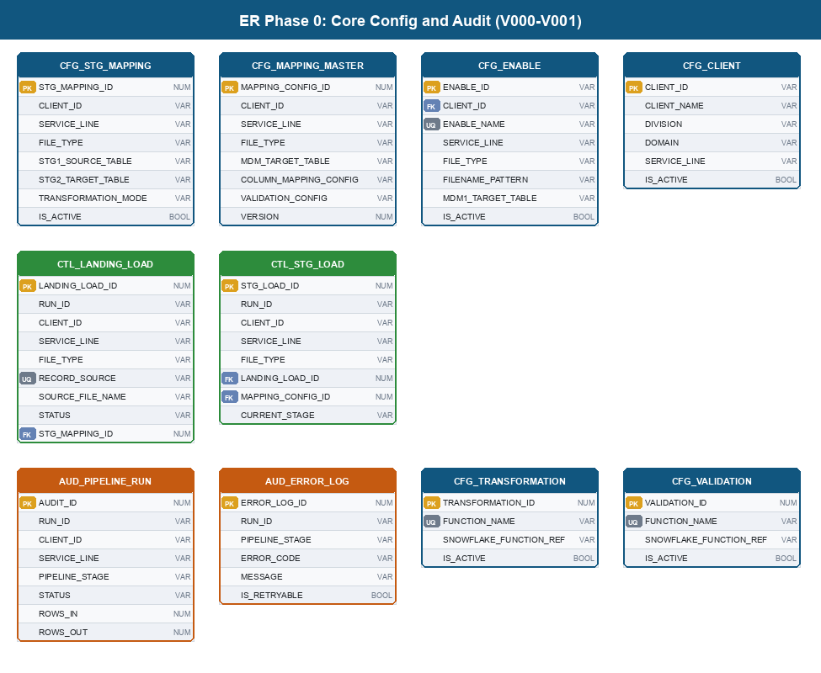
Figure 1. Phase 0 entity-relationship diagram: Core Config and Audit.

3.2 Phase 1: HITL and Ontology (V002-V003)
HITL_TICKET and HITL_TICKET_ITEM form the human review queue. The ONT_ tables materialise the OWL 2 ontology concept hierarchy, regulatory tags, validation rules, and synonyms. AUD_ONTOLOGY_PROMOTION is insert-only so the promotion history cannot be altered.
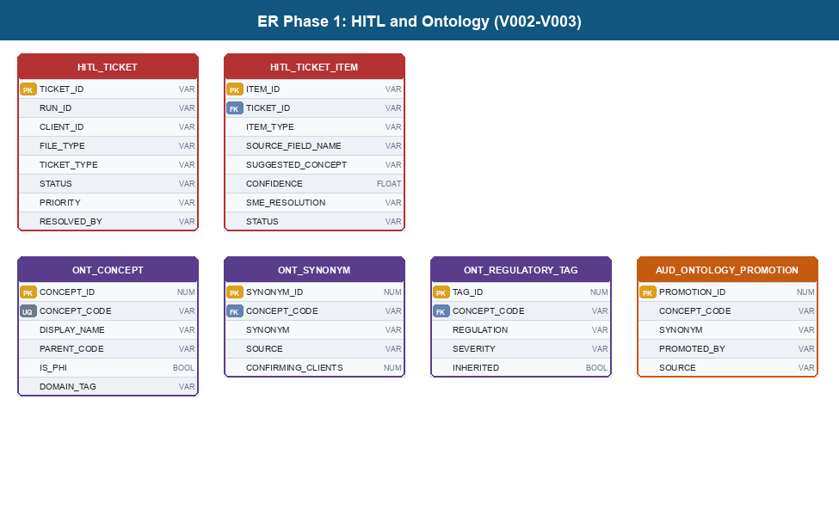
Figure 2. Phase 1 entity-relationship diagram: HITL and Ontology.

3.3 Phase 2: Audit Extensions (V004)
AUD_DECISION_TRACE records the full reasoning trail per pipeline stage, including model name, confidence, and HITL linkage. AUD_PIPELINE_METRICS provides the end-to-end timing waterfall (FILE_RECEIVED_AT through MDM1_COMPLETED_AT) that drives the Pipeline Monitor.
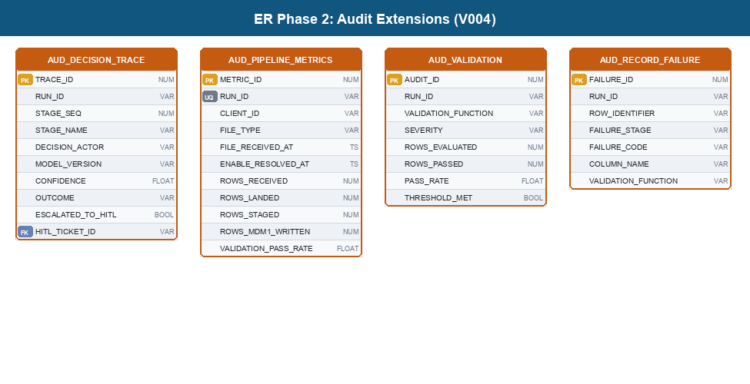
Figure 3. Phase 2 entity-relationship diagram: Audit Extensions.

3.4 Phase 3: Partition Planning and Lifecycle (V005-V006)
CTL_PARTITION_PLAN is the work queue for large-file parallel processing. STAGE_WORKER tasks claim rows atomically using MERGE to prevent duplicate work. V006 adds the four lifecycle stages and the archive path columns to CTL_LANDING_LOAD.
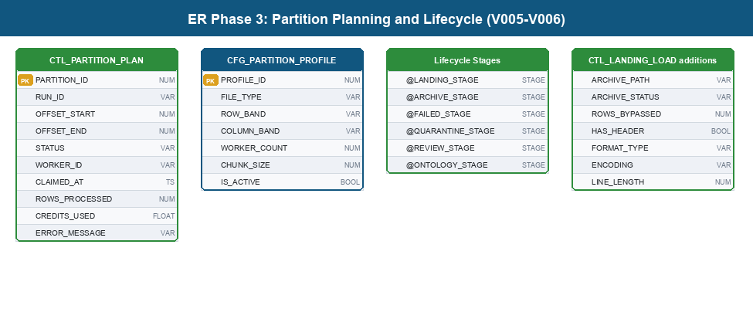
Figure 4. Phase 3 entity-relationship diagram: Partition Planning and Lifecycle.

3.5 Phase 4: Agent State and Archival (V007-V008)
CTL_AGENT_EXEC_STATE stores checkpoint data so long-running Cortex batch calls resume from the last completed chunk after a warehouse restart. CFG_ARCHIVAL_POLICY drives the five archival strategies; AUD_ARCHIVAL_RUN records every execution for accountability.
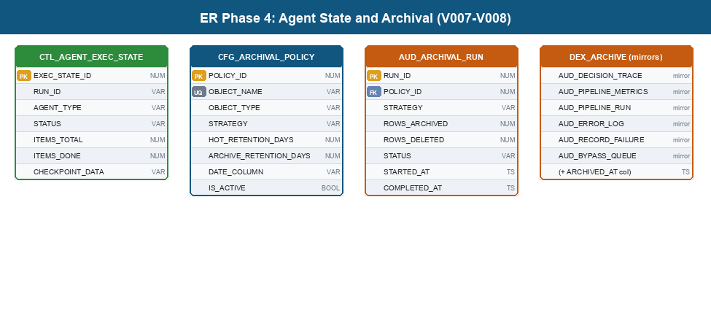
Figure 5. Phase 4 entity-relationship diagram: Agent State and Archival.

3.6 Phase 5: Data Dictionary RAG (V009)
CFG_DATA_DICTIONARY stores chunked client data dictionaries (500-char chunks, 100-char overlap). DATA_DICTIONARY_SEARCH is a Cortex Search Service that indexes the chunks so source_config.py can retrieve relevant context by column name without reading the full document.
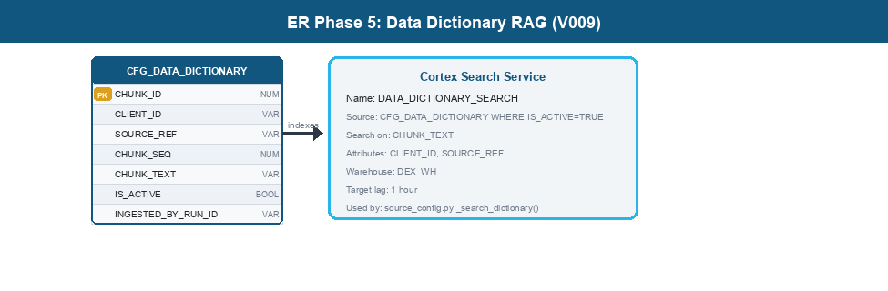
Figure 6. Phase 5 entity-relationship diagram: Data Dictionary RAG.

3.7 Phase 6: FACS Ingestion and Enable Resolution (V010-V013)
The FACS-specific tables. CFG_FILE_LAYOUT_SPEC stores confirmed field positions from prior runs. CFG_RECORD_TYPE_CATALOG routes each record type to its staging table. CFG_FACS_XWALK is the deterministic mapping layer (FACS code to CIF concept) that runs before any LLM call. CTL_LANDING_LOAD gains four new columns for enable resolution results.
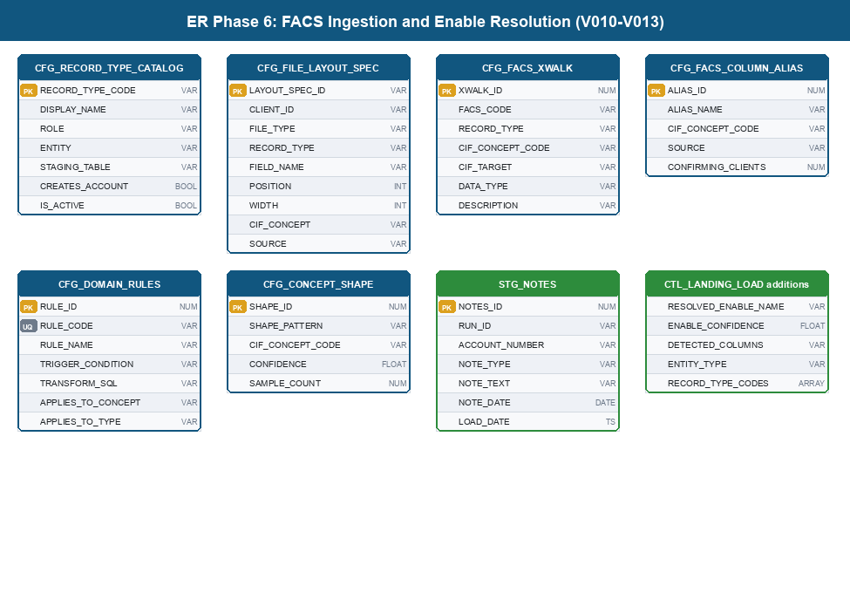
Figure 7. Phase 6 entity-relationship diagram: FACS Ingestion and Enable Resolution.

4. Core Knowledge Artifacts: FACS Enable, Crosswalk, and Ontology
Three knowledge artifacts drive the whole pipeline: the FACS Enable (the client's file blueprint), the FACS crosswalk (the deterministic code-to-concept map), and the OWL ontology (the governance source of truth). This section explains what each one is, shows a real sample, and describes why it exists and how the pipeline translates it into working behaviour.

4.1 FACS Enable (Layout Specification)

What it is
A FACS Enable is the per-client, per-file-type blueprint authored by the Business RCM expert. It defines the file format and embeds two rule families: DMRS clinical rules and DFPS financial rules. Each Enable is unique because every hospital has different insurance contracts and a different mainframe configuration.

Why it matters (the design problem)
In the legacy system a developer hand-coded a job for each Enable, which took 2 to 3 weeks per client and broke whenever a vendor changed a column. The Enable is therefore the single largest source of onboarding cost. The design goal is to consume the Enable as data rather than code, so a new client needs configuration rows, not a new program.

Sample (filter-group rule from an Enable)
A New Business Enable typically contains a guardian-substitution filter. In FACS terms it reads, in effect:
Condition: (DBINCDTE < DBBTHDTE + 6570 days) AND DBRFIRST is blank
Action: set DBRFIRST = 'THE GUARDIAN OF'
set DBRLAST = DBFIRST + ' ' + DBLAST

How it is translated and implemented
Each Enable filter is normalised into a row in CFG_DOMAIN_RULES with a stable rule code, a trigger condition, and a SQL transform. The guardian filter above becomes:
-- CFG_DOMAIN_RULES row R-D-021 (from R014 seed)
RULE_CODE = 'R-D-021'
RULE_NAME = 'Age-Based Guardian Substitution'
TRIGGER_CONDITION = DATEDIFF('year', DBBTHDTE::DATE, DBINCDTE::DATE) < 18
AND (DBRFIRST IS NULL OR
(DBRLAST = DBLAST AND DBRFIRST = DBFIRST))
TRANSFORM_SQL = SET DBRFIRST = 'THE GUARDIAN OF',
DBRLAST = DBFIRST || ' ' || DBLAST
At load time SP_STAGE_LOAD reads the active CFG_DOMAIN_RULES rows for the file type and applies each transform in order. The positional field layout of the Enable (where each field sits in a fixed-width record) is stored in CFG_FILE_LAYOUT_SPEC and reused on every subsequent file from that client, so the layout is learned once and never re-derived.

4.2 FACS Crosswalk (CFG_FACS_XWALK)

What it is
FACS files do not use readable column names; they use proprietary internal codes such as DBCLACCT or TMPSSN1. The crosswalk maps each FACS code to a CIF canonical concept and the target CIF column. It is the deterministic mapping layer that runs before any AI call.

Sample (rows from the R011 seed)
FACS_CODE REC_TYPE CIF_CONCEPT_CODE CIF_TARGET TYPE
DBCLACCT 01 ACCOUNT_NUMBER PATIENT_ACCOUNT_NUMBER CHR
TMPSSN1 01 PATIENT_SSN SSN SSN
TMPSSN2 01 GUARANTOR_SSN GUARANTOR_SSN SSN
DBBTHDTE 01 PATIENT_DOB DATE_OF_BIRTH DATE
DU25615 01 GUARANTOR_DOB GUARANTOR_DOB DATE

Why it matters (the design rationale)
Roughly 200 clients use inconsistent names for the same concept. A rules-only approach does not scale and an LLM-only approach is slow and costly. The crosswalk lets the common, known codes resolve instantly and for free, leaving the LLM to handle only genuinely new or ambiguous fields. This is the deterministic-first principle recorded in ADR-003.

How it is used
SP_FACS_CONCEPT_CLASSIFY runs a five-phase cascade. Phase 1 is a direct CFG_FACS_XWALK lookup by FACS code and record type. A hit resolves the column with no AI call. A miss falls through to phonetic matching, value-shape matching, and finally the Cortex LLM. Every SME-confirmed resolution is written back so the crosswalk grows and the LLM is called less often over time.
Phase | Source | Cost | Resolves
1. Layout fingerprint | CFG_FILE_LAYOUT_SPEC | Free | Known client+file layouts
2. FACS crosswalk | CFG_FACS_XWALK | Free | Known FACS codes
3. Phonetic alias | CFG_FACS_COLUMN_ALIAS | Free | Name variants
4. Value shape | CFG_CONCEPT_SHAPE | Free | Pattern matches (SSN, date)
5. Cortex LLM | SNOWFLAKE.CORTEX.COMPLETE | Credits | New or ambiguous fields
Table 4. The five-phase concept classification cascade.

4.3 Ontology (OWL 2)

What it is
The ontology is the governance source of truth. It is an OWL 2 Turtle file (ontology/facs-mdm.ttl) that defines every CIF concept, its place in the concept hierarchy, its synonyms, and its regulatory tags (HIPAA, FCRA, FDCPA, TCPA).
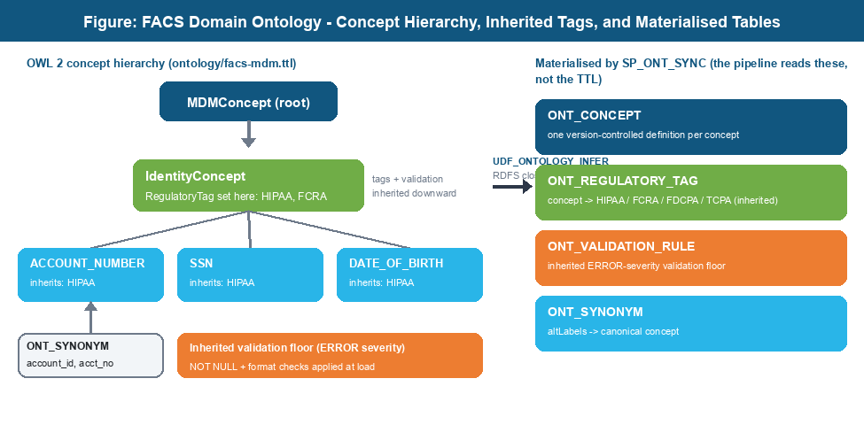
Figure 8. FACS domain ontology: the concept hierarchy, regulatory tags and the validation floor inherited down that hierarchy, and the four tables SP_ONT_SYNC materialises for the pipeline to read.

Sample (a concept definition in the TTL)
mdm:ACCOUNT_NUMBER a owl:Class ;
rdfs:subClassOf mdm:MDMConcept ;
skos:altLabel "account_id" ;
mdm:hasRegulatoryTag mdm:RegulatoryHIPAA .

Why it matters (the design rationale)
Regulatory obligations are field-level and there are hundreds of fields across 200 clients. Tagging each field by hand per client does not scale and drifts out of date. Modelling concepts as a hierarchy means a tag set on a parent concept (for example, that all identity fields are HIPAA PHI) is inherited by every child concept automatically. This is recorded in ADR-004.

How it is implemented
UDF_ONTOLOGY_INFER loads the TTL from the Snowflake stage and computes the RDFS closure (it walks the subClassOf hierarchy and propagates inherited tags). SP_ONT_SYNC calls this UDF for every canonical column and materialises the result into four queryable tables: ONT_CONCEPT, ONT_REGULATORY_TAG, ONT_VALIDATION_RULE, and ONT_SYNONYM. Downstream, the pipeline reads these tables (not the TTL) so a column tagged HIPAA automatically receives the HIPAA validation rules at load time, with no per-client configuration.
The ontology only changes through a controlled promotion path: a candidate is staged in the Ontology Queue app, an SME approves it, an immutable row is written to AUD_ONTOLOGY_PROMOTION, and SP_ONT_SYNC rebuilds the materialised tables. Auto-inferred LLM results are never promoted without SME approval.

4.4 Governance, Trust, and Lineage Learning
The crosswalk and the ontology are not just lookup tables; together they are the governance and trust layer through which every source field must pass before it is mastered. This subsection states how that works at the table level.

Governance enforcement points
Governance is enforced at four concrete points in the data model, not by convention:
Enforcement point | Table | What it guarantees
Concept definition | ONT_CONCEPT | Every canonical field has one version-controlled definition
Regulatory tagging | ONT_REGULATORY_TAG | HIPAA/FCRA/FDCPA/TCPA tags inherit down the hierarchy; drive validation
Concept assignment gate | CFG_FACS_XWALK | A source code can only map to a defined, tagged concept
Approval before use | CFG_MAPPING_MASTER | Rows are PENDING_APPROVAL until an SME confirms them
Table 5. Where governance is enforced in the data model.

Trust mechanisms
Trust comes from explainability. Every mapping decision is recorded in AUD_DECISION_TRACE with the actor (deterministic rule, named Cortex model, or SME), the confidence score, and the alternatives considered. A deterministic crosswalk hit is traceable to a specific approved row; an AI decision below the confidence threshold is held in HITL_TICKET for human approval before it is applied. No field is mapped silently, and because the trace is insert-only a reviewer can always reconstruct why a field was mapped as it was.

The lineage learning loop
The system learns from the lineage of every human decision. The loop has five steps and is what drives the per-client cost toward zero over time:
- First run: a new field is uncertain and is escalated to HITL_TICKET.
- An SME confirms the source code or column name maps to a canonical concept.
- The confirmed mapping is promoted into the knowledge layer: CFG_FACS_XWALK or CFG_FACS_COLUMN_ALIAS for the code/name, ONT_SYNONYM for the concept synonym, and CFG_FILE_LAYOUT_SPEC for the field position.
- An immutable row is written to AUD_ONTOLOGY_PROMOTION recording who promoted what and when (the lineage record).
- Next run: the same field resolves in the deterministic phases (1-4) with no AI call and no human review.
Only SME-confirmed decisions enter this loop. Auto-inferred LLM results are never promoted on their own, which keeps the learned knowledge trustworthy. The net effect is measurable in the AUD_PIPELINE_METRICS HITL counts: they start high for a new client and fall toward zero as the client's layouts become fully learned.

4.4.1 Reuse Safety: predicting for a new client without a spec
Lineage learning makes it possible to bootstrap a new client that arrives without a layout specification. The constraint is that not every rule is safe to predict. Rules are classified by ownership (ADR-008), and the class is recorded so the gate is enforced at load time rather than left to model honesty.
Reuse-safety class | Applies to | Behaviour for a new client
STANDARD | CFG_FACS_XWALK entries; DMRS rules (ACTION_TYPE DMRS_VALIDATE); structural normalisation; layout-fingerprint matches | Predicted from lineage; normal confidence bands and HITL apply
CONTRACT | DFPS financial rules (ACTION_TYPE DFPS_ROUTE, DFPS_CALCULATE) with client-specific parameters | Hard-gated to HITL regardless of model confidence; values never auto-authored
Table 6. Reuse-safety classes and their prediction behaviour.

Implementation: a REUSE_SAFETY column on the rule definition (CFG_DOMAIN_RULES, and by extension the rule classes the parser emits) carries STANDARD or CONTRACT. The load step applies a hard rule: if REUSE_SAFETY = CONTRACT, the rule is written with STATUS = PENDING_APPROVAL and a HITL_TICKET is created even when the model returned high confidence. The confidence score still orders the SME's work queue, but it can never cause a CONTRACT rule to auto-apply. Any rule class that is unclassified or ambiguous defaults to CONTRACT, so the system fails safe toward human review rather than toward silent automation.
This is the technical expression of the shared-library versus contract-config split that established RCM platforms use: the STANDARD layer is the shared library every client inherits; the CONTRACT layer is the per-client configuration a human always validates against the actual agreement.

5. Seed Data Reference
Seed files are repeatable migrations (R prefix). They use MERGE on the primary key so they are safe to re-run on every deploy and will apply any updates to existing rows.
File | Purpose | Key volumes
R001 | CFG_SYSTEM_CONFIG defaults: thresholds, model names, HITL gates | ~20 rows
R002 | CFG_CLIENT: all production healthcare clients | 624 clients
R003 | CFG_TRANSFORMATION: standard transform functions registry | ~15 functions
R004 | CFG_VALIDATION: standard validation functions registry | ~17 functions
R005 | CFG_ENABLE: all SFTP feed routing keys (enables) | 940 enables
R006 | CFG_SFTP: SFTP connection configs (SECRET_NAME references only) | 1018 configs
R007 | CFG_PARTITION_PROFILE: worker/chunk tuning by file type and row band | 18 profiles
R008 | CFG_ARCHIVAL_POLICY: retention rules for 13 objects | 13 policies
R009 | DQ drift detection thresholds per client and file type | varies
R010 | CFG_RECORD_TYPE_CATALOG: FACS record type routing (NB/DI/RI/PI/HI/TI) | 10 types
R011 | CFG_FACS_XWALK: FACS code to CIF concept crosswalk | 71 entries
R012 | CFG_FACS_COLUMN_ALIAS: source column name variants to CIF concepts | varies
R013 | CFG_CONCEPT_SHAPE: value shape patterns for concept classification | varies
R014 | CFG_DOMAIN_RULES: business rules R-D-001 to R-D-023 | 23 rules
R015 | CFG_FILE_LAYOUT_SPEC: BH1PRDR2 confirmed layout spec | per file type
R016 | CFG_CONCEPT_COOCCURRENCE: concept co-occurrence pairs for context | varies
R017 | CFG_STG_MAPPING: landing-to-staging mappings for MCD1/MCD2/MCD3 | 35 rows
R018 | CFG_MAPPING_MASTER: Conifer NB Placement bootstrap config | 1 row
R019 | CFG_MAPPING_MASTER: Conifer MCD2 config with FDCPA fields | 1 row
R020 | CFG_MAPPING_MASTER: Conifer MCD3 config with legal-specific fields | 1 row
Table 7. Seed file reference.

6. Stored Procedure Definitions
The platform has 21 stored procedures. Procedures in group 5.1-5.11 are Python Snowpark (language = Python 3.11). Seven procedures converted to SQL Scripting in V014 are listed where relevant. Every Python procedure is a thin entry point that delegates all logic to shared/processing/.

6.1 File Ingestion

SP_SFTP_POLL
Property | Value
Language | Python Snowpark 3.11
Source file | procedures/sp_sftp_poll/handler.py
Called by | SFTP_POLL_TASK (scheduled every 60 minutes)

Signature
run_sftp_poll(session) -> dict
Connects to all active CFG_SFTP feeds via paramiko, lists remote files, filters new files against CTL_LANDING_LOAD.RECORD_SOURCE, streams each new file to @DEX.LANDING_STAGE in 64 MB chunks with checkpoint/resume via CTL_AGENT_EXEC_STATE, registers a PENDING row in CTL_LANDING_LOAD, then executes FILE_RECEIVE to trigger the pipeline.
Parameter | Type | Description
session | Session | Snowpark session injected by Snowflake runtime
(returns) | DICT | status, files_landed, feeds_checked

Returns | Dependencies
VARIANT (JSON) | Reads CFG_SFTP. Writes CTL_LANDING_LOAD, CTL_AGENT_EXEC_STATE, AUD_PIPELINE_RUN.

6.2 Enable Resolution

SP_ENABLE_CLASSIFY
Property | Value
Language | Python Snowpark 3.11
Source file | procedures/sp_enable_classify/handler.py
Called by | FEED_RESOLVE task (Tier 0 of 3-tier cascade)

Signature
handler(session, run_id: str) -> str
Content-based file entity classification using three strategies in order: record type byte check against CFG_RECORD_TYPE_CATALOG, header column fingerprint against CFG_FACS_XWALK, and value shape scoring against CFG_CONCEPT_SHAPE. PHI-Zero: reads only structural metadata, never patient data values.
Parameter | Type | Description
session | Session | Snowpark session
run_id | VARCHAR | Pipeline run identifier from CTL_LANDING_LOAD

Returns | Dependencies
VARCHAR (JSON: entity_type, confidence, method) | Reads CTL_LANDING_LOAD, CFG_RECORD_TYPE_CATALOG, CFG_FACS_XWALK, CFG_CONCEPT_SHAPE.

6.3 FACS Format and Structure

SP_FACS_RECORD_SPLIT
Property | Value
Language | Python Snowpark 3.11
Source file | procedures/sp_facs_record_split/handler.py
Called by | COLUMN_MAP task

Signature
handler(session, run_id: str) -> str
Splits raw FACS file lines by record type code. Routes type 05 (Notes) to STG_NOTES. Routes structural errors (SHORT_LINE, UNKNOWN_RECORD_TYPE) to AUD_RECORD_FAILURE. Validates trailer count for R99/R98 records.
Returns | Dependencies
VARCHAR (JSON) | Reads/writes CTL_LANDING_LOAD, CFG_* tables.

SP_FACS_FIELD_PROFILE
Property | Value
Language | Python Snowpark 3.11
Source file | procedures/sp_facs_field_profile/handler.py
Called by | COLUMN_MAP task

Signature
handler(session, run_id: str, record_type: str) -> str
Profiles each field in a record-type batch: position, width, null rate, and PHI-safe value shape (#/A/a masking). Fast-path returns from CFG_FILE_LAYOUT_SPEC if a confirmed layout exists for this client and file type.
Returns | Dependencies
VARCHAR (JSON) | Reads/writes CTL_LANDING_LOAD, CFG_* tables.

SP_FACS_CONCEPT_CLASSIFY
Property | Value
Language | Python Snowpark 3.11
Source file | procedures/sp_facs_concept_classify/handler.py
Called by | COLUMN_MAP task

Signature
handler(session, run_id: str) -> str
Five-phase concept classification cascade: layout fingerprint, FACS xwalk lookup, phonetic alias match, value shape pattern match, Cortex LLM. Writes CFG_FILE_LAYOUT_SPEC proposals for confirmed mappings.
Returns | Dependencies
VARCHAR (JSON) | Reads/writes CTL_LANDING_LOAD, CFG_* tables.

6.4 Column Mapping

SP_COLUMN_MAP
Property | Value
Language | Python Snowpark 3.11
Source file | procedures/sp_column_map/handler.py
Called by | COLUMN_MAP task

Signature
handler(session, run_id: str, client_id: str, domain: str, service_line: str) -> str
Orchestrates the COLUMN_MAP stage. Calls the ReAct loop (column_map_orchestrator.py) for each source column, aggregates results, writes CFG_MAPPING_MASTER rows with STATUS=PENDING_APPROVAL, and creates HITL_TICKET + HITL_TICKET_ITEM rows for uncertain columns.
Parameter | Type | Description
run_id | VARCHAR | Pipeline run identifier
client_id | VARCHAR | Client identifier from AUD_PIPELINE_RUN
domain | VARCHAR | Domain tag from CFG_CLIENT
service_line | VARCHAR | MCD tier (mcd1/mcd2/mcd3)

Returns | Dependencies
VARCHAR (JSON: hitl_required, mapped_columns, uncertain_columns) | Reads CFG_CIF_COLUMN, ONT_SYNONYM, CFG_DATA_DICTIONARY (via RAG). Writes CFG_MAPPING_MASTER, HITL_TICKET, AUD_DECISION_TRACE.

6.5 Staging

SP_STAGE_SETUP
Property | Value
Language | Python Snowpark 3.11
Source file | procedures/sp_stage_setup/handler.py
Called by | STAGE_SETUP task

Signature
handler(session, run_id, client_id, service_line, file_type) -> str
Reads row count from the landing table. If below threshold (5M default) returns mode=single_pass. Otherwise inserts CTL_PARTITION_PLAN rows and returns mode=partitioned with the partition count.
Returns | Dependencies
VARCHAR (JSON) | Reads/writes CTL_PARTITION_PLAN, CTL_LANDING_LOAD, STG tables.

SP_STAGE_LOAD
Property | Value
Language | Python Snowpark 3.11
Source file | procedures/sp_stage_load/handler.py
Called by | STAGE_SETUP task (single_pass path)

Signature
handler(session, run_id, client_id, service_line, file_type) -> str
Single-pass landing-to-STG load. Applies transformation and validation rules from CFG_MAPPING_MASTER. Routes validation failures to AUD_RECORD_FAILURE and duplicate account numbers to AUD_BYPASS_QUEUE.
Returns | Dependencies
VARCHAR (JSON) | Reads/writes CTL_PARTITION_PLAN, CTL_LANDING_LOAD, STG tables.

SP_STAGE_WORKER
Property | Value
Language | Python Snowpark 3.11
Source file | procedures/sp_stage_worker/handler.py
Called by | STAGE_WORKER_00 through STAGE_WORKER_31 tasks

Signature
handler(session, run_id, worker_id) -> str
Atomic partition worker. Claims the next PENDING partition from CTL_PARTITION_PLAN via MERGE (prevents duplicate claims). Calls landing_to_stg for the claimed offset range. Self-terminates when no PENDING partitions remain.
Returns | Dependencies
VARCHAR (JSON) | Reads/writes CTL_PARTITION_PLAN, CTL_LANDING_LOAD, STG tables.

SP_STAGE_FINISH
Property | Value
Language | Python Snowpark 3.11
Source file | procedures/sp_stage_finish/handler.py
Called by | STAGE_FINISH task

Signature
handler(session, run_id) -> str
Checks all CTL_PARTITION_PLAN rows are COMPLETED. Retries FAILED partitions up to the configured limit. Enforces the credit circuit-breaker (max_partition_credits_per_run). Returns ok or failed.
Returns | Dependencies
VARCHAR (JSON) | Reads/writes CTL_PARTITION_PLAN, CTL_LANDING_LOAD, STG tables.

6.6 MDM Merge

SP_MDM_MERGE
Property | Value
Language | Python Snowpark 3.11
Source file | procedures/sp_mdm_merge/handler.py
Called by | MDM_MERGE task

Signature
handler(session, run_id: str, ...) -> str
Idempotent MERGE INTO MDM1 target tables using the business key defined in CFG_MAPPING_MASTER. Handles duplicate accounts via AUD_BYPASS_QUEUE. Writes row counts to AUD_PIPELINE_METRICS.
Parameter | Type | Description
run_id | VARCHAR | Pipeline run identifier

Returns | Dependencies
VARCHAR (JSON: rows_merged, rows_bypassed) | Reads CFG_MAPPING_MASTER, STG tables. Writes MDM1 tables, AUD_BYPASS_QUEUE.

6.7 Data Quality

SP_DQ_GATE
Property | Value
Language | Python Snowpark 3.11
Source file | procedures/sp_dq_gate/handler.py
Called by | Called from RUN_CLOSE task

Signature
handler(session) -> str
Two-layer DQ gate. Row reconciliation check: ROWS_RECEIVED must equal ROWS_LANDED + ROWS_REJECTED + ROWS_BYPASSED. Drift detection: compares current run pass rates against the last N historical runs using the dq_drift Cortex agent. ERROR-level findings create a HITL_TICKET.
Returns | Dependencies
VARCHAR (JSON: status, drifted, reconciliation) | Reads AUD_VALIDATION, AUD_PIPELINE_METRICS. Writes HITL_TICKET.

6.8 Ontology and HITL

SP_ONT_SYNC
Property | Value
Language | Python Snowpark 3.11
Source file | procedures/sp_ont_sync/handler.py
Called by | ONT_SYNC task (stream-triggered)

Signature
handler(session) -> str
Truncates and repopulates ONT_CONCEPT, ONT_REGULATORY_TAG, ONT_VALIDATION_RULE, and ONT_SYNONYM by calling UDF_ONTOLOGY_INFER for each canonical column in CFG_CIF_COLUMN.
Returns | Dependencies
VARCHAR | Reads/writes ONT_*, HITL_*, AUD_ONTOLOGY_PROMOTION.

SP_ONT_PROMOTE
Property | Value
Language | Python Snowpark 3.11
Source file | procedures/sp_ont_promote/handler.py
Called by | Streamlit ontology_queue app

Signature
handler(session) -> str
Reads resolved HITL tickets in bulk and extracts synonym candidates using the facs_agent Cortex call. Returns candidates to the Ontology Queue app for SME review before promotion.
Returns | Dependencies
VARCHAR | Reads/writes ONT_*, HITL_*, AUD_ONTOLOGY_PROMOTION.

SP_PROMOTE_SYNONYM
Property | Value
Language | Python Snowpark 3.11
Source file | procedures/sp_promote_synonym/handler.py
Called by | Streamlit ontology_queue app

Signature
handler(session, item_id: str) -> str
Promotes one SME-confirmed HITL_TICKET_ITEM to ONT_SYNONYM with SOURCE=sme_approved. Writes an immutable row to AUD_ONTOLOGY_PROMOTION. Only SME-confirmed resolutions are promoted; auto-inferred LLM results require explicit approval.
Returns | Dependencies
VARCHAR | Reads/writes ONT_*, HITL_*, AUD_ONTOLOGY_PROMOTION.

SP_HITL_SEED
Property | Value
Language | Python Snowpark 3.11
Source file | procedures/sp_hitl_seed/handler.py
Called by | HITL Review Streamlit app

Signature
handler(session, trans_id: str, reviewed_by: str, rationale: str) -> str
Promotes an SME-approved HITL resolution to CFG_DOMAIN_RULES. Applies FDCPA guards: records with MCD tier = mcd2/mcd3 require an explicit legal review flag before promotion.
Returns | Dependencies
VARCHAR | Reads/writes ONT_*, HITL_*, AUD_ONTOLOGY_PROMOTION.

6.9 Data Dictionary

SP_DICT_INGEST
Property | Value
Language | Python Snowpark 3.11
Source file | procedures/sp_dict_ingest/handler.py
Called by | Client Onboarding Streamlit app

Signature
handler(session, client_id: str, doc_text: str, source_ref: str, run_id: str) -> str
Chunks client data dictionary text into overlapping 500-char segments (100-char overlap). Deletes and re-inserts all chunks for this client/source_ref to ensure idempotency. The Cortex Search Service re-indexes within one hour.
Parameter | Type | Description
client_id | VARCHAR | Client identifier
doc_text | VARCHAR | Full data dictionary text
source_ref | VARCHAR | Document title or filename
run_id | VARCHAR | Pipeline run identifier for audit

Returns | Dependencies
VARCHAR (JSON: chunks_written) | Writes CFG_DATA_DICTIONARY.

6.10 Pipeline Control

SP_RUN_RETRY
Property | Value
Language | Python Snowpark 3.11
Source file | procedures/sp_run_retry/handler.py
Called by | Re-run Manager Streamlit app

Signature
handler(session, original_run_id: str, rerun_from: str, reason: str) -> str
Creates a correction run linked to the original via CORRECTION_OF_RUN_ID. Resumes the DAG from the specified stage: COLUMN_MAP, MDM_MERGE, or STAGE_WORKER_N (for a specific partition). Supported rerun_from values: COLUMN_MAP, STG_TO_MDM1, STG_STAGE_N.
Returns | Dependencies
VARCHAR | Reads AUD_PIPELINE_RUN. Creates/updates CTL tables.

SP_CREATE_LANDING_TABLE
Property | Value
Language | Python Snowpark 3.11
Source file | procedures/sp_create_landing_table/handler.py
Called by | CONFIG_SYNC task

Signature
handler(session, client_id: str, file_type: str) -> str
Creates the client-specific landing table in the LANDING schema if it does not exist. Table name follows the pattern LANDING.{CLIENT_ID}_{FILE_TYPE}_STG.
Returns | Dependencies
VARCHAR | Reads AUD_PIPELINE_RUN. Creates/updates CTL tables.

6.11 Archival

SP_ARCHIVAL_MAINTENANCE
Property | Value
Language | Python Snowpark 3.11
Source file | procedures/sp_archival_maintenance/handler.py
Called by | ARCHIVAL_MAINTENANCE task (daily 02:00 UTC)

Signature
handler(session, dry_run: bool = False) -> str
Dispatches all active CFG_ARCHIVAL_POLICY rows to their strategy handler. Five strategies: COPY_TO_ARCHIVE_TABLE (copy rows to DEX_ARCHIVE mirror then delete from hot), TTL_DELETE (delete rows older than threshold), UNLOAD_TO_STAGE (export to Parquet then delete), FILE_EXPIRY (REMOVE files from stage), RETAIN_FOREVER (no-op). Writes one AUD_ARCHIVAL_RUN row per policy per execution.
Parameter | Type | Description
dry_run | BOOLEAN | Count only, no deletes or moves if TRUE

Returns | Dependencies
VARCHAR (JSON: policies_executed, rows_archived, rows_deleted) | Reads CFG_ARCHIVAL_POLICY. Writes AUD_ARCHIVAL_RUN. Deletes from hot AUD tables.

6.12 Fan-Out / Entity Decomposition
A single source file can carry several logical entities at different grains (an account/placement file also holds insurance positions, transactions, and charges). Fan-out shreds one file into multiple normalised MDM entities, loaded parent-before-child, each on its own (composite-capable) business key. The grain, key, and parent FK of each entity are declared once in CFG_CIF_ENTITY; the physical target stays in CFG_MAPPING_MASTER. This is recorded in ADR-010.
Branches are resolved by a layered resolver with precedence OVERRIDE > STRUCTURAL > LINEAGE. STRUCTURAL derives branches from the entities a run produced (record-type split or the single mapped entity); LINEAGE reuses decompositions learned from prior SME confirmations (cross-client via a wildcard client); OVERRIDE is a manual PIN/DISABLE escape hatch (CFG_SOURCE_BRANCH). SP_MDM_MERGE runs the existing run_stg_to_mdm1 engine once per branch in FK order; a single branch with no overrides is byte-for-byte the prior single-target behaviour. A projection child (PROJECT_FROM_PARENT) reads the parent's flat STG source and changes grain via an unpivot DATA_PREP step.
An agent (branch_proposer) proposes child entities from column shape with a confidence. Gating (branch_gating) auto-applies only standards-driven structural grains above the confidence bar and routes contract/financial grains to HITL regardless of confidence - the ADR-008 predict-standards / gate-contracts boundary applied to decomposition. Confirmed decompositions are recorded in CFG_BRANCH_LINEAGE and reused for matching feeds.
Component | Module | Role
Canonical model | schema CFG_CIF_ENTITY | grain, business key, parent FK per entity
Resolver | shared/processing/branch_resolver.py | layered providers -> ordered branches
Fan-out | shared/processing/entity_fanout.py | one merge per branch, FK order
Gate | shared/processing/branch_gating.py | standards auto / contract to HITL
Proposer | cortex/agents/branch_proposer.py | AI child-entity proposals + confidence
Table 8. Fan-out / entity decomposition components.

7. User-Defined Functions
The platform registers seven UDFs. All enforce PHI-Zero.
UDF | Language | Signature | Returns | Notes
UDF_FORMAT_DETECT | Python | detect(header_sample VARCHAR) | VARIANT | Detects delimiter, encoding, format, record type discriminator. Returns format, confidence, quarantine flag, has_header, line_length.
UDF_VALUE_TO_SHAPE | Native SQL (V014) | udf_value_to_shape(v VARCHAR) | VARCHAR | Converts raw value to PHI-safe shape: # for digit, A for uppercase, a for lowercase. PHI never stored in logs.
UDF_EBCDIC_DECODE | JavaScript (V014) | udf_ebcdic_decode(s VARCHAR) | FLOAT | Decodes EBCDIC overpunch last-character encoding to a signed decimal amount.
UDF_ONTOLOGY_INFER | Python + rdflib | infer(canonical_col VARCHAR) | VARIANT | Loads facs-mdm.ttl from @DEX.ONTOLOGY_STAGE, computes RDFS closure. Returns concept_code, regulatory_tags, inherited_validations, known_synonyms.
UDF_MASK_PII | Python | mask(raw_value VARCHAR, column_name VARCHAR) | VARCHAR | Deterministic PII masking by column name pattern. Used in Streamlit to confirm no PHI is displayed.
UDF_VALIDATE | Python | validate(fn VARCHAR, value VARCHAR, params VARIANT) | VARIANT | Dispatches to the named validation function. Returns pass/fail plus error_code if failed.
UDF_TRANSFORM | Python | transform(fn VARCHAR, value VARCHAR, params VARIANT) | VARCHAR | Dispatches to the named transformation function. Returns the transformed value.
Table 9. UDF reference.

UDF_ONTOLOGY_INFER has a cold-start cost on the first invocation per warehouse session because it loads and parses the 200 KB TTL file. Subsequent calls in the same session are fast (file cached in memory).

8. Cortex AI Agent Layer
The Cortex AI layer sits inside the Snowflake boundary. All model calls use SNOWFLAKE.CORTEX.COMPLETE with CompleteOptions to force structured JSON output. PHI-Zero is enforced in every agent: only column names, null rates, cardinality class, and value shape patterns pass to the LLM.

8.1 Agent Modules
Module | Function | Model
col_intel.py | classify_column / classify_batch: MDM identity inference | llama3.3-70b-swiftkv
mapper.py | map_column / map_facs_column: CIF column mapping | llama3.3-70b-swiftkv
facs_agent.py | extract_artifact_metadata; describe_rule (no LLM call) | llama3.3-70b-swiftkv
rule_author.py | nl_to_sql: natural language to SQL; back_translate: SQL to English | claude-haiku-4-5
source_config.py | extract_from_doc / extract_from_doc_rag: mapping hints from data dictionaries | llama3.3-70b-swiftkv
hitl_agent.py | concept_ticket_body / xwalk_ticket_body: pure Jinja2 renders | n/a
dq_drift.py | detect_drift: statistical drift detection against N-run baseline | llama3.3-70b-swiftkv
column_map_orchestrator.py | column-map ReAct loop (max 8 steps) with 4 tools | llama3.3-70b-swiftkv
analyst.py | ask_analyst: Cortex Analyst text-to-SQL for Monitor and RuleStudio | Cortex Analyst API
Table 10. Cortex AI agent modules and models.

8.2 Structured Output Pattern
Every Cortex call uses CompleteOptions to force JSON schema conformance. The response is then validated through a Pydantic model (in _models.py) before any field is accessed. On ValidationError the call degrades to the model default rather than crashing the pipeline.
# Pattern used in every agent (from _context.py):
options = CompleteOptions(
response_format={'type': 'json', 'schema': ModelClass.model_json_schema()}
)
raw = Complete(model, prompt, options=options, session=session)
result = ModelClass.model_validate(json.loads(raw))

8.3 Prompt Templates
Jinja2 templates in cortex/prompts/ render the system and user prompts. All templates have a RESPONSE FORMAT section specifying the exact JSON schema. PHI-Zero is declared in every system prompt.
Template group | Files | Used by
col_intel/ | col_intel_system.j2, col_intel_batch_system.j2 (+ user variants) | col_intel.py
mapping/ | map_column_system.j2 (+ user) | mapper.py
facs/ | facs_concept_system.j2, facs_artifact_extraction.j2, facs_rule_description.j2 | mapper.py, facs_agent.py
hitl/ | hitl_ticket_concept.j2, hitl_ticket_xwalk.j2 | hitl_agent.py
rules/ | rule_author_system.j2, rule_back_translate_user.j2 | rule_author.py
source_config/ | source_config_system.j2 (+ user) | source_config.py
dq/ | dq_drift_system.j2 (+ user) | dq_drift.py
react/ | column-map reasoning-loop system and user prompts | column_map_orchestrator.py

8.4 Agents, Reasoners, and Skills
Each agent module is built from reasoners and skills. A reasoner is a method that calls SNOWFLAKE.CORTEX.COMPLETE; it is the only place an agent spends credits and the only place non-deterministic output enters the system. A skill is deterministic supporting work the agent does without the model: rendering a prompt template, retrieving reference text, looking up a code in a table, or checking a synonym. Keeping reasoners small and pushing work into skills is the deterministic-first principle applied inside the agent.
Agent | Reasoners (call the LLM) | Skills (deterministic support)
col_intel.py | classify_column, classify_batch | template render, batch chunking, rolling context note, checkpoint, decision trace
mapper.py | map_column, map_facs_column | candidate-list assembly, needs_hitl computation, checkpoint, decision trace
facs_agent.py | extract_artifact_metadata | describe_rule (pure template render, no LLM), header truncation
rule_author.py | nl_to_sql, back_translate | template render, retry-prompt construction from HITL feedback
source_config.py | extract_from_doc, extract_from_doc_rag | _search_dictionary (Cortex Search RAG), chunk dedup, truncation
hitl_agent.py | (none - no LLM call) | concept_ticket_body, xwalk_ticket_body (Jinja2 renders only)
dq_drift.py | detect_drift | baseline assembly, offline fallback, severity normalisation
column_map_orchestrator.py | column-map ReAct loop (one LLM call per loop step) | tools: search_dictionary, col_intel, lookup_cif, check_synonym; trace assembly
analyst.py | ask_analyst (Cortex Analyst) | SiS-versus-REST path selection, offline fallback, response parsing
Table 11. Agents with their reasoners and skills.

Why this design exists: the reasoner is the slow, billable, fallible part. By giving each agent rich skills (especially the crosswalk lookup, RAG retrieval, and ontology checks), most inputs are resolved or narrowed before the reasoner runs, and many never reach a reasoner at all. The hitl_agent has no reasoner because ticket bodies are pure template renders; spending a model call there would add cost and risk for no benefit.

8.5 Pydantic Schemas and Strict Typing
Every reasoner returns a typed object, never free text. cortex/agents/_models.py defines one Pydantic model per reasoner output. Each model sets extra fields to be ignored, constrains numeric ranges (confidence is bounded to 0.0-1.0), and carries a description on every field. The description is important: it is emitted into the JSON schema and tells the model what each field means.
# cortex/agents/_models.py - representative model
class ColumnMappingResult(_Base): # _Base sets extra='ignore'
cif_col_id: str = Field(default='UNKNOWN',
description='Exact CIF column id, or UNKNOWN if no confident match')
confidence: float = Field(default=0.0, ge=0.0, le=1.0,
description='0.0-1.0; below 0.5 forces HITL review')
rationale: str = Field(default='parse_failed',
description='One sentence explaining the mapping decision')
The schema is enforced at the model boundary, not just checked afterwards. complete_structured in _context.py passes the model's JSON schema to CompleteOptions so Cortex is constrained to return conforming JSON, then validates the result through the model:
# _context.py - complete_structured (forced-schema path)
options = CompleteOptions(
response_format={'type': 'json', 'schema': cls.model_json_schema()})
raw = Complete(model, prompt, options=options, session=session)
return cls.model_validate(json.loads(raw)) # ValidationError -> safe default
# If the SDK lacks CompleteOptions, it falls back to a tolerant parse that
# strips markdown fences then validates through the same model.
On a ValidationError the agent returns the model's default instance and the case is routed to HITL rather than allowing malformed data to flow downstream. Strict typing is therefore both a correctness control and a safety control.

8.6 Context Window Management
Every Cortex model has a finite context window. cortex/agents/_context.py keeps prompts inside that budget using three strategies, with no hardwired character limits.
- Token estimation: estimate_tokens uses tiktoken when available, otherwise a calibrated characters-per-token ratio per model family. Budgets and ratios are overridable by environment variable so they can be tuned without code change.
- Compaction by summarisation: when a prompt still exceeds the budget, summarize_to_fit calls CORTEX.COMPLETE with a compression prompt that preserves the structured content (concept codes, confidence scores, PHI flags, regulatory tags) and drops only verbose prose. complete() invokes this automatically on overflow and falls back to safe truncation if compaction fails.
- Rolling context across chunks: for batch work, rolling_context_note builds a short summary of results from earlier chunks and injects it into each later chunk's system prompt, so the model reasons across the full column set without re-sending every prior result.
Model | Context budget (tokens) | Use
snowflake-arctic | 8,192 | Enable resolution / routing
llama3.3-70b-swiftkv | 64,000 | Column mapping, classification, drift
claude-haiku-4-5 | 100,000 | Rule authoring, wide or unknown schemas
Table 12. Per-model context budgets (conservative; env-overridable).

Batch reasoners (col_intel, mapper) split their input with chunk_list, default 30 columns per chunk, so each Cortex call stays well inside the budget and the rolling note keeps cross-chunk context cheap.

8.7 State Management and Restart
A Snowflake task has a 15-minute runtime limit and a warehouse can restart. A large batch reasoner must therefore survive interruption without losing or repeating work. State is held in the control table CTL_AGENT_EXEC_STATE and managed by cortex/agents/_state.py.
Column | Purpose
RUN_ID | Pipeline run this checkpoint belongs to
AGENT_TYPE | Which agent (so multiple agents in one run do not collide)
ITEMS_TOTAL / ITEMS_DONE | Progress counters
CHUNK_INDEX | Index of the last completed chunk
CHECKPOINT_DATA | Accumulated results so far, as JSON
Table 13. CTL_AGENT_EXEC_STATE checkpoint columns.

The restart algorithm is straightforward and idempotent:
# Resumable batch loop (col_intel.classify_batch, mapper.map_facs_column)
prior = load_checkpoint(session, run_id, agent_type)
start = prior['chunk_index'] + 1 if prior else 0
results = prior['results'] if prior else []
for i, chunk in enumerate(chunks):
if i < start: # already done in a previous run
continue
results.extend(_classify_chunk(session, chunk, ...))
save_checkpoint(session, run_id, agent_type,
chunk_index=i, results=results)
clear_checkpoint(session, run_id, agent_type) # success: no orphan row
Because save_checkpoint uses MERGE and resume skips completed chunks, re-running the task after an interruption produces exactly the same result as an uninterrupted run. On success clear_checkpoint removes the row so no stale state is left behind. After each completed batch write_decision_trace records one AUD_DECISION_TRACE row with the column count, average confidence, and HITL count (no PHI), giving an auditable trail of what the agent decided.
This is the Cortex equivalent of an external agent control plane: the same resilience and resumability, implemented with one control table and three helper functions inside Snowflake, with nothing external to run or secure.

8.8 Confidence Scoring and HITL Routing
Every reasoner returns a confidence score with its answer, and that score governs what the pipeline does next. The confidence bands are configuration values in CFG_SYSTEM_CONFIG (CORTEX_FACS_CONFIDENCE_AUTO and CORTEX_FACS_CONFIDENCE_SOFT) so they can be tuned without code change. The exact routing is:
Confidence | Outcome | Status written | Routed to
0.85 and above | AUTO_ASSIGN | CFG_MAPPING_MASTER row applied | Continues to STAGE_SETUP
0.65 to 0.84 | SOFT_ASSIGN | NEEDS_VALIDATION = TRUE | Applied, flagged for SME validation
Below 0.65 | ESCALATE | HITL_TICKET (type MAPPING) | REVIEW_GATE, held for SME
Table 14. Column-mapping confidence routing (concept classification).

Two related thresholds use the same principle. Enable resolution (FEED_RESOLVE) auto-resolves at confidence 0.85 and above and raises a HITL_TICKET of type ENABLE_RESOLUTION below it. The column-map ReAct loop sets needs_hitl when its final confidence is below 0.5 or the resolved CIF column is UNKNOWN, regardless of what the model otherwise reported.
Where the score is recorded: every reasoner writes the confidence into AUD_DECISION_TRACE.CONFIDENCE next to the decision, the actor, and the alternatives considered. When a case escalates, the score is also carried on the HITL_TICKET_ITEM so the SME sees how sure the system was before they decide.

Why this matters for governance and HIPAA
For an agentic AI system operating on PHI, the confidence threshold is the control that bounds the AI's autonomy. HIPAA expects automated decisions that affect PHI to follow documented, consistent criteria and to give a human oversight of ambiguous cases. The threshold is that documented criterion, expressed as configuration and enforced in code:
- Bounded autonomy: a PHI-bearing field cannot be mapped automatically on a weak score; below the threshold a qualified SME must approve it before any data is loaded. The AI never silently routes uncertain PHI.
- Documented and consistent: the bands live in CFG_SYSTEM_CONFIG, are version controlled, and apply identically to every client, so the treatment of a given input is reproducible and explainable to an auditor.
- Auditable: because the score, band, actor, and any human resolution are written to the insert-only AUD_DECISION_TRACE, the organisation can demonstrate that every automated PHI decision either cleared the documented bar or was reviewed by a person. This is the evidence a HIPAA audit of an AI system asks for.
The confidence score is therefore what makes the Human-in-the-Loop step a compliance control rather than an optional feature, and it is the same score that, once an SME resolves a low-confidence case, drives the lineage learning loop described in Section 4.4.

9. Task DAG (Pipeline Orchestration)
All pipeline stages are Snowflake Tasks. The main pipeline is a chain of AFTER-triggered tasks. Three tasks run on independent schedules and do not participate in the main chain.
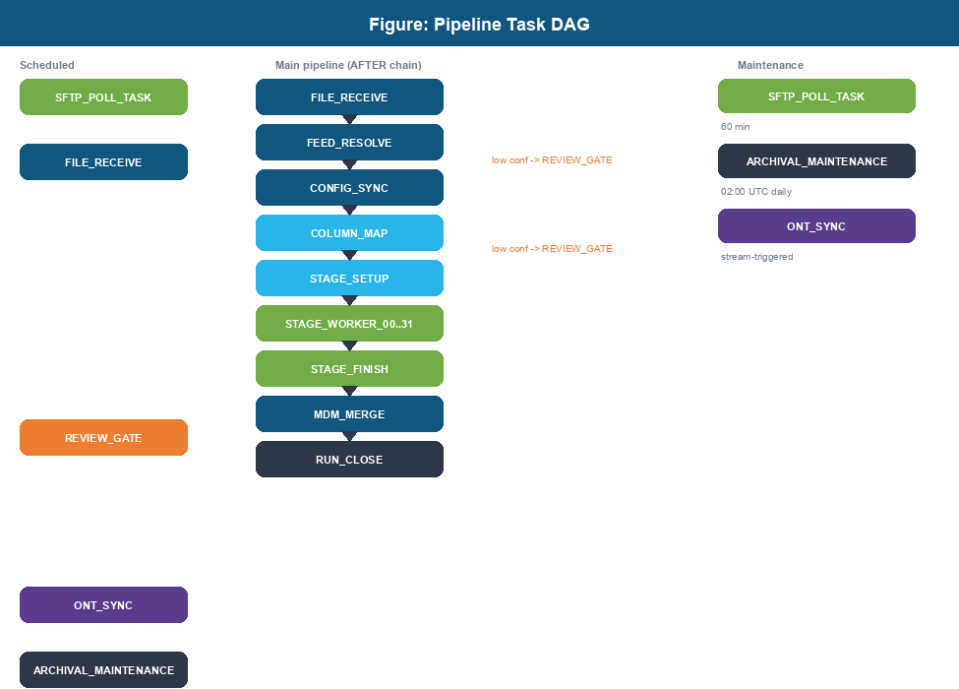
Figure 9. Full pipeline task DAG.
Task | Trigger | Calls SP | Routes to
SFTP_POLL_TASK | 60 min schedule | SP_SFTP_POLL | Executes FILE_RECEIVE per file
FILE_RECEIVE | 1440 min or EXECUTE TASK | UDF_FORMAT_DETECT inline | FEED_RESOLVE
FEED_RESOLVE | AFTER FILE_RECEIVE | SP_ENABLE_CLASSIFY (Tier 0) | CONFIG_SYNC or REVIEW_GATE
CONFIG_SYNC | AFTER FEED_RESOLVE | SP_CREATE_LANDING_TABLE | COLUMN_MAP
COLUMN_MAP | AFTER CONFIG_SYNC | SP_COLUMN_MAP | STAGE_SETUP or REVIEW_GATE
REVIEW_GATE | 5 min schedule | (polls HITL_TICKET) | STAGE_SETUP or CONFIG_SYNC
STAGE_SETUP | AFTER COLUMN_MAP | SP_STAGE_SETUP | SP_STAGE_LOAD (single) or STAGE_WORKER_00..31
STAGE_WORKER_00..31 | Resumed by STAGE_SETUP | SP_STAGE_WORKER | Self-terminates; STAGE_FINISH polls
STAGE_FINISH | AFTER last STAGE_WORKER | SP_STAGE_FINISH | MDM_MERGE
MDM_MERGE | AFTER STAGE_FINISH | SP_MDM_MERGE | RUN_CLOSE
RUN_CLOSE | AFTER MDM_MERGE | SP_DQ_GATE inline | End of run
ONT_SYNC | Stream-triggered | SP_ONT_SYNC | n/a (materialization)
ARCHIVAL_MAINTENANCE | 02:00 UTC daily | SP_ARCHIVAL_MAINTENANCE | n/a (cleanup)
Table 15. Task DAG reference.

9.1 REVIEW_GATE Intercept
REVIEW_GATE is a scheduled task that runs every 5 minutes. It polls HITL_TICKET for the current run's open tickets. When the ticket reaches RESOLVED, it resumes the appropriate downstream task (STAGE_SETUP if the ticket was for column mapping, CONFIG_SYNC if for enable resolution). On 48-hour timeout, it marks the run FAILED and suspends itself.

9.2 STAGE_WORKER Fan-out
STAGE_SETUP inserts partition rows into CTL_PARTITION_PLAN, then resumes all 32 STAGE_WORKER tasks. Each worker loops: claim the next PENDING partition atomically via MERGE, process it, mark COMPLETED. Workers that find no PENDING partitions exit immediately. STAGE_FINISH waits for all partitions to reach COMPLETED before resuming MDM_MERGE.

10. Snowpark Packaging
Snowpark Python stored procedures and UDFs run inside Snowflake. They cannot install packages via pip at runtime; all dependencies must be bundled in the deployment zip or listed in the Snowpark Anaconda channel.

10.1 What Gets Packaged
Source path | In zip as | Contents
shared/ | snowpark/ | All business logic: audit, config, processing, registry
procedures/*/handler.py | procedures/*/handler.py | Entry-point functions only, no business logic
functions/*/handler.py | functions/*/handler.py | UDF handler functions only
cortex/ | cortex/ | Cortex agent modules and prompt templates

10.2 Why the Import Path Changes
When snow snowpark deploy packages the code, it renames shared/ to snowpark/ inside the zip. This means:
# In local unit tests (shared/ is on sys.path):
from shared.audit.logger import AuditLogger
# In a deployed stored procedure (zip is mounted; shared/ -> snowpark/):
from snowpark.audit.logger import AuditLogger
# conftest.py handles this transparently for unit tests.

10.3 Approved Packages
Only packages on the Snowpark Anaconda approved list can be used inside procedures and UDFs. The approved packages used in this project are:
Package | Version | Used in
snowflake-snowpark-python | >=1.19.0 | All procedures and UDFs
paramiko | >=3.4.0 | SP_SFTP_POLL (SFTP connections)
rdflib | >=7.0.0 | UDF_ONTOLOGY_INFER (OWL 2 inference)
jinja2 | >=3.1.0 | Cortex agent prompt templates
pydantic | >=1.10 | Cortex agent output models
chardet | (Anaconda default) | UDF_FORMAT_DETECT (encoding detection)

11. Snowflake Platform Design
This section covers the Snowflake-level design decisions that a platform engineer must understand to operate and size the system: warehouses, task compute, the role model, and data retention.

11.1 Warehouses and Sizing
A single virtual warehouse, DEX_WH, runs the pipeline tasks, the Cortex Search Service refresh, and the Streamlit apps. It is sized X-Small for normal load and configured to auto-suspend quickly to control credit spend. Large-file partitioned runs are the only workload that needs more compute; for those the worker pool benefits from a multi-cluster warehouse so the 32 STAGE_WORKER tasks run concurrently rather than queueing.
Setting | Value | Reason
WAREHOUSE_SIZE | XSMALL (default) | Most files are small; scale up only for large loads
AUTO_SUSPEND | 60 seconds | Tasks are bursty; suspend fast to avoid idle credits
AUTO_RESUME | TRUE | Tasks resume the warehouse on demand
MIN/MAX_CLUSTER_COUNT | 1 / 3 | Multi-cluster absorbs the 32-worker fan-out without queueing
SCALING_POLICY | STANDARD | Add clusters only under sustained concurrency
Table 16. DEX_WH warehouse configuration.

Serverless tasks are an alternative to a warehouse-backed task for the scheduled entry points (SFTP_POLL_TASK, REVIEW_GATE). Serverless compute removes the idle-warehouse concern for low-frequency polling, at a different credit rate. The current design uses DEX_WH for all tasks for simplicity; moving the pollers to serverless is a documented future option.

11.2 Role Model (RBAC)
Access is controlled by four functional roles. PHI-bearing tables are readable only by roles with a clear operational need.
Role | Can do | PHI table access
DEX_ADMIN_ROLE | Deploy, alter tasks, manage secrets, all grants | Full
DEX_ENGINEER_ROLE | Run and re-run pipelines, read audit, edit config | Read STG/MDM1 for triage
DEX_SME_ROLE | Resolve HITL, approve ontology, author rules | No raw PHI; metadata only
DEX_READONLY_ROLE | View dashboards and audit | No PHI
Table 17. Functional role model.

The pipeline tasks run under a dedicated task-owner role with INSERT/UPDATE on control and audit tables and INSERT on STG and MDM1. The task-owner role has no DELETE on audit tables, which enforces the insert-only audit guarantee at the privilege level, not just by convention.

11.3 Data Retention and Time Travel
Retention is set per table via DATA_RETENTION_TIME_IN_DAYS. Audit tables that carry the HIPAA chain use the maximum retention; transient control tables use a short window. Time Travel covers accidental change recovery within the retention window; Fail-safe (7 days, Snowflake-managed) covers disaster recovery beyond that.
Table group | Retention | Rationale
AUD_PIPELINE_RUN, AUD_VALIDATION, AUD_RECORD_FAILURE | 2555 days (7 yr) | HIPAA audit chain
AUD_DECISION_TRACE, AUD_PIPELINE_METRICS | 90 days hot, archived after | High volume; archived to DEX_ARCHIVE
CFG_* config tables | 90 days | Change recovery
CTL_PARTITION_PLAN, CTL_AGENT_EXEC_STATE | 1-7 days | Transient; no long-term value
Table 18. Retention by table group.

12. Security Design
Security is layered: where PHI lives, who can reach it, how it is encrypted, and how access is audited. A key distinction drives the whole design.

12.1 PHI-Bearing Tables versus PHI-Free Metadata
The platform deliberately separates the small set of tables that hold patient data from the larger set that holds only metadata. This separation is what makes the PHI-Zero rule enforceable.
Category | Tables | Protection
PHI-bearing | LANDING.*, STG.*, MDM_1.*, STG_NOTES | Business Critical encryption, RBAC restricted, no values in logs or prompts
PHI-free metadata | AUD_*, CTL_*, CFG_*, ONT_*, HITL_* | Hold surrogate keys, error codes, value shapes, column names only
Table 19. PHI-bearing versus PHI-free tables.

PHI-Zero is the rule that patient values never leave the PHI-bearing tables into code, logs, error messages, audit rows, or LLM prompts. UDF_VALUE_TO_SHAPE converts a raw value to a shape pattern (for example 123-45-6789 becomes ###-##-####) before any value is used for profiling or classification. This is recorded in ADR-005.

12.2 Encryption
- At rest: Snowflake encrypts all data with AES-256 by default. Business Critical edition supports Tri-Secret Secure (customer-managed key) where the BAA requires it.
- In transit: all client connections and internal traffic use TLS 1.2+.
- SFTP egress: paramiko negotiates SSH; credentials come from a Snowflake Secret, never from code or config files.

12.3 Cortex Boundary Controls
Cortex model calls run inside the Snowflake account; prompts do not leave the boundary. Two additional controls apply at the Cortex boundary: AI_REDACT removes any residual PII before a prompt is sent, and Cortex Guard screens model output. Combined with PHI-Zero prompt construction, this gives three independent layers of PHI protection on every model call.

12.4 Access Auditing
Snowflake records every query in ACCESS_HISTORY and every login in LOGIN_HISTORY. Because PHI lives only in the tables listed in 11.1, a compliance reviewer can query ACCESS_HISTORY to see exactly who read a PHI-bearing table and when. The pipeline's own AUD_DECISION_TRACE adds an application-level trail of every automated decision.

12.5 Secrets Management
All credentials are Snowflake Secrets. SFTP credentials are stored in a single aggregated secret (DEX_ALL_SFTP_CREDENTIALS) keyed by client; see the appendix. No credential ever appears in code, config files, task SQL, or logs. The security scan in the check script fails the build if a credential-like literal is detected.

13. Reliability and Error Handling
The pipeline is designed to be safely re-runnable at every stage. This section consolidates the reliability mechanisms that appear across the stored procedures and tasks.

13.1 Idempotency
- File level: CTL_LANDING_LOAD.RECORD_SOURCE (filename + SHA-256) is unique. A file already processed is skipped, so re-running SFTP_POLL never double-loads.
- Staging and MDM: SP_STAGE_LOAD and SP_MDM_MERGE use MERGE on the business key, so re-running a stage produces the same result rather than duplicating rows.
- Config: CONFIG_SYNC uses MERGE on (CLIENT_ID, SERVICE_LINE, FILE_TYPE); seed files use MERGE on their primary key. Re-applying a seed is safe.

13.2 Error Handling
All pipeline errors are written through AuditLogger.log_error with a stable uppercase error_code (for example MISSING_STG_MAPPING) and an is_retryable flag. Messages are ASCII-only and contain no PHI. After logging, the procedure re-raises so the calling Task is marked FAILED and Snowflake task history shows the failure.
Failure type | is_retryable | Handling
Transient (network, warehouse busy) | TRUE | Snowflake task auto-retry; SP_STAGE_FINISH retries failed partitions
Configuration (missing config row) | FALSE | Run marked FAILED; surfaced in Monitor for operator action
Structural (bad file format) | FALSE | File quarantined at FILE_RECEIVE; pipeline stops cleanly
Low confidence (mapping, enable) | n/a | Routed to HITL_TICKET, not an error
Table 20. Error classification and handling.

13.3 Checkpoint and Resume
Long-running operations checkpoint to CTL_AGENT_EXEC_STATE. SP_SFTP_POLL checkpoints after each 64 MB chunk so an interrupted download resumes from the last chunk. Cortex batch classification checkpoints after each column chunk so a 15-minute task timeout does not lose completed work.

13.4 Credit Circuit-Breaker and Reconciliation
SP_STAGE_FINISH sums the credits used across all partitions and aborts the run if it exceeds max_partition_credits_per_run, preventing a runaway large-file job from consuming an unbounded budget. RUN_CLOSE enforces the reconciliation invariant ROWS_RECEIVED = ROWS_LANDED + ROWS_REJECTED + ROWS_BYPASSED and marks the run RECONCILIATION_FAILED if it does not balance.

14. Testing Strategy
Tests run without a live Snowflake connection wherever possible, so the full suite executes in CI in under a second. The Snowpark session is mocked; integration tests that need a real account are marked and skipped in CI.

14.1 Test Layers
Layer | Location | Count | Purpose
Unit | tests/unit/ | 35 files | Processing logic, agents, UDF helpers, routing, with a mocked session
Evaluation | tests/eval/ | 7 files | Cortex agent quality against realistic FACS fixtures (offline recorded, or live Anthropic)
Integration | tests/integration/ | marked | Requires a live Snowflake connection; marked requires_snowflake; skipped in CI
Table 21. Test layers.

14.2 Quality Gate (check script)
Every change must pass scripts/check.sh before commit. The script runs seven checks in order and accepts no partial pass:
Check | Tool | What it catches
Security scan | bandit | Insecure code patterns
Dependency CVEs | pip-audit | Known vulnerable dependencies
Formatting | black | Code style (100-char lines)
Import order | isort | Import grouping
Linting | ruff | Lint rules incl. SQL-injection (S608)
SQL linting | sqlfluff | SQL style and parse errors
Unit tests | pytest | All unit tests green
Table 22. check.sh quality gates.

14.3 Running the Tests
# Full quality gate (run before every commit)
bash scripts/check.sh
# Unit tests only
.venv/bin/python -m pytest tests/unit -v
# Agent evaluation report (offline; no API key needed)
.venv/bin/python tests/eval/report.py
# Agent evaluation against live Claude Haiku (optional)
ANTHROPIC_API_KEY=sk-ant-... .venv/bin/python tests/eval/report.py

14.4 PHI-Zero in Tests
Test fixtures use synthetic data only. Value-shape assertions confirm that profiling and classification operate on shape patterns, not raw values, so the tests themselves never contain or assert on PHI.

15. Snowflake Deployment
This section gives the exact technical steps to deploy the platform. All commands use the snow CLI. Replace -c dev with -c staging or -c prod for other environments.

15.1 Prerequisites
- Install snow CLI: pip install snowflake-cli-labs
- Create a connection profile in ~/.snowflake/config.toml:
[connections.dev]
account = <your_account_identifier>
user = <your_username>
authenticator = externalbrowser # or snowflake for password
warehouse = DEX_WH
database = DEX_DB
schema = DEX
- Create a Python 3.11 virtual environment: python3.11 -m venv .venv
- Install dev dependencies: .venv/bin/pip install -e '.[dev]'
- Confirm Snowflake Business Critical edition (required for HIPAA BAA).

15.2 First-Time Full Deploy
Run the following steps in order. Each is idempotent.
- Create the database and schema:
snow sql -q "CREATE DATABASE IF NOT EXISTS DEX_DB;" -c dev
snow sql -q "USE DATABASE DEX_DB; CREATE SCHEMA IF NOT EXISTS DEX;" -c dev
- Apply versioned schema migrations in order (V000 through V013):
for f in schema/V0*.sql; do
echo "Applying $f ..."
snow sql -f "$f" -c dev
done
- Apply repeatable seed files (R001 through R020):
for f in schema/R0*.sql; do
echo "Applying $f ..."
snow sql -f "$f" -c dev
done
- Upload the OWL 2 ontology file to the internal stage:
snow stage put ontology/facs-mdm.ttl @DEX.ONTOLOGY_STAGE \
--overwrite -c dev
- Deploy Snowpark objects (UDFs and Python stored procedures):
snow snowpark deploy --replace -c dev
- Deploy all Streamlit-in-Snowflake applications (10 apps):
for app in portal hitl dq_review rerun rulestudio monitor \
decision_trace compliance cif_manager ontology_queue; do
snow streamlit deploy --replace \
streamlit/${app}/app.py -c dev
done
- Deploy task SQL files (creates all Tasks in SUSPENDED state):
for f in tasks/*.sql; do
snow sql -f "$f" -c dev
done
- Resume the four scheduled entry-point tasks:
snow sql -c dev -q "
ALTER TASK DEX.SFTP_POLL_TASK RESUME;
ALTER TASK DEX.REVIEW_GATE RESUME;
ALTER TASK DEX.ONT_SYNC RESUME;
ALTER TASK DEX.ARCHIVAL_MAINTENANCE RESUME;
"
- Initialise the ontology tables by running SP_ONT_SYNC once:
snow sql -c dev -q "CALL DEX.SP_ONT_SYNC();"

15.3 Incremental Deploy (Schema Change Only)
- Apply the changed migration file: snow sql -f schema/V013__xxx.sql -c dev
- If handler.py changed: snow snowpark deploy --replace -c dev
- Streamlit app.py changes auto-reload; no redeploy needed.
- Task SQL changes: snow sql -f tasks/changed_task.sql -c dev

15.4 Adding a New Client
- Insert a CFG_CLIENT row (use the Onboarding Streamlit app or direct SQL).
- Insert CFG_SFTP rows (SECRET_NAME must point to an existing Snowflake Secret).
- Insert CFG_ENABLE rows: one per file type the client sends.
- Add new client entries to R017 (CFG_STG_MAPPING) and re-apply the seed.
- Update the DEX_ALL_SFTP_CREDENTIALS secret JSON with the new client key.
- On first file arrival FEED_RESOLVE and COLUMN_MAP auto-generate CFG_MAPPING_MASTER.

15.5 Verification Checklist
After a full deploy, run these SQL checks to confirm the deployment is complete:
-- Schema
SELECT COUNT(*) FROM DEX.CFG_STG_MAPPING; -- expect 35+
SELECT COUNT(*) FROM DEX.CFG_ENABLE; -- expect 940+
SELECT COUNT(*) FROM DEX.CFG_CLIENT; -- expect 624+
-- Objects
SHOW PROCEDURES IN SCHEMA DEX; -- expect 21
SHOW FUNCTIONS IN SCHEMA DEX; -- expect 7
SHOW STREAMLIT IN SCHEMA DEX; -- expect 10
SHOW TASKS IN SCHEMA DEX; -- all STARTED
-- Smoke test (insert a PENDING row then trigger the pipeline)
EXECUTE TASK DEX.FILE_RECEIVE;

16. CI/CD, Environments, and Operations
The operations approach is deliberately minimal and low-cost. There is no external CI server, no container registry, no Kubernetes, and no separate monitoring stack to license or run. The only tools are git, the snow CLI, and Snowflake's own built-in task history, resource monitors, and Time Travel. This keeps the running cost close to zero beyond Snowflake credits and keeps the platform inside the skill set of a SQL-first data engineering team. Every operational capability below is either a free Snowflake feature or a script already in the repository.

16.1 Current State and Continuous Integration
The local quality gate is scripts/check.sh (Section 13.2). GitHub Actions workflows for automated CI on push and gated deploys to staging and production are designed but deferred until the staging and production Snowflake accounts and their secrets are provisioned (Phase 5). Until then, check.sh is the enforced gate and deploys are run manually with snow CLI.

16.2 Environments and Promotion
Environment | Connection | Promotion gate
dev | config/dev.toml | Local check.sh pass
staging | config/staging.toml | Auto-deploy on merge to main (when CI is enabled)
prod | config/prod.toml | Manual approval; tagged release
Table 23. Environment promotion path.

The same migration and seed files deploy to every environment. Connection profiles differ only in account and database, never in logic, so an artifact verified in staging is identical to what reaches production.

16.3 Rollback
Schema migrations are forward-only (Flyway-style V-numbered). There is no automatic down-migration. Rollback options, in order of preference:
- Snowpark and Streamlit objects: re-deploy the previous git tag with snow snowpark deploy --replace; CREATE OR REPLACE restores the prior version.
- Config and seed data: re-apply the previous seed file (MERGE restores the prior values).
- Accidental data change: Snowflake Time Travel (AT/BEFORE) within the table retention window.
- Forward fix: for a bad migration, write a new higher-numbered migration that corrects it rather than editing history.

16.4 Production Monitoring and Alerting
- Task health: SHOW TASKS and TASK_HISTORY show suspended or failed tasks; the Pipeline Monitor app surfaces in-progress and failed runs.
- Run metrics: AUD_PIPELINE_METRICS gives the row-count waterfall and end-to-end duration per run.
- Data quality: the DQ gate raises a HITL_TICKET of type DQ_GATE on any ERROR-level drift or reconciliation failure.
- Credit spend: warehouse credit usage and the per-run credit circuit-breaker bound cost; configure account-level resource monitors with alert thresholds before go-live.
- Errors: AUD_ERROR_LOG holds every sanitized error; a scheduled query or alert can notify on new FAILED runs.

16.5 Backup and Disaster Recovery
- Time Travel: point-in-time recovery within each table's retention window.
- Fail-safe: Snowflake-managed 7-day recovery beyond Time Travel.
- Replication: Business Critical edition supports database replication to a second region for DR; enable per the customer BAA and RTO/RPO requirement.
- The ontology TTL and all code live in git, so the platform definition can be redeployed to a fresh account from source plus the seed data.

17. Configuration Reference
All tunable parameters are stored in CFG_SYSTEM_CONFIG. Update a row to change a threshold without redeploying code:
UPDATE DEX.CFG_SYSTEM_CONFIG
SET CONFIG_VALUE = '0.90'
WHERE CONFIG_KEY = 'enable_resolution_threshold';
Config key | Default | Purpose
large_file_row_threshold | 5000000 | Row count above which partition mode is used
partition_chunk_size | 2000000 | Rows per partition in partitioned mode
max_partition_credits_per_run | 50.0 | Credit circuit-breaker limit per run
enable_resolution_threshold | 0.85 | Arctic confidence below which HITL is raised
cortex_col_intel_model | llama3.3-70b-swiftkv | Model for column identity inference
cortex_mapping_model | llama3.3-70b-swiftkv | Model for CIF column mapping
cortex_rule_author_model | claude-haiku-4-5 | Model for NL-to-SQL rule authoring
react_max_steps | 8 | Maximum ReAct loop iterations per column in COLUMN_MAP
batch_chunk_size | 30 | Columns per Cortex COMPLETE call in batch classification
search_results_per_column | 3 | Cortex Search chunks retrieved per column in RAG
dq_drift_window_runs | 5 | Historical runs used as the drift detection baseline
dq_warning_threshold_pp | 5.0 | Pass-rate drop in percentage points that triggers WARNING
dq_error_threshold_pp | 15.0 | Pass-rate drop that triggers ERROR and HITL ticket
hitl_timeout_hours | 48 | Hours after which REVIEW_GATE marks a run FAILED
Table 24. CFG_SYSTEM_CONFIG keys and defaults.

18. User Interface Screen Specifications
Eleven Streamlit-in-Snowflake apps. This section documents each screen as the target design: layout, controls, where data is fetched from, and where it is stored. PHI-Zero applies throughout - screens show column names, shapes, and aggregate metrics, never patient values. Implementation status (which write procedures are built versus pending) is tracked in docs/IMPLEMENTATION_STATUS_UI.md.

18.1 Portal
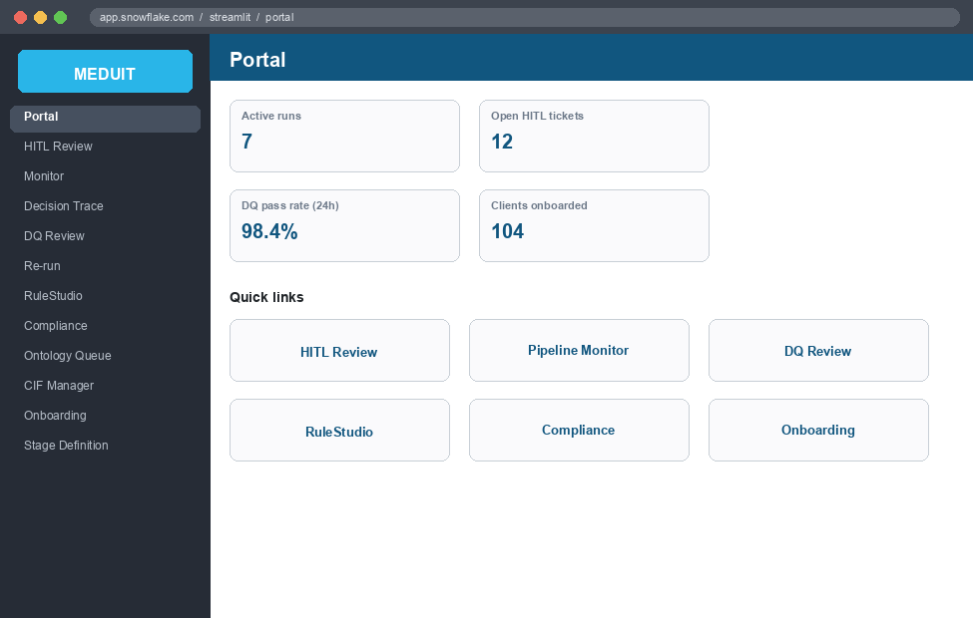
Figure 10. Portal - UI mockup
Central hub. Navigation tiles to every app plus top-line run health.
Screen / Control | Type | Fetches from | Writes via -> table
Navigation tiles | links | - | -
Run health metrics | metric | AUD_PIPELINE_RUN, AUD_PIPELINE_METRICS | -

18.2 Client Onboarding (5-step wizard)
Tabs: Client -> SFTP -> Feeds -> CIF entities -> Dry Run. Each tab unlocks after the previous one submits. A mockup of every step follows. Note (prototype): the polling-period field is not yet on screen, feeds and CIF selection are session-only, and the dry run is mocked - see the status doc.
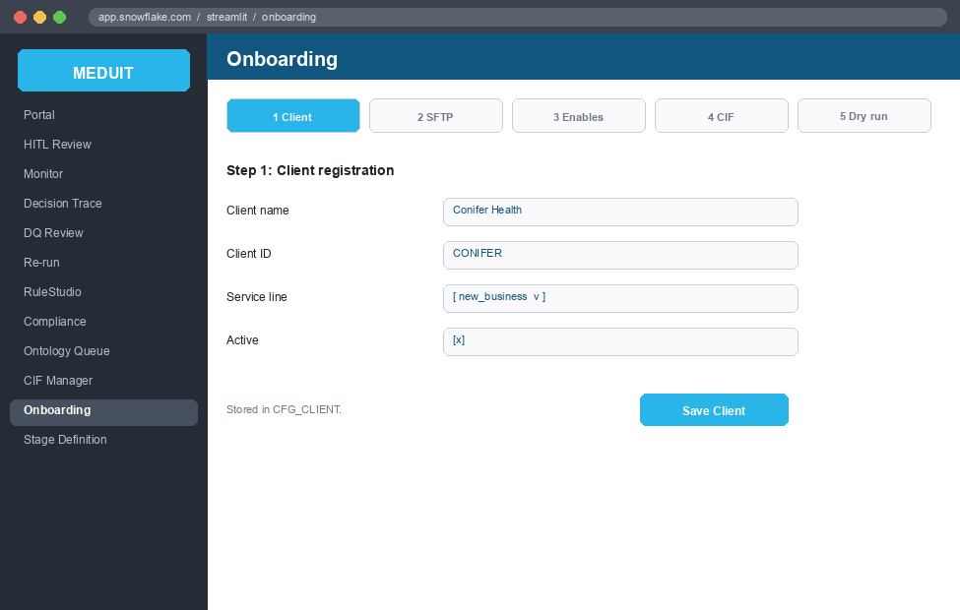
Figure 11. Onboarding Step 1 - Client registration
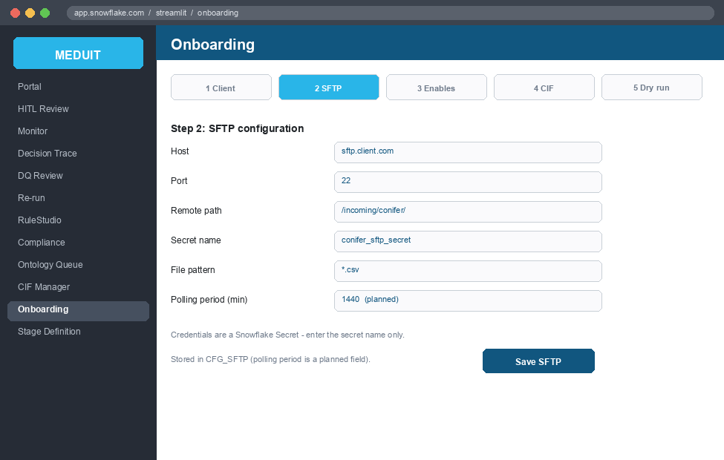
Figure 12. Onboarding Step 2 - SFTP configuration (incl. polling period)
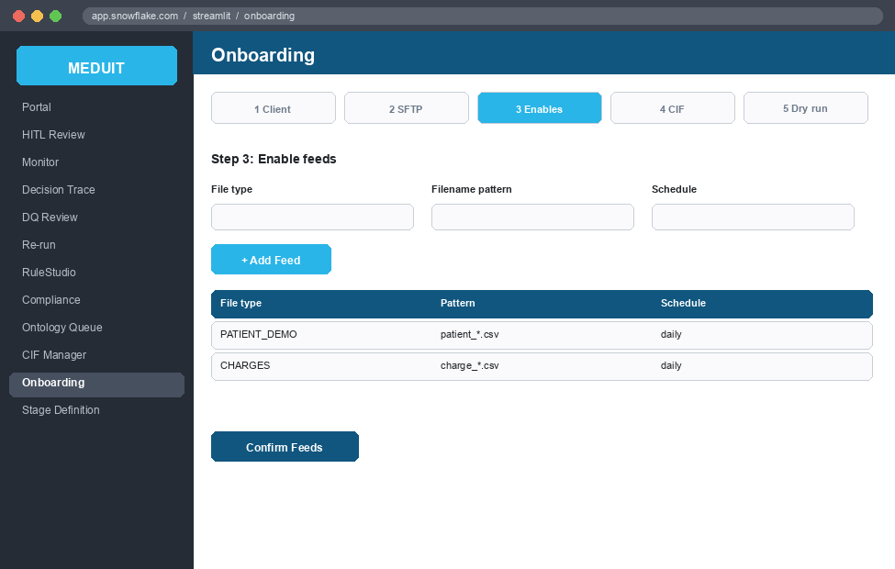
Figure 13. Onboarding Step 3 - Enable feeds
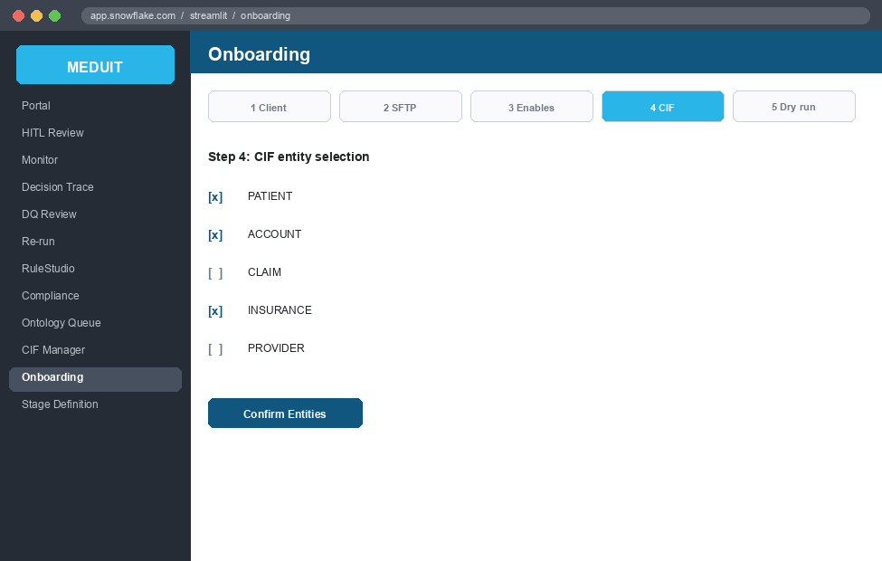
Figure 14. Onboarding Step 4 - CIF entity selection
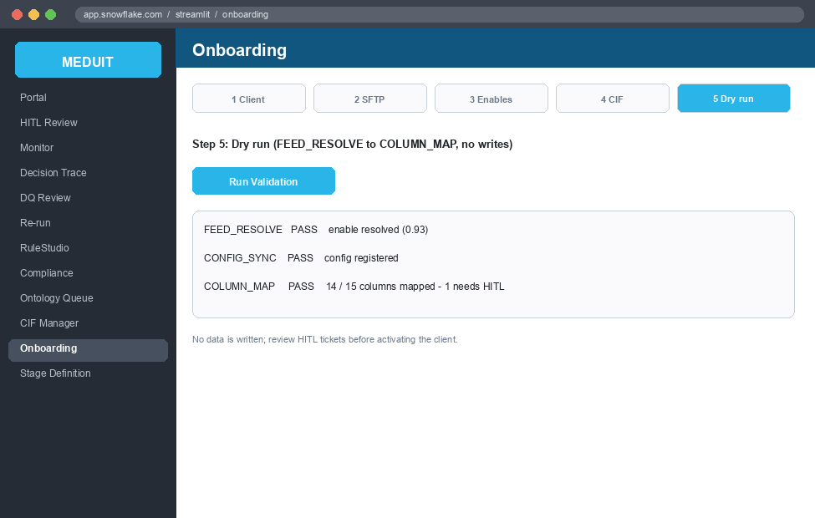
Figure 15. Onboarding Step 5 - Dry run validation
Field-to-storage mapping across the five steps:
Screen / Control | Type | Fetches from | Writes via -> table
Client Name | text | - | SP_REGISTER_CLIENT -> CFG_CLIENT.NAME
Client ID | text | - | CFG_CLIENT.CLIENT_ID
Service Line | select | - | CFG_CLIENT.SERVICE_LINE
Active | checkbox | - | CFG_CLIENT.IS_ACTIVE
Host / Port | text / number | - | SP_REGISTER_SFTP -> CFG_SFTP.HOST / PORT
Remote Path / File Pattern | text | - | CFG_SFTP.REMOTE_PATH / FILE_PATTERN
Secret Name (no password) | text | - | CFG_SFTP.SECRET_NAME (Secret ref)
Polling period (to add) | number | - | CFG_SFTP.POLL_MINUTES (default 1440)
Feeds (type, pattern, schedule) | form | - | CFG_ENABLE (target; session-only now)
CIF entity selection | multiselect | CFG_CIF_COLUMN.ENTITY_TYPE | client-entity (target)
Dry Run | button | - | FEED_RESOLVE -> CONFIG_SYNC -> COLUMN_MAP (no writes)

18.3 HITL Review (4 tabs)
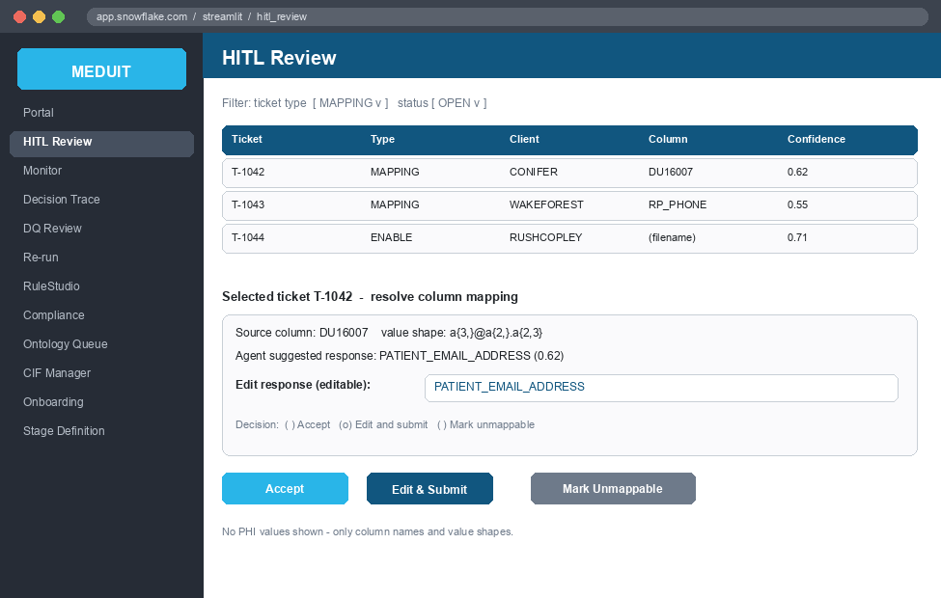
Figure 16. HITL Review - UI mockup
Tabs: Ticket Queue, Mapping Review, Bypass Queue, Enable Resolution.
On Mapping Review the reviewer sees the agent's suggested response and can Accept it, manually EDIT the response (the suggested CIF mapping / value) and submit the corrected version, or mark it unmappable. The edited response - not the original suggestion - is what is persisted to CFG_MAPPING_MASTER, and the correction is fed back to ONT_SYNONYM for reuse. The same edit-then-submit pattern applies wherever a reviewer overrides an agent decision.
Screen / Control | Type | Fetches from | Writes via -> table
Ticket queue list | table | HITL_TICKET (open / in-review) | -
Claim ticket | form | - | SP_HITL_CLAIM_TICKET -> HITL_TICKET.STATUS
Source column stats | read | column stats (no values) | -
Agent suggested response | read | agent suggestion (mapping / value) | -
Edit response and submit | editable text / field | agent suggestion (prefilled) | SP_HITL_SUBMIT_MAPPING -> CFG_MAPPING_MASTER (edited value), ONT_SYNONYM
Decision (Accept/Edit/Unmappable) | radio + text | - | SP_HITL_SUBMIT_MAPPING -> CFG_MAPPING_MASTER, ONT_SYNONYM, HITL_TICKET
Bypass queue + resolution | table + radio | AUD_BYPASS_QUEUE | SP_HITL_BYPASS_RESOLVE
Enable resolution | text + selects | CFG_CLIENT, CFG_ENABLE | SP_CFG_ENABLE_UPSERT -> CFG_ENABLE

18.4 Ontology Queue (3 tabs)
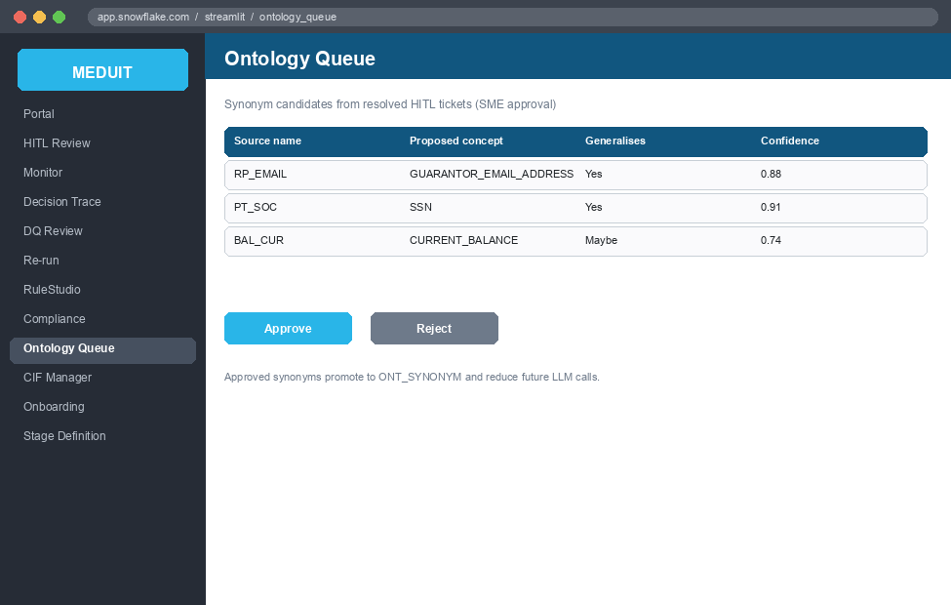
Figure 17. Ontology Queue - UI mockup
Tabs: Pending Review, Approved, Rejected. SME decisions on synonym candidates.
Screen / Control | Type | Fetches from | Writes via -> table
Pending candidates | table | ONT_SYNONYM (pending) | -
Explain | button | - | SP_CORTEX_SYNONYM_EXPLAIN (Cortex)
Decision (Approve/Reject/Edit) | radio + text | - | SP_ONT_SYNONYM_DECISION -> ONT_SYNONYM, AUD_ONTOLOGY_PROMOTION
Approved list | table | ONT_SYNONYM (active) | -
Rejected + reverse | table + form | ONT_SYNONYM (rejected) | SP_ONT_SYNONYM_REVERSE

18.5 Data Quality Review (3 tabs)
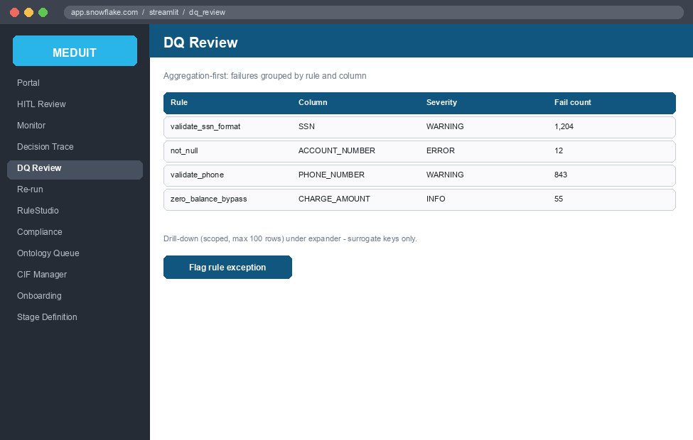
Figure 18. Data Quality Review - UI mockup
Tabs: Summary, Failures, Bypass. Scoped to one run.
Screen / Control | Type | Fetches from | Writes via -> table
Summary + severity | table | AUD_VALIDATION | -
Failures by rule + drill | select + table | AUD_RECORD_FAILURE, AUD_VALIDATION | -
Pre-approve all bypass | button | AUD_BYPASS_QUEUE | SP_BYPASS_BULK_APPROVE
SME decision / reject + re-run | button + select | - | SP_BYPASS_REJECT_RERUN

18.6 Pipeline Monitor (2 tabs)
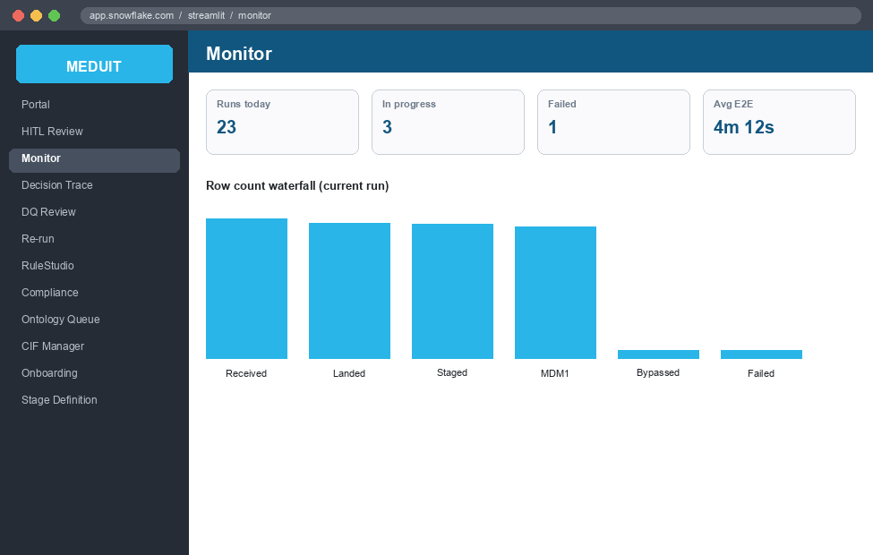
Figure 19. Pipeline Monitor - UI mockup
Tabs: Dashboard, Run Explorer.
Screen / Control | Type | Fetches from | Writes via -> table
Run volume / pass-rate / HITL-rate | charts | AUD_PIPELINE_RUN, AUD_PIPELINE_METRICS | -
Ask a question | text + button | - | Cortex Analyst (read-only)
Run list + details | table | AUD_PIPELINE_RUN | -
Gate timeline | read | AUD_GATE_TIMESTAMPS (to define) | -

18.7 Decision Trace (2 tabs)
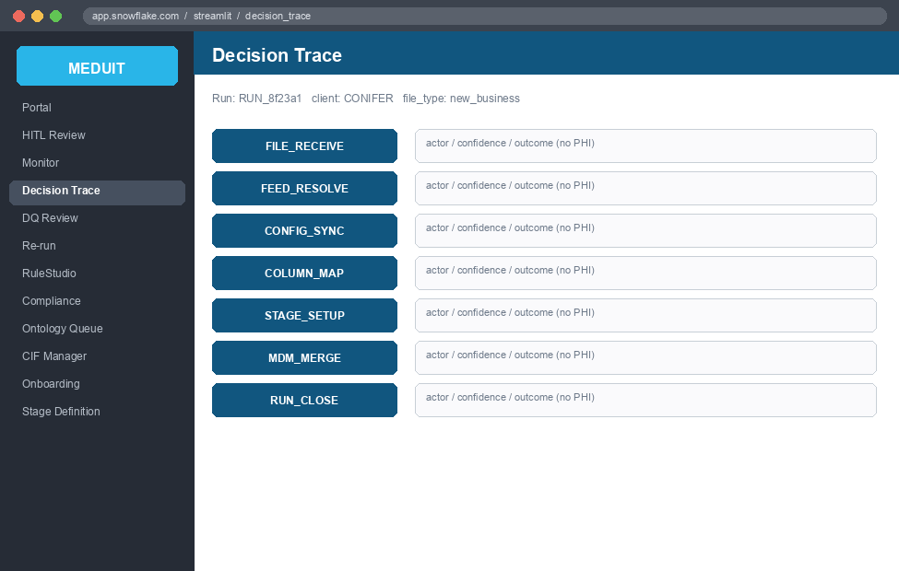
Figure 20. Decision Trace - UI mockup
Tabs: Stage Timeline, Mapping Diff.
Screen / Control | Type | Fetches from | Writes via -> table
Stage timeline + alternatives | expanders + table | AUD_DECISION_TRACE | -
Mapping diff (agent vs SME) | tables | CFG_MAPPING_MASTER + override rows | -

18.8 Re-run Manager (2 tabs)
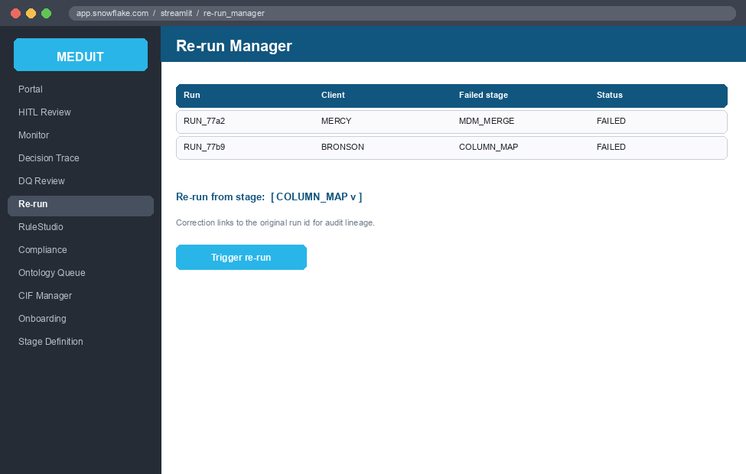
Figure 21. Re-run Manager - UI mockup
Tabs: Run List, Correction History.
Screen / Control | Type | Fetches from | Writes via -> table
Run list | table | AUD_PIPELINE_RUN | -
Trigger re-run (stage, reason) | select + text + button | - | SP_RUN_RETRY -> CTL_*, AUD_PIPELINE_RUN
Correction history | table | AUD_DECISION_TRACE | -

18.9 RuleStudio (Rule Browser, Author, Transform Studio, Ask Analyst)
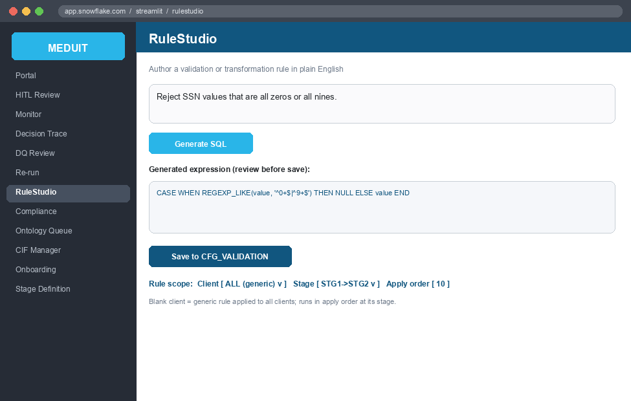
Figure 22. RuleStudio - UI mockup
RuleStudio defines every rule with explicit scope and order. Each rule (validation or transformation) is defined with three dimensions: the CLIENT it applies to, the STAGE transition it runs at (Ingestion -> STG1, STG1 -> STG2, or STG2 -> MDM1), and an APPLY ORDER (sequence number) within that stage.
If no client is selected, the rule is GENERIC and applies to ALL clients. Client-specific rules layer on top of the generic rules. Execution is deterministic: at each stage transition the engine runs the active rules in scope for that client - generic plus client-specific - in ascending apply order.
Screen / Control | Type | Fetches from | Writes via -> table
Rule scope: Client | select (blank = ALL clients) | CFG_CLIENT | rule CLIENT_ID; blank = generic rule for all clients
Rule stage | select: Ingestion->STG1 | STG1->STG2 | STG2->MDM1 | CFG_STAGE | rule STAGE (FK to CFG_STAGE.STAGE_KEY)
Apply order | number | - | rule APPLY_ORDER (ascending within the stage)
Rule browser + toggle active | table + form | CFG_VALIDATION, CFG_CLIENT_VALIDATION_EXCEPTIONS | SP_UPDATE_RULE_ACTIVE -> CFG_VALIDATION
Generate rule SQL (NL) | text + selects | - | SP_CORTEX_GENERATE_RULE_SQL (rule_author)
Back-translate SQL | button | - | SP_CORTEX_BACK_TRANSLATE_SQL
Save rule | text + button | - | SP_INSERT_CFG_VALIDATION -> CFG_VALIDATION
Add validation exception | form | - | SP_ADD_VALIDATION_EXCEPTION -> CFG_CLIENT_VALIDATION_EXCEPTIONS
Transform studio detect + apply | text + button | - | SP_UPSERT_DATA_PREP_CONFIG -> CFG_MAPPING_MASTER.DATA_PREP_CONFIG
Ask Analyst | text + button | - | Cortex Analyst (read-only)

18.10 CIF Manager
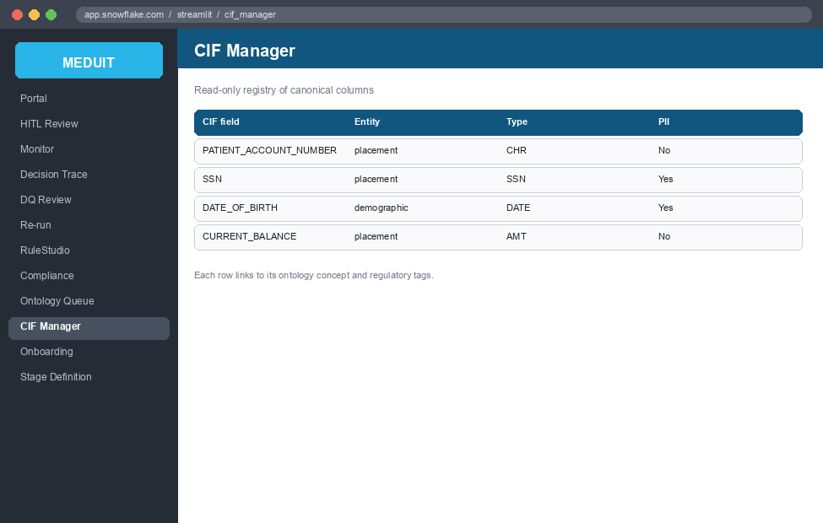
Figure 23. CIF Manager - UI mockup
Canonical column registry browser (read-only).
Screen / Control | Type | Fetches from | Writes via -> table
Column registry grid | table | CFG_CIF_COLUMN | -
Column detail | expander | CFG_CIF_COLUMN | -

18.11 Compliance (3 tabs)
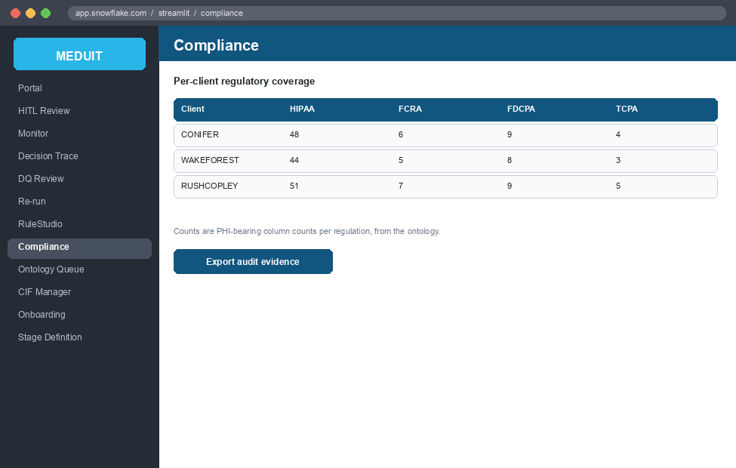
Figure 24. Compliance - UI mockup
Tabs: Regulatory Coverage, Ontology Browser, Synonym Log (read-only).
Screen / Control | Type | Fetches from | Writes via -> table
Regulatory coverage | table | CFG_MAPPING_MASTER + ONT_REGULATORY_TAG + CFG_CIF_COLUMN | -
Ontology browser + detail | table | ONT_CONCEPT, ONT_VALIDATION_RULE, ONT_SYNONYM, ONT_REGULATORY_TAG | -
Synonym log | table | AUD_ONTOLOGY_PROMOTION | -

18.12 Stage Definition (Stage Manager)
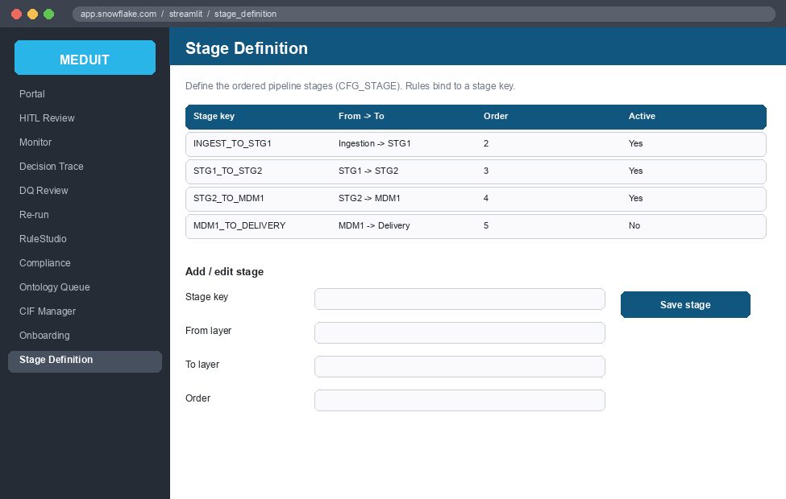
Figure 25. Stage Definition - UI mockup
Stages are first-class and defined here, not hard-coded. The Stage Definition screen manages the ordered pipeline stage transitions that rules (RuleStudio) and the engine reference. Each stage has a key, a from-layer and to-layer, an order, and an active flag, and is stored in CFG_STAGE. RuleStudio's stage selector and the engine both read CFG_STAGE, so adding or reordering a stage is configuration, not code.
Stage key | From -> To | Order | Purpose
SFTP_TO_INGEST | SFTP -> Ingestion | 1 | Land file; detect format; split records
INGEST_TO_STG1 | Ingestion -> STG1 | 2 | Map source columns to canonical; build STG1
STG1_TO_STG2 | STG1 -> STG2 | 3 | Type, clean, transform, validate
STG2_TO_MDM1 | STG2 -> MDM1 | 4 | Fan-out merge into MDM1 entities
MDM1_TO_DELIVERY | MDM1 -> Delivery | 5 | Outbound files (e.g. FACS 980) - planned
Table 25. Stage catalog (CFG_STAGE) - the ordered stage transitions.

Screen / Control | Type | Fetches from | Writes via -> table
Stage list | table | CFG_STAGE | -
Stage key | text | - | CFG_STAGE.STAGE_KEY
From layer / To layer | select | - | CFG_STAGE.FROM_LAYER / TO_LAYER
Order | number | - | CFG_STAGE.STAGE_ORDER
Active | checkbox | - | CFG_STAGE.IS_ACTIVE
Save stage | button | - | SP_UPSERT_STAGE -> CFG_STAGE

19. Stored Procedure Algorithms
Step-by-step logic of the main pipeline procedures, in run order.

SP_SFTP_POLL
1. Read active feeds from CFG_SFTP.
2. For each feed, open the transport and list files matching FILE_PATTERN.
3. Skip files already in CTL_LANDING_LOAD (RECORD_SOURCE dedup).
4. Stream each new file to @DEX.LANDING_STAGE in 64 MB chunks, checkpointing to CTL_AGENT_EXEC_STATE after each chunk (resume on restart).
5. Insert a PENDING row into CTL_LANDING_LOAD and resume FILE_RECEIVE.

SP_ENABLE_CLASSIFY (FEED_RESOLVE Tier 0/1)
1. Pick the next IN_PROGRESS file from CTL_LANDING_LOAD.
2. Tier 0: classify entity type from content (record codes, columns, shapes). Zero LLM cost.
3. If one enable matches, auto-resolve; else build a candidate list.
4. Tier 1: an LLM matches the filename to the best enable with a confidence score.
5. If confidence >= threshold, set RESOLVED_ENABLE_NAME; else raise a HITL ticket.
6. Write each decision to AUD_DECISION_TRACE.

SP_FACS_RECORD_SPLIT
1. Load raw lines from CTL_AGENT_EXEC_STATE for the run.
2. Isolate structural errors (short line, bad encoding, unknown record type) to AUD_RECORD_FAILURE.
3. For fixed-width multi: split by the record-type code; look up ROLE/ENTITY in CFG_RECORD_TYPE_CATALOG; store one sample batch per data record type.
4. For single-entity files: store one SINGLE batch (extract header if present).
5. Update AUD_PIPELINE_METRICS with landed and rejected counts.

SP_COLUMN_MAP
1. Read source columns and structural stats (PHI-Zero).
2. Run the ReAct agent: at each step call a tool (search_dictionary, col_intel, lookup_cif, check_synonym) or FINISH with a mapping.
3. Assign confidence; AUTO (>=0.85) writes CFG_MAPPING_MASTER, SOFT flags for validation, HITL (<0.65 or UNKNOWN) raises a ticket via REVIEW_GATE.
4. Run the transform planner across the column set (CONCAT/COALESCE/CAST/UNPIVOT).
5. Route to STAGE_SETUP or REVIEW_GATE.

SP_STAGE_SETUP / SP_STAGE_WORKER / SP_STAGE_LOAD
1. STAGE_SETUP: read row count; if below threshold run single-pass, else build a CTL_PARTITION_PLAN and fan to the STAGE_WORKER pool.
2. Each worker/loader applies data-prep, joins, column mapping, transforms, and validations to write the STG2 table.
3. STAGE_FINISH finalizes counts in CTL_STG_LOAD and resumes MDM_MERGE.

SP_DQ_GATE
1. Aggregate validation results for the run from AUD_VALIDATION.
2. Compare pass rates to the recent baseline (dq_drift agent) and flag drift.
3. Pass, warn, or hold the run for review based on thresholds.

SP_MDM_MERGE (fan-out)
1. Resolve the branch set for the run (structural / lineage / override), parent before child.
2. For each branch, run the STG2->MDM1 engine with the entity's (composite) business key.
3. MERGE idempotently into the MDM1 target; divert duplicate keys to AUD_BYPASS_QUEUE.
4. Record per-branch provenance and counts; resume RUN_CLOSE.

SP_ONT_SYNC / SP_PROMOTE_SYNONYM
1. ONT_SYNC materializes ONT_CONCEPT, ONT_REGULATORY_TAG, ONT_VALIDATION_RULE from facs-mdm.ttl.
2. PROMOTE_SYNONYM writes an SME-approved synonym to ONT_SYNONYM and logs it to AUD_ONTOLOGY_PROMOTION (insert-only).

SP_ARCHIVAL_MAINTENANCE / SP_RUN_RETRY
1. ARCHIVAL_MAINTENANCE applies each active CFG_ARCHIVAL_POLICY strategy and writes AUD_ARCHIVAL_RUN.
2. RUN_RETRY re-runs a failed run from a chosen stage, preserving the audit trail.

20. Data Dictionary
Tables by family. Key columns and notes; full DDL is in schema/.

20.1 CFG (configuration)
Table | Purpose and key columns
CFG_CLIENT | Client registry; CLIENT_ID, NAME, SERVICE_LINE, IS_ACTIVE
CFG_STAGE | Pipeline stage transitions; STAGE_KEY, FROM_LAYER, TO_LAYER, STAGE_ORDER, IS_ACTIVE (rules bind to STAGE_KEY)
CFG_SFTP | Feed transport; HOST, PORT, REMOTE_PATH, FILE_PATTERN, SECRET_NAME, POLL_MINUTES
CFG_ENABLE | Enable / layout spec per feed; ENABLE_NAME, FILE_TYPE, FILENAME_PATTERN
CFG_MAPPING_MASTER | Per-feed map: COLUMN_MAPPING/TRANSFORMATION/VALIDATION/JOIN/DATA_PREP_CONFIG
CFG_STG_MAPPING | STG1 source -> STG2 target table per feed
CFG_CIF_COLUMN | Canonical columns; CANONICAL_NAME, CONCEPT_CODE, SYNONYMS, VALIDATION_REGEX
CFG_CIF_ENTITY | Entity grain, BUSINESS_KEY_COLUMNS, PARENT_ENTITY, PROJECT_FROM_PARENT (fan-out)
CFG_SOURCE_BRANCH / CFG_BRANCH_LINEAGE | Branch overrides; learned branch reuse
CFG_TRANSFORMATION / CFG_VALIDATION | Named transform / validation functions
CFG_RECORD_TYPE_CATALOG | Record-type code -> ROLE, ENTITY, STAGING_TABLE
CFG_FACS_XWALK / CFG_FACS_COLUMN_ALIAS | FACS code -> CIF concept crosswalk; aliases
CFG_PARTITION_PROFILE / CFG_SYSTEM_CONFIG / CFG_ARCHIVAL_POLICY | Partition; settings; archival

20.2 CTL (control) and HITL
Table | Purpose and key columns
CTL_LANDING_LOAD | One row per landed file; RUN_ID, RECORD_SOURCE, STATUS, RESOLVED_ENABLE_NAME
CTL_STG_LOAD | One STG load; STG_LOAD_ID, CURRENT_STAGE, ROWS_READ/WRITTEN, STATUS
CTL_PARTITION_PLAN | Partition plan rows for large files
CTL_AGENT_EXEC_STATE | Agent checkpoints and record-split sample batches (resume)
HITL_TICKET / HITL_TICKET_ITEM | Review tickets and per-item detail (with confidence)

20.3 AUD (audit) and ONT (ontology)
Table | Purpose and key columns
AUD_PIPELINE_RUN / AUD_PIPELINE_METRICS | Run lifecycle; stage timing and row counts
AUD_DECISION_TRACE | Every automated decision; ACTOR, DECISION, CONFIDENCE, OUTCOME (insert-only)
AUD_VALIDATION / AUD_RECORD_FAILURE | Validation results; record-level failures
AUD_BYPASS_QUEUE / AUD_PIPELINE_TIMER / AUD_ERROR_LOG | Diverted rows; timing; errors
AUD_ONTOLOGY_PROMOTION / AUD_ARCHIVAL_RUN | Ontology changes; archival runs
ONT_CONCEPT / ONT_REGULATORY_TAG | Concepts + hierarchy (PARENT_CODE); regulatory obligations
ONT_VALIDATION_RULE / ONT_SYNONYM | Inherited validation floor; synonym pool

21. Worked Examples
Three end-to-end traces showing tables touched and procedures called at each step.

21.1 Header delimited file (single entity)
- Input: CONIFER_NEW_BUSINESS_20260601.csv, comma-delimited, header row, utf-8.
1. SFTP_POLL streams the file to @DEX.LANDING_STAGE; CTL_LANDING_LOAD gets a PENDING row.
2. UDF_FORMAT_DETECT: format=delimited, delimiter=comma, has_header=true.
3. FEED_RESOLVE matches the enable (confidence 0.93); AUD_DECISION_TRACE records it.
4. COLUMN_MAP: header columns mapped to CIF; CFG_MAPPING_MASTER written; 1 weak column -> HITL.
5. STAGE: single-pass load to the STG2 table; validations to AUD_VALIDATION; DQ gate passes.
6. MDM_MERGE: one branch (placement) upserts into MDM_1.EARLY_OUT_PLACEMENT on account number.
7. RUN_CLOSE writes final counts to AUD_PIPELINE_METRICS.

21.2 Headerless fixed-width file (single entity)
- Input: a fixed-width file with no header; layout supplied by CFG_FILE_LAYOUT_SPEC.
1. SFTP_POLL lands the file; CTL_LANDING_LOAD row created.
2. UDF_FORMAT_DETECT: format=fixedwidth_single, has_header=false, line_length fixed.
3. Columns come from the layout spec (positions), not a header row.
4. COLUMN_MAP maps by position + value shape (UDF_VALUE_TO_SHAPE) against the CIF + synonym pool.
5. STAGE applies casts/transforms; EBCDIC amounts decoded via UDF_EBCDIC_DECODE if present.
6. MDM_MERGE upserts the entity into its MDM1 target.

21.3 Multi-record fixed-width file (fan-out)
- Input: one FACS file with record types 01 (placement), 03 (insurance), 04 (transaction).
1. SFTP_POLL lands the file; FILE_RECEIVE registers it.
2. UDF_FORMAT_DETECT: format=fixedwidth_multi; distinct record types detected.
3. SP_FACS_RECORD_SPLIT splits into per-type batches in CTL_AGENT_EXEC_STATE; each maps to an ENTITY via CFG_RECORD_TYPE_CATALOG.
4. COLUMN_MAP maps each record type's columns; STAGE builds the STG2 tables.
5. MDM_MERGE resolves branches from CFG_CIF_ENTITY and loads parent before child: placement (account) -> insurance (account + position) -> transaction (charge grain).
6. Each branch upserts on its own composite key; provenance and counts are audited.

22. Appendix: Snowflake Secrets and Network Rules

22.1 DEX_ALL_SFTP_CREDENTIALS Secret
SP_SFTP_POLL reads a single aggregated Snowflake Generic String Secret named DEX_ALL_SFTP_CREDENTIALS. The secret value is a JSON object keyed by the SECRET_NAME values in CFG_SFTP. Adding a new client requires updating this JSON object only, with no code redeployment.
-- Secret JSON structure:
{
"<SECRET_NAME_FROM_CFG_SFTP>": {
"type": "password", -- or "ssh_key"
"username": "sftp_user",
"password": "...", -- for type=password
"private_key": "-----BEGIN RSA..." -- for type=ssh_key
},
"another_client_secret": { ... }
}
-- Create or update via snow CLI:
snow sql -c dev -q "
CREATE OR REPLACE SECRET DEX.DEX_ALL_SFTP_CREDENTIALS
TYPE = GENERIC_STRING
SECRET_STRING = '<json_value>';
"

22.2 SFTP Network Rule and External Access Integration
The V011 migration creates the network rule SFTP_EGRESS_HOSTS and the external access integration SFTP_ACCESS. These must be configured before SP_SFTP_POLL can reach external SFTP servers.
-- Defined in V011__sftp_poll_infrastructure.sql:
CREATE OR REPLACE NETWORK RULE DEX.SFTP_EGRESS_HOSTS
MODE = EGRESS
TYPE = HOST_PORT
VALUE_LIST = ('sftp.hospital-a.com:22', 'sftp.hospital-b.com:22', ...);
CREATE OR REPLACE EXTERNAL ACCESS INTEGRATION SFTP_ACCESS
ALLOWED_NETWORK_RULES = (DEX.SFTP_EGRESS_HOSTS)
ENABLED = TRUE;
-- Update VALUE_LIST when a new client SFTP host is added.
-- Requires ACCOUNTADMIN or CREATE INTEGRATION privilege.

