Meduit FACS - SFTP Ingestion and Folder Structure Normalization
Technical Design Document
Ingestion + Curation Service - a curation layer in front of the Meduit MDM pipeline
Version 0.1 (Draft) | Classification: Confidential | June 2026

Document Control

Version History
Version | Date | Author | Summary of change
0.1 (Draft) | 2026-06-24 | Psiog Solution Architecture | Initial draft of the Ingestion + Curation Service TDD

Related Documents
- SFTP Ingestion + File Curation - Feasibility Analysis and Recommended Design (SFTP_INGESTION_CURATION_ANALYSIS.md)
- Solution Architecture deck - SFTP Ingestion + Folder Structure Normalization (PPTX)
- Ingestion + Curation Service - Design (INGESTION_CURATION_SERVICE_DESIGN.md), the design this TDD elaborates
- Meduit FACS MDM Technical Design Document (the downstream pipeline this service feeds)
- File Normalizer POC (file-normalizer-poc/ShareNormalizer) - the proven discovery/classification logic

Architecture Decisions
The decisions that govern this design are stated below. Each is the decision; context and alternatives are recorded in the analysis and design documents.
ADR | Title | Decision
ADR-IC-001 | Read a Windows share, not SFTP | An external system already lands files from the client SFTP onto a Windows share. The service reads that share; it holds no SFTP credential.
ADR-IC-002 | NET 10 Worker Service as a Windows Service | Build the backend as a .NET 10 Worker Service hosted as a Windows Service (SCM lifecycle, auto-start). Continues the .NET POC and fits the Windows server estate.
ADR-IC-003 | Snowflake is the only durable store | All configuration, inventory, dedup state and the client/enable catalog live in Snowflake. No config, inventory or hash files are kept on the server.
ADR-IC-004 | Content-hash identity and dedup | SHA-256 of file content is the identity. Dedup is enforced by a UNIQUE CONTENT_HASH in CTL_FILE_INVENTORY; the same content is copied once across runs and machines.
ADR-IC-005 | Catalog table replaces the Excel | FILE_LIST.xlsx is replaced by CFG_FILE_CATALOG holding only the relevant columns. The workbook is a one-time seed; SME confirmations are written back as learned rules.
ADR-IC-006 | Streamlit in Snowflake for the SME UI | The SME review/classify UI is a Streamlit in Snowflake app, inside the security boundary, reading and writing only PHI-Zero metadata.
ADR-IC-007 | Reuse the MDM landing contract | Promotion does exactly what SP_SFTP_POLL does: PUT to LANDING_STAGE and register a PENDING CTL_LANDING_LOAD row. The downstream DAG is unchanged; the old poller is sunset.
ADR-IC-008 | Service-account key-pair from env vars | Snowflake auth is an RSA key-pair; user and key path come from environment variables. An interim team key-pair is used for the POC; a dedicated service account replaces it at go-live (config-only).
ADR-IC-009 | SME confirms all, then learn | Every file is SME-confirmed initially. High-confidence auto-confirm is enabled later, trained by accumulated SME decisions.
ADR-IC-010 | Polling worker over the table | The Snowflake table is the work queue; a stateless polling worker claims rows. No external orchestrator, queue or second app server.

Table of Contents
Right-click and Update Field to build the table of contents.

1. Introduction

1.1 Purpose
This document is the technical design for the Ingestion + Curation Service: a standalone service that turns the messy client file share into one normalized, deduplicated, system-bucketed, SME-curated catalog, and promotes confirmed files into the existing Meduit MDM pipeline. It elaborates the approved design into concrete components, Snowflake schema, configuration, security, deployment and operations.

1.2 Scope
In scope: discovery and normalization of files on the Windows share; the Snowflake control-plane schema; the .NET 10 Windows Service (discovery and promotion workers); the Streamlit SME UI; and the landing-contract integration that hands files to the MDM DAG.
Out of scope: any change to the downstream MDM pipeline (FILE_RECEIVE through RUN_CLOSE); an SFTP client (the share is read directly); and any second application server, queue or external orchestrator. These are deliberate YAGNI choices.

1.3 Design Principles
- SOLID. Single responsibility per class; Open/Closed via storage and staging interfaces, so Snowflake was added without touching the scan logic; Liskov-substitutable stores; small, focused interfaces; dependency inversion through one composition root.
- KISS. A polling worker over a Snowflake table - no orchestration engine, no message broker.
- DRY. One classifier feeds both discovery and the UI auto-classify; one implementation of the landing contract.
- YAGNI. Read the share (no SFTP), use the table as the queue (no Kafka), keep no local files.
- Open for extension, easy to scale and maintain. New source types, classifiers or stores are new implementations of an existing interface; horizontal scale by running additional stateless workers.

1.4 Relationship to the MDM Platform
The service is a NEW, standalone application. It does not reuse the MDM pipeline's code or credentials. It integrates only through the stable landing contract (LANDING_STAGE plus CTL_LANDING_LOAD), so the two evolve independently. Once it is live, the in-Snowflake poller SP_SFTP_POLL is decommissioned.

2. Solution Architecture

2.1 Context and Data Flow
Files arrive on the Windows share under inconsistent names and shifting folders. The service normalizes them, records every file in Snowflake, and an SME confirms before any file is promoted to the MDM pipeline. Snowflake holds all state; the MDM DAG is unchanged. The figure below shows the components and, on each link, how the caller authenticates (AuthN) and what it is authorized to do (AuthZ).
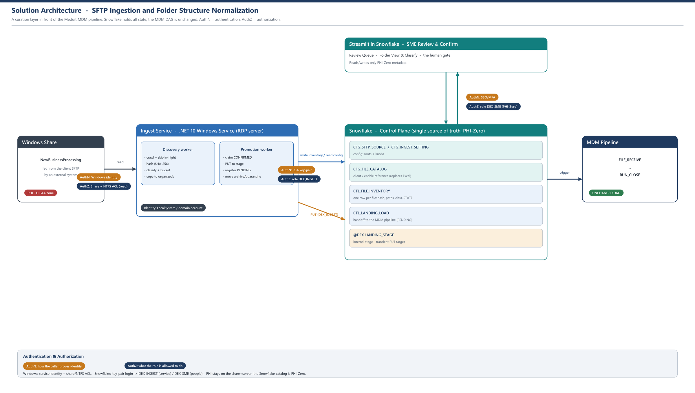
Figure 1. Solution architecture, with the authentication and authorization on each link.

2.2 Control Plane and Data Plane
Control plane: Snowflake holds the durable state (config, inventory, catalog, landing). Data plane: the file bytes live on the share and on the server organized tree (the PHI zone), and are PUT to the Snowflake stage only at promotion. The service is stateless between cycles; it reads what to do from Snowflake and writes results back, so it can restart or scale freely.

2.3 Component Model
The proven POC logic becomes the inner domain. New responsibilities are added behind interfaces, wired in a single composition root, so each concern is isolated and independently testable.
Interface | Responsibility | Implementation(s)
ISourceScanner | Crawl a root and yield candidate files, pruning skip folders | FileSystemScanner (POC Scanner logic)
IClassifier | Resolve system, client, year-month, kind; exclusion test | Classifier (POC logic, unchanged)
ICatalog | Client/enable reference and matching (exact/contains) | SnowflakeCatalog (reads CFG_FILE_CATALOG, cached)
IContentHasher | SHA-256 content identity | Sha256Hasher (POC HashUtil)
IFileStore | Copy into organized; move between trees | FileSystemStore
IInventoryStore | Persist/read a file row; claim by STATE; dedup | SnowflakeInventoryStore; InMemory fake for tests
IFileStager | PUT to the stage and register CTL_LANDING_LOAD | SnowflakeStager (the landing contract)
IRunStatusReader | Poll the terminal outcome of a pipeline run | SnowflakeRunStatusReader
ISnowflakeSession | Connection factory; key-pair auth (configurable) | SnowflakeSession
ISettingsProvider | Read configuration from CFG tables | SnowflakeSettingsProvider

3. Codebase Structure

3.1 Projects and Layers
A small set of .NET 10 projects with dependencies pointing inward (Clean Architecture). The domain has no external dependency; infrastructure implements the interfaces the domain declares.
Project | Layer | Contents
Ingestion.Domain | Domain | Models (FileRecord, InventoryState, classification results) and interfaces. No I/O.
Ingestion.Application | Application | DiscoveryWorker and PromotionWorker orchestration; depends only on interfaces.
Ingestion.Infrastructure | Infrastructure | Snowflake (session, inventory, stager, settings, catalog), FileSystem store/scanner, hasher.
Ingestion.Host | Host | Worker Service host, Windows Service integration, composition root (DI wiring).
Ingestion.CatalogSeeder | Tool | One-time loader: FILE_LIST.xlsx into CFG_FILE_CATALOG (reuses POC XlsxReader).
Ingestion.Tests | Tests | Unit tests against the interfaces with in-memory fakes; PHI-Zero fixtures.
ui (Streamlit) | UI | Streamlit in Snowflake app for SME review and classify (Python, in Snowflake).

3.2 Composition Root and Dependency Inversion
Ingestion.Host builds configuration (env-var bootstrap, then CFG tables) and registers one implementation per interface in the dependency-injection container. Workers receive only interfaces. Swapping a store or adding a source type is a registration change, not a rewrite.

3.3 Mapping from the POC
POC class | Becomes | Change
Scanner | FileSystemScanner + DiscoveryWorker | Split crawl from orchestration; writes inventory to Snowflake
Classifier | IClassifier / Classifier | Unchanged logic (system/client/year/kind/exclude)
FileListCatalog + XlsxReader | SnowflakeCatalog + CatalogSeeder | Runtime reads CFG_FILE_CATALOG; XlsxReader used only to seed
InventoryWriter (CSV) | SnowflakeInventoryStore | CSV replaced by CTL_FILE_INVENTORY rows
copied-hashes.txt | CTL_FILE_INVENTORY.CONTENT_HASH | File replaced by UNIQUE column + in-memory run cache
normalizer.conf | CFG_INGEST_SETTING + CFG_SFTP_SOURCE | File replaced by Snowflake config tables
HashUtil / Logger | Sha256Hasher / ILogger | Standard host logging

4. Snowflake Schema (Control Plane)
PHI-Zero: the control plane stores names, paths, hashes, classification and SME decisions only - never patient values. All tables carry standard audit columns (created/updated timestamps).

4.1 CFG_SFTP_SOURCE
Column | Type | Notes
SOURCE_ID | NUMBER | Primary key
SYSTEM | VARCHAR | Pinned system: MCD1 / MCD2 / MCD3 / BOPC
ROOT_PATH | VARCHAR | UNC path to crawl, e.g. \\Newbusiness...\FCS
IS_ACTIVE | BOOLEAN | Only active roots are crawled

4.2 CFG_INGEST_SETTING
Typed key/value knobs, seeded one-to-one from the POC configuration. A new knob is a new row, with no schema change.
Column | Type | Notes
SETTING_KEY | VARCHAR | Primary key, e.g. minYear, yearSource
SETTING_VALUE | VARCHAR | Raw value (lists are comma-separated)
VALUE_TYPE | VARCHAR | string | int | bool | list
DESCRIPTION | VARCHAR | Human-readable purpose

4.3 CFG_FILE_CATALOG
Replaces FILE_LIST.xlsx with only the columns the classifier uses. The workbook's email, network path, batch and frequency columns are dropped.
Column | Type | From the workbook / use
CATALOG_ID | NUMBER | Primary key
SYSTEM | VARCHAR | Planner Label / tab -> system bucket
DIRECTORY | VARCHAR | New Business / Directory (FCS/IMC/ABS/BOPC)
CLIENT_FOLDER | VARCHAR | folder name -> client match (exact/contains)
ENABLE_NAME | VARCHAR | Enable Name -> enrichment + landing
CLIENT_CODE | VARCHAR | Client Code -> enrichment
FILE_NAME_PATTERN | VARCHAR | File Name / _Ini -> filename to enable match
IS_ACTIVE | BOOLEAN | Soft delete
SOURCE | VARCHAR | SEED (from workbook) or SME (learned)

4.4 CTL_FILE_INVENTORY
One row per discovered file - the catalog and the state machine. Columns map one-to-one to what the discovery worker computes today.
Column | Type | Notes
FILE_ID | NUMBER | Primary key
CONTENT_HASH | VARCHAR(64) | SHA-256, UNIQUE - the dedup identity
SYSTEM / CLIENT | VARCHAR | Classifier + catalog
ENABLE_NAME / CLIENT_CODE | VARCHAR | Catalog enrichment (best-effort)
KIND | VARCHAR | source | processed | unknown
YEAR_MONTH | VARCHAR(7) | yyyy-MM bucket (Date-Modified rule)
FILE_NAME / EXTENSION | VARCHAR | Original name and extension
SIZE_BYTES / LAST_MODIFIED | NUMBER / TIMESTAMP | File metadata
SOURCE_PATH / SERVER_PATH | VARCHAR | Share path and organized path
STATE | VARCHAR | State machine (Section 9)
CONFIDENCE | FLOAT | Auto-classification confidence
SME_BY / SME_AT / REJECT_REASON | VARCHAR / TS | Set by the UI
RUN_ID | VARCHAR | Set at promotion; FK to CTL_LANDING_LOAD

4.5 CTL_LANDING_LOAD (existing)
Unchanged. The promotion worker writes a PENDING row exactly as SP_SFTP_POLL does: RECORD_SOURCE (idempotency key), SOURCE_FILE_NAME, SOURCE_FILE_HASH, STATUS. FILE_RECEIVE then takes over.

5. Configuration Model

5.1 Connection Bootstrap (environment variables only)
The only local configuration is the minimal set needed to reach Snowflake - supplied as environment variables, never as a file, never in the repo.
Variable | Purpose
SF_ACCOUNT | Snowflake account identifier
SF_USER | Login (interim team key-pair user; service account at go-live)
SF_ROLE | DEX_INGEST (least privilege)
SF_WAREHOUSE / SF_DATABASE / SF_SCHEMA | Session context
SF_AUTH_MODE | keypair
SF_PRIVATE_KEY | Path to the RSA private key
SF_STAGE | Target stage, configurable (default @DEX.LANDING_STAGE)

5.2 Settings in Snowflake
Everything else is read from CFG_INGEST_SETTING and CFG_SFTP_SOURCE at startup and refreshed each cycle. The full key reference is in Section 17.

5.3 No Local Files
There is no normalizer.conf, no inventory.csv and no copied-hashes.txt on the server. Configuration, inventory, dedup state and the catalog all live in Snowflake. The server holds only the published Windows Service binaries, the environment-variable bootstrap, and the organized PHI file tree (the actual data files).

6. Discovery Worker
The discovery worker is the POC normalizer, now writing to Snowflake. For each active source root it crawls, classifies and copies files into the normalized tree, upserting one inventory row per unique file.

6.1 Crawl and Skip
- Manual, fault-tolerant recursion: a single unreadable folder does not abort the scan.
- In-flight working folders (to process and similar) are skipped - those hold files mid-write.
- Only the configured roots are crawled (MCD1/MCD2/MCD3); everything else is out of scope.

6.2 Classification
- System is pinned per root (FCS=MCD1, IMC=MCD2, ABS=MCD3); the catalog is the fallback authority.
- Client is the canonical folder name from CFG_FILE_CATALOG, matched exactly or by substring (so disk 'ADVANCED RADIOLOGY' maps to 'ADVANCED RAD').
- EnableName and ClientCode are filled only when exactly one of the client's file patterns matches - a best-effort hint, not authoritative.
- Kind (source / processed / unknown) is a triage hint from filename signals; nothing is dropped on its strength.

6.3 Year and Bucket Resolution
The bucket is the file's Date Modified yyyy-MM. If the filename or a folder names a year other than the target year (minYear), the year defaults to the target year - so a stray or misread year in a name or folder can never create a wrong-year folder. Files older than the target year (by Date Modified) are skipped.

6.4 Exclusions and Deduplication
- excludeFilePatterns: acknowledgment / message / output files (for example .ack.txt, _ack.txt, .msg) are never copied; matched before hashing.
- Deduplication is enforced by the UNIQUE CONTENT_HASH in CTL_FILE_INVENTORY: identical content is copied once across runs and machines.
- A re-run copies only new content; previously copied files are skipped and not re-listed.

6.5 Normalized Folder Layout
<organized>\<System>\<Client>\<yyyy-MM>\<original-filename>
No matter how the client reshuffles the source tree, the organized side is always the same shape.

7. Client and Enable Catalog

7.1 CFG_FILE_CATALOG
The catalog is the authority for client identity and enable enrichment. It is loaded into memory at startup (small, hundreds of rows) and refreshed periodically.

7.2 Matching
- Exact match on a path segment against CLIENT_FOLDER first.
- Then, when enabled, the longest case-insensitive substring match in either direction (guarded by a minimum length to avoid false hits).
- Enable resolution matches the file name against the client's FILE_NAME_PATTERN values; it fills the enable only when exactly one matches.

7.3 Seeding from the Workbook
Ingestion.CatalogSeeder reads FILE_LIST.xlsx once (reusing the POC XlsxReader and the per-sheet header detection) and inserts the relevant columns into CFG_FILE_CATALOG with SOURCE = SEED. The workbook is then retired from the runtime.

7.4 Learning from SME Decisions
When an SME confirms or corrects a mapping in the UI, the decision is written back to CFG_FILE_CATALOG with SOURCE = SME. Over time the catalog improves and the review queue shrinks, delivering durable standardization rather than a one-off.

8. Promotion and Landing Contract
The promotion worker turns SME-confirmed files into MDM pipeline work, using the existing landing contract so the downstream DAG is untouched.
- Claim: an atomic UPDATE moves a batch of CONFIRMED rows to STAGING and stamps the worker id - this is how multiple workers share the queue without collision.
- Stage PUT: the service-account session PUTs the file (uncompressed, bare filename) to the configured stage, for example @DEX.LANDING_STAGE.
- Register: INSERT a PENDING row into CTL_LANDING_LOAD (RECORD_SOURCE, SOURCE_FILE_NAME, SOURCE_FILE_HASH, STATUS), then set the inventory row to LANDED.
- Trigger and watch: optionally EXECUTE TASK FILE_RECEIVE, then poll the run status to move the inventory row to PROCESSED (file to archive) or QUARANTINED (file to quarantine).
State is always committed in Snowflake before the file is moved on disk, so a crash never leaves the two out of step; a reconciliation pass re-derives disk location from STATE on restart.

9. State Machine and Folder Lifecycle
STATE | Owner | Meaning
DISCOVERED | Service | Crawled, hashed, copied to organized
CLASSIFIED | Service | Auto system/client/enable with a confidence
NEEDS_REVIEW | Service | Low confidence or ambiguous - shown in the UI
CONFIRMED | SME / auto | Approved as a source file to load
STAGING | Service | PUT to the stage and registering the landing row
LANDED | Service | PENDING registered; the MDM DAG owns it
PROCESSED | Pipeline | Run reached RUN_CLOSE OK; file moved to archive
REJECTED | SME | Not a source / duplicate / processed-output; never promoted
QUARANTINED | Service | Transfer or run failure; file to quarantine, dead-letter
Folder trees: organized -> moved -> archive (or quarantine). Duplicate, excluded and too-old files are never promoted; they are recorded as terminal REJECTED reasons or simply not inventoried, matching the current behavior.

10. Streamlit SME User Interface
Two screens, built as Streamlit in Snowflake, that read and write only PHI-Zero metadata - the control-plane tables. The UI never touches the file bytes or the stage; it only moves rows through the state machine. The wireframes below show each screen and, alongside it, exactly how it stores and retrieves data.

10.1 Review Queue (original to normalized)
A table of each messy original name and path next to the proposed normalized name, with System and State (AUTO / REVIEW / IGNORE). The SME multi-selects and chooses Confirm selected or Ignore selected. Ignore marks the row REJECTED - kept in the catalog, never promoted.
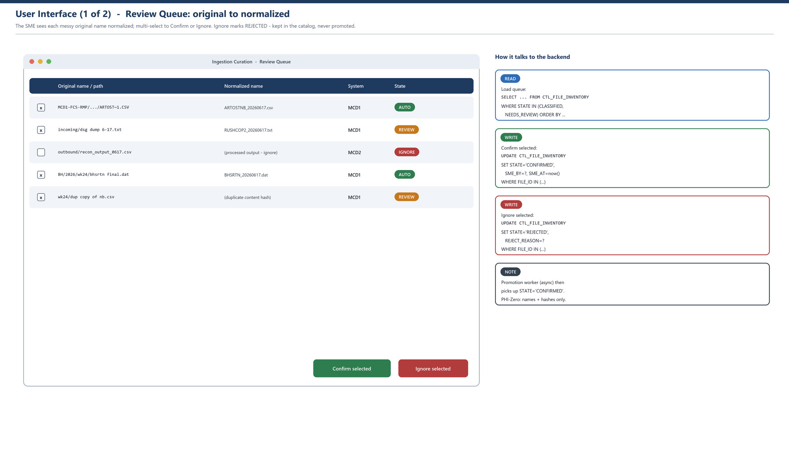
Figure 2. Review Queue screen and its backend reads and writes.
- Retrieve: SELECT from CTL_FILE_INVENTORY where STATE in (CLASSIFIED, NEEDS_REVIEW).
- Confirm: UPDATE CTL_FILE_INVENTORY SET STATE = CONFIRMED, SME_BY, SME_AT for the selected FILE_IDs.
- Ignore: UPDATE CTL_FILE_INVENTORY SET STATE = REJECTED, REJECT_REASON. The promotion worker then picks up CONFIRMED rows asynchronously.

10.2 Normalized Folder View and Classify
Browse the normalized tree (system / client / feed / month). For an item the classifier proposes System, Client and Enable; the SME confirms or rejects. The proposal draws on CFG_FILE_CATALOG.
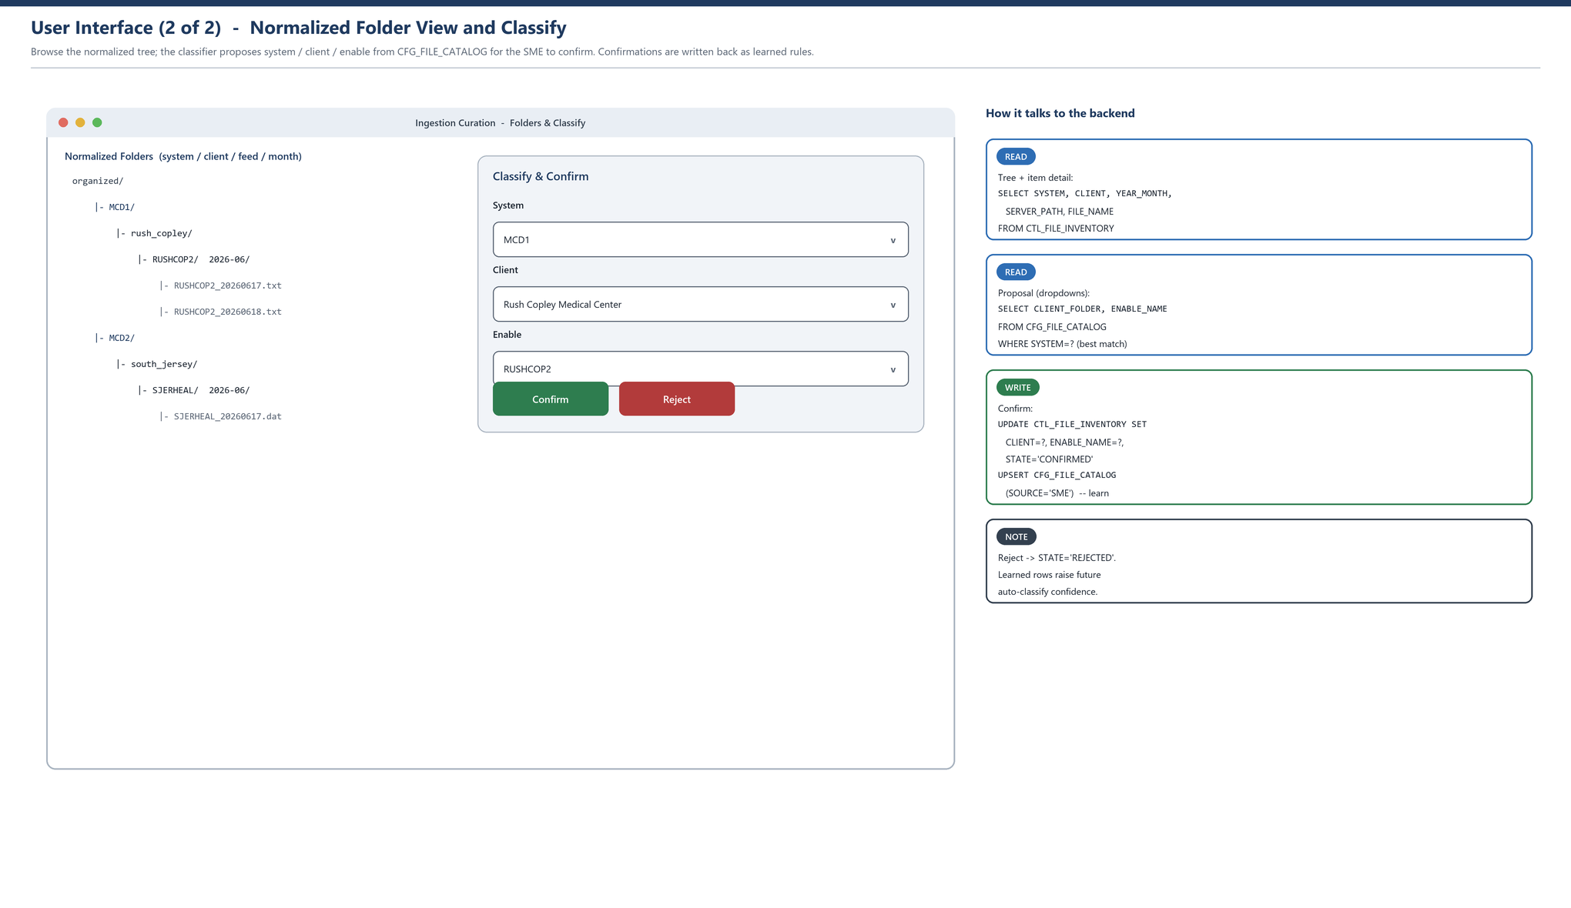
Figure 3. Folder View and Classify screen and its backend reads and writes.
- Retrieve tree/detail: SELECT SYSTEM, CLIENT, YEAR_MONTH, SERVER_PATH, FILE_NAME from CTL_FILE_INVENTORY.
- Retrieve proposal: SELECT CLIENT_FOLDER, ENABLE_NAME from CFG_FILE_CATALOG (best match for the system).
- Confirm: UPDATE CTL_FILE_INVENTORY (CLIENT, ENABLE_NAME, STATE = CONFIRMED) and UPSERT CFG_FILE_CATALOG with SOURCE = SME.

10.3 Learning Loop
Confirmations and corrections are written back to CFG_FILE_CATALOG (SOURCE = SME), so future discovery auto-classifies more files at higher confidence and the review queue shrinks over time.

11. Security Design

11.1 Identities and Access
- One Windows service identity reads the share (LocalSystem if local, a domain account for a remote UNC); granted at install. No SFTP credential on our side.
- One Snowflake login: an RSA key-pair with the DEX_INGEST least-privilege role (PUT to the stage; write inventory and landing; read config). Interim team key-pair for the POC; dedicated service account at go-live.
- People (the SME) authenticate separately via SSO to the DEX_SME role; they can read and curate metadata only - no stage, no landing, no PHI.
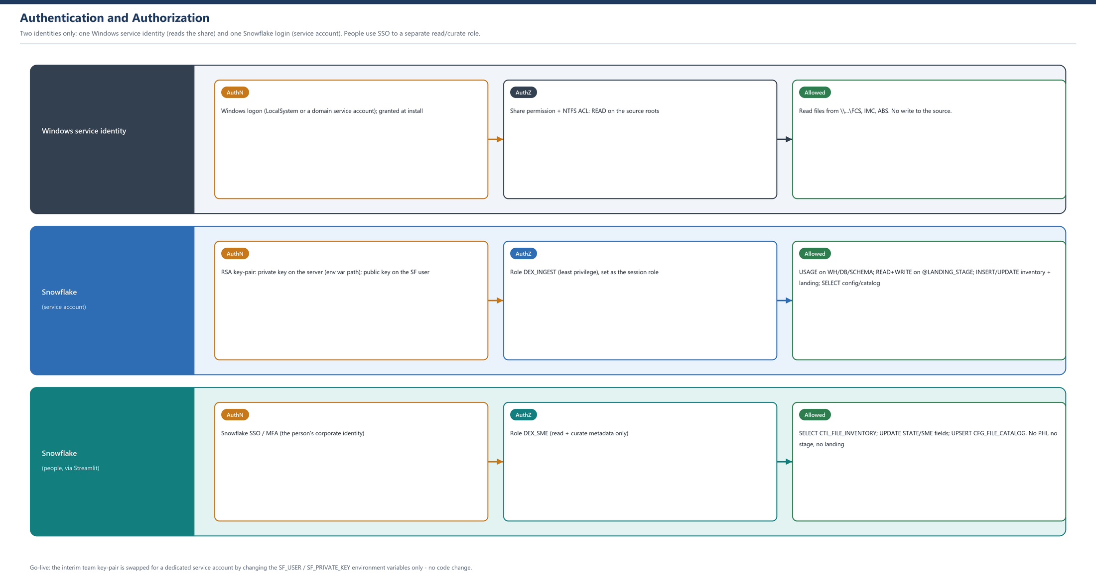
Figure 4. Authentication (how identity is proven) and authorization (what each role may do).

11.2 PHI Zones and PHI-Zero Catalog
- PHI lives on the share and the server organized/moved/archive tree - a HIPAA zone: encrypt at rest, restrict OS access, audit, define retention, minimize dwell time.
- The Snowflake control plane stays PHI-Zero: names, paths, hashes, classification and SME decisions only.

11.3 Secrets Management
The Snowflake user and private key path are environment variables on the Windows Service; secrets are never in the repository or in a config file. The POC-to-go-live swap to the dedicated service account is a change of environment variables only - no code change, no redeploy.

12. Reliability and Error Handling

12.1 Idempotency and Deduplication
Content-hash identity makes every step idempotent: re-runs and crashes never double-load. The UNIQUE CONTENT_HASH is the backstop even if a row write is retried.

12.2 Move-After-Commit and Reconciliation
Snowflake state is committed before any disk move. A periodic reconciliation job verifies that disk reality matches STATE and repairs drift (for example a file staged but not moved).

12.3 Restart and Scale
The service holds no durable state, so it restarts cleanly and scales horizontally: run N workers, each claiming rows with an atomic UPDATE. A partial-file guard (size/re-hash) avoids ingesting a file that is still being written.

13. Deployment
Deployment has two halves that are provisioned independently: the Windows side (the service binaries and the service identity that reads the share) and the Snowflake side (the objects, the roles and the key-pair). The end-to-end sequence is below, followed by the exact permissions for each side.

13.1 Deployment Sequence
- On a build machine with the .NET 10 SDK, restore and publish a self-contained build (no SDK/NuGet needed on the server).
- In Snowflake, create the schema objects (CFG and CTL tables and the @LANDING_STAGE if not present) and the DEX_INGEST and DEX_SME roles with the grants in Section 13.4.
- Create the Snowflake login: register the RSA public key on the service user; place the private key on the server and reference it from the SF_PRIVATE_KEY environment variable.
- Seed configuration: insert CFG_SFTP_SOURCE (the three roots) and CFG_INGEST_SETTING (the knobs); run Ingestion.CatalogSeeder once to load CFG_FILE_CATALOG from FILE_LIST.xlsx.
- Copy the published folder to the server; set the machine-level environment variables (Section 5.1).
- Grant the service identity the Windows permissions in Section 13.3; install and start the Windows Service (Section 13.2).
- Run the verification checklist (Section 13.5). Run in parallel with the old poller until cut over - content-hash dedup makes double-running safe.

13.2 Build, Publish and Service Install
dotnet publish Ingestion.Host -c Release -r win-x64 --self-contained true
REM on the server, register with the Service Control Manager (auto-start at boot)
sc.exe create MeduitIngestion binPath= "C:\meduit\ingestion\Ingestion.Host.exe" start= auto obj= "DOMAIN\svc-meduit-ingest" password= "***"
sc.exe description MeduitIngestion "Meduit SFTP Ingestion and Curation Service"
sc.exe start MeduitIngestion
Use LocalSystem only when the share is local to the server; for a remote UNC share, run the service under a domain service account (obj= above) that has share + NTFS read on the source.

13.3 Windows Identity - Roles and Permissions
Resource | Permission | Why
Service account (svc-meduit-ingest) | Log on as a service | Run the Windows Service unattended
Source share roots (FCS, IMC, ABS) | Share: Read; NTFS: Read & Execute, List | Crawl and read source files; never writes to the source
Output tree (organized/moved/archive/quarantine) | NTFS: Modify (Read/Write/Delete) | Normalize, move through lifecycle, purge per retention
Private key file (SF_PRIVATE_KEY) | NTFS: Read (service account only) | Snowflake key-pair authentication; locked down
Environment variables (machine scope) | Set by the Admin at install | Connection bootstrap (Section 5.1)

13.4 Snowflake - Roles and Grants
Two least-privilege roles. DEX_INGEST is the service account (machine); DEX_SME is for people via Streamlit. Neither owns the MDM pipeline objects.
Role | Granted | Purpose
DEX_INGEST | USAGE on warehouse, database, schema | Session context
DEX_INGEST | READ, WRITE on STAGE @DEX.LANDING_STAGE | PUT confirmed files for the pipeline
DEX_INGEST | SELECT, INSERT, UPDATE on CTL_FILE_INVENTORY, CTL_LANDING_LOAD | Write the inventory and register PENDING landings
DEX_INGEST | SELECT on CFG_SFTP_SOURCE, CFG_INGEST_SETTING, CFG_FILE_CATALOG | Read config and the catalog
DEX_SME | USAGE on warehouse, database, schema | Session context
DEX_SME | SELECT, UPDATE on CTL_FILE_INVENTORY | Review and move STATE / SME fields
DEX_SME | SELECT, INSERT, UPDATE on CFG_FILE_CATALOG | Confirm and learn mappings
DEX_SME | (no stage, no landing, no PHI) | Curation is metadata-only
CREATE ROLE DEX_INGEST;
GRANT USAGE ON WAREHOUSE DEX_WH TO ROLE DEX_INGEST;
GRANT USAGE ON DATABASE DEX TO ROLE DEX_INGEST;
GRANT USAGE ON SCHEMA DEX.INGEST TO ROLE DEX_INGEST;
GRANT READ, WRITE ON STAGE DEX.LANDING_STAGE TO ROLE DEX_INGEST;
GRANT SELECT, INSERT, UPDATE ON DEX.INGEST.CTL_FILE_INVENTORY TO ROLE DEX_INGEST;
GRANT SELECT, INSERT, UPDATE ON DEX.CTL_LANDING_LOAD TO ROLE DEX_INGEST;
GRANT SELECT ON ALL TABLES IN SCHEMA DEX.INGEST TO ROLE DEX_INGEST; -- CFG_*
GRANT ROLE DEX_INGEST TO USER SVC_MEDUIT_INGEST;

13.5 Verification Checklist
- Service starts and authenticates to Snowflake with the key-pair (DEX_INGEST).
- A test file on the share appears as a DISCOVERED row and a copy in the organized tree.
- The SME (DEX_SME) can see the queue, Confirm a row, and cannot see PHI, the stage or landing.
- An SME Confirm promotes the file: a PENDING CTL_LANDING_LOAD row and a LANDED inventory row.
- Duplicates and excluded files are not copied; too-old files are skipped.

14. Testing Strategy
- Unit tests for the classifier (system/client/year/kind/exclude), catalog matching and bucket rules, using in-memory fakes - no files, no Snowflake.
- Integration tests against a Snowflake test schema for the inventory store, stager and settings provider.
- Contract test for the landing contract: a promoted file produces exactly the row the MDM DAG expects.
- PHI-Zero in tests: fixtures use synthetic names and hashes only.

15. Operations and Monitoring
- Each cycle logs a summary: scanned, copied, duplicates, excluded, too-old, errors.
- Metrics (discovered / confirmed / landed / processed / failed per cycle) are written to a small table and shown on a Streamlit ops page.
- Quarantine and dead-letter rows are surfaced in the UI for triage, with the failure reason.
- A heartbeat row lets operators confirm the service is alive.

16. Phased Delivery Plan
Phase | Deliverable
Phase 0 | Snowflake schema (CFG and CTL tables), DEX_INGEST role, ISnowflakeSession seam, catalog seeder
Phase 1 (done) | Crawl, hash, classify, copy, inventory - the POC logic, ready to port into the service
Phase 2 | Read config and catalog from Snowflake; SnowflakeInventoryStore; Streamlit review UI
Phase 3 | Promotion worker: service-account PUT and register CTL_LANDING_LOAD; run old and new in parallel
Phase 4 | moved/archive/quarantine lifecycle; reconciliation; ops metrics
Phase 5 | Learn from SME decisions; enable auto-confirm; sunset SP_SFTP_POLL

17. Configuration Reference (CFG_INGEST_SETTING)
The runtime knobs, seeded one-to-one from the POC configuration. Lists are comma-separated.
Key | Type | Example | Meaning
minYear | int | 2026 | Keep files whose Date Modified year is this or later; also the target year
yearSource | string | modified | modified = bucket by Date Modified (default); filename = filename date wins
clientMatchContains | bool | true | Allow substring match of a folder to a catalog client, not just exact
excludeFilePatterns | list | .ack.txt,_ack.txt,.msg | Filename patterns never copied (suffix, or wildcard with *)
skipFolderNames | list | to process,working,temp | In-flight folders never read
dataExtensions | list | .txt,.csv,.dat,... | Acceptable formats (a hint for Kind)
outputFileMarkers | list | ack,output,reject,... | Filename markers that hint a processed/output file
inputCandidatesOnly | bool | false | Copy only INPUT_CANDIDATE files (everything is still inventoried)
loopSeconds | int | 300 | Re-scan interval; 0 = run once
promote.enabled | bool | true | Run the promotion worker
promote.autoConfirm | bool | false | Auto-confirm high-confidence rows (Phase 5)

