Health Robot: Hardware e Software
Vanderson da Silva do Santos
Leopoldo Rideki Yoshioka
Polytechnic School of the University of São Paulo
vanderson.santos@usp.br

Objectives
At the beginning of the project, the objective was to develop and build one delivery robot that was capable of autonomously navigate in USP campus, managing to interact with sidewalks, pedestrians and cyclists without need for intervention, with the aim of perform deliveries.

Nonetheless, as the COVID-19 pandemic (unasus, 2020) intensified, a robot that could perform similar functions in hospitals became necessary, due to the huge flow of inpatients with contagious symptoms, which, in addition to placing in risk the hospital staff, they could make the environment unhealthy. Because of that, the need to build a hospital delivery robot was noted, whose main mission was to transport medications and tests without the need for people to help. This way, avoiding unnecessary contact.

Materials and Methods

Initially, the robot would be for deliveries throughout the university city of the University of São Paulo. After a while, the project idea was redone and it became a robot to perform deliveries in the hospital environment. Because of this, the first version of the robot was not properly adapted to the place it was immersed. Thus, a second version of the robot was produced, but this time, trying to make the robot better adapted to the place it was immersed.

For the hardware part of the robot, a series of prototypes of embedded electronic modules were produced, which aim to exercise complete control of the robot, from motors to doors and sensor reading. These modules began to be designed at the end of 2020 and due to lack of time, the official versions have not yet been finalized.

Figure 1: Structure assembly and cabling
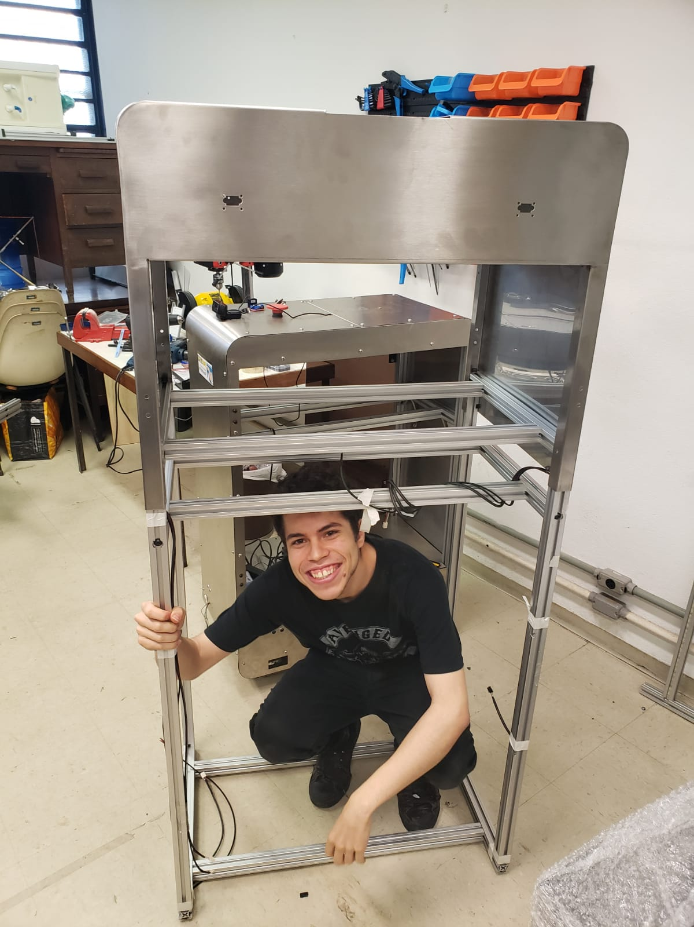

For the robot software, at first, the main function is to produce the control algorithms with the aid of ROS (ROS, s.d.), a very important and famous tool in the scope of robotics. From this area of the team, each member is assigned to develop certain algorithms and then integrate with the core algorithms.
In the beginning, to validate the control algorithms, a simulation environment was created, which emulated the health robot in a hospital. Thus, being able to validate the codes made without conflicting with any problems in the hardware.

Figure 2: Hardware and Software Project Architecture
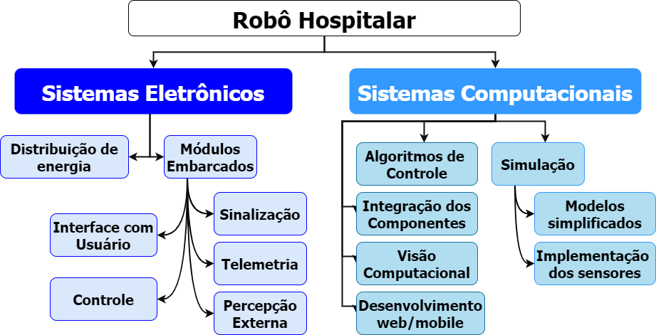

Results
As a whole, everything developed for the hospital robot in recent times was thought of trying to solve the problems of the first version of the hospital robot, which, despite being functional, didn't have a project documentation structure that would make it easier for new members understand what has been implemented.

The first version of the Health Robot's hardware and software was not very inviting. The software, as functional as it was and had countless qualities, was disorganized in the code, had no documentation and almost no standards. In fact, it was evident that it was software made in a rush, individually and with no intention of making it easy to understand. The hardware, in turn, didn’t have a defined electrical structure in relation to the electronic modules and no project, in general.

For the second version of the hospital robot, the entire project was made thinking about the problems of the first version, all the robot software was completely redone, however, this time, being very careful with code parameterization, separation of long scripts, documentation of everything that was done, addition of object orientation to build the algorithms and finally and most importantly, the addition of Git (Git, s.d.) and GitHub (GitHub, s.d.) together with Gitflow, to store the codes developed and reconciling group work. Thus, both the control algorithms and the new simulation environment were made again.

Figure 3: Health Robot simulation environment
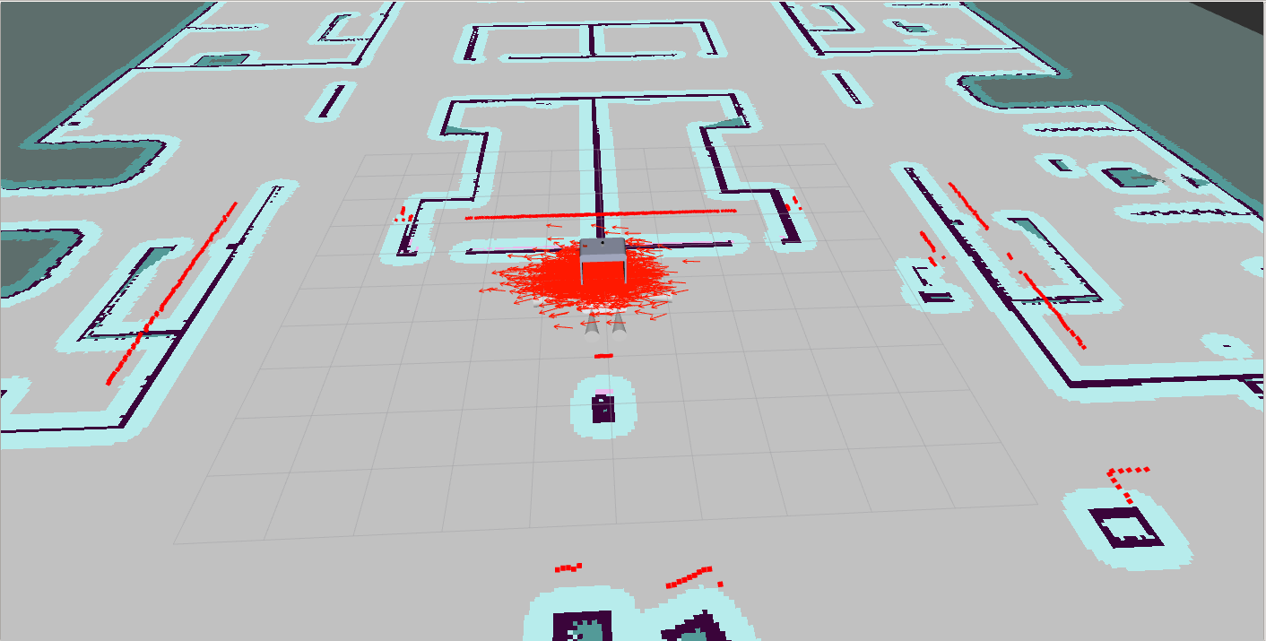

Also in the second version, the Hardware scope of the project was completely restructured, and so was the Software, taking much more care to document the entire project using tools such as Git (Git, s.d.) and GitHub (GitHub, s.d.) . All modules, made in Altium Design software (Altium Designer®, s.d.), are all being designed to work individually or not, so, for maintenance cases, it would not be necessary to change the entire board, but only one module. In total, 5 prototype modules were produced and 5 official modules are being produced.
Figure 4: Signaling module
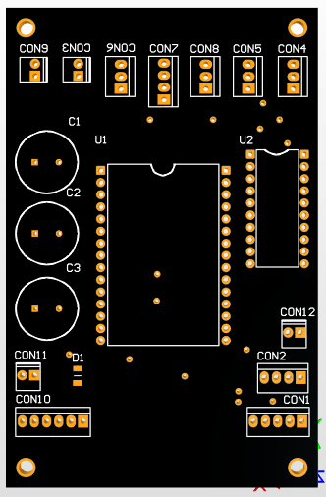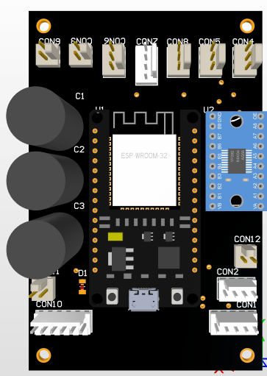
Conclusions
In the field of computing and electronics, software and hardware, which go very close together, the results were satisfactory, but nothing more. It was a lot of work in a short time, however, not as many tests were performed as was idealized due to periods without being able to attend USP.
With regard to Hardware, the official modules have not yet been manufactured, as it is necessary to better review the schematics and test all prototypes completely to order them made. However, considering that almost the entire restructuring of the project takes just under 8 months, and a few more than 10 printed circuit boards (PCBs) were synthesized, it is still a good result.
As far as the Software is concerned, in just under 6 months, all simulation environment and control algorithms were produced. As much as the code of the first version was functional, very little was reusable due to the lack of organization and documentation of everything developed. Because of that, everything was redone. However, there were many results produced and guarantee of a code that can be passed on to future generations of project members.
Figure 5: 2° Version of the Health Robot (Incomplete)
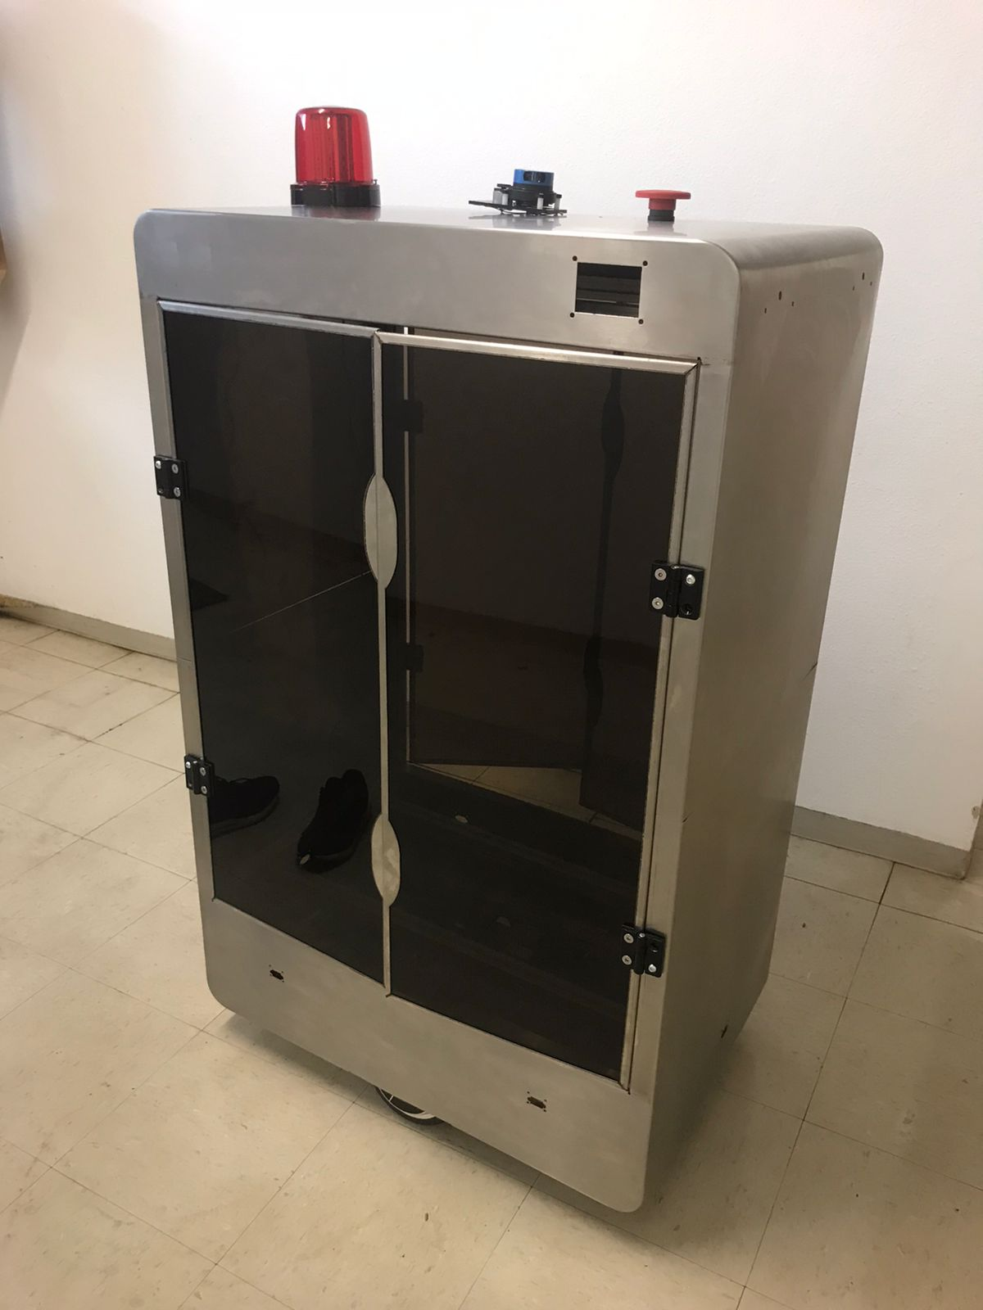

References
Altium Designer®. (s.d.). Altium. Fonte: https://www.altium.com/altium-designer/
Escola politécnica . (s.d.). Projeto de Robô Hospitalar para o Hospital Universitário da USP. Fonte: Health Robot: https://www.poli.usp.br/robohospitalar
Git. (s.d.). git --distributed-even-if-your-workflow-isnt. Fonte: https://git-scm.com/
GitHub. (s.d.). GitHub: Where the world builds software. Fonte: GitHub: https://github.com/
ROS. (s.d.). Robot Operating System. Fonte: https://www.ros.org/
unasus. (Março de 2020). Organização Mundial de Saúde declara pandemia do novo Coronavírus. Fonte: unasus: https://www.unasus.gov.br/noticia/organizacao-mundial-de-saude-declara-pandemia-de-coronavirus

