Vanderbull

Vanderbull

Design Document for:

Yeti:
The Mountain guardian.

The most bizarre love story ever

“Hey! This is a must read document , so please continue”™

All work Copyright ©2006 by Vanderbull

Written by Rickard Skeppström

Version # 1.00

Table of Contents

Yeti: 1
Game Overview 4
Philosophy 4
Making it appealing to a wider audience 4
What to focus on 4
Common Questions 4
What is the game? 4
Why create this game? 4
Where does the game take place? 4
What do I control? 4
How many characters do I control? 4
What is the main focus? 4
What’s different? 5
Feature Set 5
General Features 5
The Game World & enemies 6
Overview 6
Mountains – Scene 1 6
Caves – Scene 2 6
FORREST – Scene 3 6
Settlement – Scene 4 6
Travel 6
Scale 6
Objects 6
Time 7
Controls 7
Game Engine 7
Overview 7
Timing 7
Overview 8
Global 2D light 8
Game Characters 8
Overview 8
Creating a Character 8
Enemies and Monsters 8
Musical Scores and Sound Effects 9
Overview 9
Sound Design 9
Single-Player Game 9
Overview 9
Snowy Mountains 9
Story 10
Hours of Game play 10
Victory Conditions 10
High score 10
Character Rendering 11
Overview 11
Yeti Rendering Detail 11
User Interface 12
Overview 12
Menu screen 12
Main game screen(Playing) 12
Weapons 13
Overview 13
Hunting rifle 13
Snow boulder 13
Tree trunk 13
Rock 14
Fists 14
Bullet 14
Avalanche 14
Cave in 14
Trees falling 14
Overview 15
Things implemented if time left 15
Weather 15
Day and night cycle 15
Alternate ending 15
Throwing things at a angle 15
“Objects Appendix” 16
Meat 16
Hillbilly 16
Dog 16
Falcon 17
Bike 17
Car 17
“Dialog Appendix” 18
Overview 18
Details 18
19
“Story Appendix” 19

Game Overview

Philosophy

Making it appealing to a wider audience

The underlying idea is a game that should be able to capture audience both among the children but also from the grownups with a good love story but also quite simple interface and cute graphics. There is also the part where you will have the option to choose gender that could make it more attractive to play for the female gamers not having to play the big male brute all the time.

What to focus on

- parallax (World)
- Scrolling (World)
- sprites och sprite animations (blit, clipping) (Characters and enemies)
- collision handling (weapons & characters and world)
- missile object (Players thrown item and enemies bullets)
- movement pattern (
- 8-bits color depth (all the graphics)
- palette effect (fade, rotation etc.) (fade in game area when starting new game)

The above goals will have to be fulfill, therefor the focus will be on implementing those into the game. Also they will be noted in this document so that It will be easier to make a time plan. My thoughts are that I should be focusing on the parts that have the different requirements and therefor allocate more time in these areas. Still keeping focus on making it a fully functioning game.

Common Questions

What is the game?

The game is a side scrolling shooter with a twist where the story is about a Yeti that have lost its loved one a is set out to find him/her. Along the way you will have to keep remembering clues.

Why create this game?

I am creating this game as a project part of my studies in game development.

Where does the game take place?

The game takes place in the mountains of Alaska and takes you on a journey to a human settlements down below to find out what happened to your loved one.

What do I control?

You will be controlling a very angry Yeti with great anguish that will throw a lot of stuff.

How many characters do I control?

You are in control of a Yeti that’s it.

What is the main focus?

To find your loved one and go back to the mountain and live happy ever after. And hopefully have a great time doing so.
As far as game development the focus lies in making a simple functioning 2D shooter for show.

What’s different?

The difference is mostly the love story of a Yeti that I don’t think have been done before. Also that the focus in playing it have a great weight in keep remembering clues not just shoot stuff and get points.

Feature Set

General Features

four different types of landscape
A Yeti
8-bits color
2D graphics

Game play
Throwing ice/snow boulders, tree trunks, rocks at the enemy
Getting attacked by Hunters, falcons, dogs, vehicles.
Special attack (Anguish that will release a a special attack depending on the location)
Eating meat to regain your power.
Different types of landscape that will alternate as the story moves on.
Close combat.
Getting different types of Special attacks depending on the location.
The finding of clues from the loved one that gives the game a bit more meaning to play then just the ordinary running and shooting stuff for the highest score possible.

The Game World & enemies

Overview

You are starting in the mountains of Alaska and will be traveling through caves, Forests and lowland to reach a settlement.

Mountains – Scene 1

This is the Snowy mountains that will be towering in the background and there will be a lot of snow on the ground. Special attacks possible in the area are the avalanche. Ground is covered in snow. Enemies encountered here are the Hillbilly's.

Caves – Scene 2

Dark and moist caves, where you will have the “cave in” special attack. Enemies are the bikers and the Hillbilly's

Forrest – Scene 3

A vast forrest with mud on the ground. Enemies are the Hillbilly's, falcon and bikers.

Settlement – Scene 4

This is the little settlement of the humans called Thiensville, here is where you as the Yeti will find out what really happened to your loved one. Enemies are the Hillbilly's, bikers, and cars.

Travel

The player moves through the world in a side scrolling manner and it will be based on the length the player have moved to know when to change landscape and when to reach different parts of the story.

Scale

Your character will have a height of 150 pixels and a width of 50. The Human Enemies will only be half that height.

Objects

Meat Fallen trees
Bikes Cars
Snow boulders Rocks
Tree trunks Heap of rocks
Avalanche
See the “Objects Appendix” for a list of all the objects found in the world.

Time

Time will have quite a big part in this game as it will be part of any movement done by the Computer players as well as being part of the anguish meter that will be reloaded depending on time elapsed in seconds, also it will have charge of changing the weather and day and night cycle things not included in version 1.0 but will be added at a later stage of development.

Controls

The user interfaces are the using of the mouse and keyboard to control your character.
Controls
Left mouse button – fires the characters projectile.
Spacebar – jump with character.
Right arrow key to move the character forward.
Controls in menus
you navigate the menu with the mouse.

Game Engine

Overview

This is the mother of the game, here everything is controlled, everything from timing to collision detection.

Timing

This will be a great class that should control the frame rate and trigger the different timer based actions happening in the game.

Dialog
Controlling the flow that the dialog takes depending on how the player answers the questions.

Enemies appearance and movement
A control class for the creation of new enemies and how they should move.

Throwing
Controlling item thrown and creating it.

Collision
Simple circle collision should suffice.

Action handler class
A form of interface or what you could call it to the input module of the game. Here is a simple explanation of what my thoughts are.
Input class catches the input from the user and sends it to the game engine that in turn will call for the appropriate action.

Shooting
The enemies will shoot with rifles and the game engine will be calculating how far the bullet have moved and if it hit something, if it hit the Player it will call for a withdrawal of HP. When exiting outside screen the object should be destroyed.

Lighting Models

Overview

A Global 2D light.

Global 2D light

Will be changing dependant on the day and night cycle. Not implemented in first version

Game Characters

Overview

The Characters in the game is a Yeti. A great big one that is you as a player and the small and crazy that you will face in the cave.

Creating a Character

You will personalize the character by choosing what type of gender you have. At this stage you will also be introduced to the goals of the game. That you will be looking for clues of what happened along the way.

Enemies and Monsters

See the appendix for objects for further details about each enemy.

Hunters are humans looking like hillbilly's that carries rifles.

Falcons are birds and can fly.

Dogs can jump.

Bikes that carry one hillbilly and are dependant on that character to move.
Car carries two hillbilly's and are also dependant on them to move.

Musical Scores and Sound Effects

Overview

The sound and music will be there to enhance the gaming experience, all the sound effects are described in the sections holding the description of the object or character causing them. Same for the music.

Sound Design

Make use of GoDot engines sound design features primarily.

Single-Player Game

Overview

You are walking throughout a series of different landscapes and must be keeping your lookout for clues of what might have happened to your loved one. Along the road to the final area the settlement you will fight of hillbilly's and there helpers with snow boulder rocks and tree trunks.

Snowy Mountains

Here you will have the ability avalanche. Clue (scarf) part of the background picture.

Caves

Ability cave in. Stones drop from the ceiling removing any enemies on screen. Clue (name on wall) part of the background picture

Forrest

Ability Falling trees. Clue (heart carved into a tree) part of the background picture

Settlement

Ability none, Clue (none) Here you should just remember a color of the first house.

Special abilities
These will help you along the way, when there are to much enemies to face.
Details
These are in fact all the same, they will all destroy any enemy on screen. They only difference is the appearance they will have when executed.

Story

You are a Yeti in search of your lost loved one and are facing a variation of different enemies on your travels down to the settlement where you will finally find you answer.

See Appendix for more information.

Hours of Game play

This game will have a playing length of some 10-20 minutes.

Victory Conditions

When reaching the settlement you will at a certain point of time be faced with your loved one. You will be notified that you have found your loved one and a dialog will start where you will answer a bunch of questions and after which the game ends and you might be prompted with a screen saying highscore if you have the most correct answers on the questions.
See dialog appendix for more information about the dialog

High score

Overview

A Simple text with most correct answers to the questions.

Details

There should just be a counter counting each time the answer is correct and then compare it to the current high score.

.

Character Rendering

Overview

The Characters will be rendered as bitmaps on the screen surface with a black background as transparency.

Yeti Rendering Detail

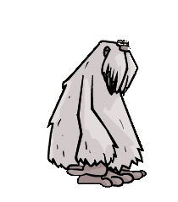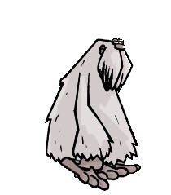
Should be using a collection of bitmaps of a Yeti that it will scrolls through to give the appearance of movement.

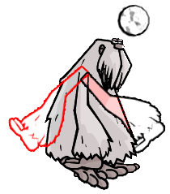
Yeti throwing things, animation of theYeti swinging the arm. No movement rendering will occur if the player throws things. The arm should be animated like in the picture throwing item straight forward only.

User Interface

Overview

Main screen
Menu screen
High score screen

Menu screen

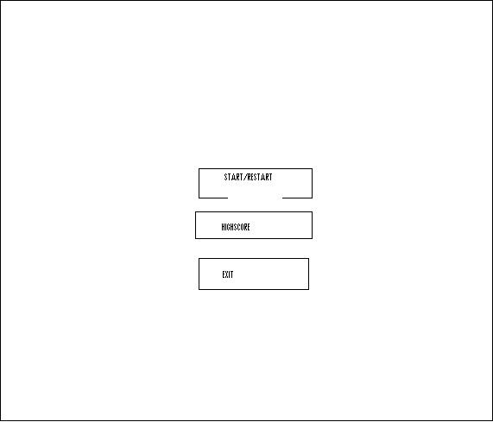
This is the menu payout for the game.

Main game screen(Playing)
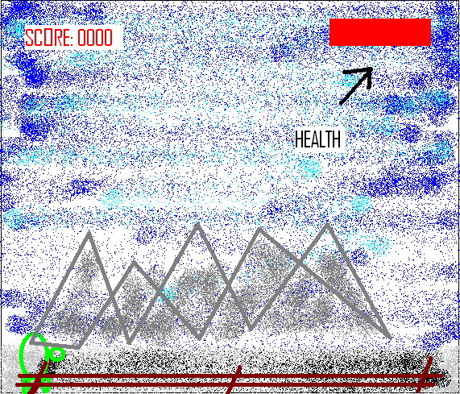
This is how the game looks when playing, Number of lives up in the right corner.

High score
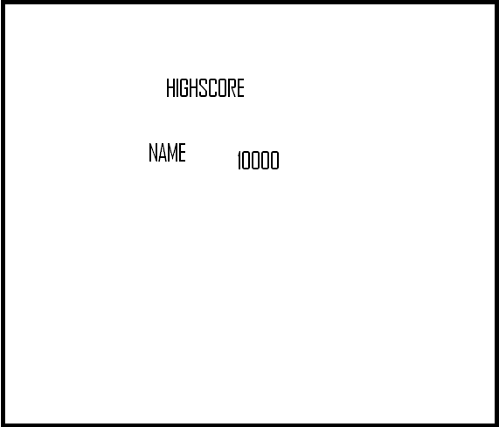
Display of the Highest number of correctly answered questions and the players name.

Weapons

Overview

Hunting rifles Snow boulder Tree trunk Rock Fists
Bullet

Special attacks

Avalanche Falling trees Rock slide

Hunting rifle


Remington 870 rifle with a wood stock. The graphics will be a part of the Hillbilly character.

Damage: see bullet
Rate of fire: every 2 seconds.
Sound effect: Rifle Bang.
Velocity: See bullet.

Snow boulder


Snow boulder much bigger though.

Damage: 1
Rate of fire: Depending on players ability to swing the mouse and press left mouse button.
Sound effect: thumping sound when colliding.
Velocity: Depending on the speed the player moves the mouse.

Tree trunk


Tree trunk

Damage: 1
Rate of fire: Depending on the players ability to swing mouse and press left mouse button.
Sound effect: thumping sound when colliding.
Velocity: Depending on the speed player moves the mouse.

Rock
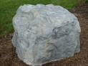
A great grey big rock.
Damage: 1
Rate of fire: Depending on the Players ability to swing mouse and press button
Sound effect: thumping sound when colliding.
Velocity: Depending on the speed the player moves the mouse.

Fists


The almighty hands of the Yeti

Damage: 1
Rate of fire: Depending on the the Player ability to press the mouse button
Sound effect: thud sound when colliding.
Velocity: None.

Bullet

Bullet that will be fired from rifle.
Damage: 1
Rate of fire: See rifle
Velocity: 10 pixels per second.

Special attacks

Avalanche

This will only be a animation of snow from the mountain, the effect is that every enemy on screen will automatically die.

Cave in

This will only be a animation of stones dropping from the top of the screen, the effect is that every enemy on screen will automatically die.

Trees falling

This will only be a animation of two trees falling from the side of the road, the effect is that every enemy on screen will automatically die.

Extra Miscellaneous Stuff

Overview

This is where all the extra cool stuff will end up, as there almost never is time for implementation of them.

Things implemented if time left

Weather

Giving the player a feeling of climate with things like snow effects in the mountain and sun rays in the lowlands or the chilling sounds of the cave where the wind rushes throughout the cave and the dripping of water from the ceiling. Also there could be a form of time altered changing in the weather so at a random time it begins to rain all of a sudden.

Day and night cycle

The game will have an altering day and night cycle that will change according to time. That is if time leftover when everything else is done. See “Extra miscellaneous stuff” for more information of none game critical things to the game play. Things that will be implemented at a later date.

Alternate ending

This is just to give the player a better feeling for replaying the game, so it wont just be the same old thing over and over again.

Throwing things at a angle

If time allows there should be a mouse controlled swinging of the arm to calculate the trajectory of the throw and speed/power at which item is thrown. Will be based on how fast the mouse is moved.

“Objects Appendix”

This Appendix is here to give you a detailed information of the different objects that one can find in the game.

Meat


Piece of meat that appears when enemies die, that the player can eat.

Regain health: 1

Sound effect: When eating a mushing type of sound.

Hillbilly


The hunters that the player is fighting. 100 points value

Health: 1

Sound effect: Some kind of statement like “Where is that bastard of a Yeti”

Weapon: Rifle

Speed: 10 pixels per second.

Dog


German Shepard dogs a helper for the hunter. 150 points value

Health: 1

Sound effect: Barking like a dog

Weapon: Biting

Speed: 15 pixels per second.

Falcon


Falcon a vicious bird that swoops down at the Player. 200 points value

Health: 1

Sound effect: Falcon shrieking.

Weapon: Fangs.

Speed: 10 pixels per second

Special: Flying

Bike


The mighty kick bike that propels a hillbilly at high
speed.

Speed: Hillbilly movement speed + 10 pixels

Special feature: Gives Hillbilly a extra HP point.

Value: 10 points

Car

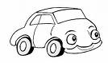
A happy car, that propels two hillbilly's. Value 20 points.

Speed: Hillbilly movement speed + 10 pixels.

Special feature: Carries two hillbilly's.

“Dialog Appendix”

Overview

Provide a description of how the flow in the dialog will be progressing.

Details

Questions that the player will face when getting to the end of the game.

- What item in the snowy mountain did you find?
Three choices:
Snowball
Tricycle
Scarf (right)

- What name was carved into the wall?
Two choices:
Lisalotta
Franky(right)

- What was carved into one of the trees?
Two choices:
A carrot
Heart(right)

- What color was the first house?
Two choices:
Blue
Yellow(Right)

“Story Appendix”

Part where you can read the background story of what has happened and triggered the current series of events.
A mighty roar can be heard echoing through the Alaska mountains, it is the the Yeti who have found out that its great big love have vanished. As the Yetis anguish sets he sets out to find a human he thinks is responsible, but it isn't an easy journey as the humans are out to kill the Yeti for the fame and money. The humans have issued a bounty of 1,000,000c for who ever finds and kills a Yeti.
You will have to fight your way through a horde of people armed with whatever they think is useful to track and kill a Yeti.

As you start wandering through the mountains on your way to the human settlement you are attacked by a hunter and his dog, hurling a great boulder of snow and ice crushing the hunter underneath it you just quick enough to swing your big hand knocking the dog to the ground.
All this wandering and fighting have made you hungry and so you pick up the dog and rip a hind leg from it eating the meat you feel refreshed and continue your journey towards the settlement.
The game will take you throughout a series of different environment and at the end you will be facing the settlement and the answers you have been seeking.

