**VILLAREAL, VANDEROHE VERNON B.**

**Exercise 1**

**(PLD-CpE11S1)**

**1. What is a Computer?**

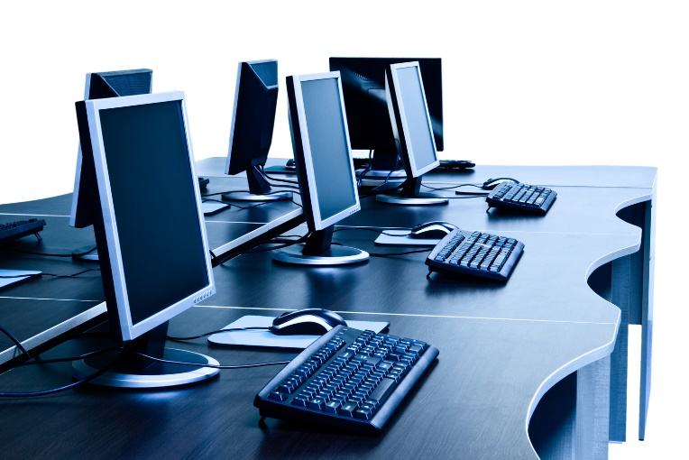

> A computer is a device that is commonly used for storing files/documents in a virtual form, a computer is also used as a data retriever in case one’s data is lost, a computer can retrieve these lost files and it processes existing data. A computer can also manipulate data or information that can are usually used in schools, organizations, and communities, etc.

**2. What are the essential parts of a computer?**

> The usual 5 "Most Important" components of a computer are (1). **Motherboard** also known as the heart of a computer is the foremost main circuit of the entire computer system, it centralizes on making all of the components of the computer to function by connecting all of the components together, it uses certain connectors for each specific component inside the computer. (2). **Central processing unit** (CPU) in which is a complex set of electronic circuitries that is used in order for a computer's operating system or OS to function. (3). Next is the **Graphical Processing Unit** (GPU) this component of a computer is very crucial in some situations such as rendering or texturing. This component purpose is to render graphics and images by performing rapid mathematical calculations within its system. (4). **Random Access Memory** or commonly known as RAM is usually in the form of a rectangular flat circuit board with memory chips attached to it. The RAM's purpose is to process computer data that needs to be running while a computer is turned on or to run your desired applications. The speed of the RAM's processing will depend on the amount of Gigabytes (gb) it has, so the higher the GB the faster it processes data. (5). Lastly is the **Storage Device**, this component's purpose is simple; it stores data or documents within the computer. There are many types of storage devices first is the most used in the which is the Hard Drive Disk (HDD) and Solid State Drive (SSD) these are inbuilt storage systems that can be located inside the computer's hardware, there are also Universal Serial Bus (USB) that is also a storage device, however this is separated from the computer and can be used to transfer data from one to another.

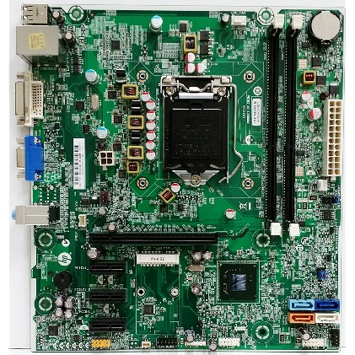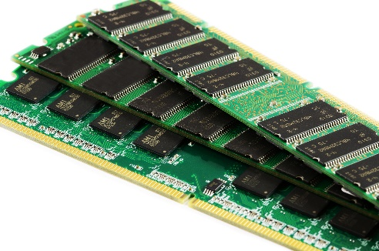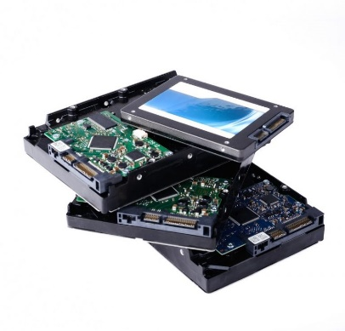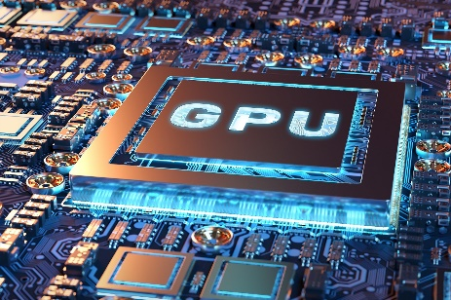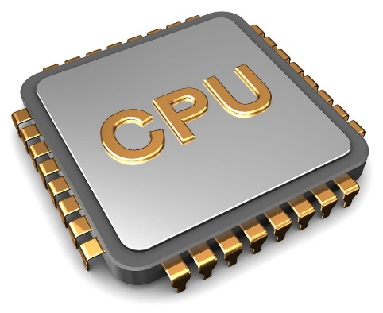

**3. Who are the Notable Inventors of Hardware and Software? (Cite at least (5) software developers and (5) hardware developers)**

**> Hardware Inventors:**



- **Patty McHugh**: She is an IBM engineer and is the inventor behind the computer's heart or Motherboard in 1981.

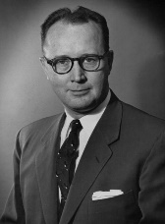 - **Reynold B. Johnson:** He's known as the "Father of the Hard Drive" as he created the first ever Hard Disk Drive back in 1954

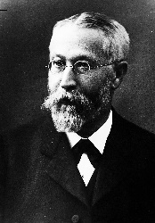

- **Karl Ferdinand Braun**: A German physicist who known for the creation Cathode Ray Tube which was the precursor of the modern monitors

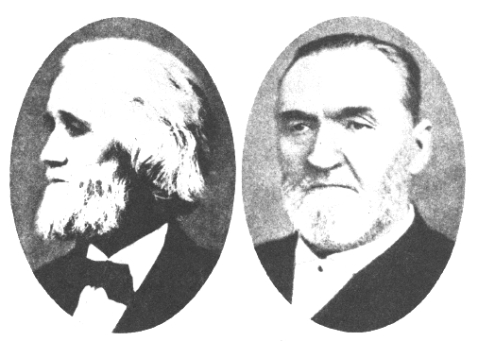

- **Sholes & James** **Densmore**: Back in 1878 these two patented the QWERTY layout keyboard that is now used even now in modern times

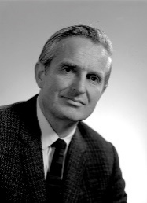

- **Douglas Engelbart & Bill English**: The creators/inventors of computer mouse, which was patented in the year 1970

**> Software Inventors:**



- **Steve Chen & Chad Hurley:** These two are the original inventors of the application YouTube which would later then be sold in 2006 to Google for $1.65m



- **Steve Jobs**: The inventor of one and debatably most famous and powerful companies in the entire world, Apple.



- **Linus Torvalds**: A Finnish software engineer that created the operating system called Linux back in 1991.



- **Bill Gates**: A Businessman, Harvard dropout, and the founder of Microsoft in 1975, that is now one of the most used operating system in the world.



- **Larry Elison**: The chairman and founder of the Oracle company in 1977 and was the CEO until 2014.

**4. Citations (APA format)**

**REFERENCES**

* + *Computer*. (2024, April 9). https://www.computerhope.com/jargon/c/computer.htm
  + *Computer Basics: What is a Computer?* (n.d.). GCFGlobal.org. https://edu.gcfglobal.org/en/computerbasics/what-is-a-computer/1/
  + *Motherboard: What does a motherboard do | Lenovo Philippines*. (2023, May 28). https://www.lenovo.com/ph/en/glossary/what-does-a-motherboard-do/?srsltid=AfmBOorzXtxHmKcSD19zBQ0FsO-fQS8xaADxC__r4vIQdrNTT_OIV9RX
  + Arm Ltd. (n.d.). *What is a Central Processing Unit? – Arm®*. Arm | the Architecture for the Digital World. https://www.arm.com/glossary/cpu
  + Awati, R., Gillis, A. S., & Steele, C. (2023, November 8). *graphics processing unit (GPU)*. Virtual Desktop. https://www.techtarget.com/searchvirtualdesktop/definition/GPU-graphics-processing-unit
  + Intel. (n.d.). *Computer and Laptop RAM*. Intel. https://www.intel.com/content/www/us/en/tech-tips-and-tricks/computer-ram.html
  + Rouse, M. (2019). *What is a Storage Device? - Definition from Techopedia*. Techopedia.com. https://www.techopedia.com/definition/1119/storage-device
  + *Why do I Need a Storage Device? A Guide to Different Types | Lenovo Philippines*. (2021). Lenovo.com. https://www.lenovo.com/ph/en/glossary/storage-device/#:~:text=There%20are%20several%20types%20of
  + Volle, A. (2023, April 21). *Motherboard | Definition, History, & Facts*. Encyclopedia Britannica. https://www.britannica.com/technology/motherboard
  + *1956: First commercial hard disk drive shipped | The Storage Engine | Computer History Museum*. (n.d.-b). https://www.computerhistory.org/storageengine/first-commercial-hard-disk-drive-shipped/
  + Testbook. (2023, October 31). *Father of Monitor – Know who invented computer monitor & How!* Testbook. https://testbook.com/articles/father-of-monitor     \
  + Bellis, M. (2020, January 13). *The history of the computer keyboard*. ThoughtCo. https://www.thoughtco.com/history-of-the-computer-keyboard-1991402
  + *When and by whom was the first computer mouse invented?* (2017, December 29). https://www.computerhope.com/issues/ch001083.htm
  + Hosch, W. L. (2024, August 10). *YouTube | History, founders, & facts*. Encyclopedia Britannica. https://www.britannica.com/topic/YouTube
  + Beattie, A. (2024, May 22). *Steve Jobs and the Apple Story*. Investopedia. https://www.investopedia.com/articles/fundamental-analysis/12/steve-jobs-apple-story.asp
  + *Understanding Linux*. (n.d.). https://www.redhat.com/en/topics/linux
  + Bill Gates. (2021, May 3). *Biography*. https://www.biography.com/business-leaders/bill-gates
  + *Larry Ellison | Executive Biography*. (n.d.). https://www.oracle.com/corporate/executives/larry-ellison/
  + *Top 10 software innovators of all time*. (n.d.). https://www.devtopics.com/top-10-software-innovators-of-all-time/