Tutorial - git for gear heads

Table of Contents
1. Git
1.1. Installing on your machine
1.1.1. Windows
1.1.2. Mac
1.1.3. Linux
1.1.4. Generating an SSH key
1.1.5. Telling Github about your SSH key
1.2. Using Git
1.3. References

Git

Installing on your machine

Windows
First I really recommend that you install Windows PowerShell. Its a better commandline interface for Windows. Installing PowerShell on Windows - PowerShell | Microsoft Learn
Download the Git installed for windows Git for Windows, it contains Bourne Again Shell (BASH) which is used to communicate between the user and the OS.

Mac
Check the Linux section,

Linux
I believe in you, you made it this far. It should come by default on your distro, if not that means you have one of these lightweight distribution so you already know what to do.

Generating an SSH key
To ensure security and prove who you are, GitHub uses Secure Shell (SSH). The SSH Protocol is a cryptographic network protocol for operating network services securely over an unsecured network.
To use SSH you must first generate a private key using the command bellow then follow the prompts
ssh-keygen -t ed25519 -C "your_email@example.com"
For SSH to work you also need the SSH-Agent to be running
# start the ssh-agent in the background
Get-Service -Name ssh-agent | Set-Service -StartupType Manual
Start-Service ssh-agent
# then tell ssh about your key. If not sure what is the name you gave it check the .ssh folder
ssh-add c:/Users/YOU/.ssh/id_ed25519 # or your choosen file.
INFO: Never ever share this key. If you accidentaly do so you must invalidate it soonest.

Telling Github about your SSH key
Copy your Public key, you can tell which one is public as it ends with a .pub.
clip < ~/.ssh/id_ed25519.pub
# Copies the contents of the id_ed25519.pub file to your clipboard
For linux you can use xclip or simply open the file with any editor and copy the content manually
- Go to Github (ensure you have an account, its easy to create one)
- Go to settings (upper right corner of the page by clicking on your profile picture)
- Go to SSH and GPG keys
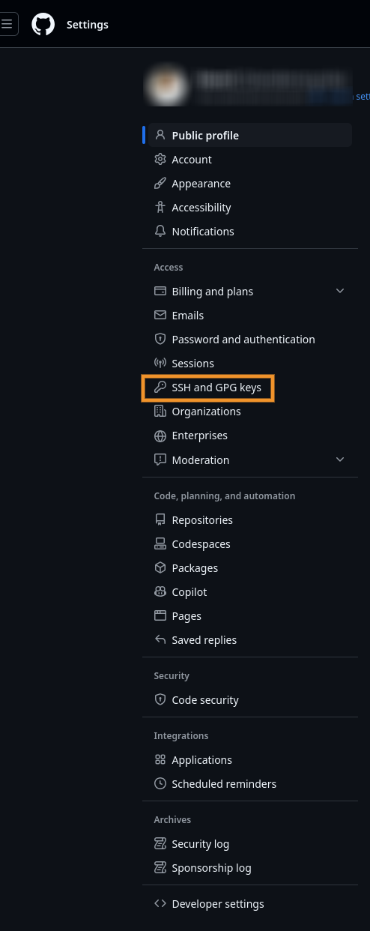
- Click add the new key
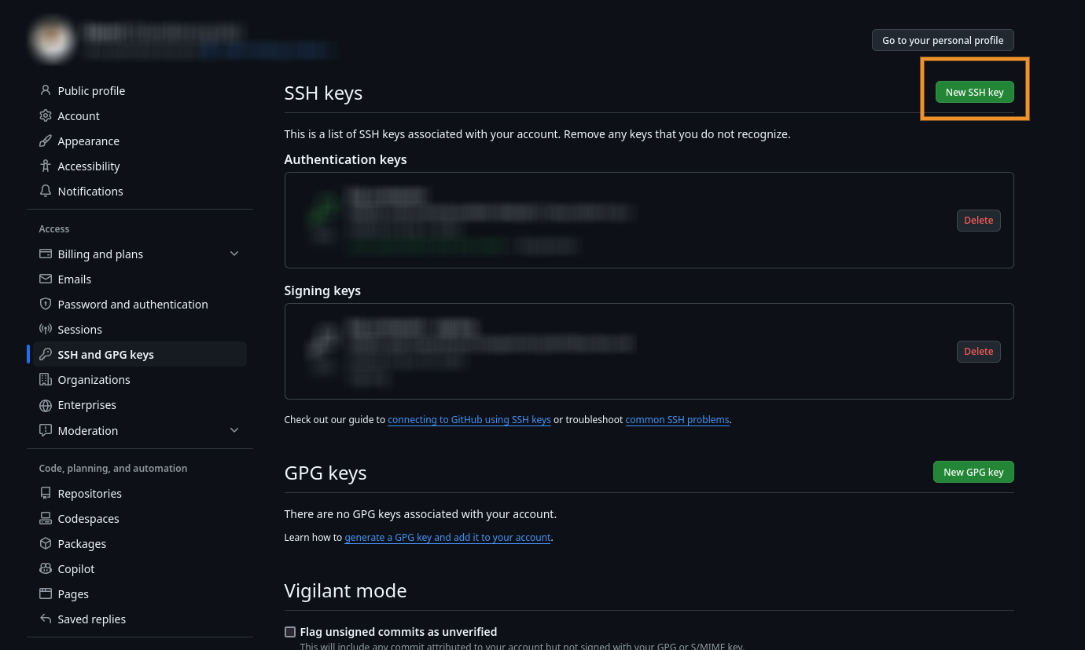
- Copy the Public key and add a title
- Test your connection with Git Bash
ssh -T git@github.com
Video guide: 🐱Generate a New SSH Key and Add it to your GitHub - YouTube GitHub Docs: Generating a new SSH key and adding it to the ssh-agent - GitHub Docs

Using Git
Honestly, me explaining it won't help you very much. Its best to test it yourself. Hello World - GitHub Docs And for practiced try these katas GitHub - eficode-academy/git-katas: A set of exercises for deliberate Git Pra…

References
Git tutorial Git - Reference

