

**KAVERI COLLEGE OF ARTS, SCIENCE & COMMERCE**

**CERTIFICATE**

This is to certify that

Mr. /Ms. Vandith V. Kadamba and Om Pasalkar

Has completed the project titled

For the partial fulfillment of the BACHELOR DEGREE COURSE IN COMPUTER APPLICATION (**T.Y.B.B.A(CA) Sem V )**, **Savitribai Phule Pune University** for the academic year 2022-2023.

Exam Seat No. Date:

**Seen By**

**Teacher-in-charge Head of the Department**

**Internal Examiner: External Examiner:**

**Principal**

**Index**

# Introduction

* **Problem Statement**

# Scope

* **Methodology**

# DFD

* **API Diagram**

# Hardware Requirements

* **Software Requirements**

# Snapshots Of Website

* **Conclusion**

# Reference

**Introduction:-**

We have developed “NothingMuch” a Web Application with a main motive of “Entertainment”. No formal knowledge is needed by user to use this sytem.

Therefore, it is user-friendly. This is a very light a web applction which will provide many functionalities. The word “NothingMuch” symbolises that you can do many fun activities even when you are doing nothing.

The development and exponential growth of internet and popularity of social network applications has led to many possibilities for development of a website or an application. Most of the present-day websites are using HTML, Scripting languages and Backend Services. But the most overlooked and less known concept is that of APIs. But the use of APIs is vast and there is a massive chance that almost every user of internet has used API integrated applications. There are many types of APIs and the ones that we have used in our projects are that of curing boredom or for having fun and in layman terms “Time-pass”.

# Problem Statement:-

Idea of “NothingMuch” is motivated from an English phrase “An idle mind is a devil’s workshop”. Basically, it says that a lazy and idle mind would lead to negative thoughts and these thoughts would harm not only oneself but also people around them. So, to prevent this we have developed this web application which would help the users cure boredom.

# Scope:-

This Web application allows user to interact with fun activities. Our main target users of this web application are the people who have lot of free time and don’t know how to spend that available extra time in doing something. However, the user can avail it anytime and anywhere with an active internet connection.

# Methodology:-

As boredom is caused by following a same cycle every time, we have decided to use concepts which would keep changing the content dynamically. Hence, we have made use of APIs which would constantly display a new output every time the user interacts with it.

We have made use of HTML, CSS, JavaScript, jQuery along with 4 APIs: -

1. Bored API: - By using this we have created a page which would give you a task on a click of a button and if you like the task given you can do that or you can click the button again for a new task.
2. avatars dicebar API: - This is rather a fun API than that of a productive one, the page would display a random avatar once you enter your name. The fun part is that it would remember the avatar associated with your name and would

display the same when you enter the same name again.

1. Meme API: - This page would fetch memes from a reddit channel and display new memes every time you click the button.
2. Dog CEO API: - This page is made for the people who love dogs, you have to select a dog breed and it would display a slideshow of that particular breed.

# DFD:-

**API Diagrams:-**

APIs used in our website:-

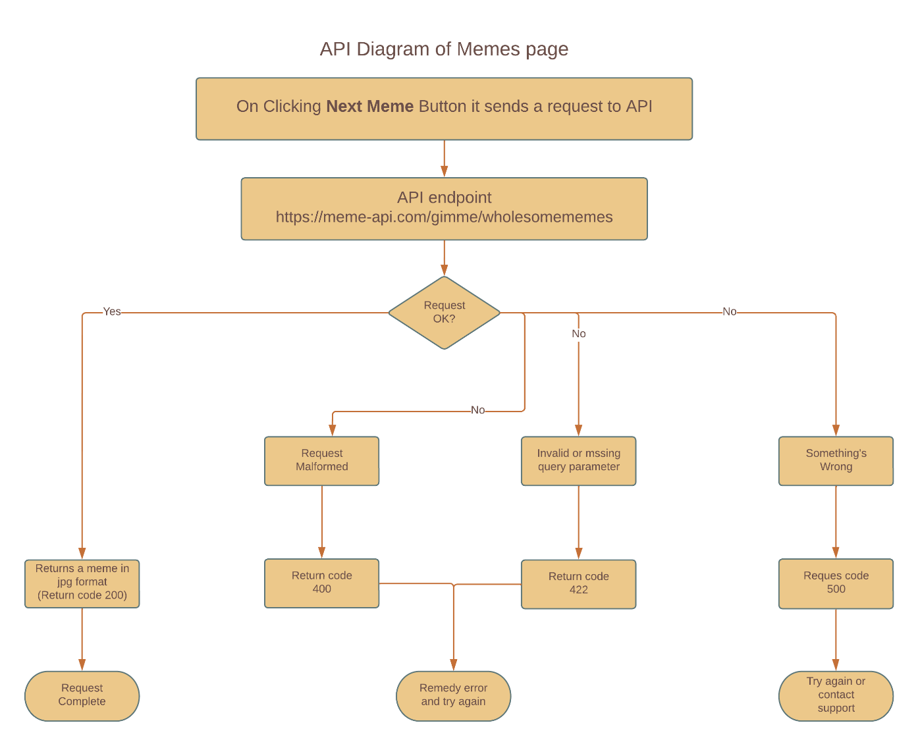

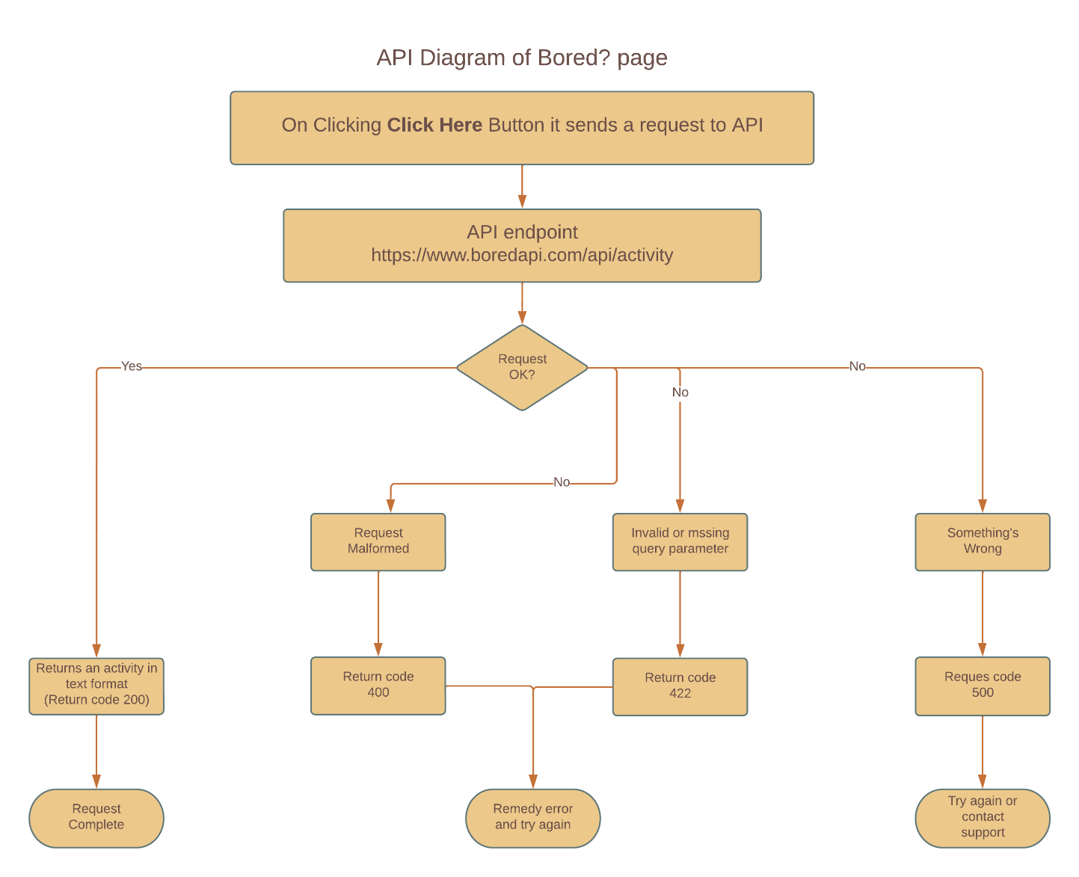

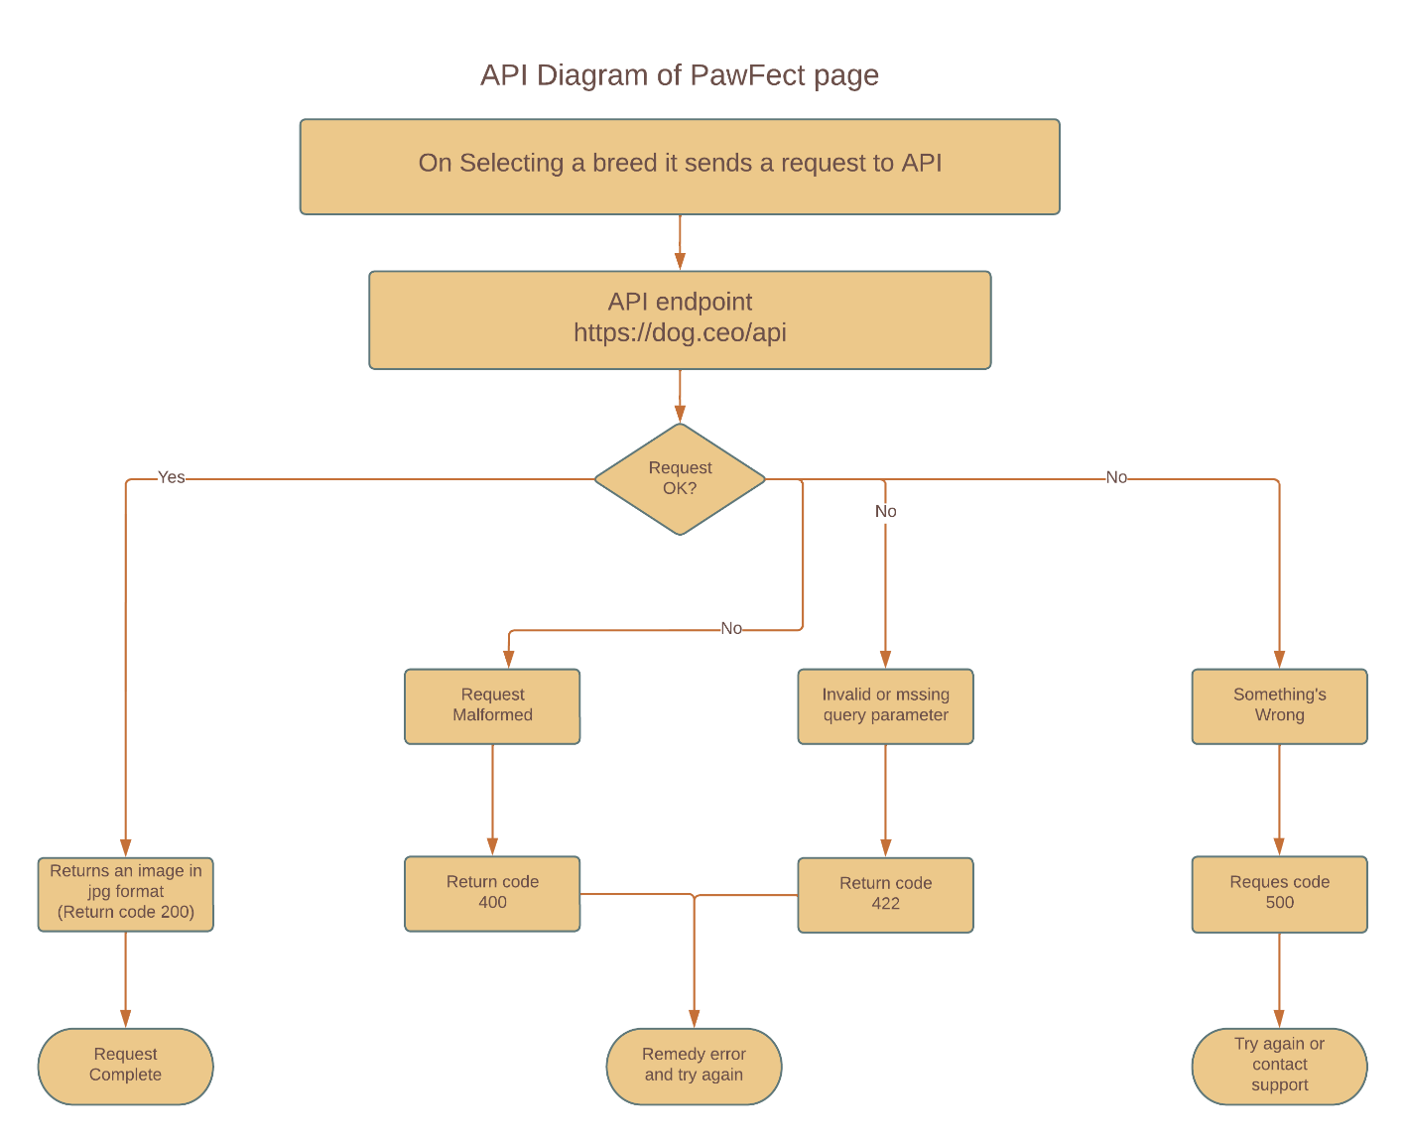

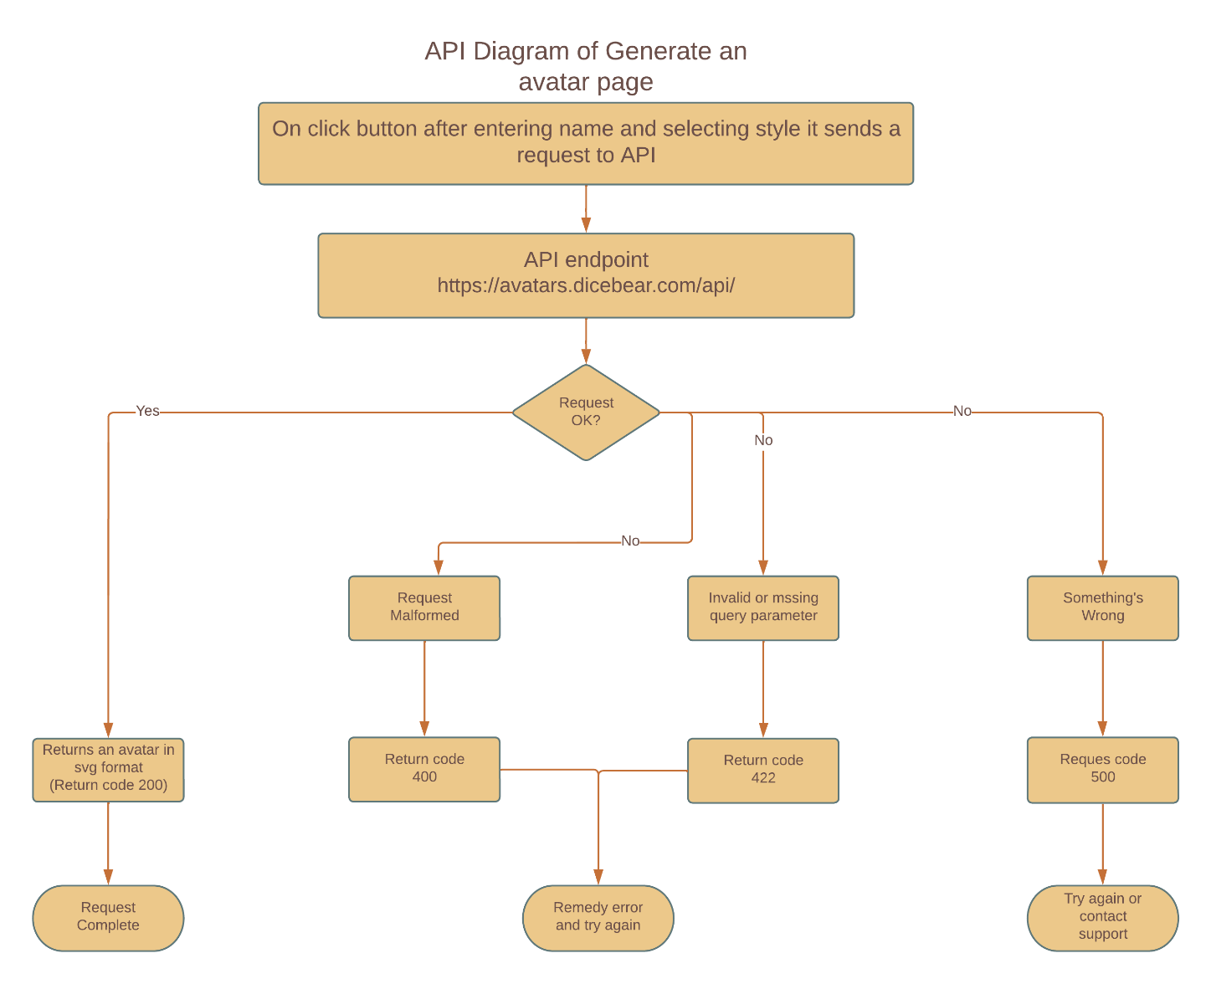

# Hardware Requirements:-

* + Pentium IV or higher, (PIV-300GHz recommended)
  + 4GB RAM
  + 1 Gb hard free drive space

# Software Requirements:-

* JavaScript enabled Web Browser: Google Chrome, Mozilla Firefox, Microsoft edge, Opera etc.
* Operating System: Windows XP or higher.

# Snapshots of website:-

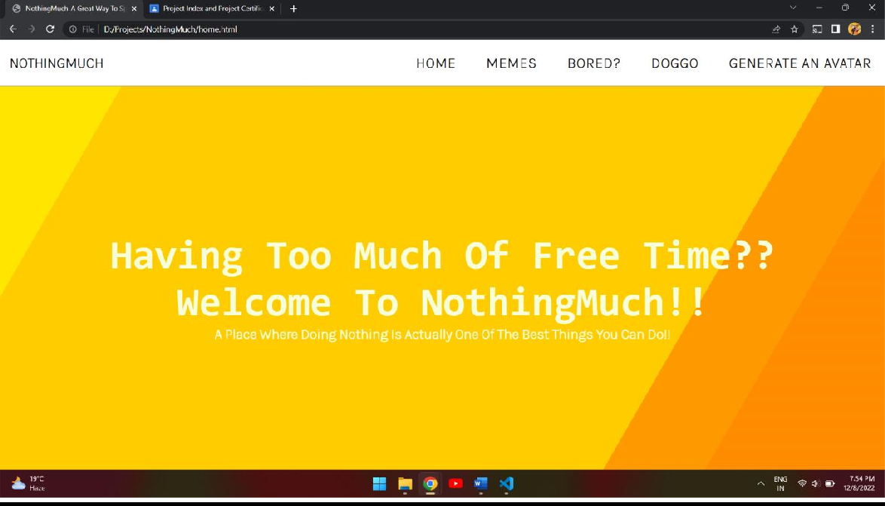

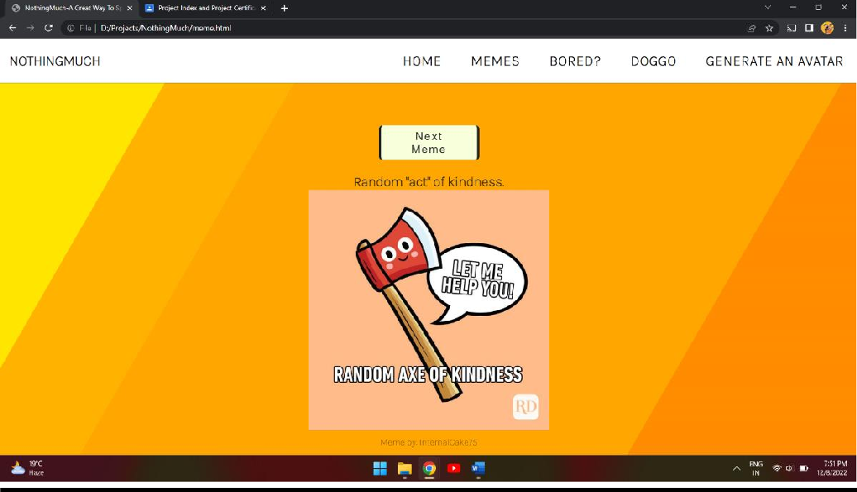

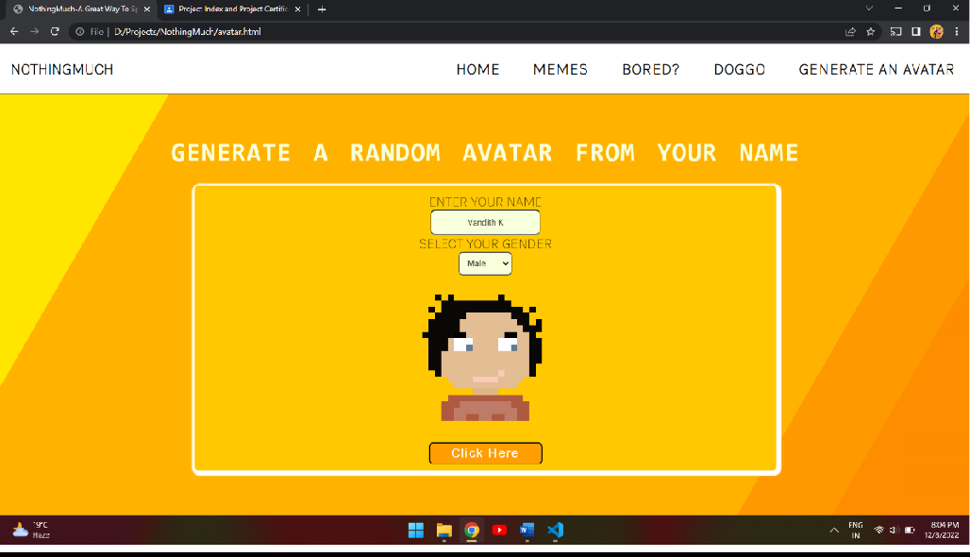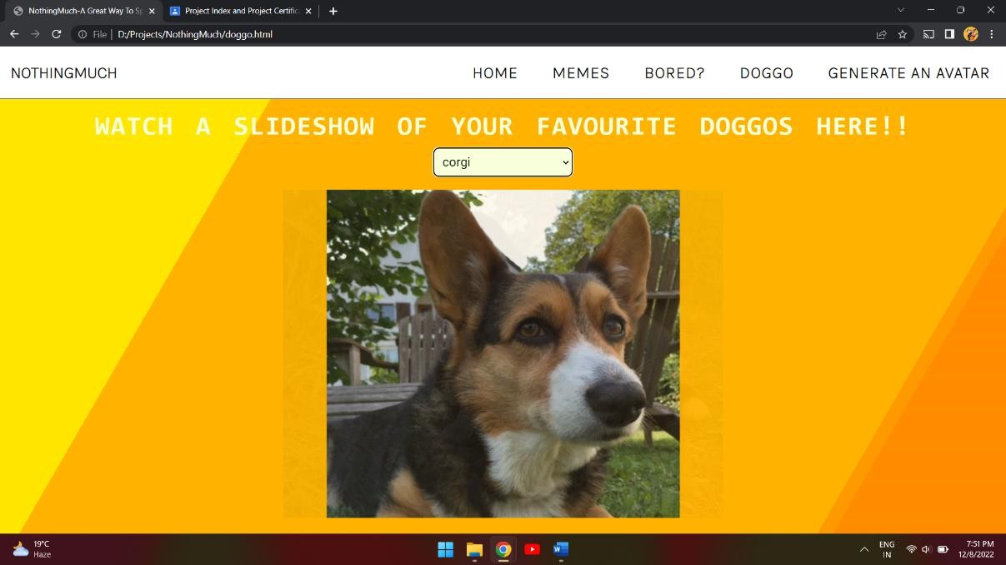

**Conclusion:-**

Concluding the documentation, we have created a web application for all the people who are having a lot of free time and will provide means to spend that time on fun activities. All the basic functionalities for this project have been created, yet we can keep on adding new functionalities as the sky is the limit for any project. As a team we were able to discover our creative side from choosing a unique topic to creating the Web Application. The purpose of the project is achieved.

# References:-

* YouTube.com
* Google.com
* github.com
* geeksforgeeks.com
* rapidapi.com
* lucidsparks.com