**Assignment (30/jan/2016)-**

**1. Gmail login:**

**package TestPro;**

**import org.openqa.selenium.By;**

**import org.openqa.selenium.WebDriver;**

**import org.openqa.selenium.firefox.FirefoxDriver;**

**public class Test {**

**WebDriver driver;**

**public void sample() throws InterruptedException**

**{**

**System.setProperty("webdriver.firefox.marionette","C:\\Selenium\\geckodriver.exe");**

**driver=new FirefoxDriver();**

**driver.get("http://www.gmail.com");**

**driver.findElement(By.id("Email")).sendKeys("sharmavandna261@gmail.com");**

**driver.findElement(By.id("next")).click();**

**Thread.sleep(5000);**

**driver.findElement(By.id("Passwd")).sendKeys("1234");**

**driver.quit();**

**}**

**public static void main(String[] args) throws InterruptedException {**

**// TODO Auto-generated method stub**

**Test obj=new Test();**

**obj.sample();**

**}**

**}**

**Screenshot:**

Entering the email id:

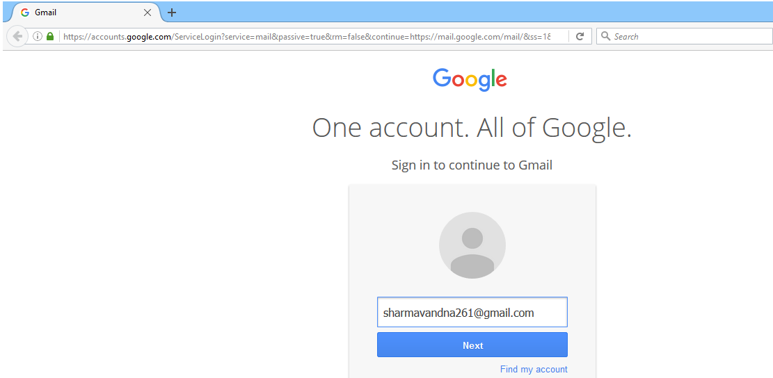

“Next” button is pressed and entering the password:

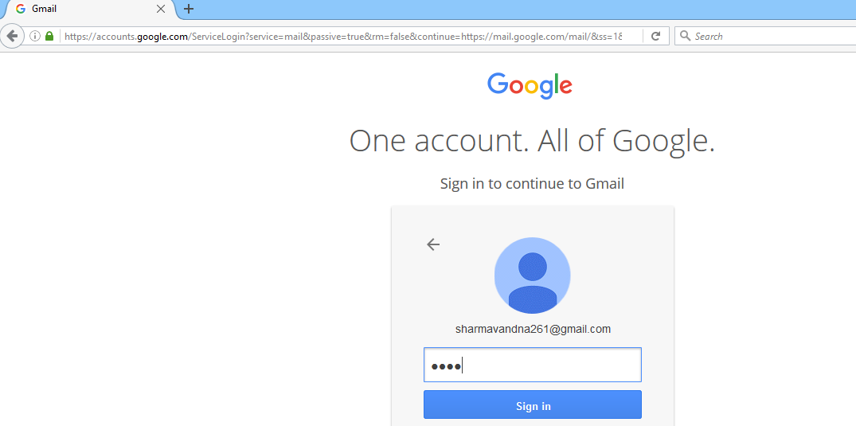

Now clicking on “Sign in” button and browser will check whether the entered password is correct or not:

*here as we entered wrong password, thus the browser window look like this

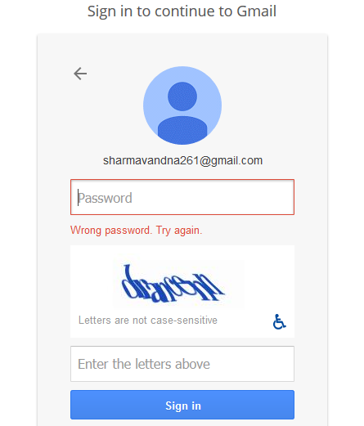

And the eclipse window looks like:

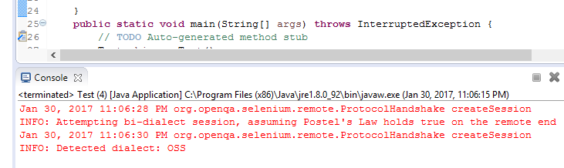

**Facebook- register or sign up page with data entered:**

**package** automate1;

**import** org.openqa.selenium.By;

**import** org.openqa.selenium.WebDriver;

**import** org.openqa.selenium.firefox.FirefoxDriver;

**public** **class** Register {

WebDriver Driver;

**public** **void** met() **throws** InterruptedException

{

System.*setProperty*("webdriver.firefox.marionette","C:\\Selenium\\geckodriver.exe");

Driver=**new** FirefoxDriver();

Driver.get("http://www.facebook.com");

Driver.findElement(By.*id*("u_0_1")).sendKeys("ojasvini");

Thread.*sleep*(500);

Driver.findElement(By.*id*("u_0_3")).sendKeys("prashar");

Thread.*sleep*(500);

Driver.findElement(By.*id*("u_0_6")).sendKeys("prashar12@gmail.com");

Thread.*sleep*(500);

Driver.findElement(By.*id*("u_0_9")).sendKeys("prashar12@gmail.com");

Thread.*sleep*(500);

Driver.findElement(By.*id*("u_0_b")).sendKeys("goodmorning");

Thread.*sleep*(500);

Driver.findElement(By.*id*("day")).sendKeys("12");

Thread.*sleep*(500);

Driver.findElement(By.*id*("month")).sendKeys("march");

Thread.*sleep*(500);

Driver.findElement(By.*id*("year")).sendKeys("1997");

Thread.*sleep*(500);

Driver.findElement(By.*id*("u_0_i")).click();

Thread.*sleep*(2000);

//Driver.findElement(By.id("u_0_j")).click();

Driver.findElement(By.*id*("u_0_f")).click();

Thread.*sleep*(3000);

}

**public** **static** **void** main(String[] args) **throws** InterruptedException {

// **TODO** Auto-generated method stub

Register ab=**new** Register();

ab.met();

}

}

**Screenshot:**

Entering the details for Sign Up or Creating Account.

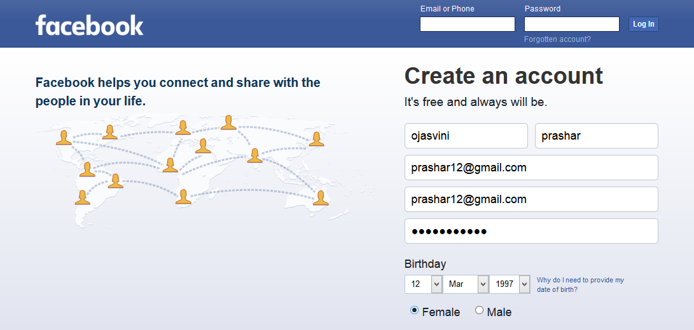

Create Button has been clicked:

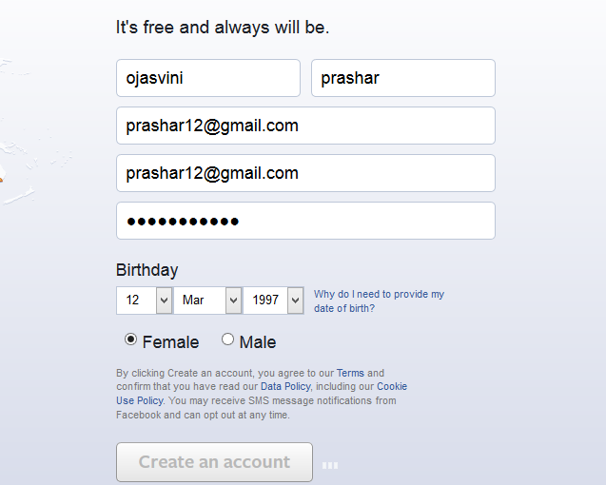

Redirecting to the next page for further process:

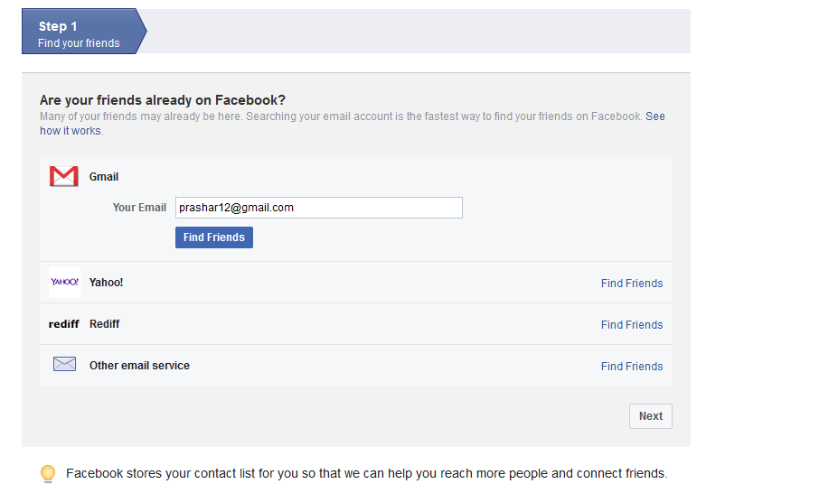

**Logging In (Facebook):**

**package** automate1;

**import** org.openqa.selenium.By;

**import** org.openqa.selenium.WebDriver;

**import** org.openqa.selenium.firefox.FirefoxDriver;

**public** **class** LogInFb {

WebDriver Driver;

**public** **void** LogIn() **throws** InterruptedException

{

System.*setProperty*("webdriver.firefox.marionette","C:\\Selenium\\geckodriver.exe");

Driver=**new** FirefoxDriver();

Driver.get("http://www.facebook.com");

Driver.findElement(By.*id*("email")).sendKeys("sharmavandna34@gmail.com");

Thread.*sleep*(500);

Driver.findElement(By.*id*("pass")).sendKeys("3456123");

Thread.*sleep*(500);

Driver.findElement(By.*id*("u_0_o")).click();

Thread.*sleep*(1000);

Driver.quit();

Thread.*sleep*(500);

}

**public** **static** **void** main(String[] args) **throws** InterruptedException {

// **TODO** Auto-generated method stub

LogInFb abc=**new** LogInFb();

abc.LogIn();

}

}

**Screenshots:**

Entering the username and password.

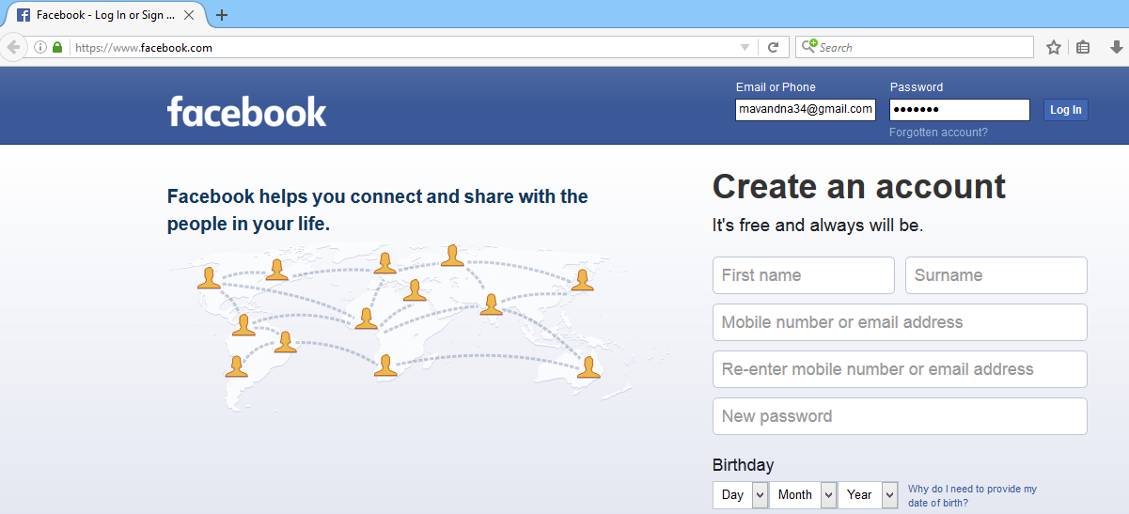

“Log In” button has been clicked:

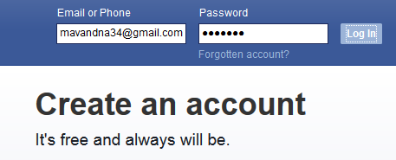

Redirecting to the next page which shows that user have entered the wrong password.

