**1. Factorial-**

**public** **class** Factorial {

**double** i,fact=1,n;

Scanner sc;

**public** **void** fact(){

sc = **new** Scanner(System.***in***);

System.***out***.println("Enter the numbers");

n = sc.nextDouble();

**for**(i=1;i<=n;i++){

fact=fact*i;

}

System.***out***.println("Factorial of "+n+" is: "+fact);

}

**public** **static** **void** main(String[] args) {

Factorial ob1=**new** Factorial();

ob1.fact();

// **TODO** Auto-generated method stub

}

}

**Screenshot:**

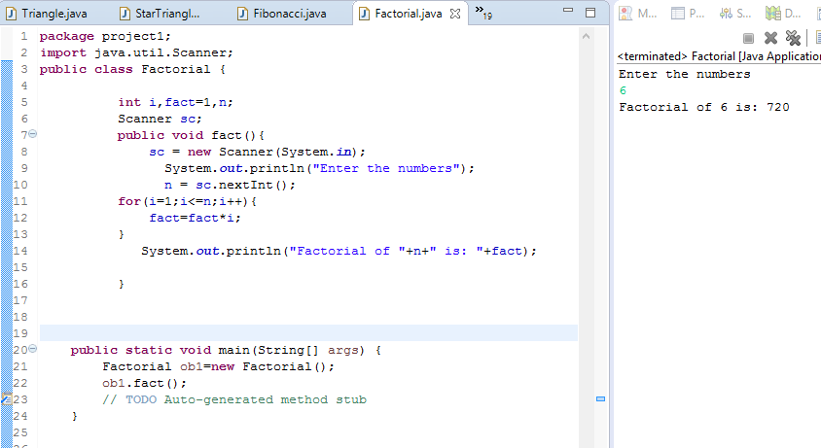

**2. Fibbonacci:**

**public** **class** Fibonacci {

**int** i,n, num1=0, num2=1, num3;

Scanner sc;

**public** **void** fibo(){

sc = **new** Scanner(System.***in***);

System.***out***.println("Enter the number till you want to print series..");

n = sc.nextInt();

System.***out***.println(num1);

System.***out***.println(num2);

**for**(i=0;i<=n;i++){

num3=num1+num2;

num1=num2;

num2=num3;

**if**(num3==n){

System.***out***.println(num3);

**break**;

}

**else**

{

System.***out***.println(num3);

}

}

}

**public** **static** **void** main(String[] args) {

// **TODO** Auto-generated method stub

Fibonacci ob=**new** Fibonacci();

ob.fibo();

}

}

**Screenshot:**

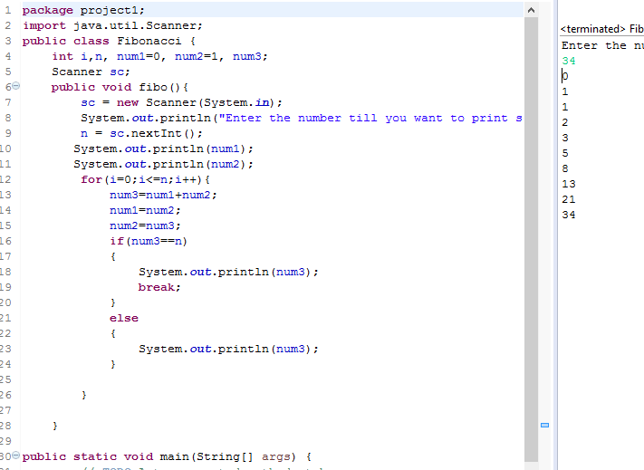

**3. Pattern programs:**

**public** **class** Pattern {

**int** i,j,k;

**public** **void** pttrn()

{

**for**(i=0; i<=6; i++)

{

System.***out***.println(" ");

**for**(j=6; j>=i; j--)

{

System.***out***.print("*");

}

}

System.***out***.println(" ");

}

**public** **static** **void** main(String[] args) {

// **TODO** Auto-generated method stub

Pattern ob=**new** Pattern();

ob.pttrn();

}

}

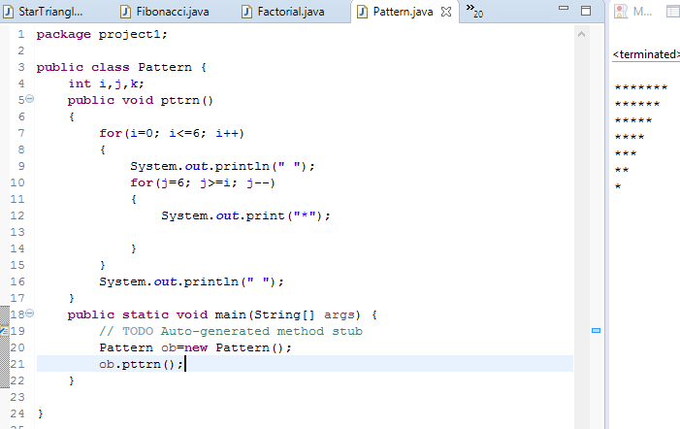

**public** **class** Triangle

{

**public** **static** **void** main(String[] args)

{

**int** i,j,k;

**for**(i=1; i<=5; i++)

{

**for**(j=4; j>=i; j--)

{

System.***out***.print(" ");

}

**for**(k=1; k<=(2*i-1); k++)

{

System.***out***.print("*");

}

System.***out***.println("");

}

}

}

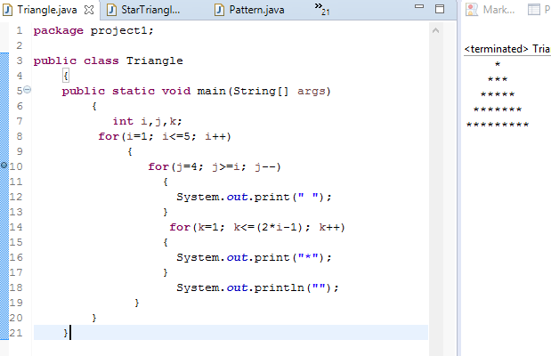

**4.String Manipulation:**

**1. String Creation:**

**public** **class** StringCreation {

**int** i=0, vowels=0, digits=0, count=0 ;

**public** **void** StCr()

{

String text1 ="happy new year";

String text2=" you";

//"hlo" is used to print

//the string and it is just a variable

**for** (**int** i = 0; i < text1.length(); i++)

{

**char** ch1 = text1.charAt(i);

**if** (ch1 == 'a' || ch1 == 'e' || ch1 == 'i' || ch1 == 'o' || ch1 == 'u' ||

ch1 == 'A' || ch1 == 'E' || ch1 == 'I' || ch1 == 'O' || ch1 == 'U')

{

count++;

System.***out***.println("no. of vowels in the string:"+count);

}

}

System.***out***.println(text1);

System.***out***.println(text1.toUpperCase());

System.***out***.println

(text1.substring(0,1).toUpperCase()+text1.substring(1).toLowerCase());

System.***out***.println("length of the string is:"+text1.length());

//include spaces

**if**(text1.isEmpty());

//"isEmpty()" used to check if there is any string or not

{

System.***out***.println("no string is there");

}

String ansr1=text1.concat(" to").concat(text2);

String ansr2=text1+" to mam";

//.concat() is used to concatenate two strings

System.***out***.println(ansr1);

System.***out***.println(ansr2);

**int** index=text1.charAt(4);

//count index from ZERO.

//here the value should be same in charAt(). why???

**char** ch=text1.charAt(4);

**int** indexof=text1.indexOf('p');

//if repeatation of char is there like "p"

//so it will take the first.??

**int** lastindexof=text1.lastIndexOf('p');

System.***out***.println("ASCII value is:"+index);

System.***out***.println("value at 4th place:"+ch);

System.***out***.println("index of p is:"+indexof);

System.***out***.println("lastindexof p is:"+lastindexof);

//it is used for repeated characters and

//it will find the index of last repated char

//present at the end of the string

//and it will include spaces.

}

**public** **static** **void** main(String []args)

{

StringCreation ob=**new** StringCreation();

ob.StCr();

}

}

**Output:**

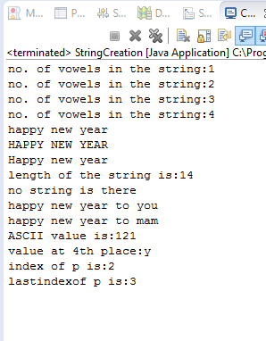

**2.String Replace:**

**public** **class** StringReplace {

String str="Be calm and Stay positive";

**public** **void** StRe()

{

System.***out***.println("String is:"+str);

String replaceString=str.replace("calm","aggresive");

String replaceString1=str.replace("positive","focused");

//String replaceString2=str.replace("","******");

System.***out***.println(replaceString);

System.***out***.println(replaceString1);

//System.out.println(replaceString2);

}

**public** **static** **void** main(String[] args) {

// **TODO** Auto-generated method stub

StringReplace sr=**new** StringReplace();

sr.StRe();

}

}

**Output:**

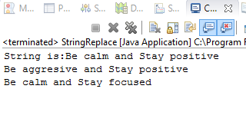

**3.String Reverse:**

**public** **class** StringReverse {

String str="My silence doesn't mean i agree with you,"

+ "it means your level of stupidity rendered me speechless ";

**public** **void** StRe()

{

System.***out***.println("String is:"+str);

String reverse=**new** StringBuffer(str).reverse().toString();

System.***out***.println(reverse);

}

**public** **static** **void** main(String[] args) {

// **TODO** Auto-generated method stub

StringReverse ob1=**new** StringReverse();

ob1.StRe();

}

}

**Output:**

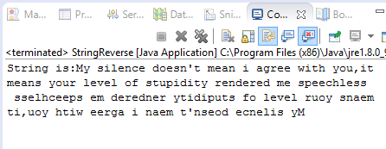

**5.Append Data To file:**

**import java.io.*;**

**import java.util.Scanner;**

**public class AppendToFileExample {**

**Scanner sc=new Scanner(System.in);**

**public void writedata() throws IOException**

**{**

**String name, rollno;**

**name=sc.nextLine();**

**rollno=sc.nextLine();**

**//System.out.println("name:"+name);**

**//System.out.println("roll no:"+rollno);**

**File f1=new File("E:/demo.txt");**

**//System.out.println("Enter the data to file");**

**//byte b[]=getBytes(b);**

**if(!f1.exists())**

**{**

**f1.createNewFile();**

**//System.out.println("Appending file");**

**}**

**FileWriter fileWritter = new FileWriter(f1.getAbsolutePath(),true);**

**BufferedWriter bw = new BufferedWriter(fileWritter);**

**//String data="good morning";**

**bw.write(name);**

**System.out.println();**

**bw.write(rollno);**

**System.out.println();**

**//bw.write(data);**

**bw.close();**

**System.out.println("Done");**

**}**

**public static void main(String args[]) throws IOException**

**{**

**AppendToFileExample obj=new AppendToFileExample();**

**obj.writedata();**

**}**

**}**

**Output:**

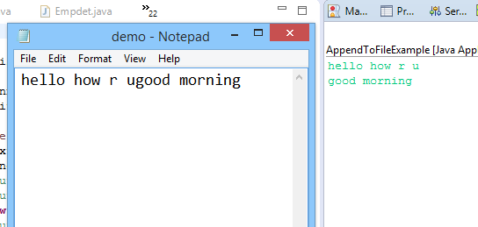

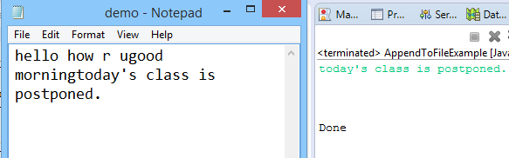

**6. Exception Handling:**

**import java.util.InputMismatchException;**

**import java.util.Scanner;**

**public class ExceptionHandling {**

**int num1, num2, res;**

**public void acceptdet()**

**{**

**try //try with multiple catch blocks**

**{**

**Scanner sc=new Scanner(System.in);**

**System.out.println("enter value of num1");**

**num1=sc.nextInt();**

**System.out.println("enter value of num2");**

**num2=sc.nextInt();**

**res=num1/num2; //checked exception automatically handled**

**System.out.println(res);**

**}**

**catch(InputMismatchException e)**

**{**

**//e.printStackTrace();**

**System.out.println("enter any integer value ");**

**}**

**catch(ArithmeticException e1)**

**{**

**System.out.println("no. can not be divide by zero");**

**}**

**finally**

**{**

**System.out.println("closing program");**

**}**

**}**

**public static void main(String[] args) {**

**// TODO Auto-generated method stub**

**ExceptionHandling ob=new ExceptionHandling();**

**ob.acceptdet();**

**}**

**}**