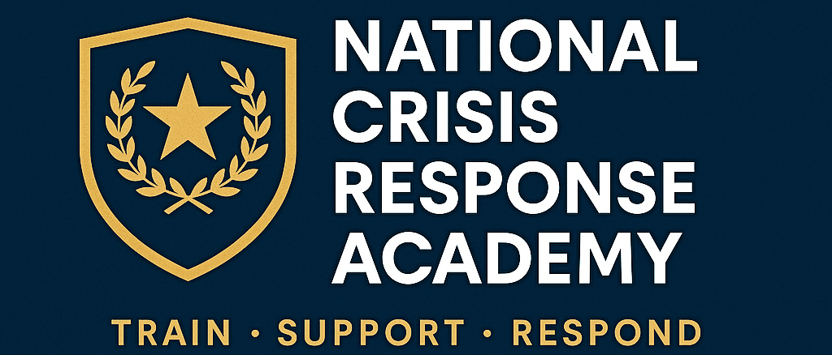

National Crisis Response Academy

Program Overview Flyer Packet

[Insert Logo / Branding Here]

# Standard 40-Hour Crisis Intervention Training (CIT)

Overview:  
Our flagship 40-hour training equips law enforcement officers with the knowledge, skills, and confidence to effectively respond to individuals in crisis. Based on the nationally recognized Memphis Model, this program emphasizes de-escalation, diversion, and officer safety.

## Core Modules

- Understanding Mental Illness and Substance Use Disorders  
- Legal Responsibilities and Crisis Response Policies  
- Communication Skills and Verbal De-escalation Techniques  
- Tactical Safety in Crisis Situations  
- Role-Play Scenarios (schizophrenia, suicide, substance crises, PTSD)  
- Building Community Partnerships (NAMI, hospitals, clinicians)

## Who Should Attend

Patrol officers, supervisors, corrections officers, and dispatchers

## Outcomes

- Reduced use-of-force incidents  
- Increased diversion to treatment  
- Safer outcomes for officers and community

# Youth Crisis Intervention Training (Youth CIT)

Overview:  
Specialized for officers responding to youth in crisis, this 40-hour program addresses the unique needs and challenges of children and adolescents experiencing mental health episodes.

## Core Modules

- Child & Adolescent Development and Mental Health  
- Recognizing Signs of Trauma and Stress in Youth  
- Family & School Dynamics in Crisis Response  
- De-escalation Strategies Tailored to Youth  
- Role-Plays: school-based incidents, suicidal ideation, runaway youth  
- Coordinating with Juvenile Justice, Schools, and Child Services

## Who Should Attend

School resource officers, juvenile justice officers, patrol officers, supervisors

## Outcomes

- Safer youth-police interactions  
- Improved diversion to school- and community-based supports  
- Reduced juvenile detention rates for youth in crisis

# Advanced De-Escalation & Escalation Prevention Training

Overview:  
Designed for officers who have completed CIT or equivalent, this advanced course deepens skills in preventing crises before they escalate and refining tactical de-escalation strategies.

## Core Modules

- Advanced Communication Psychology in Crisis Response  
- Tactical Intervention Timing: Knowing when to engage vs. contain  
- De-escalation Under Stress: Managing officer mindset  
- Escalation Prevention through Scene Control & Command Presence  
- Role-Plays: High-risk scenarios, group crises, armed individuals  
- Peer-to-Peer Coaching and Leadership in Crisis Response

## Who Should Attend

CIT-trained officers, crisis negotiators, supervisors, and field training officers

## Outcomes

- Fewer high-risk encounters escalating to force  
- Enhanced supervisory leadership in crisis incidents  
- Stronger culture of de-escalation within the agency

# Contact Us

National Crisis Response Academy  
[Your Name], Founder & Director  
📞 [Your Phone] | 📧 [Your Email] | 🌐 [Your Website]  
[Insert Address / Branding Here]