# VIVEKANANDA COLLEGE OF ENGINEERING & TECHNOLOGY

[A Unit of Vivekananda Vidyavardhaka Sangha, Puttur (R)]

Affiliated to Visvesvaraya Technological University and Approved by AICTE New Delhi & Govt. of Karnataka

Nehru Nagara, Puttur – 574 203, DK, Karnataka, India

# DEPARTMENT OF MASTER OF COMPUTER APPLICATIONS

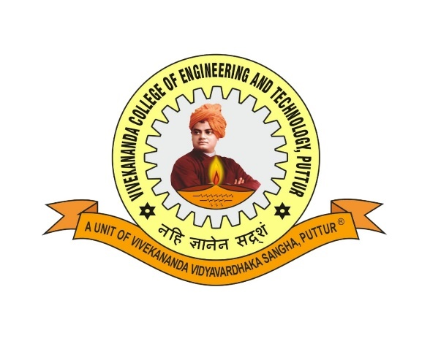

CERTIFICATE

Certified that the project work entitled **STUDENT PERFORMANCE ANALYSIS,** carried out by **RAMYA K, 4VP23MC023** a bonafide student of **VIVEKANANDA COLLEGE OF ENGINEERING & TECHNOLOGY, PUTTUR**, in partial fulfillment for the award of **MASTER OF COMPUTER APPLICATIONS** under **VISVESVARAYA TECHNOLOGICAL UNIVERSITY, BELAGAVI** during the year 2024 – 25. The project has been approved as it satisfies the academic requirements in respect of Mini-Project work prescribed for 3rd Semester **Data Analytics Lab with Mini-Project (22MCAL36)** in Master of Computer Applications Degree.

**Prof. Ramesha K Faculty in-charge**

**Dr. Jothimani K Director-MCA**

**EXTERNAL EXAMINERS**

Name of the Examiners Signature with date

1…………………………….............. ....................................

2…………………………….............. ....................................