# Food Truck Viability in Los Angeles

# Introduction

## Business Problem

In this project we will try to find the viability to establish a food truck in Los Angeles, specifically in Pershing Square. This report will be targeted to stakeholders interested in opening a Food Truck in Los Angeles, California.

## Interest

Since there are lots of Food Trucks and restaurants in Los Angeles we will try to detect the locations of all Restaurants and Food Trucks nearby, this way we can see if the chosen location is a viable point for a new Food Truck.

# Data

Based on definition of our problem, factors that will influence our decision are:

- number of existing restaurants in the neighborhood (any type of restaurant)

- number of existing food trucks in the neighborhood

Following data sources will be needed to extract/generate the required information:

- number of restaurants and food trucks and their type and location in every neighborhood will be obtained using Foursquare API

- coordinate of Pershing Square in Los Angeles will be obtained using Foursquare API

# Methodology

In this project we will direct our efforts on detecting restaurant density near the selected point chosen to put the Food Truck. We will limit our analysis to an area of 1km around Pershing Square.

In first step we have collected the required data: location and type (category) of every restaurants and Food Trucks within 1km from Pershing Square.

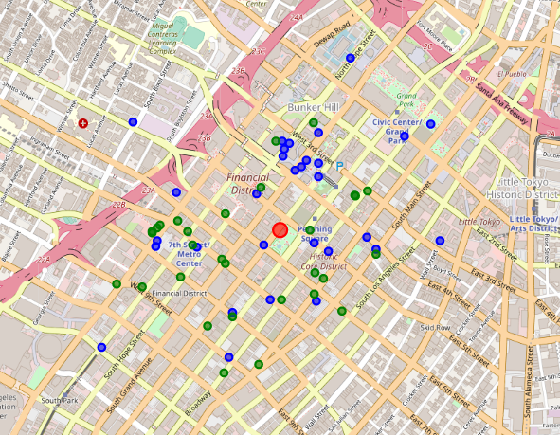

Second step in our analysis will be calculation and exploration of 'restaurant density' around Pershing Square - we will use heatmaps to identify the areas with the high number of restaurants nearby.

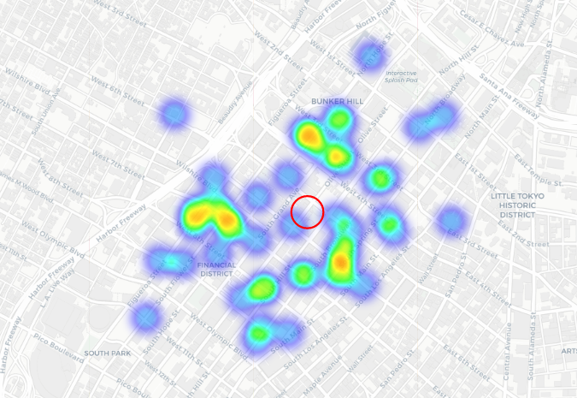

In third and final step we will focus on the areas with more restaurants or Food Trucks and within those create the clusters (using k-means clustering) of those locations to identify the quantity and distance between the restaurants and food trucks. This would tell us the business need for restaurants in those areas.

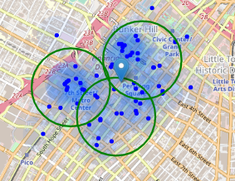

# Results and Discussion

Our analysis shows that the number of restaurants and food trucks in Los Angeles around Pershing Square (in an area of interest which was 1x1km) was only 60.

The Highest concentration of restaurants was detected north and west from Pershing Square and the lowest density is located in the east from Pershing Square. So we can tell that there are a low density of restaurants and food trucks near Pershing Square.

Despised the lowest density of restaurants nearest to Pershing Square the nearest Restaurant was 166.7 mts and the nearest Food Truck was 120.75 mts close to our desire food truck location.

We divided the data in 3 clusters using K-means, this location contain a greatest number of restaurants and food trucks. Pershing Square is between 2 clusters.

# Conclusion

The purpose of this project was to identify the areas of Los Angeles close to Pershing Square who has restaurants and food trucks in order to aid stakeholders in narrowing down the search for possible direct competition for the new food truck. By calculating restaurants and food trucks density distribution from Foursquare data we have first identified general boroughs that justify further analysis, and then generated extensive collection of locations which satisfy some basic requirements regarding existing nearby restaurants and food trucks. Then it was performed a clustering of those locations in order to create major zones of interest (containing greatest number of zones with restaurants and food trucks) and addresses of those zone centers were created to be used as starting points for final exploration by stakeholders.

Final decision on food truck location viability and food truck direct competition will be made by stakeholders based on specific characteristics of locations in the analyzed zone.