International Young Talents Exchange Program (CEP 2025)
Inventec Project
Local AI model deployment + dialogue page development

Objective: This plan is focuses on the full process of “local AI model deployment + dialogue page development”, from environment setup to final web interaction. Suitable for graduates with no work experience to quickly get started with practical operations.

Tools | Skills
Computer Windows/Mac/Linux  AI Ollama model deepseek-r1:1.5b | Python  HTML/CSS/JavaScript

This project is divides in two stages:

First one is: “Model Deployment and Basic Calling”
In this stage it’s about complete local deployment of Ollama and DeepSeek, the principal objective is realizing a command line/API calling.

Second one is: “Web Development and Model Integration”
In this stage it’s going to develop a simple dialogue page and relize the interaction between the front-end and back-end model.

Development steps
- Ollama Instalation
Install Ollama corresponding with system version from the official website. Before start with the code, we need to interact and understand the function of Ollama, so we can study it for a few minutes.

- Calling Ollama with Python
First, we need to install Python, then we need to create a new project. Additionally, we need install and use requests and json python package.
With the new project open we need to create a main function where we are going to program the way to call Ollama from the terminal from its local host.

Code:

#Date 2025/22/05 Inventec Project
#Name Project "Model Deployment and Basic Calling Ollama"
#Vanessa Nava Alberto

import requests
import json

def chat_Ollama():

print("---------------------------------------")
print("\n Ollama...Calling...\n")
print("---------------------------------------\n")

url_Ollama="http://localhost:11434/api/generate"
model="deepseek-r1:1.5b"

print("Ollama (model Deepseek-r1:1.5b)\n")
print("---------------------------------------")
print("Write 'Out' to exit...\n")

while True:
user_input=input("You: ")
if user_input.lower() in ["Out","Exit","Quit","out","exit","quit"]:
print("\nChat End\nSee you soon!\n")
print("---------------------------------------\n\n")
break

#Body
data={
"model":model,
"prompt":user_input
}

try:
#Call Post local to Ollama
response = requests.post(url_Ollama,json=data,stream=True)
response.raise_for_status()

#Print Ollama anwser
print("\nOllama:",end=" ",flush=True)
full_response = ""

#process anwser by line
for line in response.iter_lines():
if line:
json_data = json.loads(line.decode("utf-8"))
text_part=json_data["response"]
full_response += text_part
print(text_part,end="",flush=True)
elif json_data.get("done"):
break

print("\n")

except requests.exceptions.RequestException as e:
print(f"\nError to connect Ollama: {e}\n")

if __name__=="__main__":
chat_Ollama()

We can analize that in the code we have three fundamental parts:

First, we have the call to http://localhost:11434/api/generate that let us to connect with ollama, also behind that line we have declared the model that we are using “deepseek-r1:1.5b”.

Second, we have a try code block where we save the response of the prompt in response and it is processed line by line and decoded into utf-8 and save it again in full_response, after we will able to print the content on the terminal. The exception sends us a message in case if we have an error to connect with Ollama.

Third, we have the initialization of the function.

- HTML document creation

We write a simple code for a dialogue page with HTML. It needs to include: title, ollama model, input box, end button, dialogue area.

<!--Date 2025/22/05 Inventec Project
#Name Project "Model Deployment and Basic Calling Ollama"
#Vanessa Nava Alberto -->

<!DOCTYE html>
<!--Language-->
<html lang="en">

<head>
<!--Codification-->
<meta charset="UTF-8">
<meta name="viewport" content="width=device-width,initial-scale=1.0"/>

<title>Interface AI</title>

<!--Charge local files CSS-->
<link rel="stylesheet" href="style.css"/>
</head>

<body>
<div class="container">
<header>
<h1>IA Assistant</h1>
<p>Ollama DeepSeek-r1:1.5b</p>
</header>

<main id="chat-box">
<div class="message bot">
<div class="bubble">Hello! How can I help you today?</div>
</div>
</main>

<form id="chat-form">
<input
type="text"
id="user-input"
placeholder = "Write your question"
autocomplete = "off"
required/>
<button type = "submit" id="send-btn">Send</button>
</form>
</div>

<script src="script.js"></script>
</body>
</html>

We code just the basic information that we want to appear on the website. Also we add the chat box where user is going to interact with Ollama.

- Design and personalization of website

We create a css file to personalize our website using code, we can chose the colors and the shape of the chat.

/* Date 2025/22/05 Inventec Project
Name Project "Model Deployment and Basic Calling Ollama"
Vanessa Nava Alberto */

/*Principal staments*/
*{
margin:0;
padding:0;
box-sizing:border-box;
font-family:"Segoe UI", Roboto, Helvetica, Arial, sans-serif;
}

/*Back body*/
body{
background: linear-gradient(135deg,#20124d,#351c75);
color: #e2e8f0;
display: flex;
justify-content: center;
align-items: center;
height: 100vh;
}

/*Information container*/
.container {
width: 90%;
max-width: 650px;
height: 80vh;
background: #8e7cc3;
border-radius: 18px;
box-shadow: 0 0 30px rgba(0, 0, 0, 0.4);
display: flex;
flex-direction: column;
overflow: hidden;
}

/*Header of container*/
header{
padding: 16px;
text-align: center;
background: #4b0082;
color: #ffff;
}

header h1{
font-size: 1.6em;
margin-bottom: 4px;
}

/*Chat*/
main{
flex: 1;
padding: 20px;
overflow-y: auto;
display: flex;
flex-direction: column;
gap: 16px;
}

.message{
display: flex;
}

.message.user{
justify-content: flex-end;
}

.bubble{
max-width: 75%;
padding: 12px 16px;
border-radius: 16px;
line-height: 1.4;
animation: fadeln 0.3s ease;
}
.message.user .bubble{
background: #483d8b;
color: #fff;
border-bottom-right-radius:4px;
}

.message.bot .bubble{
background: #6a5acd;
color: #e2e8f0;
border-bottom-left-radius: 4px;
}

/*format*/
form{
display: flex;
padding: 12px;
background: #674ea7;
border-top: 1px solid #483d8b;
}

#user-input{
flex: 1;
padding: 10px 14px;
border: none;
border-radius: 8px;
background: #306;
color: #e2e8f0;
}

#user-input:focus{
outline: 2px solid #b4a7d6;
}

#send-btn{
margin-left: 8px;
padding: 10px 18px;
background: #b4a7d6;
border: none;
border-radius: 8px;
color: white;
cursor: pointer;
font-weight: 600;
transition: background 0.3s;
}

#send-btn:hover{
background: #b4a7d6;
}

/*animation*/
@keyframes fadenln{
form{opacity: 0; transform: translateY(10px);}
to {opacity: 1; transform: translateY(0);}
}

/*scrollbar*/
main::-webkit-scrollbar{
width: 6px;
}
main::-webkit-scrollbar-thumb{
background: #483d8b;
border-radius: 10px;
}

Here we can personalize the font, back body from the chat, headers form, position, messages bubbles, send button, margins, borders, opacity, etc.

- Interaction between front-end and back-end

To create interaction between the front-end and back-end, we need two additional files: a .js file and a .py file.
In .js file, we code the connection of the prompt that the users write on the website to send it to Ollama, while in the .py file, we call to local host of Ollama. In this python file, we need to work with flask and json.

Let’s analyze first the js file

const form = document.getElementById("chat-form");
const userInput = document.getElementById("user-input");
const chatBox = document.getElementById("chat-box");

form.addEventListener("submit",async(e)=>{
e.preventDefault();
const message = userInput.value.trim();
if (!message) return;

addMessage(message, "user");
userInput.value = "";

addMessage("Thinking...","bot");

try{
const response = await fetch("http://127.0.0.1:5000/chat",{
method:"POST",
headers:{
"Content-Type":"application/json",
},
body:JSON.stringify({prompt:message}),
});

const data = await response.json();

//Delete "Thinking..."
chatBox.removeChild(chatBox.lastElementChild);
addMessage(data.response, "bot");
} catch (error){
console.error("Error: ", error);
chatBox.removeChild(chatBox.lastElementChild);
addMessage("Error connecting to backend.","bot");
}
});

function addMessage (text, sender){
const messageDiv = document.createElement("div");
messageDiv.classList.add("message",sender);

const bubble = document.createElement("div");
bubble.classList.add("bubble");
bubble.textContent = text;

messageDiv.appendChild(bubble);
chatBox.appendChild(messageDiv);

chatBox.scrollTop = chatBox.scrollHeight;
}

With this code we are going to connect the cha

Now, let’s analyze the py file

from flask import Flask, request, jsonify
import requests
from flask_cors import CORS
import json

app = Flask(__name__)
CORS(app)

Ollama_URL = "http://localhost:11434/api/generate"
Model = "deepseek-r1:1.5b"

@app.route("/chat",methods=["POST"])
def chat():
data = request.get_json()
prompt = data.get("prompt","")

try:
response = requests.post(Ollama_URL,json={"model":Model,"prompt":prompt},stream=True)
full_response = ""

for line in response.iter_lines():
if line:
json_data = json.loads(line.decode("utf-8"))
text_part = json_data.get("response","")
full_response += text_part
elif json_data.get("done"):
break
return jsonify({"response":full_response.strip()})
except Exception as e:
return jsonify({"response":f"Error:{e}"}),500

if __name__=="__main__":
app.run(debug=True)

In the code we can analyze that we are using libraries like Flask, Json and requests, those libraries are a fundamental piece to create the connection between the local AI and the website.
The first thing that it is necessary to do it is make the call to Ollama with a request from the local host, and we need to up Ollama too service to make connection between website and local host.
In other hand we can look that in the code is a “post request” witch one ask for the users prompt and the model that Ollama is using. With that we wait the answer from Ollama and when it answer we show all the information to the user by the website.
There is a case if we can make correctly the connection with Ollama and it will appear on screen.

Running example
First we need to call ollama from local host
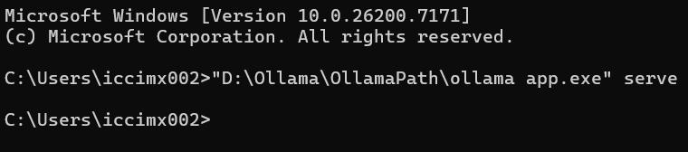

We verify connection from
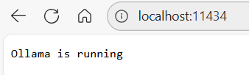

If we try to open and run the index.tml we are not going to have service
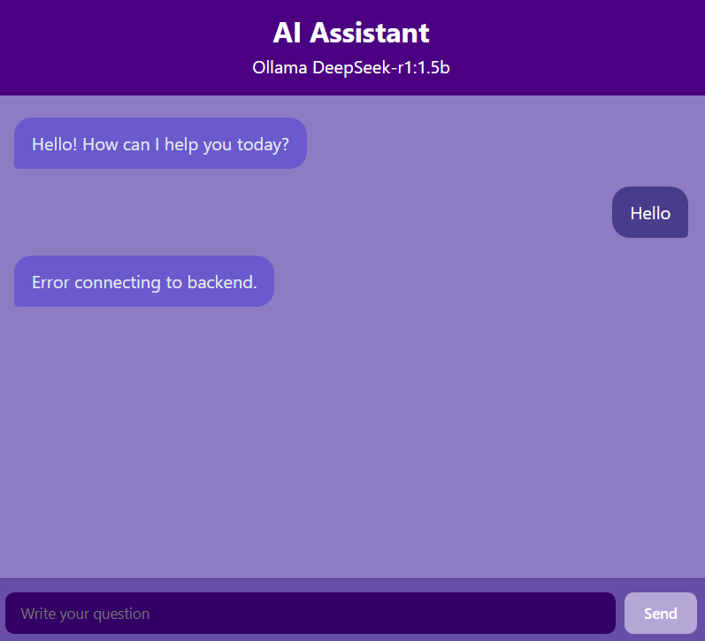

Because we need to create the connection between the local host and the website, so we nees to run serve.py

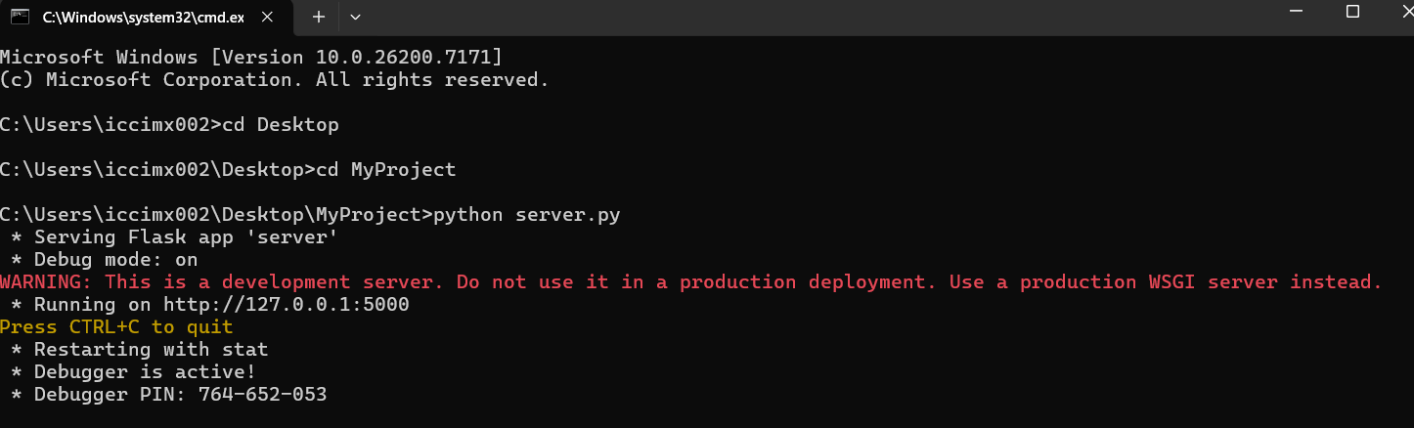

Finally we reset index.html and we can see that its working ollama without troubles.
