Assignment#3 Report

Name:Vaneeza Ahmad

Roll no: 21I0390

Section: A

BS(CS)

## Functional Dependencies:

The functional dependencies in different tables are listed as follows:

**Players:**

*Player_id ->First_Name, Last_Name, Nationality, DOB, Team_id, Jersey_Number, Height, Weight, Foot*

This is a full functional dependency.

*Jersey_Number->Position*

This is also a full functional dependency.

Player_id has partial functional dependency with position.

**Teams:**

*Team_Id ->Team_Name, Country, Home_stadium_id*

This is a full functional dependency.

**Stadiums:**

*Stadium_id -> Name, Country, Capacity*

This is full functional dependency.

*City -> Country*

This is also a full functional dependency.

*Stadium_id -> City*

This is partial functional dependency.

**Managers:**

*Manager_Id -> First_Name, Last_Name, Nationality, DOB, Team_id*

This is full functional dependency.

**Matches:**

*Match_id -> Season, Date_time, Home_team_id, Away_team_id, Stadium_id, Home_team_score, Away_team_score, Penalty_shoot_out, Attendance*

This is full functional dependency.

**Goals:**

*Goal_id -> Match_id, Pid, Duration, Assist, Goal_Desc*

This is a full functional dependency.

*{Match_id, Pid} -> Goal_id, Duration, Assist, Goal_Desc*

This is also a full functional dependency.

## Normalization:

The normal forms and normalization for all tables are as follows:

**1NF:**

The given tables in the data set are already in 1st normal form because no multivalued attributes.

**2NF:**

To remove partial dependencies from Players table and Stadiums table we can make separate tables for City and Jersey.

Where the City table has columns City_Name and Country_Name.

And the Jersey table has columns Jersey_Number and Position.

This will render our tables into the 2nd normal form.

**3NF:**

There are no transitional dependencies in the tables, hence all the tables are in 3rd normal form.

**BCNF:**

For all the above functional dependencies, the relationship, X->Y , when Y is prime attribute, X cannot be prime attribute, holds true. Hence the tables are in BCNF.

**QUERIES**

**QUERY 1:**

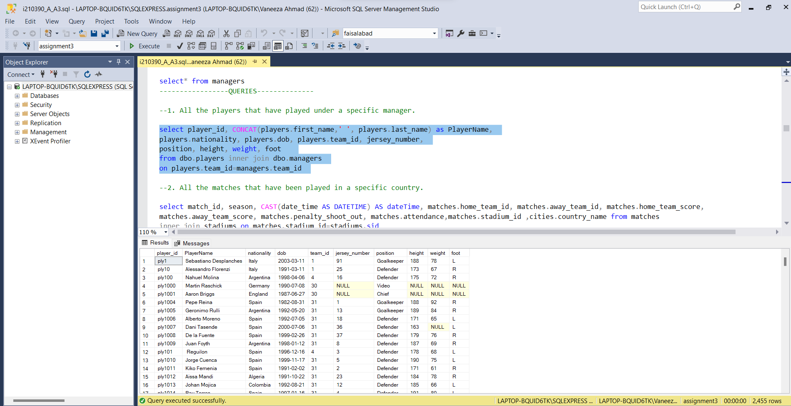

QUERY:2

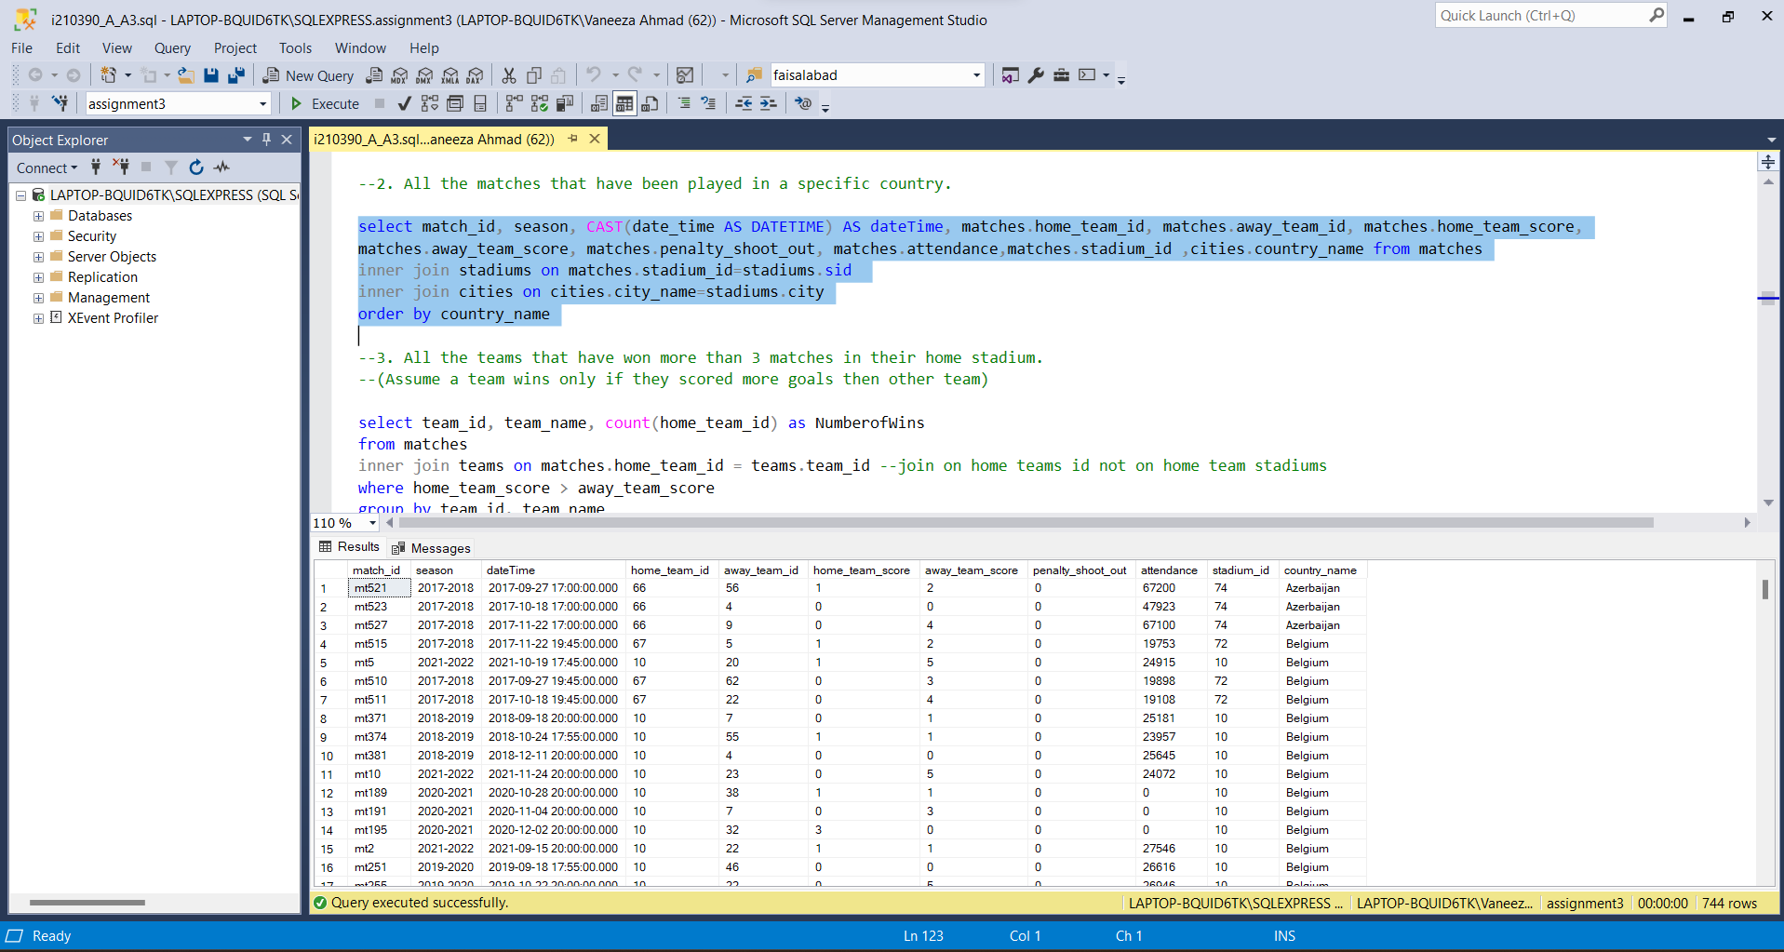

QUERY:3

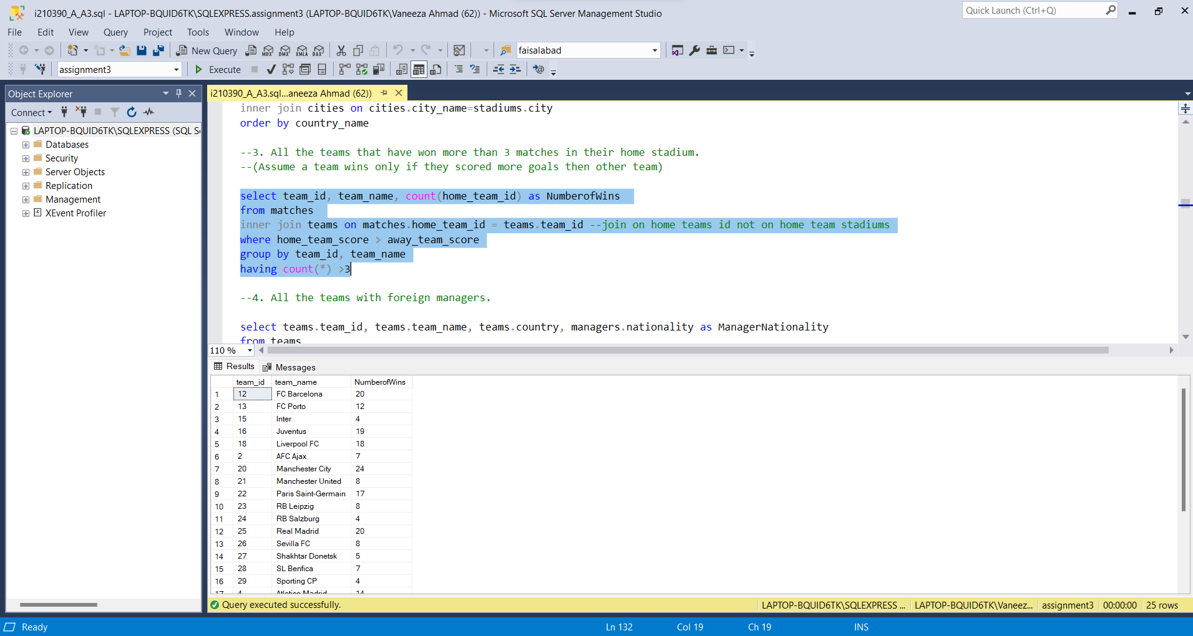

QUERY4:

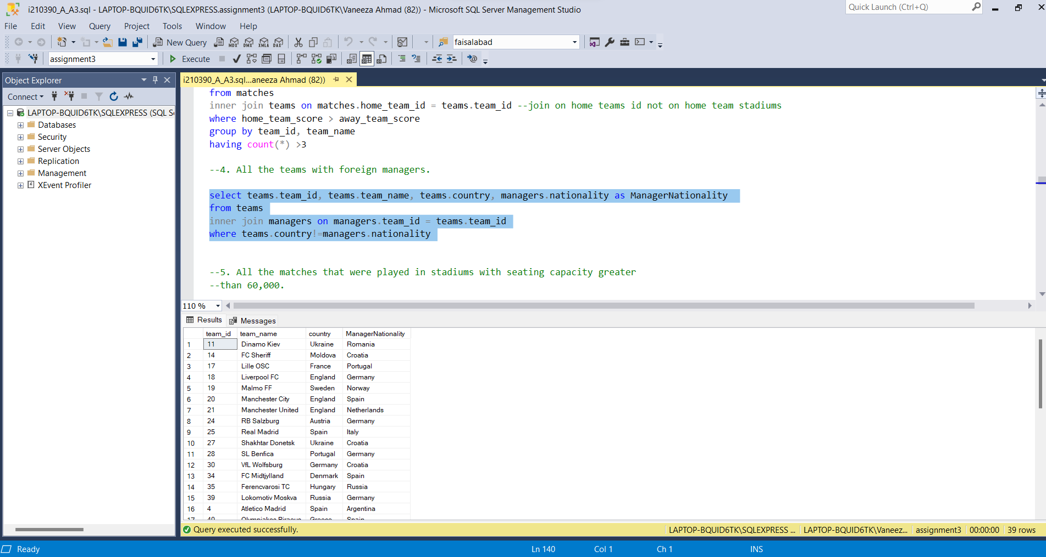

QUERY5:

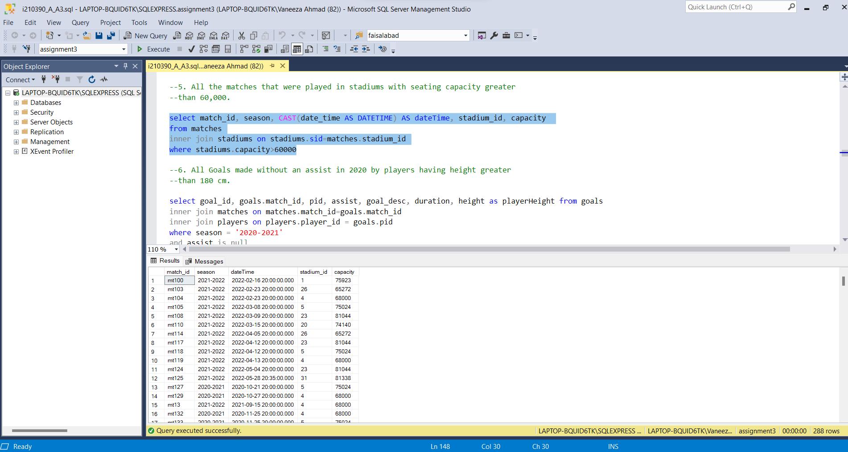

QUERY6:

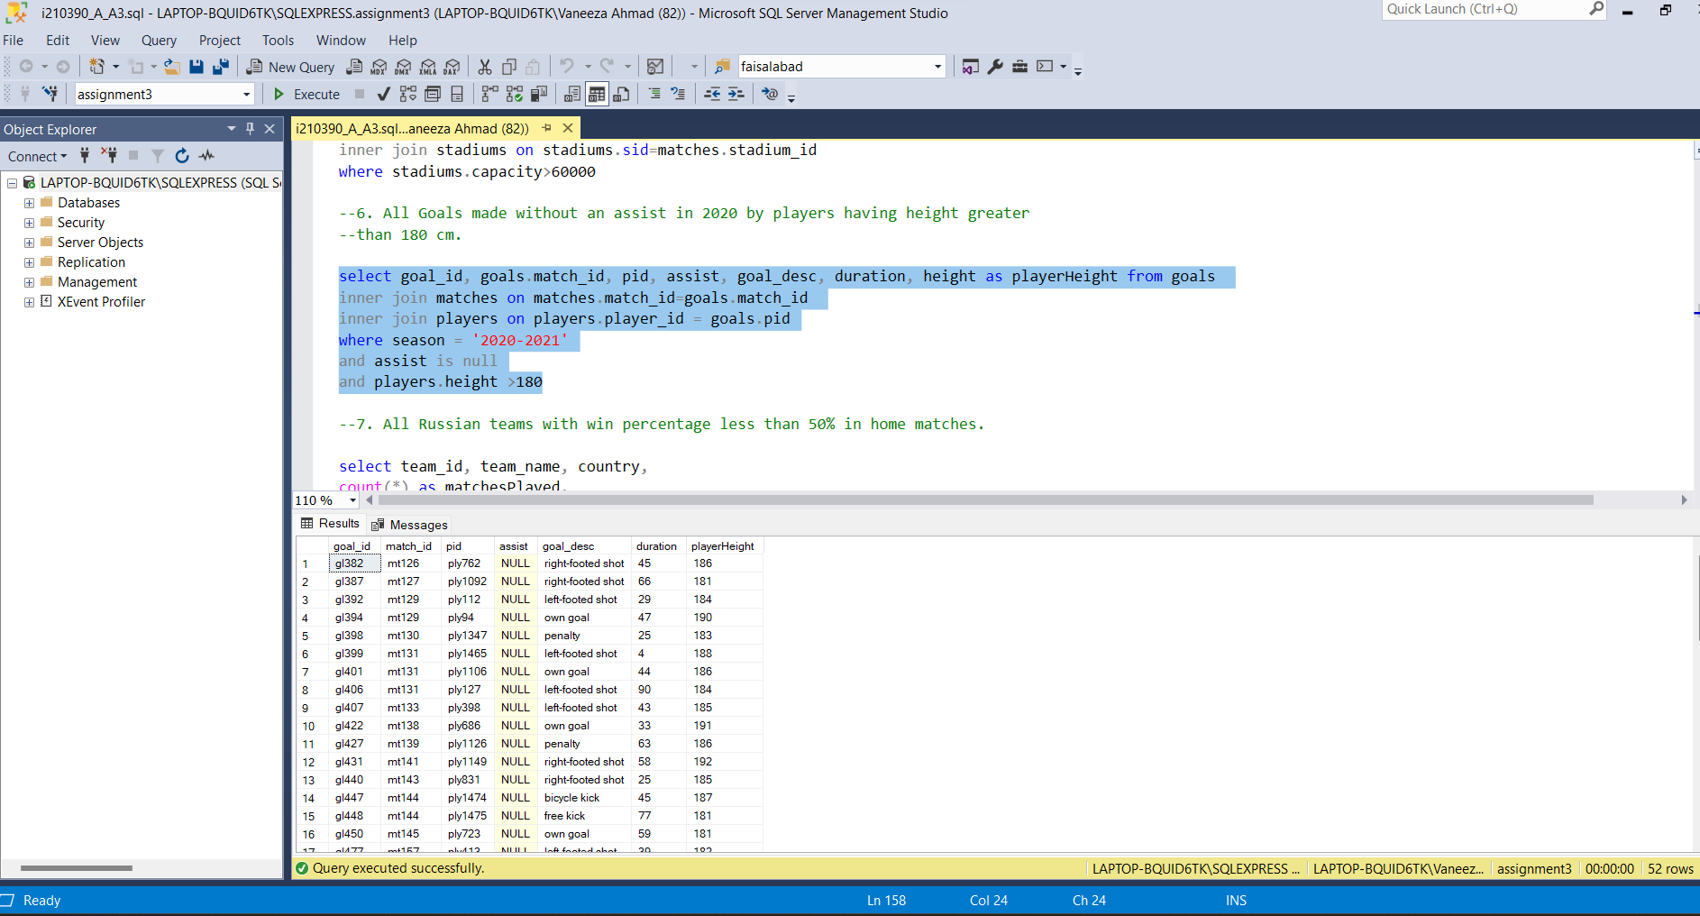

QUERY7:

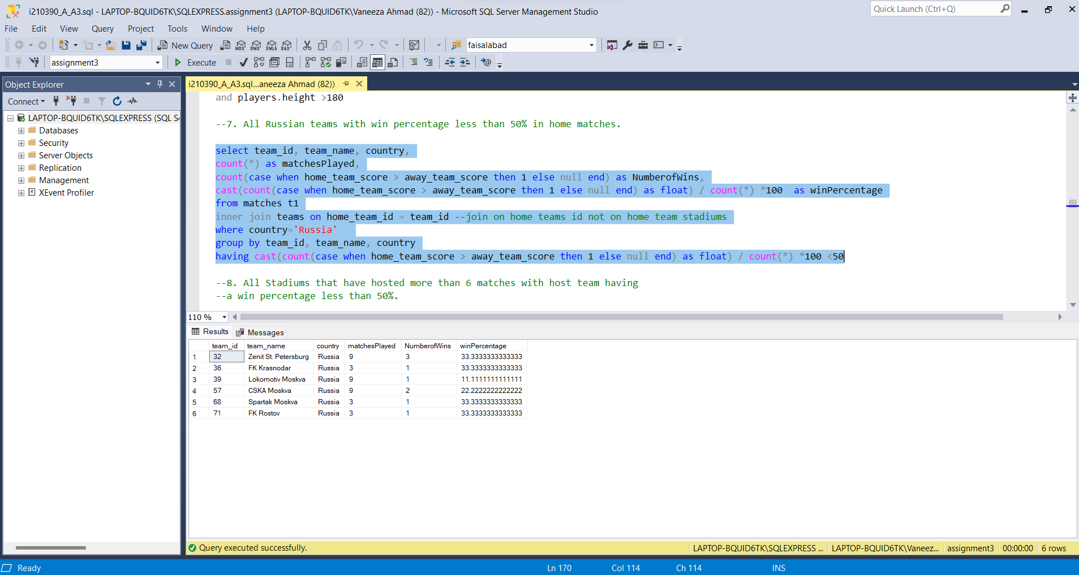

QUERY8:  
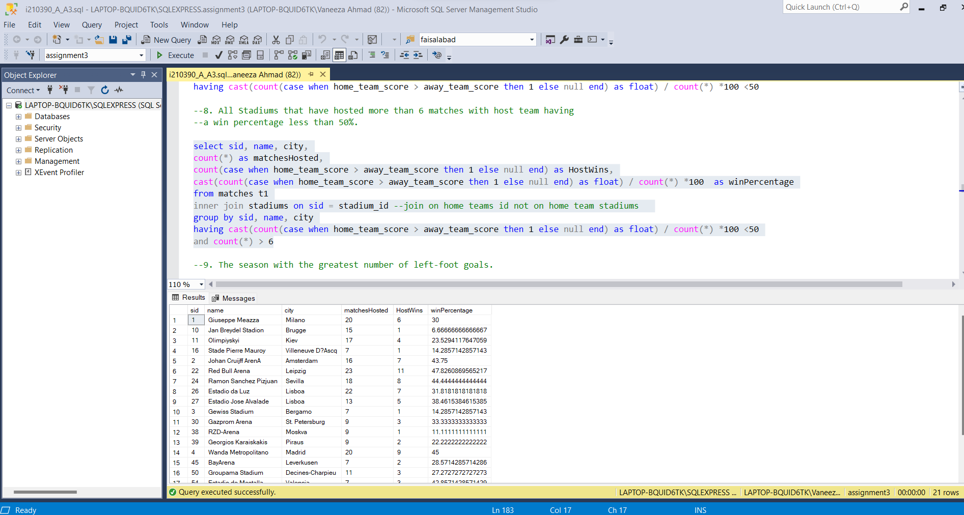

QUERY9:

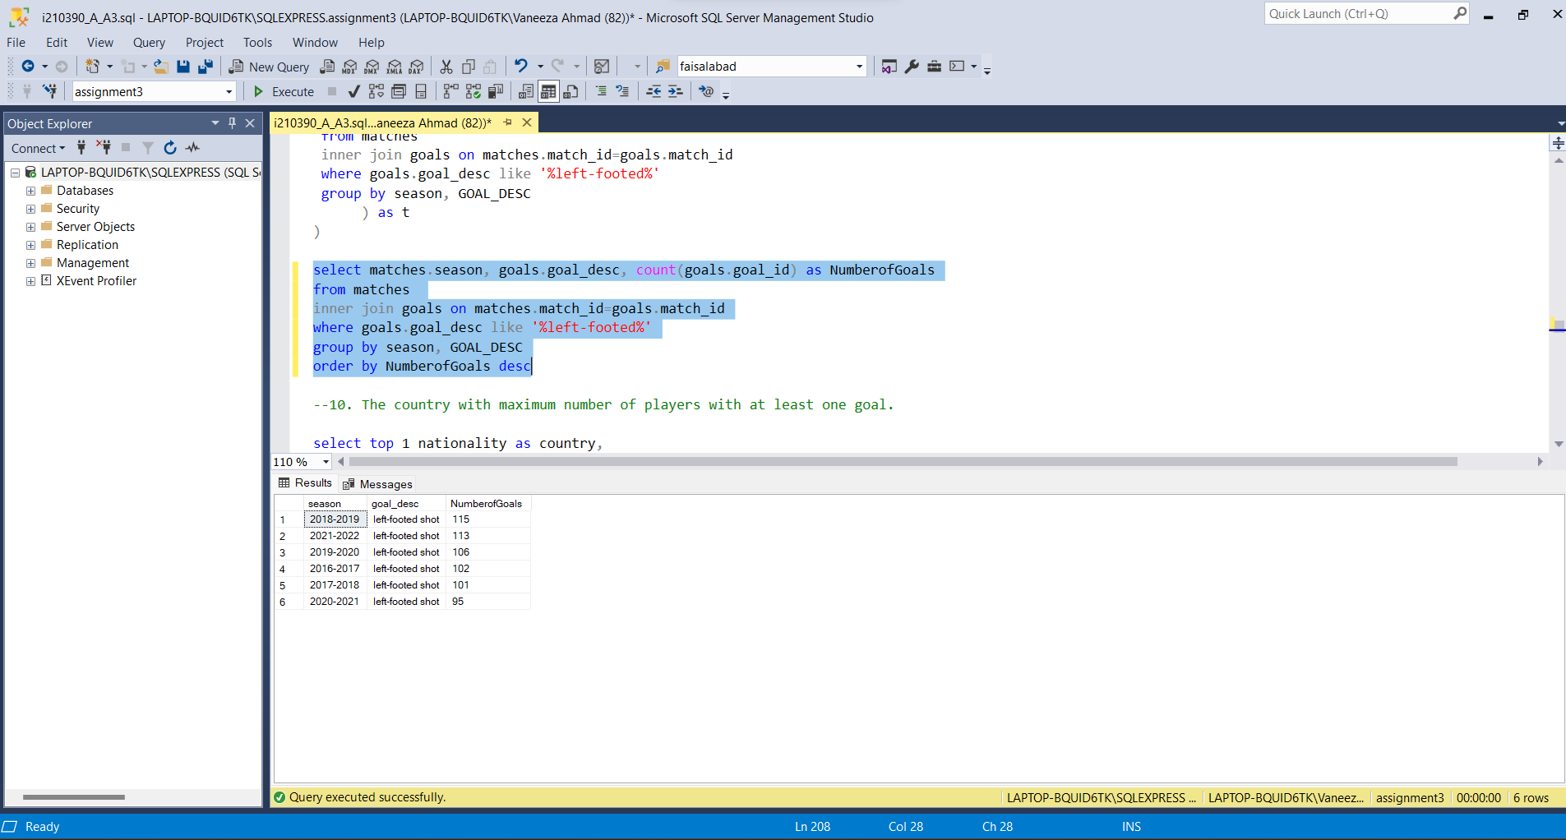

QUERY10:

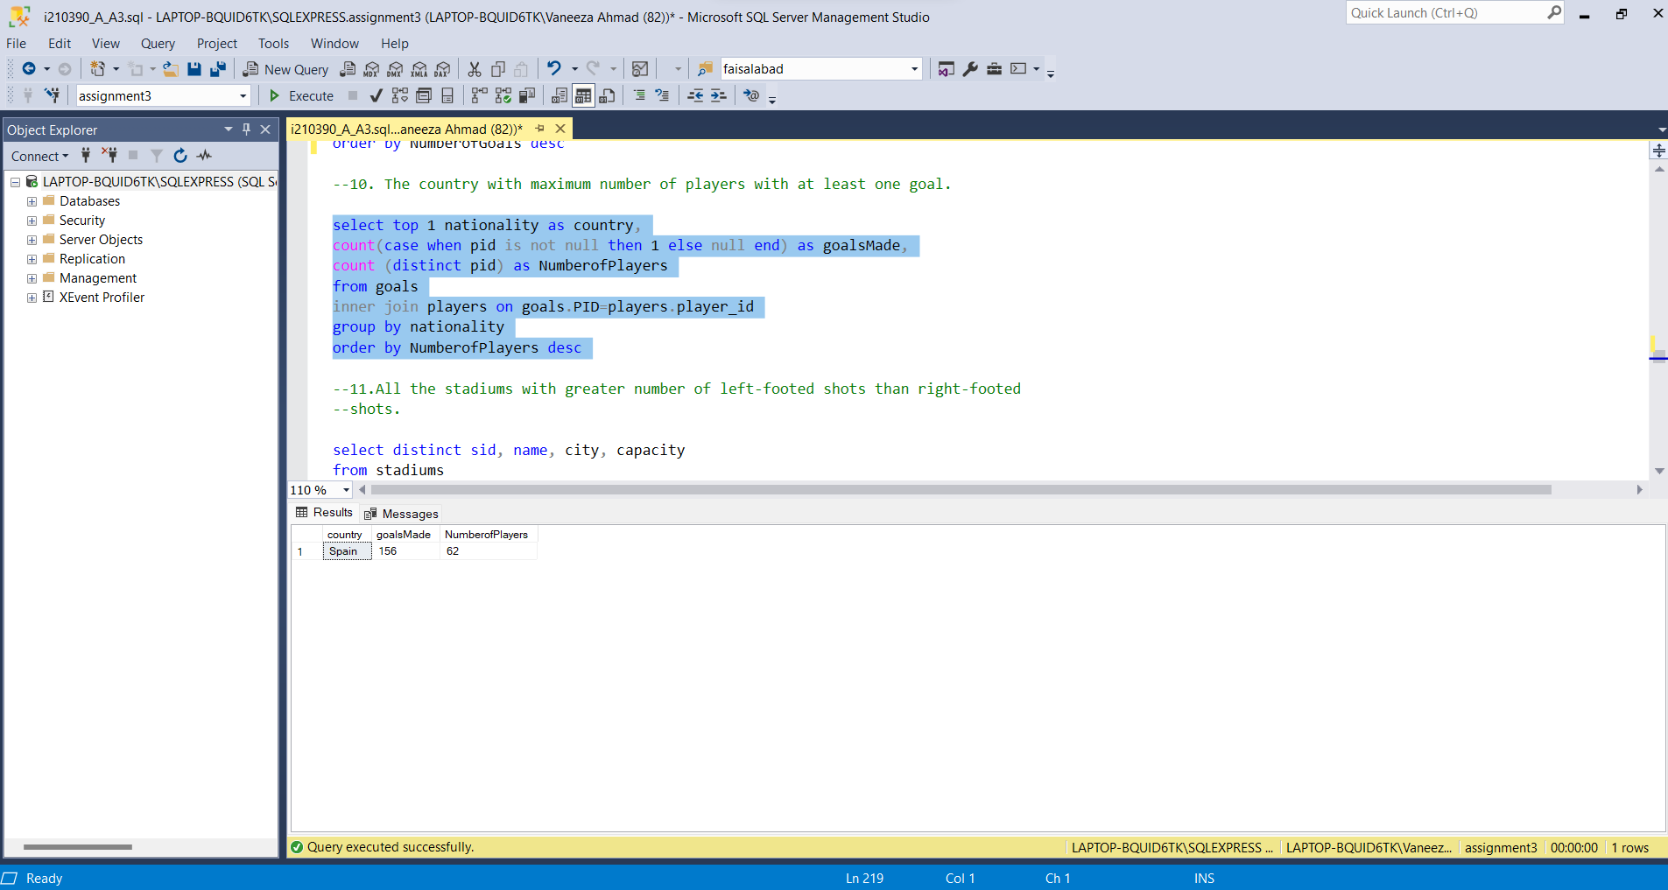

QUERY11:

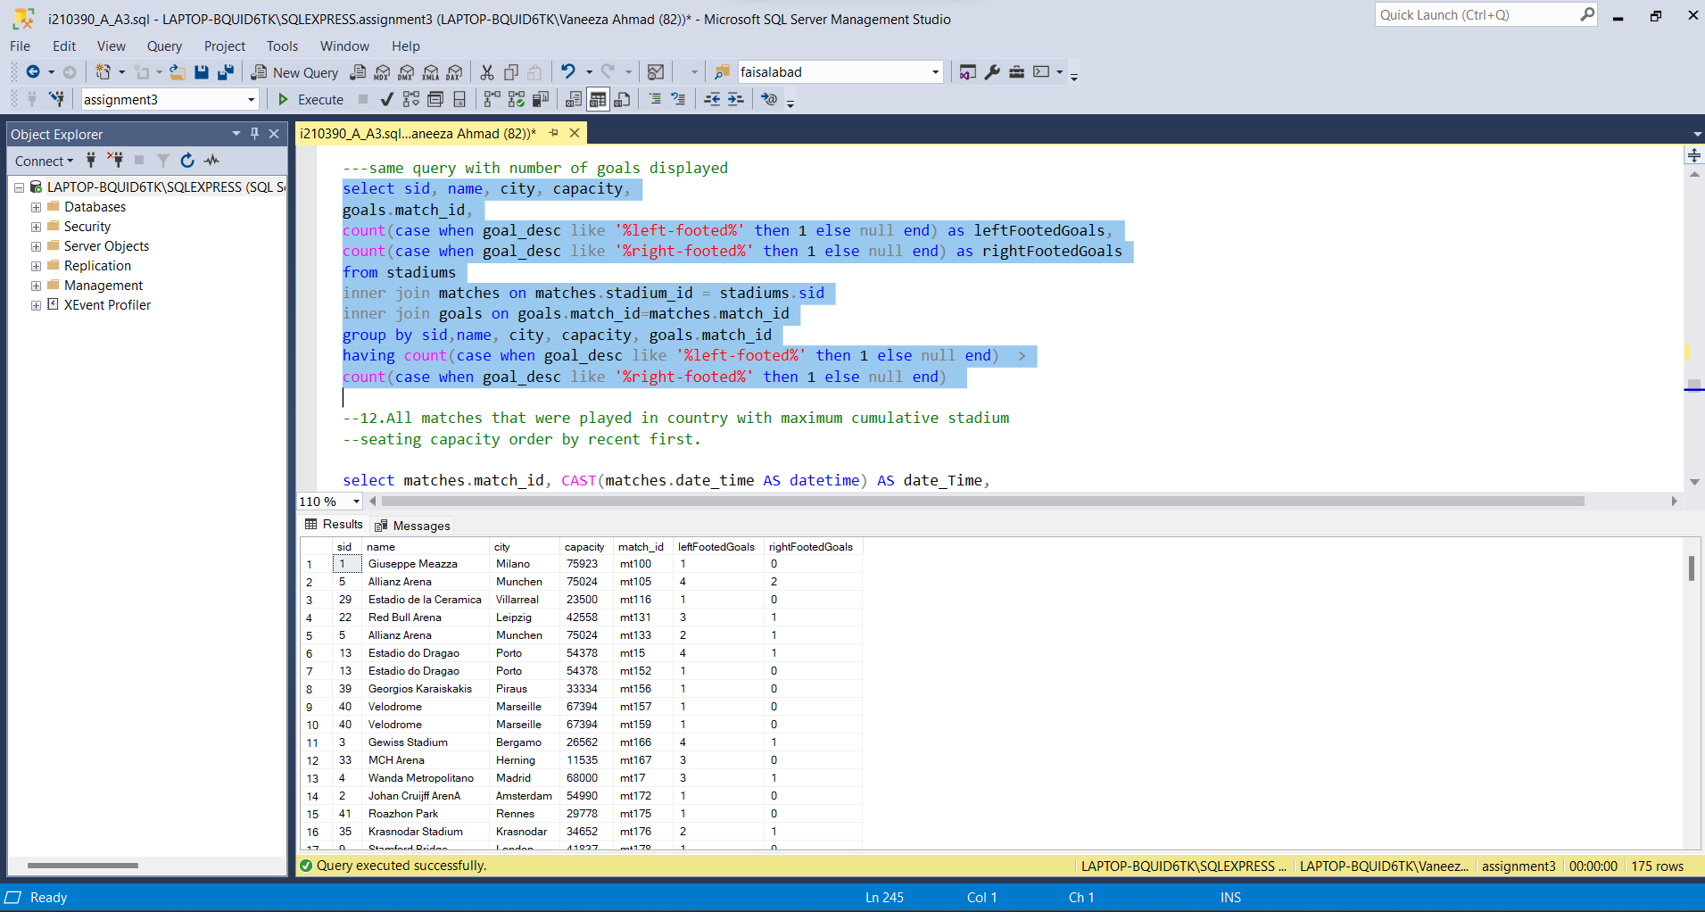

QUERY12:

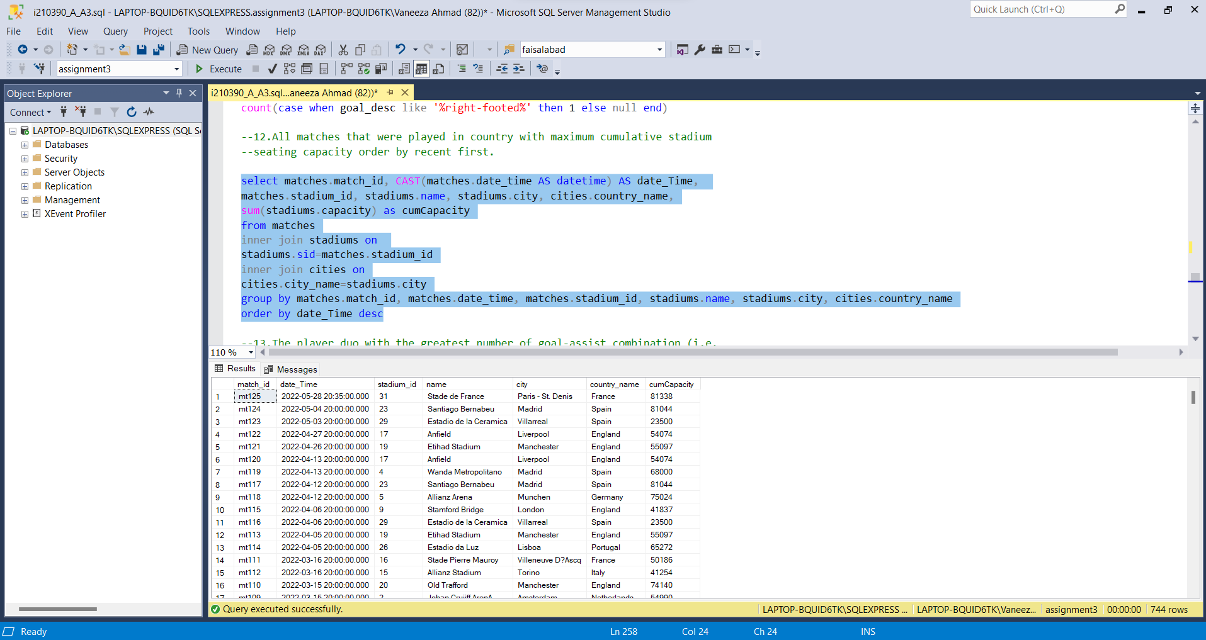

QUERY14:

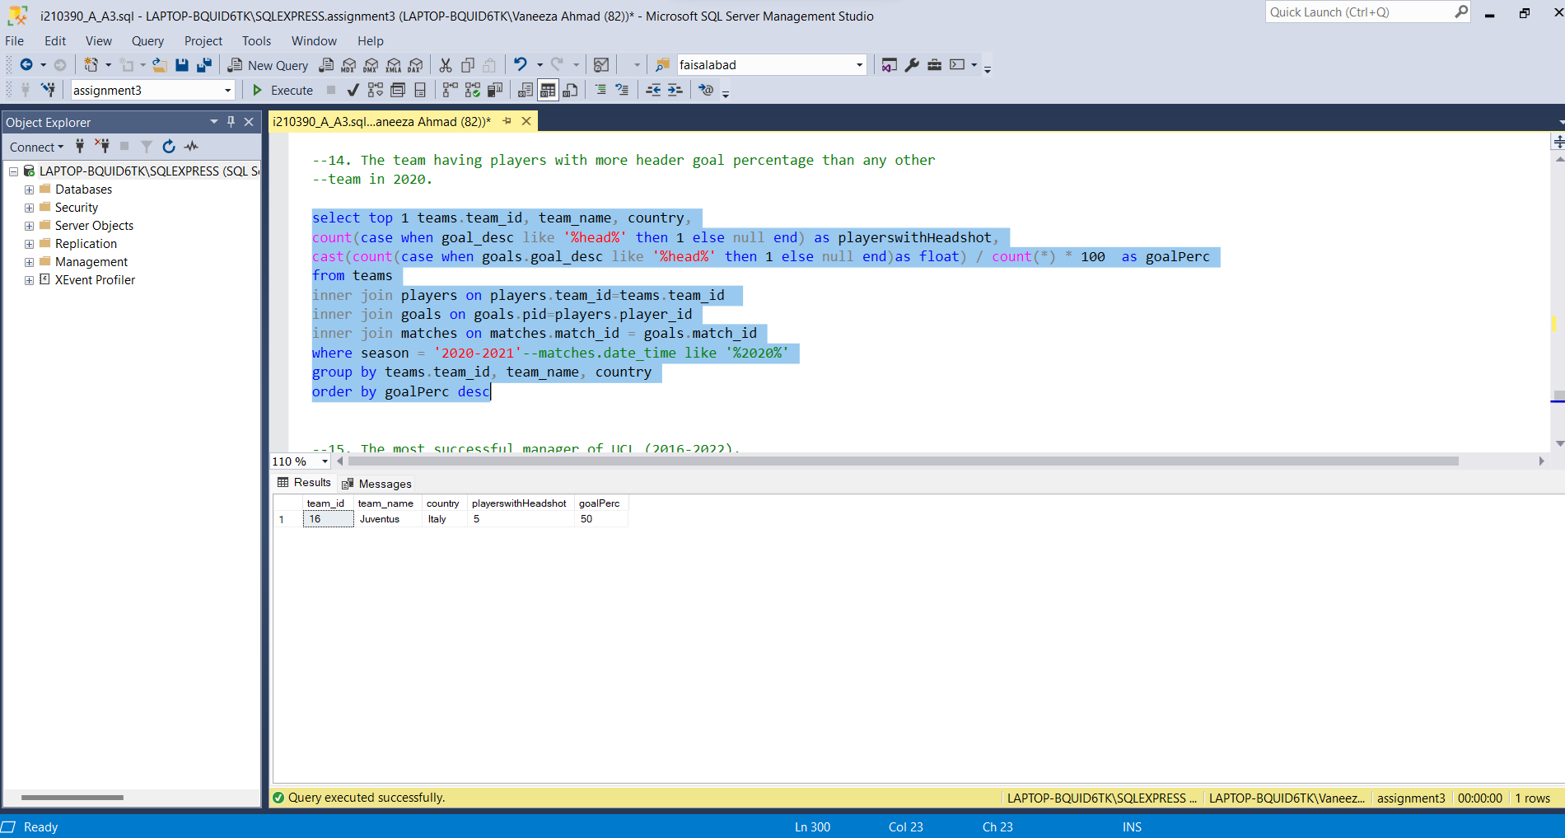

QUERY15:  
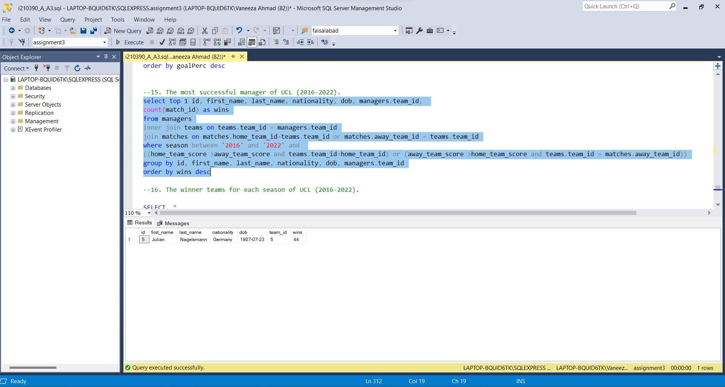

QUERY16:  
