**Microprocessor Lab**

Laboratory Activity No. 2

**Arduino and Tinkercad Interface**

|  |
| --- |
|  |

Score

*Submitted by:*

**Oliva, Vanessa A.**

**<Saturday 4 pm – 7 pm > / <CpE 0412-2 >**

*Date Submitted*

**16-09-2023**

*Submitted to:*

**Engr. Maria Rizette H. Sayo**

I. Objectives

This laboratory activity aims to implement the principles and techniques of hardware programming using Arduino through:

- creating an Arduino programming and circuit diagram.

II. Method/s

- Perform a task problem given in the presentation.

- Write a code and perform an Arduino circuit diagram of a ring counter that display eight (8)LEDs starting from left.

III. Results

**TinkerCad**

**Exercise 1: Write a code that does a ring counter display for eight (8) LEDs starting from left.**

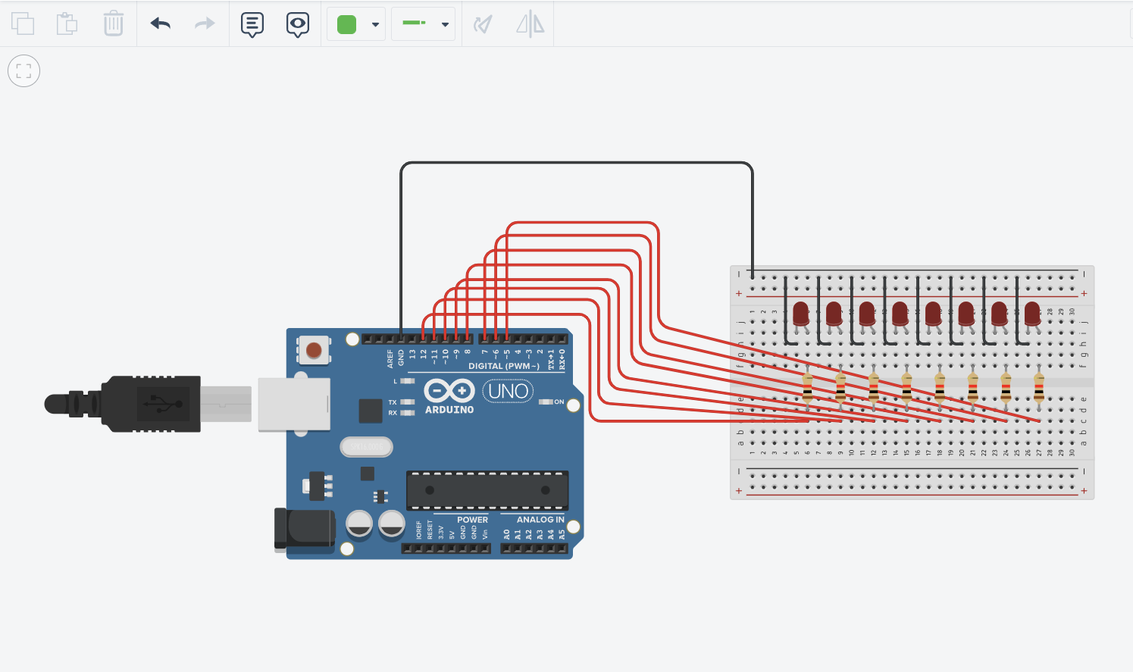

Figure No.1 Ring Counter Display Circuit Diagram

**Components Used**

1. 8 LEDs
2. Resistor
3. Breadboard

**CODE:**

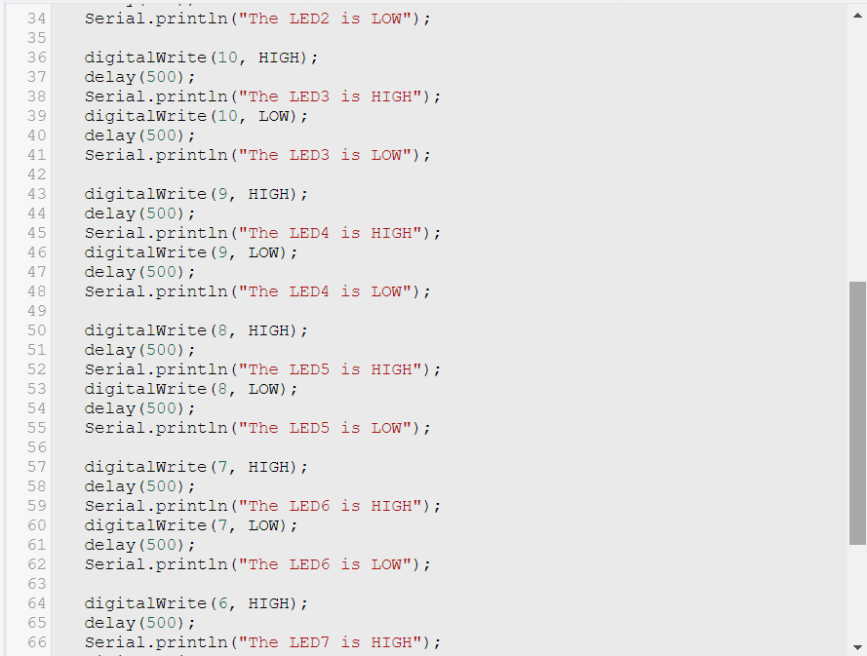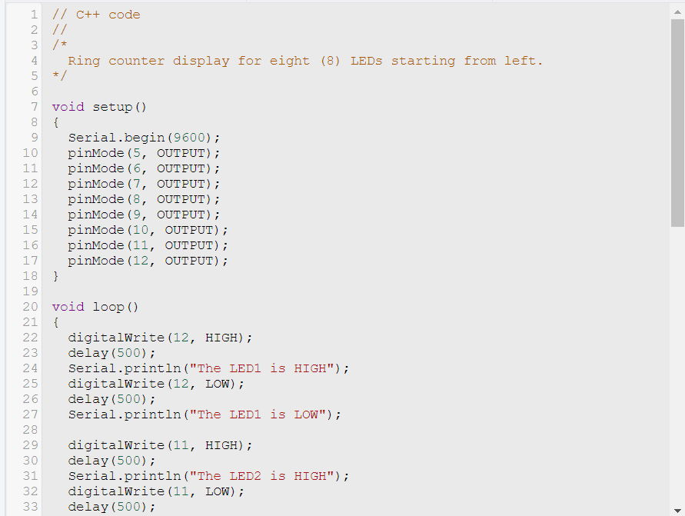

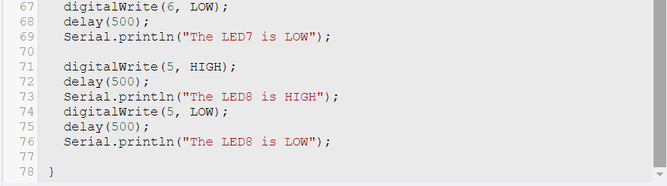

**OUTPUT:**

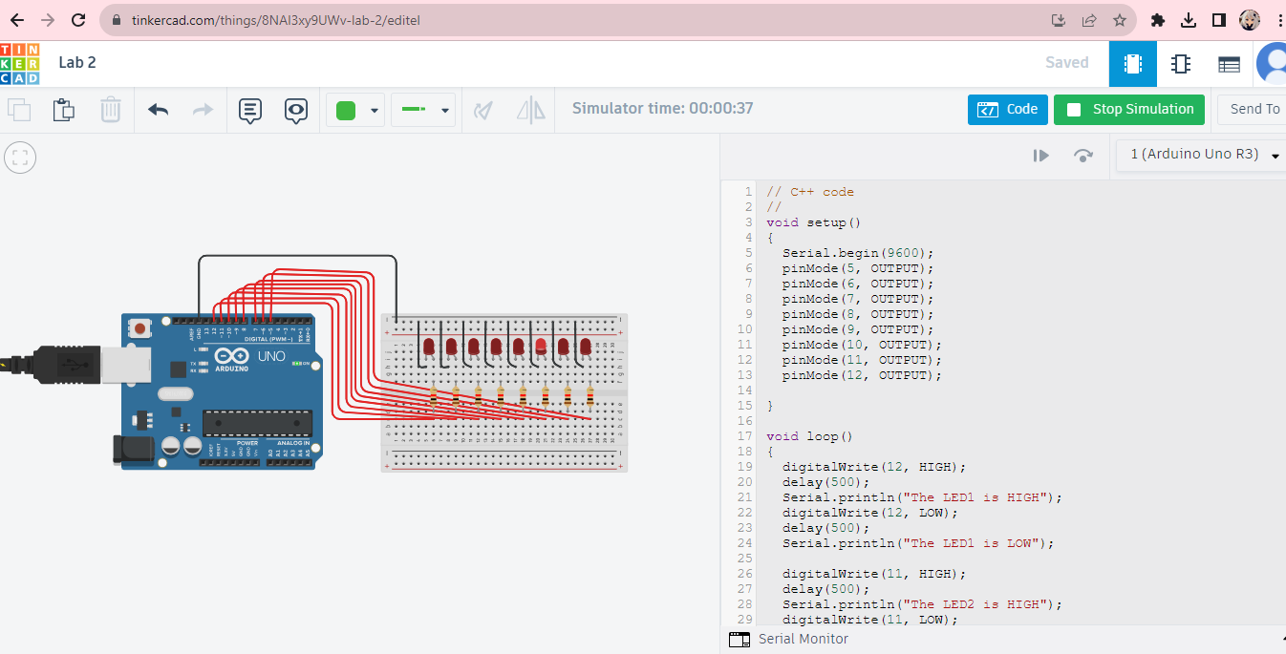

IV. Conclusion

In conclusion, this laboratory activity helps us improve and become more familiar with the fundamentals of creating circuit diagrams in Tinkercad and using Arduino programming. This also improves our problem-solving and creative skills in figuring out how to perform the ring counter display using the 8 LED lights whenever we make a mistake in our activity. Overall, this activity is simple but very useful for us beginners, and it may help us prepare for more difficult tasks in the future*.*

**References**

[1] D.J.D. Sayo. “University of the City of Manila Computer Engineering Department Honor Code,” PLM-CpE Departmental Policies, 2020.

*<This is in a separate page>*