**Microprocessor Lab 3**

Laboratory Activity No. 3

**Binary Representation from 0 to 256 decimal using 8 LEDs**

|  |
| --- |
|  |

Score

*Submitted by:*

**Oliva, Vanessa A.**

**<Saturday 4 pm – 7 pm > / <CpE 0412-2 >**

*Date Submitted*

**14-10-2023**

*Submitted to:*

**Engr. Maria Rizette H. Sayo**

1. Objectives

This laboratory activity aims to apply the principles and techniques of hardware programming using Arduino by designing and creating a circuit diagram in TinkerCad.

II. Method/s

Create an Arduino circuit of Binary representation (decimal 0-256 using 8 LEDs)

III. Results

**TinkerCad**

**Exercise 1: Create an Arduino circuit of Binary representation (decimal 0-256 using 8 LEDs).**

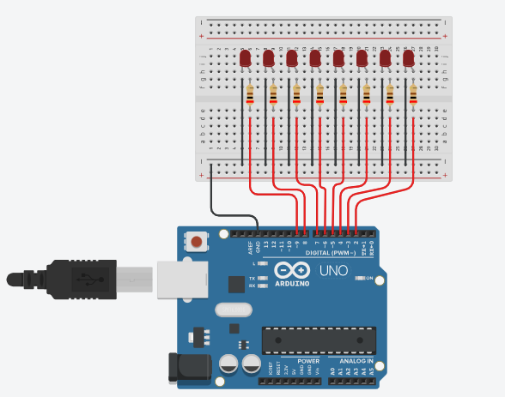

Figure No.1 Binary Represenation from 0 to 256 Circuit Diagram

**Components Used**

1. 8 LEDs
2. Resistor
3. Breadboard

**CODE:**

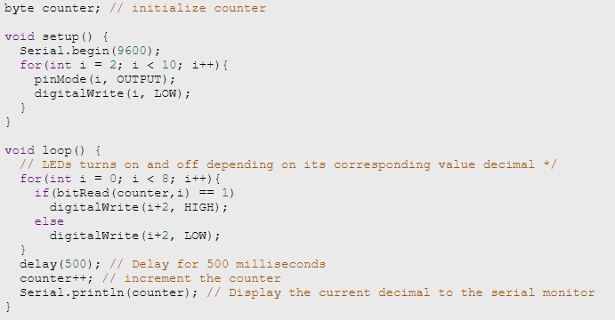

IV. Conclusion

In conclusion, by employing 8 LEDs to create binary outputs, this activity is an excellent way to put what we have learned in previous laboratory exercises and lectures into practice. Practicing simulating and testing digital logic circuits through this activity. Overall, this helps me acquire better understanding and problem-solving skills in using TinkerCad and Arduino programming.

**References**

*<This is in a separate page>*