Cover page

NAMES OF GROUP MEMBERS:
LUMWI STACY CHE 1195269.
NGUM VANESSA CHE AA562618.
BLESSING NWEGAPE 1195222.

ASSIGNMENT TITLE: BANKING SYSTEM ASSIGNMENT.
SUBMISSION DATE: 27 MAY 2026.
LECTURERS NAME: MR. OWAMI.
GITHUB REPOSITORY LINK:

Table of Contents
Cover page 1
Table of Contents 2
Introduction…………………………………………………………………………………………………………………………………….3
Purpose and scope of the system
Background and moltivation
Objectives of the project

System overview…………………………………………………………………………………………………………………………..4
High level describtion of the banking system
List of core functionality
Technnologies and tools used

Database design: 5………………………………………………………………………………………………………………….. 6
Entity relationship diagram(ERD)
Explanation of each table
Primary and foreign key justification
Normalisation explanation

Application features documentation 6…………………………………………………………………………………….8
Feature list with describtion
Screenshots of running application
Input/output describtion
Error handling describtion

User manual ………………………………………………………………………………………………….8
Step by step instruction of using the system
How to run the application
How to set up the database
Common errors and solutions

Challenges and reflections, 9…………………………………………………………………………………….10
Challenges faced during development
How challenges were resolved
Lesson learned
Individual contribution statement

INTRODUCTION

- Purpose and Scope of the System

The purpose of the Zenith Digital Bank System is to provide a simple banking application that allows staff and customers to perform banking operations digitally. The system is designed for bank staff to manage customer accounts and for customers to perform transactions such as deposits, withdrawals, transfers, and loan applications.

- Background and Motivation

Traditional banking processes can be slow and require manual record management. This banking system was developed to improve efficiency by automating banking activities and providing secure account management. The project also demonstrates programming concepts such as arrays, methods, validation, authentication, and transaction processing using Java.

- Objectives of the Project

* Develop a banking management system using Java.
* Allow customer registration and secure login.
* Enable deposits, withdrawals, and money transfers.
* Maintain transaction history.
* Support account management for bank staff.
* Implement loan application calculations.
* Improve understanding of Java programming and system development.

System Overview

- High-Level Description of the Banking System

The Zenith Digital Bank System is a console-based banking application developed in Java. The system contains two main user roles: staff and customers. Staff members can register customers, create accounts, update customer information, and delete accounts. Customers can log in securely and access banking services including deposits, withdrawals, transfers, balance enquiries, loan applications, and transaction history.

- List of Core Functionalities

* Staff login authentication
* Customer registration (Sign Up)
* Customer login authentication
* Deposit money
* Withdraw money
* Transfer funds between customers
* Balance enquiry
* Loan application and repayment calculation
* View transaction history
* Account creation and deletion
* Account type management (Savings, Cheque and Student account)

- Technologies and Tools Used
* Programming Language: Java
* Database System: Arrays used for temporary data storage (if not yet connected to SQL)
* Concepts Used: Arrays, methods, loops, conditional statements, authentication, input validation, and object-oriented programming principles.
DATABASE DESIGN
- Entity Relationship Diagram
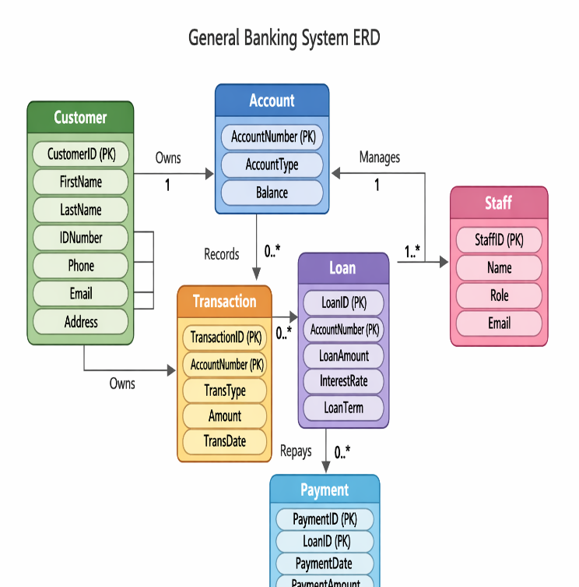

- Explanation of Tables
Customers: Stores personal information and contact details for each user.
Accounts: Stores the customer’s information.
Transaction: Record the banking activities performed on an account such as deposit and withdrawal.
Loans: Stores loan information to customers.
Payment: Record payment made towards loan.
Staff: Stores employees information for bank staff member who manage accounts and loans .

- Primary and foreign key justification
Primary Key
Customer ID : Customer ID is unique for every customer and never changes. It auto generates, so there are no duplicates
Account Number: Every account must have a unique account number. It is what customer use to identify their account.
Foreign Key:
Customer ID: This enforces that every account must belong to a real customer.

- Normalization Explanation:
This design achieves Third Normal Form (3NF):
First Normal Form (1NF): Each column contains atomic (indivisible) values, and there are no repeating groups. Second Normal Form (2NF): It is in 1NF, and all non-key attributes are fully functionally dependent on the Primary Key. For example, ⁠customer name⁠ depends entirely on ⁠customer id⁠. Third Normal Form (3NF): It is in 2NF, and there are no transitive dependencies. All attributes depend only on the primary key, not on other non-key attributes. For instance, in the ⁠Orders⁠ table, the ⁠total amount⁠ is calculated or associated directly with the order, not derived from customer details.

APPLICATION FEATURES DOCUMENTATION
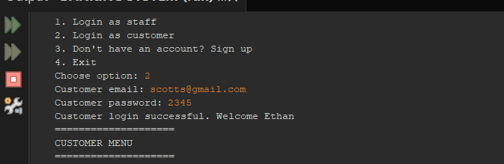
Customer Login
Allows customers to enter their login details. The Customer Login feature allows existing users to securely access their accounts by providing their registered email address and password. It validates credentials against the database and grants access to the Customer Menu upon successful authentication

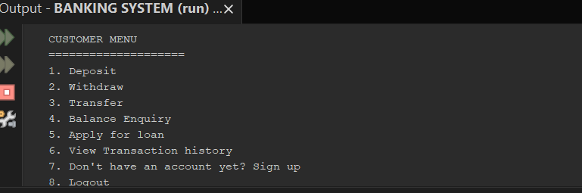
Customer main menu
This allows the customer to deposit funds to their account, withdraw money, transfer fund from their account to another. It also display the current available balance in the users account, it allow users to request loans from banks. Transaction history displays a log of all past deposits, withdrawals and transfers. Sign up allows the user to create a bank account. Logout terminates the current session and return to the main login.

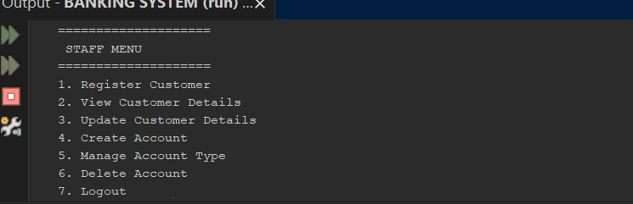
Staff menu
The Staff Menu serves as the central administrative interface for authorized staff members. It provides a suite of CRUD (Create, Read, Update and Delete) operations to manage banking data.
Register Customer: Adds a new customer profile to the system. View Customer Details: Retrieves and displays existing information for a specific customer. Update Customer Details: Modifies existing customer records. Create Account: Initializes a new banking account for a customer. Manage Account Type: Modifies account configurations (e.g., Savings, Checking). Delete Account: Removes a banking account from the system. Logout: Terminates the current staff session.
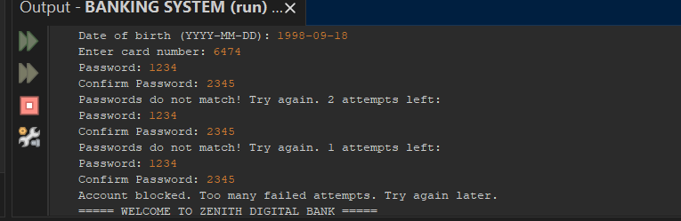
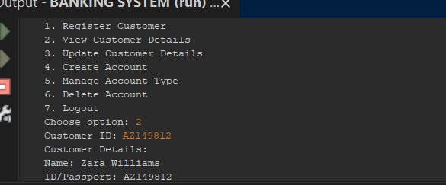
View Customer details
This feature allows bank staffs to retrieve and display a customer’s stored information by entering the customer ID. The system searches the customer’s records and displays details such as the customer’s name and ID.
- Error handling
If the strings do not match, the system rejects the input and displays the message: Passwords do not match! Try again.
Attempt: To prevent brute-force attacks or unauthorized access attempts, the system enforces a maximum number of failed attempts 3 times. The system provides clear, user-friendly feedback by displaying the number of remaining attempts, which guides the user on their remaining chances to enter the correct information. Upon reaching the maximum number of failed attempts, the system triggers a security lock. It displays the message: "Account blocked. Too many failed attempts. Try again later."

USER MANUAL
- Step-by-Step Instructions (Non-Technical Focus)
Keep the language simple. Instead of saying "execute SQL DDL statements," say "open the database tool and copy this code."
Structure: Start with the "Why" and "What" (e.g., "This application helps you manage [task]").
Visuals: Use annotated screenshots. A screenshot with a red circle around the "Start" button is better than a paragraph describing where it is.
Avoid Jargon: If you must use a technical term, include a brief, one-sentence definition in parentheses.

- How to Run the Application
For a NetBeans-based project, the user needs to know how to open and run the code.
Prerequisites: List what must be installed first (e.g. NetBeans, XAMPP).
Opening: Include steps like: Open NetBeans > File > Open Project > Select [Project Folder].
Execution: Clear instructions on which file or "Main" class to run and which button (usually the green "Run" arrow ) to click or F6.

- How to Set Up the Database
Activation: Explicit instructions to open the XAMPP Control Panel and click Start for both Apache and MySQL.
Access: Direct them to ⁠http://localhost/phpmyadmin⁠.
Importing: Provide a clear path: Click 'New' (to create a database) > Click 'Import' tab > Choose file > Click 'Go'. Ensure you provide the ⁠.sql⁠ file they need to import.

CHALLENGES AND REFLECTIONS
- Challenges Faced
Challenge 1:
I had problems in the signup option printing an account, the first name gave me an error so when I enter more three characters it gives me an error. I also had problems deciding if I should have different options like the staff members login option and a customer login option. During the development of the transfer feature, I struggled to ensure that if a withdrawal from Account A succeeded but a deposit to Account B failed the system wouldn't leave the data in an inconsistent state.
Challenge 2:
I initially found it difficult to manage exceptions when the Java application attempted to connect to the MySQL database. The application would crash entirely if the database server was unreachable or if the credentials were incorrect, rather than informing the user of the issue. I also had syntax error that took me 3 hours to find.
- Resolution of Challenges
Resolving Challenge 1:
My arrays stored 3 people maximum so I was supposed to add more than 3 characters in the array.
In the login option the customer was not given option as the staff members, so we included the options.
Resolving Challenge 2:
To fix the connectivity issues, I implemented a robust ⁠Database Connector⁠ class. Instead of letting the application crash, I used descriptive error messages that catch ⁠SQL exception⁠. This allows the application to remain stable even when the database is offline, providing the user with a clear.

- Lessons Learned
Through these challenges, I realized the importance of defensive programming. I learned that a banking system is only as reliable as its error handling. In future projects, I would prioritize building a more modular architecture for database access to separate business logic from data persistence, which would make the code easier to test and maintain.

- Individual Contribution Statement
LUMWI STACY is responsible for the database schema design and the implementation of all SQL queries.
VANESSA CHE developed the Java console-based application, including the customer and account management modules.
BLESSING NWEGAPE drafted the full technical documentation, including the ERD, system manual, and the reflections provided here.

