Systematic Literature Review
Tools and Methods for A Priori Prediction of Neural Network Training Energy Consumption

1 Introduction

1.1 Rationale
The energy cost of training neural networks has become one of the most pressing sustainability concerns in modern computing. Strubell et al. (2019) were among the first to quantify this cost at scale, demonstrating that training a single large natural language processing model can produce carbon emissions comparable to a transatlantic flight and that full research cycles spanning hundreds of hyperparameter experiments can cost the equivalent of years of electricity consumption. Patterson et al. (2021), drawing on measured power data from Google's internal profiling systems, extended this analysis across five large models and showed that training GPT-3 consumed approximately 1,287 MWh and produced 552 metric tons of CO2 equivalent. Critically, their analysis also revealed that combined choices of model architecture, processor type, data center efficiency, and energy mix can reduce the training carbon footprint by up to 1,000 times, a finding that directly motivates the need for tools capable of estimating these costs before training begins, when those choices are still open.
Schwartz et al. (2020) formalized this challenge as the Green AI problem, drawing a contrast between Red AI, research that pursues accuracy at exponentially increasing computational cost and Green AI, which treats efficiency as a first-class criterion alongside accuracy. Their survey of papers from leading AI conferences found that between 75 and 90 percent of contributions targeted accuracy as the primary metric, with efficiency rarely reported. They further confirmed that the accuracy-compute relationship is at best logarithmic: marginal gains in performance increasingly come at disproportionate energy cost. These findings established both the normative case and the empirical foundation for energy-aware neural network design.
Translating this motivation into practical tools requires either monitoring energy during training or predicting it before training begins. CarbonTracker (Anthony et al., 2020) represents the most widely adopted monitoring approach. It measures actual GPU, CPU, and DRAM power draw during training using hardware interfaces — NVIDIA Management Library (NVML) and Intel Running Average Power Limit (RAPL) — and then linearly extrapolates total energy from the first epoch. This achieves prediction errors of 4.9 to 19.1 percent after observing a single epoch, but it fundamentally requires training to have started before any estimate is possible. The same constraint applies to Zeus (You et al., 2023), which optimises batch size and GPU power limits during training, and to tools such as CodeCarbon and Experiment-Impact-Tracker. As García-Martín et al. (2019) explicitly noted in their survey of energy estimation approaches for machine learning, very few studies had emerged to incorporate energy-use a priori during the training phase. That gap remains substantially open.
Two benchmark datasets published in 2024 create the empirical foundation needed to address it. BUTTER-E (Tripp et al., 2024) provides 63,527 real watt-meter energy measurements across diverse multilayer perceptron (MLP) architectures varying in depth, width, shape, and dataset characteristics, collected on an HPC system using node-level watt-meters rather than on-chip sensors. EC-NAS (Bakhtiarifard et al., 2024) extends the NAS-Bench-101 benchmark with measured training energy data for approximately 423,000 CNN architectures trained on CIFAR-10, and demonstrates that a surrogate model trained on a sample of those measurements achieves a Kendall-Tau R-squared of 0.9030 in predicting architecture-level training energy. Together, these datasets provide the scale and architectural diversity required to train and evaluate data-driven a priori prediction models.

1.2 Objectives and Contributions
The following research question motivates this review:
What tools and methods have been proposed for predicting the energy consumption of neural network training before execution begins, and how well do they generalize across different architectures and hardware platforms?
Here, prediction specifically denotes estimation performed before training begins, using only pre-training features such as architectural specifications, hardware characteristics, and training configuration. To address this question systematically, the following sub-questions structure the review:
RQ1. What approaches have been proposed for a priori energy estimation of neural network training, and what are their underlying methodologies?
RQ2. For what architecture families and hardware platforms were these approaches designed and validated?
RQ3. To what extent do existing approaches generalize across different architectures and hardware platforms, and what conditions limit their transferability?
For each discovered tool or method, this review characterizes the approach it relies on, the context for which it was designed, whether it operates before, during, or after training, and the extent to which it generalizes across architectures and hardware platforms.
This review makes two contributions to the literature.
Contribution 1. This review is, to our knowledge, the first systematic literature review focused specifically on a priori prediction of neural network training energy consumption. Unlike broader surveys (Rodriguez et al., 2024; García-Martín et al., 2019), the scope is deliberately narrow i.e. we examine only approaches that estimate training energy before any computation begins, distinguishing them rigorously from measurement and monitoring tools that require training to be running or already completed. This distinction has not previously been the organizing axis of any systematic review in this space.
Contribution 2. This review exposes the absence of cross-architecture validation as a structural gap in the field, not merely an incidental limitation of individual papers. By examining the reviewed approaches against a consistent set of questions — what is predicted, on what architecture family, on what hardware, and under what distribution assumptions — we demonstrate that no existing method has been validated simultaneously across MLP and CNN architecture families under consistent hardware conditions. This finding defines the specific gap that empirical work building on this review is positioned to address.

1.3 Paper Overview
This review is organized as follows. Section 2 defines the systematic review protocol, including data sources, search strategy, inclusion and exclusion criteria, and the classification scheme applied to selected papers. Section 3 documents the execution of the search, from initial database queries through to the final corpus. Section 4 presents the taxonomy and synthesis of selected papers, organized by prediction timing and examined against the research question. Section 5 presents conclusions and identifies directions for future work.

2 Methods
The research protocol follows the guidelines established by Kitchenham and Charters (2007) for systematic literature reviews in software engineering and is reported in accordance with the PRISMA 2020 statement (Page et al., 2021). The protocol proceeds in three main steps: collection of a pool of candidate items, selection of items based on defined inclusion and exclusion criteria, and classification and quality assessment of selected items with structured data extraction.

2.1 Information Sources

2.1.1 Database Sources
Four publisher databases were selected to ensure broad coverage of relevant literature across computer science, machine learning, and energy-efficient computing. IEEE Xplore Digital Library was selected for its coverage of journals, conference papers, and technical standards in electrical engineering and computer science. ACM Digital Library was selected as a primary academic database for computer science publications. Science Direct (Elsevier) provided access to peer-reviewed journals and conference proceedings across engineering and computer science. Springer Link contributed computer science conference proceedings and journals. These four databases collectively span the principal venues in which work on neural network energy estimation has been published.

2.1.2 Initial Pool
Prior to the formal database search, an initial pool of papers was assembled through domain knowledge, supervisor recommendations, and prior literature survey work. This pool spans foundational Green AI studies (Strubell et al., 2019; Schwartz et al., 2020), carbon footprint estimation tools (Anthony et al., 2020; Bouza et al., 2023), energy measurement and benchmarking (Patterson et al., 2021; García-Martín et al., 2019), and predictive approaches (Cai et al., 2017; Bakhtiarifard et al., 2024). The pool was merged with formal search results after deduplication.

2.2 Eligibility Criteria
Items were included in the corpus if they satisfied four criteria. First, relevance: the paper proposes or evaluates tools or methods that predict, estimate, or measure the energy consumption of neural network training, or provides methodological context for such approaches. Inference-only papers were included where they offer methodological insights relevant to the training prediction problem. Second, literature type: peer-reviewed articles, conference papers, workshop papers, and arXiv preprints were all eligible. Third, accessibility: full text must be available. Fourth, language: only English-language papers were considered.
Items were excluded if they used deep learning to predict building, vehicle, grid, or IoT device energy, a direction that inverts the prediction target, if they proposed hardware chip designs that only incidentally reported energy figures, or if they addressed energy in fields entirely unrelated to machine learning compute.
Studies were grouped for narrative synthesis along two primary dimensions: (1) prediction timing — a priori, during-training, or post-hoc — which is the central axis of the research question; and (2) contribution type — new method, applied use, or survey. No quantitative meta-analysis was planned or conducted, because the heterogeneity of outcome measures, architecture families, hardware platforms, and experimental conditions across reviewed studies precluded direct statistical pooling.

2.3 Search Strategy and Keywords
Queries were constructed to return results containing at least one term from each of three semantic categories, following the structured keyword approach of Kitchenham and Charters (2007). The first category concerns system context and includes neural network, deep learning, machine learning, CNN, DNN, MLP, and artificial intelligence. The second category concerns the action of interest and includes predict, prediction, estimate, estimation, measure, measuring, consumption, and evaluate. The third category concerns the target quantity and includes energy, power, energy consumption, carbon footprint, carbon emissions, watts, and environmental impact.
To reduce noise from off-topic fields, results containing any of the following exclusion terms in their titles were filtered during title screening: wind, building, buildings, vehicles, solar, photovoltaic, medical, hospital, manufacturing, industrial, ships, and biological. These terms reliably identify papers concerned with energy prediction in engineering or environmental domains rather than machine learning compute.

Academic Library | Search Strings
IEEE Xplore Digital Library | - Title: "neural network" AND "energy consumption" AND "training"  - Title: "deep learning" AND "energy consumption" AND "prediction"  - Title: "carbon footprint" AND "deep learning" AND "training"  - Title: "energy efficiency" AND "neural network" AND "training"  - Title: "neural architecture search" AND "energy"
ACM Digital Library | - [Title: neural network] AND [Title: energy consumption] AND [Title: training]  - [Title: "deep learning] AND [Title: energy consumption] AND [Title: prediction]  - [Title: energy] AND [Title: neural network]
Science Direct (Elsevier) | - Title: "neural network" AND "energy consumption"  - Title: "deep learning" AND "energy consumption"  - Title: "energy efficiency" AND "neural network"  - Title: "neural network" AND “energy”
Springer Link | - Title: "neural network" AND "energy consumption" AND "training"  - Title: "deep learning" AND "energy consumption" AND "prediction"  - Title: "energy efficiency" AND "neural network" AND "training"  - Title: "neural architecture search" AND "energy"
Table 2.1. Database search strings. All searches were restricted to the paper title field.

2.4 Data Collection Process
Data were extracted from each included paper by the single reviewer using a structured extraction form. For each paper, the following variables were recorded: full citation and venue; the specific quantity predicted (training energy, inference energy, CO2 equivalent, or surrogate metric); the prediction timing category (a priori, during-training, or post-hoc); the approach and methodology; the input features used; hardware and experimental setup; architecture families tested; key quantitative results; and limitations bearing on generalization across architectures or hardware platforms.
Where a paper's reported results were ambiguous, the reviewer re-read the full text before assigning a value. No data were sought from study authors by correspondence. Extraction was conducted once per paper; no reliability check across multiple extractors was possible given the single-reviewer design. The completed extraction table is available on request.

2.4 Data Items
The primary outcome sought across all included studies was a quantitative estimate of energy consumption for neural network training or inference (in joules, kilowatt-hours, or CO2 equivalent). For a priori approaches, the additional outcome of interest was prediction accuracy, operationalized as any reported error metric (MAPE, R², Kendall-Tau, percentage accuracy) comparing predicted to measured energy.
Secondary variables extracted from each study included: (a) the architecture family or families studied (MLP, CNN, Transformer, RNN, or mixed); (b) the hardware platform (GPU, CPU, edge device, FPGA); (c) the input features used by the prediction model; (d) the dataset or search space used for evaluation; and (e) whether ground-truth energy was measured by hardware instrumentation (watt-meter, NVML, RAPL) or approximated through proxy metrics (FLOPs, parameter count).
No assumptions were required about missing data for the primary outcomes. Where hardware details or feature sets were incompletely reported, this was noted explicitly in the quality assessment (Section 2.7) and recorded in the extraction table.

2.4 Quality Assessment
PRISMA 2020 item 11 requires specification of the methods used to assess risk of bias in included studies. Following the approach recommended by Kitchenham and Charters (2007) for software engineering SLRs, and consistent with practice in comparable reviews, a custom five-criterion quality assessment checklist was developed and applied. Each criterion was scored on a three-point scale: 1 (Yes, fully met), 0.5 (Partially met), or 0 (Not met). The maximum possible score per study is 5.
Quality assessment was conducted by the single reviewer. The supervisor reviewed all assessments for the ten studies assigned the highest scores and the five studies assigned the lowest scores, and no changes to scores were required. The checklist criteria and their scoring rationale are defined in Table 2.2

Code | Criterion | Operationalization | Scoring
QA1 | Methodological transparency | Is the prediction approach (architecture, features, training/validation procedure) described in enough detail to assess or reproduce? | 1 = Yes, fully described  0.5 = Partial description 0 = Not described
QA2 | Ground-truth validation | Is the estimate validated against measured energy (watt-meter, NVML/RAPL), not solely against FLOPs or a proxy? | 1 = Validated against measured energy  0.5 = Proxy or indirect validation  0 = No empirical validation
QA3 | Quantitative accuracy reporting | Are concrete error or accuracy metrics reported (e.g. R², MAPE, Kendall-Tau), rather than qualitative claims alone? | 1 = Quantitative metrics reported  0.5 = Partial or inconsistent metrics  0 = Qualitative only
QA4 | Experimental scope disclosure | Are the hardware platform, architecture family, and dataset or search space fully specified? | 1 = All three fully specified 0.5 = One or more partially specified 0 = Insufficient detail
QA5 | Generalizability discussion | Does the study explicitly discuss the limits of transferability (cross-architecture, cross-hardware, or distribution drift)? | 1 = Explicit generalizability discussion  0.5 = Implicit or minor mention  0 = Not discussed
Table 2.2. Quality assessment criteria and scoring guidance.

The rationale for QA5 (generalizability discussion) warrants specific comment. This review's central research question concerns cross-architecture and cross-hardware transferability. A study that does not discuss its scope of generalizability provides weaker evidence for or against the claim that its method can transfer to new settings, irrespective of its reported accuracy within its own evaluation context. QA5 is therefore doing substantive diagnostic work for the review's narrative, not merely flagging a reporting gap.
Table 2.3 presents the quality assessment scores for all studies included in the final corpus. Studies scoring below 3.0 are treated as providing weak evidence and are interpreted cautiously in the synthesis.

Study | QA1 | QA2 | QA3 | QA4 | QA5 | Score (/5)
NeuralPower | 1 | 1 | 1 | 1 | 0.5
EC-NAS

2.4 Reporting Bias Assessment
This review addresses reporting bias in two ways. First, the search strategy was designed to be inclusive with respect to study type, explicitly including negative and null results, arXiv preprints, and workshop papers alongside journal and conference publications. This reduces the threshold for inclusion of work that may not have reached formal publication. Second, where included studies report only aggregate accuracy figures without breaking down performance by architecture family or hardware platform, this is noted explicitly in the synthesis as a limitation of the evidence base. The qualitative pattern across studies — that positive results within constrained settings predominate, and cross-architecture or cross-hardware failures are rarely reported — is itself treated as evidence of potential positive publication bias, and is discussed as a limitation in Section 5

3 Results
This section documents the execution of the search protocol described in Section 2. A PRISMA flow diagram is included as Figure 1 to visualize the selection process.

3.1 Study Selection
The formal search was executed across the four databases using the keyword combinations defined in Section 2.1.3, restricted to paper title fields. The search yielded 89 results from ACM Digital Library, 66 from IEEE Xplore, 174 from Science Direct, and 45 from Springer, for a combined total of 374 results before deduplication. An additional pool of papers assembled through domain knowledge was prepared for merging after the database screening stages were complete.

3.2 Study Characteristics
Title screening applied the exclusion keyword list to the 374 database results, removing papers from off-topic fields including building energy prediction, IoT device optimization, renewable energy systems, and industrial process management. A second pass during title screening removed hardware chip design papers — those addressing energy efficiency of FPGAs, ASICs, and ReRAM-based accelerators — that had matched keyword combinations but did not address neural network training energy in the sense required by the research question. Following title screening, 111 papers were retained.
Cross-database comparison identified three duplicate entries, leaving 108 unique papers. Each of the 108 papers was then assessed against the full inclusion and exclusion criteria based on abstract and, where necessary, full text. Papers using deep learning as a method to predict building, vehicle, grid, or IoT energy consumption were excluded, as were hardware chip designs that reported energy only as an incidental figure. This stage yielded 30 papers from the formal search pool.
The 30 formal search papers were merged with the initial knowledge-based pool. After removing papers appearing in both sets, the final corpus was established for synthesis.

Table 1. Paper counts at each selection stage.
Stage | Papers Retained | Papers Removed | Notes
Initial database search | 374 | — | ACM: 89 IEEE: 66 Science Direct: 174 Springer: 45
After title screening | 111 | 263 | Off-topic domains; hardware chip design papers
After deduplication | 108 | 3 | Cross-database duplicates removed
After abstract screening | 30 | 78 | Inverted prediction direction; hardware-only focus
After merge with initial pool | 45 | — | 15 papers added from domain knowledge pool
After final deduplication | Final corpus | 9 | Papers appearing in both sets removed

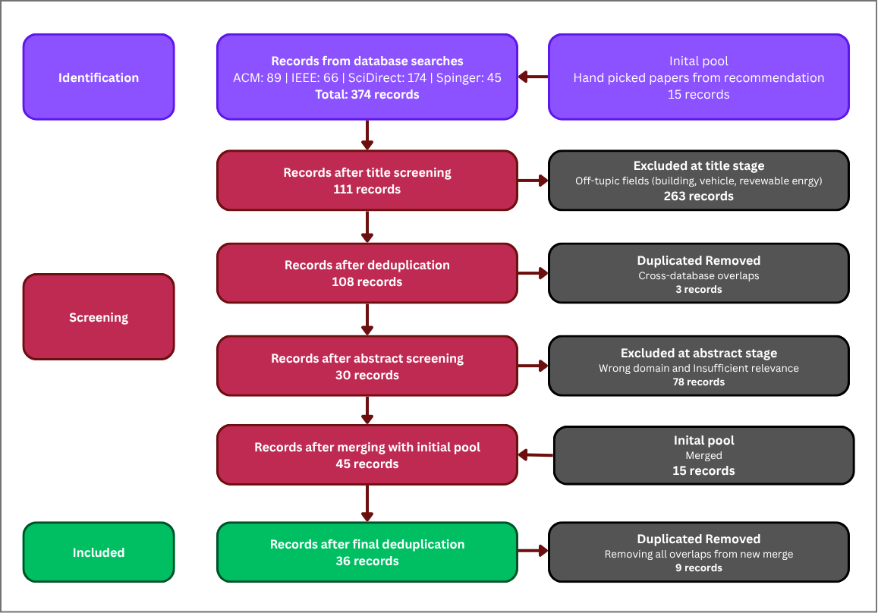
Figure 1. PRISMA flow diagram illustrating paper identification, screening, eligibility assessment, and final inclusion.

4 Results of Syntheses

4.1 Study Characteristics
The selected papers are classified along two dimensions: prediction timing and contribution type. These dimensions were chosen because they map directly onto the research question. Prediction timing determines whether a paper can in principle answer the question of what training energy will cost before training begins. Contribution type determines the nature of the evidence it provides — whether it introduces a new method, applies an existing one, or synthesizes prior work.
The distribution of papers across these dimensions reveals the landscape of the field at a glance. The overwhelming majority of papers that measure or estimate neural network energy do so during training or at inference, not before training begins. Genuinely a priori approaches — those that produce estimates from pre-training features alone — are a small minority, and within that minority, only a subset directly targets training energy rather than inference energy. This asymmetry is not incidental: it reflects the fact that training energy prediction is structurally harder than inference energy prediction, because the computation being predicted has not yet occurred and cannot be partially observed.

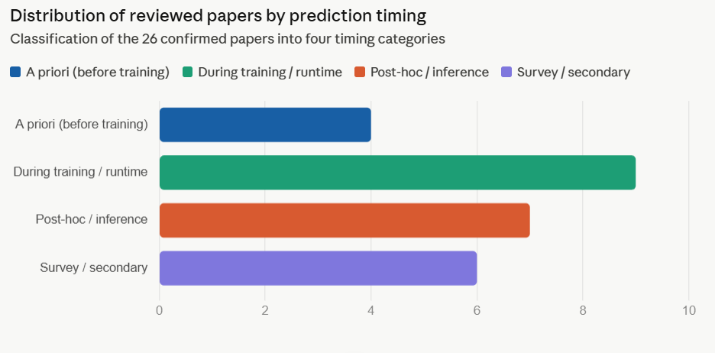

Figure 2. Distribution of reviewed papers by prediction timing category.

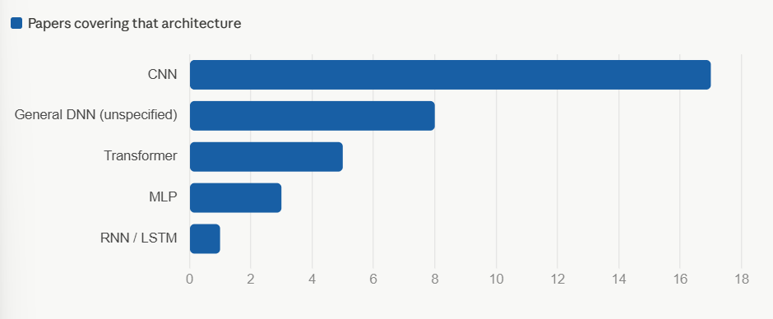

Figure 3. Architecture families covered across reviewed papers, illustrating the dominance of CNN-focused work.

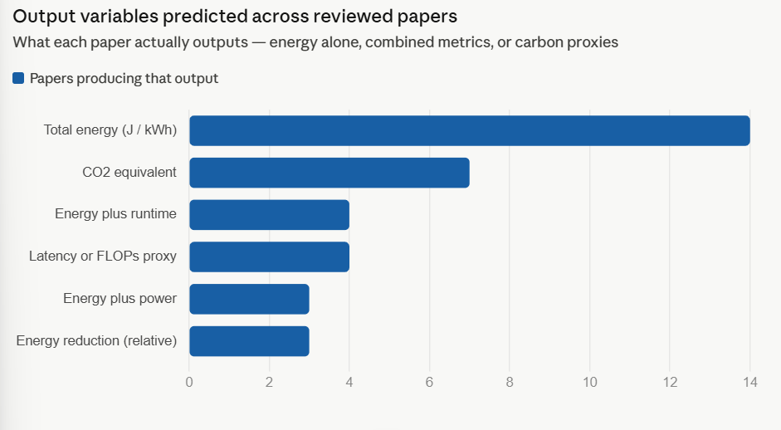
Figure 4. Output variables predicted across reviewed papers, illustrating methodological fragmentation.

[another idea - add last chart about Prediction scope versus generalization]

Two additional observations from the taxonomy are worth noting before entering the paper-level synthesis. First, the field shows a clear methodological split between papers that build standalone predictive models — tools that can be queried with architecture specifications and return an energy estimate — and papers that embed energy as a constraint or objective within a neural architecture search loop. These two types of work address related but distinct problems: the former aims to predict energy for arbitrary architectures, while the latter aims to find architectures that are energy-efficient within a defined search space. The distinction matters for the research question because only standalone predictors can generalize to architectures outside their training distribution. Second, the reviewed papers overwhelmingly target GPU hardware, with CPU measurements appearing in only a small number of studies and edge or mobile hardware in fewer still. This hardware concentration limits what the existing literature can say about generalization across platforms.

4.2 A Priori Energy Estimation Approaches
The research question asks specifically about methods that predict training energy before execution begins. The reviewed literature surfaces a small number of approaches that qualify, and it is important to examine each carefully, because the a priori claim is not equally strong across all of them. NeuralPower (Cai et al., 2017) is a priori in its prediction mechanism but targets inference energy, not training. EC-NAS (Bakhtiarifard et al., 2024) and the NSGA-II framework of Gratia et al. (2024) are the only reviewed approaches that directly predict training energy from pre-training features. The Transistor Operations model (Li et al., 2022) occupies an intermediate position: it is analytical rather than data-driven, and it targets both training and inference energy, but its validation is limited and it has not been tested in the context of architecture selection. The NAS-integrated approaches — Multi-Complexity DNAS, Mixed Precision NAS, and others — embed energy as a search objective but do not provide standalone predictors in the sense the research question requires. These distinctions are examined in the subsections that follow.

NeuralPower - Cai et al. (2017)
NeuralPower is the earliest and most cited learning-based framework for predicting the energy consumption of a neural network without executing it. Given a CNN architecture and a target GPU platform, it predicts power, runtime, and energy during the serving phase — that is, during inference, not training. This distinction is important for the research question: NeuralPower answers how much energy a deployed model will consume per inference, not how much energy training that model will require.
The framework operates in two stages. At the layer level, separate polynomial regression models are trained for convolutional, fully connected, and pooling layers. For convolutional layers, the input features include batch size, input and output tensor dimensions, kernel size, stride, padding, total floating-point operations, and memory access counts. Logarithmic versions of these features are added for the power model to capture the non-linear saturation behaviour of GPU power near its thermal ceiling. At the network level, total runtime is the sum of layer-wise predictions, average power is a runtime-weighted average across layers, and total energy is their scalar product. Model complexity is controlled by selecting polynomial degree through ten-fold cross-validation with Lasso regularization.
Evaluated on an NVIDIA GeForce GTX Titan X under TensorFlow 1.0, NeuralPower achieves average energy prediction accuracy of 97.21 percent across five held-out CNN architectures, with 88.34 percent accuracy in power and 88.24 percent in runtime. Cross-platform validation on an NVIDIA GTX 1070 shows generally consistent performance, though prediction errors increase where dynamic GPU clock speeds introduce additional variance. A notable empirical finding is that runtime is not a reliable proxy for energy: in VGG-16, the fully connected layer fc6 accounts for the longest runtime in the network but draws comparatively low power, so energy prediction requires a dedicated model rather than a runtime or FLOPs surrogate. This finding transfers directly to the training energy problem.
Against the research question, three limitations are definitive. NeuralPower targets inference energy, not training, and has not been validated on training workloads. It covers only CNN architectures — convolutional, pooling, and fully connected layers — and cannot be applied to MLP architectures without complete retraining of all layer-level models. It must also be retrained from scratch for each new GPU platform, requiring hardware-specific measurement campaigns that limit practical transferability. These limitations do not diminish the technical contribution, but they mean that NeuralPower does not address the cross-architecture, cross-hardware training energy prediction problem that this review examines.

EC-NAS - Bakhtiarifard et al. (2024)
EC-NAS is the paper most directly relevant to the research question. It extends the NAS-Bench-101 benchmark — a tabular database of CNN architectures with pre-measured accuracy and training time — with measured training energy consumption and carbon footprint data for approximately 423,000 architectures trained on CIFAR-10. It also introduces a surrogate model that predicts training energy from architectural features, and uses that surrogate within a multi-objective neural architecture search to identify the energy-accuracy Pareto front.
Architecture search spaces in EC-NAS are represented as directed acyclic graphs in which each node applies one of three operations — 3x3 convolution, 1x1 convolution, or 3x3 max pooling — and the binary adjacency matrix determines connectivity. Energy measurements were collected during actual training using CarbonTracker on NVIDIA Quadro RTX 6000 GPUs, logging GPU, CPU, and DRAM energy every ten seconds, expressed in kilowatt-hours, with a data centre power usage effectiveness of 1.59 applied. The surrogate is a multilayer perceptron with architecture 36 to 128 to 64 to 32 to 1, using GeLU activations and L1 loss trained with the Adam optimiser, fitted on 4,310 randomly sampled architectures and evaluated on the remainder. It achieves a Kendall-Tau R-squared of 0.9030, indicating strong rank-order preservation — the surrogate reliably identifies which architectures are more or less energy-intensive relative to one another, even if absolute predictions carry some error.
The central finding from the NAS application is that knee-point architectures on the energy-accuracy Pareto front offer approximately 70 percent less training energy than accuracy-maximising baselines, with only one percent degradation in classification performance. EC-NAS also demonstrates that FLOPs and training time are inadequate proxies for training energy, explicitly noting that a small architecture can consume more energy than a larger one on a high-throughput GPU due to underutilisation — a hardware-mediated non-linearity that neither FLOPs nor parameter counts capture.
Against the research question, three limitations define the scope of EC-NAS's contribution. The surrogate model was trained and evaluated entirely within the NAS-Bench-101 CNN search space, and the paper explicitly acknowledges that it has not been validated on MLP architectures. The 36 input features to the surrogate are not fully documented, which limits reproducibility and makes it difficult to assess which architectural properties drive prediction accuracy. And energy values for smaller sub-spaces within NAS-Bench-101 are partially extrapolated linearly beyond four training epochs rather than measured exhaustively, introducing measurement uncertainty for the smallest architectures. These limitations are consequential for the research question: EC-NAS is the most rigorous a priori training energy predictor in the reviewed corpus, but its generalisation has not been tested outside a single CNN search space on a single hardware class.

Energy-Aware Neural Architecture Search - Gratia et al. (2024)
Gratia et al. propose a sustainable NAS framework that combines a CNN generator called CNNGen with the NSGA-II multi-objective genetic algorithm to discover CNN architectures that balance accuracy and energy efficiency without training any candidate model during the search. The framework's a priori component consists of two predictors trained once on a dataset of 40,000 CNNGen-generated architectures pre-trained for 20 epochs, and then used to evaluate all subsequent candidates without further training. An accuracy predictor based on a Transformer model reads CNN architecture descriptions as text and predicts validation accuracy. An energy predictor based on a Random Forest of 50 decision trees takes eight manually engineered architectural features — number of layers, FLOPs, total parameter count, number of convolutional layers, number of fully connected layers, and the presence or absence of global average pooling, max pooling, and flattening operations — and outputs predicted CO2 equivalent in grams.
The framework's reported results are promising at the aggregate level: across 500 generations of evolutionary search, average energy consumption falls by 39 percent alongside only a 5 percent drop in average accuracy. However, the paper is candid about a critical limitation that bears directly on the research question. Predictor reliability degrades progressively as NSGA-II steers the search toward architectures that are increasingly dissimilar from the original training distribution. Energy prediction errors grow from approximately 2 percent in early generations to as high as 15 percent by generation 500, and accuracy errors occasionally exceed 20 percent for individual architectures. The grammar defining valid CNN topologies is also violated with increasing frequency as crossover and mutation operations produce architectures that cannot be compiled, rising from one percent of candidates at generation zero to approximately ten percent by generation 500. The authors propose periodic predictor retraining every 200 generations as a mitigation strategy, but this has not been validated in the current work.
Against the research question, the Gratia et al. framework makes a genuine contribution to the idea of a priori energy prediction for architecture selection, but its scope is narrow in ways that matter. It covers CNN architectures only, generated by a specific grammar, and the energy predictor's performance outside that grammar is unknown. Hardware details are not disclosed, making cross-platform assessment impossible. And the aggregate-level results mask substantial per-architecture prediction errors that would be consequential in practical deployment. Taken together with EC-NAS, the Gratia et al. framework confirms that a priori training energy prediction is technically feasible within a constrained CNN setting, but does not resolve the question of whether such prediction generalises across architecture families or hardware platforms.

Transistor Operations Model - Li et al. (2022)
Li et al. develop an analytical approach to energy prediction grounded in hardware theory rather than data-driven regression. Their Transistor Operations (TOs) model translates a neural network's computational structure into transistor-level operation counts by decomposing each layer's forward pass, backpropagation, and loss computation into five basic operations — addition, subtraction, multiplication, division, and root — and then mapping those operations to transistor counts based on standard integrated circuit designs for arithmetic logic units. A polynomial regression model is then fitted to link theoretical TOs to measured energy consumption on specific hardware.
The approach is validated on feedforward DNNs and CNNs across laptop CPU, desktop CPU, and desktop GPU hardware. Reported precision ranges from 93.61 to 99.51 percent across configurations, and TOs-based prediction outperforms FLOPs-based prediction by 0.14 to 2.56 percentage points in precision, with approximately 10 percent lower average estimation error in joules. Importantly, the model covers both training and inference energy by computing TOs separately for forward passes, backpropagation, and loss calculation, making it one of the few analytical approaches in the corpus that explicitly addresses the training phase.
Against the research question, the model's coverage of non-linear activation functions — including Sigmoid, Tanh, and GELU — represents a genuine technical advance over FLOPs-based methods, which ignore these operations. However, the polynomial regression component must be re-fitted for each new hardware platform, and the validation scope is limited to two architecture families on a small set of configurations. The model explicitly does not account for data movement energy, which the BUTTER-E analysis demonstrates can be the dominant energy component for certain network sizes. Its generalization across architecture families and hardware classes therefore remains an open question.

NAS-Integrated Energy Estimation Approaches
Several reviewed papers embed energy estimation within a neural architecture search loop rather than providing a standalone predictor. Multi-Complexity-Loss DNAS (Risso et al., 2022) incorporates an operations-count proxy formula into a differentiable NAS loss function to steer the search toward low-energy CNN architectures on microcontroller hardware. Mixed Precision NAS (Gong et al., 2019) uses energy estimates from the Bit Fusion hardware simulator as a search objective, jointly optimising quantisation precision and architecture topology for inference on edge devices. ETNAS uses operator-level power measurements on FPGA hardware as a constraint within a DARTS-based NAS procedure.
These approaches share a common characteristic that distinguishes them from the standalone predictors discussed above: they produce architecture rankings within a search space rather than calibrated energy estimates for arbitrary architectures. This is not a deficiency in their intended use — ranking is sufficient for guiding a search. But it means they cannot be directly applied to the research question, which asks about generalisation across architectures and hardware platforms. An energy estimator that has been tuned to rank candidates within a CNN search space on a specific edge microcontroller provides no validated basis for predicting the training energy of an MLP on a data centre GPU. This distinction is important to state clearly, because these papers are sometimes cited as evidence that a priori energy prediction has been achieved when, in the precise sense the research question requires, it has not.

Synthesis of A Priori Approaches
Considered together, the a priori approaches in the reviewed corpus provide a partial and fragmented answer to the research question. They establish that architecture-level features can predict energy with meaningful accuracy within a constrained setting — a single architecture family, a single hardware platform, a search distribution that does not drift. NeuralPower demonstrates this for CNN inference energy. EC-NAS demonstrates it for CNN training energy within NAS-Bench-101. Gratia et al. demonstrate it for CNN training CO2 within CNNGen's grammar. The Transistor Operations model demonstrates it analytically for both DNN and CNN training and inference energy on a small hardware set.
What none of these approaches demonstrates is generalization in the sense the research question asks. No reviewed method reports validated energy predictions across both MLP and CNN architecture families. No reviewed method quantifies how prediction error grows as the target hardware diverges from the training hardware. No reviewed method was designed with cross-architecture transferability as an explicit objective. The fragmentation is not accidental: each method was developed to solve a specific problem within a specific context, and the evaluation was scoped accordingly. The implication is that the field currently lacks a prediction framework that can serve as a general tool for researchers selecting between diverse architecture families before committing to training.

Table 2. Summary of a priori energy estimation approaches.
Study | Method | Predicts | Architecture | Accuracy | Key Limitation
NeuralPower (Cai et al., 2017) | Layer-wise sparse polynomial regression on architectural and hardware features | Inference energy (not training) | CNN only | 97.21% energy; 88.34% power; 88.24% runtime | Inference only; CNN only; hardware-specific retraining required
EC-NAS (Bakhtiarifard et al., 2024) | MLP surrogate trained on 4,310 measured CNN architectures; 36 input features | Training energy | CNN (NAS-Bench-101, approx. 423,000 architectures) | Kendall-Tau R-squared = 0.9030 | CNN only; input features not fully documented; partial energy extrapolation for small spaces
Gratia et al. (2024) | Random Forest of 50 trees trained on 8 manually engineered architectural features | Training CO2 equivalent (20 epochs, CIFAR-10) | CNN (CNNGen grammar) | 2 to 15% error; degrades with distribution drift | CNN only; hardware not disclosed; predictor instability over NAS generations
Li et al. (2022) | Bottom-up transistor operations model linked to measured energy via polynomial regression | Both training and inference energy | Feedforward DNN and CNN | 93.61 to 99.51% precision | No data movement energy; regression must be refitted per hardware platform; limited architecture families

4.3 During-Training Measurement and Optimization Studies
The papers in this category measure, monitor, or optimize neural network energy consumption while training is executing. None of them operates a priori in the sense the research question requires — all require training to be running or at minimum to have started before any energy estimate is produced. They are included in the review for two reasons. First, they establish what is empirically known about training energy and its determinants, providing the ground truth against which a priori predictions must eventually be evaluated. Second, several identify specific architectural and configuration features as dominant drivers of training energy, directly motivating the feature engineering choices available to a priori predictors.
Strubell et al. (2019) produced the first widely cited quantification of training energy and carbon cost at scale, measuring GPU power during training of Transformer, ELMo, and BERT variants using nvidia-smi and Intel RAPL. Their total energy formula integrates average CPU, DRAM, and GPU power over training time and applies a data center power usage effectiveness multiplier. The paper's finding that training a single large model can cost the equivalent of a transatlantic flight in carbon emissions catalyzed the Green AI research agenda, though a key figure — the estimated NAS cost of 656,347 kWh — was later corrected by Patterson et al. (2021) by a factor of 88 due to incorrect assumptions about hardware and task scale. Patterson et al., drawing on Google's internal power profiling tools, revised these figures substantially and introduced the important observation that combined choices of architecture, processor, data centre efficiency, and energy mix can together reduce training carbon footprint by up to 1,000 times, establishing hardware context and location as co-equal determinants of training cost alongside architecture.
Schwartz et al. (2020) formalized the conceptual framework underlying this concern, naming the Red AI paradigm and proposing floating-point operations as a hardware-agnostic proxy for computational cost. CarbonTracker (Anthony et al., 2020) operationalized monitoring at the training level, introducing the linear epoch-extrapolation approach that achieves 4.9 to 19.1 percent prediction error after a single monitored epoch. Its measurement design — distinguishing GPU, CPU, and DRAM energy components — established that GPU alone accounts for 50 to 60 percent of training energy, meaning GPU-only estimation systematically understates total footprint by 40 to 50 percent. The Fischer et al. (2025) validation study subsequently confirmed that software-based monitoring tools including CarbonTracker and CodeCarbon systematically underestimate energy relative to external watt-meter measurements, establishing hardware-level watt-meter data as the more reliable ground truth.
Zeus (You et al., 2023) shifts from measurement to optimisation, demonstrating that batch size and GPU power limit are the dominant configuration-level determinants of training energy. By dynamically tuning these two parameters using a Multi-Armed Bandit algorithm, Zeus achieves energy reductions of 15.3 to 75.8 percent across six workloads on four GPU platforms. For the research question, Zeus's most relevant contribution is empirical rather than methodological: it confirms that batch size and GPU power configuration, both of which are known before training begins, are major levers on total training energy cost. This directly motivates their inclusion as features in a priori prediction models.
Luccioni et al. (2022) provide a full lifecycle carbon analysis of the BLOOM 176-billion parameter language model, finding that dynamically consumed GPU energy accounts for only approximately 49 percent of total training carbon cost, with embodied hardware emissions contributing 22 percent and idle infrastructure power 29 percent. This finding is relevant to the research question because it establishes that the energy a model architecture directly causes — the component that architectural features can plausibly predict — is less than half of the true training footprint. Tripp et al. (2024), whose BUTTER-E dataset is one of the two empirical foundations of this review, demonstrate through large-scale watt-meter measurement that the relationship between network size and training energy is non-linear and mediated by cache hierarchy effects. In particular, the most energy-efficient network size for a given task is typically one where the backward-pass working set just fills a cache level — a hardware-architecture interaction that neither FLOPs nor parameter counts capture.

Table 3. Summary of during-training measurement and optimisation studies.
Study | Approach | Key Finding | Relevance to Research Question
Strubell et al. (2019) | nvidia-smi and Intel RAPL during training of NLP models | Training BERT consumed 1,507 kWh; NAS estimate later corrected by factor of 88 | Foundational quantification of training cost; establishes why the gap matters
Patterson et al. (2021) | Google Xprof measured power; same formula as Strubell et al. | GPT-3 consumed 1,287 MWh; combined architecture, hardware, and location choices can reduce CO2 by up to 1,000 times | Corrects prior figures; establishes hardware and location as co-equal drivers alongside architecture
Schwartz et al. (2020) | Survey and FLOPs analysis | Coined Green AI; 75 to 90 percent of AI papers target accuracy only; FLOPs proposed as hardware-agnostic efficiency proxy | Definitional paper; FLOPs as conceptual predecessor to a priori feature-based prediction
CarbonTracker (Anthony et al., 2020) | RAPL and NVML polling; linear extrapolation from first epoch | 4.9 to 19.1% error after one epoch; GPU accounts for 50 to 60% of total energy; 61-fold CO2 variation across EU regions | Direct measurement baseline; a priori prediction must improve on this without requiring any execution
Zeus (You et al., 2023) | Just-in-time profiling and Thompson Sampling bandit optimisation | 15.3 to 75.8% energy reduction; batch size and GPU power limit are dominant energy control variables | Both drivers are pre-training configuration choices, motivating their inclusion as a priori prediction features
Tripp et al. — BUTTER-E (2024) | Node-level watt-meter measurements on HPC system across 63,527 MLP training runs | Energy-network size relationship is non-linear and cache-mediated; FLOPs and parameter count are not linear predictors of training energy | Primary dataset for this review; empirically establishes the features and non-linearities that a priori models must capture
Luccioni et al. (2022) | GPU power measurement and lifecycle analysis for BLOOM | Dynamic GPU energy is only 49% of true training carbon footprint; embodied and idle power account for the remainder | Establishes the limits of architecture-based prediction; some training cost components are not predictable from architecture alone

4.4 Post-Training and Inference Energy Studies
The papers in this category examine energy consumption at inference — after training is complete and the model is deployed. They are included because the inference literature is substantially more mature than the training prediction literature and contains methodological approaches and empirical findings that transfer directly to the training problem. In particular, the inference literature provides evidence on which architectural features are predictive of energy, how well feature-based prediction models perform relative to FLOPs-based proxies, and how hardware-architecture interactions shape energy consumption across deployment settings.
Desislavov et al. (2023) provide the most comprehensive trend analysis in the corpus, examining inference energy across approximately 70 computer vision models from 2012 to 2021 and 20 NLP models from 2017 to 2020. Using the relationship Energy equals FLOPs divided by hardware efficiency in GFLOPS per watt, they find that while state-of-the-art models show exponential energy growth over time, general-use models — efficient successors appearing one to two years after each state-of-the-art paper — achieve near-constant energy at increasing accuracy. Hardware GPU efficiency grew approximately 15-fold from 2010 to 2020, partially offsetting FLOPs growth. Validation against measured GPU power shows estimation errors of 4 to 27 percent using FLOPs and specification-sheet TDP, confirming that FLOPs-based estimation is directionally meaningful but insufficiently precise for engineering decisions.
Phoeni6 (Oliveira-Filho et al., 2025) provides large-scale empirical evidence that pre-execution-known features can predict inference energy with high reliability. Across 2.29 million inference runs on AlexNet and MobileNet, image size achieves a Pearson correlation of 0.975 with inference energy for AlexNet and 0.862 for MobileNet. Input format also matters substantially: PNG requires approximately 15 percent more energy than JPEG and BMP requires 20 to 30 percent less. These correlations are relevant to the research question because they confirm that architectural and input features knowable before execution are strongly predictive of energy — a necessary premise for a priori prediction to be feasible at all.
The Watts study (2025) benchmarks per-query inference energy across a broad range of deployed ML models, finding that architecture type and model size are the primary determinants of inference energy cost across task types. The study's relevance to the training prediction problem is indirect but important: it establishes that the architectural drivers of inference energy are consistent and predictable, suggesting that similar architectural features should also be predictive of training energy, though the two phases differ structurally in ways that NeuralPower's inference-versus-training distinction makes concrete.
The remaining inference papers — the hardware accelerators survey (Sze et al., 2020), the dynamic pruning study (Maleki et al., 2021), the dynamic beam width study (Jahier Pagliari et al., 2019), quantised deep neural networks (Courbariaux et al., 2016), Multi-Complexity DNAS (Risso et al., 2022), and Mixed Precision NAS (Gong et al., 2019) — each contribute one or more findings with methodological transfer value. Maleki et al. confirm that filter count and layer depth are primary drivers of CNN inference energy, consistent with the architectural feature sets used in EC-NAS and Gratia et al. Jahier Pagliari et al. is notable as the only paper in the corpus that addresses RNN architectures at all, a further illustration of the architecture coverage gap the review identifies. The NAS-related inference papers demonstrate that OPs-based proxy formulas can guide architecture search effectively within constrained search spaces, providing a baseline against which more general prediction models can be compared.

Table 4. Summary of post-training and inference energy studies.
Study | Architecture | Key Finding | Relevance to Research Question
Desislavov et al. (2023) | CNN and Transformer (CV and NLP) | Inference energy grows exponentially for SOTA models but near-constant for general-use successors; FLOPs-based estimation achieves 4 to 27% error | Training energy is a bounded predictable upfront cost; FLOPs estimation directionally valid but imprecise
Phoeni6 (Oliveira-Filho et al., 2025) | AlexNet, MobileNet (CNN) | Image size achieves Pearson correlation 0.975 with inference energy; input format changes energy 20 to 30% | Pre-execution features predict energy with high reliability, validating the a priori prediction premise
Watts (2025) | Transformer and CNN across diverse tasks | Architecture type and model size are primary determinants of per-query inference energy | Architectural features are consistent drivers of energy across phases, supporting feature-based prediction
Maleki et al. (2021) | CNN (AlexNet, VGG16, ResNet and others) | 70% average energy saving via input-adaptive pruning; filter count and depth are primary energy drivers | Filter count and depth as architectural energy features, consistent with a priori prediction feature sets
Risso et al. (2022) | CNN (ResNet8, MobileNetV1 on microcontroller) | 2.2 times inference energy reduction with 0.23% accuracy drop | OPs-based proxy formula provides a simple baseline for feature-based energy estimation
Gong et al. (2019) | CNN (MobileNetV2 search space) | 63% inference energy reduction versus 8-bit baseline via joint NAS and quantisation | Architectural and precision co-optimisation produces interpretable layer-wise energy patterns
Jahier Pagliari et al. (2019) | RNN and LSTM (neural machine translation) | 25 to 33% execution time reduction via confidence-based beam width tuning | Only RNN paper in corpus; confirms corpus coverage gap in architecture diversity

4.5 Surveys and Secondary Studies
The secondary studies in the corpus — surveys, systematic reviews, validation studies, and position papers — collectively establish the methodological vocabulary and empirical standards against which the primary studies can be assessed. They also define the boundaries of what was already known before this review was conducted.
García-Martín et al. (2019) remains the foundational survey of energy estimation approaches applicable to machine learning. Their taxonomy distinguishes software-level models, at application level and instruction level, from hardware-level models, and they demonstrate an applied use case using the SyNERGY regression model on ARM Cortex-A57, achieving only 68.91 percent average relative accuracy across three ConvNets. Most consequentially for this review, their paper explicitly states that very few studies had emerged to incorporate energy-use a priori during the training phase, and identifies GPU-based training energy estimation as a critical open gap. That statement, made in 2019, remains substantially accurate in 2024 — the gap this review identifies is a continuation of the same structural absence García-Martín et al. diagnosed.
Rodriguez et al. (2024) provide the most comprehensive prior survey in the corpus, covering 118 selected studies across all energy evaluation tools for machine learning in a systematic review that was accepted at ECAI 2024. Their taxonomy organises approaches into four categories — measurement, data-based estimation, analytical estimation, and on-chip sensors — and their experimental comparison of five tools against an external power meter confirms that on-chip sensor tools produce estimates closest to the reference, while FLOPs-based analytical estimation performs poorly for computer vision tasks. Rodriguez et al. is the most directly comparable prior work to the present review in scope and methodology. The key difference is that their research question asks what tools and methods exist to evaluate energy, spanning both training and inference, while the present review asks specifically what tools and methods predict training energy before execution begins.
Bouza et al. (2023) offer a practical guide to carbon footprint estimation method selection across hardware measurement tools, software monitoring libraries, and analytical approaches. Lannelongue et al. (2021) developed the Green Algorithms framework, an online calculator that highlights how geographic location can produce multi-fold differences in carbon cost for computationally identical workloads, reinforcing the need for energy prediction models that account for hardware and location context rather than architecture alone. Green AI (Schwartz et al., 2020) and the carbon emissions paper (Patterson et al., 2021) have been discussed in earlier sections. Fischer et al. (2025) provide the validation evidence that software-based monitoring tools systematically underestimate energy, establishing watt-meter measurement — as used in BUTTER-E — as the appropriate ground truth for training energy.

Table 5. Summary of survey and secondary studies.
Study | Type | Key Taxonomy or Finding
García-Martín et al. (2019) | Survey and applied use cases | Application-level, instruction-level, and hardware-level taxonomy; SyNERGY on ARM achieves 68.91% accuracy; explicitly identifies the a priori training energy gap
Rodriguez et al. (2024) | Systematic literature review and experiments (118 papers) | Measurement, data-based estimation, analytical estimation, on-chip sensors; FLOPs-based estimation performs poorly; on-chip tools closest to watt-meter reference
Bouza et al. (2023) | Systematic review | Practical method selection guide across hardware measurement, software monitoring, and analytical estimation approaches
Fischer et al. (2025) | Validation study | CodeCarbon and comparable tools systematically underestimate energy relative to external watt-meter; watt-meter measurements are the reliable ground truth
Lannelongue et al. — Green Algorithms (2021) | Framework and web tool | TDP-based analytical estimation with location and hardware context; geographic location can produce multi-fold differences in carbon cost for identical computations
Schwartz et al. — Green AI (2020) | Position paper and empirical analysis | Named the Green AI paradigm; 75 to 90% of AI papers target accuracy only; FLOPs proposed as hardware-agnostic efficiency metric

5 Conclusion and Outlook
This systematic literature review has examined the literature on neural network energy prediction with a specific and narrow focus: methods that estimate training energy before any computation begins. The central finding is that the field has not yet produced a general answer to this question. The reviewed approaches demonstrate that a priori training energy prediction is technically feasible within constrained settings — a single architecture family, a known hardware platform, a search distribution that does not drift — but no reviewed method has been validated across the conditions that real-world model selection requires.
Of the reviewed a priori approaches, EC-NAS represents the most rigorous contribution to training energy prediction: its surrogate model achieves a Kendall-Tau R-squared of 0.9030 within the NAS-Bench-101 CNN search space, and its central finding — that Pareto-front architectures can reduce training energy by approximately 70 percent with only one percent accuracy degradation — establishes that the energy-accuracy tradeoff is large enough to matter in practice. NeuralPower demonstrates that architecture-level polynomial regression models can achieve 97 percent energy prediction accuracy for CNN inference, providing a methodological template whose core insight — that energy should be modelled directly from layer configuration rather than approximated through FLOPs — transfers to the training problem. The Transistor Operations model of Li et al. (2022) extends this insight to a transistor-level analytical framework covering both training and inference, though its validation scope and the absence of data movement modelling limit its immediate applicability.
What the literature consistently confirms, across both the a priori approaches and the inference-phase studies, is that FLOPs and parameter counts are insufficient proxies for energy. Phoeni6 demonstrates correlations of 0.975 between pre-execution input features and inference energy. Tripp et al. demonstrate that training energy is mediated by cache hierarchy effects that are invisible to operation counts. EC-NAS demonstrates that a small architecture can consume more training energy than a larger one due to GPU underutilisation. Taken together, these findings establish that dedicated predictive models — not proxy formulas — are the appropriate basis for training energy estimation.
The cross-architecture generalisation gap identified in Contribution 2 of this review is not a secondary concern. It is the specific condition that separates a proof of concept from a deployable tool. A researcher choosing between MLP and CNN architectures for a new task needs a prediction framework that can evaluate candidates from both families against the same energy scale. No reviewed method provides this. EC-NAS covers CNNs. BUTTER-E covers MLPs. Neither has been evaluated on the other's architecture family, and no reviewed method explicitly models the features that distinguish these families from each other in energy terms. Addressing this gap — building and evaluating a data-driven a priori predictor trained jointly on both datasets and tested on cross-family transfer — is the natural and immediate next step that this review defines.
Three directions for future work follow directly from the synthesis. First, the development and evaluation of a data-driven a priori prediction model trained jointly on BUTTER-E and EC-NAS, with cross-architecture generalisation as an explicit evaluation criterion, would directly address the gap that no reviewed method has closed. Second, the extension of prediction frameworks to Transformer and RNN architecture families — currently absent from the a priori literature — would substantially broaden the practical scope of training energy prediction. Third, the explicit integration of hardware context into a priori models, building on the demonstrated importance of cache hierarchy, GPU power limits, and data centre efficiency identified across multiple reviewed studies, would bring prediction accuracy closer to what is required for engineering decisions.

References
Anthony, L. F. W., Kanding, B., & Selvan, R. (2020). Carbontracker: Tracking and predicting the carbon footprint of training deep learning models. ICML 2020 Workshop on Challenges in Deploying and Monitoring Machine Learning Systems. arXiv:2007.03051.
Bakhtiarifard, P., Igel, C., & Selvan, R. (2024). EC-NAS: Energy consumption aware tabular benchmarks for neural architecture search. arXiv:2210.06015v4.
Bouza, L., et al. (2023). How to estimate carbon footprint when training deep learning models? A guide and review. arXiv preprint.
Cai, E., Juan, D.-C., Stamoulis, D., & Marculescu, D. (2017). NeuralPower: Predict and deploy energy-efficient convolutional neural networks. Proceedings of Machine Learning Research, 77, 622–637. ACML 2017.
Desislavov, R., Martínez-Plumed, F., & Hernández-Orallo, J. (2023). Trends in AI inference energy consumption: Beyond the performance-vs-parameter laws of deep learning. Sustainable Computing: Informatics and Systems, 38, 100857.
Fischer, A., et al. (2025). Validating CodeCarbon against external power measurements. arXiv preprint.
García-Martín, E., Rodrigues, C. F., Riley, G., & Grahn, H. (2019). Estimation of energy consumption in machine learning. Journal of Parallel and Distributed Computing, 134, 75–88.
Gong, C., Jiang, Z., Wang, D., Lin, Y., Liu, Q., & Pan, D. Z. (2019). Mixed precision neural architecture search for energy efficient deep learning. ICCAD 2019.
Gratia, A., Temple, P., Perrouin, G., & Schobbens, P.-Y. (2024). Energy-aware neural architecture search: Leveraging genetic algorithms for balancing performance and consumption. WIVACE 2024. HAL:hal-04957679.
Jahier Pagliari, D., Panini, F., Macii, E., & Poncino, M. (2019). Dynamic beam width tuning for energy-efficient recurrent neural networks. GLSVLSI 2019 (pp. 69–74). ACM.
Jeong, H.-J., et al. (2024). An energy-efficient parallelism scheme for deep neural network training and inferencing on heterogeneous cloud resources. ICIIT 2024 (pp. 493–498). ACM.
Kitchenham, B., & Charters, S. (2007). Guidelines for performing systematic literature reviews in software engineering. Technical Report EBSE 2007-001.
Lannelongue, L., Grealey, J., & Inouye, M. (2021). Green algorithms: Quantifying the carbon footprint of computation. Advanced Science, 8(12).
Li, C., Tsourdos, A., & Guo, W. (2022). A transistor operations model for deep learning energy consumption scaling law. arXiv:2205.15062v2.
Luccioni, A. S., Viguier, S., & Ligozat, A. L. (2022). Estimating the carbon footprint of BLOOM, a 176B parameter language model. arXiv:2211.02001. JMLR 2023.
Maleki, M.-A., et al. (2021). An energy-efficient inference method in convolutional neural networks based on dynamic adjustment of the pruning level. ACM Transactions on Design Automation of Electronic Systems, 26(6), Article 49.
Oliveira-Filho, A., et al. (2025). Phoeni6: A systematic approach for evaluating the energy consumption of neural networks. arXiv:2502.17734v1. Preprint.
Patterson, D., et al. (2021). Carbon emissions and large neural network training. arXiv:2104.10350.
Risso, M., et al. (2022). Multi-complexity-loss DNAS for energy-efficient and memory-constrained deep neural networks. ISLPED 2022. ACM.
Rodriguez, C., et al. (2024). Evaluating the energy consumption of machine learning: Systematic literature review and experiments. arXiv:2408.15128. ECAI 2024.
Schwartz, R., Dodge, J., Smith, N. A., & Etzioni, O. (2020). Green AI. Communications of the ACM, 63(12), 54–63.
Servais, J., & Atoofian, E. (2021). Adaptive computation reuse for energy-efficient training of deep neural networks. ACM Transactions on Embedded Computing Systems, 20(6), Article 114.
Strubell, E., Ganesh, A., & McCallum, A. (2019). Energy and policy considerations for deep learning in NLP. Proceedings of ACL 2019, 3645–3650.
Tripp, C. E., et al. (2024). Measuring the energy consumption and efficiency of deep neural networks: An empirical analysis and design recommendations. arXiv:2403.08151.
You, J., Chung, J.-W., & Chowdhury, M. (2023). Zeus: Understanding and optimizing GPU energy consumption of DNN training. USENIX NSDI 2023, 119–139.

Appendix A — Search Queries
The following queries were executed for each database, restricted to paper title fields. Full query strings and result counts are documented in the SLR Master Workbook.
Table A1. Database search queries and result counts.
Database | Total Results | Sample Query String
ACM Digital Library | 89 | [Title: neural network] AND [Title: energy consumption] AND [Title: training]
IEEE Xplore | 66 | Document Title: "deep learning" AND "energy consumption" AND training
Science Direct | 174 | TITLE(neural network AND energy consumption AND prediction)
Springer Link | 45 | title:"neural network" AND title:"energy consumption" AND title:"training"
Total | 374 | —

