CAL-ENERGY: Calibration- and Domain-Aware A Priori Prediction of Neural Network Training Energy
Vanessa Atta-Fynn¹, Kofi Sarpong Adu-Manu¹,*
¹ Department of Computer Science, University of Ghana, Legon, Accra, Ghana
* Corresponding author: Kofi Sarpong Adu-Manu (ksadu-manu@ug.edu.gh)

Abstract
Estimating neural-network training energy before execution can support sustainable model selection, compute budgeting, and energy-aware scheduling. Existing a priori predictors differ substantially in target, architecture scope, measurement instrument, and evaluation setting, and, to our knowledge, none has been evaluated on unseen hardware without target-device data. This paper presents CAL-ENERGY, a calibration- and domain-aware framework for a priori prediction of total training energy from pre-execution metadata. CAL-ENERGY combines a family-agnostic feature core with masked family-specific descriptors, log-target XGBoost regression, grouped data splitting, and explicit tests of architecture- and hardware-domain shift. CAL-GATE complements the predictor by assessing whether a request lies within the empirical support of the calibration data and, when target-domain pilot measurements are available, applying a robust multiplicative recalibration. Evaluation uses 37,055 BUTTER-E multilayer-perceptron runs with node-level power labels and 2,532 EC-NAS convolutional architectures with measured four-epoch energy labels. Within-family prediction achieves Kendall’s τ of 0.932 and 0.851, with MAPE of 9.6% and 5.9%, for BUTTER-E and EC-NAS, respectively. Zero-shot cross-family and held-out-GPU predictions preserve part of the candidate ordering but lose absolute calibration, with MAPE of 53.5–673.0% where the target energy scale differs from the source. CAL-GATE flags every such request, and five measured pilot runs reduce MAPE from 87.0% to 9.3% on RTX 3060, from 53.5% to 16.7% on RTX 3090, and from 673.0% to 18.0% for MLP-to-CNN transfer; recalibration does not repair shifts caused by missing workload descriptors. CAL-ENERGY thus provides pre-execution energy prediction, applicability assessment, and low-cost recalibration under domain shift.
Keywords: training-energy prediction; sustainable computing; Green AI; cross-architecture generalization; hardware transferability; neural architecture search; energy-aware scheduling

Highlights
- Predicts the training energy from pre-execution metadata for MLP and CNN benchmarks.
- Separates interpolation accuracy from architecture and hardware domain shifts.
- Dataset-scale features lifted the MLP R² from 0.087 to 0.971.
- Five pilot runs cut held-out-GPU MAPE from 87.0% to 9.3%.
- CAL-GATE flags unsupported domains before the estimates are treated as calibrated.

1. Introduction
Deep learning has become central to advances in computer vision, natural-language processing, recommendation, and scientific computing, but these gains have been accompanied by increasing computational and energy demands during model development and training [1–4]. Recent studies further show that energy consumption depends jointly on model architecture, training configuration, dataset scale, hardware characteristics, power-management settings, and the measurement methodology used to quantify consumption [5–9]. Consequently, energy estimation is most valuable before execution, when researchers and infrastructure managers can still revise model, hardware, scheduling, or resource-allocation decisions.
Building on this need, a priori predictors of training energy now range from learned regressors and surrogates [10–13] to analytical power laws [14–16] and node-load regression [17]. EC-NAS augments NAS-Bench-101 [18] with measured energy data and a surrogate model so that search procedures can evaluate energy-performance trade-offs without exhaustively training every candidate [10]. Gratia et al. embed a random-forest carbon predictor in a genetic architecture search [11], del Rey et al. regress energy on architecture and GPU specifications with kernel ridge regression [12], and Mayaki and Charpenay fit per-operation power laws for Transformer, LSTM, and GRU training [15]. Liao et al. use pre-execution task metadata and symbolic regression to estimate GPU training power-curve components across ResNet, VGG, MobileNet, ViT, and BERT workloads [7]. Collectively, these studies establish the value of prediction for sustainable computing, while also showing that the predicted quantity varies across total energy, per-epoch energy, carbon, and power-curve components [7,10–12,15].
Against this background, the central research problem is whether the total energy of a proposed training run can be estimated solely from metadata available before execution while, at the same time, identifying whether the request lies within the predictor’s empirical calibration domain. The second requirement is essential because a numerically precise point estimate may be misleading under architecture, workload, or hardware shift. The problem therefore extends beyond neural architecture search: shared clusters, institutional compute-allocation systems, and sustainability dashboards require estimates that are both available before execution and explicit about their calibration validity.
Recent work has expanded pre-execution prediction beyond single search spaces, but transfer evidence remains limited. Most published predictors are evaluated on the hardware and model family used for fitting [10–13,16], several refit the predictor for each new device [14,15,19], and Liao et al. are, to our knowledge, the only authors to test transfer to a different architecture family [7]; as of October 2026, we are not aware of an a priori training-energy predictor evaluated on unseen hardware without target-device data. That cross-family test reported peak-phase energy error rising from 3.76% for ResNet-50 to 21.95% for ViT and 20.84% for BERT [7]. Accordingly, this study does not base its novelty on being the first cross-model predictor. Instead, novelty arises from jointly addressing independent MLP and CNN benchmark families with different measurement provenance, a shared-plus-masked feature representation, grouped and leave-domain-out evaluation including a zero-shot held-out-GPU test, and an applicability procedure (CAL-GATE) that distinguishes calibrated prediction from unsupported extrapolation.
The resulting empirical claim is intentionally bounded: CAL-ENERGY provides accurate within-family estimates for the two benchmark families, whereas the available data do not support reliable zero-shot calibration across unseen architecture families or GPUs. Rather than treating these negative transfer results as incidental, the study diagnoses the specific sources of failure—missing workload descriptors, training-budget mismatch, and absence of hardware variation—and uses them to define the conditions required for more transferable energy predictors. It also shows that a small number of target-domain pilot runs restores calibration when the shift is a change of energy scale.
Accordingly, this study makes five contributions:
- A pre-execution total-training-energy formulation that combines a family-agnostic feature core with masked family-specific and workload descriptors, allowing MLP and CNN data to be represented without imposing a shared layer ontology.
- A comparison of direct total-energy regression with a power × duration decomposition, extending the alternative target of del Rey et al. [12] to pooled benchmarks with different measurement provenance.
- A reproducible evaluation protocol that couples grouped interpolation with leave-one-dataset-out, leave-one-family-out, and held-out-GPU tests, thereby distinguishing within-domain prediction from architecture and hardware extrapolation.
- CAL-GATE, an applicability procedure that quantifies empirical support for a candidate request and permits pilot-based multiplicative recalibration when domain shift is detected, together with its evaluation on the within-family, leave-one-dataset-out, cross-family, and held-out-GPU regimes.
- An empirical characterization of failure modes showing that workload volume, training-budget coverage, and hardware variation are prerequisites for transferable a priori energy prediction, together with computational-complexity analysis and reproducibility guidance.

2. Related Work and Research Gap

2.1 Energy measurement and optimization
Reliable energy prediction first depends on understanding how the target is measured. Machine-learning energy studies use both external power instrumentation and software estimators based on GPU telemetry, CPU counters, and runtime models. Carbontracker integrates software-based energy and carbon accounting into training workflows [20] and the ML Emissions Calculator estimates carbon from hardware type, runtime, and location [21], whereas Zeus combines measurement with adaptive control of recurring DNN jobs [8]. Fischer validated CodeCarbon against external measurements and reported errors of up to 40%, with its dynamic estimation mode consistently underestimating consumption by 20–30% and the error depending on model size and hyperparameters such as batch size [5]; Rodriguez et al. likewise report differences between on-chip tools and an external reference meter [22]. Published a priori training-energy predictors take their labels mainly from software estimators [10,13,15] or GPU power interfaces [7,12]; node-level power is used in BUTTER-E [23] and by Newkirk et al. [17], and we are not aware of any such predictor whose labels were checked against an external reference meter. Consequently, energy labels collected with different instruments cannot be assumed to be directly interchangeable in a pooled predictive model [5].
Within this measurement context, optimization-oriented systems should be distinguished from stand-alone a priori prediction. EC-NAS and Gratia et al. use energy estimates to search for low-energy architectures [10,11]; Zeus adapts recurring jobs using measurements obtained during execution [8]; and He et al. combine offline prediction with online correction for GPU/workload configuration selection, which requires one epoch of the target job at default settings [6]. CAL-ENERGY addresses the preceding estimation stage: it produces a pre-execution estimate of total training energy together with an applicability status that can subsequently inform optimization, scheduling, or budgeting.

2.2 A priori energy prediction and recent 2025–2026 work
Prior a priori methods differ in both prediction target and representation. Learned regressors and surrogates fit a statistical model to measured runs: EC-NAS trains a four-layer MLP surrogate for CNN training energy within the NAS-Bench-101 search space [10], Gratia et al. a random forest for training carbon [11], del Rey et al. kernel ridge regression over architecture and GPU specifications [12], and Betello et al. a transformer predictor of cumulative per-epoch energy across three GPUs [13]. Analytical and semi-empirical models derive energy from counted work with few fitted coefficients: per-operation power laws [15], a roofline-style law over FLOPs and memory traffic [16], transistor-operation counts [14], and the cache-aware linear model of Tripp et al., which shows that energy per FLOP changes as the working set moves across cache levels [23]. Newkirk et al. regress H100 node power on effective FLOPs per node [17]. Inference-energy predictors fall outside this scope but inform representation design: NeuralPower models layer-level power and latency and recomposes inference energy [24], and SDEnergy combines graph-based network encoding with device features and reports 5.35% MAPE for inference energy [9].
Among recent studies, Liao et al. [7] provide the closest methodological comparison to CAL-ENERGY because they predict training-energy characteristics from metadata available before execution. Using 459 A800 training records, their symbolic-regression models incorporate variables such as image size, dataset size, parameter count, computational complexity, batch size, and CPU-thread count [7]. They report mean relative errors of 2.67% for valley energy, 8.42% for valley duration, 5.16% for peak power, and 3.64% for peak duration, with a supplementary RTX 2080 Ti evaluation (2.12% MRE for valley energy) for which refitting is not stated [7]. In their source-to-target test, a model fitted on ResNet-50 predicts ResNet-50 valley-phase energy with 2.63% MRE, rising to 7.65–7.80% for other ResNets and to 9.88% and 9.66% for ViT and BERT, while peak-phase energy error rises from 3.76% to 21.95% and 20.84% [7]. To our knowledge, this is the only published cross-family test of an a priori training-energy predictor, and it shows accuracy degrading under family shift rather than transferring intact. CAL-ENERGY addresses a complementary setting by predicting total run energy across two independently collected public benchmark families, contrasting their measurement provenance, and testing held-out hardware as well as architecture shift.
Gratia et al. integrate a random-forest carbon predictor within NSGA-II over generated CNN topologies [11], whereas He et al. use KNN-XGBoost prediction followed by lightweight online search to refine GPU configurations after one epoch of the target job [6]. The predictor of Gratia et al. is a priori; that of He et al. depends on telemetry from the target run and is therefore treated here as an adjacent method rather than an a priori comparator [6]. Table 1 compares the methods by target, representation, hardware, ground truth, and evaluation setting, separating a priori training-energy predictors from adjacent methods, while Fig. 1 summarizes the capabilities that bear on transfer without imposing a common performance ranking.

Table 1. Methodological positioning against a priori training-energy predictors and adjacent methods. Same setting: evaluated on the hardware and model family used for fitting; recalibrated: refitted with target-platform data; zero-shot: applied to unseen hardware or families without target data.
Study | Primary target | Representation / method | Hardware | Ground truth | Evaluation setting
A priori training-energy predictors
EC-NAS [10] | Training energy per run (kWh) | Four-layer MLP surrogate; NAS-Bench-101 cell graph | Quadro RTX 6000; four-vertex subset on four GPUs | Carbontracker (GPU, CPU, DRAM) | Same setting (random split); surrogate not evaluated across GPUs
Gratia et al. [11] | Carbon per run (g CO₂e) | Random forest in NSGA-II over generated CNNs | Not reported | Own runs; instrument not restated | Same setting
del Rey et al. [12] | Power × duration, or energy per epoch | Kernel ridge regression; architecture and GPU specifications | GTX 750 Ti, RTX 3070, RTX 3090 | nvidia-smi (1 s) + RAM coefficient | Same setting (30% held out)
GREEN [13] | Cumulative energy per epoch (normalized) | Transformer predictor; infrastructure feature vector | A100, RTX 4090, L40S | CodeCarbon (CPU, GPU) | Same setting; unseen datasets
Mayaki and Charpenay [15] | Energy per epoch | Per-operation power laws + linear regression | A100, RTX 2080 Ti | CodeCarbon + Nsight | Recalibrated per GPU
Liao et al. [7] | Power-curve components | Task metadata + symbolic regression | A800 (1 and 4 GPUs); RTX 2080 Ti (supplementary) | nvidia-smi GPU power (0.1 s) | Held-out configurations; ResNet-50 to ViT/BERT without refit
Newkirk et al. [17] | Node power → energy | Non-linear regression on FLOPs per node | 8×H100 nodes | Node-level power | Out-of-sample workloads, same node class
BUTTER-E [23] | Node energy per run | Cache-aware linear model | Xeon CPU nodes; V100 GPU nodes | Node power, HPE iLO (1 min) | In-sample fit only
Adjacent methods (not a priori training-energy predictors)
SDEnergy [9] | Inference energy | GNN structure encoder + device encoder | Multiple device scenarios | — | Inference target; outside a priori training scope
He et al. [6] | Training-energy optimization | KNN-XGBoost + online local search | GPU configuration search | — | Requires one epoch of the target job
This work
CAL-ENERGY | Total training energy per run | Shared + masked metadata; XGBoost; CAL-GATE | Xeon CPU and V100 nodes (BUTTER-E); four NVIDIA GPUs (EC-NAS) | Node power, HPE iLO (BUTTER-E); Carbontracker (EC-NAS) | Same setting (grouped); zero-shot leave-family-out and held-out GPU; pilot recalibration (CAL-GATE)
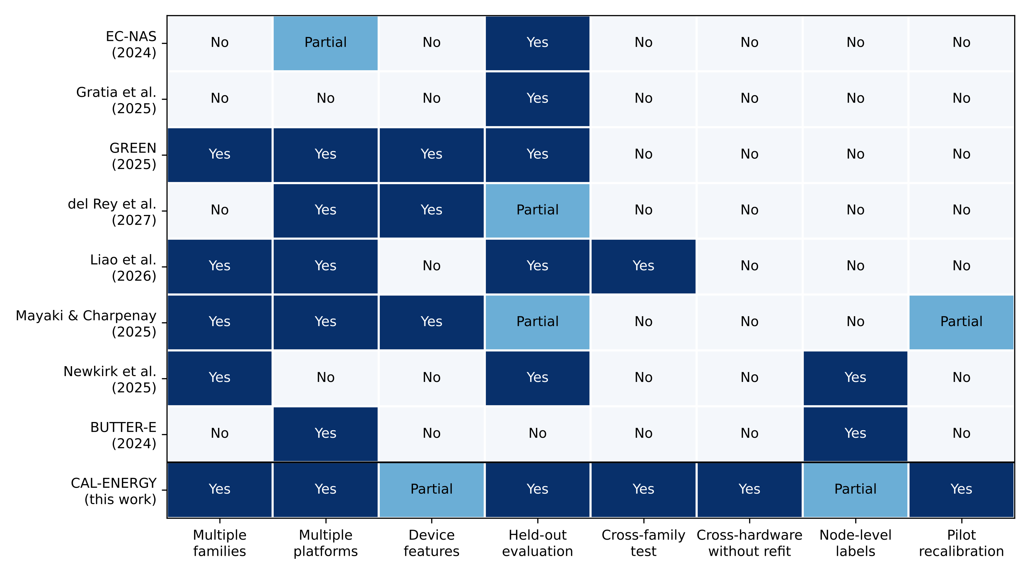
Fig. 1. Capability matrix of a priori training-energy predictors and CAL-ENERGY. Columns record the capabilities that bear on transfer and on label fidelity. “Partial” denotes limited or non-primary evidence. “Cross-hardware without refit” records whether such a test was run, not whether it succeeded. Rows: EC-NAS [10], Gratia et al. [11], GREEN [13], del Rey et al. [12], Liao et al. [7], Mayaki and Charpenay [15], Newkirk et al. [17], and BUTTER-E [23].
Although Table 1 clarifies methodological scope, the numerical results reported across these studies are not directly commensurate because their prediction targets, datasets, hardware, and evaluation protocols differ. Table 2 therefore reports each published quantity in its original context and evaluation setting, and Fig. 2 separates percentage errors reported within the fitting setting from those reported under transfer. In particular, power-curve-component MRE, node-energy error computed with measured duration, and total-training-energy MAPE should not be interpreted as equivalent measures of the same task.
Table 2. Quantitative evidence from a priori training-energy predictors, adjacent methods, and this work; values are not directly comparable across rows.
Study | Reported quantitative result | Metric | Prediction/optimization target | Evaluation setting
A priori training-energy predictors
EC-NAS [10] | 0.903 | Kendall’s τ* | Training energy per run | Same setting (random split)
del Rey et al. [12] | 30.36 kJ | RMSE | Power × duration, or energy per epoch | Same setting (30% held out)
GREEN [13] | 0.010–0.035 | Normalized MAE | Cumulative energy per epoch | Same setting; unseen datasets
Liao et al. [7] | 2.67%, 8.42%, 5.16%, 3.64% | MRE | Valley energy, valley duration, peak power, peak duration | Held-out configurations (A800)
Liao et al. [7] | 9.88% (ViT), 9.66% (BERT); 21.95% (ViT), 20.84% (BERT) | MRE | Valley-phase energy; peak-phase energy | Zero-shot cross-family from ResNet-50
Newkirk et al. [17] | 5.4% | Percentage error | Node energy, using measured duration | Out-of-sample workloads, same node class
BUTTER-E [23] | ±2.74% (GPU); ±20.2% (CPU) | Percentage error | Node energy per run | In-sample fit only
Adjacent methods
SDEnergy [9] | 5.35% | MAPE | Inference energy | Different target and dataset
He et al. [6] | 13.2% energy reduction; 14.1% runtime reduction; 13.8% EDS improvement | Relative change | Offline–online configuration optimization | Requires one epoch of the target job
This work
CAL-ENERGY | 9.6% (BUTTER-E); 5.9% (EC-NAS) | MAPE | Total training energy | Same setting (grouped split)
CAL-ENERGY | 83.9% and 673.0% (cross-family); 5.1–87.0% (held-out GPU) | MAPE | Total training energy | Zero-shot
CAL-ENERGY | 9.3% (RTX 3060), 16.7% (RTX 3090), 18.0% (BUTTER-E → EC-NAS) with five pilot runs | MAPE | Total training energy | Recalibrated (CAL-GATE)
* Captioned as Kendall’s τ in [10]; the corresponding plot label reads “Kendall-Tau R²”.
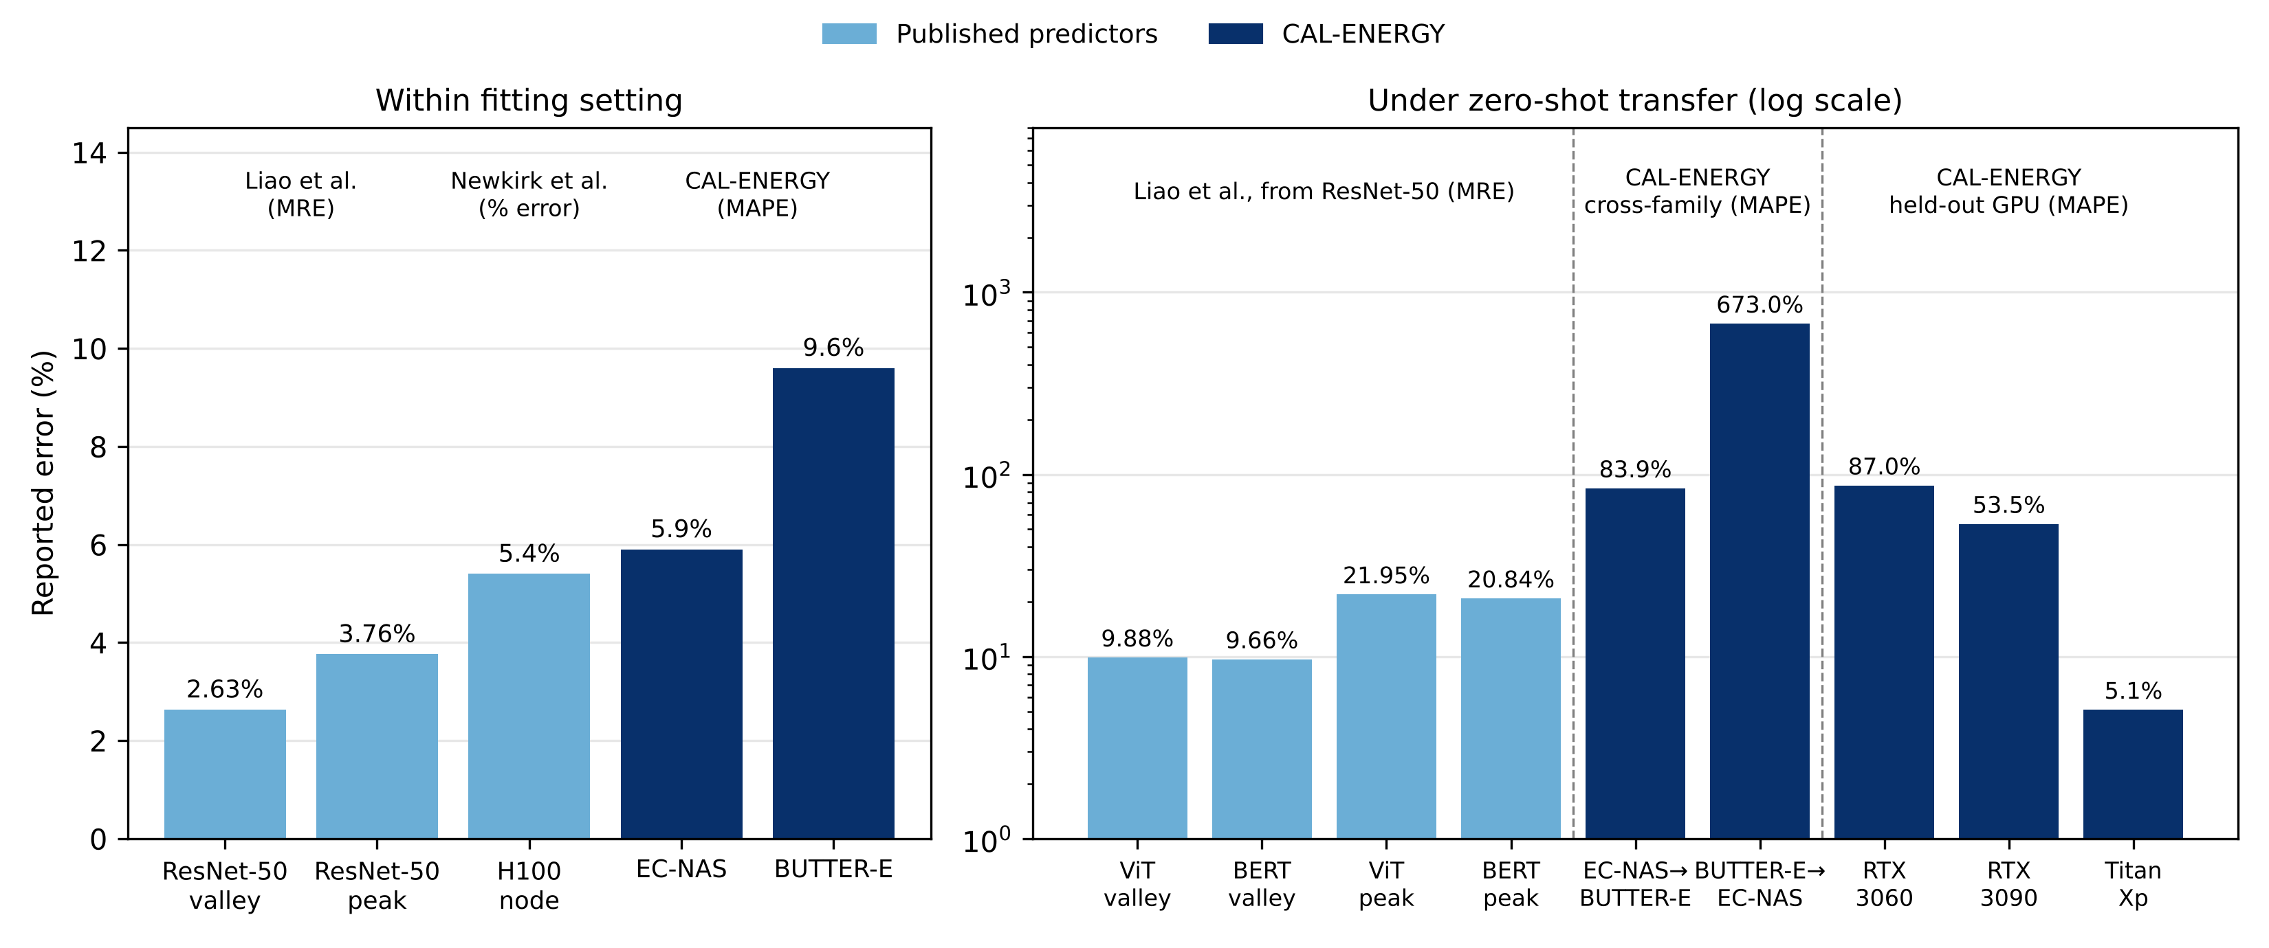
Fig. 2. Percentage errors reported within the fitting setting (left) and under zero-shot transfer (right, logarithmic scale). Published values are MRE for Liao et al. power-curve phases from a ResNet-50 source [7] and percentage error for Newkirk et al. node energy computed with measured duration [17]; CAL-ENERGY values are MAPE for total training energy (Tables 7, 11 and 12). Because targets, metrics, datasets, and hardware differ, the figure is descriptive and does not constitute a head-to-head ranking.

2.3 Research gap and paper positioning
The evidence reviewed in Sections 2.1–2.2 leaves four gaps that directly motivate this work: (i) predictive accuracy is commonly established within the calibration or search domain, with limited deployment-oriented assessment of whether a new request is supported by the calibration data; (ii) measurement provenance is seldom treated explicitly as a potential source of label-scale uncertainty, although labels come mainly from software estimators or GPU power interfaces and, to our knowledge, none has been validated against a reference meter; (iii) family-specific architectural encodings can impede transfer when operation vocabularies differ across model families; and (iv) cross-family transfer has, to our knowledge, been tested once, with errors rising up to sixfold [7], and we are not aware of an a priori predictor evaluated on unseen hardware without target-device data, least of all when training budgets and measurement instruments also change [10–15].
CAL-ENERGY addresses these gaps by combining a shared feature core with masked family-specific descriptors, a direct-versus-decomposed output analysis, grouped interpolation tests, and leave-domain-out evaluation. CAL-GATE extends the framework from prediction to applicability assessment by testing empirical feature support before an estimate is interpreted as calibrated. The resulting predictor can serve as an energy-cost oracle for NAS or GPU-configuration optimization, but it can also support scheduling and compute-budgeting decisions when no optimization loop is present.

3. Materials and Methods

3.1 Problem formulation
For each training run, indexed by i = 1, …, n, CAL-ENERGY represents the information available before execution using four descriptor blocks: architecture Aᵢ, dataset Dᵢ, hardware Hᵢ, and training configuration Cᵢ. These blocks are concatenated into the feature vector defined in Equation (1). Here, Aᵢ contains structural descriptors such as parameter count and depth; Dᵢ describes the training dataset; Hᵢ represents available hardware descriptors; and Cᵢ contains configuration variables such as epoch budget and batch size.
 | $$x_{i}=\left[A_{i},D_{i},H_{i},C_{i}\right]$$ | (1)
The supervised objective is to learn an estimator fθ that maps the pre-execution vector to total measured training energy, as expressed in Equation (2), where θ denotes the fitted model parameters, Eᵢ is the observed energy for run i, and Êᵢ is the corresponding prediction.
 | $${\hat{E}}_{i}=f_{θ}\left(x_{i}\right)$$ | (2)
To preserve family-specific information without requiring a common layer vocabulary, Equation (3) partitions the representation into a shared core and an auxiliary branch that is activated through the family mask m(Fᵢ). The Hadamard product ⊙ suppresses auxiliary variables that are undefined for the corresponding architecture family.
 | $${\tilde{x}}_{i}=\left[x_{i}^{core}, m_{F_{i}}⊙x_{i}^{aux}\right]$$ | (3)
Because the measured energy values span several orders of magnitude, the regression target is transformed with log1p before model fitting and mapped back to the original energy scale after prediction, as shown in Equation (4). The transformation reduces the disproportionate influence of high-energy observations while preserving positivity after inversion.
 | $$z_{i}=log\left(1+E_{i}\right), {\hat{E}}_{i}=exp\left({\hat{z}}_{i}\right)-1$$ | (4)
In addition to direct prediction of total energy, the study evaluates the physical factorization in Equation (5), where Pᵢ denotes average training power and Tᵢ denotes training duration. Separate regressors estimate Pᵢ and Tᵢ, and their product is compared with a direct-energy regressor under the same data split and feature representation.
 | $$E_{i}=P_{i}T_{i}$$ | (5)
Fig. 3 integrates Equations (1)–(5) into the complete CAL-ENERGY workflow, linking feature construction, model fitting, applicability assessment, and domain-shift evaluation.
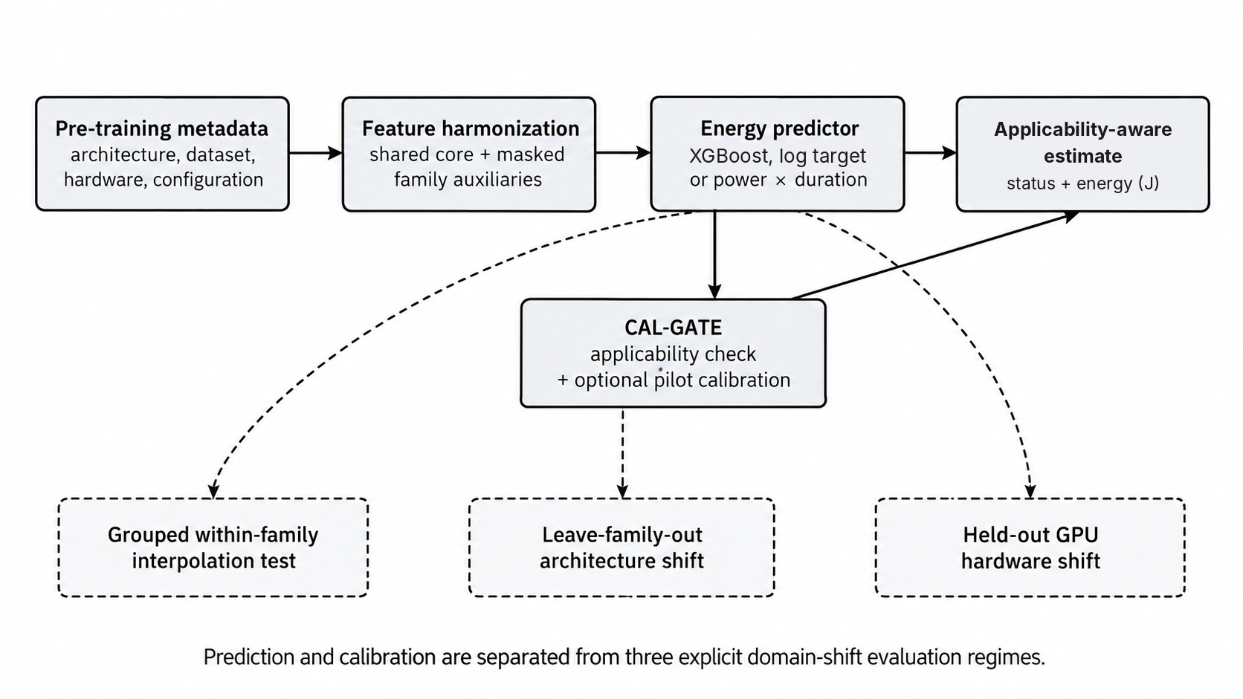
Fig. 3. CAL-ENERGY workflow from pre-execution metadata to applicability-aware energy prediction.
Shared and family-specific descriptors are harmonized, modelled using either direct energy regression or the power–duration decomposition, and passed to CAL-GATE, which returns the estimate with an applicability status. Evaluation separates within-domain interpolation from architecture- and hardware-domain shift.

3.2 Datasets and measurement provenance
To evaluate both within-domain accuracy and domain shift, CAL-ENERGY uses two public benchmarks that differ in architecture family and measurement provenance. BUTTER-E covers 13 PMLB datasets [25], but the smallest, 505_tecator, was used by its authors to estimate per-run setup and tear-down overheads and has no standardized energy records [23]; it therefore contributes 37,055 MLP training runs on 12 datasets, with node-level power read from the HPE Integrated Lights-Out (iLO) management chip at 1-minute intervals and integrated over each run [23]. EC-NAS contributes 2,532 unique CNN architectures with training energy measured by Carbontracker over four epochs for the principal within-family experiments and a 4V benchmark containing 91 shared architectures per GPU for hardware-transfer analysis [10]. Surrogate-only entries from the wider EC-NAS search space are excluded from all ground-truth evaluations so that measured and model-generated targets are not mixed [10].
Table 3 summarizes these datasets. Their complementarity enables MLP–CNN and hardware-domain analyses, but it also creates an important confound: architecture family and measurement instrument vary together in the primary cross-family comparison. The pooled table used in Section 4.3 is formed by stacking the two benchmarks on their shared columns rather than by a row-level merge; because every BUTTER-E run uses 3,000 epochs and every EC-NAS run uses four, the epoch budget alone identifies the source benchmark, so a pooled model can learn a separate energy scale for each benchmark.
Table 3. Dataset characteristics and measurement provenance.
Property | BUTTER-E | EC-NAS
Architecture family | Fully connected MLPs | CNNs from NAS-Bench-101
Primary measured sample | 37,055 runs | 2,532 unique directly measured architectures
Energy measurement | Node-level power, HPE iLO chip (1-min intervals) | Carbontracker software estimate (GPU, CPU, DRAM)
Training budget | 3,000 epochs in measured subset | 4 epochs in primary direct-measurement subset
Primary hardware | Xeon CPU nodes; V100 GPU nodes | Quadro RTX 6000
Domain-shift resource | 12 task datasets | 91 shared architectures on Quadro RTX 6000, RTX 3060, RTX 3090, and Titan Xp
Role in study | Within-family + leave-dataset-out | Within-family + held-out-GPU

3.3 Feature representation
To separate descriptors that can transfer across model families from those that are intrinsically family-specific, the input representation is partitioned into a shared core and masked auxiliary branches. The shared core contains parameter count, network depth, epoch budget, and batch size, each of which has the same interpretation for the MLP and CNN benchmarks. The auxiliary branches retain additional workload or structural information only where the corresponding semantics are well defined.
Table 4 details the final feature groups. For BUTTER-E, dataset descriptors are included because the measured runs share a fixed 3,000-epoch budget; consequently, the number of training observations directly affects the amount of data processed across the run. For EC-NAS, operation counts describe cell composition beyond what parameter count alone captures.
Table 4. CAL-ENERGY feature groups.
Feature group | Variables | Use
Shared core | parameter count; depth; epochs; batch size | Defined consistently across MLP and CNN families
BUTTER-E auxiliary | CPU/GPU flag; network shape; observations; input features; classes; task type; class imbalance | Captures workload scale and MLP-specific structure
EC-NAS auxiliary | 3×3 convolution count; 1×1 convolution count; pooling count; DAG edge count | Captures operation composition beyond parameter count
Hardware-transfer auxiliary | peak FP32 throughput; memory bandwidth; arithmetic-intensity proxy | Tests whether static device descriptors alone enable transfer

During pooled training, family-specific auxiliary variables are set to zero outside the family in which they are defined, consistent with Equation (3). For leave-family-out experiments, only the shared core is retained so that the source model is evaluated solely on information it could have learned without access to target-family descriptors.

3.4 CAL-ENERGY training and evaluation algorithm
The predictor is XGBoost, selected by the per-family model comparison described in Section 3.6. The implementation uses XGBRegressor with 300 trees, a maximum depth of 6, and a learning rate of 0.1, with all other hyperparameters at their library defaults and no tuning [26]. Algorithm 1 then specifies the complete CAL-ENERGY workflow, including feature harmonization, grouped splitting, model fitting, inverse transformation, and evaluation under within-domain and leave-domain-out regimes; the mathematical steps refer to Equations (1)–(5) and (9)–(11).
Algorithm 1. CAL-ENERGY training and evaluation.
Line | Procedure
1 | Input: measured training runs R = {(xᵢ, Eᵢ, Fᵢ, Gᵢ)} for i = 1, …, n, where Fᵢ is the architecture-family label and Gᵢ is the grouping key used to prevent split leakage.
2 | Construct the pre-execution feature vector xᵢ according to Eq. (1).
3 | Form the fixed-dimensional masked representation x̃ᵢ according to Eq. (3).
4 | Transform Eᵢ to zᵢ using the forward mapping in Eq. (4).
5 | Partition the data by grouping key Gᵢ rather than by individual rows so that repeated or near-identical configurations cannot cross the training and test sets [27].
6 | Fit fθ using XGBoost regression on the training partition with the configuration reported in Section 3.4 [26].
7 | Predict ẑᵢ and recover Êᵢ using the inverse mapping in Eq. (4).
8 | Compute MAPE, R², and Kendall’s τ using Eqs. (9)–(11).
9 | Repeat the procedure for the within-family, pooled, leave-one-dataset-out, leave-one-family-out, and held-out-GPU regimes, as applicable.
10 | Output: energy predictions, calibration/ranking metrics, and domain-shift diagnostics.

Algorithm 1 provides the common experimental procedure used in Sections 4.1–4.6; only the training/test domain definition changes across the within-family, pooled, leave-dataset-out, leave-family-out, and held-out-GPU evaluations.

3.5 CAL-GATE: applicability-aware deployment procedure
The domain-shift experiments motivate a separate applicability layer because a predictor may preserve rank ordering while losing absolute calibration outside its training support. CAL-GATE operationalizes this distinction by classifying a requested prediction as within support, requiring recalibration, or pilot-calibrated. It does not replace the underlying regressor; rather, it governs how the regressor’s output should be interpreted under domain shift.
For a candidate feature vector x*, Equation (6) defines the standardized nearest-neighbor distance to the calibration set over the input features used by the predictor, which are the shared core for leave-family-out and held-out-GPU requests. The diagonal matrix S = diag(s₁, …, sₚ) contains feature-scale terms estimated from the training data, so no single variable dominates the support measure solely because of its numerical units.
 | $$d\left(x^{*}\right)=\min_{x_{i}∈X_{train}}{∥S^{-1}\left(x^{*}-x_{i}\right)∥}_{2}$$ | (6)
Equation (7) derives the applicability threshold δ from the leave-one-out nearest-neighbor distances of the unique configurations in the calibration data, so that repeated runs of one configuration do not shrink the threshold to zero, using the 95th percentile as a conservative default. This threshold is fixed from the training distribution and therefore does not require target labels for the initial support decision.
 | $$δ=Q_{0.95}\left({\left\{d_{-i}\left(x_{i}\right)\right\}}_{i=1}^{n}\right)$$ | (7)
When a candidate lies outside the support region, or when its architecture family or hardware domain is absent from training, CAL-GATE marks the raw estimate as requiring recalibration rather than interpreting it as physically calibrated. If a small labeled pilot set is available in the target domain, Equation (8) estimates a robust multiplicative factor α from the median ratio of measured to predicted energy and applies that factor to subsequent predictions.
 | $$α={median}_{k∈P}\left(\frac{E_{k}}{{\hat{E}}_{k}}\right), {\hat{E}}^{pilot}=α\hat{E}$$ | (8)

Algorithm 2. CAL-GATE applicability check and optional pilot recalibration.
Line | Procedure
1 | Input: trained predictor fθ, candidate vector x*, calibration support 𝒳ₜᵣₐᵢₙ, applicability threshold δ, known family/hardware labels, and an optional labeled pilot set P.
2 | Construct the candidate representation x̃* using the feature-construction and masking rules of Algorithm 1.
3 | Compute the support distance d(x*) from Eq. (6) and compare it with the threshold δ from Eq. (7).
4 | If the architecture family and hardware domain are represented in the calibration data and d(x*) ≤ δ, return the raw prediction with status “within support”.
5 | If the request is outside support and no pilot measurements are available, return the prediction for ranking only with status “recalibration required”.
6 | If pilot measurements are available, compute α and the recalibrated estimate using Eq. (8).
7 | Return the recalibrated estimate with status “pilot calibrated” while retaining the original domain-shift flag.

CAL-GATE does not alter the predictor or the accuracy results in Sections 4.1–4.6. Section 4.7 evaluates it retrospectively on the same regimes: the support check is applied to every test request, and pilot recalibration is simulated by drawing k ∈ {1, 3, 5, 10} target-domain architectures or configurations as the labeled pilot set P, estimating α from Equation (8), and scoring the recalibrated predictions on the remaining target runs over 200 random draws (50 for the 37,055-run BUTTER-E target).

3.6 Baselines and model selection
The evaluation uses two baseline levels. A parameter-count-only linear regression provides a parsimonious analytical baseline, while a four-layer MLP following the EC-NAS surrogate design provides a stronger learned baseline [10]. Model selection compares linear regression on the full feature set and Random Forest [28], both implemented in scikit-learn [29], with XGBoost [26] and a feed-forward neural network within each family, using log-target training, the final feature set of that family, and five grouped 80/20 splits; fitting time is measured separately on one split with no concurrent workload. Table 5 and Fig. 4 report the comparison. XGBoost has the lowest mean MAPE in both families (9.2% on BUTTER-E and 6.1% on EC-NAS) and fits in 0.6 s and 0.2 s, compared with 12.1 s and 0.7 s for Random Forest and 95.0 s and 7.1 s for the neural network. On EC-NAS, XGBoost and Random Forest lie within one standard deviation of each other on every metric, so the selection rests on BUTTER-E accuracy and on fitting cost rather than on a uniform advantage. The advantage of both tree ensembles over the neural network is consistent with benchmark evidence on tabular data [30].
Table 5. Per-family model comparison (log-target training, grouped 80/20 splits; mean ± standard deviation over five split seeds; fitting time from a single split).
Family | Model | MAPE (%) | R² | Kendall τ | Fit time (s)
BUTTER-E | Linear (full features) | 73.7 ± 0.7 | 0.590 ± 0.023 | 0.647 ± 0.003 | 0.023
BUTTER-E | Random Forest | 10.0 ± 0.9 | 0.959 ± 0.009 | 0.931 ± 0.003 | 12.1
BUTTER-E | XGBoost | 9.2 ± 0.3 | 0.972 ± 0.003 | 0.935 ± 0.002 | 0.64
BUTTER-E | Feed-forward neural network | 11.8 ± 0.3 | 0.960 ± 0.009 | 0.920 ± 0.001 | 95.0
EC-NAS | Linear (full features) | 18.7 ± 0.6 | 0.573 ± 0.037 | 0.636 ± 0.013 | 0.002
EC-NAS | Random Forest | 6.2 ± 0.2 | 0.955 ± 0.004 | 0.845 ± 0.007 | 0.68
EC-NAS | XGBoost | 6.1 ± 0.2 | 0.957 ± 0.004 | 0.850 ± 0.008 | 0.18
EC-NAS | Feed-forward neural network | 7.1 ± 0.2 | 0.944 ± 0.004 | 0.830 ± 0.007 | 7.1
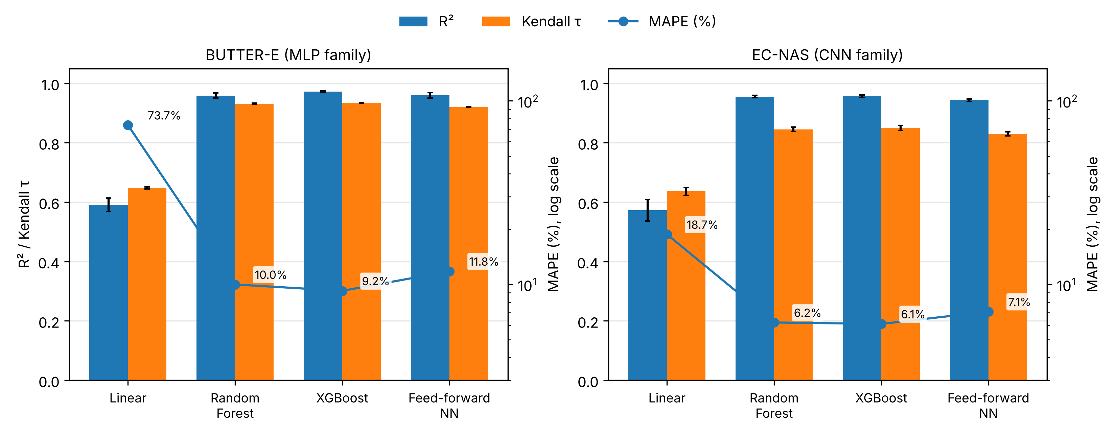
Fig. 4. Per-family model comparison. Bars show mean R² and Kendall’s τ over five grouped splits with ±1 standard deviation; the line shows mean MAPE on a logarithmic axis. XGBoost is retained for the remaining experiments.

3.7 Evaluation metrics and statistical validation
Performance is evaluated using three complementary metrics because no single statistic captures relative error, absolute-scale fit, and candidate ordering simultaneously. MAPE measures relative absolute error but can become unstable when observed values approach zero [31]; the percentage form used in this study is defined in Equation (9), where n is the number of test observations, Eᵢ is the measured energy, and Êᵢ is the prediction.
 | $$MAPE=\frac{100}{n}\sum_{i=1}^{n}{\left|\frac{E_{i}-{\hat{E}}_{i}}{E_{i}}\right|}$$ | (9)
Equation (10) defines the coefficient of determination, R², where Ē is the mean measured energy in the test set. R² quantifies raw-scale variance explained and is particularly informative for detecting systematic calibration errors that preserve ranking but shift the prediction scale.
 | $$R^{2}=1-\frac{\sum_{i=1}^{n}{{\left(E_{i}-{\hat{E}}_{i}\right)}^{2}}}{\sum_{i=1}^{n}{{\left(E_{i}-\overline{E}\right)}^{2}}}$$ | (10)
For energy-aware screening, the relative ordering of candidate runs is also important. Equation (11) therefore reports the tie-corrected Kendall rank correlation τᵦ, where C and D are the numbers of concordant and discordant pairs and Tₓ and Tᵧ are tie counts for the two variables [32].
 | $$τ_{b}=\frac{C-D}{\sqrt{\left(C+D+T_{x}\right)\left(C+D+T_{y}\right)}}$$ | (11)

Throughout the Results section, Kendall’s τ denotes τᵦ unless otherwise stated. Uncertainty is summarized with five-seed repetition of the model comparison and with a cluster bootstrap for the within-family results: per-example test predictions of XGBoost, Random Forest, and the MLP surrogate are retained, test groups (repeated configurations or architectures) are resampled with replacement 1,000 times, and percentile 95% intervals are reported for each metric and for the paired difference between XGBoost and each comparator.

3.8 Computational complexity
Let n denote the number of training runs, p the number of recorded features, T the number of boosted trees, d the maximum tree depth, and q the number of candidate runs to screen. Table 6 summarizes the resulting asymptotic costs. These costs show that the predictor is computationally lightweight relative to executing DNN training runs; consequently, the principal scalability constraint is coverage of architecture, workload, and hardware domains rather than prediction-time computation.
Table 6. Computational-complexity summary.
Stage | Approximate complexity | Practical implication
Feature construction | O(np) | Linear in recorded metadata
XGBoost training | O(Tdnp + np log n) | One-off cost; split search parallelized across features
Prediction per run | O(Td) | Cheap tabular inference
Ranking q candidates | O(qTd + q log q) | Suitable for pre-screening large candidate lists
CAL-GATE naive support check | O(np) per candidate | Can be accelerated with nearest-neighbor indexing
Leave-domain-out evaluation | Same prediction complexity | Accuracy, not compute, is the limiting factor

4. Results

4.1 Within-family predictive performance
Following Algorithm 1, the first evaluation considers grouped within-family train/test splits so that repeated or near-identical configurations do not cross partitions. Table 7 reports the resulting performance, and Fig. 5 compares R² and Kendall’s τ with the two baselines. CAL-ENERGY attains MAPE = 9.6%, R² = 0.971, and τ = 0.932 on BUTTER-E, and MAPE = 5.9%, R² = 0.961, and τ = 0.851 on EC-NAS.
The parameter-count-only model performs substantially worse, particularly on BUTTER-E, where it explains only 6.5% of the raw-scale variance. The four-layer MLP surrogate is considerably stronger and remains a competitive baseline. Its EC-NAS τ of 0.836 is lower than the 0.903 reported for the original surrogate [10]; the original was evaluated on a random split of 4,310 architectures from the larger seven-vertex space, whereas the re-implementation here uses grouped splits over the 2,532 directly measured architectures, so the two values are not directly comparable. CAL-ENERGY produces the lowest MAPE and the highest R² and Kendall’s τ in both families, and the cluster-bootstrap intervals in Section 4.4 show that its advantage over the MLP surrogate exceeds sampling uncertainty on all three metrics in both families.
Table 7. Within-family performance against identical-data baselines.
Family | Model | MAPE (%) | R² | Kendall τ
BUTTER-E | Parameter-only linear | 143.1 | 0.065 | 0.283
BUTTER-E | Four-layer MLP surrogate | 11.7 | 0.966 | 0.921
BUTTER-E | CAL-ENERGY XGBoost | 9.6 | 0.971 | 0.932
EC-NAS | Parameter-only linear | 19.2 | 0.578 | 0.620
EC-NAS | Four-layer MLP surrogate | 6.8 | 0.948 | 0.836
EC-NAS | CAL-ENERGY XGBoost | 5.9 | 0.961 | 0.851
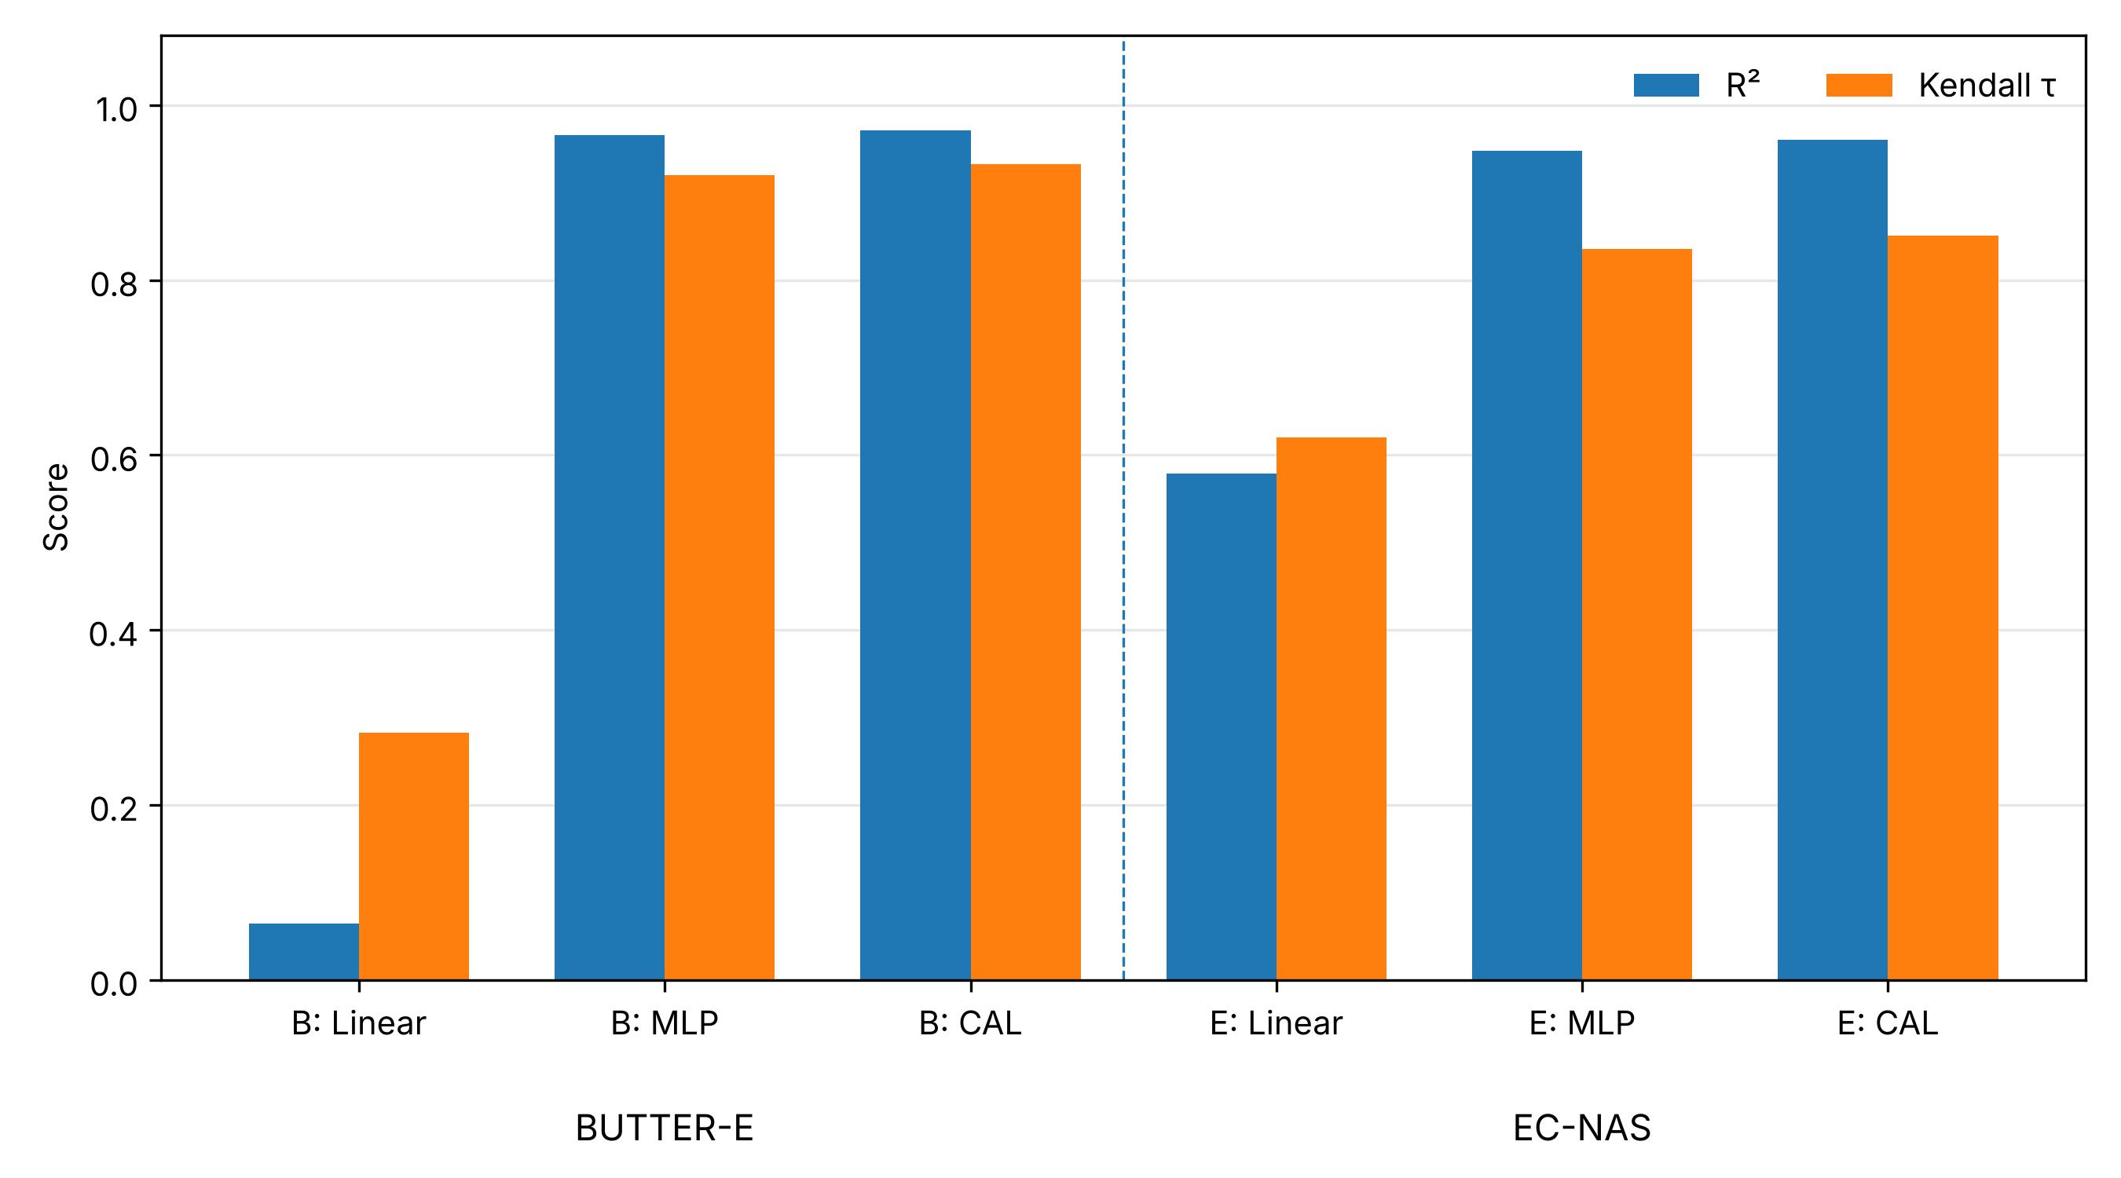
Fig. 5. Within-family predictive performance. B denotes BUTTER-E and E denotes EC-NAS. The figure compares R² and Kendall’s τ for parameter-only linear regression, the re-implemented MLP surrogate, and CAL-ENERGY on the same study data.

4.2 Feature sensitivity and leave-dataset-out robustness
Table 8 and Fig. 6 quantify the effect of progressively enriching the BUTTER-E representation. With shared architectural/configuration variables alone, performance is weak (R² = 0.087; τ = 0.273). Adding hardware type and network shape yields only a modest improvement in ranking, and the memory/cache proxy changes every metric by less than 0.5 percentage points of MAPE or 0.003 in R² and τ. This contrasts with the cache-aware model of Tripp et al., in which energy per FLOP on the same BUTTER-E runs changes as the working set moves across cache levels [23]. The proxy used here largely re-encodes network size (Table 8), whereas the effect reported by Tripp et al. depends on working-set size relative to each cache level of the specific CPU or GPU and was established by in-sample fit [23]; the negative result therefore applies to this proxy, not to memory effects in general. Adding dataset descriptors, however, increases R² to 0.971 and τ to 0.932, demonstrating that workload information explains most of the residual variation left by architecture-only features.
This result is mechanistically plausible because the BUTTER-E subset fixes training at 3,000 epochs [23]. Under a fixed epoch budget, increasing the number of training observations increases the volume of data processed over the run and therefore affects duration and energy. Dataset scale should thus be interpreted as a workload-volume descriptor rather than as a purely statistical correlate.
Table 8. BUTTER-E feature-sensitivity analysis.
Feature set | MAPE (%) | R² | Kendall τ | Interpretation
Shared core only | 132.6 | 0.087 | 0.273 | Architecture scale alone is insufficient
+ hardware type + network shape | 104.7 | 0.080 | 0.375 | Small rank gain; weak absolute fit
+ memory/cache proxy | 104.4 | 0.082 | 0.376 | Rejected: mostly re-encodes size
+ dataset properties (final) | 9.6 | 0.971 | 0.932 | Workload scale closes most residual gap
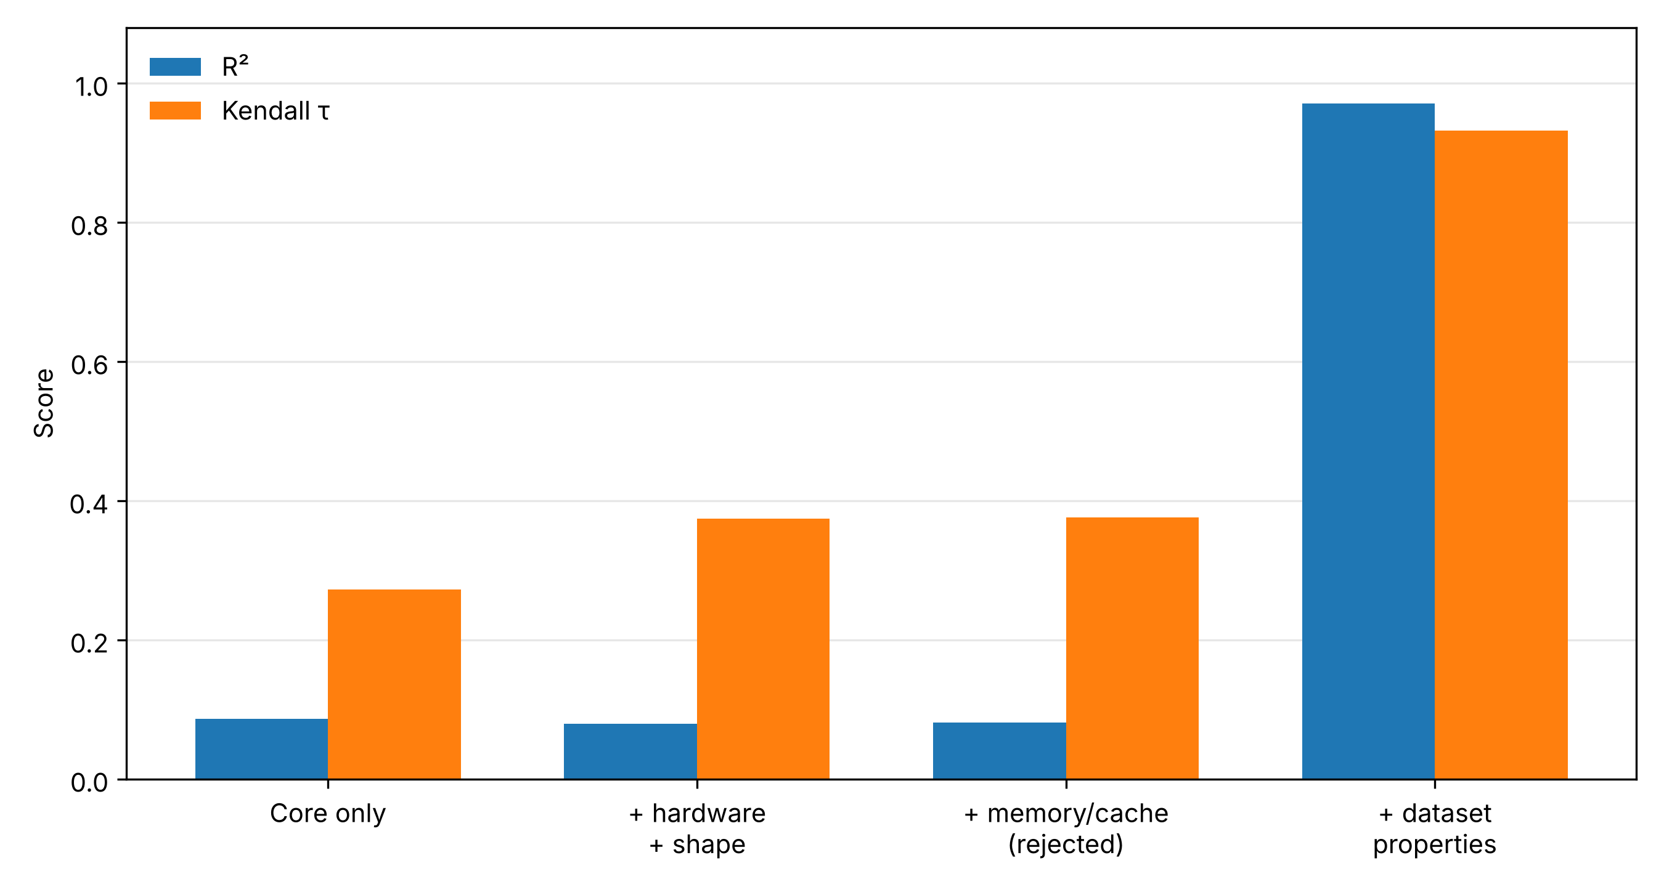
Fig. 6. BUTTER-E feature sensitivity. Dataset-level descriptors cause the dominant gain in both variance explained and rank correlation, whereas hardware/shape and the rejected memory/cache proxy do not close the architecture-only gap.
To test whether the dataset features merely encode the identity of the 12 BUTTER-E tasks, a leave-one-dataset-out analysis trains on 11 datasets and evaluates on the excluded dataset. Mean Kendall’s τ remains approximately 0.84, whereas mean R² falls to about 0.56 and becomes negative for one dataset (splice) near the boundary of the observed feature space. The result suggests that relative ordering transfers more robustly than absolute calibration and that the current task diversity is insufficient to establish unrestricted dataset generalization.

4.3 Output structure
The power–duration formulation in Equation (5) provides no material predictive advantage over direct total-energy regression on the pooled split (Table 9, Fig. 7): MAPE is 9.1% versus 9.0%, and R² (0.968) and τ (0.938) are the same to three decimals. The power sub-model is the more accurate component (MAPE 3.0%, against 8.7% for duration), so most of the recomposed error comes from duration. Because the epoch budget identifies the source benchmark in the pooled table (Section 3.2), these pooled figures largely reflect two benchmark-specific fits and should not be read as evidence of cross-family learning. The decomposition is therefore retained for interpretability and for targeting power-only corrections, not because the present experiments demonstrate superior accuracy.
Table 9. Pooled output-structure comparison.
Experiment | MAPE (%) | R² | Kendall τ
Direct total energy | 9.0 | 0.968 | 0.938
Decomposed output: power × duration | 9.1 | 0.968 | 0.938
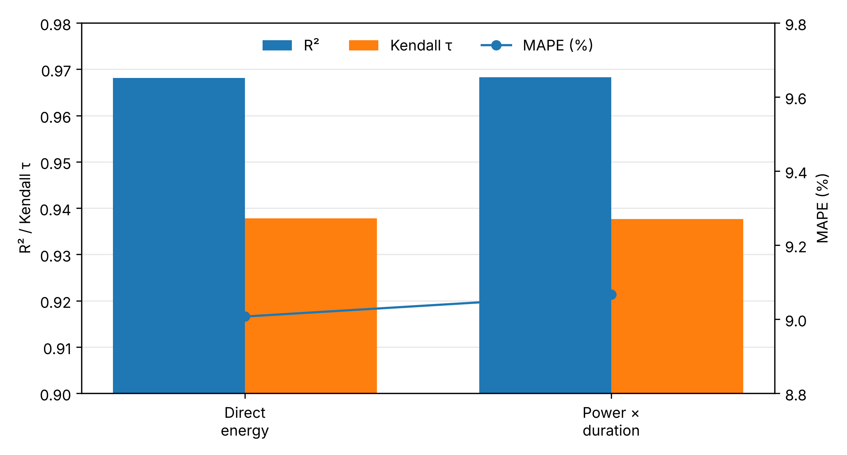
Fig. 7. Pooled output-structure comparison. Direct total-energy regression and the power × duration decomposition reach the same R² and Kendall’s τ, with MAPE differing by 0.1 percentage points.

4.4 Statistical uncertainty
The within-family Kendall correlations indicate strong monotonic agreement between predicted and measured energy. Table 10 reports cluster-bootstrap intervals obtained by resampling test groups. The intervals for τ are 0.928–0.937 for BUTTER-E and 0.832–0.867 for EC-NAS, and those for MAPE are 9.1–10.3% and 5.5–6.3%. Paired bootstrap differences show that XGBoost improves on the MLP surrogate on every metric in both families (MAPE difference −2.74 to −1.91 percentage points on BUTTER-E and −1.36 to −0.55 on EC-NAS) and on Random Forest on every metric for BUTTER-E (MAPE difference −4.38 to −0.46 percentage points), whereas for EC-NAS the XGBoost–Random Forest intervals include zero for all three metrics.
Table 10. Within-family uncertainty for CAL-ENERGY (XGBoost): cluster-bootstrap 95% intervals.
Family | CAL-ENERGY τ | Bootstrap 95% CI (τ) | Bootstrap 95% CI (MAPE, %)
BUTTER-E | 0.932 | 0.928–0.937 | 9.1–10.3
EC-NAS | 0.851 | 0.832–0.867 | 5.5–6.3

Split sensitivity is more pronounced in the smaller hardware benchmark. Across seven random 80/20 splits of the Quadro RTX 6000 runs, the within-hardware reference Kendall correlation ranges from 0.62 to 0.89 (mean 0.77) for the 91-architecture subset, whereas the held-out-GPU results in Table 12 are identical across seven model seeds because the XGBoost configuration involves no row or column subsampling. Such split-to-split variation is a recognized source of uncertainty in machine-learning benchmarks [33], and here it indicates that the subset is too small to support an overly precise single-split ceiling and motivates interpreting the held-out-GPU results through both point metrics and the diagnosed failure mechanisms.

4.5 Architecture-family generalization
Architecture-family transfer is evaluated by training on one family and testing on the other using only the shared feature core, following the leave-one-domain-out protocol used in domain generalization [34,35], as specified in Algorithm 1. Table 11 and Fig. 8 show that zero-shot transfer does not preserve within-family calibration. EC-NAS → BUTTER-E yields MAPE = 83.9%, R² = −0.387, and τ = 0.232, whereas BUTTER-E → EC-NAS preserves more ordering information (τ = 0.688) but exhibits severe absolute-scale error (MAPE = 673.0%; R² = −384.3).
The two transfer directions fail for different, identifiable reasons. An EC-NAS-only model does not observe the dataset-level variation that dominates BUTTER-E and must also extrapolate beyond part of its parameter-count range. Conversely, BUTTER-E fixes training at 3,000 epochs, so a source-only model cannot learn the energy scaling associated with EC-NAS’s four-epoch regime. The large negative R² values therefore reflect systematic domain-scale mismatch rather than random regression instability.
Table 11. Leave-one-family-out architecture transfer.
Transfer direction | MAPE (%) | R² | Kendall τ | Main diagnosed cause
EC-NAS → BUTTER-E | 83.9 | −0.387 | 0.232 | Missing workload features + parameter-range extrapolation
BUTTER-E → EC-NAS | 673.0 | −384.3 | 0.688 | Epoch-budget mismatch + scale extrapolation
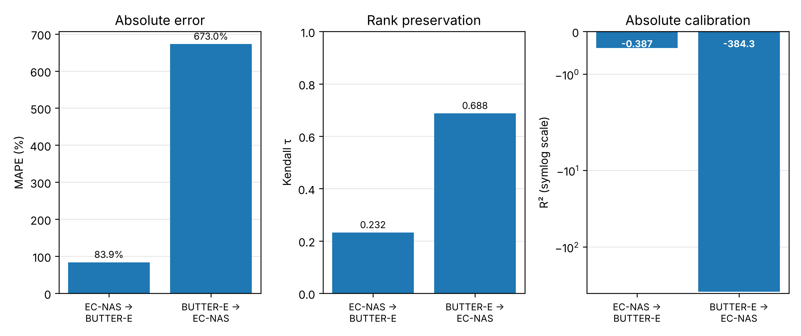
Fig. 8. Architecture-family transfer shown in separate panels for MAPE, Kendall’s τ, and R². Separating the metrics prevents the extreme negative R² in the BUTTER-E → EC-NAS direction from visually suppressing the rank-correlation signal and makes the distinction between ordering and calibration explicit.
These findings provide the empirical motivation for CAL-GATE. In both directions, either the target family is unseen or key shared variables lie outside the source-domain regime. Algorithm 2 is designed to flag such cases before the numerical prediction is interpreted as calibrated, thereby separating the tasks of candidate ranking and absolute energy estimation.

4.6 Hardware transferability
Hardware transfer is evaluated with the EC-NAS 4V benchmark, which measures the same 91 architectures on four GPU classes [10]. A model trained only on Quadro RTX 6000 measurements is tested on RTX 3060, RTX 3090, and Titan Xp. Table 12 and Fig. 9 reveal a consistent distinction between ranking and calibration: RTX 3060 preserves strong ordering (τ = 0.867) despite poor absolute fit (R² = −3.743), RTX 3090 shows weaker ordering (τ = 0.688) and only partial calibration (R² = 0.206), and Titan Xp appears well calibrated primarily because its observed energy scale is close to that of the source GPU.
Table 12. Held-out-GPU transfer from a Quadro RTX 6000 source: CAL-ENERGY on core features, CAL-ENERGY with static GPU specifications added, and a training-free peak-throughput scaling rule.
Target GPU | Method | MAPE (%) | R² | Kendall τ
RTX 3060 | CAL-ENERGY (core features) | 87.0 | −3.743 | 0.867
RTX 3060 | + static GPU specifications | 87.0 | −3.743 | 0.867
RTX 3060 | Peak-throughput scaling rule | 139.5 | −11.501 | 0.847
RTX 3090 | CAL-ENERGY (core features) | 53.5 | 0.206 | 0.688
RTX 3090 | + static GPU specifications | 53.5 | 0.206 | 0.688
RTX 3090 | Peak-throughput scaling rule | 32.3 | 0.002 | 0.678
Titan Xp | CAL-ENERGY (core features) | 5.1 | 0.970 | 0.899
Titan Xp | + static GPU specifications | 5.1 | 0.970 | 0.899
Titan Xp | Peak-throughput scaling rule | 31.8 | 0.024 | 0.885
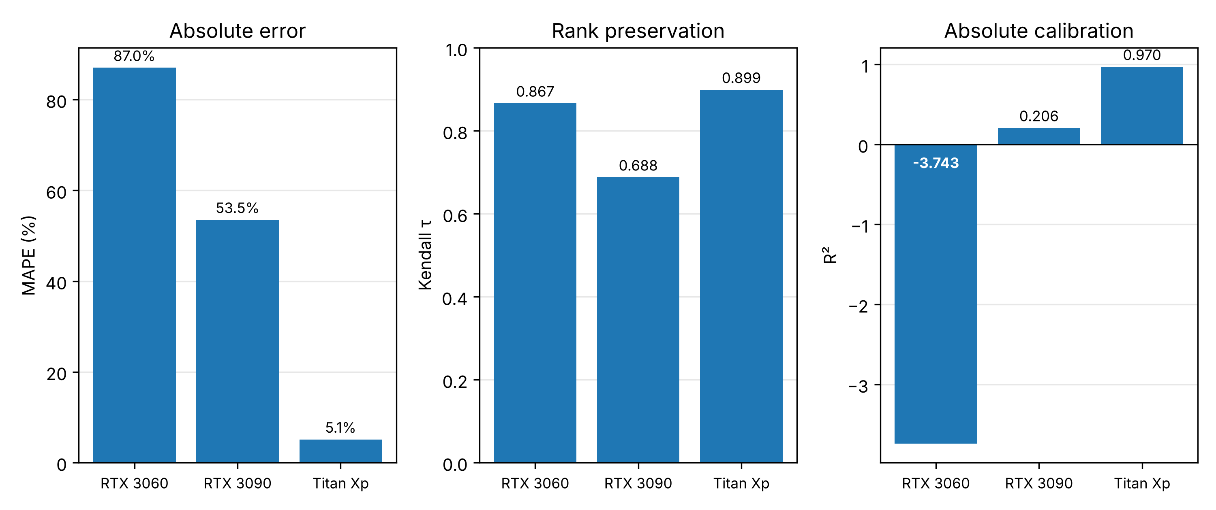
Fig. 9. Held-out-GPU transfer shown separately for MAPE, Kendall’s τ, and R². RTX 3060 preserves ordering despite poor absolute calibration; Titan Xp appears accurate because its aggregate energy scale resembles the source GPU.
Static hardware specifications do not resolve this limitation when the source training data contain only one GPU, because features such as peak throughput and memory bandwidth are constant and therefore provide no learnable within-source variation; adding them leaves every held-out-GPU prediction unchanged (Table 12). A training-free rule that scales each architecture’s measured Quadro RTX 6000 energy by the ratio of peak FP32 throughputs reaches a lower MAPE than CAL-ENERGY on RTX 3090 (32.3% against 53.5%) but performs worse on absolute fit for every GPU, with R² of −11.501 on RTX 3060, 0.002 on RTX 3090, and 0.024 on Titan Xp, because rated FLOPs do not determine energy when a workload is not compute-bound, consistent with GPU power/performance models and the roofline perspective [36,37]. Existing multi-device a priori predictors obtain device coverage either by refitting for each platform [14,15,19] or by including device descriptors in a model fitted on several GPUs [12,13]; none of these reports a zero-shot test on a held-out device. The present held-out-GPU experiment is such a test, and it shows that a single-GPU source does not support absolute calibration on other GPUs. Robust hardware transfer therefore requires calibration data spanning multiple devices, or a small target-device pilot set (Section 4.7), and pre-execution descriptors that better proxy occupancy, memory traffic, precision, and kernel mix, as begun in roofline-style and cache-aware training-energy models [16,23].

4.7 CAL-GATE applicability and pilot recalibration
CAL-GATE (Algorithm 2) is evaluated on the regimes of Sections 4.1–4.6 without changing the underlying predictor. Table 13 reports how often each component of the support check flags a request, together with the MAPE of flagged and unflagged requests. Within each family, the distance rule flags 4.7% of BUTTER-E and 0.8% of EC-NAS test runs, and those runs have higher error than the rest (12.3% against 9.5% MAPE on BUTTER-E; 17.6% against 5.8% on EC-NAS). Every cross-family request is flagged by both the distance rule and the family label. Held-out-GPU requests are flagged only by the hardware label: the 4V benchmark measures the same architectures on every GPU, so the feature-space distance to the source data is zero and the distance rule alone cannot detect a change of device. In leave-one-dataset-out evaluation, the distance rule flags every run of every held-out BUTTER-E dataset, including datasets predicted with MAPE near 11%, so in that regime it identifies novelty conservatively rather than separating accurate from inaccurate predictions.
Table 13. CAL-GATE support check: share of requests flagged by the distance rule (Equations (6)–(7)) and by the family/hardware label rule, with MAPE of flagged and unflagged requests.
Regime | Requests | Flagged by distance (%) | Flagged by label (%) | MAPE flagged (%) | MAPE not flagged (%)
Within BUTTER-E | 7,427 | 4.7 | 0.0 | 12.3 | 9.5
Within EC-NAS | 507 | 0.8 | 0.0 | 17.6 | 5.8
Leave-one-dataset-out, BUTTER-E | 37,055 | 100.0 | 0.0 | 23.8 | —
EC-NAS → BUTTER-E | 37,055 | 100.0 | 100.0 | 83.9 | —
BUTTER-E → EC-NAS | 2,532 | 100.0 | 100.0 | 673.0 | —
Quadro RTX 6000 → RTX 3060 | 88 | 0.0 | 100.0 | 87.0 | —
Quadro RTX 6000 → RTX 3090 | 91 | 0.0 | 100.0 | 53.5 | —
Quadro RTX 6000 → Titan Xp | 91 | 0.0 | 100.0 | 5.1 | —

Table 14 and Fig. 10 report pilot recalibration. With five measured pilot runs, the median MAPE over 200 random pilot draws falls from 87.0% to 9.3% on RTX 3060 and from 53.5% to 16.7% on RTX 3090, and from 673.0% to 18.0% for BUTTER-E → EC-NAS transfer. On RTX 3060 the recalibrated error approaches that of an XGBoost model fitted on RTX 3060 itself by five-fold grouped cross-validation (6.6%), and on RTX 3090 it is lower than that reference (28.7%). On Titan Xp, where the source and target energy scales already agree, recalibration leaves MAPE essentially unchanged (5.1% before, 5.3% after). Fitting a new model on the same pilot runs is consistently worse than rescaling the source model; with ten pilots its median MAPE remains 20.0%, 37.0%, and 20.4% on the three GPUs. Because α multiplies every prediction by the same factor, Kendall’s τ is unchanged by recalibration. The 4V benchmark measures the same 91 architectures on every GPU, so the source model has already seen each target architecture on the Quadro RTX 6000; the held-out-GPU results therefore isolate a change of device and do not test unseen architectures on unseen hardware, and the comparison with the reference fitted on the target GPU favors the source model, which is trained on all 91 architectures.
Table 14. Pilot recalibration with Equation (8): median MAPE (%) on the remaining target runs over 200 random pilot draws (50 for EC-NAS → BUTTER-E). “Refit on 10 pilots” fits a new XGBoost model on the ten pilot runs only; “Fitted on target” is five-fold grouped cross-validation on the target GPU’s own runs.
Target | Uncorrected | k = 1 | k = 3 | k = 5 | k = 10 | Refit on 10 pilots | Fitted on target
RTX 3060 | 87.0 | 10.2 | 9.6 | 9.3 | 9.0 | 20.0 | 6.6
RTX 3090 | 53.5 | 18.8 | 16.9 | 16.7 | 16.5 | 37.0 | 28.7
Titan Xp | 5.1 | 6.2 | 5.4 | 5.3 | 5.2 | 20.4 | 8.1
BUTTER-E → EC-NAS | 673.0 | 20.6 | 18.0 | 18.0 | 17.3 | 20.8 | —
EC-NAS → BUTTER-E | 83.9 | 147.4 | 142.8 | 149.5 | 147.5 | 218.9 | —

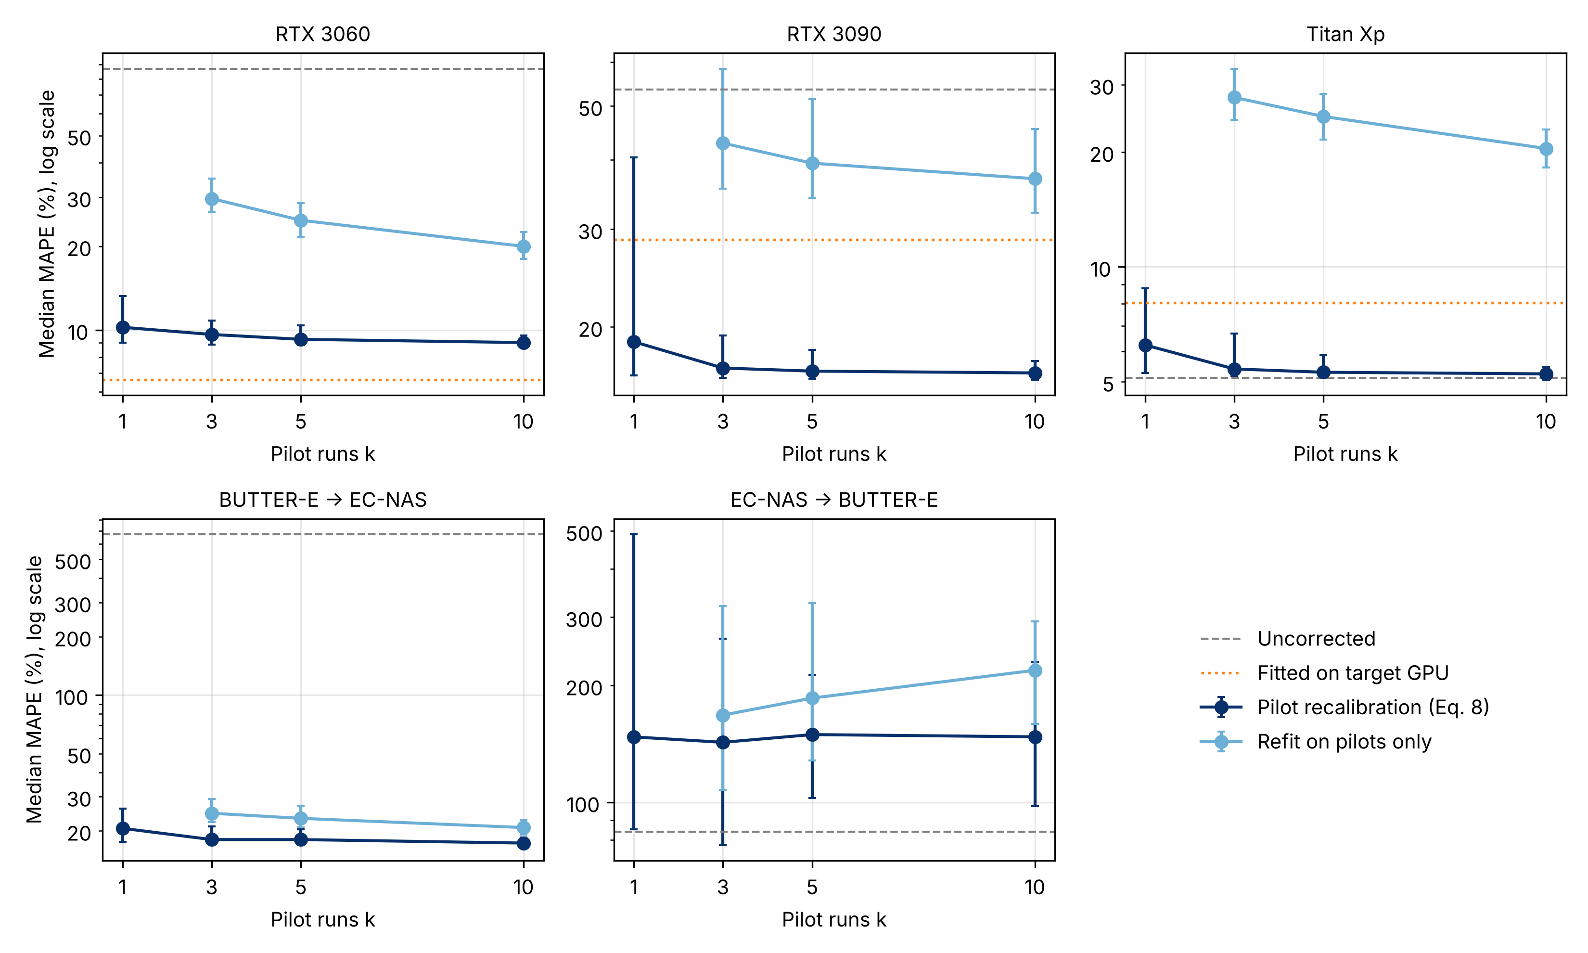
Fig. 10. Pilot recalibration as a function of the number of pilot runs k. Points show the median MAPE over random pilot draws and bars the interquartile range; dashed lines mark the uncorrected predictor and dotted lines an XGBoost model fitted on the target GPU itself.
Recalibration fails for EC-NAS → BUTTER-E transfer, where the median MAPE rises from 83.9% to 149.5% with five pilots and varies widely between draws (interquartile range 102.6–213.3%). In this direction the source model lacks the dataset descriptors that explain most BUTTER-E variation (Table 8), so the error is not a common scale factor and a single multiplicative correction cannot remove it. CAL-GATE pilot recalibration is therefore appropriate when the shift is a change of energy scale, such as a different GPU or epoch budget, and not when the target domain varies along inputs that the source model never observed. Rank preservation under shift is also uneven, with τ between 0.232 and 0.899 across Tables 11 and 12, so the “ranking only” status in Algorithm 2 marks a weaker use of the estimate rather than a guarantee that candidate ordering is reliable.

5. Discussion

5.1 Why within-family prediction improves
The feature-ablation results, which are used here instead of impurity-based importance because the latter is biased towards continuous and high-cardinality variables [38], indicate that CAL-ENERGY’s within-family improvement arises primarily from a better representation of workload demand rather than from increased regressor complexity. In BUTTER-E, the fixed 3,000-epoch schedule makes dataset size a direct determinant of the volume of repeated data processing [23]. Once observation count and related task descriptors are included, architectures that appear similar from structural features alone become distinguishable in terms of training workload. In EC-NAS, operation composition provides complementary information because cells with similar parameter counts can execute different mixtures of convolution and pooling and therefore induce different hardware-utilization patterns [10].
These results support a broader systems interpretation: no single architecture-scale proxy is sufficient to explain training energy across heterogeneous workload families. A priori prediction must jointly represent network structure, workload volume, training configuration, and execution environment. Parameter count and FLOPs remain useful coarse descriptors, but prior work and the present experiments both show that they should not be treated as universal energy laws [9,10,14,16,23,24,39–42].

5.2 Comparison with related predictors
Comparison with recent work clarifies both the scope and limits of the present contribution. The cross-family results agree in direction with the only earlier cross-family test: Liao et al. report peak-phase energy MRE rising from 3.76% to 21.95% and 20.84% when a ResNet-50 model is applied to ViT and BERT [7], whereas CAL-ENERGY’s MAPE rises from 5.9–9.6% within family to 83.9–673.0% between the MLP and CNN benchmarks (Tables 7 and 11). The larger degradation here is consistent with the larger shift, since the two benchmarks also differ in training budget and measurement instrument. del Rey et al. [12] and GREEN [13] include device descriptors and fit across three GPUs but are evaluated in the same setting used for fitting; the held-out-GPU test in Table 12 is complementary because it removes the target device from training altogether. SDEnergy reports 5.35% MAPE for device-aware inference-energy prediction [9]; this value should not be ranked against CAL-ENERGY’s 5.9% EC-NAS MAPE because the targets, datasets, and hardware differ.
Gratia et al. [11] and He et al. [6] demonstrate how predictive models can be embedded within optimization procedures. Their primary decision variable is the architecture or GPU/workload configuration to select, whereas CAL-ENERGY focuses on the preceding estimation question: what total energy should be expected, and is the request within the predictor’s calibration domain? The two roles are complementary; Algorithm 2 can precede an optimizer by allowing well-supported candidates to be ranked directly and routing unsupported candidates to pilot measurement before they influence an energy-aware decision.

5.3 Calibration and the role of CAL-GATE
Pooled fit statistics cannot, by themselves, establish physical comparability across benchmarks. Because the epoch budget identifies the source benchmark in the pooled table, a flexible model fits a separate energy scale for each benchmark, and the high pooled R² in Table 9 (0.968) coexists with cross-family R² of −0.387 and −384.3 (Table 11). For sustainable-computing applications that use predictions for resource allocation, reporting the calibration domain of an estimate is consequently as important as reporting conventional prediction error.
CAL-GATE implements this principle as a deployment rule. When Equation (6) places a request outside the empirical support defined by Equation (7), or when the target family/hardware domain is absent from the calibration data, the raw estimate is marked as requiring recalibration. If pilot measurements are available, Equation (8) applies a robust target-domain scale factor. This strategy is conceptually related to offline–online correction in He et al. [6], but the objective differs: CAL-GATE calibrates the applicability and scale of an existing energy predictor rather than searching the local GPU-configuration space. Pilot recalibration also corresponds to the per-device refitting used by existing multi-platform predictors [14,15,19], but requires only a scale factor estimated from a small target-domain pilot set rather than a full refit. Section 4.7 shows that this distinction matters in practice: rescaling with five pilots outperforms refitting on the same pilots on every GPU, while the distance rule must be paired with explicit hardware labels because identical architectures on a new device are indistinguishable in feature space.

5.4 Scalability, sensitivity and robustness
Scalability in this problem has three distinct dimensions. (i) Computational scalability is favorable because tabular prediction is inexpensive relative to neural-network training, as summarized in Table 6. (ii) Statistical scalability depends on the diversity of independent tasks and devices rather than the raw number of rows; adding many observations from the same 12 datasets or one GPU does not teach responses to unseen domains. (iii) Domain scalability requires crossed variation across the factors to which the predictor is expected to respond, including architecture family, dataset scale and modality, epoch budget, precision mode, GPU generation, utilization regime, and measurement instrument.
The ablation in Table 8, leave-one-dataset-out analysis, output-structure comparison in Table 9, leave-family-out results in Table 11, held-out-GPU results in Table 12, and CAL-GATE evaluation in Tables 13 and 14 provide a structured robustness assessment. The pattern is consistent: interpolation is strongest within joint feature support; rank ordering can survive some distribution shift; absolute calibration fails earlier under training-budget or hardware-scale changes; and both ranking and calibration deteriorate when the source data omit predictive dimensions that vary in the target domain. Scale failures can be repaired with a few pilot runs, whereas failures caused by omitted predictive dimensions cannot.

5.5 Implications for sustainable computing
For supported within-family requests, CAL-ENERGY can provide low-overhead pre-execution estimates for candidate ranking, energy-aware scheduling, compute-budget allocation, and surrogate-guided model selection. For unseen hardware or other unsupported domains, however, the current evidence does not justify interpreting the raw output as physically calibrated energy. A practical deployment should therefore combine metadata-based screening with targeted pilot measurement only when CAL-GATE identifies domain shift, reducing measurement overhead while preserving a clear distinction between statistical prediction and physical calibration; in the held-out-GPU experiments, five pilot runs per new device were sufficient to bring MAPE below 17%.

6. Threats to Validity and Limitations
- Architecture family and measurement instrument remain confounded because the MLP and CNN benchmarks were collected under different measurement regimes, and the two benchmarks were stacked on their shared columns rather than harmonized, so the epoch budget identifies the source benchmark. Resolving the confound requires the same architectures to be measured with both instrument classes [5]. Neither benchmark reports validation of its labels against an external reference meter [10,23].
- Cross-family evaluation in this study is limited to MLPs and CNNs. The only other cross-family test, from ResNet-50 to ViT and BERT, also reports rising error [7], and a priori predictors covering Transformers or recurrent networks have otherwise been evaluated only on families present in their fitting data [13,15–17]; transfer to recurrent, mixture-of-experts, or foundation-model training therefore remains untested.
- The held-out-GPU analysis covers four NVIDIA GPU classes and 91 shared architectures per device [10]. This design is sufficient to expose scale mismatch, but it is too narrow to establish a general hardware-transfer law across vendors, generations, or utilization regimes, a limitation shared with most published a priori predictors, which are evaluated on NVIDIA GPUs [7,10,12,13,15,17]. Because the same architectures appear on the source and target GPUs, the analysis also does not cover the joint shift of an unseen architecture on unseen hardware.
- BUTTER-E contributes only 12 source datasets to the workload-level analysis [23]. Leave-one-dataset-out evaluation reduces concern about literal dataset-identity memorization but cannot substitute for validation on a larger, independently collected task suite.
- Paired bootstrap comparisons are reported for the within-family results only; the transfer experiments are single source–target pairs, and their uncertainty is characterized by repeated pilot draws and seeds rather than by resampling independent domains. XGBoost was used with fixed, untuned hyperparameters, so the reported accuracies are not upper bounds for the model class.
- CAL-GATE is evaluated retrospectively on the same benchmarks that motivated it, with three held-out GPUs and two cross-family directions. The 95th-percentile support threshold flagged every held-out BUTTER-E dataset regardless of accuracy, and pilot recalibration did not help when the shift involved unobserved inputs; both the threshold and the recalibration rule should be tested prospectively on additional architecture families and hardware vendors.
- Finally, static hardware specifications are not direct measurements of utilization. Future hardware-aware predictors should incorporate pre-execution proxies for memory traffic, arithmetic intensity, numerical precision, kernel composition, and expected occupancy, consistent with established performance-modeling principles [36,37]; roofline-style and cache-aware training-energy models provide a starting point [16,23].

7. Conclusion
This study introduced CAL-ENERGY, a calibration- and domain-aware framework for estimating neural-network training energy from pre-execution metadata and for distinguishing supported predictions from extrapolations that require recalibration. Within the two benchmark families, CAL-ENERGY achieves strong predictive performance: Kendall’s τ is 0.932 with MAPE 9.6% for BUTTER-E and τ is 0.851 with MAPE 5.9% for EC-NAS. The feature analyses show that architecture alone is insufficient: dataset-scale descriptors are essential in BUTTER-E, while operation composition provides additional structural information in EC-NAS.
The contribution should therefore be interpreted as an integrated prediction-and-applicability framework rather than as a claim of universal zero-shot generalization or transferability. The only earlier cross-family test also reports rising error under family shift [7], and we are not aware of an earlier a priori predictor tested on unseen hardware without target-device data; CAL-ENERGY complements that evidence through cross-benchmark and held-out-GPU analyses. The observed zero-shot failures identify specific requirements for future sustainable-AI benchmarks—crossed variation across model families, datasets, training budgets, hardware, utilization regimes, and measurement instruments—while CAL-GATE prevents unsupported estimates from being treated as calibrated energy, and five target-domain pilot runs were sufficient to restore calibration when the shift was a change of energy scale.

Data and Code Availability
Project repository: https://github.com/VanessaAttaFynn/NN-Energy-Prediction-Framework
BUTTER-E and EC-NAS are used under the provenance and licensing terms of their original repositories [10,23]. The project repository (MIT License) contains the BUTTER-E energy and metadata files and EC-NAS records used in this study, the processed feature tables for both benchmarks, the feature-construction, experiment, and CAL-GATE evaluation scripts (scripts/build_features.py, scripts/run_experiments.py, scripts/cal_gate.py, and scripts/cal_gate_experiments.py) with their configuration file (config/experiment_config.yaml) and package requirements, the analysis notebooks, and the result tables, including the per-dataset leave-one-dataset-out results and the per-example within-family test predictions used for the bootstrap analysis.

Declaration of Competing Interest
The authors declare that they have no known competing financial interests or personal relationships that could have appeared to influence the work reported in this paper.

Funding
This research did not receive any specific grant from funding agencies in the public, commercial, or not-for-profit sectors.

CRediT Authorship Contribution Statement
Vanessa Atta-Fynn: Investigation, Data curation, Methodology, Software, Formal analysis, Visualization, Writing – original draft.
Kofi Sarpong Adu-Manu: Conceptualization, Supervision, Methodology, Validation, Writing – review & editing.

References
[1] R. Schwartz, J. Dodge, N.A. Smith, O. Etzioni, Green AI, Communications of the ACM 63(12) (2020) 54–63. https://doi.org/10.1145/3381831.
[2] E. Strubell, A. Ganesh, A. McCallum, Energy and policy considerations for deep learning in NLP, Proceedings of ACL (2019) 3645–3650. https://doi.org/10.18653/v1/P19-1355.
[3] D. Patterson, J. Gonzalez, Q. Le, C. Liang, L.-M. Munguia, D. Rothchild, D. So, M. Texier, J. Dean, Carbon emissions and large neural network training, arXiv:2104.10350 (2021).
[4] A. de Vries, The growing energy footprint of artificial intelligence, Joule 7(10) (2023) 2191–2194. https://doi.org/10.1016/j.joule.2023.09.004.
[5] R. Fischer, Ground-truthing AI energy consumption: Validating CodeCarbon against external measurements, it – Information Technology 67(4–6) (2026) 155–163. https://doi.org/10.1515/itit-2025-0031.
[6] L. He, D. Li, C. Jiang, J. Liu, C. Xu, L. Zhang, A predictive offline–online hybrid approach to DNN training energy optimization, Sustainable Computing: Informatics and Systems 51 (2026) 101415. https://doi.org/10.1016/j.suscom.2026.101415.
[7] X. Liao, Y. Li, S. Zhang, X. Wei, J. Hu, Predicting GPU training energy consumption in data centers using task metadata via symbolic regression, Energies 19(2) (2026) 448. https://doi.org/10.3390/en19020448.
[8] J. You, J.-W. Chung, M. Chowdhury, Zeus: Understanding and optimizing GPU energy consumption of DNN training, USENIX NSDI (2023) 119–139.
[9] C. Guo, S. Wang, R. Xie, J. Song, Estimating energy consumption of neural networks with joint structure–device encoding, Sustainable Computing: Informatics and Systems 45 (2025) 101062. https://doi.org/10.1016/j.suscom.2024.101062.
[10] P. Bakhtiarifard, C. Igel, R. Selvan, EC-NAS: Energy consumption aware tabular benchmarks for neural architecture search, Proceedings of IEEE ICASSP (2024) 5660–5664. https://doi.org/10.1109/ICASSP48485.2024.10448303.
[11] A. Gratia, P. Temple, P.-Y. Schobbens, G. Perrouin, Energy-aware neural architecture search: Leveraging genetic algorithms for balancing performance and consumption, in: Artificial Life and Evolutionary Computation, CCIS 2532, Springer (2025) 173–185. https://doi.org/10.1007/978-3-031-93631-9_14.
[12] S. del Rey, L. Cruz, X. Franch, S. Martínez-Fernández, Estimating deep learning energy consumption based on model architecture and training environment, Computer Standards & Interfaces 99 (2027) 104170. https://doi.org/10.1016/j.csi.2026.104170.
[13] F. Betello, A. Purificato, V. Vineis, G. Tolomei, F. Silvestri, One search fits all: Pareto-optimal eco-friendly model selection, arXiv:2505.01468 (2025).
[14] C. Li, A. Tsourdos, W. Guo, A transistor operations model for deep learning energy consumption scaling law, IEEE Transactions on Artificial Intelligence 5(1) (2024) 192–204. https://doi.org/10.1109/TAI.2022.3229280.
[15] M.Z.A. Mayaki, V. Charpenay, Modeling energy consumption in deep learning architectures using power laws, ECAI 2025, Frontiers in Artificial Intelligence and Applications 413 (2025) 936–943. https://doi.org/10.3233/FAIA250900.
[16] M.Z.A. Mayaki, The energy consumption of Transformer fine-tuning: A roofline-inspired scaling model, arXiv:2606.23546 (2026).
[17] A.C. Newkirk, J. Fernandez, J. Koomey, I. Latif, E. Strubell, A. Shehabi, C. Samaras, Empirically-calibrated H100 node power models for accurate AI training energy estimation, Environmental Research: Energy 2(4) (2025) 045016. https://doi.org/10.1088/2753-3751/ae2486.
[18] C. Ying, A. Klein, E. Real, E. Christiansen, K. Murphy, F. Hutter, NAS-Bench-101: Towards reproducible neural architecture search, ICML (2019) 7105–7114.
[19] J. Zhang, Z. Wang, H. Wang, T. Song, H. Su, R. Chen, Y. Hua, X. Zhou, R. Ma, M. Pan, H. Guan, AMPERE: A generic energy estimation approach for on-device training, ACM SIGMETRICS Performance Evaluation Review 53(2) (2025) 27–32. https://doi.org/10.1145/3764944.3764951.
[20] L.F.W. Anthony, B. Kanding, R. Selvan, Carbontracker: Tracking and predicting the carbon footprint of training deep learning models, ICML Workshop on Challenges in Deploying and Monitoring Machine Learning Systems (2020), arXiv:2007.03051.
[21] A. Lacoste, A. Luccioni, V. Schmidt, T. Dandres, Quantifying the carbon emissions of machine learning, arXiv:1910.09700 (2019).
[22] C. Rodriguez, L. Degioanni, L. Kameni, R. Vidal, G. Neglia, Evaluating the energy consumption of machine learning: Systematic literature review and experiments, arXiv:2408.15128 (2024).
[23] C.E. Tripp, J. Perr-Sauer, J. Gafur, A. Nag, A. Purkayastha, S. Zisman, E.A. Bensen, Measuring the energy consumption and efficiency of deep neural networks: An empirical analysis and design recommendations, arXiv:2403.08151 (2024).
[24] E. Cai, D.-C. Juan, D. Stamoulis, D. Marculescu, NeuralPower: Predict and deploy energy-efficient convolutional neural networks, Proceedings of Machine Learning Research 77 (2017) 622–637.
[25] R.S. Olson, W. La Cava, P. Orzechowski, R.J. Urbanowicz, J.H. Moore, PMLB: A large benchmark suite for machine learning evaluation and comparison, BioData Mining 10 (2017) 36.
[26] T. Chen, C. Guestrin, XGBoost: A scalable tree boosting system, Proceedings of ACM KDD (2016) 785–794.
[27] S. Kaufman, S. Rosset, C. Perlich, O. Stitelman, Leakage in data mining: Formulation, detection, and avoidance, ACM Transactions on Knowledge Discovery from Data 6(4) (2012), Article 15.
[28] L. Breiman, Random forests, Machine Learning 45 (2001) 5–32. https://doi.org/10.1023/A:1010933404324.
[29] F. Pedregosa, G. Varoquaux, A. Gramfort, V. Michel, B. Thirion, O. Grisel, M. Blondel, P. Prettenhofer, R. Weiss, V. Dubourg, J. Vanderplas, A. Passos, D. Cournapeau, M. Brucher, M. Perrot, É. Duchesnay, Scikit-learn: Machine learning in Python, Journal of Machine Learning Research 12 (2011) 2825–2830.
[30] L. Grinsztajn, E. Oyallon, G. Varoquaux, Why do tree-based models still outperform deep learning on typical tabular data?, NeurIPS Datasets and Benchmarks (2022).
[31] R.J. Hyndman, A.B. Koehler, Another look at measures of forecast accuracy, International Journal of Forecasting 22(4) (2006) 679–688.
[32] M.G. Kendall, A new measure of rank correlation, Biometrika 30(1/2) (1938) 81–93.
[33] X. Bouthillier, P. Delaunay, M. Bronzi, A. Trofimov, B. Nichyporuk, J. Szeto, N. Mohammadi Sepahvand, E. Raff, K. Madan, V. Voleti, S. Ebrahimi Kahou, V. Michalski, T. Arbel, C. Pal, G. Varoquaux, P. Vincent, Accounting for variance in machine learning benchmarks, Proceedings of MLSys 3 (2021).
[34] I. Gulrajani, D. Lopez-Paz, In search of lost domain generalization, ICLR (2021), arXiv:2007.01434.
[35] K. Zhou, Z. Liu, Y. Qiao, T. Xiang, C.C. Loy, Domain generalization: A survey, IEEE Transactions on Pattern Analysis and Machine Intelligence 45(4) (2023) 4396–4415.
[36] S. Williams, A. Waterman, D. Patterson, Roofline: An insightful visual performance model for multicore architectures, Communications of the ACM 52(4) (2009) 65–76.
[37] S. Hong, H. Kim, An integrated GPU power and performance model, ACM SIGARCH Computer Architecture News 38(3) (2010) 280–289.
[38] C. Strobl, A.-L. Boulesteix, A. Zeileis, T. Hothorn, Bias in random forest variable importance measures, BMC Bioinformatics 8 (2007) 25.
[39] M. Dehghani, A. Arnab, L. Beyer, A. Vaswani, J. Uszkoreit, The efficiency misnomer, ICLR (2022), arXiv:2110.12894.
[40] R. Desislavov, F. Martínez-Plumed, J. Hernández-Orallo, Trends in AI inference energy consumption: Beyond the performance-vs-parameter laws of deep learning, Sustainable Computing: Informatics and Systems 38 (2023) 100857. https://doi.org/10.1016/j.suscom.2023.100857.
[41] C. Lyu, M. Nourazar, B. Goossens, Predicting inference time and energy consumption in deep learning using MLPs, IEEE ISPA (2024) 990–996. https://doi.org/10.1109/ISPA63168.2024.00131.
[42] A. Oliveira-Filho, W. Silva-de-Souza, C.A.V. Sakuyama, S. Xavier-de-Souza, Phoeni6: A systematic approach for evaluating the energy consumption of neural networks, arXiv:2502.17734 (2025).

