Natural Language Processing
Assignment 1: Word Analogy

- Which embedding model do you use? What are the pre-processing steps? What are the hyperparameter settings?
I use Word2Vec as my word embedding model. Word2Vec is a widely used algorithm for learning vector representations of words, commonly known as word embeddings. These embeddings capture the semantic meanings of words within a continuous vector space, where words with similar meanings are positioned closely together.
The pre-processing steps:
- Convert to lowercase
This step enhances data consistency, reduces vocabulary size, and ensures improved word embeddings by aggregating context from both lowercase and capitalized versions of words.

- Tokenization
The tokenization method I used is the `word_tokenize` function from the Natural Language Toolkit (NLTK), which splits the text into individual words (tokens). This function is designed to handle a variety of punctuation marks and text patterns, splitting on whitespace while keeping words intact.

- Filter Non-Alphabetic Tokens
By filtering out non-alphabetic tokens—anything that is not composed of letters—I can direct the model's learning toward words that convey semantic meaning, rather than irrelevant tokens such as numbers or punctuation.

- Custom Stopwords Removal
Since the English stopwords list provided by NLTK includes words that I need to retain rather than eliminate, I decided to customize the list by removing common words that do not significantly contribute to the meaning of a sentence. This adjustment aims to reduce the amount of noise generated, allowing the Word2Vec model to concentrate on more content-relevant words.
- Create Iterable Class
Define an iterable class to handle large text data files and process them in batches, ensuring memory efficiency when training the Word2Vec model in chunks instead of loading the entire dataset at once.

The Hyperparameter Settings:
Vector  Size | Window Size | Minimum Count | Workers | Batch  Size | Epochs
100 | 5 | 5 | 2 | 1000 | 1

Vector Size: Dimensionality of the word vectors.
Window Size: Maximum distance between the current word and the predicted word within a sentence.
Minimum Count: setting ignores words that appear fewer times.
Workers: Number of CPU cores utilized during training for parallelization.
Batch Size: Number of sentences to be processed in each batch.
Epochs: Number of times the training process iterates over the entire corpus.

- What is the performance for different categories or sub-categories?

Accuracy Evaluation of 14 Sub-Categories:
Category | Semantic | 55.69%
Category | Syntactic | 44.20%
Sub-Category | capital-common-countries | 79.45%
Sub-Category | capital-world | 68.17%
Sub-Category | currency | 7.74%
Sub-Category | city-in-state | 40.25%
Sub-Category | family | 77.67%
Sub-Category | gram1-adjective-to-adverb | 15.22%
Sub-Category | gram2-opposite | 8.13%
Sub-Category | gram3-comparative | 57.28%
Sub-Category | gram4-superlative | 27.72%
Sub-Category | gram5-present-participle | 39.96%
Sub-Category | gram6-nationality-adjective | 78.74%
Sub-Category | gram7-past-tense | 49.49%
Sub-Category | gram8-plural | 45.50%
Sub-Category | gram9-plural-verbs | 42.30%

- What do you believe is the primary factor causing the accuracy differences for your approach?

The primary factor contributing to the differences in accuracy may be related to:
- Some important words may be removed due to a customized stopwords list (e.g., "what", "which"), potentially reducing the context of certain categories. Categories that require subtle linguistic distinctions (e.g., syntax categories) may be more significantly affected.
- While converting text to lowercase helps normalize data, it may also diminish the ability to distinguish between proper nouns (such as cities and countries) versus common words, particularly in semantic tasks.
- The large batch size may cause the model to overlook certain nuances by averaging gradients across extensive batches. This could result in suboptimal updates for specific subcategories, especially those related to syntax, which may require more context-sensitive training that captures subtle distinctions.
- Despite the vector size being reasonable, certain tasks may benefit from higher-dimensional embeddings to capture additional semantic and syntactic nuances.
- This window size may not adequately capture the long-range dependencies required for certain categories, such as family relationships.
- The sampled 20% of the Wikipedia corpus may not provide adequate coverage for certain sub-categories, such as syntactic patterns or less common words. This limitation could lead to poor performance in categories like plural-verbs or comparative.
- Training for only one epoch in each batch may not provide the model with sufficient time to learn complex patterns, particularly in syntactic categories where nuanced word relationships are crucial.

- What’s your discovery from your t-SNE visualization plots?

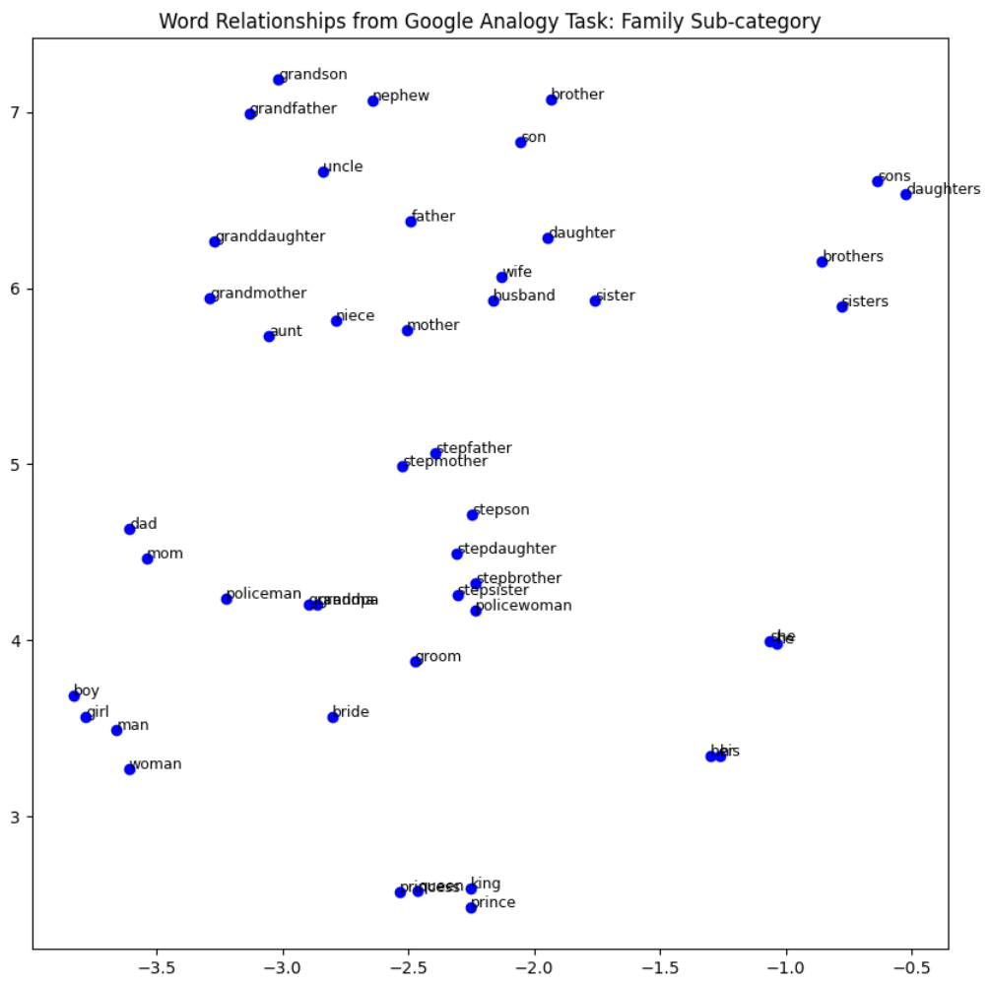

- Words like "sons", "brothers", "daughters", and "sisters" form closely related clusters. This indicates that the Word2Vec model captures the semantic similarity between family members of the same type (e.g., plural nouns).
- Another distinct cluster is observed for "grandfather", "grandmother", "grandson", and "granddaughter". These words are semantically connected through the concept of "grand" relations, and their proximity suggests that the model identifies their commonality.
- This plot also reveals that the Word2Vec model can distinguish between genders. For instance, words like "man", "woman", "boy", and "girl" are grouped together based on their gender-related meaning.
- Similarly, pairs like "king" and "queen", "prince" and "princess" are spatially close to each other, showing that the model understands these as gendered word pairs.
- Words representing family roles, such as "father", "mother", "son", and "daughter", are relatively close to each other, suggesting the model grasps familial relationships.
- There is also a clear separation between words representing extended family members, such as "uncle", "aunt", "nephew", and "niece", which form another grouping.
- Words like "policeman", "policewoman", "groom", and "bride" are on the periphery of the plot. These terms are not central family members but have some connection to social or gender roles, which might explain why they are grouped separately.
- Words such as "stepfather", "stepmother", "stepson", and "stepdaughter" are clustered together, which indicates the model captures the "step" family relationships distinctly from biological family relationships.

Summary:
The t-SNE visualization demonstrates that my Word2Vec model has effectively learned to encode the semantic relationships among family-related words, distinguishing between plural forms, gender roles, and generational differences.

- What’s the difference in word representations if you increase the amount of training data?

- Comparison of Quantitative Results

Accuracy Evaluation of 14 Sub-Categories at Different Sampling Ratios:
Wikipedia articles |  | sampled 10% | sampled 20%
Category | Semantic | 50.61% | 55.69%
Category | Syntactic | 41.02% | 44.20%
Sub-Category | capital-common-countries | 77.08% | 79.45%
Sub-Category | capital-world | 62.09% | 68.17%
Sub-Category | currency | 2.66% | 7.74%
Sub-Category | city-in-state | 36.56% | 40.25%
Sub-Category | family | 72.13% | 77.67%
Sub-Category | gram1-adjective-to-adverb | 11.49% | 15.22%
Sub-Category | gram2-opposite | 6.53% | 8.13%
Sub-Category | gram3-comparative | 54.73% | 57.28%
Sub-Category | gram4-superlative | 23.53% | 27.72%
Sub-Category | gram5-present-participle | 37.59% | 39.96%
Sub-Category | gram6-nationality-adjective | 75.98% | 78.74%
Sub-Category | gram7-past-tense | 43.08% | 49.49%
Sub-Category | gram8-plural | 43.92% | 45.50%
Sub-Category | gram9-plural-verbs | 40.23% | 42.30%

Quantitative Analysis:
From the overall improvement in semantic and syntactic categories, it is evident that increasing the amount of training data enhances the accuracy of word representations across most categories and sub-categories. This suggests that a larger training dataset enables the Word2Vec model to better understand both common and more complex word relationships. Rare categories (e.g., currency) demonstrate significant improvement with additional data, as the model gains more exposure to less frequent words. In some instances (e.g., plural verbs), the increase in accuracy is marginal, possibly because the model has already achieved optimal performance with the existing dataset size.

- Comparison of Qualitative Results

Randomly Sampled 10% of Wikipedia Articles
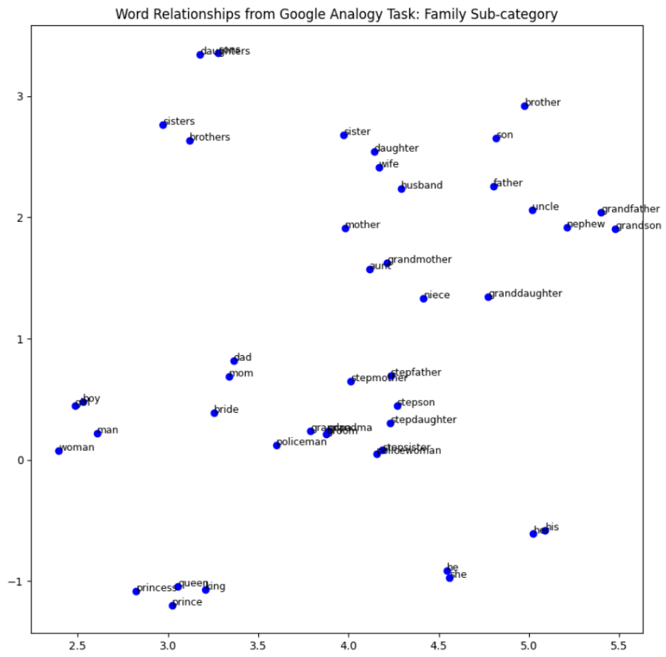

Randomly Sampled 20% of Wikipedia Articles
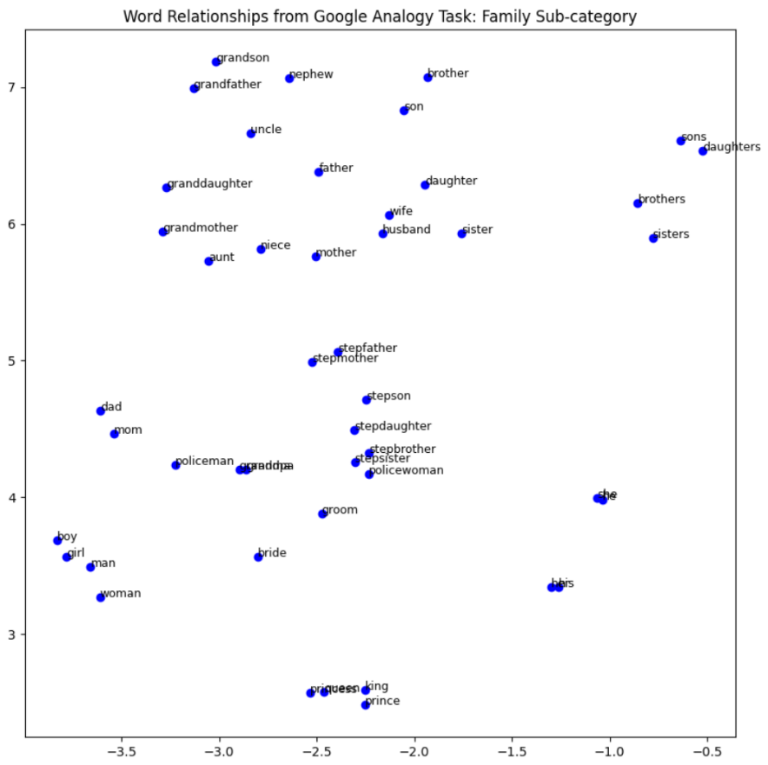

Qualitative Analysis:
With larger training datasets, word embeddings become more distinct and dispersed, indicating enhanced word representations with reduced overlap. For example, clusters of related words such as "father," "mother," "son," "daughter," etc., are more clearly defined and separable in the 20% sampling plot compared to the 10% sampling plot. Words that share similar relationships, such as family members, form tighter and more precise clusters. In conclusion, increasing the amount of training data generally results in better-differentiated word representations, leading to clearer groupings of related words.

Environment Types
Running Environment | Colab
Python Version | Colab

I utilize ChatGPT to enrich the content of the report and to remind me if any sections are incomplete or require correction.

