Natural Language Processing
Assignment 2: Arithmetic as a language

- What impact does using different learning rates have on model training?

learning rate = 0.001
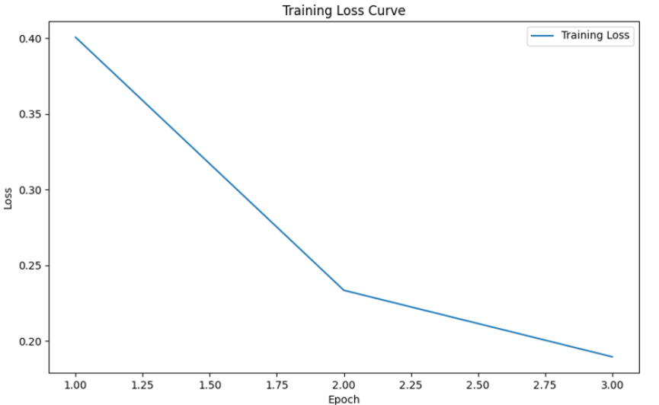
0.04 ↓
0.17 ↓
Epoch | Loss
1 | 0.40
2 | 0.23
3 | 0.19

learning rate = 0.005
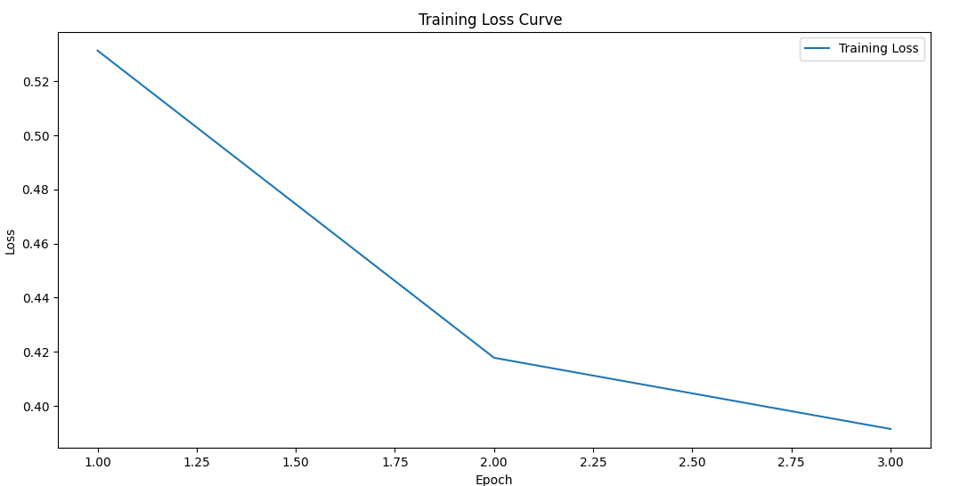
0.03 ↓
0.11 ↓
Epoch | Loss
1 | 0.53
2 | 0.42
3 | 0.39

learning rate = 0.0002
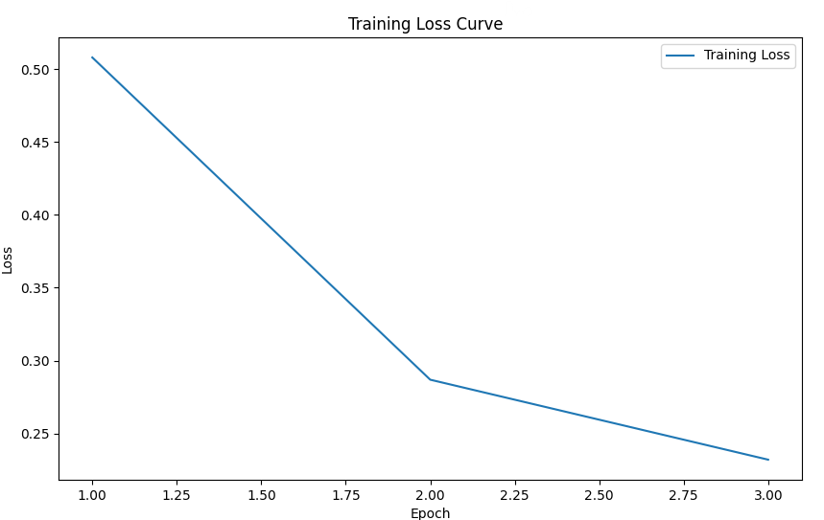
0.06 ↓
0.22 ↓
Epoch | Loss
1 | 0.51
2 | 0.29
3 | 0.23

The Hyperparameter Settings
Batch  Size | Epochs | Embedding Dimension | Hidden  Dimension | gradient clipping
64 | 3 | 256 | 256 | 1

Based on the three figures and the four tables presented above, I can analyze the effects of different learning rates from three perspectives.

- Convergence Speed
Learning Rate = 0.001: demonstrates steady convergence, with the loss consistently decreasing across epochs. This rate strikes a balance between speed and accuracy, resulting in an effective convergence pace.
Learning Rate = 0.005: by observing the loss values from the previous batches, it is evident that this learning rate converges more quickly at first, leading to a substantial reduction in loss during the initial epoch. However, the rate of convergence diminishes over time, and ultimately, the loss does not decrease as significantly as it does with a learning rate of 0.001.
Learning Rate = 0.0002: exhibits the slowest convergence speed, resulting in a gradual decrease in loss. Although it is stable, this rate necessitates more epochs to achieve the same loss levels as the other learning rates.

- Final Loss Value
Learning Rate = 0.001: achieves the lowest final loss of 0.19, indicating that this rate leads to a more effective solution within the three epochs presented.
Learning Rate = 0.005: results in a final loss of 0.39, which is higher than the loss achieved with a learning rate of 0.001. While it reduces the loss rapidly at the beginning, it does not attain as optimal a value as the lower learning rate of 0.001.
Learning Rate = 0.0002: results in a final loss of 0.23, while this is an improvement over 0.005, it remains higher than 0.001. This indicates that additional epochs may be necessary to reach an optimal loss.

- Training Stability
Learning Rate = 0.001: shows stable training, characterized by a smooth and consistent decrease in loss across epochs. This makes it an excellent choice for balanced training.
Learning Rate = 0.005: remains relatively stable, but the higher initial loss and slower improvement afterward suggest it might not be as efficient or stable as 0.001.
Learning Rate = 0.0002: demonstrates high stability, with a gradual and consistent decrease in loss, though at a slower rate.

Summary
Learning Rate = 0.001: offers the best balance between convergence speed, stability, and final loss, making it the most optimal choice for this model and dataset.
Learning Rate = 0.005: converges faster initially but ends with a higher final loss. This setting is suitable when prioritizing speed in training over precision.
Learning Rate = 0.0002: provides stability during training but results in slow convergence. It may be particularly beneficial for fine-tuning over extended epochs when high precision is required.

- If you use RNN or GRU instead of LSTM, what will happen to the quality of your answer generation? Why?

Exact Match Accuracy at Each Epoch for Three Different Models
Epoch | LSTM | RNN | GRU
1 | 86.57% | 71.03% | 85.04%
2 | 91.60% | 70.96% | 87.97%
3 | 92.22% | 71.53% | 88.63%

Answer Generation for Three Different Models
src | tgt | Generation
src | tgt | LSTM | RNN | GRU
1+1= | 2 | 2 | 3 | 4
2-3= | -1 | -1 | 0 | -1
4*6= | 24 | 24 | -11 | 24

Based on the two tables above, I can analyze the impact of using RNN or GRU instead of LSTM for answer generation.

LSTM (Long Short-Term Memory networks): achieves the highest accuracy, improving from 87% in the first epoch to 92% by the third epoch. Additionally, LSTM successfully generates all the expected answers.
RNN (Recurrent Neural Networks): maintains an accuracy of approximately 71% across all epochs, showing minimal improvement and the lowest accuracy among the three models. Additionally, the RNN generates incorrect answers for all inputs.
GRU (Gated Recurrent Units): starts at 85% accuracy and improves to 89% by the third epoch, performing slightly better than the RNN but still lower than the LSTM. Additionally, the GRU correctly generates answers for two out of three inputs.

The reasons for the discrepancies among the results of the three different models are as follows:

LSTM: possess specialized mechanisms known as gates, which enable them to retain information over extended sequences. This capability makes them particularly effective at managing long-term dependencies within data sequences. For tasks such as answer generation, where comprehending context and the relationships between sequences is essential, LSTM demonstrate greater reliability compared to RNN or GRU.
RNN: often struggle to learn long-term dependencies because of the vanishing gradient problem. This limitation renders them ineffective for tasks that require an understanding of relationships over extended sequences, such as arithmetic operations or sequence-based generation tasks.
GRU: are designed to mitigate some of the vanishing gradient problems encountered in traditional RNN. They often perform comparably to LSTM in sequence tasks with shorter dependencies. However, GRU have fewer parameters than LSTM, which may limit their ability to capture complex dependencies effectively. While GRU generally outperforms RNN, it still does not achieve the same level of accuracy and consistency as LSTM.

- If we construct an evaluation set using three-digit numbers while the training set is constructed from two-digit numbers, what will happen to the quality of your answer generation?

Exact Match Accuracy of the Evaluation Set (Three-Digit Numbers)
Epoch | LSTM
1 | 53.66%
2 | 52.44%
3 | 52.44%

Answer Generation for the Evaluation Set (Three-Digit Numbers)
src | tgt | Generation
154+432+321= | 907 | 89
(315*2)+111= | 741 | 76
512-(403*3)= | -697 | -95

Based on the two tables above, I can analyze the potential reasons for the decline in the quality of answer generation.

- Distribution Shift: the training set, which consists exclusively of two-digit numbers, establishes a limited range for the model. This range serves as the foundation for the model's learning of patterns, calculations, and relationships. When evaluated on three-digit numbers, the model experiences a distribution shift—a mismatch between the training distribution (two-digit numbers) and the evaluation distribution (three-digit numbers).
- Generalization Limits: while deep learning models, particularly recurrent models such as LSTM, can generalize to some extent, they often struggle with examples that fall outside the training distribution. When the model has not been exposed to three-digit examples, it fails to generalize effectively and apply the learned patterns to larger numbers, leading to low accuracy on the evaluation set.
- Numeric Scaling and Precision: LSTM do not possess an inherent understanding of arithmetic or numeric magnitude. Instead, they approximate patterns based on the sequences they have encountered. Larger numbers present additional challenges related to "numeric precision", where minor errors in representation or calculation can accumulate, particularly during arithmetic operations. This discrepancy becomes especially pronounced when the model has been trained exclusively on lower-magnitude numbers.
- Increased Arithmetic Complexity: three-digit calculations tend to require more complex, multi-step arithmetic operations. For instance, performing multiplication or addition with larger numbers increases the computational "depth" the model needs to navigate to reach the correct answer. If the training data lacks exposure to these types of calculations, the model may be ill-equipped to handle the additional steps, resulting in outputs that reflect only a portion of the calculation or a simplified version of it.

- If some numbers never appear in your training data, what will happen to your answer generation?

Since each number in the training data falls within the range [0, 50), I used several numbers from the range [51, 100] to perform the arithmetic and generate the results as follows:

src | tgt | Generation
65+80= | 145 | 53
91*100= | 9100 | 230
64*(81-52)= | 1856 | -224

Based on the table above, I can analyze the potential reasons for the decline in the quality of answer generation.

- Lack of Representation: the LSTM model has not developed internal representations for these larger numbers.
- Generalization Gaps: without exposure to a broader range of numbers, it can’t generalize arithmetic operations beyond those it is familiar with.

- Why do we need gradient clipping during training?

- Preventing Exploding Gradients: in deep neural networks, particularly those with recurrent structures such as LSTM or GRU, the gradients during backpropagation can occasionally increase exponentially, especially when dealing with long sequences. This phenomenon is known as the exploding gradient problem. When gradients explode, they become excessively large, which can cause instability in the training process. Specifically, this can lead to: NaN or infinite values, which can cause the model to malfunction.
- Stabilizing Training: gradient clipping ensures that gradients remain within a manageable range by “clipping” or capping their values when they exceed a specified threshold. By limiting the gradient values, we can prevent sudden and erratic updates to the model weights, which promotes more stable and consistent training. This technique is particularly beneficial for models dealing with long sequences, such as those used in language modeling, time series analysis, or other sequential data tasks.
- Promoting Faster Convergence: without gradient clipping, training can often be disrupted by high-gradient values, which may slow down or hinder convergence. Clipping allows the model to make more consistent and meaningful progress toward optimal weights, thereby facilitating a more efficient convergence during the training process.
- Working with Higher Learning Rates: gradient clipping enables the use of slightly higher learning rates without destabilizing the training process. While higher learning rates can accelerate convergence, they also increase the risk of exploding gradients. Clipping helps mitigate this risk, facilitating faster training without compromising stability.

Environment Types
Running Environment | System: Windows 11 Pro 24H2,  CPU: i7-1165G7
Python Version | Python 3.12.2
I utilize ChatGPT to enrich the content of the report and to remind me if any sections are incomplete or require correction.

