**Opioid Utilization Rates and Substance Use Disorder Trends**

Kameron Thao, Mary Vang and Sandra Braun

**Background**

According to the CDC, substance use disorders (SUDs) are treatable chronic conditions marked by an unhealthy pattern of substance use, resulting in health impairments, social dysfunction, and lack of control over substance use. This cluster of physical, behavioral, and cognitive manifestations indicates a person's continuous use of the substance in spite of harmful effects. The presence of symptoms due to substance use (drugs or alcohol) can assist providers in diagnosing a person with an SUD. The range of SUDs can range from mild to extreme, and it can affect anyone regardless of race, gender, income level, or social class. 1

Opioids are a class of drugs that bind to opioid receptors on nerve cells in the body and brain, resulting in decreased pain signals and sensations. This category of drugs consists of the illicit drug heroin; synthetics such as fentanyl, which often are manufactured and obtained illegally; and legally-obtained prescriptions like oxycodone, hydrocodone, codeine, and morphine.2

According to the CDC, in 2020 there were 40.3 million Americans aged 12 or above who had a SUD in the past year. This equates to one in seven individuals reporting the presence of a SUD.1 The CDC also reported that 2.7 million of those individuals suffered from an opioid use disorder specifically in the last year.2

It is important to note that SUDs can include alcohol, cannabis, hallucinogens, inhalants, opioids, sedatives, hypnotics, anxiolytics, stimulants, nicotine, and any other substance. These afflictions can lead to substantial obstacles in all aspects of an individual's life, including employment, education, and home life. To ensure positive results, coordinated care is paramount in treating anyone with a SUD and any simultaneous disorders, such as mental health conditions. 1

**Research Questions**

* Is there an association between usage, risk, and disorder rates to total population?
  + Is there a state correlation?
  + Which state has the highest amount of heroin abuse? Which has the lowest?
  + What are the top 5 states with the highest numbers of prescriptions?
* Is there an association between opioid prescribing rates and substance use disorder?
  + Is there an association between heroin usage and substance use disorder?
  + Is there an association between perceived risk of using opioids and substance use disorder?

**Data Sources**

* CMS State Drug Utilization Data3
  + https://www.medicaid.gov/medicaid/prescription-drugs/state-drug-utilization-data/index.html
* 2019-2020 National Survey on Drug Use and Health: Model-Based Prevalence Estimates (50 States and the District of Columbia)4
  + https://www.samhsa.gov/data/report/2019-2020-nsduh-state-prevalence-estimates
* American Community Survey - Demographic and Housing Estimates5
  + https://data.census.gov/table?q=DP05

**Methods**

Data was obtained from our three data sources of interest and downloaded in CSV file formats.

The American Community Survey5 had to be transposed and some of the row values had to be further transposed again into columns to allow for one row per each state. The data is structured by state and includes population estimates and percentages. Our group selected the 18+ years of age population as the target age of interest for our analysis.

The CMS State Drug Utilization Data3 had to have its state names converted from two-digit abbreviations to the full state names. The nine-digit national drug code (NDC) code had to be converted from its eleven-digit format provided in the file. This conversion removed the product quantity from the NDC code. An additional source from the New York State Department of Health had to be referenced to create a cross-reference table to remove all non-opioid prescription data from our dataset to limit the data to opioid prescriptions only.6

The 2019-2020 National Survey on Drug Use and Health4 was limited to tables nine, ten, and twenty-one. These tables included data covering heroin use in the past year, perceptions of risk with trying heroin once or twice and self-reported substance use disorder in the past year. The data is structured by state and provides state average estimates and upper and lower confidence intervals. Our group selected the 18+ years of age population as the target age of interest for our analysis.

After individual cleaning was completed on the data sets all files were merged with the state fields being set as the index value. Rate of prescriptions was calculated by dividing the number of prescriptions from the total population for each state. The dataset was then sorted by rate of prescription.

The overall rate of prescriptions was then plotted as a bar chart for each state. The rates of prescriptions by substance use disorder, the risk perception by substance use disorder, and the heroin use by substance use disorder was also plotted as scatter plots with trend line included for each state. Correlation coefficients were calculated on the scatter plots.

From there the analysis was then limited to the top five states based on the descending rates of prescriptions. These analyses included bar charts for heroin use rates in the 18+ population in each state, perceived risk rates in the 18+ population in each state, and disorder rates in the 18+ population in each state. These same analyses were further analyzed in bar charts to display the total 18+ population with the targeted populations of interest in a side-by-side comparison. All five states also had individual pie charts created to visualize the 18+ population reported use, perceptions of risk and disorder incidence.

**Results**

Figure one displays the number of prescriptions in each state. The actual count of prescriptions varies widely and can be explained partially by differences in population for each state. Figure two displays the rate of opiate prescriptions in each state by self-reported substance use disorder in each state. A slight positive correlation was detected in this analysis with the correlation coefficient of 0.06. This indicates that as rates of prescriptions increase, so do the rates of self-reported substance use disorder. Figure three displays the perception of risk with trying heroin in each state by self-reported substance use disorder in each state. A strong negative correlation was detected in this analysis with the correlation coefficient of -0.61. This indicates that as perceptions of risk with trying heroin increase that the rates of substance use disorder decrease. Figure four displays the self-reported heroin usage rates in each state by self-reported substance use disorder in each state. A positive correlation was detected in this analysis with the correlation coefficient of 0.43. This indicates that as rates of self-reported heroin use increase so do the rates of self-reported substance use disorder.

Figure 1

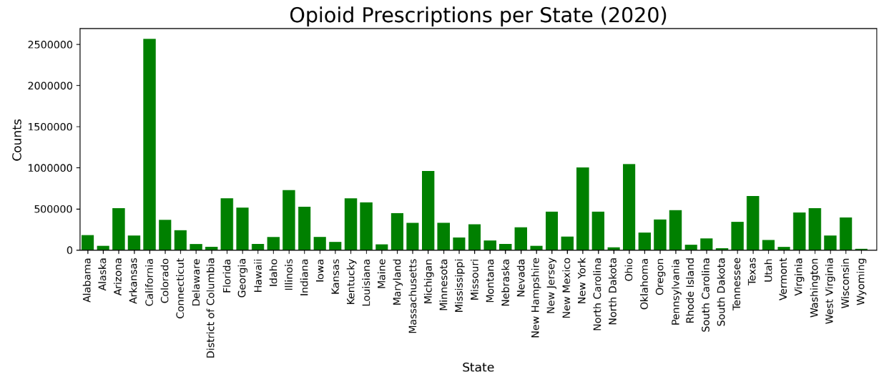

Figure 2

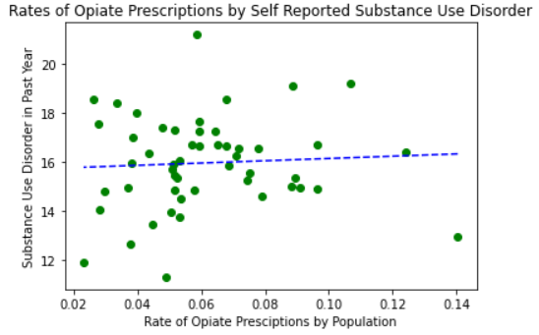

Figure 3

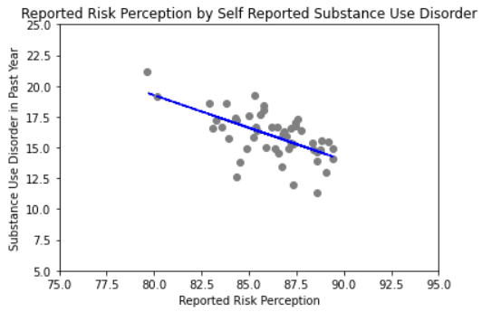

Figure 4

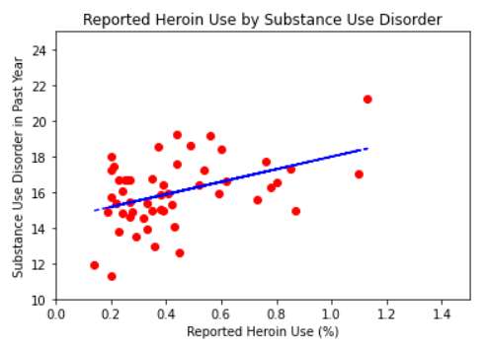

The remaining results focuses on the top five states in the data set that were sorted by rates of prescriptions. Figure five displays the number of prescriptions by the self-reported substance use disorder. These five states displayed in figure five had the highest raw count of prescriptions, while the remaining states were analyzed based on the rate of prescriptions per their population and thus the states differ due to this difference in analysis. Figure six displays the perceived risk of trying Heroin in the 18+ population for these selected states. The perceptions of risk are all fairly similar to one another in each state. Figure seven displays the perceived risk of trying heroin in the 18+ population and the total population that are 18+ in the selected states. Figure eight displays the self-reported heroin usage rates in the 18+ population for these selected states. Figure eight shows that reports of heroin use are higher in West Virginia compared to other states. Figure nine displays the self-reported heroin usage rates in the 18+ population and the total population that are 18+ in the selected states. Figure ten displays the self-reported substance use disorder rates in the 18+ population for these selected states. Figure ten shows that reports of substance use disorder are higher in Montana. Figure eleven displays the self-reported substance use disorder rates in the 18+ population and the total population that are 18+ in the selected states.

Figure 5

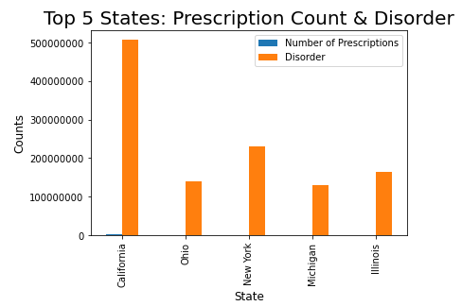

Figure 6

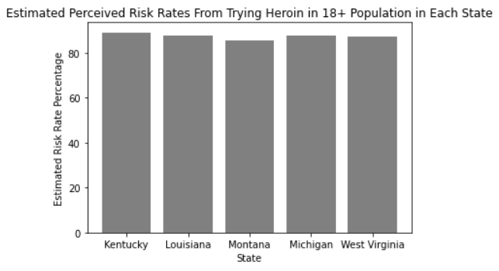

Figure 7

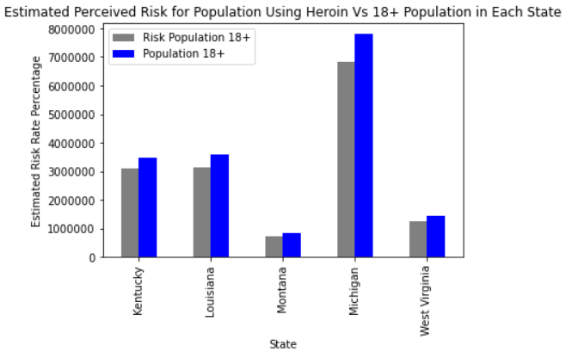

Figure 8

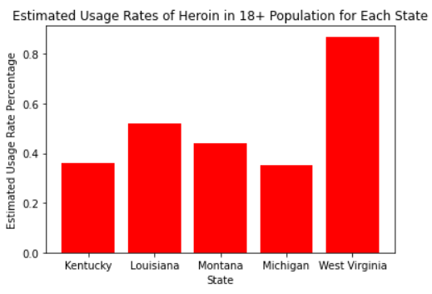

Figure 9

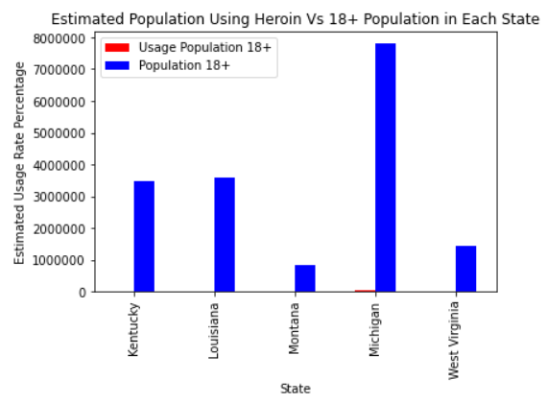

Figure 10

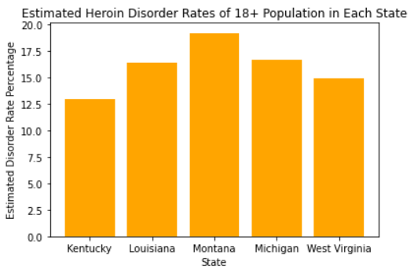

Figure 11

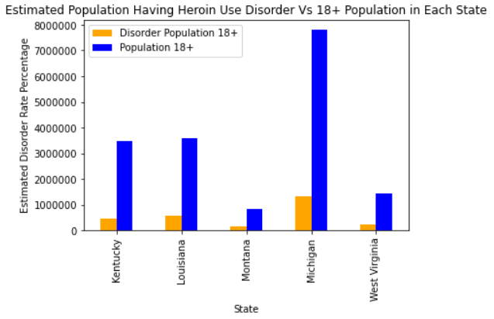

The remaining pie charts for each state (figures twelve through sixteen) show how the breakdown between risk perception, use and disorder relate to one another in the 18+ population.

Figure 12

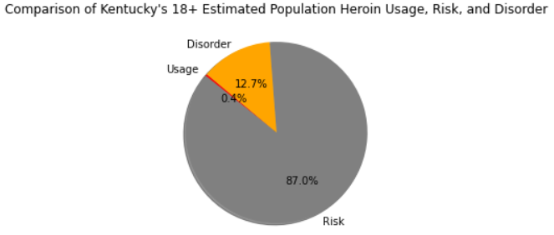

Figure 13

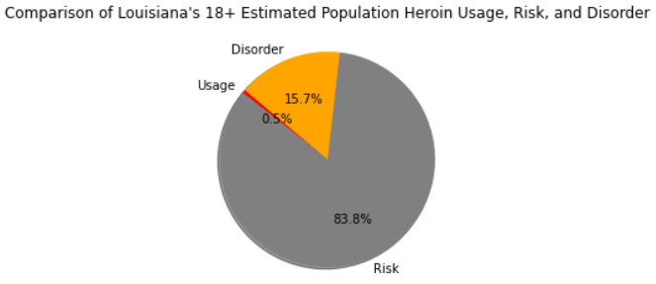

Figure 14

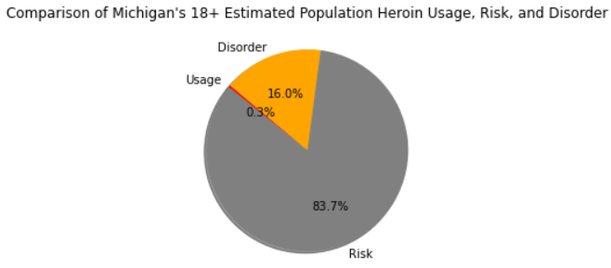

Figure 15

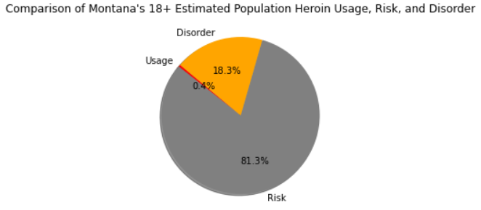

Figure 16

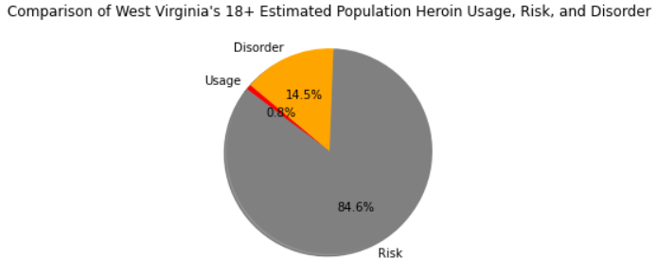

**Limitations**

As our team began the data cleaning process and analysis, we discovered some limitations. The state drug utilization data had more than half of the opioid prescriptions suppressed due to concerns of being potentially identifiable. We elected to drop those rows from the analysis, but this likely significantly causes the rates of prescriptions being under reported. Further the state drug utilization data is not broken down by age, and likely contains prescription data for the minor population, whereas the other two data sets were limited to adults only.

This analysis was primarily focused on opioids specifically but substance use disorder rates is not mutually exclusive for opioid use only and can include other substances or polysubstance abuse.

Lastly the number of states included in the analysis at times made visualizations challenging and that is why we elected to focus on the top five states.

**Discussion**

Due to the limitations discovered within our data set it is impossible to draw a concrete conclusion that opioid prescription rates are associated with substance use disorder. However, the national survey on drug use and health (NSDUH) did demonstrate there were associations present with heroin use and substance use disorder as well as perceptions of risk with trying heroin and substance use disorder.

Our selected analytics methods did not make it possible to determine if there was an association present between usage rates, risk and disorder to the total population or specific to state-based differences. However, we were able to determine the highest count of opioid prescriptions was in California and the least were in South Dakota (not displayed). The analysis showed that the top five states with the highest counts of prescriptions included California, New York, Illinois, Ohio, and Michigan.

**Citations**

1. “Substance Use Disorders (SUDS).” Centers for Disease Control and Prevention, Centers for Disease Control and Prevention, 5 Oct. 2022, https://www.cdc.gov/dotw/substance-use-disorders/index.html.
2. “Opioid Use Disorders (SUDS).” Centers for Disease Control and Prevention, Centers for Disease Control and Prevention, 5 Oct. 2022, https://www.cdc.gov/dotw/opioid-use-disorder/index.html.
3. “State Drug Utilization Data.” Center for Medicare and Medicaid Services, Health and Human Services, https://www.medicaid.gov/medicaid/prescription-drugs/state-drug-utilization-data/index.html.
4. “2019-2020 National Survey on Drug Use and Health: Model-Based Prevalence Estimates (50 States and the District of Columbia).” Substance Abuse and Mental Health Services Administration, U.S. Department of Health &amp; Human Services, 29 Dec. 2021, https://www.samhsa.gov/data/report/2019-2020-nsduh-state-prevalence-estimates.
5. “2020 Demographic and Housing Five Year Estimates.” American Community Survey, U.S. Census Bureau, https://data.census.gov/table?q=DP05.
6. “NDC MME TABLE.” Opioid Drug Listing, New York State Department of Health, 4 Jan. 2021, https://health.ny.gov/professionals/narcotic/docs/opioid_drug_listing.pdf.