FLIGHT MANAGEMENT SYSTEM

**PREPARED FOR : JEE Cloud Training Program Capgemini Technology Services**

PREPARED BY:

Masthan G

**Functionality:** Flight and Scheduling Flight

**Requirements:**

**Entity Layer:**

**Classes:**

1. Airport.java

Attributes:

airportCode : String

airportLocation : String

airportName: String

1. Flight.java

Attributes:

flightName : String

flightCode : String

seatCapacity : String

1. ScheduledFlight.java

Attributes:

scheduledFlightId : Integer

availableSeats : Integer

arrivalTime : LocalDateTime

minutes : int

departureTime : LocalDateTime

scheduleStatus : String

fare : double

**DAO Layer:**

**interface:**

1. FlightDao

addFlightSchedule

deleteFlightSchedule

1. FlightDaoImpl

Implementation for above interface.

**DTO Layer:**

1. **Class :** ScheduleForm

Attributes:

seats: int

departureTime: LocalDateTime

minutes : int

fare : double

flightCode : String

destAirportCode : String

**Service Layer:**

**Interface:**

1. AddFlightScheduleSerive.java

addFlightSchedule

editFlightSchedule

1. AddFlightScheduleSeriveImpl.java

Implementation for above interface

**Controller Layer:**

**Class:**

AddFlightScheduleController

ViewScheduledController

**Exceptions:**

1. DateException
2. ScheduledFlightIdException
3. ScheduledFlightIdNotFoundException

CLASS DIAGRAM:

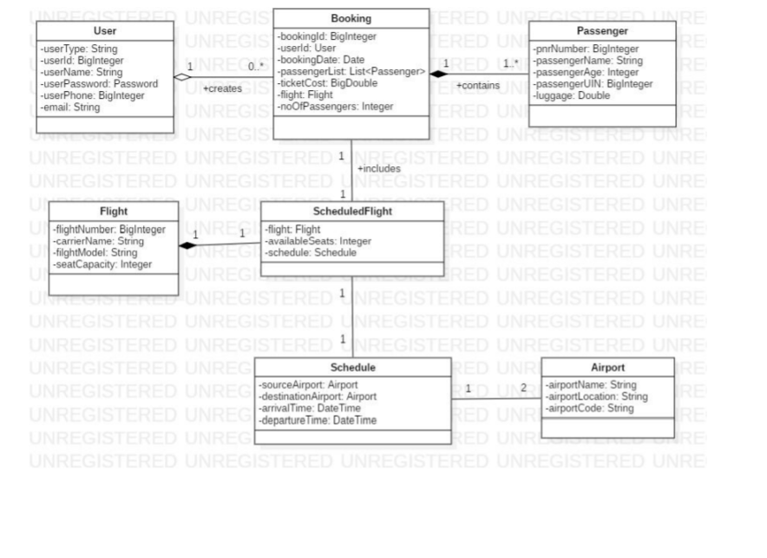

SEQUENCE DIAGRAM:

