A Mini-Project report On

RFID BASED PREPAID CARD FOR CANTEEN MANAGEMENT

*Submitted in the partial fulfillment of the requirements for the award of the degree of*

**BACHELOR OF TECHNOLOGY**

**IN**

**ELECTRONICS AND COMMUNICATION ENGINEERING**

*SUBMITTED BY*

**VANGALI MOUNIKA 18P61A04L2**

**THOTA AJAY 18P61A04N1**

**VALLAMDAS SHIVA 18P61A04L0**

Under the Esteemed Guidance of

***Mr. Md Mohsin Ali***

**Assistant Professor**



(Affiliated to JNTU Hyderabad, Approved by APSCHE &AICTE)Aushapur (v), Ghatkesar (m), Medchal Dist, Hyderabad-501301 2021



(Affiliated to JNTU Hyderabad, Approved by APSCHE &AICTE)Aushapur (v), Ghatkesar (m), Medchal Dist, Hyderabad-501301 2021

# CERTIFICATE

This is to certify that the Mini Project report **“RFID BASED PREPAID CARD FOR CANTEEN MANAGEMENT”** being

submitted by **Vangali Mounika (18P61A04L2), Thota Ajay (18P61A04N1), Vallamdas Shiva (18P61A04L0)** in partial fulfillment for the award of the Degree of Bachelor of Technology in ELECTRONICS & COMMUNICATION ENGINEERING to

Jawaharlal Nehru Technological University is a record of a Bonafide work carried out by them under my guidance and supervision.

The result embodied in this project report has not been submitted to any otherUniversity/Institution for the award of any Degree/Diploma.

**INTERNAL GUIDE HEAD OF THE DEPARTMENT**

**Mr. Md Mohsin Ali Dr. U. Poorna Lakshmi**

### Assistant professor Professor

**EXTERNAL EXAMINER**

# CANDIDATES DECLARATION

We hereby declare that this Mini Project Report titled **“RFID BASED PREPAID CARD FOR CANTEEN MANAGEMENT”** submitted by

us to the Department of **Electronics and Communication Engineering,** VBIT, Aushapur, Under JNTUH, is a Bonafide work undertaken by and it is not submitted to any other University or Institution for the award of any degree or diploma.

### By

**VANGALI MOUNIKA 18P61A04L2 THOTA AJAY 18P61A04N1 VALLAMDAS SHIVA 18P61A04L0**

# ACKNOWLEDGEMENT

At the outset we sincerely thank God for having got my Mini project report completed in time. Firstly we would thank our parents who have been a motivating factor throughout our lives. Secondly we sincerely thank our principal **Dr. PVS Srinivas** and our Head of the department **Dr. U. Poorna Lakshmi** for their kind cooperation and Encouragement for the successful completion of Project work and providing the necessary facilities.

We are most obliged and grateful to our project guide **Md. Mohsin Ali**, for giving us guidance in completing this project successfully.

We express our sincere gratitude to our Project coordinators, Department of ECE and my other faculty for attending our project seminars and for their insightful comments and constructive suggestions to improve the quality of this project work.

### By

**VANGALI MOUNIKA 18P61A04L2 THOTA AJAY 18P61A04N1 VALLAMDAS SHIVA 18P61A04L0**

# ABSTRACT

The main aim of this project is to produce the canteen bills using RFID cards. RFID is an acronym for Radio Frequency Identification. In this project the canteen owner or canteen administrative person will give a RFID card to the user. So, that the user uses this card to order the items in the canteen. RFID card reader can be defined as automatic identification technology card which uses radio frequency electromagnetic fields to identify objects carrying tags when they come close to a reader. Then the microcontroller checks whether the card is authorized card or unauthorized card and it displays the message on the LCD. If the card is authorized then the user has the access to buy/order the items. Here we are using the push buttons to order and recharge the card. The user can recharge the card with certain amount. This recharging of the card is been done manually. If the card is authorized then the person has the access to order the items. If the balance is zero and if they try to order then the buzzer gets buzzed. Advantage of this is it is easily accessible and less complex. It is most effectively used everywhere.

**TABLE OF CONTENTS**

|  |  |
| --- | --- |
| **CERTIFICATES** |  |
| **CANDIDATE DECLARATION** | **iii** |
| **ACKNOWLEDGEMENT** | **iv** |
| **ABSTRACT** | **v** |
| **LIST OF FIGURES** | **viii** |
| **NAME OF THE CHAPTER** | **PAGE NO** |
| 1. **INTRODUCTION** | 1 |
| 1. **BLOCK DIAGRAM**    1. BLOCK DIAGRAM | 3 |
| 2.2. CIRCUIT DIAGRAM | 4 |
| 1. **HARDWARE MODULES**    1. RFID TAGS | 5 |
| 3.2 RFID READER | 5 |
| 3.3 MICRO CONTROLLER | 6 |
| 2.4.1 PIN DIAGRAM OF MICRO CONTROLLER | 7 |
| 3.4 LIQUID CRYSTAL DISPLAY (LCD) | 8 |
| 2.5.1 PIN DIAGRAM OF LCD | 8 |
| 3.5 BUZZER | 9 |
| 3.6 VOLTAGE TRANSFORMER | 10 |
| 3.7 DIODE | 10 |
| 1. **SOFTWARE MODULES**    1. INTRODUCTION TO KEIL | 11 |
| 4.2 CREATING YOUR OWN APPLICATION | 11 |
| 4.3 STEPS TO WRITE C LANGUAGE PROGRAMME | 12 |
| 5. **RESULTS** | 16 |
| 6. **ADVANTAGES**, **APPLICATIONS** | 21 |

7. FUTURE SCOPE AND CONCLUSION 22

REFERENCES 23

APPENDIX 24

**LIST OF FIGURES**

|  |  |  |
| --- | --- | --- |
| **SNO** | **TITLE** | **PAGE NO.** |
| 1 | 2.1 Block Diagram | 3 |
| 2 | 2.2 Circuit Diagrams | 4 |
| 3 | 3.1 RFID cards | 5 |
| 4 | 3.2 RFID Reader | 5 |
| 5 | 3.3 Micro Controller | 6 |
| 6 | 3.4 Pin diagram of Micro controller | 7 |
| 7 | 3.5 LCD Display | 8 |
| 8 | 3.6 Pin diagram of LCD | 8 |
| 9 | 3.7 Piezoelectric buzzer | 9 |
| 10 | 3.8 Voltage Transformer | 10 |
| 11 | 3.9 Diode | 10 |
| 12 | 4.1 Main page of Keil software | 11 |
| 13 | 4.2 Selection of device | 12 |
| 14 | 4.3 Add files to the program | 12 |
| 15 | 4.4 Program | 13 |
| 16 | 4.5 Peripherals | 13 |
| 17 | 4.6 Running the code | 14 |

|  |  |  |
| --- | --- | --- |
| 18 | 5.1 Switching On the kit | 15 |
| 19 | 5.2 Placing the card | 16 |
| 20 | 5.3 Authorized card with zero balance | 16 |
| 21 | 5.4 Recharging | 17 |
| 22 | 5.5 Ordered Coffee | 17 |
| 23 | 5.6 Ordered Snacks | 18 |
| 24 | 5.7 Ordered Drinks | 18 |

**LIST OF TABLES**

|  |  |  |
| --- | --- | --- |
| **SNO** | **TITLE** | **PAGE NO** |
| 1 | 3.1 Description of pin  diagram of LCD | 9 |
| 2 | 3.2 Menu Keys | 10 |

**CHAPTER 1 INTRODUCTION**

Now a days, cash payment is the only option for making the payment canteens or restaurants etc. This is the case for small canteens. In some of the big canteens credit card capability is providing but that’s very rare. The main drawback of cash payment system is that user always needs to carry the cash with him/her. The person needs to pay the exact amount otherwise there is problems for the remaining amount. The owner has to maintain some register or he needs to deliver coupons to canteen users. If the canteen owner gives token for the remaining amount then user has to carry that coupon. One more problematic is that in colleges the students are going to have food in the same canteen throughout the month. In some of the cases an account of students is maintained in a notebook. The canteen owner writes record details of students who ever ordering food basis and at the end of the Month total is calculated. This method has limit and draw backs of keeping paper based records. Suppose records can get spoiled or damaged and data of student account might get lost.

A user (student/employee) needs to pay cash to the canteen owner to recharge this RFID card. User can recharge this card depending upon his/her requirements or usages. User can recharge the card for minimum amount of Rs.100 to the maximum amount of Rs.2500. Prepaid RFID card for canteen project has a keypad for recharge and this keypad will be accessible only to the canteen owner.

Embedded systems are application specific & single functioned; application is known a priori, the programs are executed repeatedly. Efficiency is of paramount importance for embedded systems. They are optimized for energy, code size, execution time, weight & dimensions, and cost. Embedded systems are typically designed to meet real time constraints; a real time system reacts to stimuli from the controlled object/ operator within the time interval. Dictated by the environment.

We tested that the RFID identifies the RFID tags or not, if identified then we can able to know by indicating LED glow and buzzer sound .Then we proceed with the AT89S52, we wrote program in our AT89S52 board that check the received ID number is valid or not by comparing with the valid ID number which already stored in AT89S52 board. Then we observed that when we place RFID near to the reader then the AT89S52 board checks the received data and we can see the received ID is valid or not. If it is valid ID then gate is open I fit in valid ID then gate is not open. Finally we implemented the whole thing in our kit and saw the result successfully.

RFID is an acronym for Radio Frequency Identification. RFID is one member in the family of Automatic Identification and Data Capture (AIDC) technologies and is a fast and reliable means of identifying just about any material object. This project can be used for security purpose where it gives information about the authorized cards and unauthorized cards. This can be applied in real time systems as such in recording the attendance, in the companies and in industries to know who are authorized. RFID is increasingly used with biometric technologies for security. Primarily, the two main components involved in a Radio Frequency Identification system are the Transponder (tags that are attached to the object) and the Interrogator (RFID reader). Communication between the RFID reader and tags occurs wirelessly and generally doesn’t require a line of sight between the devices.

RFID Technology has brought a vast difference in day-to-day life. This project for paying the money by student or employee in canteen using RFID card. The development of RFID based canteen management system has proved that RFID technology have good results in implementing in different applications but the standard company have develop the framework of applications.

* 1. **BLOCK DIAGRAM**

# CHAPTER 2 BLOCK DIAGRAM

**RFID READER**

**MENU KEYS**

**Fig 2.1: Block diagram**

**REGULATED POWER**

**8052**

**Micro Controller**

**LIQUID CRYSTAL DISPLAY (LCD**)

**RECHARGE KEYS**

**BUZZER**

## CIRCUIT DIAGRAM

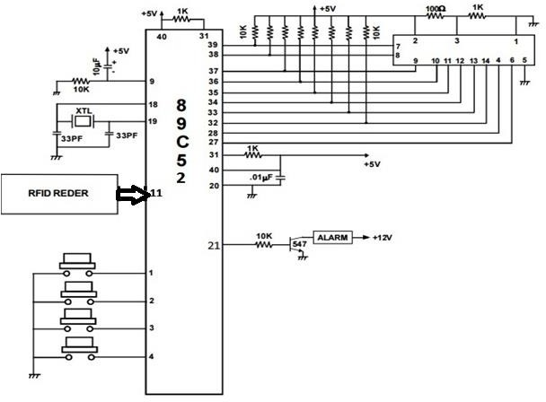

### Fig 2.2: Circuit Diagram

The RFID module reader typically contains a module, a control unit and a coupling element. This module is interfaced with the micro controller and when the card is brought near to the RFID module it reads the data in the card. If the data in the card is matched with the data in the program memory then displays authorized message else unauthorized. If the card is authorized then the user has the access to order the items, the authorized user has to recharge the card with the maximum amount of Rs.100.So that the user can order the items. If the balance is zero and the user tries to access the items then the buzzer gets buzzed. If the card is unauthorized then they don’t have the access to order.

# CHAPTER 3 HARDWARE MODULES

## RFID TAGS

A radio-frequency identification system uses tags, or labels attached to the objects to be identified. Two-way radio transmitter-receivers called interrogators or readers send a signal to the tag and read its response. RFID tags can be either passive, active or battery assisted passive. An active tag has an on-board battery and periodically transmits its ID signal. A battery assisted passive (BAP) has a small battery on board and is activated when in the presence of a RFID reader. A passive tag is cheaper and smaller because it has no battery.

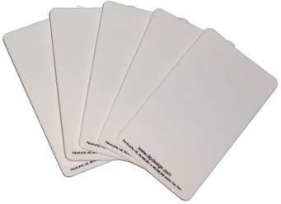

## RFID READER

### Fig 3.1: RFID Cards

RFID systems can be classified by the type of tag and reader. A Passive Reader Active Tag (PRAT) system has a passive reader which only receives radio signals from active tags (battery operated, transmit only). RFID offers advantages over manual systems or use of bar codes. The tag can be read if passed near a reader, even if it is covered by the object or not visible. The tag can be read inside a case, carton, box or other container, and unlike barcodes, RFID tags can be read hundreds at a time.

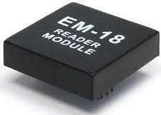

## MICROCONTROLLER

### Fig 3.2: RFID Reader

Microcontroller is the central component, which reads data from the RFID reader and displays the details on the digital display (LCD). In order to display the number on tag details, in the controller a program must be written to perform the operation. This program is called firmware. In order to execute the program, Microcontroller requires basic configuration like 5V regulated power supply, clock and reset circuit. When the power is applied to microcontroller, it initializes display, RFID reader, etc. Then it reads the RFID tag/card from RFID reader and displays the details in the LCD.

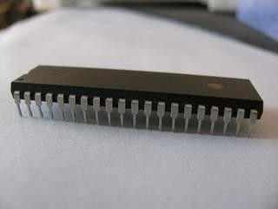

**Fig 3.3: AT89C52 Microcontroller**

## PIN DIAGRAM OF MICROCONTROLLER

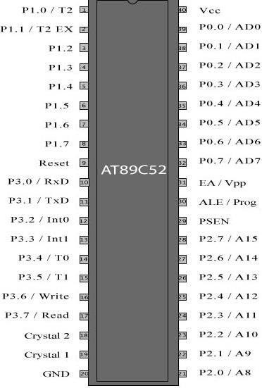

### Fig 3.4 Pin diagram of Microcontroller

There are four 8-bit bi-directional I/O ports. They are the Port 1, Port 2, Port 3 and Port 4. The Port 1 output buffers can sink/source four TTL inputs. When 1s are written to Port 1 pins, they are pulled high by the internal pull ups and can be used as inputs. As inputs, Port 1 pins that are externally being pulled low will source current (IIL) because of the internal pull ups.

**ALE/PROG:** Address Latch Enable is an output pulse for latching the low byte of the address during accesses to external memory. This pin is also the program pulse input (PROG) during Flash programming.

**PSEN:** Program Store Enable is the read strobe to external program memory.

**EA/VPP:** External Access Enable

**XTAL1:** Input to the inverting oscillator amplifier and input to the internal clock operating circuit.

**XTAL2:** Output from the inverting oscillator amplifier.

## LIQUID CRYSTAL DISPLAY

LCD Displays are dominating LED displays, because these displays can display alphabets, numbers and some kind of special symbols, Where as LED’s (seven segment display) can display only numbers. These LCD displays are very useful for displaying user information and communication. LCD displays are available in various formats. Most common are 2 x 16, is that two lines with 16 alphanumeric characters. Other formats are 3x16, 2x40, 3x40 etc.

[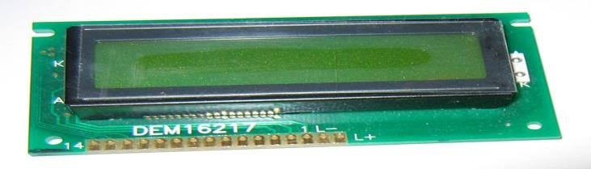](http://upload.wikimedia.org/wikipedia/commons/2/24/LCD_display_16x2_alphanumeric.jpg)

**Fig 3.5: LCD Display**

## PIN DIAGRAM OF LCD

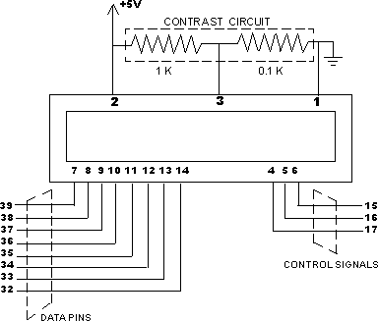

**Fig 3.6 Pin diagram of LCD**

|  |  |  |
| --- | --- | --- |
| **Pin** | **Symbol** | **Description** |
| 1 | VSS | Ground |
| 2 | VCC | +5V Power supply |
| 3 | VEE | Power supply to Control Contrast |
| 4 | RS | RS = 0 to select command RS=1 to select data register |
|  | R/W | R/W =0 for write, R/W=1 for read |
| 6 | E | Enable |
| 7 | DB0 | The 8-bit data bus |
| 8 | DB1 | The 8-bit data bus |
| 9 | DB2 | The 8-bit data bus |
| 10 | DB3 | The 8-bit data bus |
| 11 | DB4 | The 8-bit data bus |
| 12 | DB5 | The 8-bit data bus |
| 13 | DB6 | The 8-bit data bus |
| 14 | DB7 | The 8-bit data bus |

**Table 3.1 Description of Pin diagram of LCD**

## BUZZER

Piezoelectric buzzers use the inverse piezoelectric principle to create movement of a ceramic disc to produce sound waves. The buzzer includes a built-in oscillating circuit. Piezo buzzers operate over a wide temperature range and create noises ranging from soft and gentle to loud and aggressive.

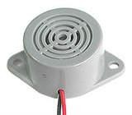

**Fig 3.7: Piezoelectric buzzer**

## VOLTAGE TRANSFORMER

While VTs were formerly used for all voltages greater than 240V primary, modern meters eliminate the need VTs for most secondary service voltages. VTs are typically used in circuits where the system voltage level is above 600 V. Modern meters eliminate the need of VT's since the voltage remains constant and it is measured in the incoming supply.

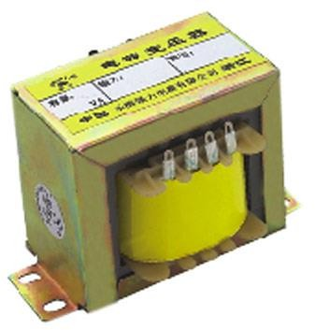

## DIODE

### Fig 3.8: Voltage Transformer

A diode is a semiconductor device that essentially acts as a one-way switch for current. It allows current to flow easily in one direction, but severely restricts current from flowing in the opposite direction.

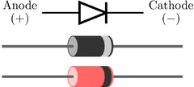

## MENU KEYS

**Fig 3.9: Diode**

|  |  |  |
| --- | --- | --- |
| Switch number | Name of the switch | Money assigned |
| SW1 | Coffee | 10Rs |
| SW2 | Drinks | 20Rs |
| SW3 | Snacks | 30Rs |

**Table 3.2 Menu keys**

# CHAPTER 4 SOFTWARE MODULE

## INTRODUCTION TO KEIL MICRO VISION (IDE)

Keil an ARM Company makes C compilers, macro assemblers, real-time kernels, debuggers, simulators, integrated environments, evaluation boards, and emulators for ARM7/ARM9/Cortex-M3, XC16x/C16x/ST10, 251, and 8051 MCU families. Compilers are programs used to convert a High Level Language to object code. Desktop compilers produce an output object code for the underlying microprocessor, but not for other microprocessors.

## CREATING YOUR OWN APPLICATION IN µVISION2

To create a new project in µVision2, you must:

* + 1. Select Project - New Project.
    2. Select a directory and enter the name of the project file.
    3. Select Project - Select Device and select an 8051, 251, or C16x/ST10 device from the Device Database™.
    4. Create source files to add to the project.
    5. Select Project - Targets, Groups, File, Add/Files, select Source Group1, and add the source files to the project.
    6. Select Project - Options and set the tool options. Note when you select the target device from the Device Database™ all special options are set automatically. You typically only need to configure the memory map of your target hardware. Default memory model settings are optimal for most applications.
    7. Select Project - Rebuild all target files or Build target.

## STEPS TO WRITE C LANGUAGE PROGRAMME IN KEIL

1. Click on the Keil Vision Icon on Desktop
2. The following fig will appear

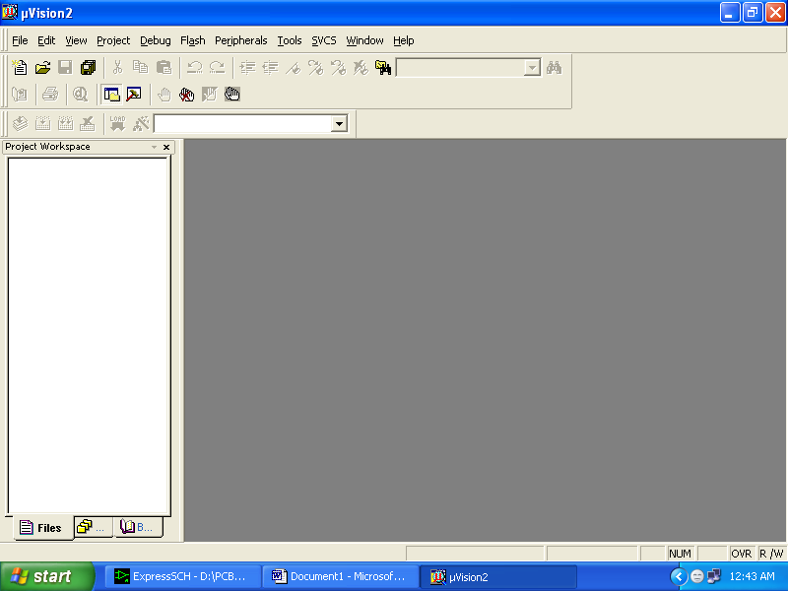

### Fig 4.1: Main page of Keil software

1. Click on the Project menu from the title bar
2. Then Click on New Project
3. Then Click on save button
4. Select the component for u r project i.e. Atmel……
5. Click on the + Symbol beside of Atmel
6. Select AT89C51 as shown below

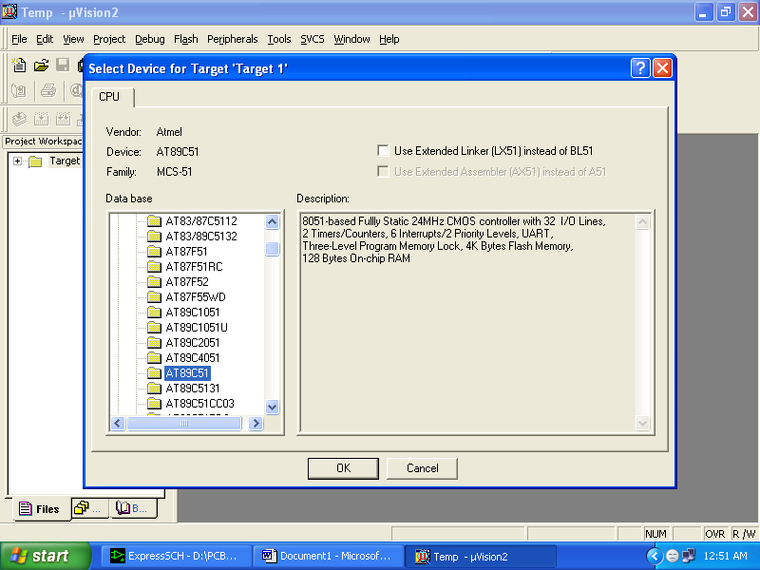

### Fig 4.2: Selection of device

1. Then Click on “OK”
2. The Following fig will appear

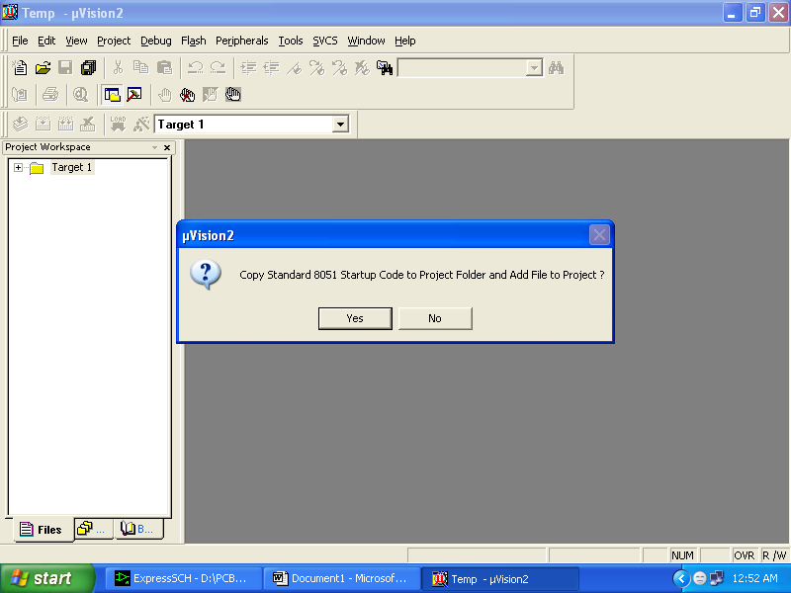

### Fig 4.3: Add files to project

1. The next screen will be as shown in next page, and just maximize it by double clicking on its blue border.
2. Now start writing program in either in “EMBEDDED C” or “ASM”.

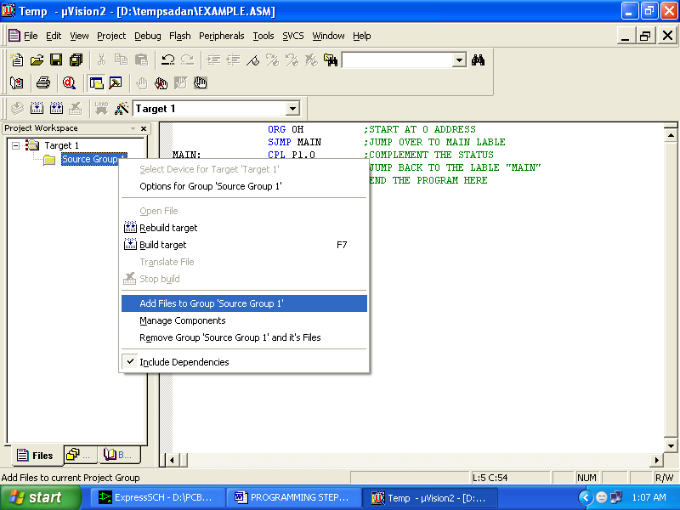

### Fig 4.4: Program

1. Now you will get another window, on which by default “EMBEDDED C” files will appear.
2. Now click on the Peripherals from menu bar, and check your required port as shown in fig below.

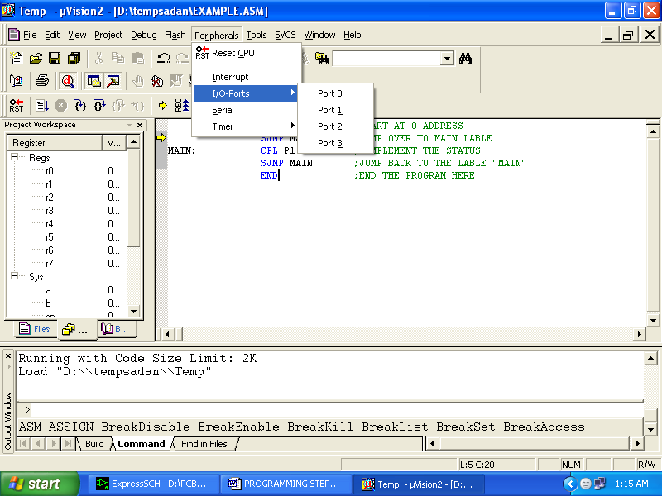

### Fig 4.5: Peripherals

1. Drag the port a side and click in the program file.

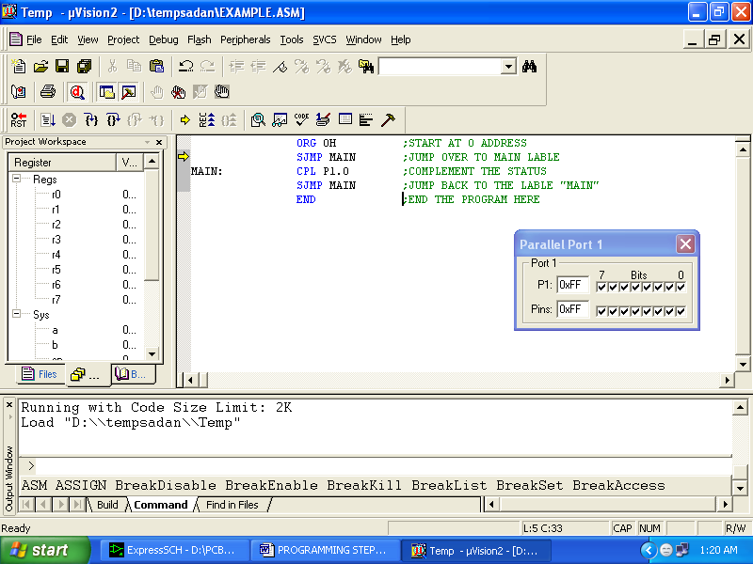

### Fig 4.6: Running the code

1. Now keep Pressing function key “F11” slowly and observe. You are running your program successfully

# CHAPTER 5 RESULTS

1. Switch on power supply, then the LCD displays to place the card on the reader

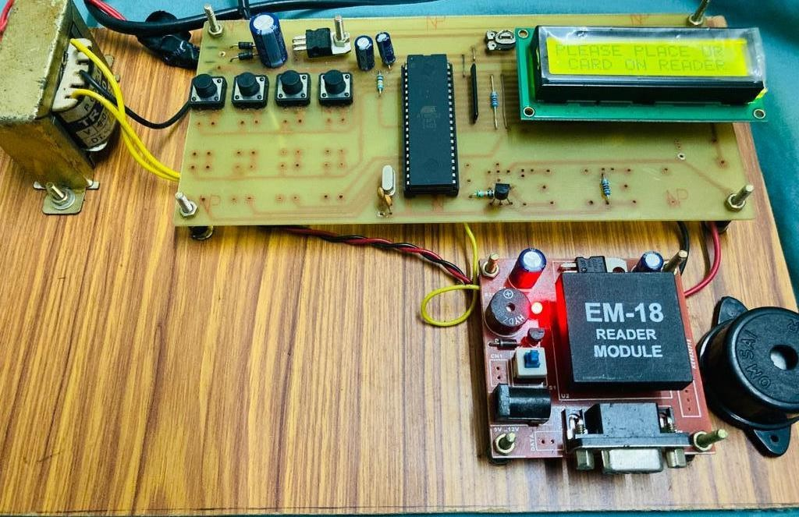

### Fig 5.1: switching ON the kit

1. After placing the card on the reader then the reader collects the data from the card and the collected data is been sent to the Microcontroller and asks the Microcontroller to verify the given data whether the data is Matched or Unmatched which is already existing in the controller, If the data is matched then the LCD displays as authorized card if not unauthorized

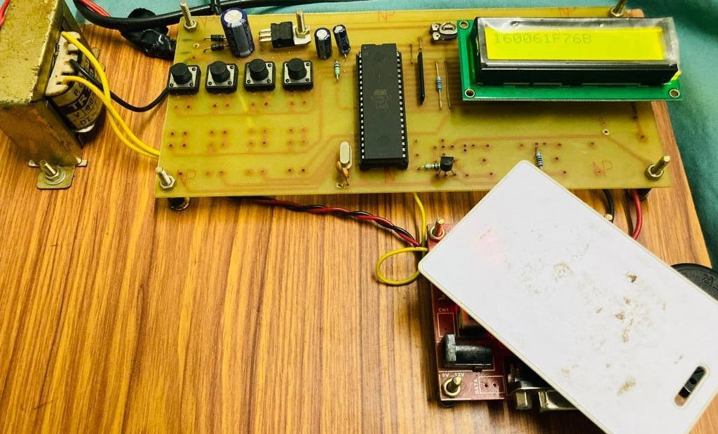

### Fig 5.2: placing the card

1. If it is authorized card it will display on LCD as authorized. So, that the user can order the items. To access the items firstly the user has to recharge the card with the maximum amount of Rs.100.

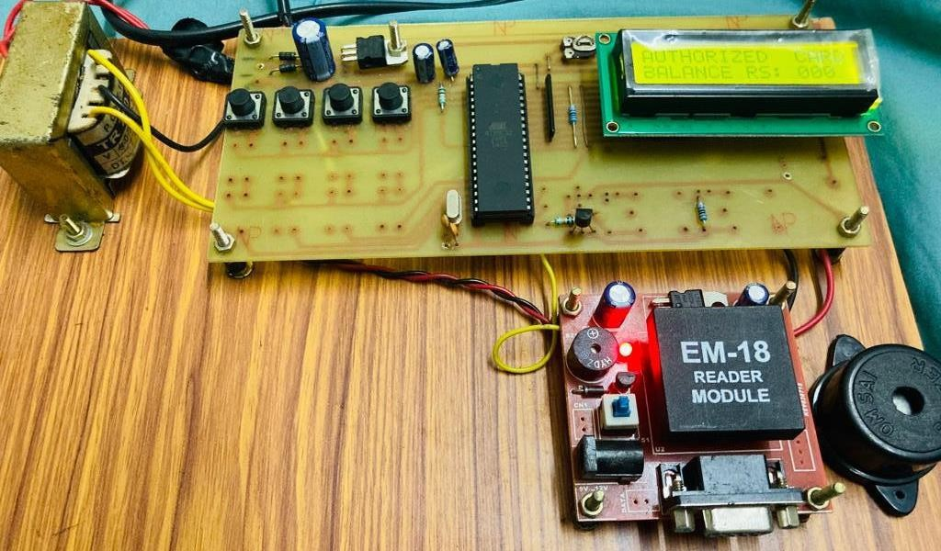

### Fig 5.3: Authorized card with zero balance

1. When we switch off and on amount in the card will get 0.
2. By pressing recharge button we have to recharge the card. The fourth push button is for Recharge purpose.

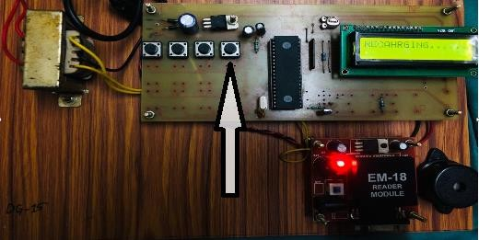

### Fig 5.4: Recharging

1. In our project we are using three, menu keys they are coffee, drinks, snacks.
2. We have to push button to order the items the respective amount of that item will be deducted.

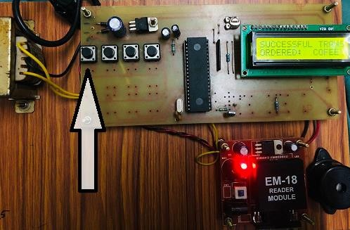

**Fig 5.5: Ordered coffee**

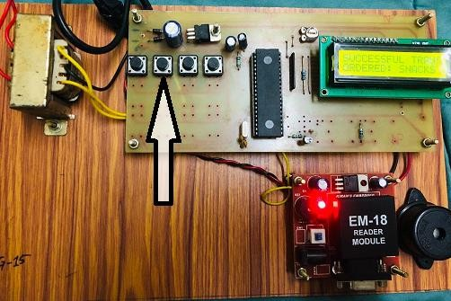

**Fig 5.6: Ordered snacks**

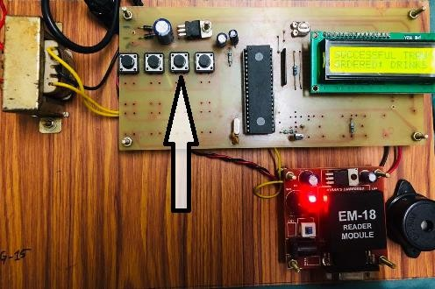

**Fig 5.7: Ordered drinks**

# CHAPTER 6 ADVANTAGES AND APPLICATIONS

## ADVANTAGES

* Low cost
* Easily accessible
* Less complexity
* Most efficiently used

## APPLICATIONS

* Schools and colleges
* Toll collection
* Offices
* Used to recharge the TATA NEXON cars

# CHAPTER 7

**FUTURE SCOPE AND CONCLUSION**

## FUTURE SCOPE

Voice feedback system can be included in RFID based prepaid card for canteen management system, and the same technique can be implemented in Figure print authentications are also developed in canteen management system and also in recharging the battery of Electric vehicles

## CONCLUSION

To some extent the system has increased the efficiency in canteen daily business transactions as compare to manual way of performing business transactions in the past, this new computerized system has faster and higher calculation capability. Therefore, it has increased the throughput of business transactions. Besides given correct input, the new computerized system can generate zero error, unlike manual work done by human.

The system give effective solution and also In-Time only bill will be produced. For that the students are particular time only stay at canteen. As a result, the students and the customer’s satisfaction of service are relatively improved and this will attract new potential students to make order with the canteen.

# REFERENCES

1. Arun N. Nambiar- RFID Technology: A Review of its Applications Proceedings of the World Congress on Engineering and Computer Science 2009 Vol II WCECS 2009,

October 20-22

1. Shweta Shashikant Tanpure, Priyanka R. Shidankar, Madhura M. Joshi, **“Automated Food Ordering System with Real-Time Customer Feedback”**, in International Journal of Advanced Research in Computer Science and Software Engineering, Vol. 3, Issue 2, February 2013.
2. Canteen Food Ordering Android System, Abhishek Singh, Amit Tanwar, Aditya Sawant, Chaitanya Parulekar, Kunal Yadav, IT Department, MUMBAI University, Journal on Recent and Innovation Trends in Computing and Communication.
3. S SumitaNainan1, Romin Parekh, Tanvi Shah - **RFID Technology Based Attendance Management System** from NMIMS University Mumbai, Maharashtra.
4. S. B. Patil, Srikantha Rao, P. S. Patil 2001 ‘Canteen Management Design Principles’ Proceedings of the International Conference & Workshop on Trades in Technology, pp. 765-766, viewed 7 October 2001
   * [www.atmel.com](http://www.atmel.com/)

# APPENDIX PROJECT CODE

|  |  |  |
| --- | --- | --- |
| SW1 | BIT | P1.3 |
| SW2 | BIT | P1.2 |
| SW3 | BIT | P1.1 |
| LOAD | BIT | P1.0 |
| BUZZ | BIT | P2.0 |

MONEY DATA 21H CNT21 DATA 22H CNT31 DATA 23H MENU DATA 24H

|  |  |  |
| --- | --- | --- |
| RS | BIT | P2.7 |
| EN | BIT | P2.6 |

ORG 0000H

CLR BUZZ

MOV CNT21, #00H MOV CNT31, #00H MOV MONEY, #00H MOV MENU, #00H

mov a,#38h ; 2 line lcd intialization lcall com

lcall delay ST:

mov a,#01h lcall com lcall delay

mov a,#80h lcall com lcall delay

LCALL WELCOME MOV R0, #30H

mov SCON, #50h mov TMOD,#20h mov TH1,#0FDH

setb TR1 MAIN:

JNB RI, MAIN CLR RI

MOV A, SBUF MOV @R0, A INC R0

MOV A, R0

CJNE A, #3AH, MAIN

mov a,#01h ;clear the screen lcall com

lcall delay MOV A, #80H LCALL COM

LCALL DELAY MOV R0, #30H MAINX:

MOV A,@R0 LCALL RATA LCALL DELAY INC R0

MOV A, R0

CJNE A, #3AH, MAINX

LCALL DELAY2 LCALL DELAY2 MOV R0, #36H MOV A,@R0 CJNE A, #'F', VV3

mov a,#80h lcall com lcall delay LCALL AUC LCALL DISP MAINY:

JB LOAD, YY1 LCALL RECH LJMP ST

YY1:

JB SW1, YY2 MOV A, MONEY CJNE A, #10D, ZX1 ZX1: JC XIT

SUBB A, #10D MOV MONEY, A LJMP COFEE

YY2:

JB SW2, YY3 MOV A, MONEY CJNE A, #20D, ZX2 ZX2: JC XIT

SUBB A, #20D MOV MONEY, A LJMP DRINKS

YY3:

JB SW3, MAINY MOV A, MONEY CJNE A, #30D, ZX3 ZX3: JC XIT

SUBB A, #30D MOV MONEY, A LJMP SNACKS

VV3:

mov a,#01h ;clear the screen lcall com

lcall delay MOV A, #80H LCALL COM

LCALL DELAY LCALL UNC LCALL DELAY2 LCALL DDELAY LJMP ST

XIT:

SETB BUZZ

mov a, #01h lcall com lcall delay mov a,#80h lcall com

lcall delay LCALL NOBAL CLR BUZZ

LJMP ST

COFEE:

mov a,#01h lcall com lcall delay mov a,#80h lcall com lcall delay LCALL ST1 LCALL DISP

LCALL DELAY2 LJMP ST

SNACKS:

mov a,#01h lcall com lcall delay mov a,#80h lcall com lcall delay LCALL ST2 LCALL DISP

LCALL DELAY2 LJMP ST

DRINKS:

mov a,#01h lcall com lcall delay mov a,#80h lcall com lcall delay LCALL ST3 LCALL DISP

LCALL DELAY2 LJMP ST

DISP:

mov a,#0C0h lcall com

lcall delay LCALL BAL LCALL H_D

LCALL STR_SEG RET

H_D:

mov a,MONEY

cjne a,#00h, CHEKDA MOV CNT21, #00H MOV CNT31, #00H RET

CHEKDA: clr c

mov A,MONEY

MOV R2, A

mov a, #00h mov r1, #00h

LOOP6: clr c inc a

ADD A, #00H

da a

jnc CONT

inc r1

CONT: djnz R2, LOOP6

mov CNT21, a mov CNT31, r1 RET

STR_SEG:mov a,#0CCh lcall com

lcall delay

MOV A, CNT31 ANL A, #0FH

ADD A, #30H LCALL RATA LCALL DELAY

MOV A, CNT21 ANL A, #0F0H SWAP A

ADD A, #30H LCALL RATA LCALL DELAY

MOV A, CNT21 ANL A, #0FH

ADD A, #30H LCALL RATA LCALL DELAY

RET; EEPROM RECH:

MOV MONEY, #100D

mov a,#01h lcall com lcall delay mov a,#80h lcall com lcall delay LCALL RCH RET

WELCOME:

mov dptr,#0A00h ;welcome mov r6,#12h

l8: mov a, #00h movc a,@a+dptr lcall Rata

lcall delay

inc dptr

djnz r6,l8

MOV A, #0C0H

LCALL COM LCALL DELAY

mov dptr,#0A20h mov r6,#12h

AQ3: mov a, #00h movc a,@a+dptr

lcall Rata

lcall delay

inc dptr

djnz r6,AQ3 RET

RCH:

mov dptr,#0A40h ;welcome mov r6,#12h

AQ4: mov a, #00h movc a,@a+dptr lcall Rata

lcall delay

inc dptr

djnz r6,AQ4

mov r1,#01h ;stay 2-sec l9: lcall delay2

djnz r1,l9

lcall delay RET

BAL:

mov dptr,#0A50h ;welcome

mov r6,#12h

AQ55: mov a, #00h movc a,@a+dptr

lcall Rata

lcall delay

inc dptr

djnz r6,AQ55 RET

NOBAL:

mov dptr,#0A60h ;welcome mov r6,#12h

AQ5: mov a, #00h movc a,@a+dptr lcall Rata

lcall delay

inc dptr

djnz r6,AQ5

mov r1,#01h ;stay 2-sec l9X: lcall delay2

djnz r1,l9X

lcall delay RET

ST1:

mov dptr,#0A80h ;welcome mov r6,#12h

AQ6: mov a, #00h movc a,@a+dptr lcall Rata

lcall delay

inc dptr

djnz r6,AQ6 MOV A, #0C0H LCALL COM LCALL DELAY

mov dptr,#0AA0h ;welcome mov r6,#12h

AQ7: mov a, #00h movc a,@a+dptr lcall Rata

lcall delay

inc dptr

djnz r6,AQ7

mov r1,#01h ;stay 2-sec l9X1: lcall delay2

djnz r1,l9X1

lcall delay RET

ST2:

mov dptr,#0A80h ;welcome mov r6,#12h

AQ62: mov a, #00h movc a,@a+dptr

lcall Rata

lcall delay

inc dptr

djnz r6,AQ62 MOV A, #0C0H LCALL COM LCALL DELAY

mov dptr,#0AC0h ;welcome mov r6,#12h

AQ7C: mov a, #00h movc a,@a+dptr

lcall Rata

lcall delay

inc dptr

djnz r6,AQ7C

mov r1,#01h ;stay 2-sec l9X12: lcall delay2

djnz r1,l9X12 lcall delay RET

ST3:

mov dptr,#0A80h ;welcome mov r6,#12h

AQ63: mov a, #00h movc a,@a+dptr

lcall Rata

lcall delay

inc dptr

djnz r6,AQ63 MOV A, #0C0H LCALL COM LCALL DELAY

mov dptr,#0AE0h ;welcome mov r6,#12h

AQ7E: mov a,#00h movc a,@a+dptr lcall Rata

lcall delay

inc dptr

djnz r6,AQ7E

mov r1,#01h ;stay 2-sec l9X13: lcall delay2

djnz r1,l9X13 lcall delay RET

UNC:

mov dptr,#0B00h ;welcome mov r6,#12h

AQ64: mov a, #00h movc a,@a+dptr

lcall Rata

lcall delay

inc dptr

djnz r6,AQ64 RET

AUC:

mov dptr,#0B20h ;welcome mov r6,#12h

AQ642: mov a, #00h movc a,@a+dptr

lcall Rata

lcall delay

inc dptr

djnz r6,AQ642 RET

com:

mov p0,a

clr rs

setb en

clr en ret

Rata:

mov p0,a

setb rs

setb en

clr en ret

delay:

mov r2,#20h

l7: mov r3, #24h djnz r3,$

djnz r2,l7 ret

Ddelay:

mov r2,#40D

laa1D: mov r3, #40D laa0D: mov r5, #40D djnz r5,$

djnz r3,laa0D djnz r2,laa1D ret

delay2:

mov r2,#64h

laa1: mov r3, #64h laa0: mov r5, #64h djnz r5,$

djnz r3,laa0 djnz r2,laa1 ret

org 0A00h

db 'PLEASE PLACE UR '

org 0A20h

db ' CARD ON READER '

org 0A40h

db 'RECHARGING. '

org 0A50h

db 'BALANCE RS: 000 '

org 0A60h

db 'RECHARGE PLEASE '

org 0A80h

db 'SUCCESSFUL TRANS'

org 0AA0h

db 'ORDERED: COFEE '

|  |  |
| --- | --- |
| org db | 0AC0h  'ORDERED: SNACKS ' |
| org | 0AE0h |
| db | 'ORDERED: DRINKS ' |
| org | 0B00h |
| db | 'UNAUTHORZED CARD' |
| org | 0B20h |
| db | 'AUTHORIZED CARD' |

END