Job Posting Market Analysis Dashboard

Project Overview
This project analyzes job posting data to identify hiring trends, required skills, salary patterns, and industry demand using Power BI.
Tools Used
Power BI
Excel
SQL
Key Insights
• Data Analyst roles dominate job demand
• SQL and Excel are the most required skills
• IT industry generates the majority of job postings
• Cybersecurity roles show higher average salaries
Dashboard Preview
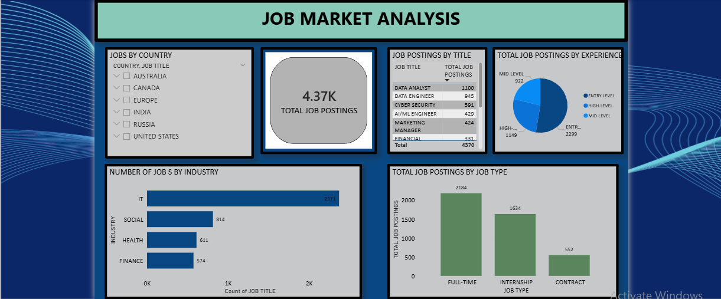
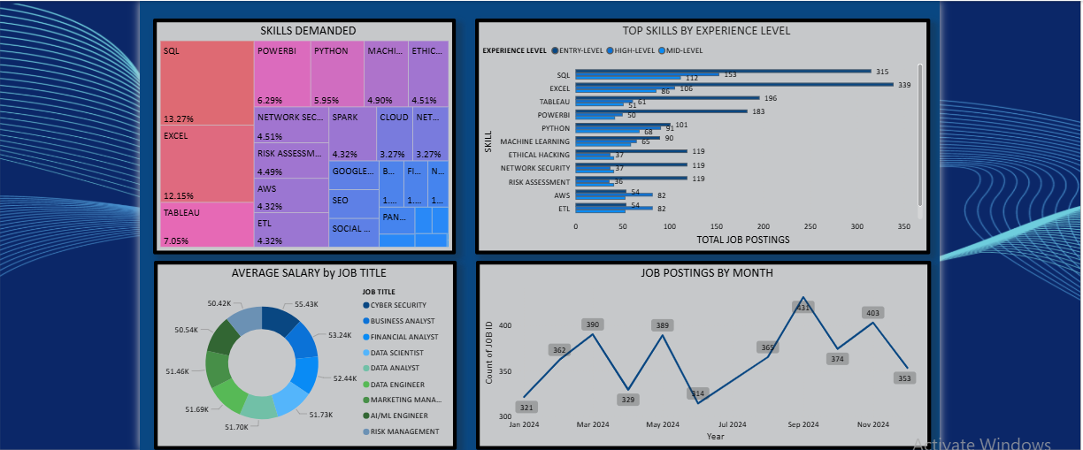
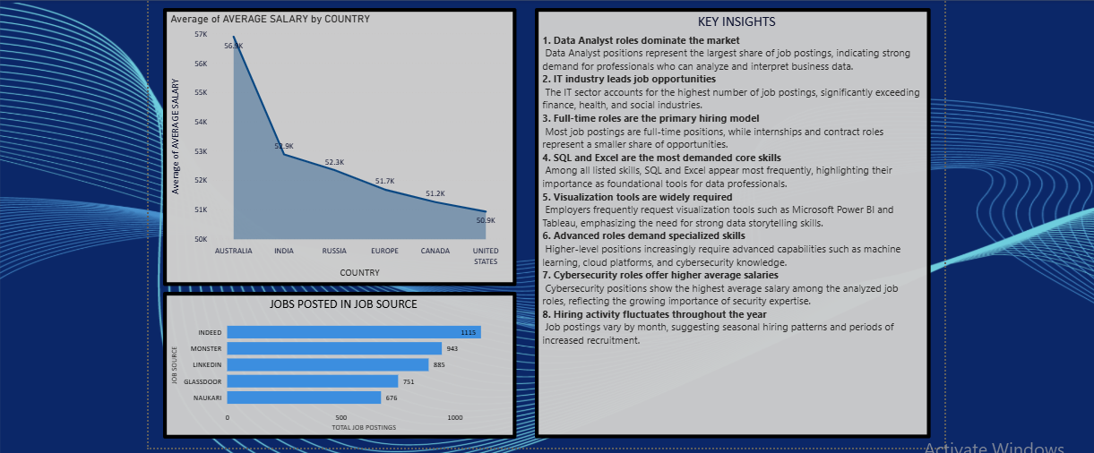
Dataset
The dataset contains job titles, companies, industries, skills, salaries, job types, and posting dates.
How to Use
Download the PBIX file and open it in Power BI Desktop.

