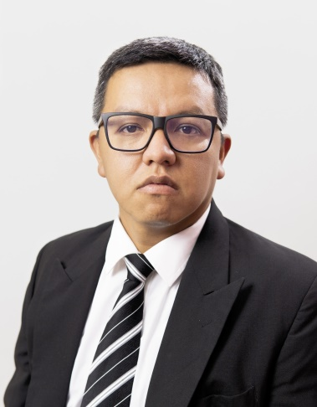

Contact

3313578846 (Mobile)

[vanguard9417@gmail.com](mailto:vanguard9417@gmail.com)

**Main Competences**

IT Support Reporting

Scripting

Web and desktop development

Customer Service

**Languages**

Español (Native)

English (Full Professional) French (Limited Reading and writing)

German (Limited Reading)

**Tech Skills**

JavaScript (2 years)

Linux (6 years)

Windows Server (6 years)

SQL (3 years)

HTML (2 years)

XML (1 year)

VMWare (4 years)

Python (2 years)

.Net (1 years)

React (6 months)

Git (6 months)

PHP (6 months)

Odoo (6 months)

PowerBi (6 months)

Juan Manuel Cortes Martínez

## IT L2 Analyst

## Guadalajara Area, México

## Repository

## <https://github.com/Vanguard94-RR>

## Portfolio

## <https://vanguard94-rr.github.io/MCMWeb-Dev-Portfolio/>

Experience

Claris International México (Outsourced to Bayer de México)

### IT Maintenance Analyst

January de 2020 - Present

Zapopan, Jalisco México

-SAP PM/MM/FI Level 2 support (Key user, User training & Documentation)

-Ticket Management

-IM / Phone Contact Center

-Installing software and hardware for desktop and remote machines

-AWS Device Pilot for IOT data acquisition (Production line support)

-Bash Scripting for terminal maintenance

-Odoo back-end support (HTML, XML, Python, SQL, Dockers)

-Internal Web Service support (HTML, JavaScript, TypeScript, React)

-Python Web Scrapping for Report Generation (Production and Finances)

-Device Administration for Permission management

-Crystal Reports support for SAP FI and MM

-Ubuntu 16.04.6/ 18.04.5 System support for 129 production line equipment.

-Reporting for SQL Server 2014 (Windows Server 2012 based)

-Server & Lan Support for Nextipac offices (VM Ware)

-Finance & Administration KPI Reporting

-Infrastructure Maintenance Planning & Scheduling

Ipsu Mexico

### IT Maintenance Analyst

December de 2017 – January 2020 (2 years)

El Salto, Jalisco Mexico

-SAP PM/MM Implementation and Level 1 support (Key user, User training & Documentation)

-Engaged in supporting users on desktops, mobile, handheld devices, desktop applications, web applications. (Windows Based, Linux based)

-Ticket Management

-IM / Phone contact Center

-Installing software and hardware for desktop and remote machines

-Responsible for Virtualization (VirtualBox) and Permissions on Vpn.

-Areca Backup and Flyback for Linux terminals

-Simple Bash scripting for terminal maintenance

-Linux Mint 18.2 Sonya/Ubuntu 18.04.3 Desktop/Laptop installation and support for 47 in-home users.

-Query creation and reporting for SQL Server 2014 (Windows server 2008 based)

-KPI tracking reporting

-Python Data Reporting (Pandas, Matplotlib, Statistics)

-Python support and debugging for Internal reporting system (Home-made)

## Fábrica de Papel San Francisco S.A. de C.V.

### Maintenance Technical Data Engineer

November de 2013 - October de 2017 (4 years)

El Salto Jalisco México

-SAP PM/MM Implementation and Roll Out for 3 plants (Key user, User training & Documentation)

-Network installation of Ubuntu terminals (26) for local control of manufacturing processes

-CentOs 6 Server Installation and support for processes control

-Symantec Backup procedures for mfg data in Cent/Os Server

-Python programming for transducer & sensor reading

-SQLite CRUD data base creation for MFG processes

-Query creation and reporting for PM, and MFG

-IT support for Materials & Manufacturing & Maintenance Department (mail, User accounts,

-Installation and deployment of MFG/MM/PM Data Server for Windows Server 2012

-KPI reporting for PM, MM

-Achieved a user satisfaction rating of 4.8/5.0 (7% higher than average); consistently logged and monitored ticket status to ensure fast, quality resolution of every issue.

-Set up secure WiFi, LAN and VoIP networks at remote terminals,

leading client/server configuration and performance-tuning of mgf and pm infrastructure.

## Desarrollo de Productos SA de CV

### Head Of Technical Service

October de 2011 - mayo de 2013 (1 year 8 mo) Guadalajara Jalisco México

-Design and implementation of the web system of Technical Service Management, (Python, Django, MySql)

-Development of Graphs and Technical Service Statistics

-Implementation of the Virtual Service Network System based on SMS and Windows Server 2008.

-Call Center implementation and KPI Reporting.

-Call Center Operational Budget Control.

-Call Center Operation Cost Report.

-Quality System Management ISO 9001-2000.

-Compaq accounting system support and reporting in Power BI.

Education

Alinnco

-Maestría en Dirección de Proyectos · (August 2021 – On going)

UTZMG

-Ingeniería en Energías Renovables Área Solar/Negocios, (2010 - 2013)

-Técnico Superior Universitario en Energías Renovables Área Solar/ Negocios, Energías Renovables Área Solar/Negocios · (2008 - 2010)

-Conalep Guadalajara II

Profesional Técnico en Contabilidad Financiera y Fiscal, Contabilidad · (2001 - 2004)