
Hanoi University of Science and Technology
Cyber Security K67
Class 149324 - IT3100E - Object-Oriented Programming
Lecturer: Prof. Nguyen Thi Thu Trang

Mini-Project Report:

Visualization of operations on tree data structures

Group 04
Members:
Phan Việt Anh – 20225566
Nguyễn Thế Hùng – 20225573
Lê Hải Nhật – 20225583
Table of Contents
I. Mini-project description 3
1. Mini-project requirements: 3
2. Use case diagram overview: 4
II. Design 6
1. General class diagram overview: 6
2. Packages 'class diagram: 6
3. Explanation of the design: 8
III. Implementation 12
1. Java 12
2. JavaFX 12
3. Scene builder 12
4. MVC Architecture 12
IV. Evaluation 13
1. Result and evaluation of effectiveness and feasibility 13
2. Restrictions 13
3. Direction for improvement 13
V. Assignment of members: 13
VI. Reference: 15

Mini-project description

Mini-project requirements:
Tree is a useful data structure with lots of applications in computer science. In this project, you will design a program to display and explain some basic operations four types of trees.
In this project, we will only consider undirected-weight trees, with integer node values and no duplicated node values allowed.
There are 4 types of trees that we consider:
- Generic tree: (no special properties): A tree is a nonlinear hierarchical data structure that consists of nodes connected by edges and contains no cycles.
- Binary tree: A binary tree is a tree where each node has at most two children.
- Balanced tree: A balanced tree is a tree where each leaf node is “not more than a certain distance” away from the root than any other leaf.
- Balanced binary tree: A balanced binary tree has the properties of both a binary tree and a balanced tree.

Use case diagram overview:
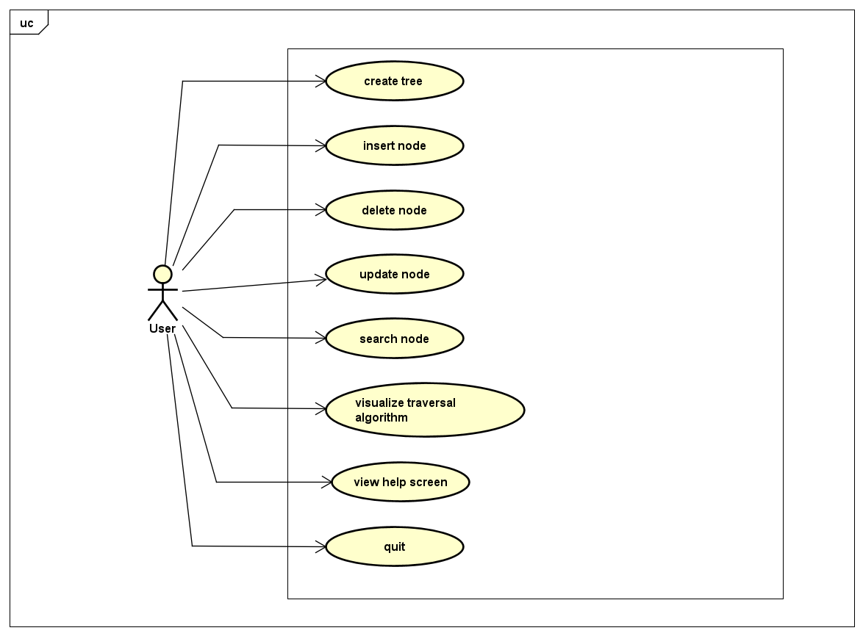
Figure 1: use case diagram
- Create tree
User can decide what type of tree to watch and decide the value of the root node at the main menu screen of the app.
- Insert node
When the root node is created, user can decide its child nodes by insert the value of the root node into the “Parent Node” box so the program can know which node is needed to add child node to and then user can type the value of the child node they want into the “New Node” box.
- Delete node:
The user can decide what node will be deleted by texting its value in the “Node Value” box and then click the “Delete” button.
- Update node
Putting the value of the node that the user wants to update in the “Old Value” box and then insert the new value of it in the “New Value” box. Click “Update” to replace the two values.
- Search node:
Inserting the value of the node that the user wants to find at the “Search for” box and then click “Search” to find it.
- Visualize traverse algorithm:
User can choose between two types of traverse algorithm which is Breadth First Search (BFS) or Depth First Search (DFS). The pseudo code which helps the user to keep track of the searching progress will be displayed. During the traverse progress, the user can choose to pause, continue, or go backward or forward a step in the execution.
- View help screen:
Clicking the “Help” box will show the user a summary introduction of how to use the program.
- Quit:
Clicking “Quit” button or manually closing the application by the menu bar will exit the app. An alert dialog will pop up and will confirm the user about their choice of exit.

Design

General class diagram overview:
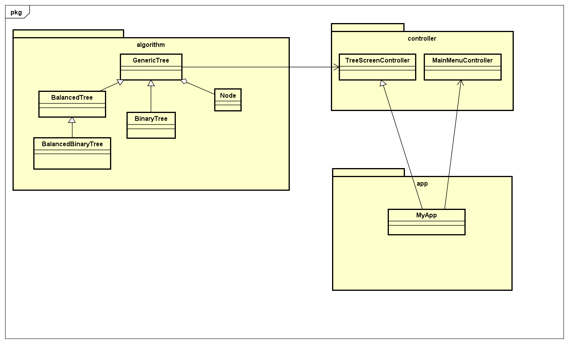

Packages 'class diagram:
2.1. App package’s class diagram:
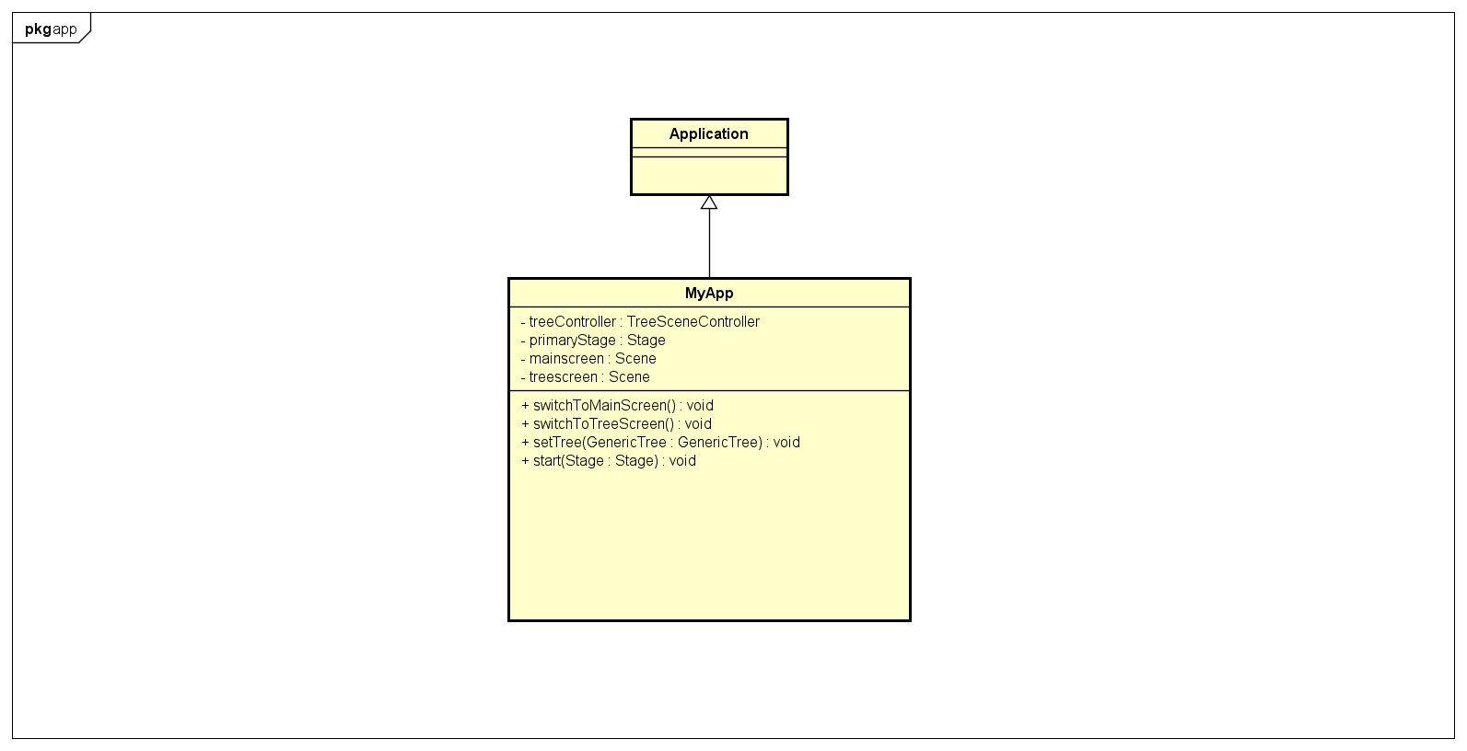
2.2. Algorithm package’s class diagram
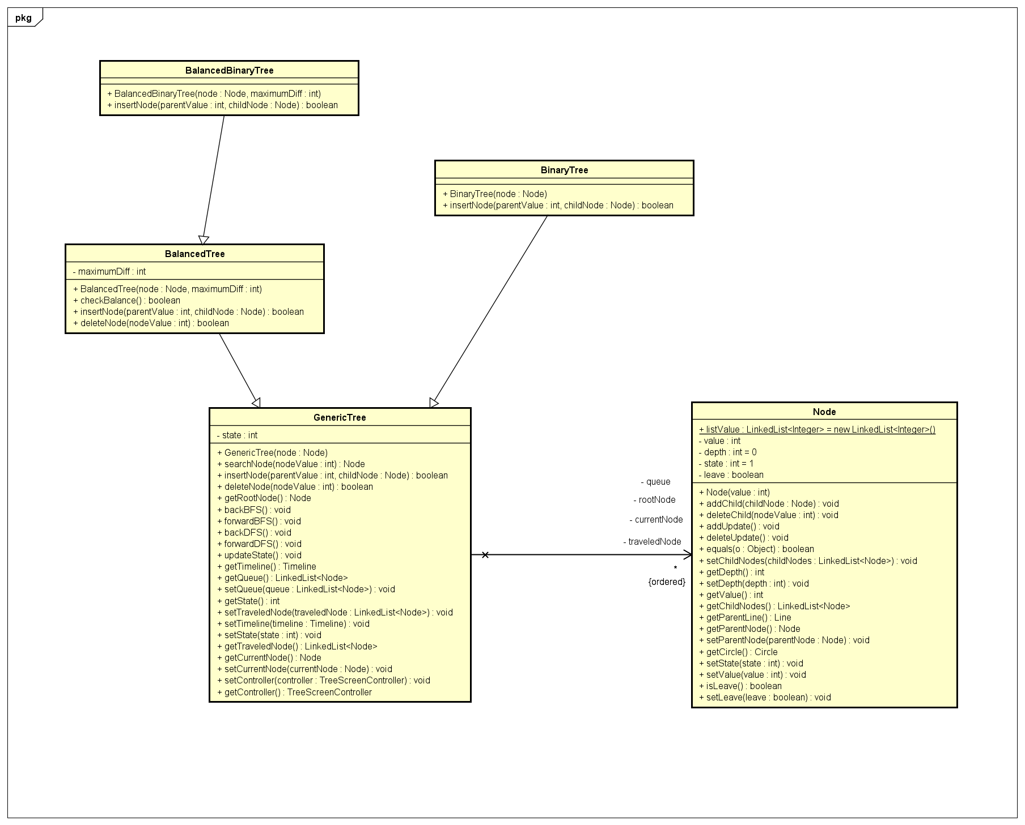
2.3. Controller package’s class diagram
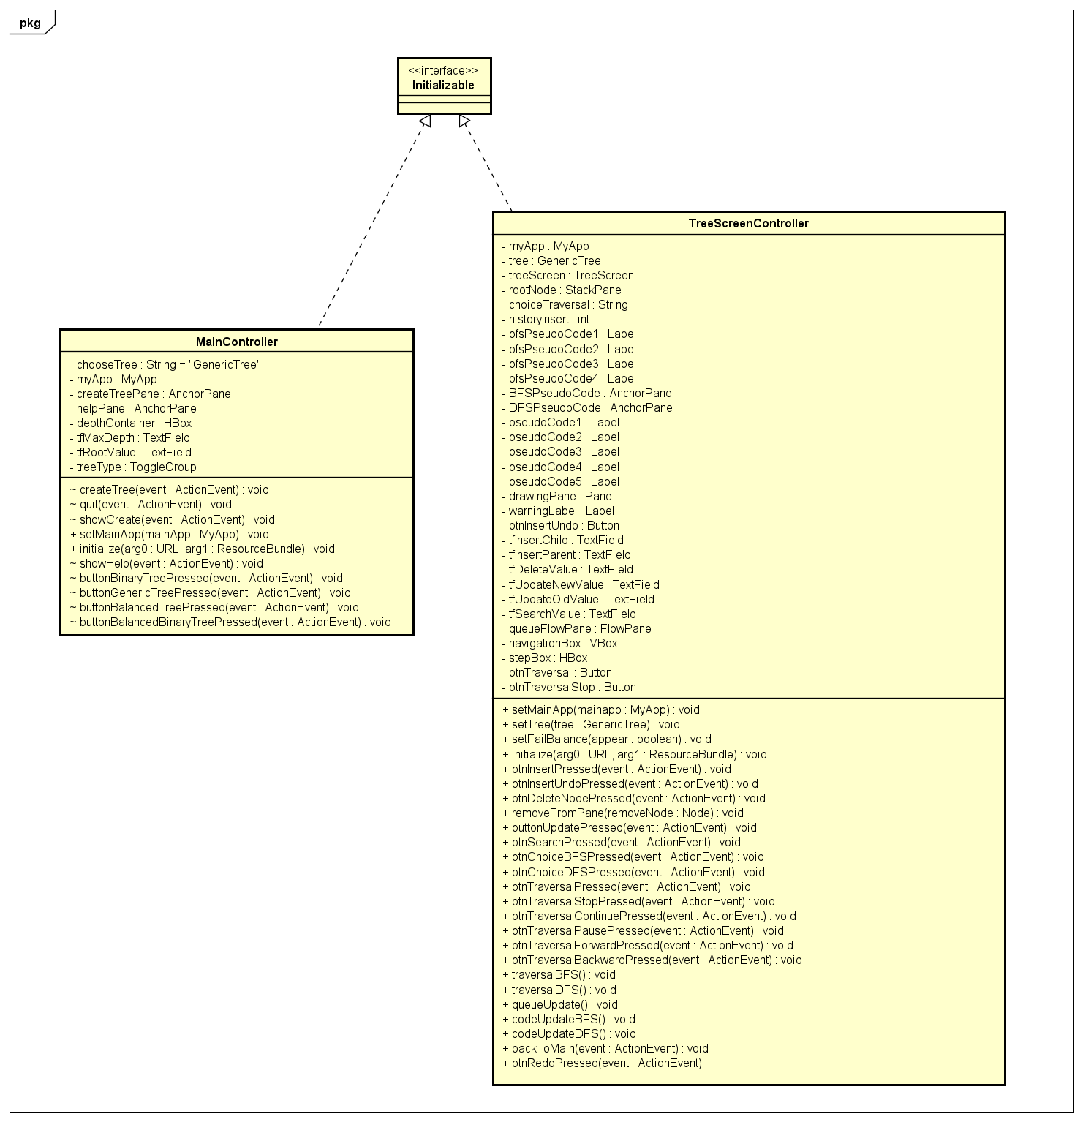

Explanation of the design:
When starting the program, the main working screen window is displayed. In the main screen window, the first thing visible is the tree creation function (4 optional tree types) with the value of the root node. Besides, there is a help function, displaying information about the trees that can be created. Button quit has the ability to exit the program
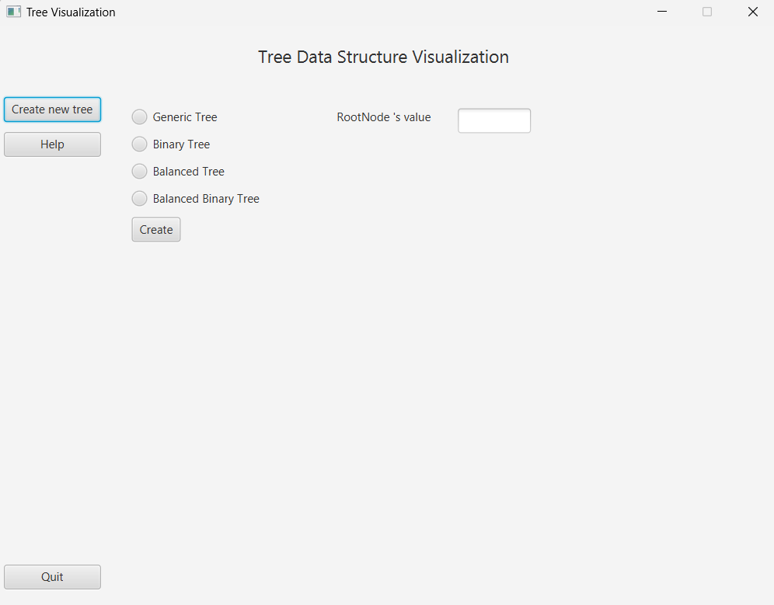
For balanced tree and balanced binary tree, users can choose the max depth difference between leaves 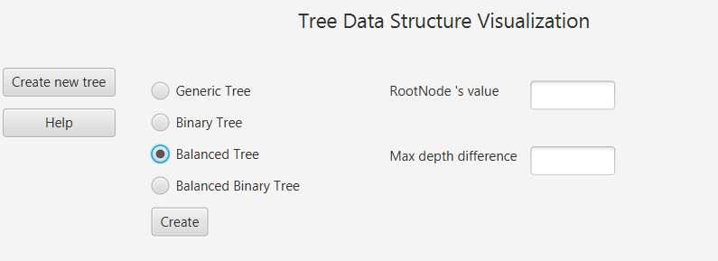
After creating a tree with the root node, the user can add nodes to the tree providing the value of the parent node and the value of the newly added node.
The image below is the tree with some nodes added to it.

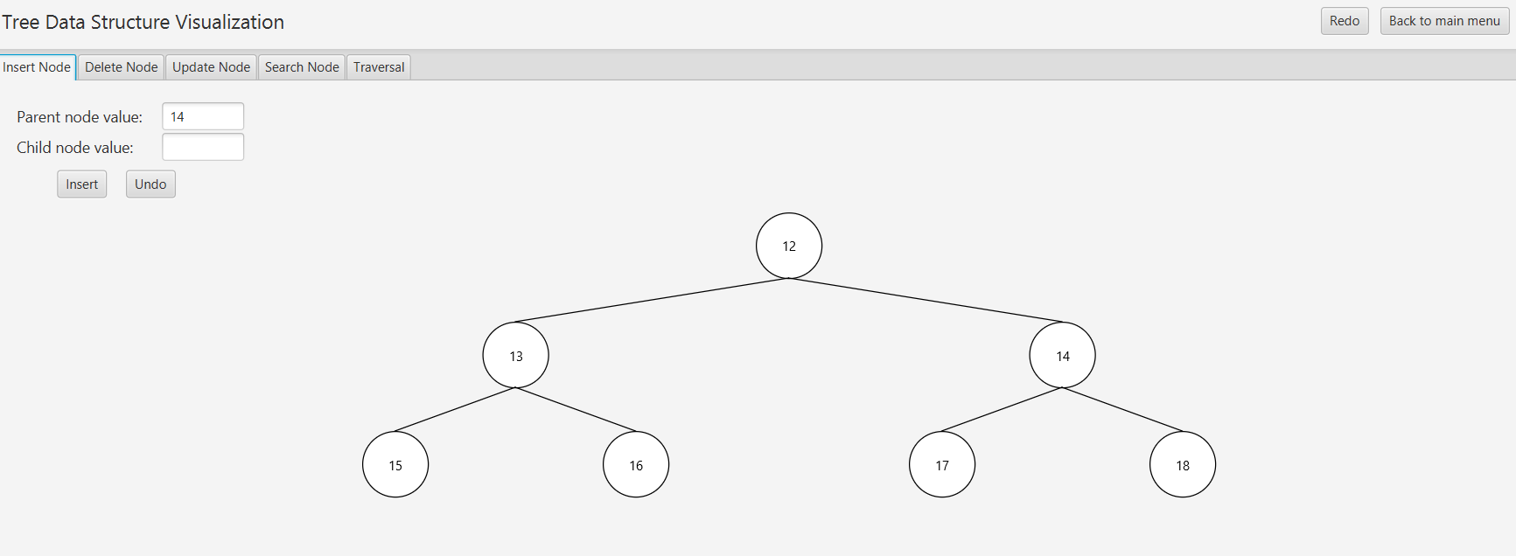
The user can delete a leaf in the tree by providing the value of the leaf node
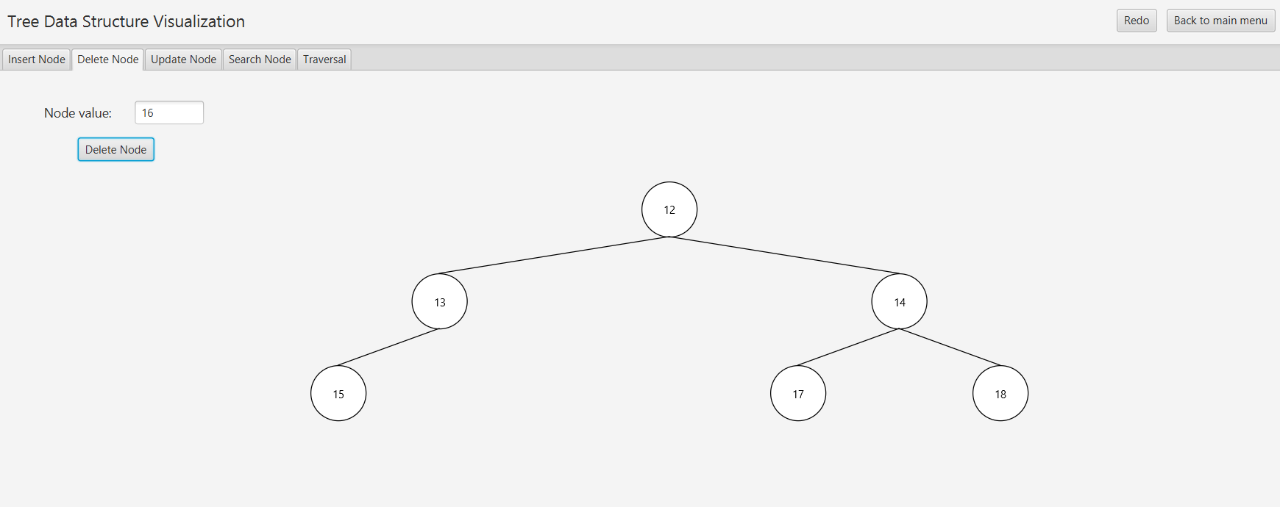

The user can change the value of a node in the tree by providing the value of the node they want to change and the new value for that node.
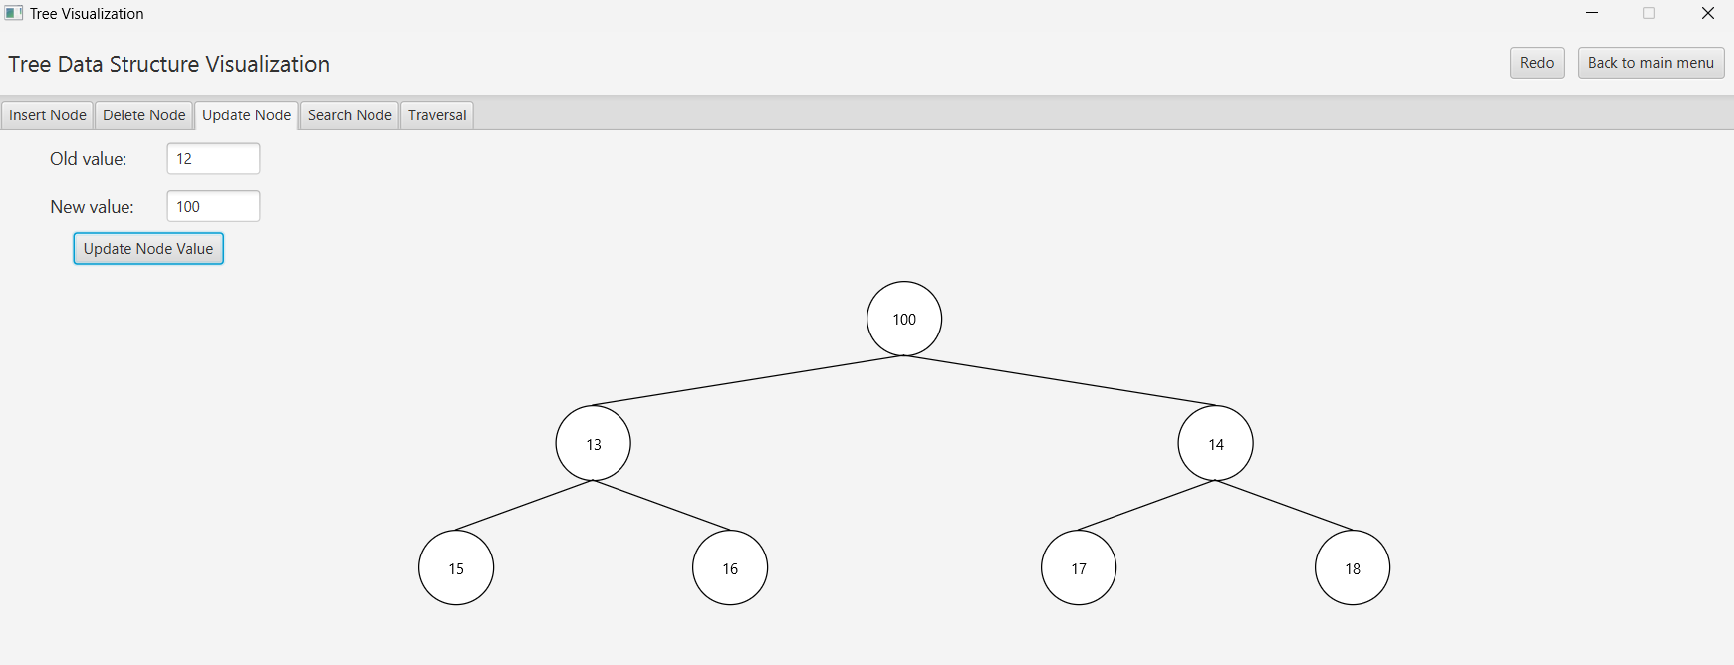

The user can perform a search for a node by providing the value of that node, the program will check each node. Red indicates the current node is not the search node and green indicate that the current node is the node search. When the desired node is found, the program stops.
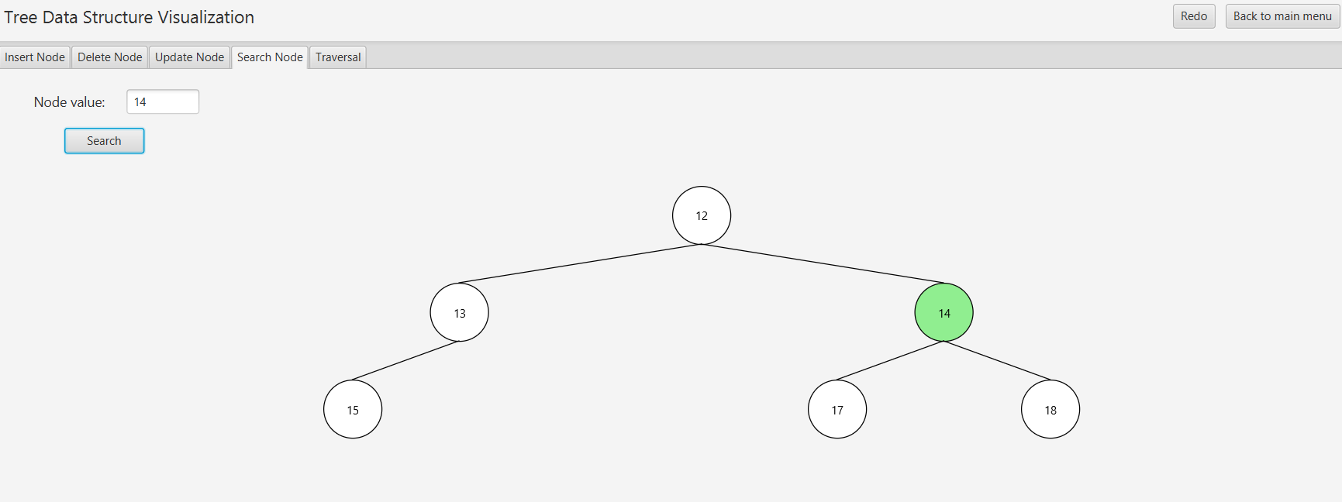
User can observe traversal in the tree with two options: BFS and DFS. When performing traversal, the lower left corner of the screen will display the nodes in the queue and the lower right corner will display the Pseudo code for the program being executed below.
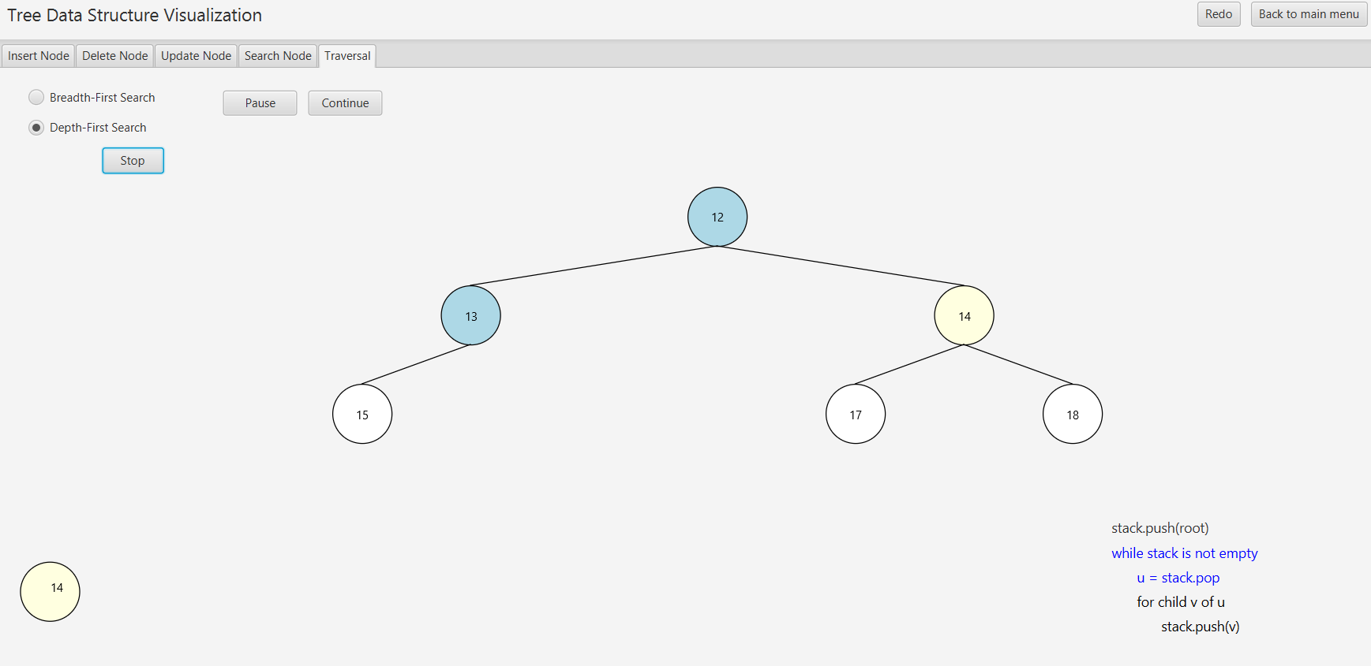
In particular, the traversal function can also be navigated with each step ò the traversal. Users can choose pause to stop the traversal process and use Forward or Backward to go back or forward one step (node) during the traversal process. The continue button is used to continue the traversal process.
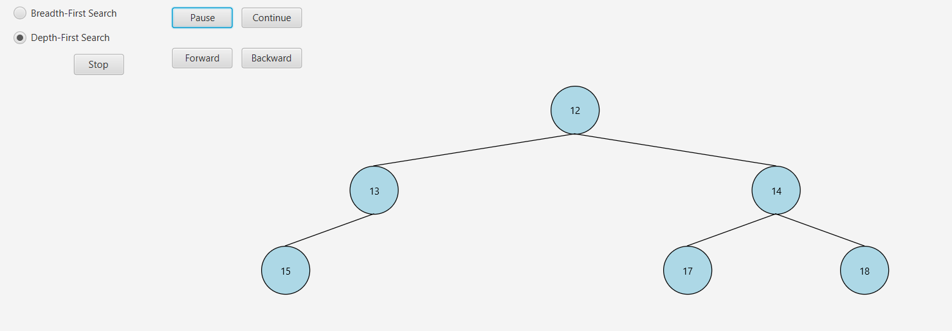

Implementation

Java
Java is a widely used programming language and computing platform, originally developed by Sun Microsystems in 1995 and later acquired by Oracle Corporation.
This program is fully in Java programming language.

JavaFX
JavaFX is a platform for developing rich internet applications (RIAs) with a modern user interface (UI) for Java applications. It is considered a successor to AWT and Swing, offering more powerful and flexible UI capabilities.
JavaFX Scene Graph and FXML support are the most useful feature and used in this program.

Scene builder
Scene builder is a visual design tool for JavaFX applications, allowing developer to design the UI by dragging and dropping UI components without manually writing FXML code
The UI of this program take use of this tool for easier design.

MVC Architecture
The program logic is divided into three interconnected elements (model-view-controller).
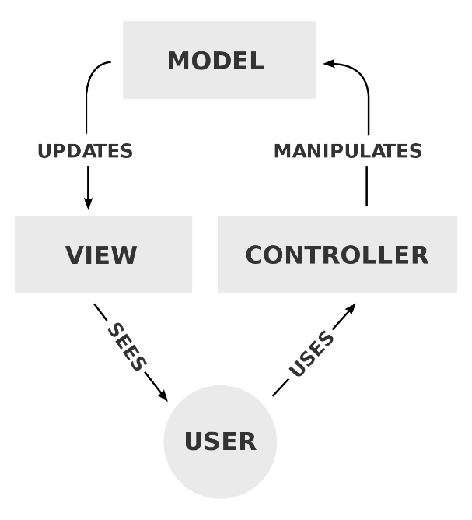
The user will interact with the program through the user interface (view), user actions such as creating a tree, adding nodes, deleting nodes… will be monitored by controllers. This controller will listen to user action on user interface and update them to model. After making changes to the model, the controller displays these changes on the user interface so that the user can see it.
Specifically, model is algorithm package, view and controller are packages with the same name.
- Model is algorithm package which includes Node class and tree data structure classes.
- View is a package storing FXML files.
- Controller package includes controllers for main scene and tree visualization scene.

Evaluation

Result and evaluation of effectiveness and feasibility
The program can visualize some basic data structure tree types with functions such as creating trees, adding nodes, deleting nodes, changing node value, searching for node and traversal

Restrictions
- Algorithm
In the program, the tree data structures used are the most common tree data structures of each type, designed according to the program description. Specifically:
  - Binary tree is a tree where each node has at most two children instead of specific type of binary tree such as Binary Search Tree, Red-Black Tree ...
  - Balanced tree is not a specific type of balance tree such as AVL Tree.
  - Balance binary tree is the tree has the properties of both a binary tree and a balanced tree instead of specific type of balance binary tree such as AVL Tree B-Tree
Therefore, tree manipulation algorithms are a bit limited and ineffective.
- Model
MVC model is used to make the program more logical, easy to maintain and extend, improve organization and project management.
However, this program is not too complicated, so using the MVC model here does not maximize its effectiveness.
- User interface
The tree visualization program contains most of the feature that the user can use to understand the fundamental of tree data structure. Even so, the program cannot be able to help the user to auto generate a tree with a height that the user wants. The user must manually generate the tree by insert value of the root node and its child node.

Direction for improvement
- Using specific tree data structure or multiple type of tree data structure to make the program richer and more diverse.
- Divide program logic into smaller component to take full advantages of MVC model.
- Implement a new class to auto generate a typical tree with the height that inserted by user.

Assignment of members:
- Phan Viet Anh – 20225566: leader, implement the tree screen controller class, complete the class diagram, make report and slide.
- Nguyen The Hung – 20225573: design the class diagram, implements the main menu, main menu controller and tree screen, complete the report
- Le Hai Nhat –20225583: implements the algorithm (model), complete the report, GUI and final code modification.

Reference:
- Algorithm:
  - https://www.geeksforgeeks.org/binary-tree-data-structure/
  - https://www.geeksforgeeks.org/balanced-binary-tree/
  - Multiple videos from https://www.youtube.com/
- Tree visualization:
  - https://github.com/tamht194450/OOP.DSAI.20202.Team13.git
  - https://visualgo.net/en/bst

