# Solution Template

Name: Tim Vanherwegen

Student number: R0748760

Fill in each answer in the respective box. Intermediate computations can be done on a separate page.

1b.

1a.

P(W_i =0|R_i=1)

P(W_i =1|R_i=1)

P(W_i =1|R_i=0)

P(W_i =0|R_i=0)

P(S_i =0|W_i=0)

P(S_i =0|W_i=1)

P(S_i =1|W_i=0)

P(S_i =1|W_i=1)

P(W_i =1|W_(i-1)=1, R_i=1 )

P(W_i =1|W_(i-1)=1, R_i=0 )

P(W_i =1|W_(i-1)=0, R_i=1 )

P(W_i =1|W_(i-1)=0, R_i=0 )

P(W_i =0|W_(i-1)=1, R_i=1 )

P(W_i =0|W_(i-1)=1, R_i=0 )

P(W_i =0|W_(i-1)=0, R_i=1 )

P(W_i =0|W_(i-1)=0, R_i=0 )

P(R_i=1)

P(R_i=0)

1c. Number of parameters: 18 Definition of parameters:

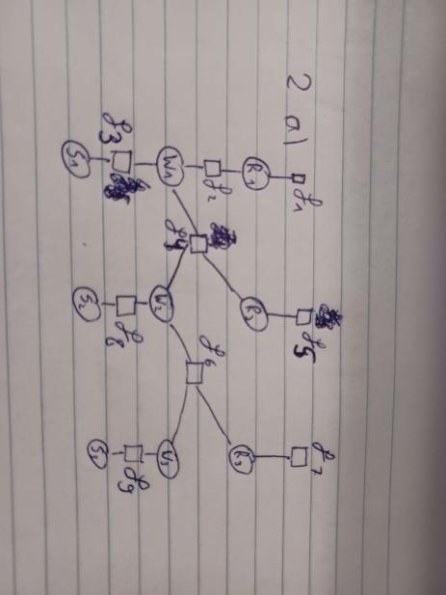

2a.

3d.

3b. Number of messages: 17

Factor graph with message schedule:

3a.W_3

2b. 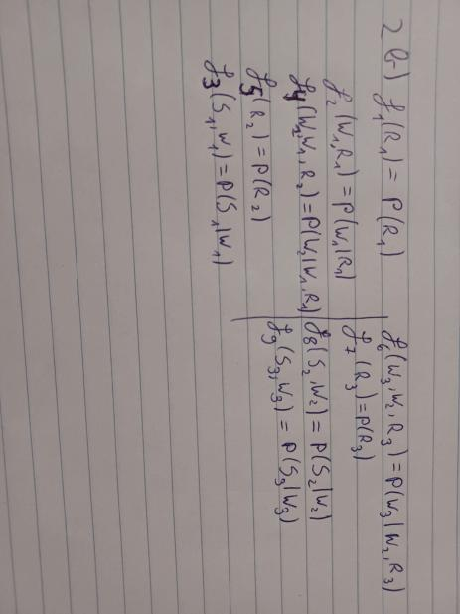

3c.34