Lightweight transcriptomics

Surojit Biswas1†, Konstantin Kerner2, Paulo José Pereira Lima Teixeira3,4, Jeffery L. Dangl3-7,*, Vladimir Jojic8,*, Philip A. Wigge9,*,†

1 Department of Biomedical Informatics, Harvard Medical School, Boston, MA 02115, USA

2 Botanical Institute, Biocenter, University of Cologne, Cologne, Germany

3 Howard Hughes Medical Institute and 4 Department of Biology, University of North Carolina at Chapel Hill, Chapel Hill, NC 27599, USA.

5 Carolina Center for Genome Science, University of North Carolina at Chapel Hill, Chapel Hill, NC 27599, USA

6 Department of Microbiology and Immunology, University of North Carolina at Chapel Hill, Chapel Hill, NC 27599, USA

7 Curriculum in Genetics and Molecular Biology, University of North Carolina at Chapel Hill, Chapel Hill, NC 27599, USA

8 Department of Computer Science, University of North Carolina at Chapel Hill, Chapel Hill, NC 27599, USA

9 Sainsbury Laboratory, University of Cambridge, Cambridge CB2 1LR, UK

* Contributed equally

† Correspondence: surojitbiswas@g.harvard.edu, Philip.Wigge@slcu.cam.ac.uk

**Abstract**

**Introduction**

As the critical determinant of the proteome and therefore cellular status, the transcriptome represents a key node of regulation for all life1. Transcriptional control is managed by a finely tuned network of transcription factors that integrate environmental and developmental cues in order to actuate the appropriate responses in gene expression2–4. Importantly, the transcriptomic state space is constrained. Pareto optimality suggests that no gene expression profile or phenotype can be optimal for all tasks, and consequently, that some expression profiles or phenotypes must come at the expense of others5,6. Furthermore, across all major studied kingdoms of life, metabolic networks demonstrate remarkably conserved scale-free properties that are topologically characterized by a small minority of highly connected regulatory nodes that link the remaining majority of sparsely connected nodes to the network7–9. These theories suggest that the effective dimension of the transcriptome should be far less than the total number of genes it contains. If true to a large enough extent, it may be possible to faithfully compress and prospectively reconstruct the entire transcriptomes using only a small, carefully chosen subset of it.

Indeed, previous studies have exploited this reduced dimensionality to perform gene expression imputation for microarray data for missing or corrupted values10–12. Others have extended these intuitions to predict expression from probe sets containing a few hundred genes13,14. However, prediction accuracies have been modest and usually limited to 4,000 target probes/genes. Recently, several studies examined the transcriptomic information recoverable by shallow sequencing especially as it applies to single-cell experiments15–18. Jaitin *et al.* (2014) and Pollen *et al.* (2014) demonstrated only tens of thousands of reads are required per cell to learn and classify cell types *ab initio*16,18. Heimberg *et al.* (2016) extended these intuitions and showed the major principal components of a typically sequenced mouse bulk or single-cell expression dataset are estimatable with little error at even 1% of the depth15. However, though these approaches advance the notion of strategic transcriptome undersampling, they only recover broad transcriptional states and are restricted to measuring only the most abundant genes. During sample preparation -- arguably the most expensive cost of a multiplexed sequencing experiment -- shallow sequencing based approaches still utilize protocols meant for sampling the entire transcriptome and therein consume more resources than necessary. Furthermore, given expression of even the most abundant genes is highly skewed, sequencing effort is wastefully distributed compared to an approach that chooses which genes to measure more wisely. Finally, it is still not clear from sample sizes and biological contexts previously studied whether the low dimensionality of the transcriptome may be leveraged unconditionally (or nearly so) across organism and application.

In this work, we introduce Tradict (transcriptome predict), a novel, robust-to-noise, and probabilistically sound algorithm for inferring the expression of all transcriptional programs and genes in the transcriptome using only the expression measurements of a single, context-independent, machine-learned subset of 100 marker genes. Using a transcriptionally representative sampling of over 23,000 publicly available, transcriptome-wide RNA-Seq datasets for *Arabidopsis thaliana* and *Mus musculus*, we train Tradict to prospectively reconstruct gene expression, and to predict, to near perfection, the expression of a comprehensive, but quickly interpretable collection of transcriptional programs. Our work demonstrates, for the first time, the development and large-scale application of a multivariate count/non-negative data model, and highlights the power of directly modeling the expression of transcriptional programs in a supervised manner. We believe Tradict, coupled with targeted RNA sequencing, can improve the time and cost of performing large forward genetic, breeding, or chemogenomic screens, accurately profiling single-cells, and performing gene expression based clinical diagnostics.

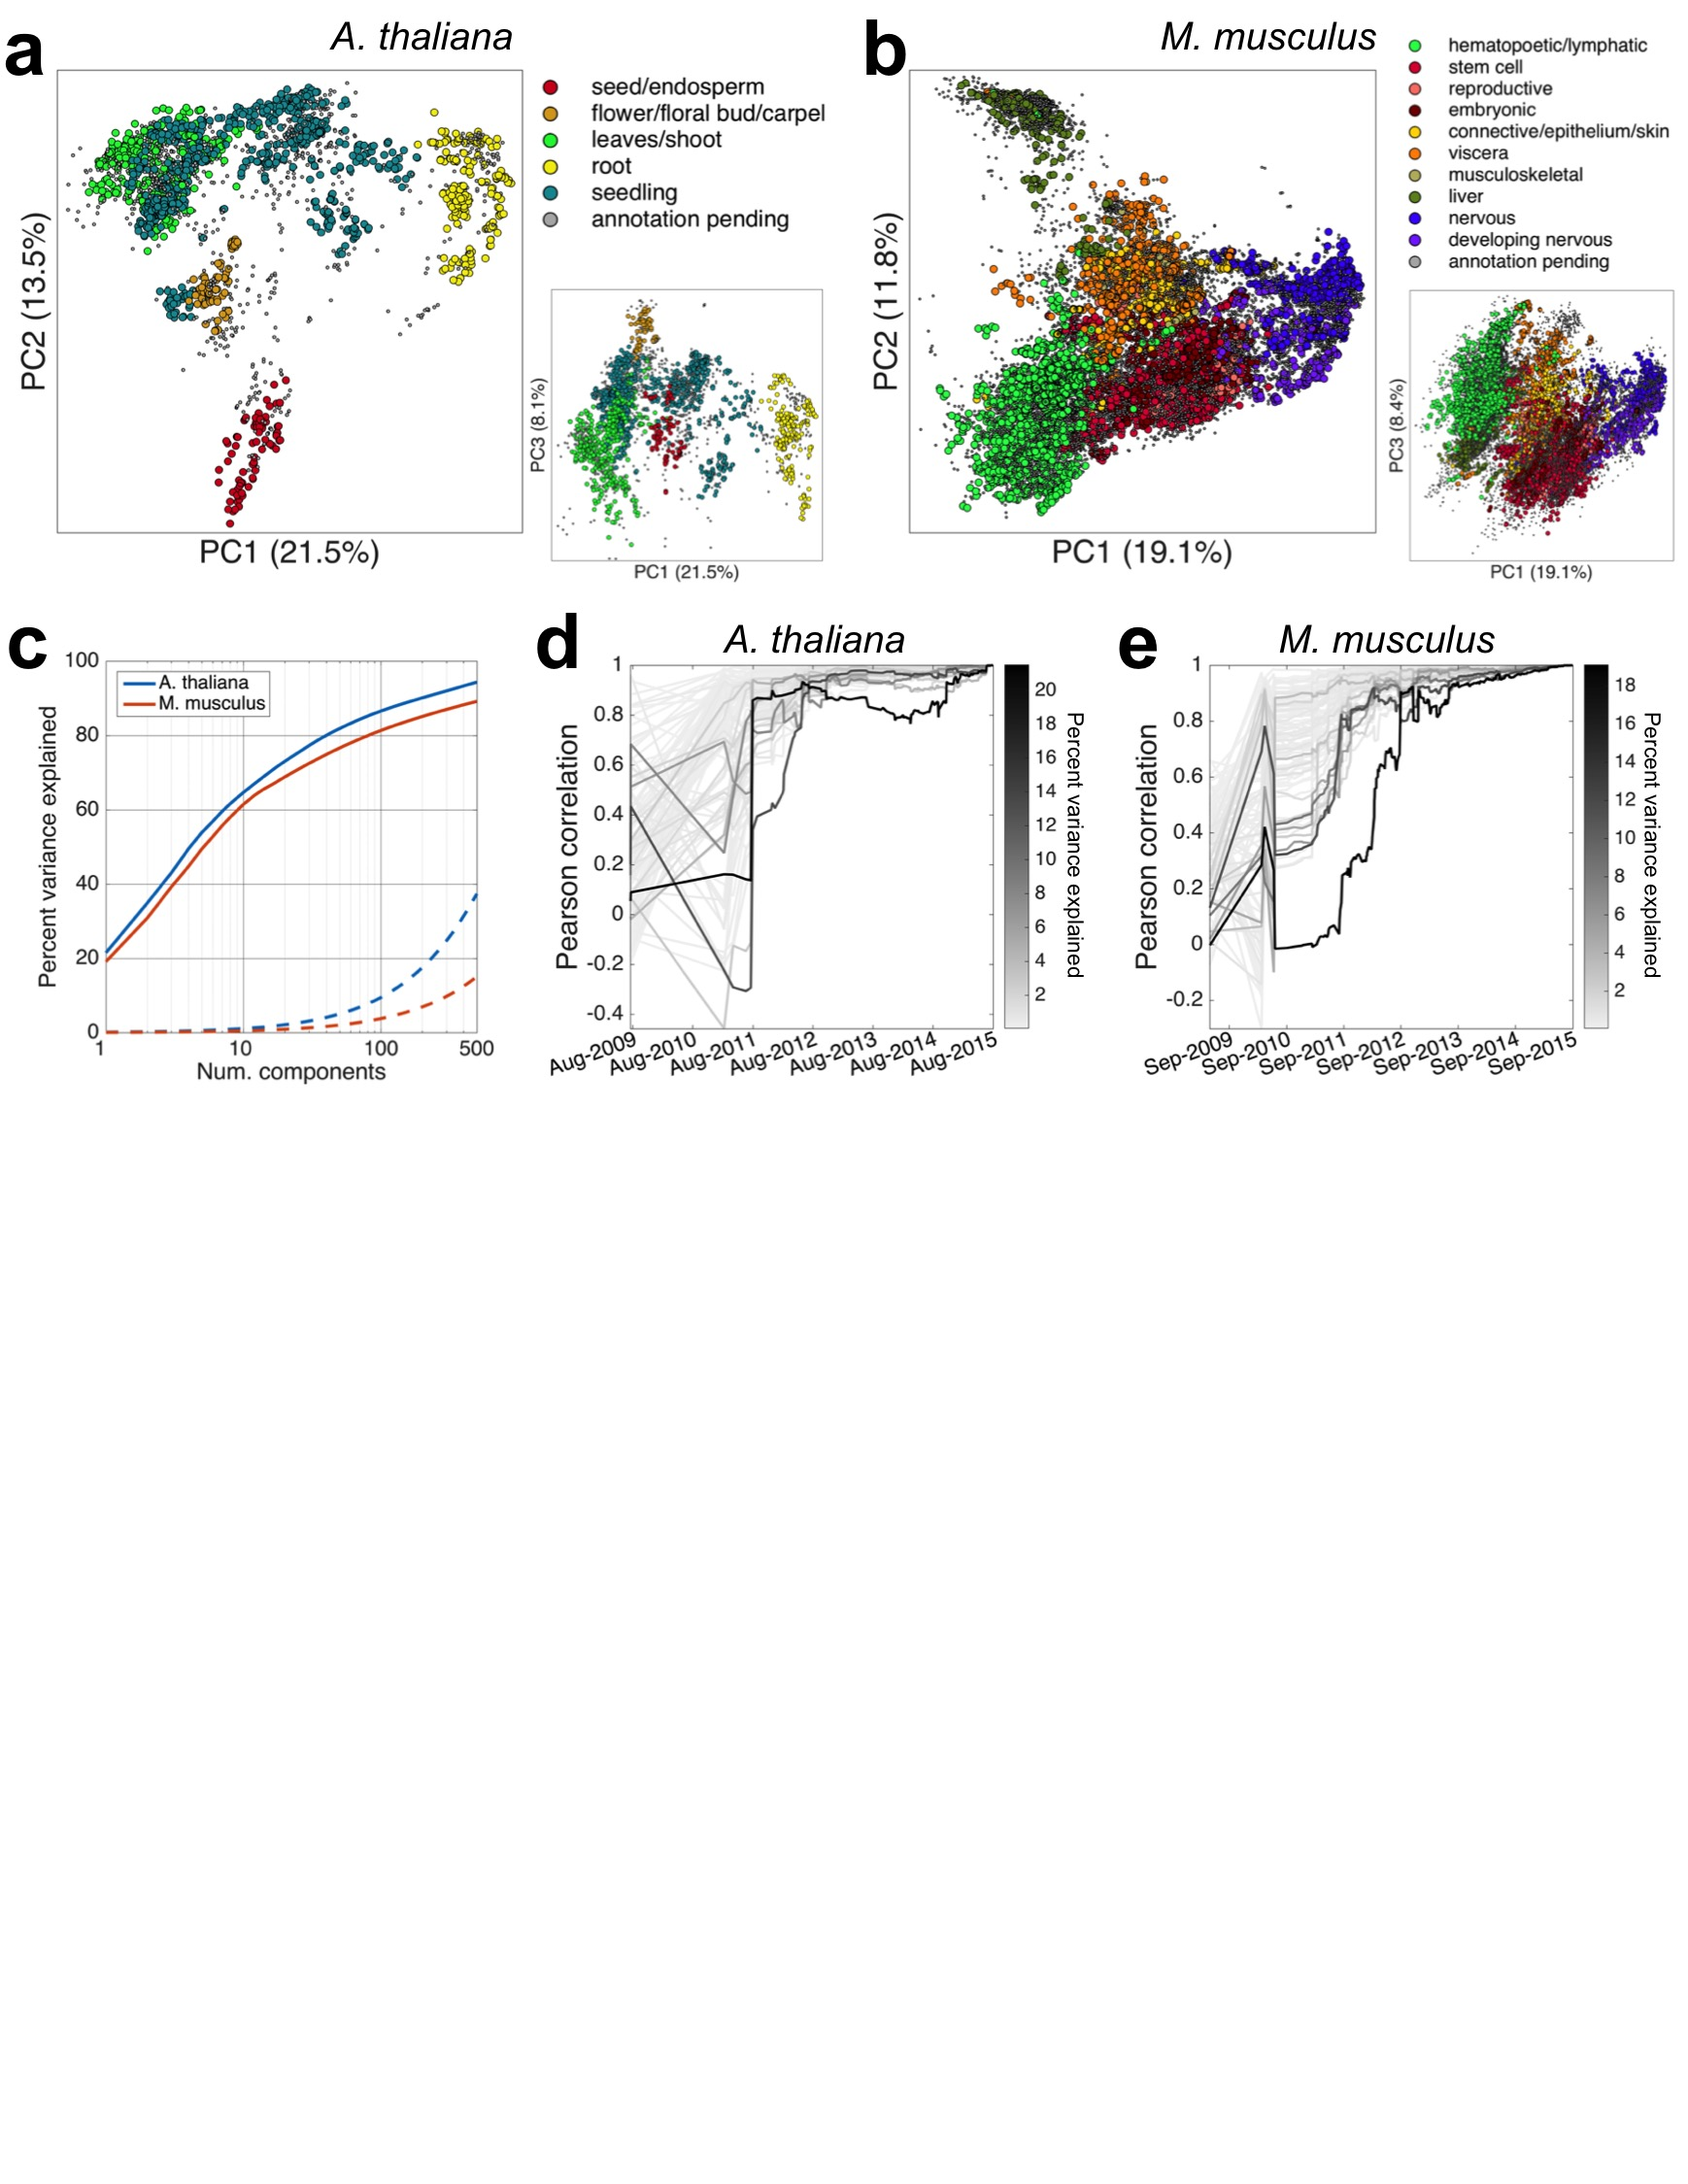

Figure 1. Our assembled training transcriptome collection is transcriptionally comprehensive and stable. a & b) Principal components analysis revealed that the major drivers of variation in our training collection are tissue and developmental context, for both *A. thaliana* and *M. musculus*. c) The transcriptome is of strikingly low dimensionality, with 100 principal components able to explain 80% or more of expression variation. Dotted lines illustrate cumulative expression variation explained on a null model realization, where each gene’s expression vector was permuted to break correlative ties to other genes. d & e) the expression space is comprehensive and stabilized ~2.5 years ago. For each of the first 100 principal components (PCs), depicted is the Pearson correlation between how samples are distributed along the PC at a select point in the past and how they are distributed currently. Each line, representing a PC, is shaded by the percent variance explained by that PC.

Need to change order of panels in this figure to reflect text.

**Results**

**Assembly of a comprehensive training collection of transcriptomes**

We attempted to download all available Illumina sequenced publicly deposited RNA-Seq samples (transcriptomes) on NCBI’s Sequence Read Archive (SRA). Among samples with at least 4 million reads, we successfully downloaded and quantified the raw sequence data of 3,621 and 27,450 transcriptomes for *A. thaliana* and *M. musculus,* respectively. After stringent quality filtering, we retained 2,597 (71.7%) and 20,847 (76.0%) transcriptomes comprising 225 and 732 unique SRA submissions for *A. thaliana* and *M. musculus*, respectively. An SRA ‘submission’ consists of multiple, experimentally linked samples submitted concurrently by an individual or lab. We defined 21,277 (*A. thaliana*) and 21,176 (*M. musculus)* measurable genes with reproducibly detectable expression given our tolerated minimum sequencing depth and mapping rates. See Supplemental Information “Materials and Methods” for further information regarding data acquisition, transcript quantification, quality filtering, and expression filtering. We hereafter refer to the collection of quality and expression filtered transcriptomes as our *training transcriptome collection*.

In order to assess the quality and comprehensiveness of our training collection, we performed a deep characterization of the expression spaced spanned by these transcriptomes. We found that the transcriptome was highly compressible and that the primary drivers of variation were tissue and developmental stage (Figure 1a-b), with many significant, biologically realistic trends within each cluster (Supplemental Note 1). We additionally examined the distribution of submissions across the expression space, compared inter-submission variability within and between tissues, inspected expression correlations among genes with well-established regulatory relationships, and assessed the evolution of the expression space across time. These investigations revealed our training collection is of high and reproducible technical quality, reflective of known biology, and stable (Supplemental Note 1). Given additionally the diversity of tissues, genetic perturbations, and environmental stimuli represented in the SRA, these results, taken together, suggest that our training collection is an accurate and representative sampling of the transcriptomic state space that is of experimental interest for both organisms.

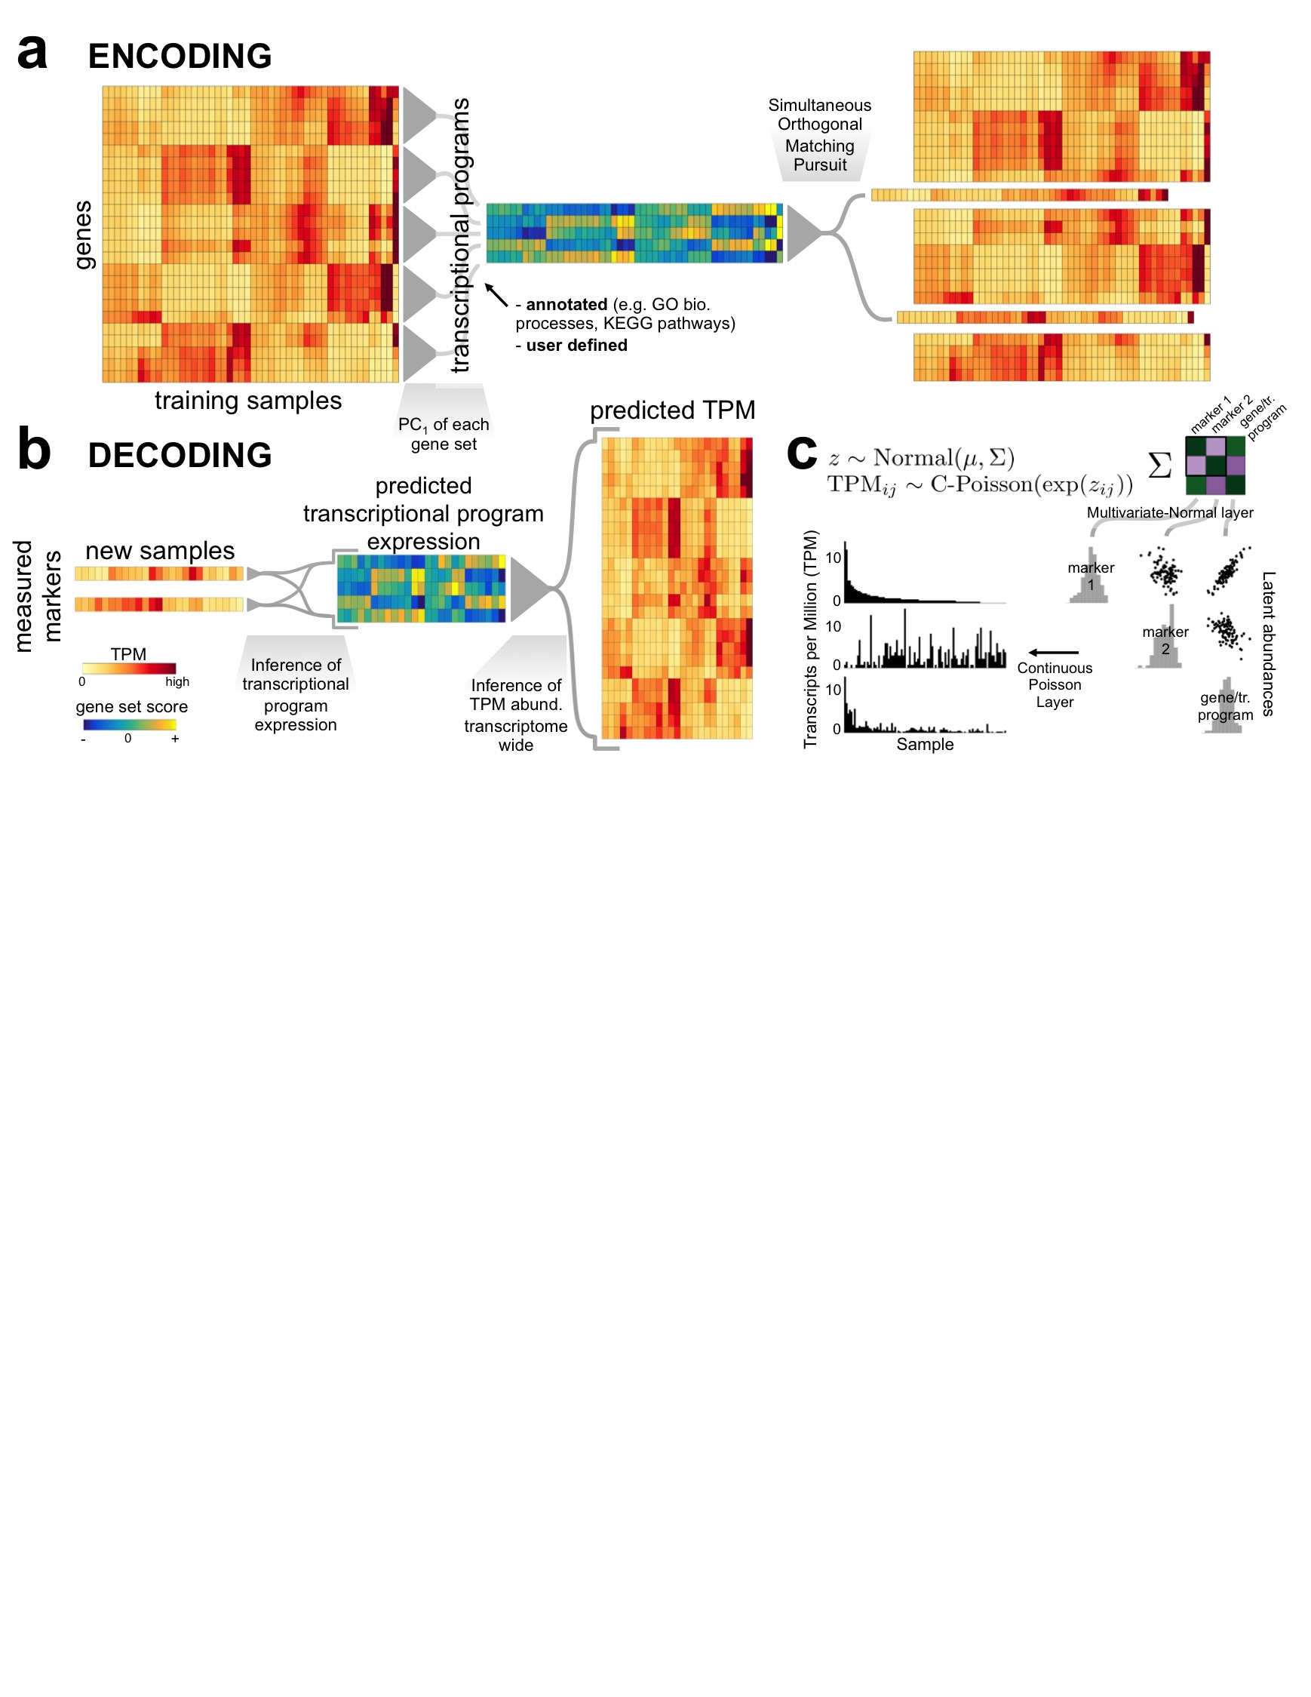

Figure 2. Tradict’s algorithmic workflow. a) During encoding the transcriptome is first quantitatively summarized in terms of a collection of a few hundred, biologically comprehensive transcriptional programs. These are then decomposed into a subset of marker genes using an adaptation of the Simultaneous Orthogonal Matching Pursuit algorithm, and a Multivariate Normal Continuous-Poisson hierarchical model is used as a predictive model to capture covariance relationships between markers, transcriptional programs, and non-markers. b) During decoding, Tradict predicts the expression of transcriptional programs and all genes in the transcriptome using only expression measurements of the marker genes. c) The Multivariate Normal Continuous-Poisson hierarchy enables Tradict to efficiently model statistical coupling between the non-negative expression measurements typical of sequencing. This is done by assuming that associated with each observed, noisy TPM measurement, there is an unmeasured, denoised latent abundance the logarithm of which comes from a Multivariate Normal distribution over all genes and transcriptional programs.

**Tradict and baseline algorithms overview**

[expression optimization]

Given a training sample of transcriptomes, Tradict simultaneously encodes the transcriptome into a single subset of globally representative *marker* genes and learns their predictive relationship to the expression of a comprehensive collection of transcriptional programs (e.g. pathways, biological processes) and to the rest of the transcriptome. Tradict’s key innovation lies in using a Multivariate Normal Continuous-Poisson hierarchical model to model marker latent abundances -- rather than their measured, noisy abundances -- jointly with the expression of transcriptional programs, and ultimately, the latent abundances of the remaining non-marker genes in the transcriptome. In so doing, Tradict is able to 1) efficiently capture covariance structure within the non-negative, right-skewed output typical of sequencing experiments, and 2) perform robust inference of gene set and non-marker expression even in the face of extreme noise.

Figure 2 illustrates Tradict’s general workflow. Estimates of expression are noisy, especially for low to moderately expressed genes. Given samples are often explored unevenly and that the *a priori* abundance of each gene differs, the level of noise in a gene’s measured expression for a given sample varies, but it is estimatable. Therefore, during training, Tradict first learns the logl-latent, denoised abundances for each gene in every sample in the training collection using the lag transformation20. It then collapses this latent transcriptome into a collection of predefined, globally comprehensive collection of *transcriptional programs* that represent the major processes and pathways of the cell related growth, development, and response to the environment. In this work, we focus on creating a Gene Ontology derived panel of transcriptional programs, in which the first principal component of all genes contained within an appropriately sized and representative GO term is used to define an accordingly named transcriptional program. The expression values of these programs are then encoded using an adapted version of the Simultaneous Orthogonal Matching Pursuit into a small subset of marker genes selected from the transcriptome21,22. Tradict finally stores the mean and covariance relationships between the log-latent expression of the selected markers, the transcriptional programs, and the log-latent expression of the remaining non-marker genes at the Multivariate Normal layer of the underlying hierarchical model for use in future decoding (Figure 2a).

Prospectively, only the expression of these marker genes needs to be measured and the expression of transcriptional programs and/or the rest of the transcriptome can be inferred as needed. During this process of decoding, Tradict first utilizes an iterative Bayesian updating algorithm to learn the log-latent abundances associated with each measured maker for every sample. Though a simply a consequence of proper inference of our model, this denoising step adds considerable robustness to Tradict’s predictions. Tradict then uses the covariance relationships learned during training to formulate a prediction for the expression of transcriptional programs and the most likely expression values for all remaining non-marker genes (Figure 2b).

As baselines for Tradict, we consider three alternative approaches. The first two, locally weighted averaging (LWA) and structured regression (SR) are the two best performing methods used in Donner *et al.* (2012)14. LWA, a non-parametric and non-linear approach, formulates predictions as weighted averages of the entire training set, where weights are determined by the distance between a query set of marker expressions and the expression of those markers in a training transcriptome. The exact weighting function is given by a Gaussian kernel, whose bandwidth we learn through cross-validation. In contrast, SR selects markers and predicts expression using regularized regression and the *L*0,∞ objective. The appropriate level of regularization is again learned through cross-validation.

In the third baseline (Tradict Shallow-Seq), we employ Tradict as usual; however, we restrict Tradict’s selected markers to be the 100 most abundant genes in the transcriptome. This provides a control for Tradict’s marker selection algorithm, and simulates a situation that would be typical of shallow sequencing, where only the most abundant genes are used to make conclusions about the rest of the transcriptome.

**The eukaryotic transcriptome is compressible -- [move to supplemental information]**

To understand the compressibility of our training transcriptome collection beyond the first three PCs, we examined the percent of expression variation explained by subsequent components. Strikingly, we found the first 100 principal components were sufficient to explain 86.6% and 81.4% of expression variation in the observed transcriptomes for *A. thaliana* and *M. musculus*, respectively. By contrast, the first 100 principal components of a null model realization, in which the expression vectors for each gene were independently permuted, could only explain 5-10% of expression variation for both organisms (Figure 1c). Given the phylogenetic distance spanned by *A. thaliana* and *M. musculus*, this transcriptomic compressibility is likely a shared property of all eukaryotes.

We applied Tradict to compress all observed transcriptomes for both *A. thaliana* and *M. musculus*. Despite being a highly restricted compared to PCA, Tradict was 92.0% and 86.3% as efficient as PCA for 100 selected markers for *A. thaliana* and *M. musculus*, respectively. A small minority of markers explained a substantial proportion of expression variation, with the first 5 explaining 41.3% (*A. thaliana)* and 35.1% (*M. musculus*). In terms of in-sample prediction accuracy, Tradict achieved a Pearson Correlation Coefficient (PCC) between predicted and actual gene expression of 0.9 and 0.84 for *A. thaliana* and *M. musculus*, respectively. Importantly, Tradict's reconstruction was unbiased (p-value = 0.43, paired t-test).

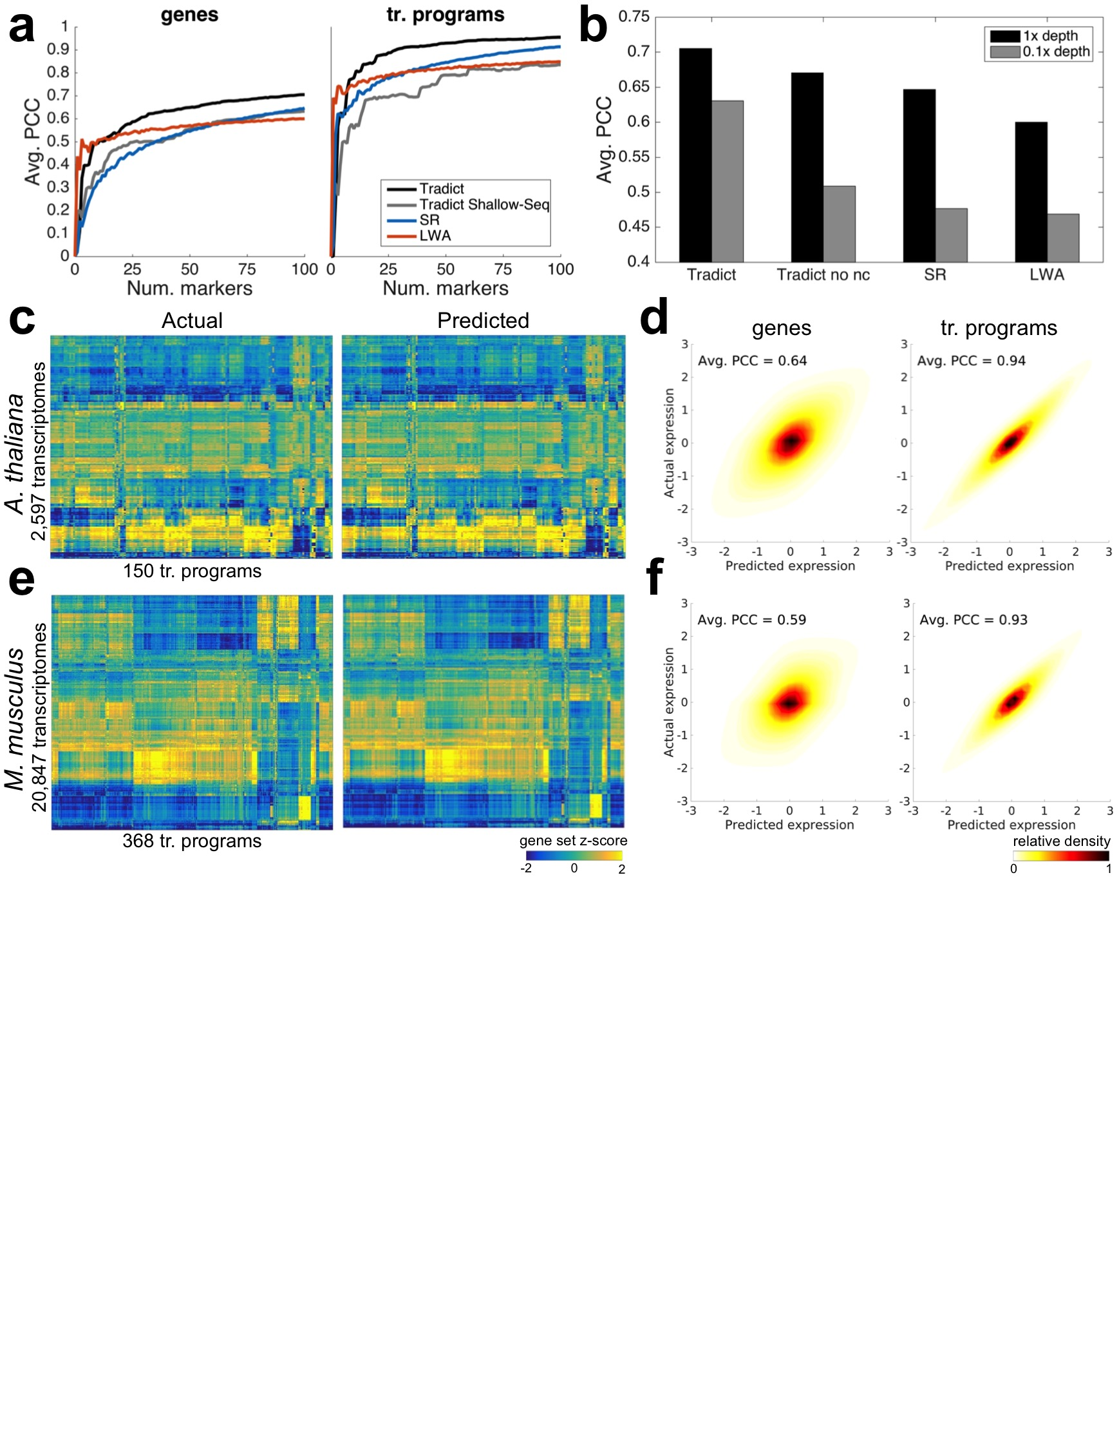

Figure 2. Tradict prospectively predicts unseen transcriptomes with robust accuracy. Tradict was trained on the first (historically speaking) 90% of SRA submissions and then tasked with predicting the remaining 10% of “test-set” submissions. a) Average Pearson correlation coefficients between predicted and actual expression of genes (left) and transcriptional programs (tr. programs; right) in the test-set as a function of the number of markers used in the model. b) Prediction performance on the same test-set processed normally or rarefied to 0.1x depth. ‘Tradict no nc’ uses the same algorithm as Tradict, however, a diagonal covariance is used over markers, instead of a full one. c-f) Tradict’s prospective prediction accuracy during 20-fold cross validation of the entire training collection for both organisms. c) Heatmaps illustrating test-set reconstruction performance of all transcriptional programs for *A. thaliana*. d) Density plots of predicted vs. actual test-set expression for all genes (left) and transcriptional programs (right) for *A. thaliana*, after controlling for inter-sumbission biological signal. The intra-submission expression of each gene and transcriptional program was z-score transformed to make their expression dynamics comprarable. e & f) Same as c & d, but for *M. musculus*.

**Tradict prospectively predicts unseen transcriptomes and transcriptional programs with robust accuracy**

[Error increases in decreasing mean expression]

To assess Tradict’s prospective predictive performance and how it compares to the baseline models, we first partitioned our transcriptome collection for *A. thaliana* into a training set and test set by submission and historical date. An SRA submission consists of multiple, experimentally linked samples submitted concurrently by an individual or lab. Consequently, high *intra*-submission prospective prediction accuracy is most indicative a method’s performance. In order to mimic Tradict’s use in practice as closely as possible, the training set contained the first 90% of submissions (208 submissions comprised of 2,389 samples) deposited on the SRA, and the test set contained the remaining 10% (17 submissions comprised of 208 samples).

Tradict and the baseline models were each first trained on the training set. Their predictive performance on the test set was then determined by providing only the expression values of selected markers as input, and subsequently examining the Pearson correlation coefficient (PCC) between the predicted and actual expression of transcriptional programs and the remaining non-marker genes in the transcriptome. Because submissions to the SRA span a broad array of biological contexts, the total biological signal contained in the test set exceeds that of what would be expected for typical application, which in turn would lead to overly optimistic estimates of prediction accuracy. To therefore evaluate *intra-submission* accuracy, PCC calculations were performed on ‘submission-adjusted’ expression values in which each submission’s mean expression was subtracted from the expression values of all associated samples.

Figure 3a illustrates the intra-submission performance of each method as a function of the number of markers entered into the model. LWA demonstrates the quickest performance gain, but then saturates after 10 markers. This is likely because a non-linear kernel based approach makes the cleverest use of a few markers, but is plagued by the curse of dimensionality as more markers are added. The parametric methods (Tradict, SR) navigate this dimensionality increase more efficiently and ultimately realize better performance for still reasonable numbers of markers. Tradict outperforms SR and Tradict Shallow-Seq, ultimately obtaining a PCC between predicted and actual expression of 0.71 for genes and strikingly 0.96 for transcriptional programs. This suggests Tradict’s probabilistic framework is more reasonable than SR’s and that Tradict’s marker selection is more optimal than picking the most abundant genes.

We noticed that though Tradict iteratively selects markers to maximize explanatory power, these markers are not orthogonal. Consequently, during inference of the marker latent abundances, on which all expression predictions are based, the internal covariance among the markers will be used during estimation. In increasing data (larger sequencing depth, higher *a priori* abundance) the latent abundance inference will place less emphasis on this internal covariance; however, in situations of measurement error or inadequacy, the internal covariance will help to learn the correct latent abundances, which in turn, should stabilize predictions in noisy situations. To test this hypothesis, we considered a version of Tradict, ‘Tradict no nc’ (noise correction), in which only the diagonal of the internal marker covariance was used, effectively decoupling marker abundances in Tradict’s underlying model. We re-evaluated intra-submission prediction accuracy for all of the methods, excluding Tradict Shallow-Seq, on the same training and test set above using 100 markers. However this time, in order to simulate situations of high measurement error, we rarefied samples in the test set to 0.1x depth and evaluated each method’s predicted (depth-normalized) expression accuracy; the original 1x depth values formed the basis of comparison. The 10th, 25th, 50th, 75th, and 90th percentiles of read depths in the 0.1x scenario were 0.65, 1.1, 2.1, 3.1, and 4.4 million reads, respectively -- all below the recommended depths for *A. thaliana*. 30-40% of the markers had zero abundance in nearly half of the samples. Figure 3b illustrates that though all methods perform worse at 0.1x depth, Tradict is least affected. Importantly, we notice that Tradict no nc’s performance is substantially reduced at lower depth, confirming our hypothesis that the internal marker covariance provides a valuable source of noise correction.

To more completely understand Tradict’s prospective predictive performance, we performed 20-fold cross validation on the training transcriptome collections for both *A. thaliana* and *M. musculus* and evaluated intra-submission PCC for each fold when the remaining 95% of folds were used for training. To make this experiment as reflective of reality as possible, folds were again divided by submission so that samples from the same set of experiments would not appear both in training and test sets. Figures 3c and 3e illustrate that the reconstruction performance for transcriptional programs in both organisms is strikingly accurate across all collected submissions. Quantitatively speaking, the average intra-submission PCCs for transcriptional programs are 0.94 and 0.93 for *A. thaliana* and *M. musculus*, respectively. This is despite lower, but still accurate prediction performance on gene expression (Figures 3d and 3f). Intuitively, this is a consequence of the Central Limit Theorem -- transcriptional programs are measured as as linear combinations of the log-latent TPMs of the genes that comprise them, effectively smoothing over noise in each gene’s expression prediction.

Need marker lists in supplemental

**Case studies reveal the power of predicting and studying predefined transcriptional programs**

To better contextualize how Tradict may be applied in practice, we focused on two case studies related to innate immune signaling -- one in *A. thaliana*, and the other in *M. musculus*. We trained Tradict on our full collection of training transcriptomes for each organism to produce two organism-specific Tradict models. Each was based on the selection of 100 markers that we assert are globally representative, and context-independent. The case study samples do not, of course, appear in the collection of training transcriptomes.

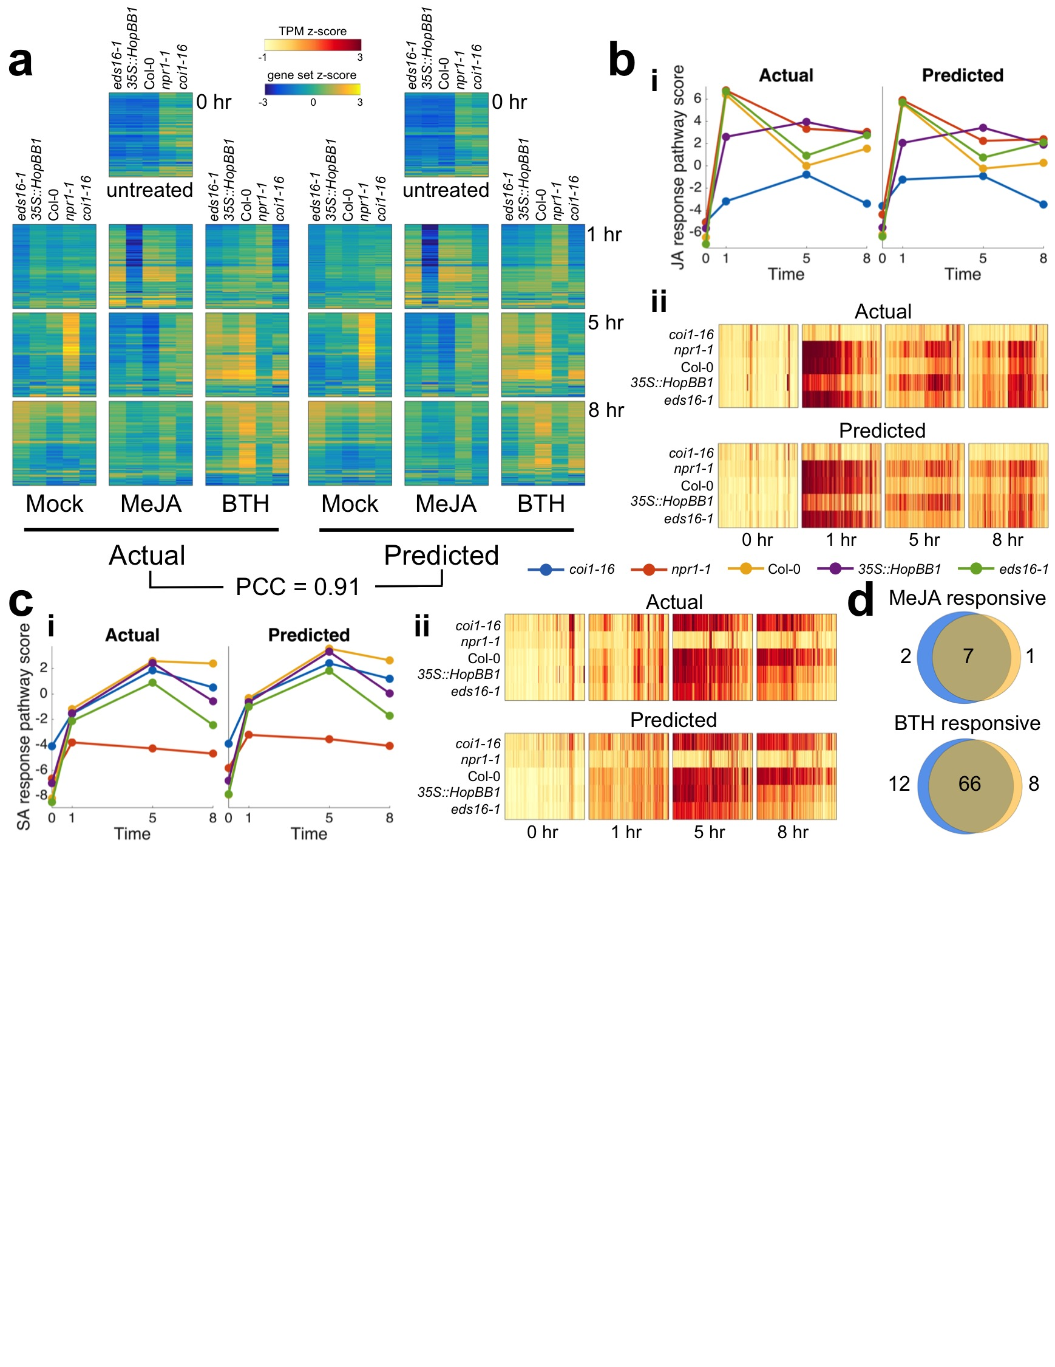

Figure 3. Tradict accurately predicts transcriptional responses across time in response to hormone perturbation in an *A. thaliana* innate immune signaling dataset. After being trained on the full *A. thaliana* training transcriptome collection, the selected set of 100 globally representative and context-independent markers were used to predict the expression of transcriptional programs and all genes for the transcriptomes presented in Yang *et al.* (2016). a) Actual vs. predicted heatmaps for the expression of all 150 transcriptional programs in *A. thaliana* across genotype, time, and hormone treatment. b) Predicted vs. actual expression of i) the JA response transcriptional program, and ii) the genes involved in the JA response program. c i-ii) Same as b, but for the SA response transcriptional program. d) Hypothesis free, differential transcriptional program expression analysis as performed on the actual expression of transcriptional programs vs those predicted by Tradict. Blue circles represent the actual and orange represent the predicted. All heatmaps are clustered in the same order across time, treatment, genotype, and between predicted and actual.

Change “JA response pathway score” to “JA response”

**Tradict accurately predicts temporal transcriptomic expression patterns for a diverse panel of immune signaling mutants under different hormone perturbations -** The hormones salicylic acid (SA) and jasmonic acid (JA) play a major, antagonistic regulatory role in the activation of plant defense responses to pathogens. Yang *et al.* (2016) investigate the effect of a transgenically expressed bacterial effector, HopBB1, on JA signaling in *A. thaliana*23*.* In their study, they perform a time course experiment, treating plants with MeJA (a JA response inducer), BTH (an SA mimic and SA response inducer), or mock buffer and monitoring the transcriptome of bulk seedlings at 0 hr, 1 hr, 5 hr, and 8 hr post treatment. Importantly, their experiments include several immune signaling mutants with differing degrees of response efficiency to MeJA and BTH treatment. Among other findings, they conclude that HopBB1 enhances the JA response, thereby repressing the SA response and facilitating pathogen infection.

We asked to what extent reduced sampling of the transcriptome and application of Tradict could quantitatively recapitulate the findings of Yang *et al.* (2016). Given Tradict’s near perfect accuracy on predicting the expression of transcriptional programs, we took a top down, but hypothesis driven approach to our analysis which first examined the expression of transcriptional programs. Figure 4a illustrates the actual and predicted expression all transcriptional programs in *A. thaliana* as a function of time and treatment. Here, Tradict delivers a slightly below-average performance, but is able to reconstruct the expression of all transcriptional programs with an average PCC of 0.91.

Recall the genes participating in each of our transcriptional programs are pre-defined, in this work, by a carefully chosen, interpretable, but maximally representative GO biological processes. Therefore, given the goals of this study, we next examined the expression of the “response to jasmonic acid” and “response to salicylic acid” transcriptional programs. Figure 4b shows the expression behavior for the “response to jasmonic acid” transcriptional program across all the genotypes and time points upon MeJA treatment. More specifically, part (i) shows that the predicted expression and actual expression are qualitatively and quantitatively in agreement, both in magnitude and rank across the different genotypes. For example, as expected, *coi1-16*, which cannot sense JA, does not respond to the MeJA stimulus, while wildtype Col-0 does. However, even more subtle expression dynamics are captured by Tradict’s predictions. For example, *eds16-1* and *npr1-1 --* slightly and strongly impaired SA responders, respectively -- are slightly and strongly hyper-responsive to MeJA, respectively -- just as expected from the JA-SA antagonism. Furthermore, as demonstrated in Yang *et al.* (2016), the *35S::HopBB1* transgenic line demonstrates a prolonged and sustained JA response for both the actual and predicted expression for this transcriptional program. Part (ii) of Figure 4b illustrates the expression of all the MeJA responsive genes in this transcriptional program. Again Tradict’s predictions are in agreement with actuality, achieving a PCC of 0.72, and it’s visually clear that the expression magnitude of these genes positively correlates with the registered expression magnitude of the “response to jasmonic acid” transcriptional program. Figure 4c parts (i) and (ii) are presented in the same light as Figure 4b, but are instead illustrated for the SA response transcriptional program and constituent genes under BTH treatment. Again predictions match actuality, and the observed trends make biological sense [REF].

In order to illustrate Tradict’s use in hypothesis-free investigation, we performed a differential transcriptional program expression analysis for transcriptional programs affected by MeJA or BTH treatment (Figure 4d, see Methods). Differentially expressed transcriptional programs based on Tradict’s predictions versus actual measurements were highly concordant and biologically reasonable. Transcriptional programs differentially expressed with respect to MeJA treatment included “response to bacterium,” “defense response to fungus”, “response to wounding,” and “response to jasmonic acid” as expected. Transcriptional programs differentially expressed with respect to BTH treatment included various abiotic stress responses, “defense response to fungus”, “response to jasmonic acid” (via antagonism), and “response to salicylic acid,” again, as expected.

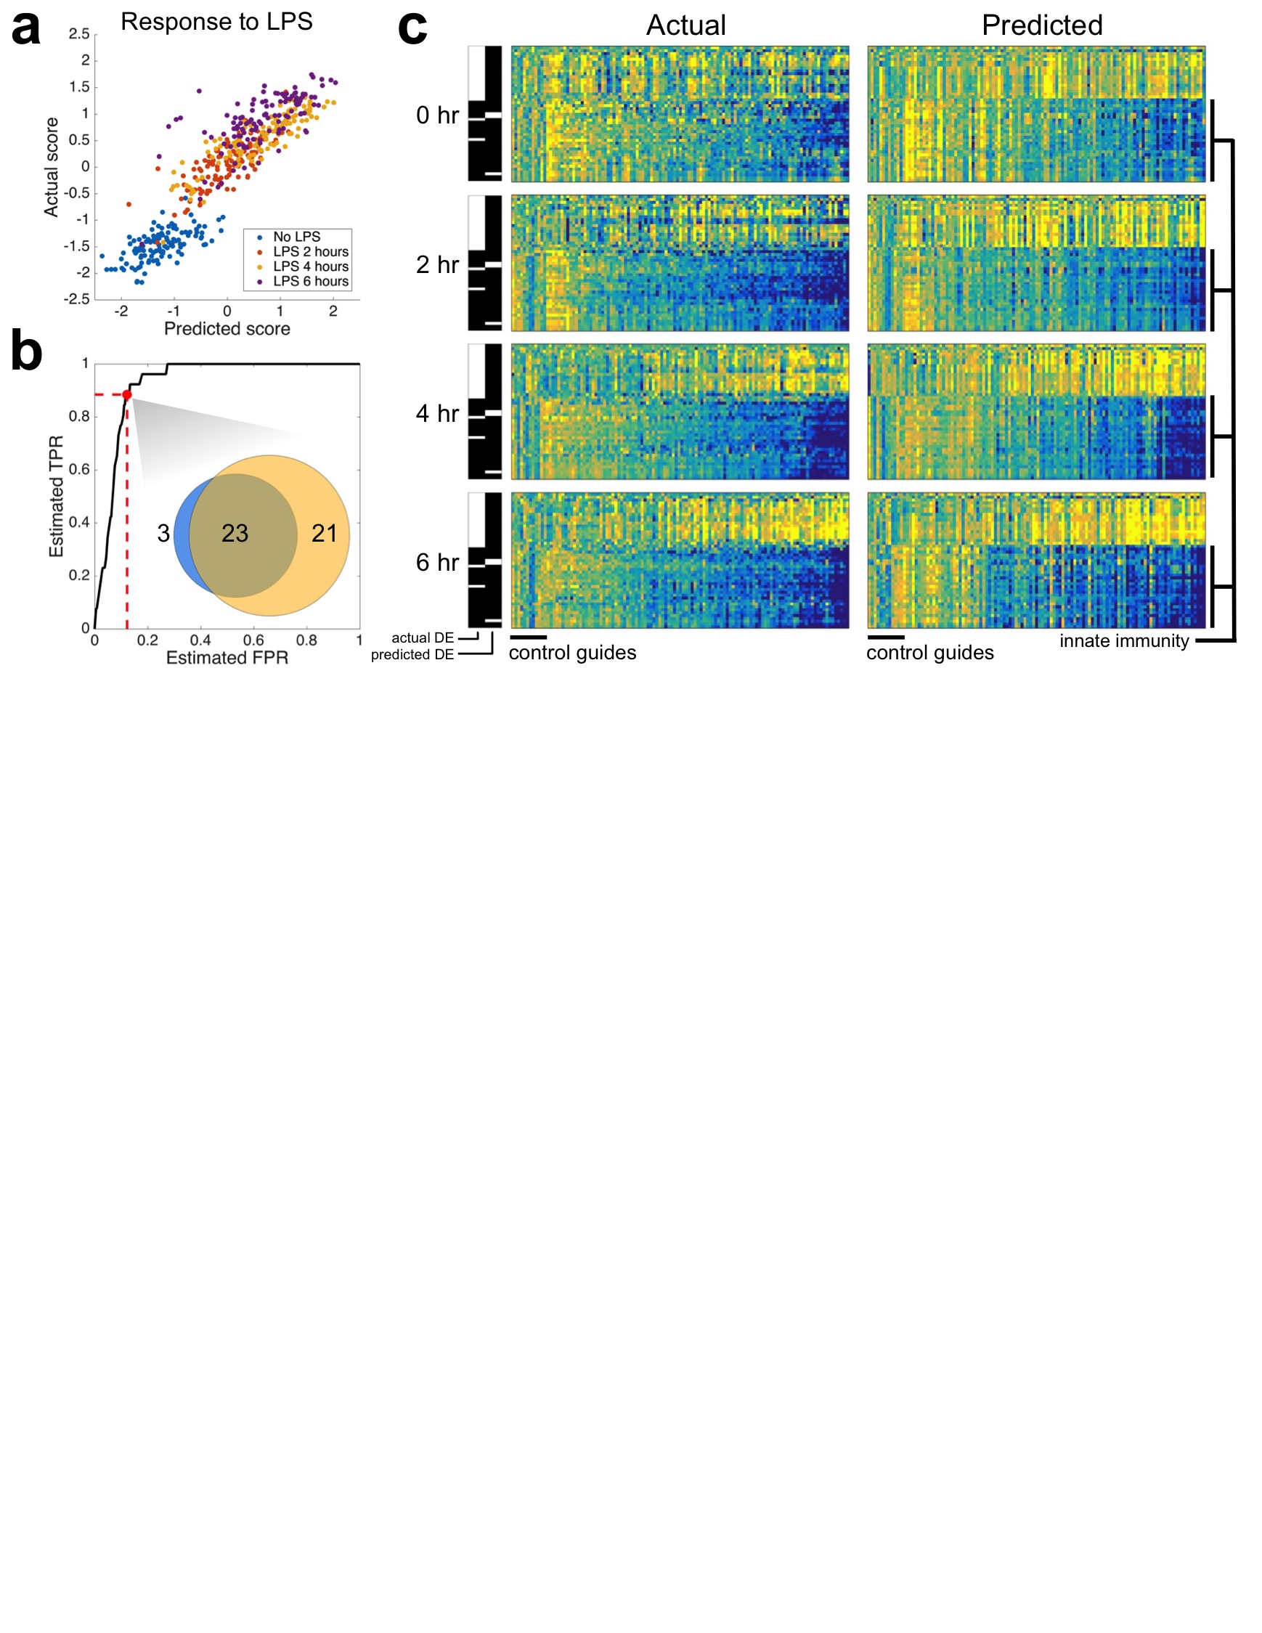

Figure 4. Tradict accurately predicts temporal transcriptional responses to lipopolysaccharide treatment in a dendritic cell line CRISPR library. a) Actual vs. predicted z-score standardized expression of the “response to lipopolysachharide” transcriptional program. Samples are colored by time point. b) Receiver operator characteristic (ROC) curve illustrating Tradict’s accuracy for identifying differentially expressed (DE) transcriptional programs. Here the “truth set” was considered to be all DE programs with FDR < 0.01 based on actually measured expression values. The marked point along the ROC curve and the inset venn diagram depict the concordance between the predicted and actual set of DE transcriptional programs when an FDR threshold of 0.01 for predicted DE programs was also used. c) Predicted vs actual heatmaps of DE transcriptional programs (rows) across time for different CRISPR lines (columns). Here, DE programs included those found either in actuality or by prediction and are accordingly marked by the black and white indicator bars on the left of each sub-block. Columns of these heat maps represent different profiled lines. The first 12 correspond to negative control guides, whereas the remaining columns correspond to positive regulators of Tnf expression. The expression of programs in each sub-block is z-score normalized to their expression in the negative control guide lines. The bottom 26 programs are all of those directly related to innate immunity among the 368 programs we’ve defined for *M. musculus*. All heatmaps are clustered in the same order across time, genotype, and between predicted and actual.

Change “score” to “expression” -- score is a previous terminology.

Add PCC between predicted and actual in part (a).

**Tradict accurately predicts temporal dynamics of innate immune signaling in CRISPRed in primary immune cells**

To further dissect Tradict’s capabilities, we examined a *M. musculus* dataset from Parnas *et al.* (2015) in which one of the first CRISPR screens were performed on primary immune cells to look for regulators of tumor necrosis factor (Tnf) expression24. They found many positive regulators of Tnf expression and created clonal bone-marrow derived dendritic cell (BDMC) lines where each positive regulator was disrupted using CRISPR. They used shallow RNA-sequencing (2.75 +/- 1.2 million reads) to profile the transcriptomes of these lines for 6 hours after lipopolysaccharide (LPS) treatment. We note that while our previous analysis focused on deeply sequenced, bulk seedling transcriptomes from *A. thaliana*, this dataset consists of shallowly sequenced cell lines from *M. musculus*.

We asked whether Tradict’s predictions could quantitatively recapitulate actuality, despite the challengingly noisy marker measurements due to the low sequencing depth. To be specific, approximately 30% of the markers had zero measured expression in greater than 40% of samples. After performing the batch correction described in Parnas *et al.* (2015), we examined the expression of the “response to lipopolysaccharide” transcriptional program. Figure 5a illustrates that despite the limitation on marker measurement accuracy, Tradict predicts response to LPS with a PCC accuracy of 0.89. Differential transcriptional program expression analysis revealed that DE programs based on Tradict’s predictions were highly concordant with those based on actual measurements (Figure 5b). Strikingly, programs found DE based on Tradict predictions included 92% of those directly related to innate immune signaling in mice.

We next examined the quantitative quality of Tradict predictions by observing how the DE programs found by either analysis of actual measurements or predictions behave across time. Figure 5c illustrates that despite the high marker measurement error, Tradict’s predictions are quantitatively concordant with actuality (PCC value?). As expected most lines of CRISPRed positive regulators demonstrate loss of innate immune signaling.

**Discussion**

[pending]

**Conclusion**

[pending]

**References**

1. Jacob, F. & Monod, J. Genetic regulatory mechanisms in the synthesis of proteins. *J. Mol. Biol.* **3,** 318–356 (1961).

2. Kaufmann, K., Pajoro, A. & Angenent, G. C. Regulation of transcription in plants: mechanisms controlling developmental switches. *Nat. Rev. Genet.* **11,** 830–842 (2010).

3. Mitchell, P. J. & Tjian, R. Transcriptional Regulation in Mammalian Cells by DNA Binding Proteins. *Science (80-. ).* **245,** 371–378 (1989).

4. Segal, E. *et al.* Module networks: identifying regulatory modules and their condition-specific regulators from gene expression data. *Nat. Genet.* **34,** (2003).

5. Hart, Y. *et al.* Inferring biological tasks using Pareto analysis of high-dimensional data. *Nat. Methods* **12,** (2015).

6. Shoval, O. *et al.* Evolutionary Trade-Offs, Pareto Optimality, and the Geometry of Phenotype Space. *Science (80-. ).* **336,** 1157–1160 (2012).

7. Jeong, H., Tombor, B., Albert, R., Oltvai, Z. N. & Barabási, a L. The large-scale organization of metabolic networks. *Nature* **407,** 651–654 (2000).

8. Albert, R., Lee, J. H. & Barabási, A.-L. Error and attack tolerance of complex networks. *Nature* **406,** 378–382 (2000).

9. Barabási, A.-L. & Albert, R. Emergence of Scaling in Random Networks. *Science (80-. ).* **286,** 509–513 (1999).

10. Troyanskaya, O. *et al.* Missing value estimation methods for DNA microarrays. **17,** 520–525 (2001).

11. Liew, A. W., Law, N. & Yan, H. Missing value imputation for gene expression data : computational techniques to recover missing data from available information. **12,** 498–513 (2010).

12. Celton, M., Malpertuy, A., Lelandais, G. & Brevern, A. G. De. Comparative analysis of missing value imputation methods to improve clustering and interpretation of microarray experiments. (2010).

13. Ling, M. H. T. & Poh, C. L. A predictor for predicting Escherichia coli transcriptome and the effects of gene perturbations. *BMC Bioinformatics* **15,** 140 (2014).

14. Donner, Y., Feng, T., Benoist, C. & Koller, D. Imputing gene expression from selectively reduced probe sets. *Nat. Methods* **9,** (2012).

15. Heimberg, G. *et al.* Low Dimensionality in Gene Expression Data Enables the Accurate Extraction of Transcriptional Programs from Shallow Sequencing Article Low Dimensionality in Gene Expression Data Enables the Accurate Extraction of Transcriptional Programs from Shallow Sequencing. *Cell Syst.* **2,** 239–250 (2016).

16. Pollen, A. A. *et al.* Low-coverage single-cell mRNA sequencing reveals cellular heterogeneity and activated signaling pathways in developing cerebral cortex. *Nat. Biotechnol.* **32,** (2014).

17. Kliebenstein, D. J. Exploring the shallow end; estimating information content in transcriptomics studies. *Front. Plant Sci.* **3,** 1–10 (2012).

18. Jaitin, D. A. *et al.* Massively Parallel Single-Cell RNA-Seq for Marker-Free Decomposition of Tissues into Cell Types. *Science (80-. ).* **343,** 776–779 (2014).

19. Crowley, J. J. *et al.* Analyses of allele-specific gene expression in highly divergent mouse crosses identifies pervasive allelic imbalance. *Nat. Genet.* **47,** (2015).

20. Biswas, S. The latent logarithm. *arXiv* 1–11 (2016).

21. Tropp, J. a & Gilbert, A. C. Signal Recovery From Random Measurements Via Orthogonal Matching Pursuit. **53,** 4655–4666 (2007).

22. Tropp, J. a., Gilbert, A. C. & Strauss, M. J. Algorithms for simultaneous sparse approximation. Part I: Greedy pursuit. *Signal Processing* **86,** 572–588 (2006).

23. Yang, L. *et al.* The Pseudomonas syringae type III effector HopBB1 fine tunes pathogen virulence by gluing together host transcriptional regulators for degradation. *Submitted* (2016).

24. Parnas, O., Jovanovic, M., Eisenhaure, M. & Zhang, F. A Genome-wide CRISPR Screen in Primary Immune Cells to Dissect Regulatory Networks. *Cell* **162,** 1–12 (2015).