Dear Editor,

We wish to submit a manuscript titled “Tradict enables accurate prediction of eukaryotic transcriptional states from 100 marker genes” for your consideration. The transcriptome, the intermediary between DNA and protein, represents a critical node of regulation for all life, and consequently, the ability survey the entire transcriptome through RNA-seq is revolutionizing our understanding of how cells and organisms grow, develop, and respond to the environment. However, the current required effort and cost entailed in generating read counts for every (or most) transcripts are limiting for scaling transcriptome analyses to thousands of samples. Being able to generate many cheap but accurate summaries of the transcriptome is an unexplored niche that sits between single phenotype/reporter screening and deep RNA-Seq based transcriptomic profiling. Such an approach would enable large-scale simultaneous screening and mechanistic investigation, processes that are usually decoupled.

We developed a method we call **Tradict (transcriptome predict).** Tradict is a novel, robust-to-noise, and probabilistically sound algorithm for inferring eukaryotic transcriptional states using only the expression measurements of a single, context-independent, machine-learned subset of 100 marker genes (~0.05% of the transcriptome). Tradict was trained using a representative sampling of over 23,000 *Arabidopsis thaliana* and *Mus musculus* RNA-Seq datasets to prospectively reconstruct gene expression, and to predict, with a high degree of accuracy, the expression of a comprehensive, but quickly interpretable collection of transcriptional programs that represent the major biological processes and pathways of the cell. To our knowledge, Tradict is the first method to:

1) Propose and use a novel, large-scale data model capable of directly modeling the non-negative outputs of sequencing-based expression measurement assays -- the current state-of-the-art.

2) Learn, by virtue of the size and comprehensiveness of its training dataset, a marker panel that can be used independently of most (if not all) contexts and applications.

3) Define and accurately model the expression of a comprehensive, but interpretable list of a few hundred transcriptional programs in a supervised manner.

The latter point is, in our view, especially important. It suggests that Tradict not only enables cheap and scalable transcriptome-wide screening/high-throughput profiling, but also simultaneously affords readily interpretable mechanistic insight that monitoring a single phenotype cannot. This unique coupling should greatly facilitate genetic dissection (e.g. forward genetic screening, breeding, QTL mapping) and drug discovery (e.g. narrowing in on the mode-of-action of a small molecule during screening itself). We believe Tradict compares favorably with previous studies in this area as these have not modeled the expression of transcriptional programs, do not work transcriptome-wide, and have been based on increasingly obsolescent technology (microarrays)1,2. We further provide easy-to-use software that users can use to 1) build their own transcriptome databases from personal/custom or large pre-existing publicly available sources and 2) train and apply Tradict for their own applications. Taken together, we suggest that Tradict offers unparalleled advantages in large-scale transcriptomics, and therefore has the potential to be a rapidly disseminated, breakthrough technology.

Our manuscript was recently rejected from Nature Biotechnology. In our view, this was primarily due to the lack of a complete practical demonstration of Tradict, which includes prospectively designed experiments where we actually use targeted RNA-sequencing along with Tradict in a large scale experiment. Though these experiments would have certainly been a compelling demonstration of Tradict’s utility, we argue that given the advances we have presented in this work and how well targeted RNA-Sequencing established is3,4, there little barrier, but large incentive for adopting Tradict. As for the other reviewer comments, we have responded to these by greatly deepening our analyses and expanding Tradict’s capabilities. These are more completely described in “Response to Reviewers” document.

Yours sincerely,

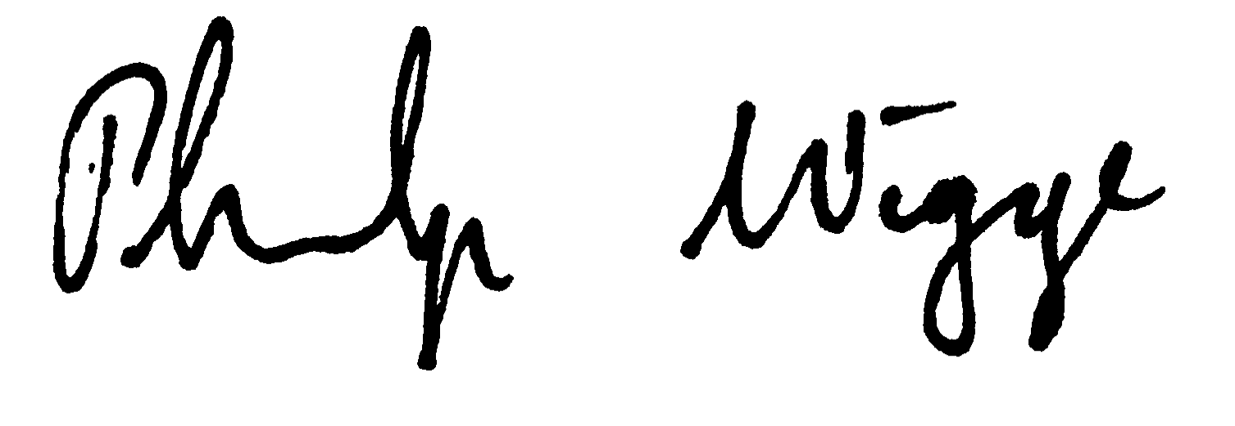

Surojit Biswasa Philip A. Wiggeb

[surojitbiswas@g.harvard.edu](mailto:surojitbiswas@g.harvard.edu) [Philip.Wigge@slcu.cam.ac.uk](mailto:Philip.Wigge@slcu.cam.ac.uk)

**References**

1. Donner, Y., Feng, T., Benoist, C. & Koller, D. Imputing gene expression from selectively reduced probe sets. *Nat. Methods* **9,** (2012).

2. Ling, M. H. T. & Poh, C. L. A predictor for predicting Escherichia coli transcriptome and the effects of gene perturbations. *BMC Bioinformatics* **15,** 140 (2014).

3. Illumina. TruSeq Targeted RNA Expression Kits. at <http://www.illumina.com/products/truseq-targeted-rna-expression-kits.html>

4. Larman, H. B. *et al.* Sensitive, multiplex and direct quantification of RNA sequences using a modified RASL assay. *Nucleic Acids Res.* 1–12 (2014). doi:10.1093/nar/gku636

As potential reviewers (should any more be needed), we would like to request: 1) Dana Pe’er (Comp. Sys. Bio; Dept. of Biological Sciences, Columbia University, [dpeer@biology.columbia.edu](mailto:dpeer@biology.columbia.edu)), 2) Joeseph Ecker (Agricultural genomics/breeding; HHMI & Salk Institute, [ecker@salk.edu](mailto:ecker@salk.edu)) 3) John Marioni (Comp. & Evo. genomics; EMBL-EBI, [marioni@ebi.ac.uk](mailto:marioni@ebi.ac.uk)) 4) Jennifer Listgarten (Machine Learning in Comp Bio.; Microsoft Research New England, [jennl@microsoft.com](mailto:jennl@microsoft.com)), 5) Oliver Stegle (Statistical Genomics; EMBL-EBI, [stegle@ebi.ac.uk](mailto:stegle@ebi.ac.uk))