Câu 1:

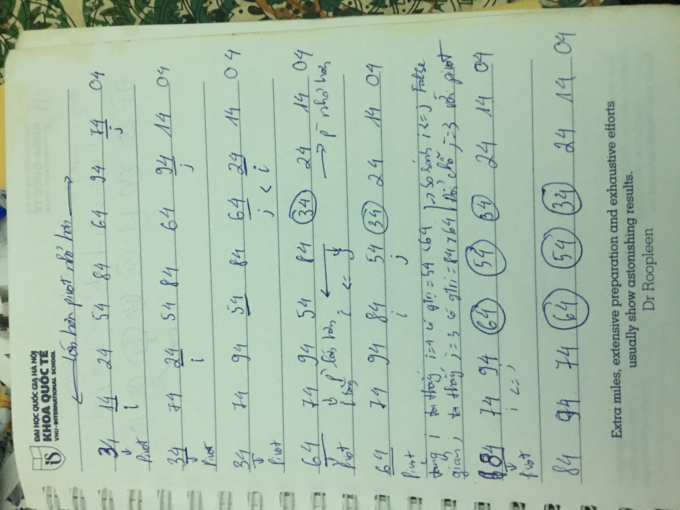

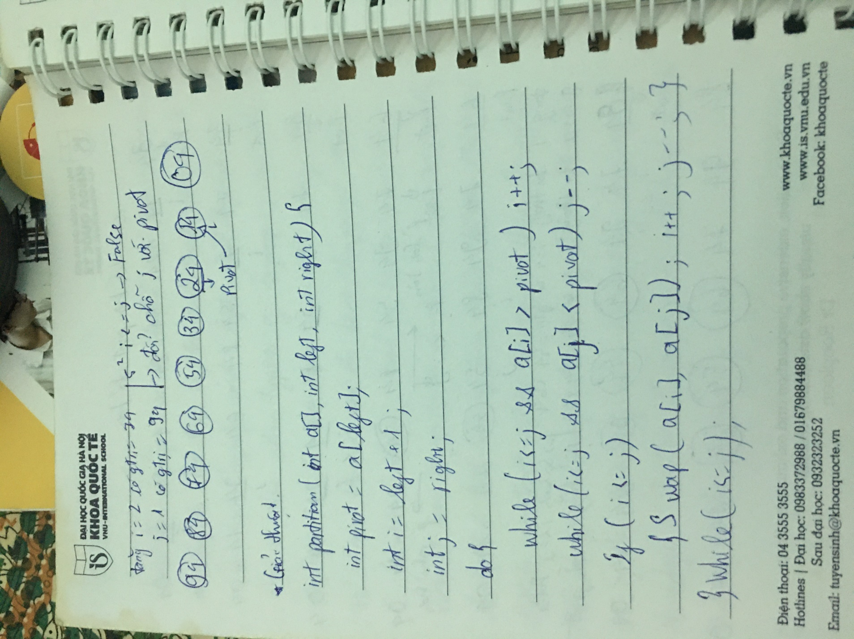



Cài đặt chương trình:

#include <iostream>

using namespace std;

void print(int a[], int n){

for(int i = 0 ; i < n ; i++){

cout<<a[i]<<"\t";

}

}

int partition(int a[], int left, int right){

int pivot = a[left];

int i = left + 1;

int j = right;

do{

while(i <= j && a[i] > pivot) i++;

while(i <= j && a[j] < pivot) j--;

if(i <= j){

int t = a[i];

a[i] = a[j];

a[j] = t;

i++;j--;

}

}while(i <= j);

int t = a[left];

a[left] = a[j];

a[j] = t;

return j;

}

void quick_sort(int a[], int left, int right){

if(left < right){

int K = partition(a,left,right);

quick_sort(a,left,K-1);

quick_sort(a,K + 1,right);

}

}

int main(){

//int n;

//cout<<"\nNhap n= ";cin>>n;

int a[9]={34,14,24,54,84,64,94,74,4};

//for(int i = 0 ;i < n ; i++){

//cin>>a[i];

//}

print(a,9);

quick_sort(a,0,9-1);

cout<<endl;

print(a,9);

return 0;

}