Git Assignment-1

Install GIT & make sure it is added into PATH.

Use GIT as local VCS. Steps to follow:

1.Create a directory ‘project_dir’ & cd to ‘project_dir’. C:\Users\HFT0002\Desktop\asgnmnt\1.PNG

2.Initialize git version database. (git init) C:\Users\HFT0002\Desktop\asgnmnt\2.PNG

3.Create a new file index.html. 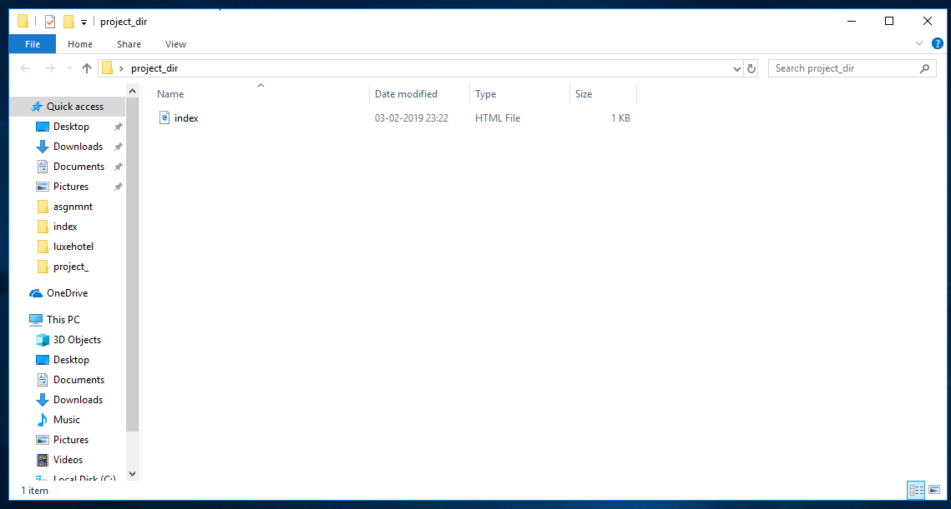

4.Check the git status. You should find index.html as untracked file. 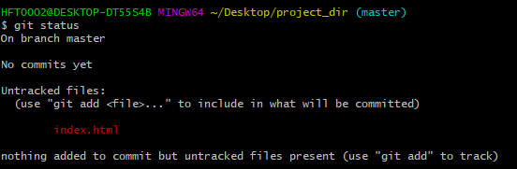

5.Stage the index.html file. 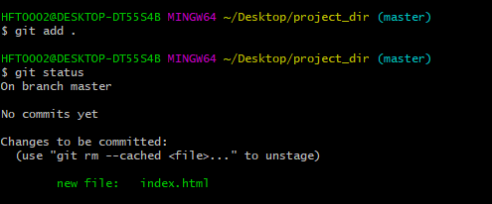

6.Commit index.html

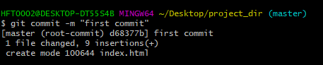

7.Make few changes in index.html & create a new file info.txt file. 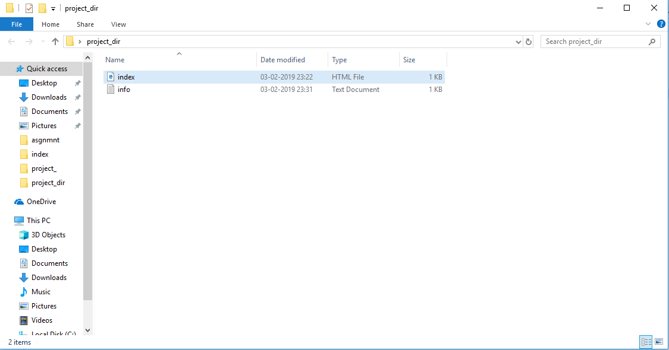

8.Check git status. You should find index.html & info.txt as untracked files. 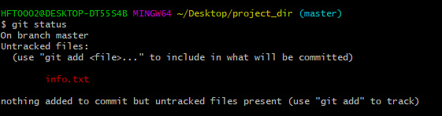

9.Configure GIT to ignore all txt files. 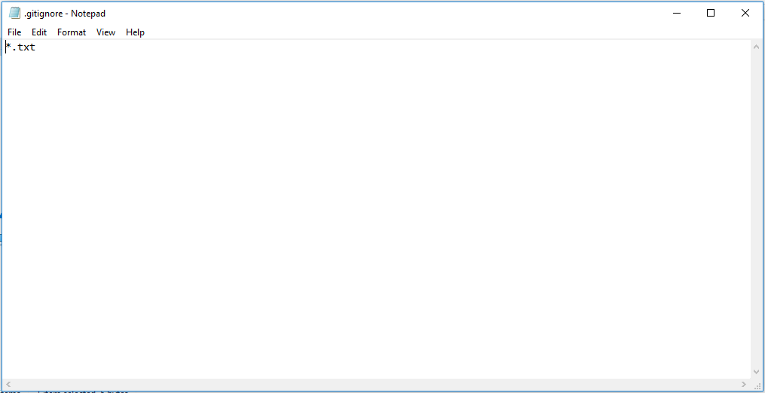

10.Again check the git status. You should find only index.html as untracked file. 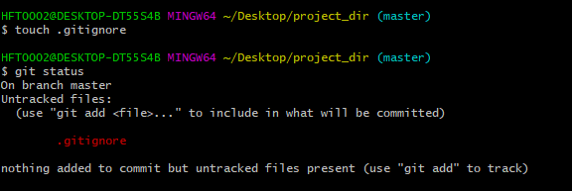

11.State & commit index.html

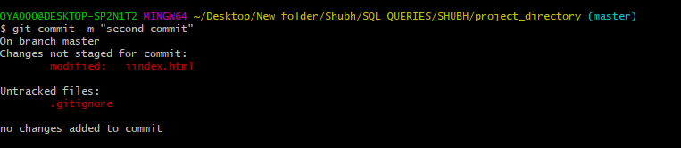

12.Log all your comments so far. 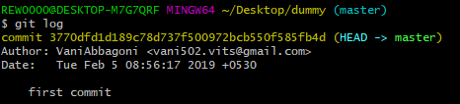

13.Make some changes in index.html. 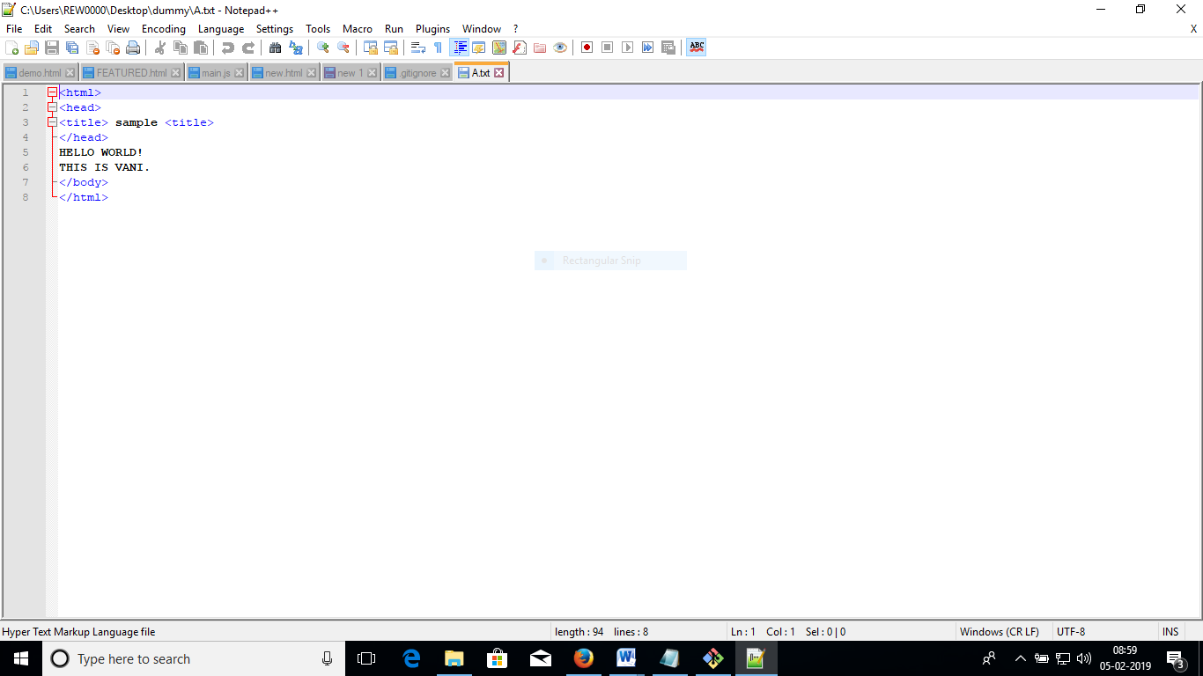

14.Revert the change made in the previous step using git command. C:\Users\HFT0002\Desktop\asgnmnt\14.1.PNG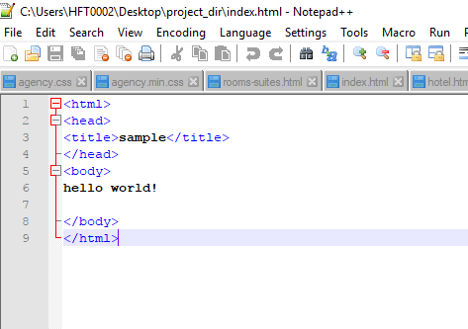

15.Again change index.html. 

16.Stage index.html

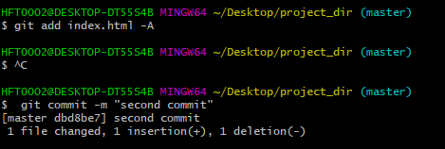

17.Revert back the last stage. C:\Users\HFT0002\Desktop\asgnmnt\17.1.PNG

18.Rename ‘add’ command to ‘my-add’. C:\Users\HFT0002\Desktop\asgnmnt\18.1.PNG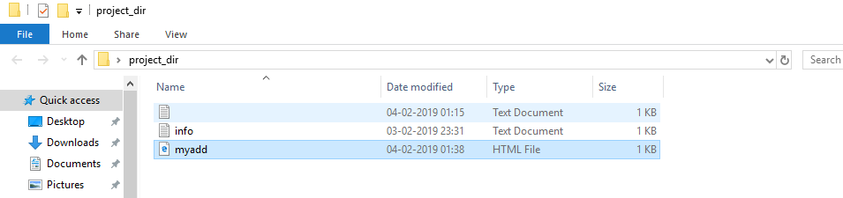

19.Using my_add command Stage index.html again & commit the changes. 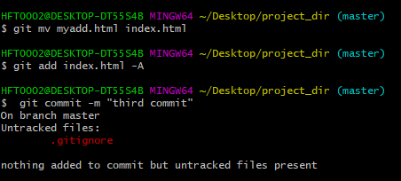

20.Revert the last commit. C:\Users\HFT0002\Desktop\asgnmnt\20.PNG