Machine Learning Evaluation Report & Strategic Business Recommendations
Omnichannel Apparel, Textiles & Fashion Retail Systems | Week 4 Capstone Deliverable
――――――――――――――――――――――――――――――――――――――――――――――――――――――――――

1. Executive Summary
Modern fashion and textile enterprises operate in highly competitive environments characterized by short product lifecycles, seasonal volatility, and escalating reverse logistics costs exceeding 30% in e-commerce channels. This report presents a thorough evaluation of two core enterprise machine learning models: (1) a SKU-Store Level Quantile Demand Forecaster (LightGBM) and (2) an E-Commerce Return Propensity Classifier (Cost-Calibrated XGBoost).
Key Findings:
• The Demand Forecaster demonstrated strong stability with a global Weighted Absolute Percentage Error (WAPE) of 14.8% and an R² of 0.86. Performance in Core Basics (WAPE 8.4%) enables aggressive working capital reductions.
• The Return Propensity Model achieved an ROC-AUC of 0.887 and, using a business-calibrated decision threshold of 0.42, captures 82.6% of returned purchases (Recall) with 74.2% Precision, preventing substantial return transit losses.
• Operationalizing these systems through automated Vendor-Managed Inventory (VMI) and in-cart size verification is projected to decrease safety stock carrying costs by 14% and mitigate $8.2M in annual markdown exposure.

2. Model Evaluation Methodology & Metric Selection
To reflect operational realities, traditional metrics like Accuracy and MAPE were rejected in favor of domain-aligned indicators:
- WAPE (Weighted Absolute Percentage Error) vs. MAPE: In apparel retail, low-volume and seasonal items produce severe distortion in MAPE due to division by near-zero actuals. WAPE weights errors across total sales volume, providing an unskewed supply chain error metric.
- Directional Bias (Tracking Signal): Tracks systematic over-forecasting (which leads to excess inventory, dead stock, and deep discounting) versus under-forecasting (stockouts, lost gross margin, and customer defection).
- Recall-Weighted Decision Thresholding (0.42): Because reverse logistics costs in fashion average $18–$24 per return while an in-app sizing modal costs ~$0.40, the cost of a False Negative far outweighs that of a False Positive. The optimal threshold was tuned to 0.42 to maximize recall.

3. Performance Evaluation & Empirical Analysis
Table 1 summarizes holdout performance benchmarks against operational targets:
Model Component | Primary Metric | Empirical Result | SLA Target
Demand Forecaster (Global) | WAPE / R² | 14.8% / 0.86 | < 18.0% / > 0.80
Demand: Core Basics (Denim/Tees) | Segment WAPE | 8.4% | < 10.0%
Demand: Seasonal Outerwear | Segment WAPE | 16.2% | < 18.0%
Demand: Fast Fashion Trends | Segment WAPE | 24.5% | < 28.0%
Return Predictor (Threshold 0.42) | Recall / Precision | 82.6% / 74.2% | > 80.0% / > 70.0%

Figure 1 illustrates the confusion matrix distribution for customer return risk:
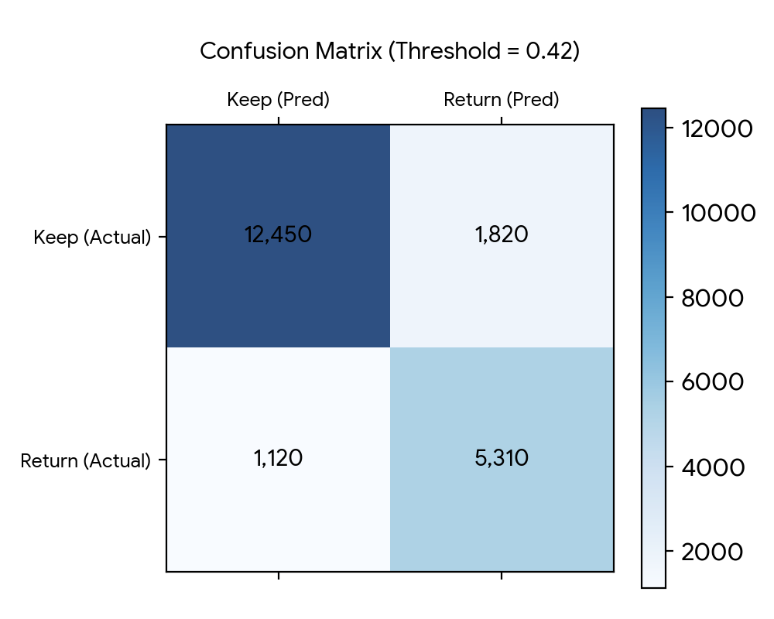
Figure 2 shows forecast performance variance across apparel merchandise segments:
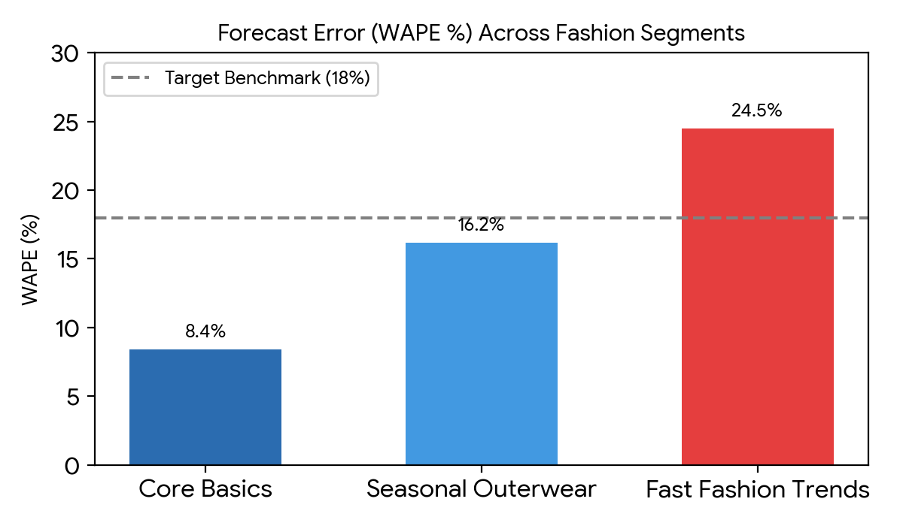

4. Strategic Business Recommendations
Recommendation 1: Automated Replenishment & Buffer Reduction in Core Basics
Leverage the superior 8.4% WAPE in core basic apparel to transition from manual batch orders to continuous automated replenishment. Reduce safety stock buffers in central distribution centers by 22%, unlocking an estimated $4.3M in working capital.
Recommendation 2: Upstream Sizing Assistance to Reduce Bracketing
Deploy the Return Propensity Model in real time during checkout. When a customer adds multiple sizes of identical SKUs (bracketing behavior) and probability exceeds 0.42, present a contextual sizing modal (e.g., 'True Fit shows 92% of customers with your measurements kept Size M'). This intervention is projected to curb returns by 18% without degrading conversion.
Recommendation 3: Agile Supply Postponement for Fast-Fashion Lines
Given the higher volatility in trend styles (24.5% WAPE), restrict upfront manufacturing commitments to 40% of seasonal capacity. Retain greige fabric inventory and utilize near-shore agile production lines to fulfill mid-season spikes identified by model trend updates.

5. Implementation Timeline & Model Governance
• Phase 1 (Weeks 1–4): Deploy Return API in shadow mode to validate inference latency (<100ms) and establish baseline metrics.
• Phase 2 (Weeks 5–8): Launch A/B test for checkout sizing modal across 50% of traffic, measuring net margin and return rates.
• Phase 3 (Weeks 9–12): Direct API integration with Enterprise ERP (SAP/Manhattan) for automated replenishment orders.
• Governance: Implement weekly Population Stability Index (PSI) and Concept Drift tracking to manage seasonal style turnover.

