**V. Graphviz**

**1. Draw the following graph using Graphviz**

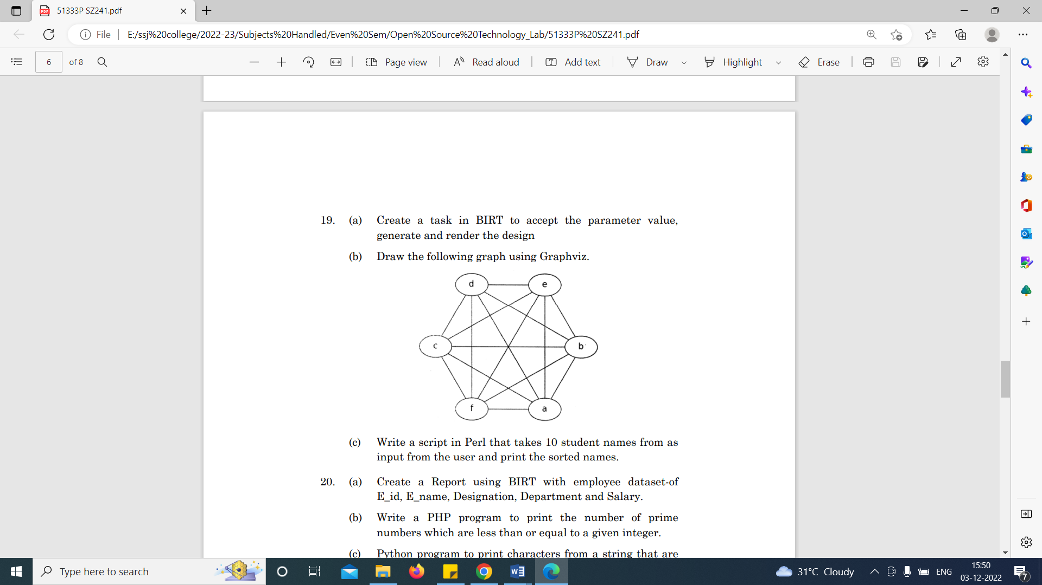

**Coding**

import graphviz

f=graphviz.Graph('G', filename='er.gv', engine='neato')

# Creating starting and Ending Nodes

f.attr(rankdir='LR', size='8.5')

f.attr('node', shape='circle')

f.node('C')

f.node('D')

f.node('E')

f.node('B')

f.node('A')

f.node('F')

# Creating Edges

f.edge('C', 'D')

f.edge('D', 'E')

f.edge('E', 'B')

f.edge('B', 'A')

f.edge('A', 'F')

f.edge('F', 'C')

f.edge('C', 'B')

f.edge('C', 'A')

f.edge('C', 'E')

f.edge('F', 'D')

f.edge('B', 'F')

f.edge('B', 'D')

f.view()

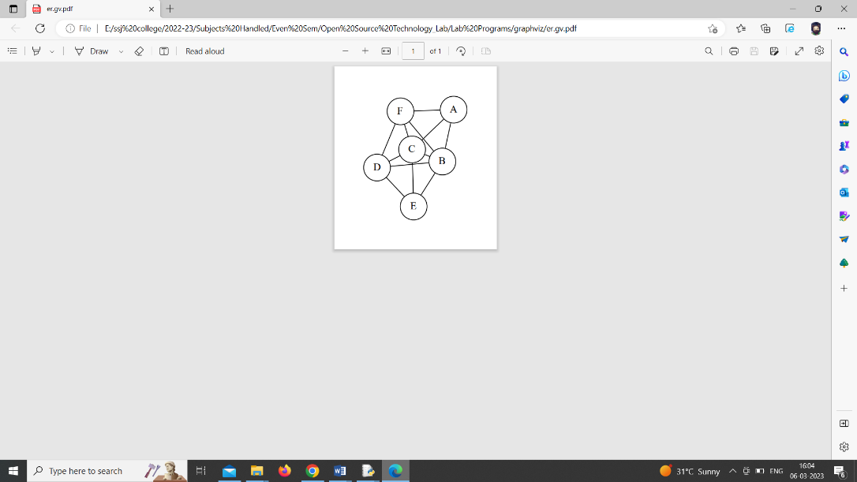**Output**

**2. Draw a graph using Graphviz and also show the path from a to d using green color.**

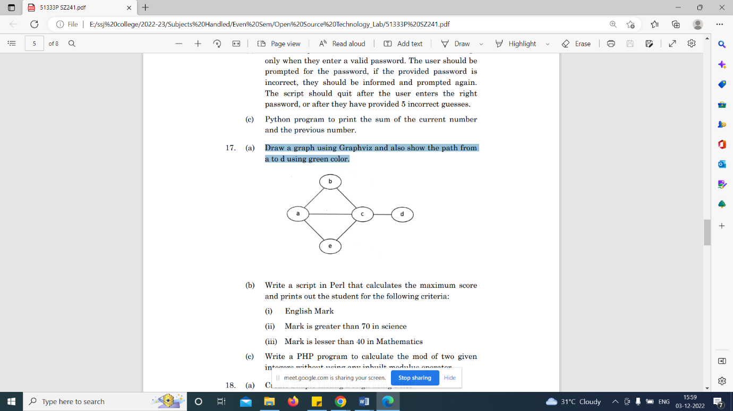

**Coding**

import graphviz

f= graphviz.Graph('G', filename='demo.gv', engine='neato')

# Creating Nodes

f.attr('node', shape='circle')

f.node('A')

f.node('B')

f.node('C')

f.node('D')

f.node('E')

#Creating edge and make the path as green

f.edge('A', 'C',color="green")

f.edge('C', 'D',color="green")

# Creating other path

f.edge('A', 'B')

f.edge('B', 'C')

f.edge('A', 'E')

f.edge('E', 'C')

f.view()

**Output**

