**App Dynamics – Handson13 (Time Slot 12:10PM – 2:10PM)**

**1.1**

**1. Give the details of Top 3 calls/min**

This is the Graph, form this I have taken Top 3 Call/min.

* + - “Welcom.execute -177,Add to cart-35,Selectprod.execute-35”These are top 3 calls/min in this graph.
    - Finally Call/min means, it calculates the average no of incoming and outgoing calls within a minute.
    - COUNT- total no of observations made.
    - SUM- sum of observed values.

**2. Give the Details of Errors Per Minute & Exceptions per Minute**

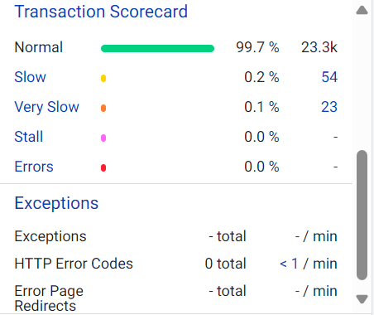

* Here you can see Total errors and exceptions. By clicking on Error, the page will show like this. Which as shown below.

* If you see from the above graph, there is no errors.
* Error per Minute means No of times error occur while call was made per min.

* If you see above graph, there is no exceptions.
* Exception per minute means no of times exceptions occur while call was made per min.
* There are no Errors Per Minute & Exceptions per Minutein this Load Test.

**3. Give the details of Top 3 very slow transactions**

* From the above you can see top 3 very slow transactions.
* But now There are no slow transactions.
* Which are taking more time to execute. It depends on high latency in milliseconds during call.

**4.** **Give the details of Error Page Redirects**

**5. Provide Snapshot of Transaction Scorecard**

* If you see the above is the Transaction Score graph.
* It displays the status of the business transactions, based on threshold. That specify when a transaction is slow, very slow, in error status.
* Transaction scorecard means It summarizes the performance of the business transactions at the application within specified time range.

**1.2 Tiers/Nodes**

**1. Give the details of number of Nodes & Tiers.**

* You can see Tiers and Nodes on left side below Service endpoint.

* If You see above snapshot there is only 1 node, and 1 tier.
* TIERS= a set or group of identical servers we call it as a tier.
* NODES=node is nothing but kind of JVM or server.
* A node is the smallest unit of any application or environment.

**2. Give the details of JVM Versions of Different Nodes available with their names**

* In the above we can see the **JVM version** as “Java Hotspot(TM) 64-Bit Server VM 1.8.0_202 Oracle Corporation”
* These is the JVM version for the node which is available. There is only one node.

**3. Mention the Agent version and Process ID of the node.**

* In the above we can see **Process ID** as “6620”.
* **Agent version** was “Server Agent #24.30.0.35708 v24.3.0 GA compatible with 4.4.1.0 r69db1fbc49e6a3ce19de214f6da77bb3f6a80d6f release/24.3.0”.

**4.Type of call graphs and difference.**

A call graph can be one of the following types:

* **Full call graphs:** It capture the entire call sequence for the business transaction invocation. Call graphs exist for each monitored node involved in the processing of the business transaction. Periodically collected and diagnostic snapshots are always full call graphs.
* **Partial call graphs:** It represent the subset of the call sequence for processing a business transaction, typically from the point at which the transaction has been determined to be slow or have errors. Partial call graphs are identified as such in the transaction snapshot.

**5.Check running JVMs in all clusters.**

* As I can see there are no clusters in this test.

**1.3 Tiers/Nodes**

**1. Give the details of Heap Utilization % of the Node,**

* For Heap utilization you have go to Memory in Tiers & Nodes.
* In that you can see heap utilization.
* current utilization-0% & Average utilization-0%

**2. Provide the details of CPU Usage % for the Node.**

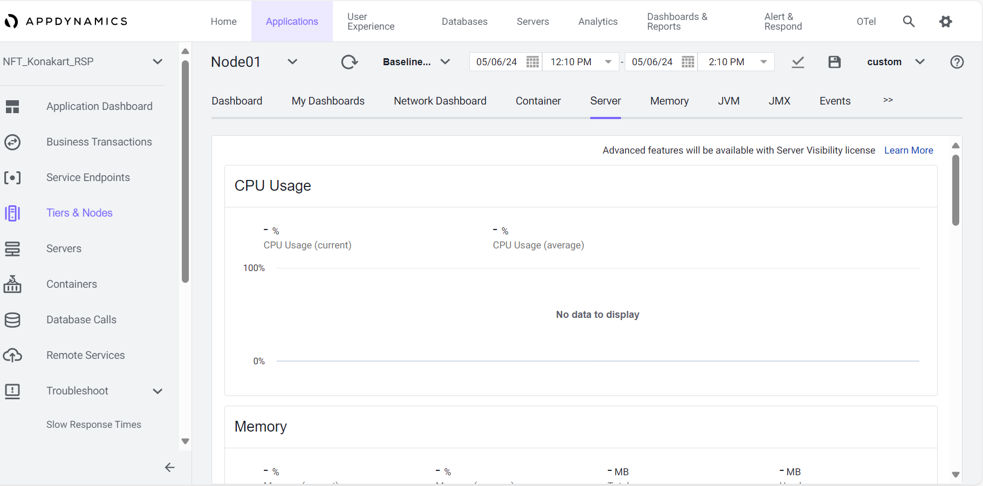

* For CPU usage we must go to Server tab in Tiers & Node.
* Here if you see there is no CPU usage.
* CPU usage means It is the percentage of the CPU consumed by process that are currently running.

**3. Identify & Analyze transaction from Tiers/Nodes which is having Response time degradation.**

* Here we can’t identify and analyze transaction from tiers & nodes which is having Response time degradation, because we are not provided with any baseline results to compare about Response time degradation.

**4. Check garbage collection pattern**

* These are the Garbage collection, how much time it spent and Minor collection & Major collection.
* Garbage collection means in this you should give some nation of ratio of minor to major collection.
* It is an automatic process; it find & get rid of objects which are no longer used by the application.

**5. Method level analysis.**

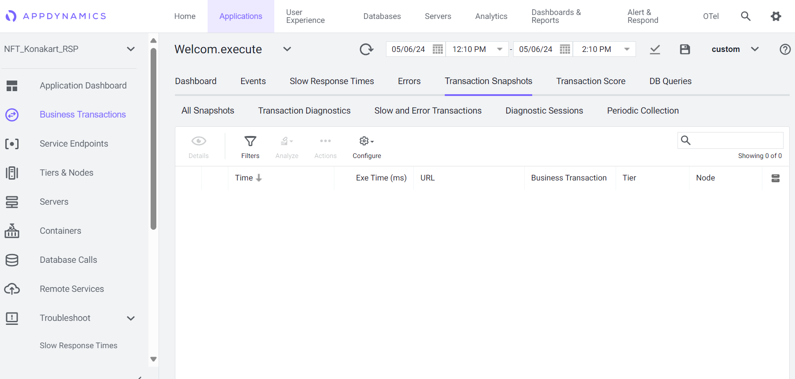

**(Reference image)**

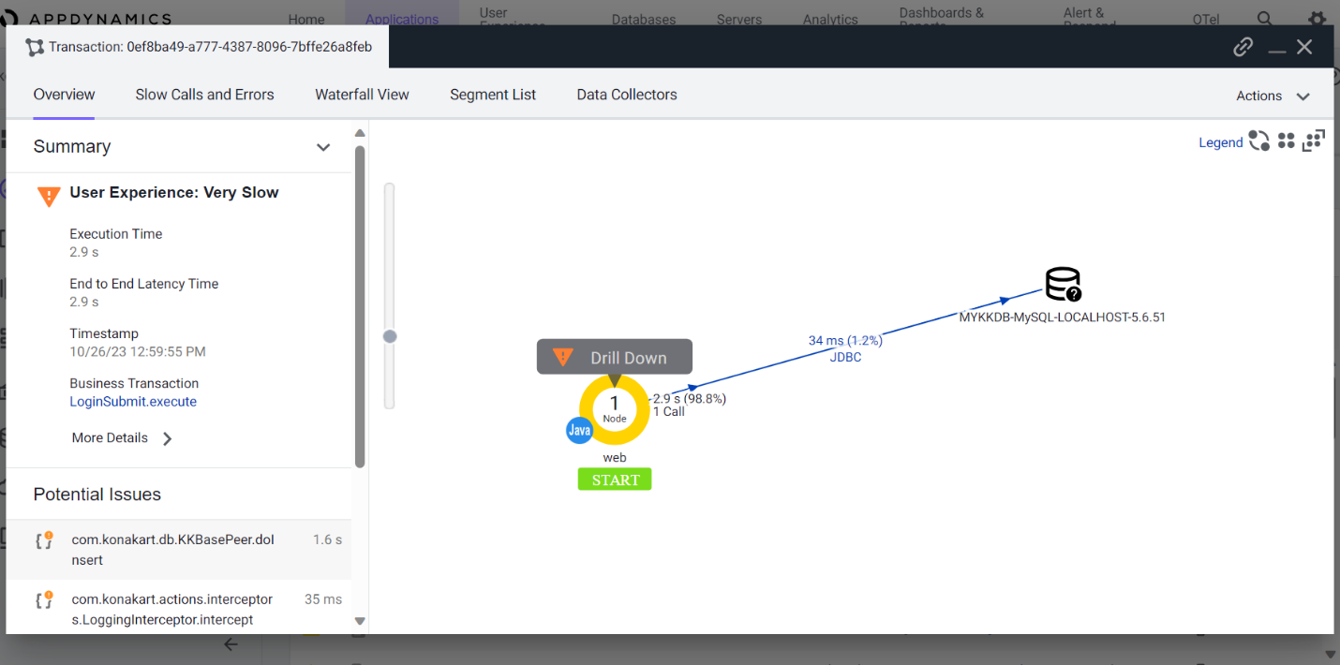

* For Method level analysis, Goto Business Transaction select any BT and go to details of that BT.
* Next go to Transaction snapshot of that BT we can see user exp as normal and very slow.
* Select any of that and check the Potential Issues of that BT.