**App Dynamics – Handson15 (Time Slot 12:10PM – 2:10PM)**

**Dashboard Creation:**

**1. Resource Metrics- CPU, Memory & Disk utilization of the server**

Then we need to provide the name of the dashboard that needs to be created.

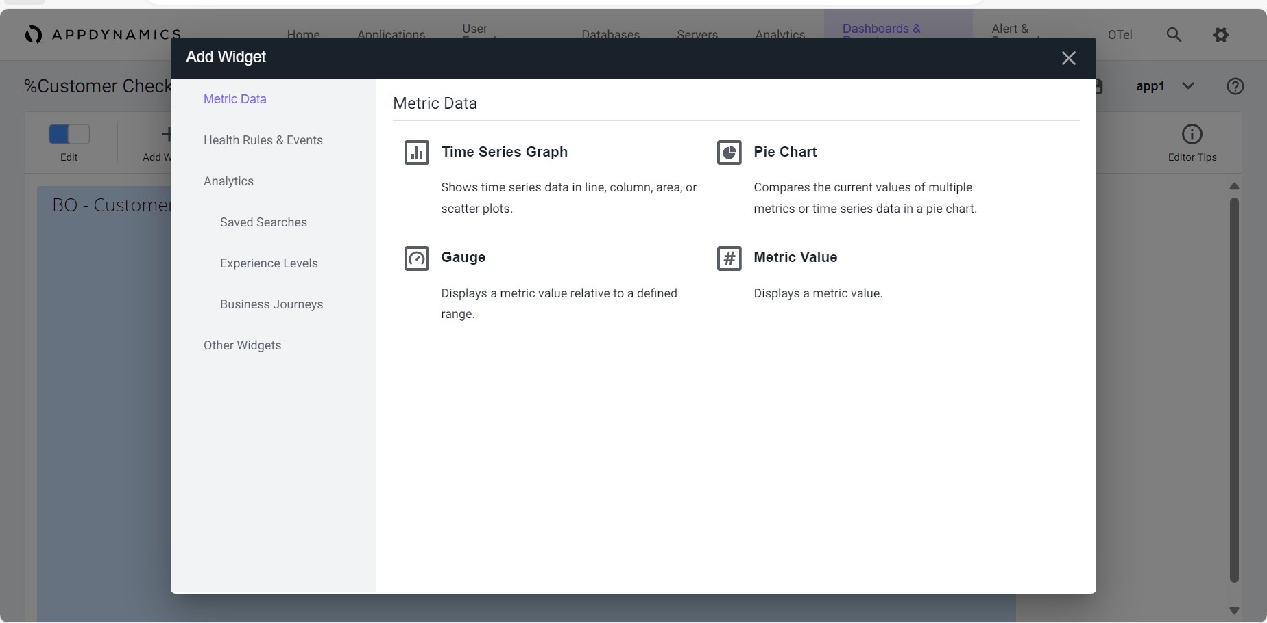

After selecting the metrics click on save then the metrics will be added to the the dashboard.

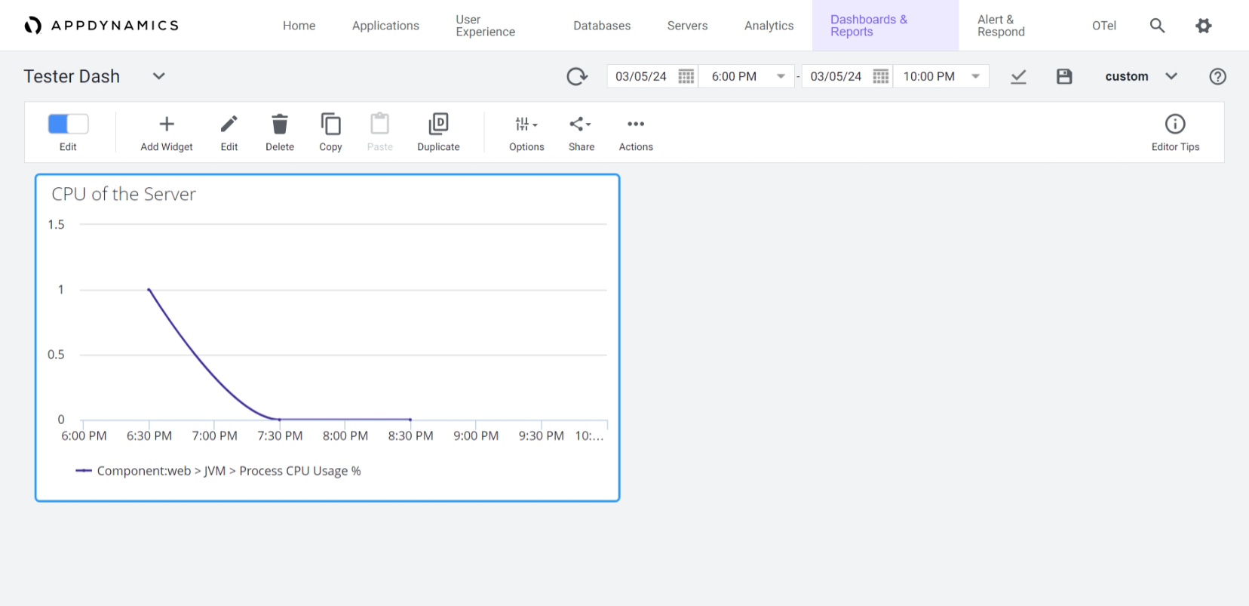

Similarly add other metrics that are required.

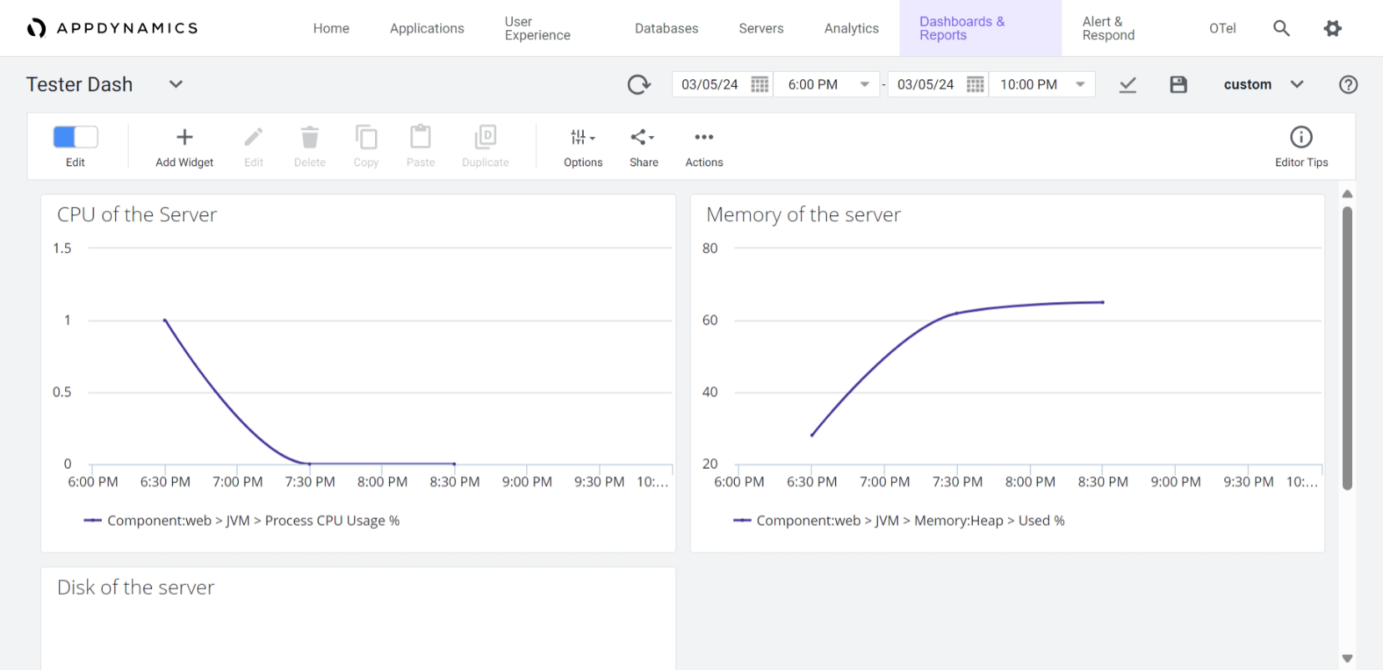

**2. Servers/JVMs- Calls per min, Errors/Exceptions Per Min, Response time**

Similarly add other metrics to the dashboard by clicking on the add widget and selecting required metrics.

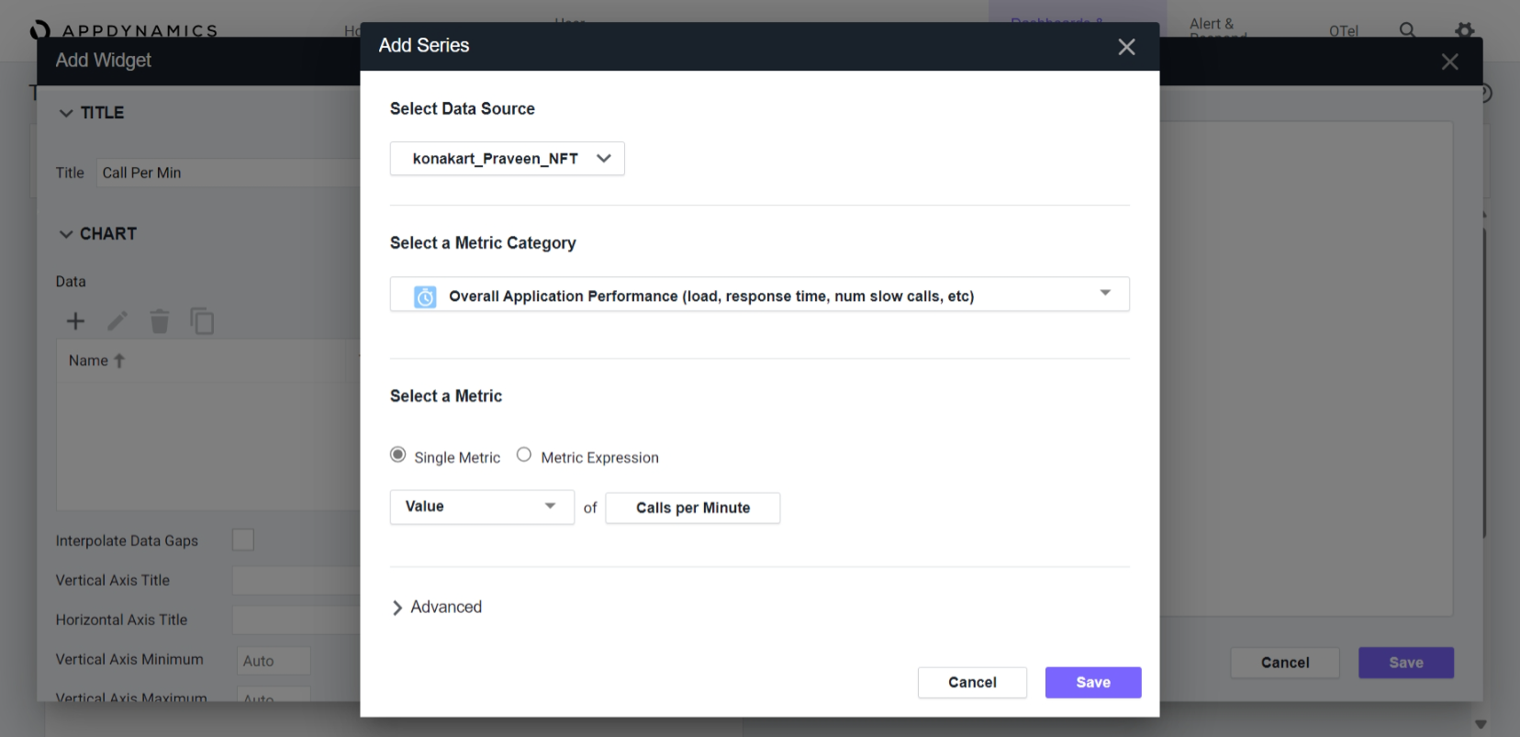

Reference

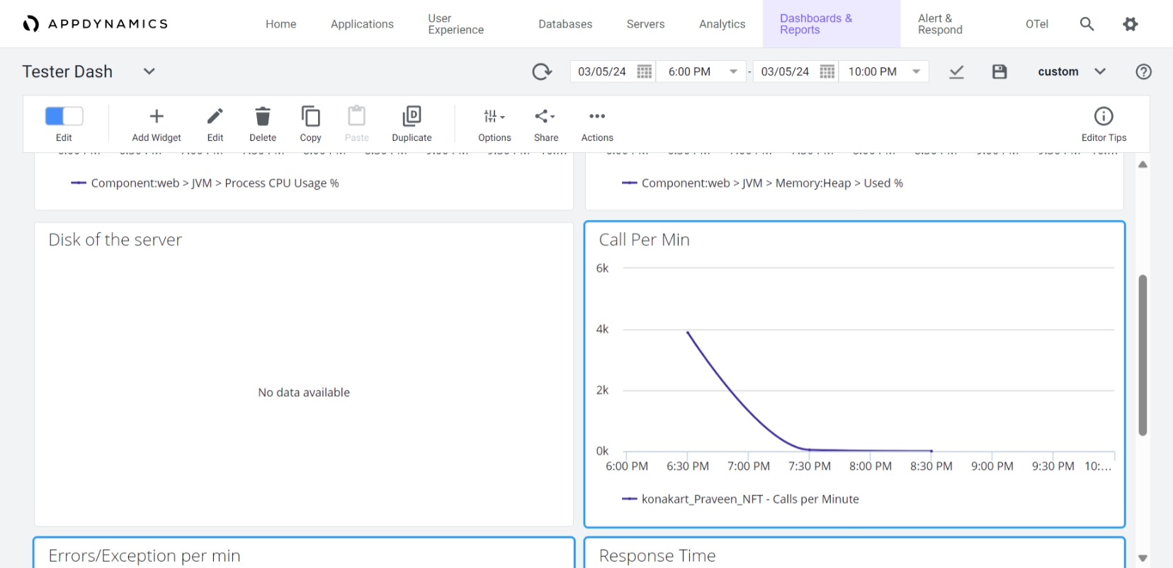

**3. Running JVMs**

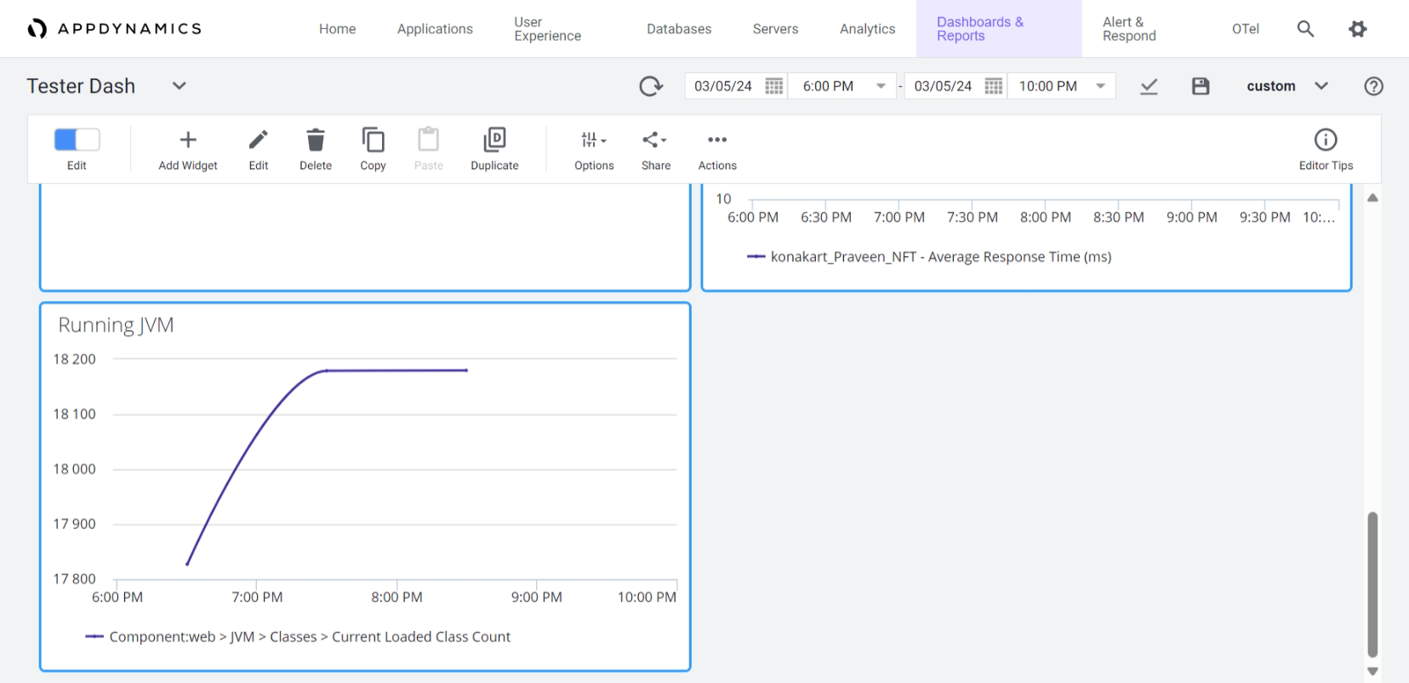

**Task: 3.2-**

**a) Average CPU Utilization.**

As we can observe from the screenshot the CPU usage is 0% for NFT_Konakart_RSP Node.

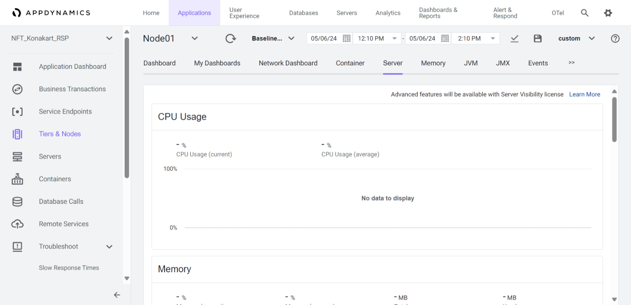

**b. Max memory Utilization**.

We can view the memory details in server tab itself.



**c. Max available heap memory.**

The Average utilization of NFT_Konakart_RSP is 0% and The Current utilization of NFT_Konakart_RSP is 0 %.

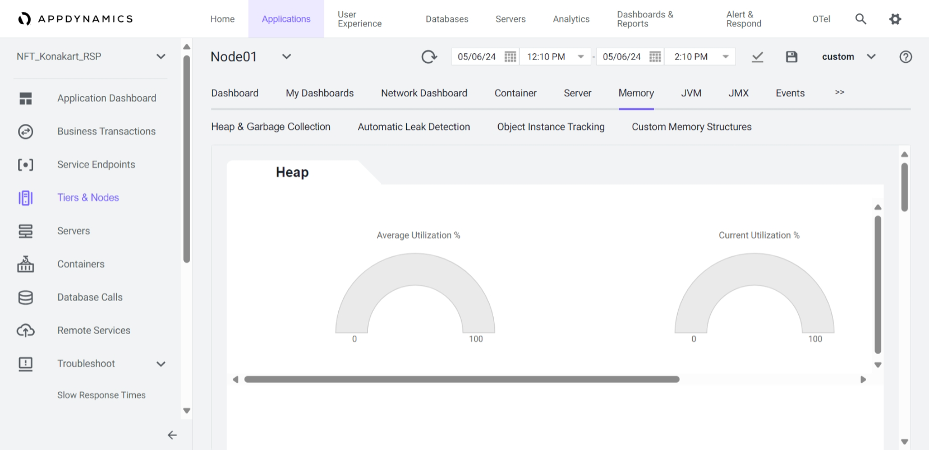

**d. Disk Usage Details**

There is no data available for disk usage.

It will be available in memory tab.



Fig-15.12: Memory

**f. Plot GC pattern for each JVM**

From the screenshot we can observe that garbage collection data is not available.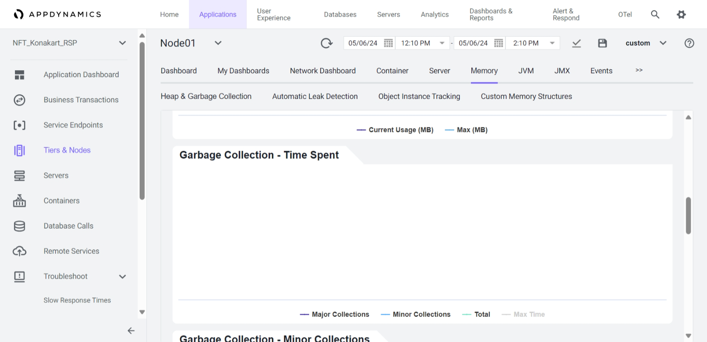

**g. Give the details of Top 3 calls/min**

As per the data received from the Top Business Transaction tab we will get to see the top 3 calls/min

**h. Give the Details of Errors Per Minute & Exceptions per Minute**

As per the data received of Errors per minute from Metric Browse there are no errors for given timeslot.

As per the data received from the application dashboard there is no data available for exception

Per min even from Metric Browser there is no data available for a given timeslot.

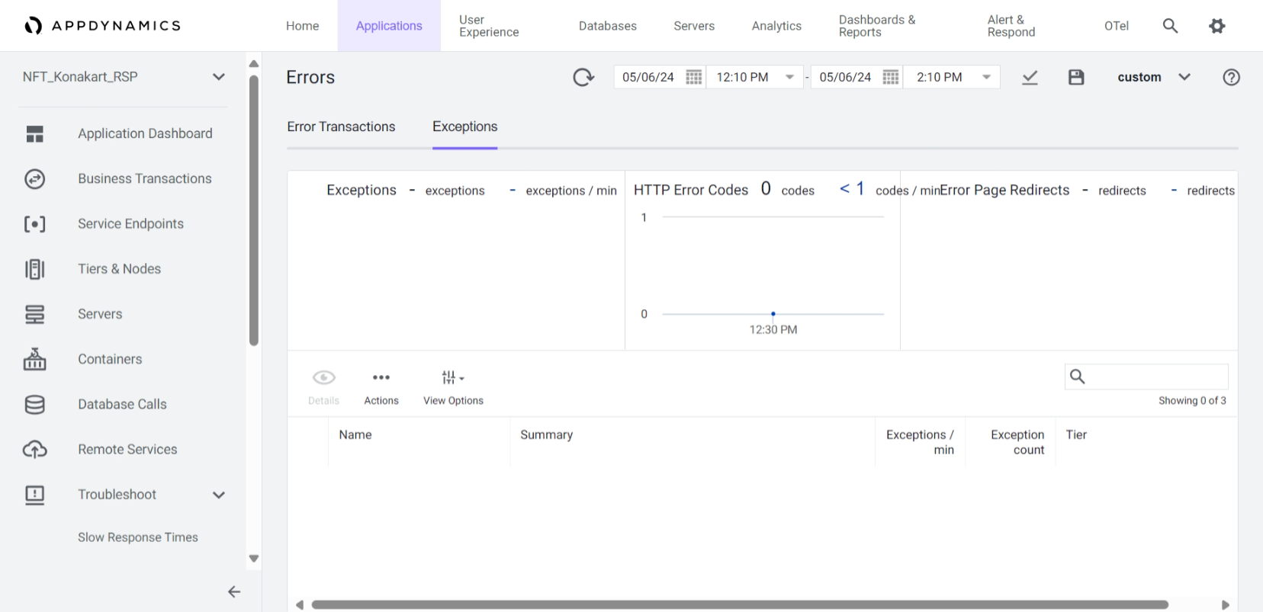

**I. Find out the BT with highest calls/min.**

As per the data received from the Top Business Transaction tab with highest calls/min is

Welcome.execute with 177 calls/min.

**j. Drilldown the high response time transaction and identify the root cause**

1.For analysis we need to select the BT with high response time and click on the details

2.Then click on transaction snapshot you will see the list of the transactions, and double click on 3.the each transaction to view the details you can see the summary and potential issues

4.There we can drill down to call graph where we can see the information.

5.There is no data available for this application.