**GROUP WORK OF INSTALLATION OF IP BASED DEVICE**

**GROUP MEMBER**

**1: Nishimwe Deborah 22RP09564**

**2: Nishimwe Mariam 22RP09007**

**3: Nishimwe Antoinette 22RP07934**

**4: Nindenkawe Vanie Aisha 22RP09366**

**Q1. Description of types network media which are:**

1. **Infrared (IR):** Imagine a silent symphony of light guiding your TV from afar. That's infrared in action! This short-range, line-of-sight technology uses invisible light waves to transmit data between devices like remote controls and receivers. Think of it as a whisper in the electromagnetic spectrum, perfect for indoor communication.

[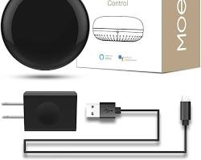 w](https://www.amazon.com/MOES-Controller-Infrared-Universal-Compatible/dp/B07QH1X7PX)

Infrared data transmission between a remote control and a TV

**2. Broadcast Radio:** Remember those crackling tunes on the radio? That's the magic of broadcast radio, a one-to-many communication method using radio waves to send signals to a vast audience within a specific range. Think of it as a megaphone for information, broadcasting news, music, and even emergency alerts to anyone with a receiver tuned to the right frequency.

[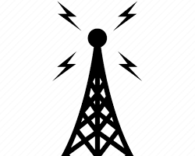w](https://www.iconfinder.com/icons/653630/antenna_broadcast_communication_connection_radio_signal_tower_icon)

Radio towers broadcasting signals

3**:Cellular Radio:** Ever wondered how your phone stays connected even on the move? Cellular radio uses a network of cell towers to transmit and receive data, creating smaller coverage areas called cells. Your phone constantly hops between these cells, ensuring seamless connectivity even as you move. Think of it as a dynamic web of invisible pathways, keeping you connected to the world.

[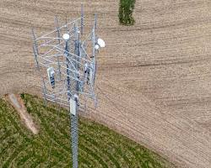w](https://en.wikipedia.org/wiki/Cell_site)

Cellular network towers and phone connecting

**4. Microwaves**: Think high-speed data zipping through the air? Microwaves, with their shorter wavelengths and higher frequencies, are the workhorses of long-distance communication. They're used in point-to-point and point-to-multipoint setups, carrying everything from phone calls to internet traffic over long distances. Imagine them as laser beams of information, piercing through the air with incredible speed.

[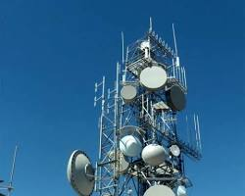w](https://en.wikipedia.org/wiki/Microwave)

Microwave data transmission towers

**5. Communication Satellites:** Ever wondered how you can video call someone on the other side of the planet? Communication satellites, orbiting the Earth, act as celestial relay stations. They receive signals from ground stations, amplify them, and retransmit them to other stations or directly to your devices. Think of them as celestial bridges, spanning vast distances and connecting the world like never before.

[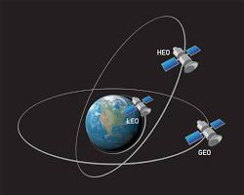 w](https://www.researchgate.net/figure/Communication-satellites-orbiting-the-Earth-in-geostationary-orbits-GEO-Low-Earth_fig3_266670547)

Communication satellites orbiting the Earth

These are just a few of the many types of network media that power our interconnected world. Each technology has its own strengths and limitations, working together to create the invisible infrastructure that keeps us informed, entertained, and connected.

**Q2.TYPES OF NETWORK CABLE**

**1.Fiber optic cable:** is an assembly similar to an electrical cable but containing one or more optical fibers that are used to carry light

**2.twisted pair cable:** isa type of communication cable in which two conductors of a single circuit are twisted together for the purpose of improving electromagnetic compatibility

**3.coaxial cable:** Is used as a transmission line for radio frequency signals

**Q3**.  
Installing a CCTV camera system requires a range of materials, tools, and equipment, both hardware and software. Here's a breakdown of the essentials and their functions:

Hardware:

* CCTV Cameras: The star of the show! Choose from various types like bullet cameras for outdoor use, dome cameras for indoors, or PTZ (pan-tilt-zoom) cameras for wide coverage.

[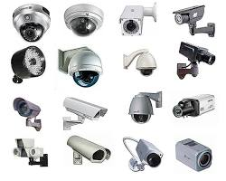w](https://www.sonitrolwesterncanada.com/blog/what-type-of-cctv-camera-should-i-buy)

CCTV Camera Types

* Camera Cables: Coaxial cables carry video signals from cameras to recording devices. Choose the right type and length based on your setup.
* Power Supply: Provides electricity to cameras. Choose the correct voltage and amperage for your cameras.
* Connectors and Adapters: Connect cables to cameras, recorders, and other equipment. Ensure compatibility.
* Camera Mounts: Secure cameras to walls, ceilings, or poles. Choose the right mount for your camera type and installation location.
* Monitor (Optional): View live footage or recorded video (though many systems can be accessed remotely). Choose the size and resolution based on your needs.
* Recording Device: Stores recorded footage. Digital Video Recorders (DVRs) and Network Video Recorders (NVRs) are popular options. DVRs use analog signals, while NVRs use digital signals from IP cameras.

[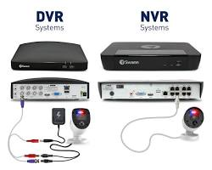w](https://blog.swann.com/dvr-vs-nvr-whats-the-difference/)

DVR vs NVR

* Storage (Optional for NVRs): NVRs can store footage internally or on external hard drives. Choose the storage capacity based on recording duration and resolution.

Software:

* CCTV Management Software: Manage and configure your camera system, view live footage, and access recordings. Some systems offer mobile apps for remote access.

Tools:

* Drill and Screwdriver: Install camera mounts and secure cables.
* Wire Strippers and Crimpers: Prepare coaxial cables for connectors.
* Ladder: Reach high mounting points.
* Level: Ensure cameras are evenly mounted.
* Cable Tester: Verify proper cable connections.

Q4.   
The world of cameras is vast and diverse, catering to a wide range of needs and budgets. From capturing your family vacation to professional filmmaking, there's a perfect camera out there waiting to be discovered. Here's a breakdown of some of the most popular types:

**1. Compact/Point-and-Shoot Cameras:**

* Ideal for: Beginners, everyday photography, travel
* Features: Simple to use, small and lightweight, built-in zoom lens, automatic settings
* Image quality: Good for casual photos, may struggle in low light
* Example: Canon PowerShot G7 X Mark III

[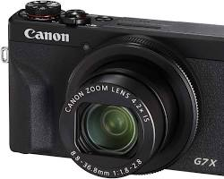w](https://www.amazon.com/Canon-PowerShot-Digital-Camera-Screen/dp/B07TKNCQZL)

Canon PowerShot G7 X Mark III camera

**2. DSLR (Digital Single-Lens Reflex) Cameras:**

* Ideal for: Enthusiasts, semi-professionals, advanced photography
* Features: Interchangeable lenses, manual controls, larger sensor for high image quality, viewfinder
* Image quality: Excellent, versatile for different lighting conditions and subjects
* Example: Nikon D3500

[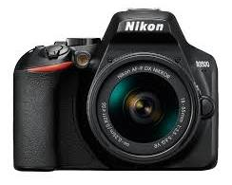w](https://www.nikonusa.com/en/nikon-products/product/dslr-cameras/d3500.html)

Nikon D3500 camera

**3. Mirrorless Cameras:**

* Ideal for: Enthusiasts, professionals, portability, video recording
* Features: Interchangeable lenses, smaller and lighter than DSLRs, electronic viewfinder, some models offer excellent autofocus
* Image quality: Excellent, comparable to DSLRs
* Example: Sony a7 IV

[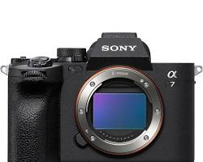w](https://www.bhphotovideo.com/c/product/1667800-REG/sony_ilce_7m4_b_alpha_a7_iv_mirrorless.html)

Sony a7 IV camera

**4. Action Cameras:**

* Ideal for: Adventure sports, outdoor activities, rugged environments
* Features: Waterproof, shockproof, dustproof, wide-angle lens, stabilization for action shots
* Image quality: Good for action shots, may not excel in detail or low light
* Example: GoPro HERO11 Black

[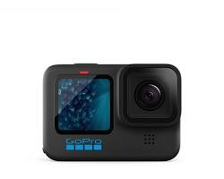w](https://www.target.com/p/gopro-hero11-action-camera-black/-/A-88833864)

GoPro HERO11 Black camera

**5. Instant Cameras:**

* Ideal for: Fun, nostalgic photos, on-the-spot printing
* Features: Prints photos immediately, simple to use, unique aesthetic
* Image quality: Lower resolution than other cameras, distinct instant film look
* Example: Fujifilm Instax Mini 11

[w](https://www.amazon.com/Fujifilm-Accessories-Including-Carrying-Stickers/dp/B08WH6JYYV)

Fujifilm Instax Mini 11 camera

**6. Medium Format Cameras:**

* Ideal for: Professionals, high-end photography, studio work
* Features: Large sensor for exceptional image quality, high resolution, interchangeable lenses
* Image quality: Superb, suitable for demanding professional needs
* Example: Hasselblad X2D 100C

[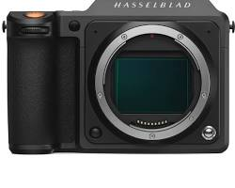w](https://www.bhphotovideo.com/c/product/1725356-REG/hasselblad_cp_hb_00000723_01_x2d_100c_medium_format.html)

Hasselblad X2D 100C camera

**7. Smartphone Cameras:**

* Ideal for: Everyday use, on-the-go photography, social media
* Features: Convenient, built-in to smartphones, improving image quality, some offer multiple lenses
* Image quality: Varies depending on smartphone model, can be good for casual photos
* Example: iPhone 14 Pro Max

[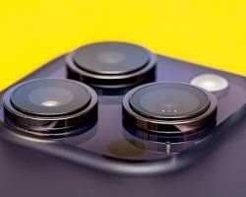w](https://www.cnet.com/tech/mobile/iphone-14-pro-cameras-are-a-big-leap-for-photo-enthusiasts/)

iPhone 14 Pro Max camera

Choosing the right camera depends on your individual needs and priorities. Consider factors like budget, skill level, intended use, and desired image quality. Whether you're a seasoned photographer or just starting out, there's a camera out there waiting to capture your unique vision.