**VYOS Installation process**

Yuvraj Mishra

19XJ1A0576

1. Install VyOS1 in VirtualBox
2. In VYOS1:

ip a # check interface name from here

sudo ip addr add 192.168.101.2/24 dev eth0

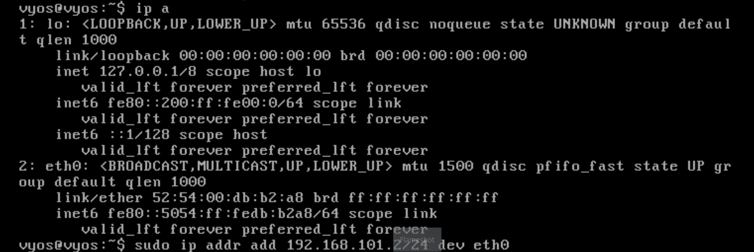

1. Turn off VYOS1

poweroff

1. In network section of VyOS1, in Adapter 2 (eth1), add internal network b2.
2. Install VyOS2 in VirtualBox
3. In VYOS2:

ip a

sudo ip addr add 192.168.100.2/24 dev eth0

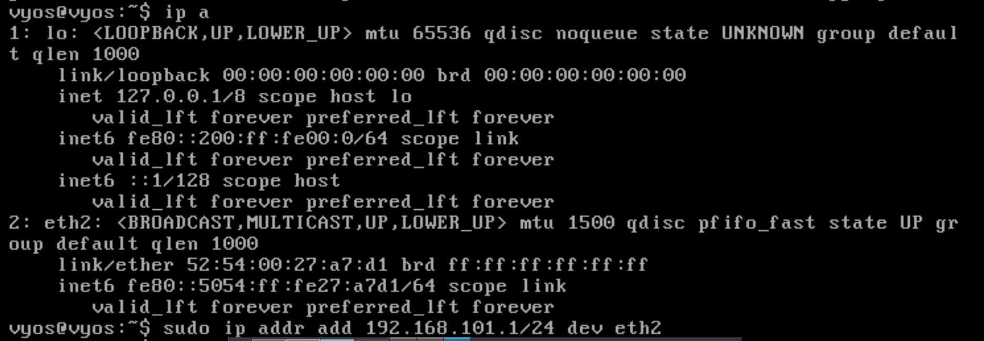

1. We now have to make sure that VyOS1’s eth0 and VyOS2’s eth2 are on same network (i.e, b2 as we added in VyOS1)

In network section of VyOS2, in Adapter 1, add internal network b2.

1. Now VYOS1 and VYOS2 are on the same network, to verify we can ping VYOS1 from VYOS2:

ping 192.168.101.2

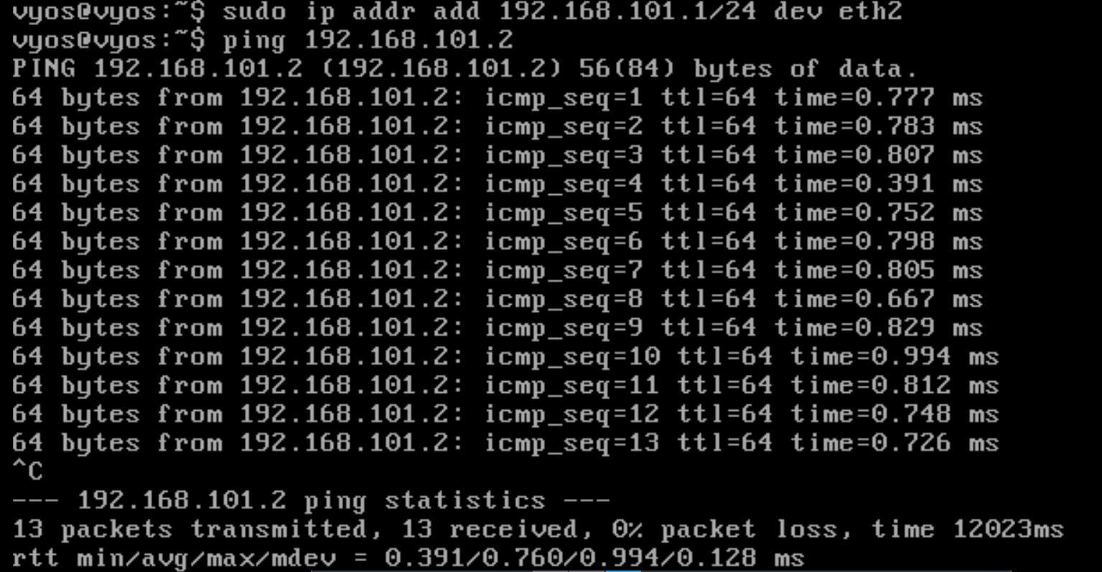Since we can ping VYOS1 from VYOS2, both are on same network.

1. We can also see all hops between VYOS1 and VYOS2. In VYOS2:

traceroute 192.168.101.2

Only 1 hop since both VYOS1 and VYOS2 are on the same subnet. Subnet mask is 255.255.255.0 (/24).