**Team members:**

Kaivalya Dixit - 19XJ1A0218

Pulkit Aggarwal - 19XJ1A0554

Yuvraj Mishra - 19XJ1A0576

**BNA dataset**

**Without bagging:**

Accuracy = 97.8102189781022

Decision tree formed:

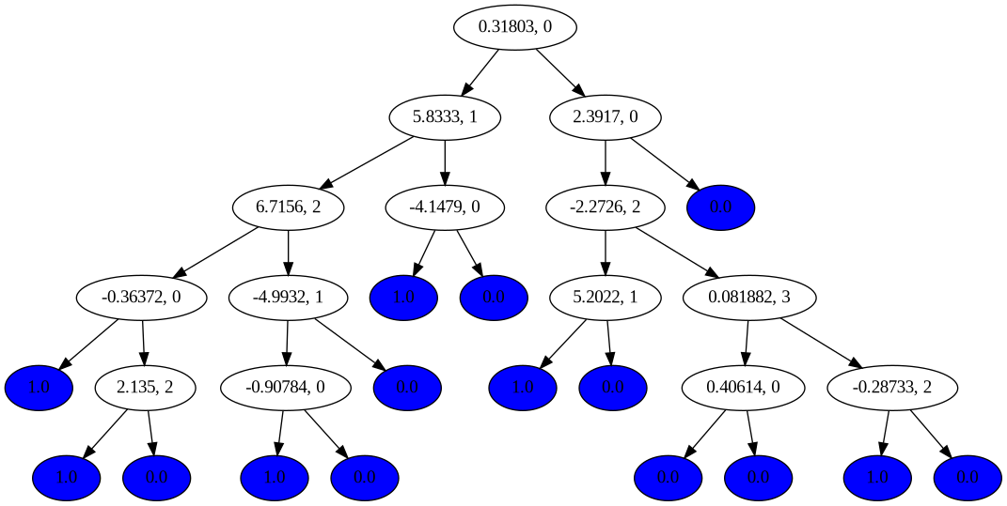

Every non-leaf node indicates the splitting value and the feature index in the dataset(starting from 0).

Every leaf node colored in blue indicates the classified class.

**With bagging:**

For bagging, no. of decision trees split = 8

Accuracy = 97.08029197080292

**SDD dataset**

Accuracy = 71.08029197080292

Accuracy is because hyperparameters were changed such that the program completes in a reasonable amount of time.

