# Ideco Selecta

The dynamic technology development provides unlimited access to a wide range of Internet resources, which can have both positive and negative impact on society. For the state, the protection of cultural and ideological values is a primary objective. Today the most effective solution is content filtering.

Ensuring maximum safety is an important and time-consuming task. The main difficulty is users control, i.e., collecting static information about actions and behavior of users on the Internet, for example, their visits to prohibited sites.

The **Ideco Selecta** software solution allows filtering of broadband HTTP/HTTPS traffic by both URL categories and the content of web pages.

This solution is applicable for medium and large businesses, educational institutions, and Internet providers.

The Ideco Cloud WebFilter cloud service is used to categorize URLs (143 categories of sites, more than 500 million URLs in the database).

### Key Features

* Filtering by domain name, URL, and category.
* Filtering of encrypted HTTPS traffic.
* Using of the continuously updated Ideco Cloud WebFilter database.
* Blocking of downloads by extension and MIME types.
* Providing secure user search.
* Blocking of IPs, networks, protocols.
* Reporting on the use of the Internet and providing statistics.
* The system can be shipped as a hardware appliance.
* Flexible configuration of user security policies.

## Types of unwanted traffic:

* Pornographic sites.
* Sites selling alcohol.
* Sites distributing narcotic drugs.
* Terrorism-related sites.

#### Categories enhancing safety:

* Phishing and fraudulent sites.
* Botnet command centers.
* Spam (sites advertised via spam letters).
* Anonymous collection of information (spyware and web trackers).
* Malware distribution centers.
* Pirate sites, illegal software and hacking tools.
* Compromised and hacked sites.

## Deployment Scheme

## 

### Network Bridge

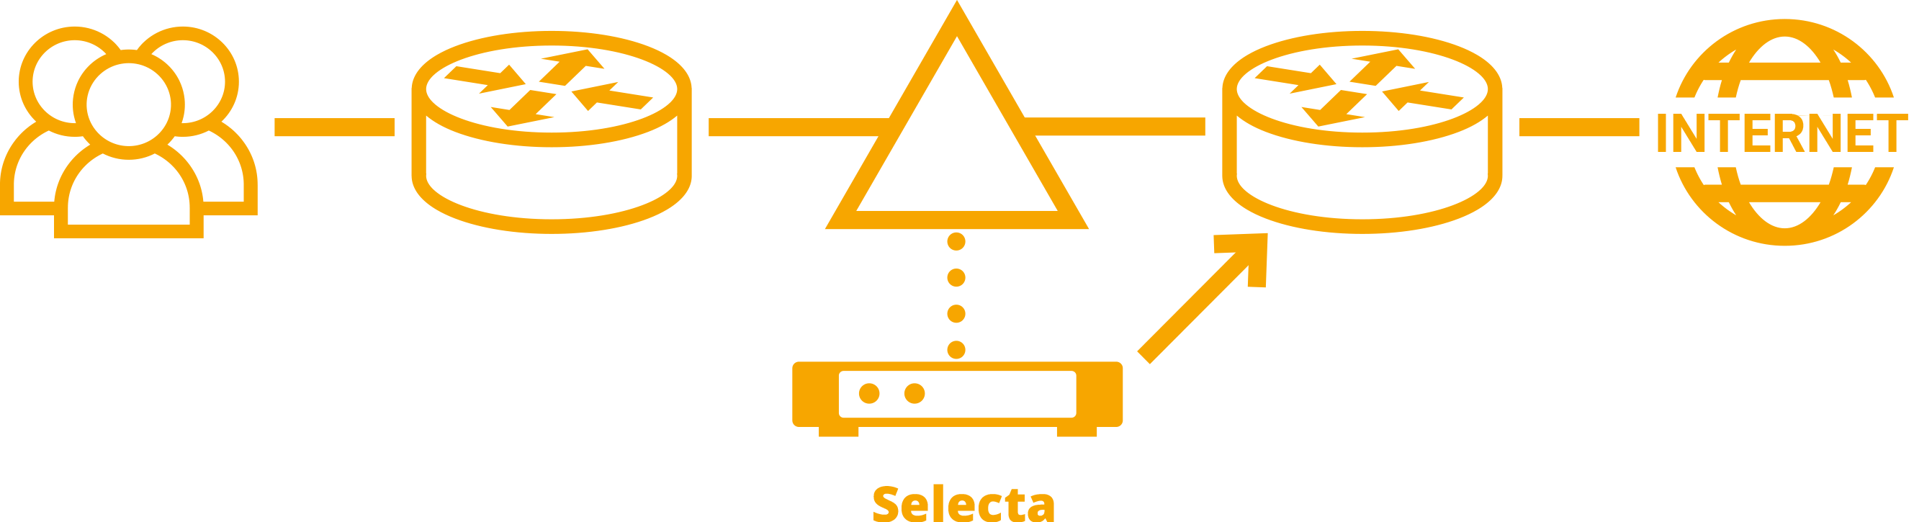

### BGP

### WCCP 2.0

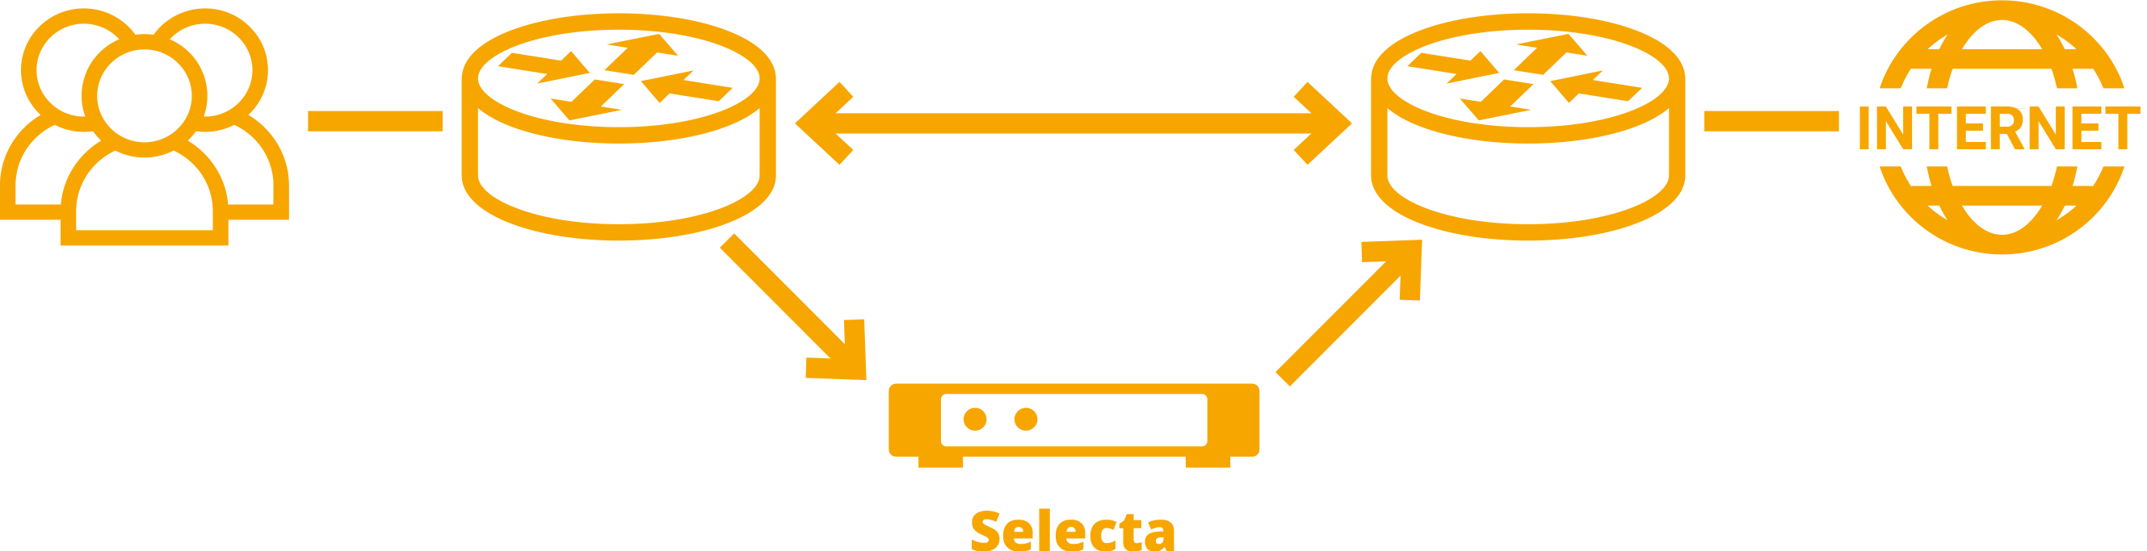

## Reports on the use of web traffic:

* Report designer with customizable sampling methods.

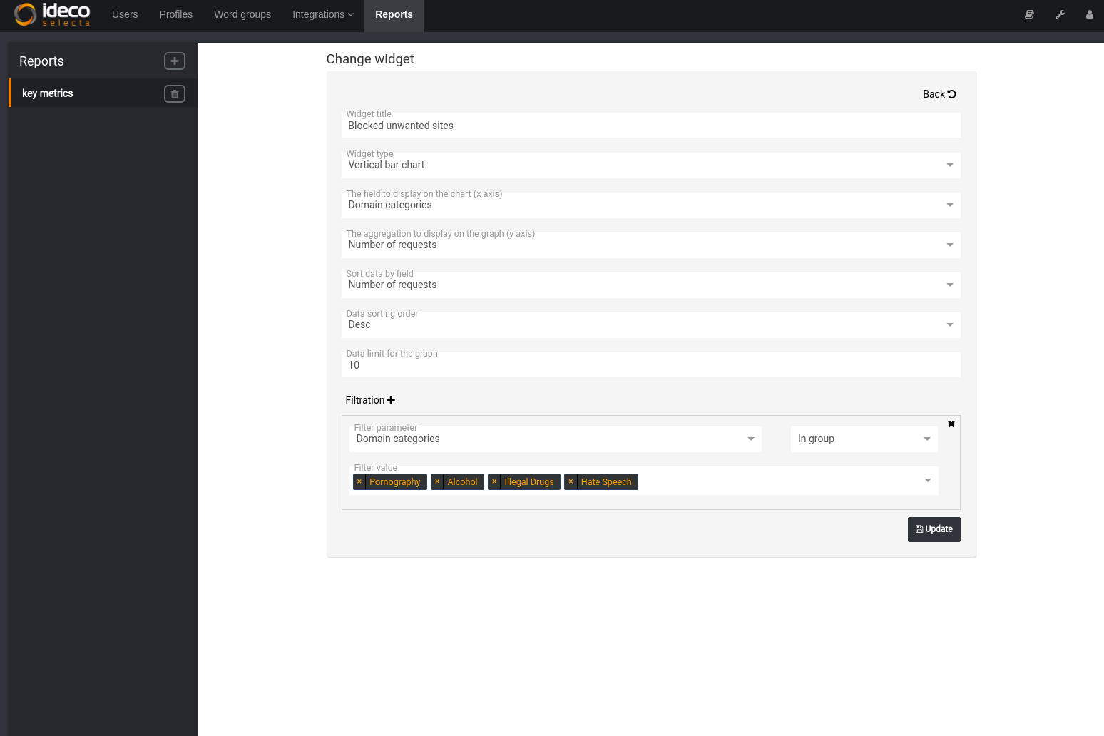

* Pre-installed reports on the blocking of dangerous sites, TOP-10 active users and TOP-10 popular resources. Detailed statistics on sites visited by users, including attempts to access prohibited resources.

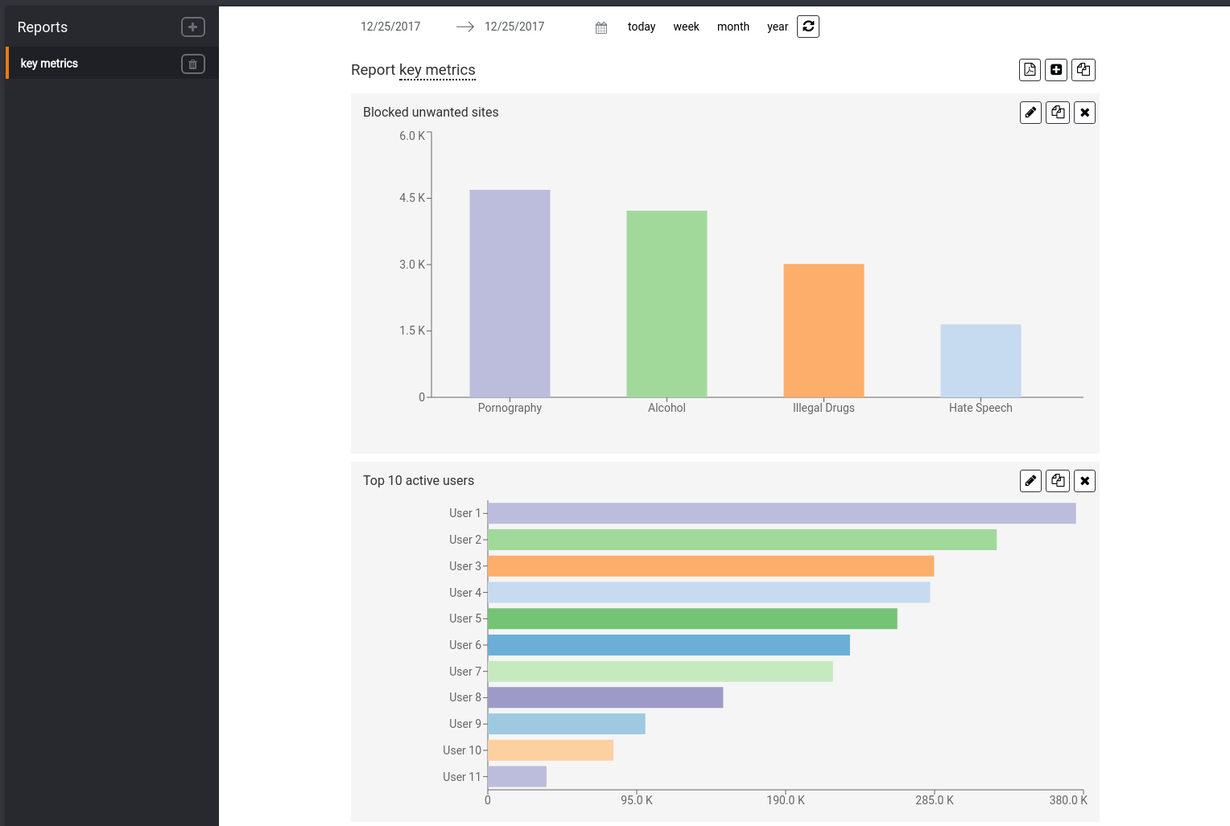

## System Requirements

|  |
| --- |
| CPU: 64-bit, dual-core (from 3 GHz) Intel or AMD supporting SSE 4.2 instructions. |
| UEFI support (mandatory requirement). |
| RAM: 4 GB and higher. |
| Storage space: 40 GB and higher. |