Sprint 5: MongoBD Queries
LEVEL 1

We start creating a new database (Cinema_db) in MongoDB Compass and a first collection “comments” based in the files of the task. Then we create the rest of the collections, one for each five Json file.
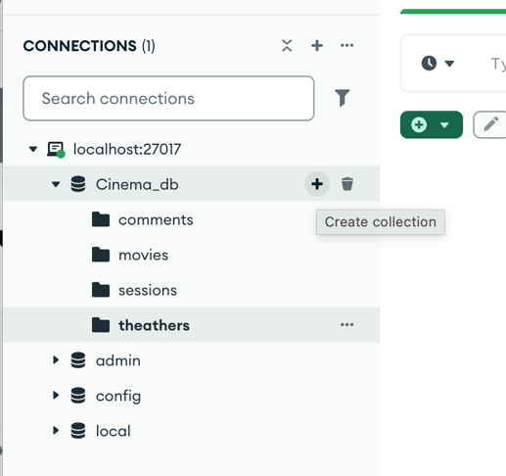
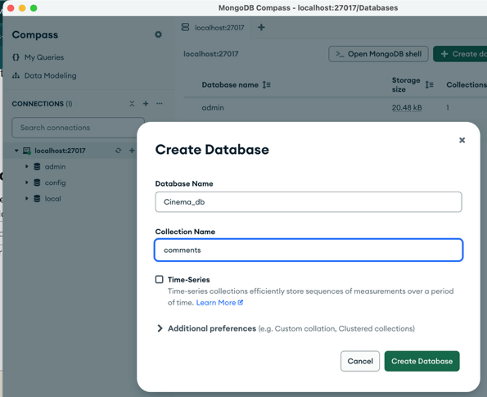

For each of the five collections we import its Json data:

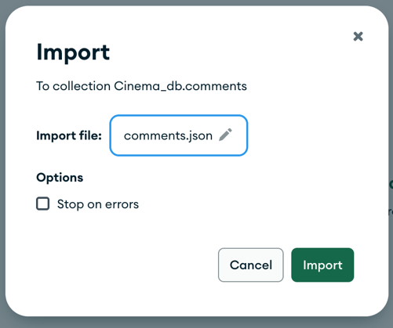

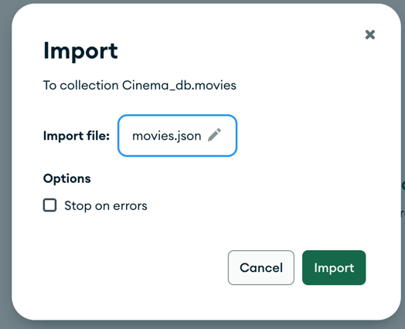

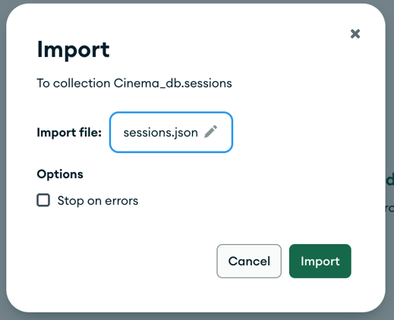

To answer all the questions on the exercises, we use the MongoDB shell: mongosh

- Exercise 1

- First, we show the first 2 comments using limit(2), from the collection comments:

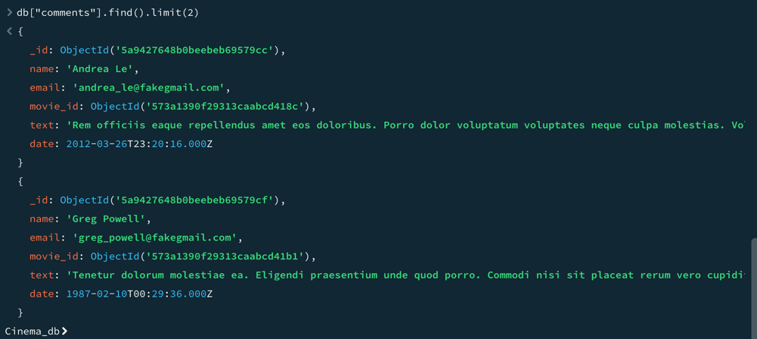

- To know the number of users registered we use countDocuments(). In this collection we have 185 users.

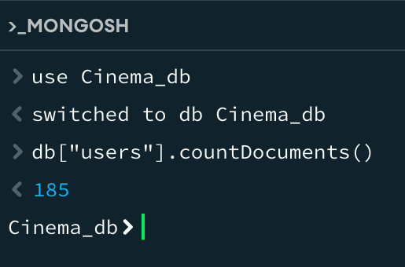

- To know how many theathers exist in California (CA) state, we need to design a query specifically for the location > address > state > CA. In this case California has 169 theathers.

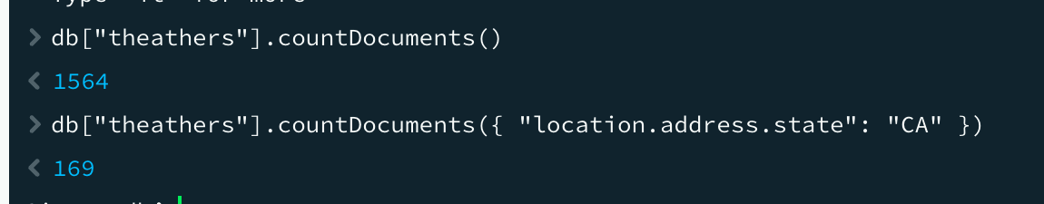

- To show the first user registered, since MongoDB stores documents in the order they are created, we so a sorting by _id in ascending order. We can see that Ned Stark is the first user registered.

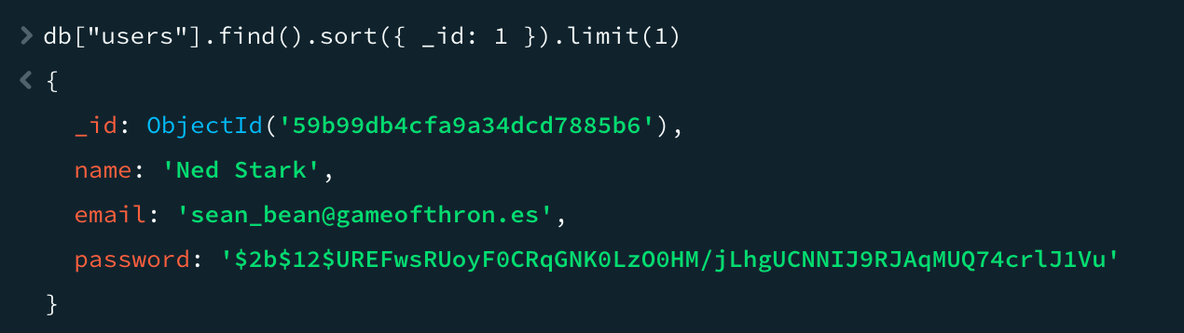

- To investigate how many movies with genre comedy we have on the database we count them: 7024 comedies.

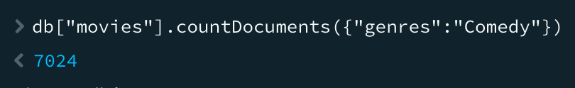

- Exercise 2
To show all the 18 movies produced in year 1932 that belong to “Drama” genre or that are in “French” language:

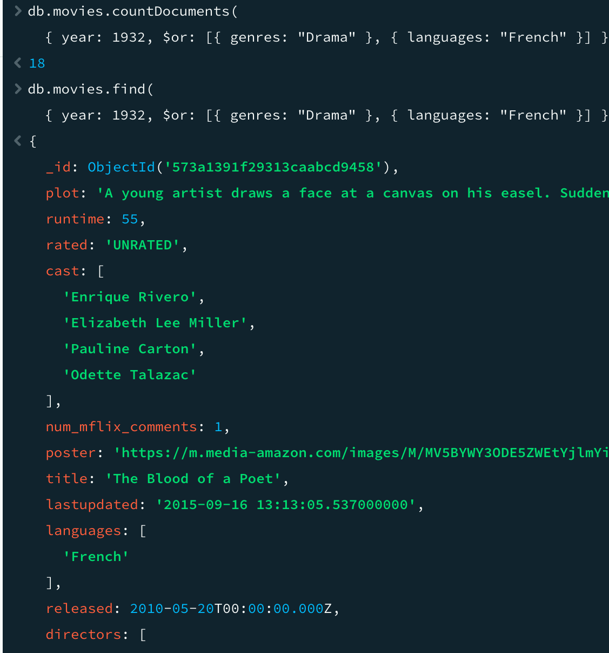
- Exercise 3
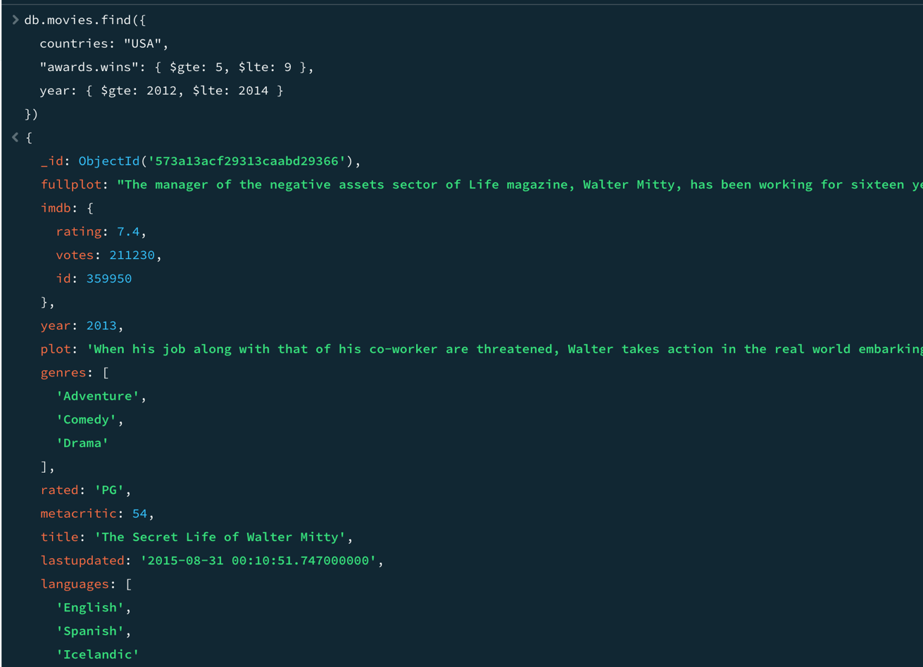
To show all the movies from USA with 5 to 9 awards, produced between 2012 and 2014, we need to apply three filters and two ranges (awards won and year of production):

LEVEL 2

- Exercise 1
To count the comments of users with “GAMEOFTHRON.ES" as email domain we also add (i) to be sure that the search is case-insensitive. We get 22841 comments.
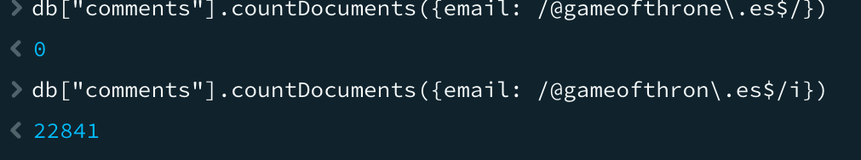

- Exercise 2
To know how many theaters exist in each postal code at Washington D.C. (DC) state, first we need to filter by state and then group by postal code. There is one theater by postal code in DC.
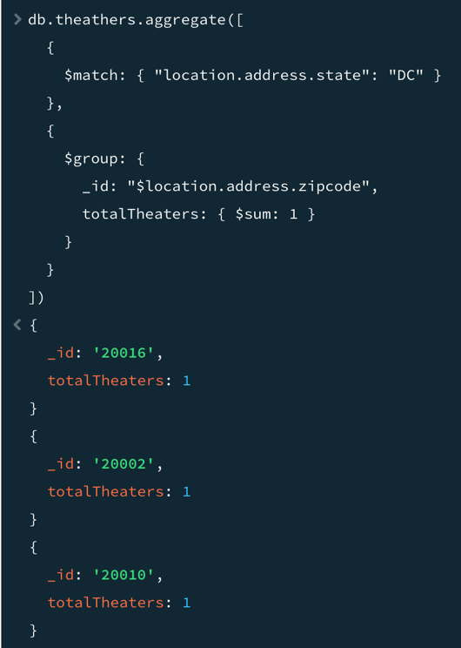

LEVEL 3
- Exercise 1

To find all movies directed by Jhon Landis with an IMDb score between 7.5 and 8, we used both filters and get 4 movies.

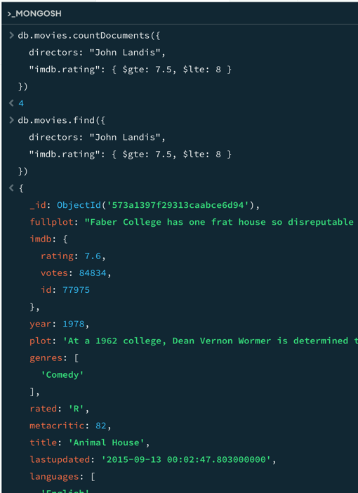

- Exercise 2

Finally, we need to show a map with all the theaters location on it following the steps in the order detail on the figure (1> theater, 2>Schema, 3> Analyze, 4 > location).

